**Low Level Programming**

Game Design Document

***Created by Claudia Brown, Joe Gamble, Miles Hoyland, Tahir Serali and Razvan Traistrau.***

***Index*:**

Table of Contents

**1.1. Genre:** 2

**2.1. Gameplay Overview:** 2

**3.1. Demographic:** 2

**4.1. Core mechanics:** 2

**5.1. Movement:** 2

**6.1. Objective:** 2

**7.1. Game collectables:** 2

**8.1. Art style:** 2

**9.1. Music and Sound effects** 2

**10.1. Playable areas:** 2

### **1.1. Genre:**

A top down combat-based RPG. Inspired by games such as Pokémon Mystery Dungeon, Mario and Luigi: Partners in Crime and South Park: Stick of truth.

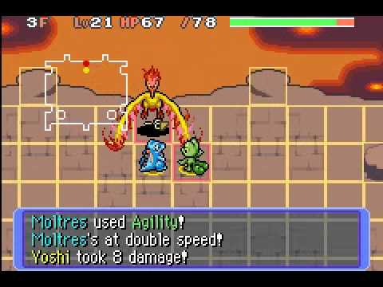 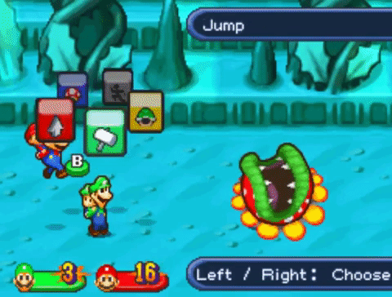

### **2.1. Gameplay Overview:**

Initially a dungeon crawler, similar to classic games such as ‘Baldur’s Gate’ and ‘Neverwinter Nights 2’. Players will travel together and defeat enemies throughout the dungeon, collecting power-ups along the way. This is until they reach the boss section of the level, where players will move into an area with a hostile opponent. The players and the opponent will take turns combating the foe. They will be able to choose between attacking, defending or casting a special effect (this will depend on the character build). The battle will end once the opponent has been defeated OR if both players have been killed.

The players abilities and skills will be upgraded upon defeating the enemy. They will also be able to upgrade specific skills, which is done if the player wants their character to be a certain build, (e.g. Mage, Paladin, Rogue.).

[Neverwinter Nights 2 Level-Up screen]

### **3.1. Demographic:**

The Game will be aimed at people of ages 12+. This is due to the explicit and gory nature of the game. It will also be aimed towards fans of classic style RPG and Dungeon crawler games.

[Example of Dungeon Crawler]

### **4.1. Core mechanics:**

4.2. Interaction:

You will be able to interact with objects throughout the game. Your character(s) will have the ability to pick up and use collectable items. This can help or hinder them.

4.3. Combat:

The characters will combat their enemies through a click-menu system. Similar to classic RPG-type battles. Their special abilities can also be clicked but will be assigned a hot-key for easy access and combo-effects.

### 

### **5.1. Movement:**

Movement will be controlled via the WASD and Up, Down, Left, Right keys. The player will be able to attack by pressing the spacebar.

### **6.1. Objective:**

Players (2-4) will use their teamwork skills to defeat the foe. This will be done via their abilities and skills. Death of both players will result in a loss, and they will be unable to progress to the next stage.

The players can also aim to gather loot and defeat smaller enemies.

### **7.1. Game collectables:**

Currency: In addition to gaining this at the end of a successful round, players may be able to gain this during combat or throughout the game. These can be used to purchase additional power-ups, skill points and bonus items.

### **8.1. Art style:**

Low-poly and cartoon looking style. Similar to games such as: Super Mario Galaxy and Legend of Zelda: Breath of the wild.

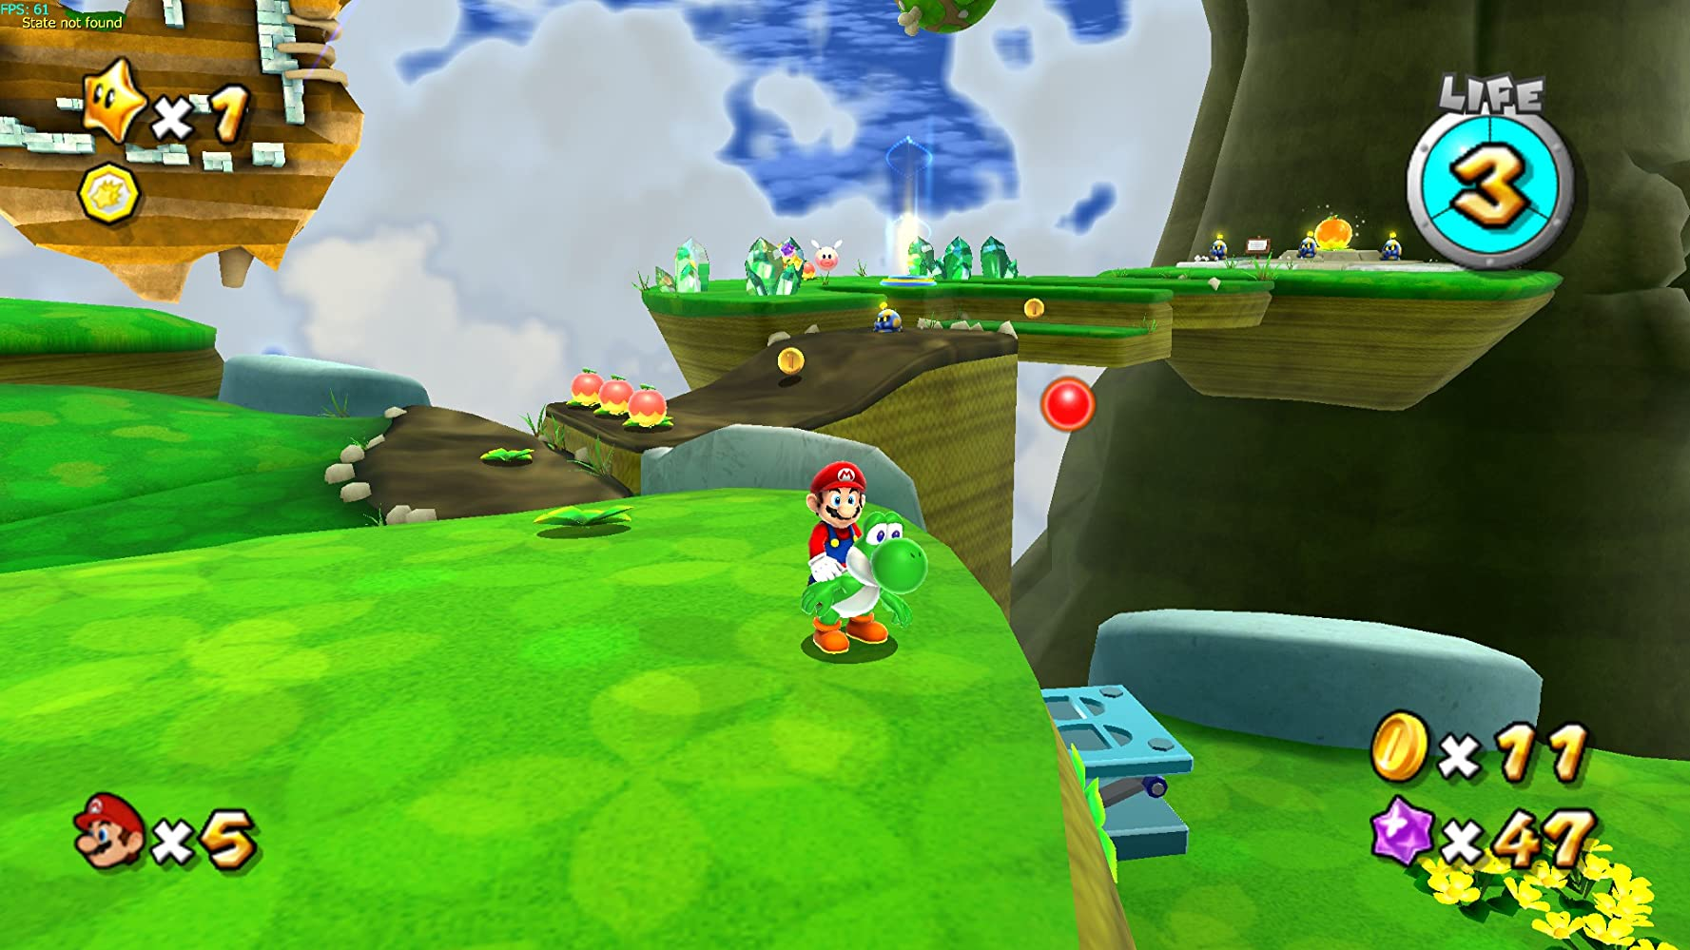

### **9.1. Music and Sound effects**

### 

### **10.1. Playable areas:**

10.1. Dungeons

Wave based with enemies of multiple types being presented to the players based on difficulty and the players level. The players can explore and loot the dungeon, whilst also combating its foes. Once they reach the end of the dungeon, a boss fight will trigger, and it must be defeated before they can progress.

The layout of each dungeon will be styled after SouthPark: Stick of Truth and Darkest Dungeon.

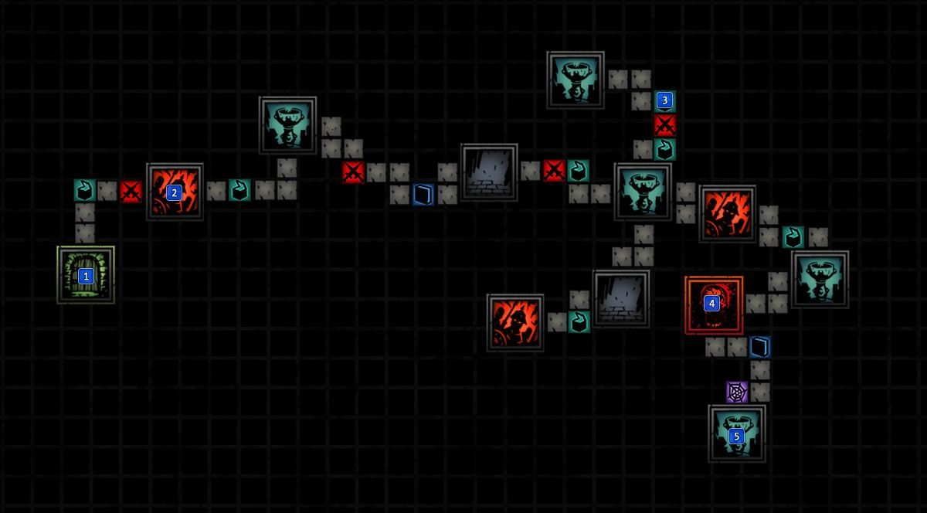

[Darkest Dungeon – Dungeon Layout]

Once the player has defeated the enemies and collected the loot, they will be able sell it or purchase upgrades at the town.

[Darkest Dungeon – Town]