***Important information for you, the player:***

In today’s study, you will play the **first-person shooter game *DOOM*.** Your goal is to shoot and kill as many zombies and demons as possible, going from one room to the next by opening doors and activating switches. Do your best to dodge attacks, pick up power-ups, and shoot the monsters. If you get lost, follow the blue arrows on the floor.

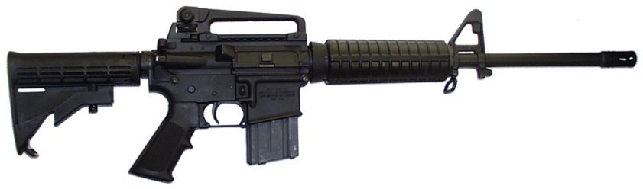

**Your weapon in this game is the American AR-15 Rifle.** Its magazine holds **twenty 5.56mm bullets**.

You will find many useful items lying on the ground. Simply walk over them to pick them up!

* Pick up lots of bullets to keep your AR-15 loaded! Bullets come in black magazines (10) or green boxes (40):

C:\Users\bartholowlab\Desktop\doom_materials\Clip.pngC:\Users\bartholowlab\Desktop\doom_materials\AmmoBrick.png

* Pick up health packs to keep your health up! Small kits replenish a little health, and big kits replenish a lot of health:

C:\Users\bartholowlab\Desktop\doom_materials\Stim.png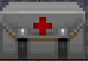

* Help protect yourself from the demons by picking up body armor:

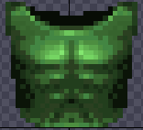

Here is a screenshot of the game with the essential parts labeled for you:

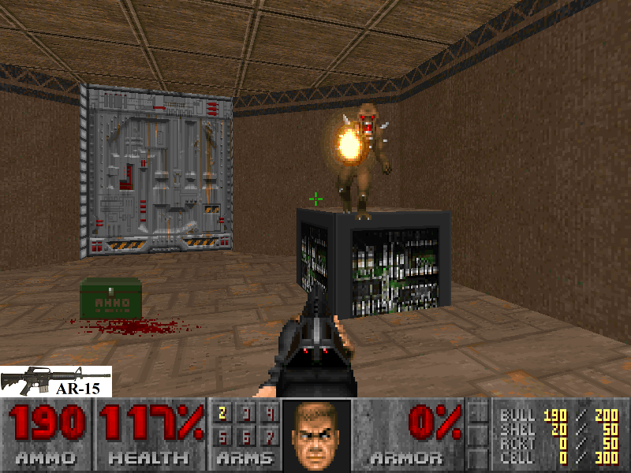

Remaining ammunition. Collect boxes of bullets. Your AR-15 won’t work if you’re out of bullets.

Health. Being hit reduces health. When health hits 0%, you die and start over.

Armor. Helps protect you from attacks.

Demons. They attack you!

Shoot them with your AR-15 to kill them.

Crosshair. Indicates where your AR-15 is aimed. The crosshair must be on the demons for the bullets to hit them. It can take several bullets to kill a demon.

Door. Press the space bar on the keyboard while touching the door to open it.

Your weapon, the American AR-15

**Controls**