***Important information for you, the player:***

In today’s study, you will play the **first-person shooter game *DOOM*.** Your goal is to shoot and kill as many zombies and demons as possible, going from one room to the next by opening doors and activating switches. Do your best to dodge attacks, pick up power-ups, and shoot the monsters. If you get lost, follow the blue arrows on the floor.

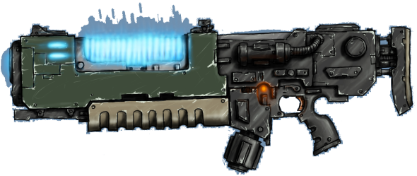

**Your weapon in this game is the Martian ZQ-5 Plasma Rifle.** Its magazine holds **twenty plasma rounds**.

You will find many useful items lying on the ground. Simply walk over them to pick them up!

* Pick up lots of plasma rounds to keep your plasma rifle loaded! Plasma comes in black magazines (10) or green boxes (40):

C:\Users\bartholowlab\Desktop\doom_materials\Clip.pngC:\Users\bartholowlab\Desktop\doom_materials\AmmoBrick.png

* Pick up health packs to keep your health up! Small kits replenish a little health, and big kits replenish a lot of health:

C:\Users\bartholowlab\Desktop\doom_materials\Stim.png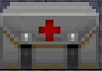

* Help protect yourself from the demons by picking up body armor:



Here is a screenshot of the game with the essential parts labeled for you:

**Controls**