**Please circle your responses to the following items.**

|  |  |
| --- | --- |
| People need freedom of speech to protect themselves. |  |
| People need firearms to protect themselves. |  |
| Even if it were proven that violent videogames are harmful, they should still be protected by the 1st Amendment. |  |
| Even if it were proven that firearms are harmful, they should still be protected by the 2nd Amendment. |  |
| It is dangerous to let the government regulate violent media. |  |
| It is dangerous to let the government regulate the sale of firearms. |  |
| The benefits of unregulated violent media outweigh the potential risks. |  |
| There will come a time in every person’s life when he or she will be glad to have freedom of speech. |  |
| There will come a time in every person’s life when he or she will be glad to carry a firearm. |  |

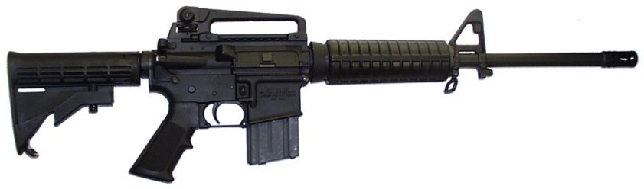**The following questions reference the AR-15 (shown on the right).  The AR-15 is a popular semi-automatic rifle that recently has been the focus of media attention.**

|  |  |
| --- | --- |
| The AR-15 would be fun to own. |  |
| The AR-15 would be useful to own. |  |
| I would feel safer if I owned the AR-15. |  |
| I feel the AR-15 would be accurate. |  |
| I feel the AR-15 would be powerful. |  |

|  |  |
| --- | --- |
| Would you like to try the AR-15? |  |
| Would you buy the AR-15 if you happened to see it in a store? |  |
| Would you actively seek out the AR-15 in a store in order to purchase it? |  |

What is the **MOST** you would be willing to pay (in dollars) for the AR-15?

*\*\*Note that* *we are* ***NOT*** *interested in fair market value – we are interested in how much you would be willing to pay to own the gun for yourself. If you are not at all interested in owning the AR-15 at any price, please write “blank” in the space below.*

__$______________________

|  |  |
| --- | --- |
| I feel I *want* the gun that I used in the video game today. |  |
| I feel I *need* the gun I used in the video game today. |  |
| I believe the US government should implement stronger gun control laws. |  |
| I think that the US government should ban assault rifles. |  |
| I think the US government should be able to determine what guns its citizens are allowed to own. |  |
| Carrying a gun would make me feel safe. | |
| School staff should be allowed to have guns in schools. |  |

Among gun owners, what percent (0%-100%) of them do you think will ever experience a *gun-related* accident (e.g., accidental discharge)?

________________________

Among gun owners, what percent of them do you think will ever have a gun *stolen* from them?

________________________

What percent of gun owners will ever use their gun in an act of self-defense?

_______________________

Among *non-gun owners*, what percent of them do you think will ever experience a *gun-related* accident (e.g., accidental discharge)?

________________________

What do you think is the maximum number of bullets in a magazine (i.e., how many bullets a gun can fire before needing re-loaded) that guns should be allowed to have?

________________________

Do you own a gun (firearm)? Yes__________ No__________

If yes, please list all names and/or types of the guns you own (please be as specific as you can).

____________________________________________________________________________________________________________________________________________________________________________________________________________________________________________________________________________________________________________________________________________________

Do you play violent video games? Yes__________ No__________

If yes, approximately how many hours **per week** over the past year have you played violent video games (i.e., games with violent content or violent graphics)?

_______________________________

What is your political affiliation (please check)?

Democrat____ Republican____ Moderate____ Libertarian ____ Other_________________

DEMOGRAPHIC INFORMATION:

GENDER: FEMALE _______ MALE ______

AGE: _________

What race would best describe you?

1. Asian American 2. African American

3. Latino/Hispanic 4. West Indian

5. White/non-Hispanic 6. Other (specify):_____________

What year of college are you in?

1. Freshman 2. Sophomore

3. Junior 4. Senior 5. Other (specify): ________________

What is your (approx.) GPA in college (or high school if you are a freshman) (0 – 4)?_________