Template

Joe Hilgard

October 30, 2015

This is my demonstration word file that serves as a template. This way I can format things for Times New Roman 12, double-spaced, no line between paragraphs of same style.

summary(cars)

## speed dist   
## Min. : 4.0 Min. : 2.00   
## 1st Qu.:12.0 1st Qu.: 26.00   
## Median :15.0 Median : 36.00   
## Mean :15.4 Mean : 42.98   
## 3rd Qu.:19.0 3rd Qu.: 56.00   
## Max. :25.0 Max. :120.00

You can also embed plots, for example:

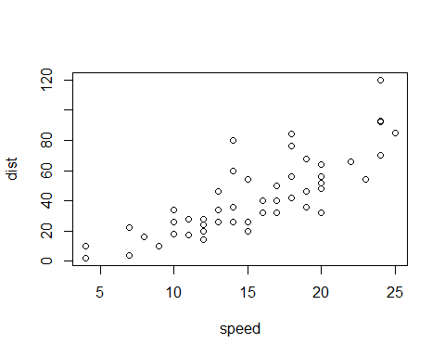

Note that the echo = FALSE parameter was added to the code chunk to prevent printing of the R code that generated the plot.