**Abstract**

Although much attention has been paid to the question of whether violent video games increase aggressive behavior, little attention has been paid to how such games might encourage antecedents of gun violence. We sought to study how the virtual portrayal of a real-world firearm (the Bushmaster AR-15) could influence players’ attitudes towards the AR-15 and gun ownership in general. 176 college undergrads played one of four modified video games in a 2 (Gun: AR-15 or science-fiction control) × 2 (Gun power: strong or weak) between-subjects design. Despite our best *p*-hacking attempts, experimental assignment did little to influence outcomes of product evaluations, purchasing intentions, or attitudes towards firearm legislation. By contrast, gender and political party had dramatic associations with these outcomes. We conclude that, if product placement shapes attitudes towards firearms, such effects will need to be studied in a more sensitive paradigm.

**Null Results of an Attempt to Study Product Placement Effects of Firearms within Violent Video Games**

Although much attention has been paid to the question of whether violent video games increase aggressive behavior, little attention has been paid to how such games might encourage antecedents of gun violence. One such potential antecedent is gun ownership. Possession of a firearm is, after all, necessary to commit gun violence. In their report to the National Science Foundation on what is known and what needs to be known about youth violence, Bushman et al. (2016) comment that youths exposed to smoking or drinking media characters are more likely to start smoking or drinking themselves. They suggest that “research should test whether youth are more interested in acquiring and using guns after exposure to movie characters that use guns.” (Bushman et al., 2016, p. 32) In line with that suggestion, one might want to research how exposure to violent video games might foster interest in the acquisition of guns as well.

To date, little research has examined how first-person shooter video games may influence attitudes towards firearms. We have reviewed one yet-unpublished article reporting a correlation between violent game exposure and gun control attitudes among college undergraduates. This cites one unpublished dissertation (Yonts, 2002) studying a modest sample (N = 78) of adolescents. This dissertation found a somewhat inconsistent correlation between violent videogame exposure and permissive attitudes towards playing with firearms.

Indeed, previous research and theory gives us reason to expect that violent video games could influence attitudes towards firearms. The General Learning Model (Buckley & Anderson, 2006) posits that video games can act as a learning tool, and that schema and associations learned within a game may influence behaviors and attitudes outside the game.

**Product Placement**

Product placement is an advertising technique that attempts to harness just that process. In product placement, a brand or product is integrated with the entertainment media. That is, in contrast to a self-contained advertisement presented during a commercial break, product placement attempts to change brand attitudes by placing the brand within the media. Such advertising is suspected of being especially effective. Because it is not explicitly an advertisement, it may circumvent viewers’ resistance to overt marketing. It may associate a brand with a favored character. Thus, viewer’s positive attitudes towards the character may create positive attitudes towards the brand.

Video games are hypothesized to be especially effective for product placement due to their interactive nature. Examples are plentiful. Sometimes in-game products are strictly incidental to gameplay. For example, Barack Obama’s 2008 presidential campaign took out ads on in-game billboards. Players in driving games would see the billboards alongside the highway as they drove, but would not have to interact directly with the advertisement. At other times, in-game products allow players to customize their avatar using real-world fashion. Expansion packs for The Sims allowed players to dress their characters in H&M clothing and furnish their homes with IKEA furniture. Skaters in *Tony Hawk* games can wear real-world fashion brands and ride branded skateboards. In other cases, the use of placed products is tied to gameplay-relevant rewards. In *Alan Wake,* players could earn an achievement by watching an advertisement for Verizon Wireless on a TV within the game. In *Oddworld: Munch’s Oddysee,* players could recover health by drinking SoBe Lifewater, a branded soft drink. SimCity 5 offered players the opportunity to place charging stations for the Nissan LEAF electric car. These charging stations made the virtual citizens happy, encouraging virtual mayors to place them. These latter cases could be expected to be more influential, as the branded product directly helps the player in achieving in-game goals.

A number of studies report evidence of the efficacy of in-game product placement, but paradigms and outcomes are heterogeneous. Results are also sometimes inconsistent across outcomes within a single study, so the robustness of the phenomenon is still uncertain. Glass (2007) reports that players of the game *Fight Night 3* were quicker to pair in-game brands with the concept “good” in an Implicit Association Task than they were control brands not seen in the game. Mackay et al. (2009) report that participants assigned to drive a Holden Monaro in the game *Gran Turismo* were more likely to remember the brand. Yang, Roskos-Ewoldsen, Dinu, & Arpan (2006) report that exposure to brands within a video game increased their accessibility in both implicit and explicit memory tasks.

Thus, there is some experimental evidence for the efficacy of video game product placement in shaping brand attitudes, awareness, and recall, but the evidence is modest and piecemeal. Moreover, none of these inspect how video game product placement might influence attitudes towards firearms.

**Firearms and Video Games**

Although the research underlying product placement is modest, these advertising practices are the subject of both consumer and media scrutiny. One particular source of scrutiny is the use of real-world firearms in popular video games, a practice that some consider a potentially-hazardous promotion of the ownership and use of deadly weapons.

Such product placement became the subject of international media attention when a military-themed first-person-shooter game made explicit and strong marketing ties to weapons manufacturers and sales. This game was *Medal of Honor: Warfighter*, a game much like the bestselling *Call of Duty* series. *Warfighter*’s marketing made much of the purported authenticity of the game’s content, featuring settings taken from real-world American military operations. As part of this marketing campaign, *Warfighter* hosted a website that listed all the guns the player could use in the game and linked to their real-world manufacturers. Players could order special editions of knives and a tomahawk licensed with the *Warfighter* brand, or even order a particular gun to be shipped to their local federally-licensed firearm dealer (Smith, 2012). *Warfighter* faced criticism over the explicit association between in-game violence and the promotion of real-world weapons, and later the special-edition tomahawk and online gun store were taken down (Bramwell, 2012; Narcisse, 2012).

This event lead the media to more closely scrutinize the associations between the marketing of real-world and virtual firearms. Some media outlets argued that in-game representations of real-world guns were a powerful marketing force. Eurogamer argued that the portrayal of guns in games is a source of both revenue and free advertising for firearms manufacturers, as the manufacturer both collects a licensing fee and enjoys increased brand awareness from the product placement (Parkin, 2013).

Eurogamer further argued that firearms manufacturers have substantial control over their products’ in-game portrayals, quoting a Barrett Firearms representative as saying “We want to know explicitly how the rifle is to be used, ensuring that we are shown in a positive light […] such as the ‘good guys’ using the rifle. [The gun must] perform to the standards that our rifles do in the real world. Barrett Firearms is known for its quality and the brand must always be placed on that foundation.” (Parkin, 2013, para. 25) This quote implies that the in-game quality of the firearm is important: a powerful weapon may become more desirable, whereas an ineffective weapon may become less desirable.

As part of their coverage, Eurogamer interviewed Anthony Toutain, a representative for Cybergun, a company that manufactures BB guns and manages licensing arrangements for video games and firearms. Toutain reported that attractive in-game portrayals increase the demand for real-world replicas:

We definitely see sales of particular [BB] guns increase when they are featured in popular video games, such as Call of Duty. For example, sales of the FAMAS [French rifle] exploded in the US when Call of Duty decided to use it as one of the best weapons in the game.

Before then children in America [didn’t] want to buy the FAMAS airsoft gun, simply because they don’t know this brand. But when they play every day with a new brand in a video game, finally they want to buy it in reality. The sales increase can be enormously significant. (Parkin, 2013, paras. 42-43)

In light of this phenomenon, we wanted to study the process by which in-game representations of firearms could influence perceptions of their real-world counterparts. If the gun seemed powerful and accurate in the game, would it seem that way outside the game?

We hypothesized that playing a video game featuring a powerful, attractive rendition of a real-world firearm will increase perceptions that the real-world firearm is powerful, effective, and desirable.

Being, as we were, two young graduate students in need of a hot phenomenon to build our careers upon, we were very excited to run this experiment, but a little nervous that we wouldn’t find anything to report. We therefore included a whole battery of dependent measures to give ourselves as many chances at statistical significance as possible. Perhaps participants might not explicitly want the gun more, but they might see gun ownership as safer or more normative. Maybe they would take more strident positions in favor of 2nd Amendment rights. These diverse outcomes were also considered as hypothesized and tested outcomes. Given the volume of outcomes collected and tested, we consider this an exploratory, not confirmatory, report.

**Method**

We report how we determined our sample size, all data exclusions (if any), all manipulations, and all measures in the study. All data and measures are available as a GitHub repository at https://github.com/Joe-Hilgard/VVG-product-placement.

**Participants**

Participants were 176 college undergraduates (122 male, 53 female) at a Midwestern state school participating for partial course credit. We can’t recall why we collected this particular sample size. Probably we had hoped to collect 50 per cell and fell a little short.

The study was listed as a study of political attitudes. Each session lasted approximately 30 minutes. All research activity was reviewed and approved by the University of Missouri’s ethical review board. Participants were chiefly White (78%), with some African-American (13%), Asian (3%), and bi-racial (5%) participants. Three percent identified as Latino.

**Procedure**

The study design was a 2 (Character’s gun: AR-15 or plasma rifle) × 2 (Gun power: strong or poor) between-subjects design. Subjects were assigned to one of the four conditions based on their subject number. The procedure is described below. Research assistants worked from a script, which is available in the GitHub repository as file “VG_procedures.docx.”

Participants were asked whether they would prefer the mouse y-axis to be inverted or not (i.e., whether they would pull the mouse towards themselves to look up or whether they would push the mouse away to look up.) The research assistant adjusted this preference accordingly in the game’s control settings.

Participants played the game for fifteen minutes. As a manipulation check, the game was programmed to log the number of enemies the player killed and the number of times the player died. At the end of the game, the research assistant pushed a button to display these logged numbers and recorded them. Games were quit directly to desktop by pressing ALT-F4.

After playing the game, participants filled out a paper survey, available in the GitHub repository as file “Survey.docx”. Upon completion of this survey, participants were thanked and debriefed.

**Measures and Manipulations**

**Video game.** Participants played one of four modified versions of the first-person-shooter video game *Doom*. Players had to navigate a series of levels, fighting through zombies and demons. Enemies would try to bite the player or to shoot the player with guns or fireballs. The player had to shoot the enemies, pick up health and ammo power-ups, and make it to the end of each level. If the player took too many wounds, the player’s health would be depleted and the level would have to be attempted again.

To ensure that participants spent as much time as possible using the gun, levels were custom-designed to be easy to navigate. This way, participants would spend as much time as possible in combat and as little time as possible exploring the level or being lost.

**Character’s gun**. In each version of the game, the player-character had only a single gun. In the AR-15 condition, this was a realistic rendition of the AR-15 Bushmaster rifle, a popular home-defense and general-purpose rifle. Like its real-world counterpart, the virtual AR-15 was a semi-automatic rifle (e.g. it fired one round at a time, but did not need to be manually rechambered between rounds) with a 20-round magazine. When the player fired the rifle, it would fire at a steady pace; after 20 rounds, it would have to be reloaded.

In the plasma rifle condition, the player-character instead had a science-fiction rifle we called the “Martian ZQ-5 Plasma Rifle.” Its properties (e.g., rate of fire, damage per bullet, rounds per magazine, accuracy) were kept identical to the virtual AR-15.

To strengthen the manipulation, a description of the assigned gun was given in the cover story (files “AR-15_cover_story.docx” and “Plasma_cover_story.docx”). Moreover, a picture-in-picture icon of the gun and its name was presented bilaterally on the game screen (see Figure 1).

**Gun power**. To make the player’s gun more or less desirable, its in-game properties were manipulated. In the strong gun condition, the gun fired with perfect accuracy, the bullets dealt substantial damage, and the rate of fire was moderate and steady. To augment the player’s perception of the gun’s strength, the gun’s firing animation and sound were further modified: the gun fired with a subtle flash of light, the screen shook, and the sound was deep and powerful. Enemies shot by the powerful rifle would send gobbets of blood into the air and across the walls and floor, and when killed, would burst into gore, losing chunks of flesh or even limbs. The powerful rifle was capable of slaying most enemies in one or two shots.

In the weak gun condition, the gun fired with dramatically poorer less accuracy, the bullets dealt substantially less damage, and the rate of fire was slightly slower. The gun did not shake the screen when fired, and its sound was anemic. Enemies shot by the rifle always died with the same, less dramatic animation, and did not lose blood or limbs when shot.

A full table of statistics for the weak and strong guns is provided in Table 1. The .wad game files for all four conditions are available online at <https://github.com/Joe-Hilgard/VVG-product-placement/tree/master/wads>. A copy of Doom II is needed to run them – simply drag and drop the .wad file onto the Doom.exe program.

**Outcomes.** This being our first experiment in this area, we were afraid we would miss some relevant construct that might yield statistical significance. To prevent this, we drafted many new scales and items for use as outcomes. The full text of all items is available in the GitHub repo within the file “Survey.docx.”

***1st and 2nd Amendment Rights Advocacy.***Participants rated nine items on a 7-point Likert scale (1-Strongly disagree, 7-Strongly agree). Four items asked about the importance of the 2nd amendment and the utility of private firearm ownership. The other five items, intended as a screen, asked about the importance of freedom of speech in violent media.

***AR-15 desirability****.* At the top of the scale, participants were instructed that the following questions reference the AR-15 semi-automatic rifle. A picture of the rifle accompanied the text. Five questions measured the utility of the AR-15 (fun, useful, would feel safer, accurate, powerful). Another three questions measured buying intentions (scale derived from Baker & Churchill, 1977). A last question asked “What is the MOST you would be willing to pay, in dollars, for the AR-15?” Participants wholly uninterested in owning an AR-15 were instructed to write “blank” for this item.

***In-game gun desirability.*** Participants rated two items for how desirable their in-game gun was (“I feel I *want* the gun that I used in the video game today” and “I feel I *need* the gun I used in the video game today”)

***Public policy.*** Five items measured attitudes towards gun control laws and the permissibility of carrying firearms in public.

***Normative gun safety and utility.*** Participants were asked what percent of gun owners would ever experience a gun-related accident (e.g. accidental discharge), what percent would ever have a gun stolen from them, and what percent would ever use their gun in an act of self-defense.

***Magazine restrictions.*** Participants were asked what should be the maximum number of bullets in a magazine, that is, how many bullets a gun should be able to fire before needing to be reloaded.

***Individual differences.*** Participants were asked whether they owned a gun, whether they played violent video games, and which political party they supported.

**Results**

**Analysis**

Again, the study hypothesis was that playing a video game featuring an AR-15 would influence gun attitudes relative to a science-fiction control, with a powerful and attractive in-game gun increasing these attitudes and an unattractive in-game gun decreasing these attitudes. We therefore tested the evidence for a 2 Gun Type × 2 Gun Power interaction.

We used the BayesFactor package (Morey & Rouder, 2015) for **R** to perform all analyses involving those outcomes that were normally distributed. This being some of the first research in the area, we did not know exactly what effect size to anticipate; thus, we used a default two-tailed Cauchy prior with scale *r* = 0.5, reflecting anticipated effects of modest size, commensurate with most effects in social psychology. For each outcome, we conducted an ANOVA with factors of Gun Type, Gun Power, participant’s gender, and participant’s political orientation.

For each Bayesian analysis, we report Bayes factors. Bayes factors represent the ratio of the probability of the data given one model over the probability of the data given another model. This gives the evidence, in odds, for one model over another model. Multiplying this Bayes factor against the prior odds gives an updated posterior odds. For example, if one thought there was only a 1 in 10 chance that Manipulation A would have an effect, and the Bayes factor for a Manipulation A model over the null model was 10:1, the posterior odds of Manipulation A having an effect would be 1:1. That is, given an unlikely phenomenon and a considerable amount of evidence, the phenomenon would be considered as likely as not.

For each analysis, we compare four models. The first is a covariates-only model, which describes outcomes as a function of subjects’ gender and political orientation. This model treats the experimental manipulations of gun type, gun power, and their interaction as having had no effect. The second is a full model consisting of the covariates, the main effects of gun type and gun power, and the interaction of gun type and gun power. The third model is an additive model similar to the full model, but it removes the interaction of gun type and gun power. The fourth model is the null model, in which no variable predicts the outcome. Comparisons of the second model (full model) against the third model (additive model) give the evidence for or against our hypothesized effect, the gun type × gun power interaction.

Our percentage-based outcomes were better described with a gamma distribution. Since BayesFactor does not allow comparison of generalized linear models, we simply report parameter estimates and *p*-values for these outcomes. Similarly, magazine capacity was not normally distributed and could not be analyzed using BayesFactor. Readers with greater modeling acumen than ours are invited to retrieve the data from the GitHub repository and perform the appropriate Bayesian analysis.

**Manipulation check.** We tested how assignment to the 2 × 2 design influenced participants' in-game performance, as measured by the number of times the player died and the number of monsters the player killed.

Count of player deaths was highly skewed and perhaps best decribed by a zero-inflated negative binomial distribution. A logit link was used for the zero inflation, and a log link was used for the negative binomial. Supporting this modeling decision, the overdispersion parameter was statistically significant, *p* = .003. Neither the Gun Power (strong vs. weak; *b* = -0.031, *t*(170) = -0.132, *p* = .895) nor Gun Type (realistic vs. sci-fi; *b* = -0.091, *t*(170) = -0.466, *p* = .642) significantly influenced this outcome. Gun Power and Gun Type did not significantly interact, *b* = 0.043, *t*(170) = 0.131, *p* = .896.

Count of killed enemies was also highly skewed, and so a negative binomial distribution was fit using a log link. Participants in the powerful-gun condition killed substantially more enemies than did those in the weak-gun condition, *b* = 0.798, *t*(170) = 10.527, *p* < .001, supporting the efficacy of the gun-power manipulation. Neither Gun Type (*b* = -0.048, *t*(170) = -0.632, *p* = .527) nor the Gun Type × Gun Power interaction (*b* = -0.045, *t*(170) = -0.419, *p* = .675) were significantly related to the number of enemies killed.

Regrettably, we did not ask participants directly about how fun, powerful, satisfying, etc. the in-game gun was. As such, we do not have direct evidence that the powerful gun was more pleasant to use than the weak gun. At best, we might make infer a difference in pleasure from the observed difference in efficacy.

Means and SDs of all variables are summarized in Table 2. Combination violin/boxplots for each outcome are summarized in Figures 2 and 3.

**2nd Amendment Advocacy.** Participants' 2nd Amendment advocacy was best modeled by a simple additive model of political orientation and gender, BF = 7.55 × 104 : 1 over the null. The covariates-only model was preferred over the full model (that is, the model with covariates, Gun Type, Gun Power, and the Gun Type × Gun Power interaction), BF = 104 : 1. This indicates that the experimental condition had little explanatory power over and above that of the covariates. Comparison of the full model against the additive model let us examine the evidence for or against the hypothesized Gun Type × Gun Power interaction. The evidence was against this interaction, BF = 1 : 3.42 for the full model relative to the additive-effects model.

**Product attitudes.** Again, attitudes towards the AR-15 were best described by a simple additive model of political orientation and gender, BF = 3.36 × 105 : 1 over the null. The covariates-only model was preferred to the full model, BF = 53.8 : 1. The evidence was against a Gun Type × Gun Power interaction, BF = 1 : 3.31 for the full model relative to the additive-effects model.

**Purchasing intentions.** Purchasing intentions were right-skewed. However, the QQplot of standardized residuals was not unbearably ugly, and transformation by square root or logarithm did not make the QQplot much prettier. Thus, we analyze this outcome in its natural units with the standard general linear modeling technique.

Purchasing intentions were best described by additive effects of political orientation and gender, BF = 3.25 × 106 : 1 over the null. The covariates-only model was preferred to the full model, BF = 17.6 : 1. The evidence was against a Gun Type × Gun Power interaction, BF = 1 : 2.08 for the full model relative to the additive-effects model.

**Desire of in-game weapon.** This variable was very badly right-skewed, with most participants choosing the minimum response. Square-root or log transformation did little to fix this. We report this in its natural units, but readers with better ideas for modeling are encouraged to use the raw data to perform further tests.

Weapon desire was best described by an effect of gender, BF = 6.8 : 1 over the null. Adding the main and interactive effects of Gun Type and Gun Power to this gender-only model was not preferred, BF = 1 : 137. The evidence was against the predicted Gun Type × Gun Power interaction, BF = 1 : 4.43 for the full model relative to the additive-effects model.

**Policy opinion.** Policy views were best described by political orientation alone, BF = 46 : 1 over the null. Adding the main and interactive effects of Gun Type and Gun Power was not supported, BF = 1 : 30. The evidence was against the hypothesized Gun Type × Gun Power interaction, BF = 1 : 4.03 for the full model relative to the additive-effects model.

**Rates of gun accidents and gun use.** Participants' estimated rates seemed to be more appropriately modeled as a gamma distribution than a normal distribution. Because responses of 0% cannot be modeled under this distribution, these responses were adjusted to 0.001%. In general, we note that estimates contained considerable uncertainty and noise, with estimates ranging from 0% to 80% or more.

Only a few idiosyncratic predictors reached statistical significance. Republicans, relative to liberals, thought it more probable that a gun owner would experience a gun-related accident such as an accidental discharge, *b* = 0.017, *t*(166) = 2.668, *p* = .008. Men, relative to women, thought it more probable that a gun owner might have a gun stolen from them, *b* = 0.015, *t*(166) = 2.373, *p* = .019. Libertarians, relative to other political parties, thought it more probable that a gun owner would ever use their gun in an act of self-defense, *b* = 0.001, *t*(166) = 0.069, *p* = .945. None of these estimated rates were significantly predicted by the game participants had played. Full tables of model output are provided in Supplementary Table 1.

**Magazine capacity.** Several participants listed very large values (e.g., 100 or more) for a maximum magazine size, or wrote in responses to the effect that there should be no such government-imposed limit. We tried modeling this outcome in two ways. First, we winsorized all responses in excess of 30 down to 30 and attempted a linear model. Second, we coded a dichotomous variable for responses less than 30 and responses equal to or greater than 30 and attempted a logistic model. The linear model suggested that males (*b* = 3.508, *t*(163) = 2.229, *p* = .027) and libertarians (*b* = 5.579, *t*(163) = 2.032, *p* = .044) supported larger magazine sizes than did females and democrats. The logistic model found no significant predictors. Neither model detected any significant effects of game.

**Discussion**

Results indicate that brief exposure to an unrealistic violent game with an attractive or unattractive representation of a real-world firearm does little to influence attitudes towards that firearm or to firearms more generally. In all the models for all the outcomes we considered, the Gun Type × Gun Power interaction explained very little variance. The observed magnitude of this coefficient was more consistent with the null hypothesis than with a reasonable alternative hypothesis. Participants’ political orientation, and often their gender, strongly accounted for their views of firearms. The best models estimated these effects of these demographic factors while treating the video game as irrelevant.

In general, men, conservatives, and libertarians, as compared to women and liberals, had more positive feelings towards guns, expressed greater subjective value for guns, and indicated more positive attitudes towards the AR-15. The experiment’s manipulation of video game content did not change these outcomes. These results indicate that attitudes towards guns may be better predicted by relatively stable personal traits than by transient influences of brief video game exposure.

**Limitations and Future Directions**

There are a number of possible reasons we did not detect an effect. The simplest explanation, of course, is that no such effect exists: product placement in violent games might have only a minimal influence on attitudes towards those products. However, this would seem a little surprising given the broader phenomenon as reported in news outlets and summarized in our introduction.

It is possible that experimental and personological factors obscured the anticipated effect. First, it is possible that fifteen minutes is not enough to influence attitudes towards a gun. Second, it is possible that the game’s setting was not conducive to product-placement effects, being too fantastic for the real-world weapon. Perhaps a more realistic setting such as an urban neighborhood or American countryside would influence attitudes moreso than did our game’s unrealistic hellish landscape populated by zombies and demons. Third, perhaps participants already had relatively crystallized attitudes towards the AR-15. Given the AR-15’s prominent role in the Newton mass shooting that had preceded our experiment by only a few months, perhaps participants had generally decided before the experiment whether they favored or disfavored the AR-15. Fourth, perhaps limiting the player to only one gun reduced the effect of the manipulation; differences in the target gun’s strength might be more salient when a second control gun is present to be compared against.

Additionally, some research suggests that violent content may distract from in-game ads (Lull, Gibson, Cruz, & Bushman, in press). Since knowledge of the particular gun brand was not necessary for effective game performance, participants may have allocated attention away from the gun brand. In contrast, games such as *Call of Duty* invite players to select a loadout of particular weapons, each having different properties, strengths, and weaknesses that have substantial influences on gameplay. In this sort of game environment, greater attention might be paid to the gun’s name and brand.

Future work could address these weaknesses through the following endeavors. First, experimental manipulations could involve longer gameplay sessions for a more powerful manipulation. Second, researchers might use and modify games with more realistic settings and enemies. Perhaps instead of *Doom*, which takes place in a science-fiction hellscape, researchers might use and modify a *Grand Theft Auto* game to have the desired weapon with the desired properties, as *Grand Theft Auto* takes place in a more realistic setting. Third, the game might do more to encourage attention to the name of the gun, perhaps by including several firearms and manipulating the strength of a branded exemplar. Lastly, researchers may wish to study firearm-product-placement effects in nonexperimental paradigms such as cross-sectional or longitudinal surveys. A comprehensive and scientific survey study could help to confirm or refute the product-placement phenomena described by media.

All the same, we conclude that product-placement effects of violent video games on the desire to own guns may be smaller, subtler, and harder to detect than we had personally anticipated.

**Thoughts of a Reformed *P*-Hacker**

It is something of a small miracle that this study did not yield statistical significance given the magnitude of the fishing expedition we undertook. We loaded the study with more than half a dozen outcomes. We looked for main effects and interactions. We added moderators and covariates, then tried it all over again in subsets of the data. When nothing worked, we mothballed the project. This was the scientific method as we understood it at the time.

We are grateful to the changes in scientific publishing practices that allow us to publish experiments that fail to yield statistically-significant results. In our estimation, the result of a compelling experiment is attributable chiefly to the will of nature; it has less to do with some individual genius in knowing which hypotheses will bear fruit. We hope that others will learn from our experiment and our result and adjust their beliefs and future experiments accordingly.

Additionally, we find that it is easier and more fun to simply make a thorough and honest report of all study outcomes than it is to carefully construct a delicate and fragile manuscript in defense of a favored outcome. Not only are such a simple manuscripts easier to write, but they are also understood to contribute to an effective and unbiased scientific method. As such, these natural manuscripts are increasingly accepted for scientific publication. This innovative form of scientific communication may dramatically reduce the amount of time scientists waste on data-dredging, significance-fishing, and story-spinning, allowing them instead to conduct and publish more research per annum.

**Conclusions**

Attitudes towards firearms are likely to be determined largely by political views. Political views are often strong and resistant to change. Relative to the influence of political beliefs, the effects of brief exposure to a violent game featuring an attractive firearm may be minimal. If product placement in videogames does change attitudes towards firearms in general or towards a brand of firearm in specific, these changes may be smaller and subtler than we anticipated, may require more sophisticated experimental procedures to study, or may be limited to some subset of the general population.

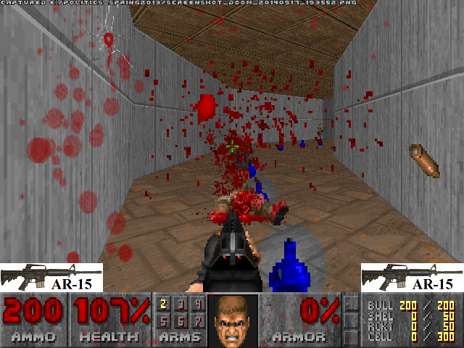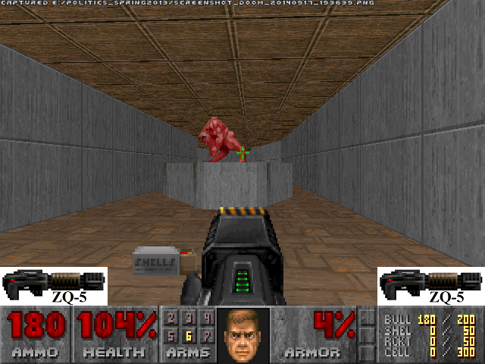

*Figure 1.*  Screenshots from the AR-15 condition (top) and ZQ-5 condition (bottom).

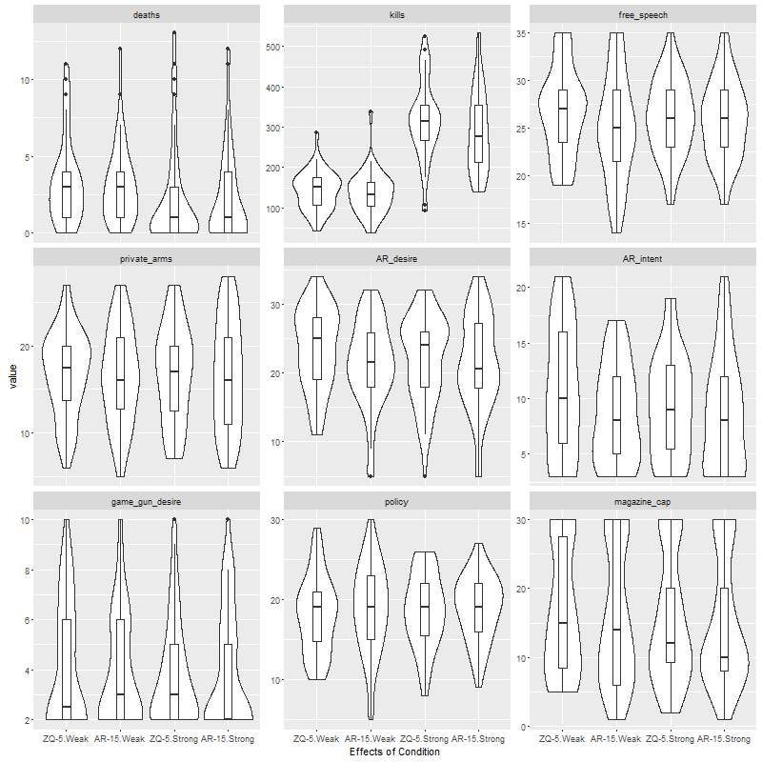

*Figure 2.* Distribution of study variables. With the exception of the manipulation checks influenced by the gun’s strength (kills, deaths), outcomes’ distributions appear mostly invariant across conditions.

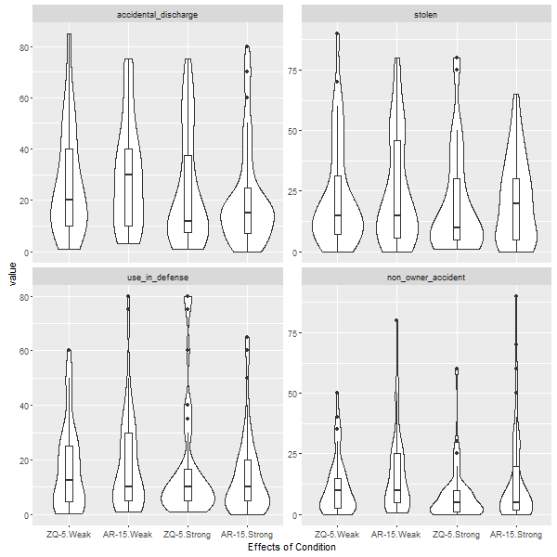

*Figure 3.* Perceived percentage rates of certain gun-related incidents across conditions. Responses are highly variable; covariates offered little in the way of prediction.

**References**

Baker, M. J., & Churchill, G. A., Jr. (1977). The impact of physically attractive models on advertising evaluations. *Journal of Marketing Research, 14* (4), 538-555. Retrieved from <http://search.proquest.com/docview/208731622>

Bushman, B. J., Newman, K., Calvert, S. L., Downey, G., Dredze, M., Gottfredson, M., … Webster, D. W. (2016). Youth violence: What we know and what we need to know. *American Psychologist, 71* (1)*,* 17-39. http://dx.doi.org/10.1037/a0039687

Bramwell, T. (Aug 16, 2012). EA pulls Medal of Honor tomahawk promotion. *Eurogamer*. Retrieved from <http://www.eurogamer.net/articles/2012-08-16-ea-pulls-medal-of-honor-tomahawk>

Glass, Z. The effectiveness of product placement in video games. *Journal of Interactive Advertising, 8* (1), 23-32.

Lull, R. B., Gibson, B., Cruz, C., & Bushman, B. J. (In press). Killing characters in video games kills memory for in-game ads. *Psychology of Popular Media Culture.*

Narcisse, E. (Aug 16, 2012). Medal of Honor website ends tomahawk promo and pulls links to weapons & gear manufacturers. *Kotaku*. Retrieved from <http://kotaku.com/5935328/medal-of-honor-website-ends-tomahawk-promo-and-pulls-links-to-weapons--gear-manufacturers>

Mackay, T., Ewing, M., Newton, F., Windisch, L. (2009). The effect of product placement in computer games on brand attitude and recall. *International Journal of Advertising, 28* (3). Retrieved from DOI: 10.2501/S0265048709200680

Meier, B., & Martin, A. (Dec 24, 2012). Real and virtual firearms nurture a marketing link. *The New York Times*. Retrieved from <http://www.nytimes.com/2012/12/25/business/real-and-virtual-firearms-nurture-marketing-link.html>

Parkin, S. (Jan 31, 2013). Shooters: How video games fund arms manufacturers. *Eurogamer*. Retrieved from <http://www.eurogamer.net/articles/2013-02-01-shooters-how-video-games-fund-arms-manufacturers>

Smith, R. (Aug 13, 2012). Partners in Arms. *The Gameological Society*. Retrieved from <http://gameological.com/2012/08/partners-in-arms/>

Yang, M., Roskos-Ewoldsen, D. R., Dinu, L., & Arpan, L. M. (2006). The effectiveness of “in-game” advertising: Comparing college students’ explicit and implicit memory for brand names. *Journal of Advertising, 35* (4), p. 143-152. DOI 10.2753/JOA0091-3367350410