MotionController Straight-Line Drift Investigation
Experimental basis and rationale for a rear-wheel synchronisation loop
Report date | 1 September 2026
System | 4-wheel robot; rear-wheel drive with encoder feedback; servo-steered front wheels
Primary test | 1000 mm straight motion at 2000 CPS; 11.4 V battery; heading feedback disabled
Controller state | Independent wheel-speed control using calibrated feedforward + Kp = 0.02; Ki = 0
Decision | Proceed to design a slow outer wheel-synchronisation loop in MotionController
Purpose
Document the observed straight-line yaw drift, assess whether reduced battery voltage degraded the existing wheel-speed controllers, determine whether the yaw drift is consistent with rear-wheel travel mismatch, and establish the engineering basis for adding a wheel-synchronisation layer before further heading-control tuning.

Executive Summary
A clean 11.4 V straight-line test shows that the existing left and right wheel-speed controllers remain individually stable, but they do not guarantee long-horizon synchronisation. Over approximately 998 mm of average rear-wheel travel, the right wheel accumulated 5.67 mm less travel than the left while IMU yaw reached -1.405°. The travel mismatch and yaw evolved in the same direction throughout the accepted run. Selected time-series samples give a descriptive Pearson association of r ≈ 0.9998 between accumulated R-L travel error and yaw; because the samples are serially correlated, this is evidence of co-evolution rather than an independent-sample significance test. Single-wheel checks at 11.4 V did not show measurable degradation relative to the controller tuned near 11.8 V. The recommended next step is therefore not to retune the fast wheel-speed loops for a 0.4 V drop, but to add a slow outer synchronisation loop in MotionController that regulates the desired left-right wheel relationship and generates corrected wheel-speed targets.

Key findings
Finding | Evidence | Interpretation
No measurable 0.4 V degradation | 11.4 V single-wheel responses remained close to the ~11.8 V tuning behaviour and retained the calibrated feedforward values. | Battery drop is not presently supported as the main cause of the changed yaw bias.
Persistent rear-wheel mismatch | At 3930 ms: L = 1000.906 mm, R = 995.234 mm; R-L = -5.672 mm. | Independent speed loops can each look satisfactory while small residual mismatch accumulates over distance.
Yaw co-evolves with mismatch | At the same point, yaw = -1.405°; both yaw and R-L error became increasingly negative through the run. | Rear-wheel synchronisation is a meaningful control objective for straight-motion accuracy.
Instantaneous CPS is too coarse for the small bias | 5.672 mm ≈ 43 encoder counts over 3.93 s ≈ 10.9 CPS average differential, while one count per 10 ms equals 100 CPS. | An outer loop should use accumulated relationship error rather than rely only on instantaneous speed difference.

1. System Context and Existing Control Structure
The robot uses two independently driven rear wheels with Hall encoders and front-wheel steering through a servo. Each rear wheel is controlled by its own WheelSpeedController. MotionController sits above the wheel-speed controllers and determines the commanded chassis motion.
The current wheel-speed loop combines a per-wheel, direction-specific feedforward model with proportional feedback. The retained tuning is Kp = 0.02 and Ki = 0. Consequently, the current loop is more precisely described as feedforward + P feedback rather than a PI loop.
The open-loop calibration is strongly linear once the motors are moving. Forward slopes are approximately 203.88 CPS/%PWM for the left wheel and 192.56 CPS/%PWM for the right wheel, with feedforward dead-zone offsets near 53% PWM. The left-right difference justifies retaining separate feedforward calibration for each motor.
P_ff ≈ P₀ + |v*| / k
The rear-wheel rolling calibration currently uses an effective diameter of 65.5 mm and 1560 encoder counts per wheel revolution, giving approximately 0.1319066 mm/count. At a 10 ms update period, encoder-derived speed is quantised in 100 CPS increments because a one-count difference within one sample corresponds to 100 counts/s.

2. Problem Statement
Straight-motion tests with the front steering servo fixed at its centre position showed that final yaw was not constant across test sessions. Earlier centred-servo runs had approximately -0.2° to -0.8° final yaw, whereas later runs were repeatedly nearer -1° to -2°. Because the wheel-speed controller had originally been tuned at roughly 11.8 V and the later tests were performed around 11.4 V, battery discharge was initially suspected.
The engineering questions were therefore:
- Did a 0.4 V battery decrease measurably degrade either individual wheel-speed controller?
- If not, does the complete robot exhibit a small left-right wheel relationship error that is invisible to the individual loops?
- Is the measured yaw drift consistent with the accumulated rear-wheel travel mismatch?
- Would a separate synchronisation objective inside MotionController address a distinct control problem rather than mask a lower-level failure?

3. Experimental Method and Data Quality
The accepted straight-line experiment used the following conditions:
Parameter | Value
Battery voltage | ~11.4 V
Command | Move straight 1000 mm
Nominal rear-wheel speed | 2000 CPS left and right
Heading feedback | Disabled (Kp = Ki = Kd = 0 at MotionController heading layer)
Front steering | Servo enabled and held at centre
Wheel-speed control | Existing calibrated feedforward + Kp = 0.02; Ki = 0
Control/log period | 10 ms
Instrumentation | Debugger RAM export; OLED updates removed during motion
A preliminary instrumented run was rejected before analysis because OLED refresh activity disrupted the intended 10 ms timing. The accepted dataset used no OLED refresh during motion and shows uniform 10 ms timestamps. No numerical evidence from the rejected run is used in the conclusions of this report.

4. Assessment of the Battery-Voltage Hypothesis
Single-wheel verification at approximately 11.4 V was compared with the behaviour obtained when the controller was tuned near 11.8 V. The left 0→2000 CPS transition remained close to the earlier tuning result, with approximately 30–35 ms rise time, about 50 ms settling, and approximately 5% overshoot. The right wheel showed similarly stable convergence. At 2000, 4000 and 6000 CPS, the original feedforward values still placed both wheels near their requested speeds, with the proportional term making only small corrections.
Accordingly, the available measurements do not show a meaningful loss of individual wheel-speed control performance following the 0.4 V decrease. This is an engineering observation, not a formal equivalence result: the experiment did not use repeated matched trials at both voltages with a pre-specified statistical hypothesis test.
Conclusion on voltage: No measurable degradation was observed from ~11.8 V to ~11.4 V. Battery discharge is therefore not supported as the primary explanation for the changed straight-line yaw bias.

5. Clean Straight-Line Result at 11.4 V
During the accepted run, both wheel-speed measurements remained primarily in the 1900–2000 CPS band after startup, with intermittent ±100 CPS differences. Despite the apparently satisfactory instantaneous tracking, the integrated rear-wheel distances slowly diverged.
Average travel (mm) | R-L travel error (mm) | Yaw (deg) | Comment
245.6 | -1.319 | -0.316 | Small mismatch already established
501.6 | -3.166 | -0.770 | Mismatch and yaw continue in same direction
653.3 | -3.825 | -0.960 | Individual CPS still appears well regulated
758.7 | -4.221 | -1.060 | Accumulated relationship error persists
998.1 | -5.672 | -1.405 | Last STRAIGHT sample before braking
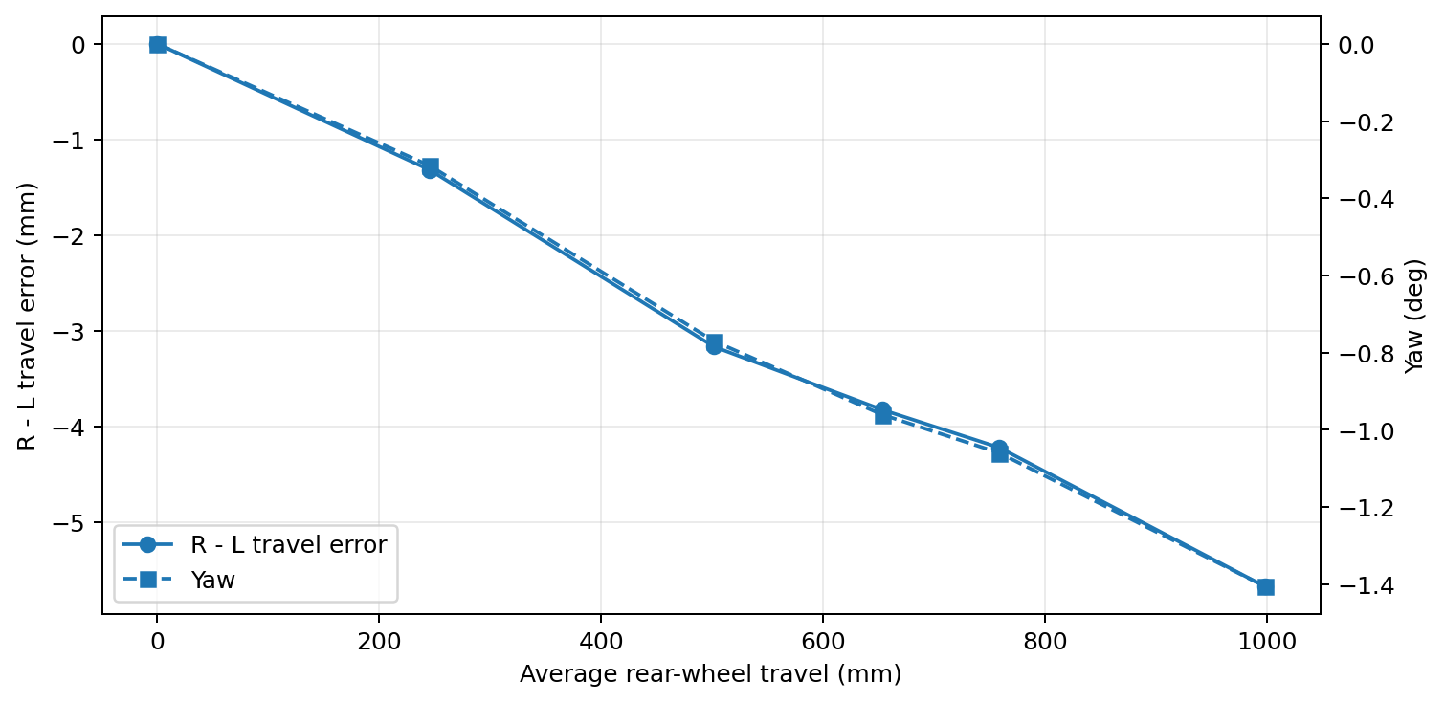
Figure 1. Selected samples from the accepted 11.4 V run. Both accumulated R-L travel error and yaw evolve negatively over distance.
At 3930 ms, immediately before the transition to BRAKING, the logged distances were L = 1000.906 mm and R = 995.234 mm. The resulting accumulated difference was R-L = -5.672 mm, while yaw was -1.405°. The average wheel travel at that instant was approximately 998.07 mm.
Δs = s_R − s_L = −5.672 mm
Using 0.1319066 mm/count, the 5.672 mm mismatch corresponds to approximately 43 encoder counts. Spread over 3.93 s, this is only about 10.9 CPS of average differential speed. This is substantially smaller than the 100 CPS quantisation of the instantaneous speed estimate at a 10 ms sample period.
|Δv̄| ≈ 43 counts / 3.93 s ≈ 10.9 CPS << 100 CPS measurement step
This explains why the individual WheelSpeedControllers can appear well tuned while a small residual wheel mismatch still accumulates into a meaningful long-distance error.

5.1 Relationship between travel mismatch and yaw
The sign and progression of the IMU yaw are consistent with the accumulated rear-wheel travel error: the right wheel falls behind the left and the yaw becomes increasingly negative. For the selected samples in Figure 1, the descriptive Pearson correlation between R-L travel error and yaw is approximately r = 0.9998.
This value must not be interpreted as an independent-sample significance result because the points are successive observations from the same run and are therefore strongly time-correlated. Its value is descriptive: it confirms that the two measured quantities co-evolve very closely in the accepted experiment.
The robot is not a differential-drive platform, so the differential-drive identity θ = (s_R - s_L)/T should not be used as an exact yaw model. Front-wheel steering constraints, tyre slip, chassis compliance and scrub alter the relationship. The evidence supports synchronisation as a meaningful fix because the wheel mismatch and yaw evolve consistently, not because a differential-drive equation predicts the exact angle.

5.2 Braking observation
After MotionController entered BRAKING, the left-right travel difference continued to increase beyond the -5.67 mm present at the end of STRAIGHT. This indicates unequal stopping behaviour as well as unequal powered travel. In the current diagnostic path, yaw is held at its final STRAIGHT value during BRAKING, so any additional braking-induced rotation is not captured by the reported final yaw. This should be corrected in later diagnostics, but it does not alter the straight-phase conclusion above.

6. Control Interpretation
The experiment distinguishes two control objectives that were previously combined implicitly:
- Absolute wheel-speed regulation: each rear wheel should track its own commanded CPS. This remains the responsibility of WheelSpeedController.
- Relative wheel synchronisation: the two rear wheels should maintain the left-right relationship required by the commanded chassis motion. This objective is currently absent.
The clean run demonstrates that satisfying the first objective does not automatically satisfy the second. A residual average difference of roughly 11 CPS is small enough to be obscured by the instantaneous speed quantisation, yet large enough to accumulate several millimetres of differential travel over one metre.

7. Recommended Architecture: Outer Wheel-Synchronisation Loop
A new, deliberately slower synchronisation loop should be added inside MotionController, above the existing WheelSpeedControllers. Its purpose is to convert a desired left-right wheel relationship into corrected left and right speed targets; it should not directly drive PWM.
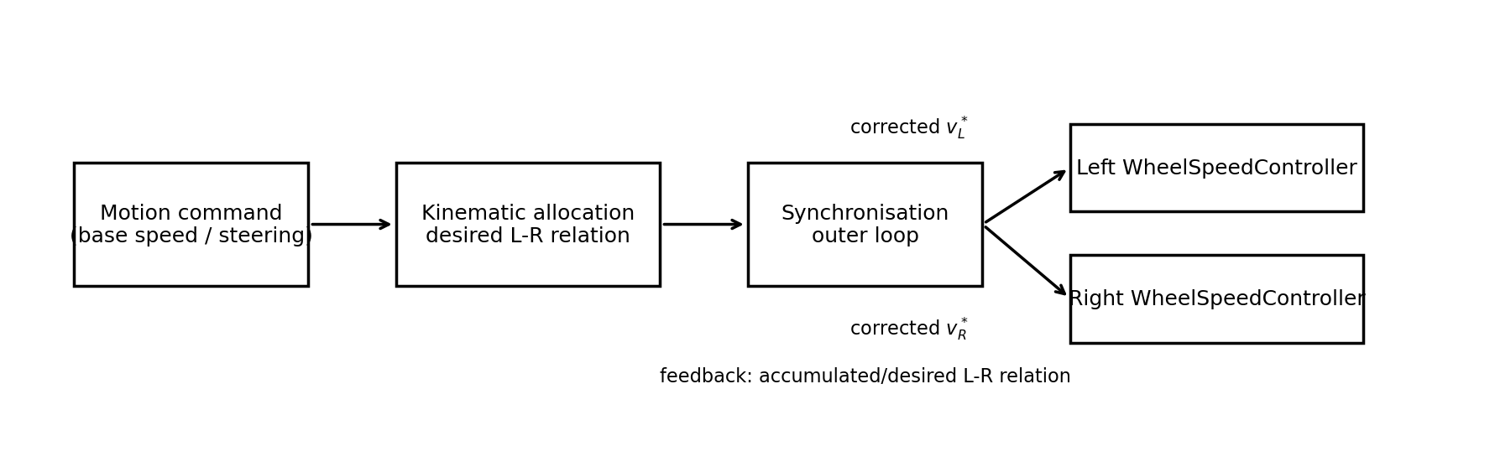
Figure 2. Recommended layering. The new synchronisation loop modifies wheel-speed targets while the existing WheelSpeedControllers retain fast local motor regulation.
For straight motion, the desired rear-wheel relationship is zero accumulated differential travel:
Δs_des = 0, e_sync = (s_R − s_L) − Δs_des
A slow controller can generate a symmetric speed correction Δv_sync and apply it around the nominal chassis speed. The sign convention should ensure that if the right wheel falls behind (e_sync < 0), the left target is reduced and/or the right target is increased.
v_L* = v_L,ff + Δv_sync, v_R* = v_R,ff − Δv_sync
For future non-zero steering, the desired left-right relationship must not remain zero. Kinematic allocation should first determine the nominal left and right wheel targets required by steering curvature; the synchronisation loop should then regulate the measured relationship around that non-zero reference. This makes the loop a general relationship controller rather than a straight-line-only equal-speed controller.

8. Preliminary Design Requirements for Implementation
Requirement | Rationale
Layering | Implement in MotionController; do not modify DCMotor or collapse the existing WheelSpeedController abstraction.
Primary feedback quantity | Prefer accumulated left-right relationship error for the outer loop; instantaneous speed difference is too coarsely quantised to expose the observed ~11 CPS average bias directly.
Bandwidth | Keep the synchronisation loop slower than the individual wheel-speed loops to avoid loop interaction and target chatter.
Straight reference | Desired relationship = equal rear-wheel travel when steering is centred.
Turning reference | Desired relationship must be generated by the vehicle kinematics when steering is non-zero.
Output | Generate corrected wheel target CPS values; do not command PWM directly.
Saturation | Limit synchronisation correction so the outer loop cannot request unreasonable speed separation or reverse a wheel unintentionally during normal forward motion.
Reset semantics | Reset synchronisation state/odometry consistently at the beginning of a new motion command.
Diagnostics | Continue debugger logging of target CPS, measured CPS, wheel distances, synchronisation error, synchronisation correction and yaw.

9. Geometry Note for Later Turning Allocation
The reported 185 mm rear width including the wheels is not automatically the rear track width used in vehicle kinematics. Track width is measured laterally between the centre planes/contact-patch centrelines of the two rear tyres. If 185 mm is an outside-to-outside measurement, the tyre width must be accounted for. The exact centreline-to-centreline track should be measured before implementing steering-dependent left-right feedforward allocation.

10. Limitations and Next Validation Steps
The present evidence is sufficient to justify implementing a synchronisation loop, but it is not yet a complete tuning dataset. The following points remain to be validated after implementation:
- Repeat the 1000 mm straight test multiple times with synchronisation disabled and enabled under the same mechanical setup.
- Quantify final yaw, peak yaw, R-L travel error, and correction magnitude for each run.
- Test at several commanded speeds to determine whether the required synchronisation gain scales with speed.
- Repeat across battery voltages if formal voltage robustness is required; use matched repeated trials rather than relying on visual similarity alone.
- Update yaw integration during BRAKING so final heading includes any stopping-phase rotation.
- After straight synchronisation is established, introduce steering-dependent desired wheel relationships and then resume heading-controller tuning.

11. Engineering Decision
Decision: Proceed with a wheel-synchronisation loop in MotionController. The loop will regulate the desired left-right rear-wheel relationship and output corrected wheel target speeds to the existing WheelSpeedControllers. The decision is based primarily on the accepted 11.4 V run, where accumulated rear-wheel travel error and yaw drift co-evolved consistently despite satisfactory individual wheel-speed regulation.

Data Sources and Provenance
- Accepted clean debugger export: motionControlTest_no_fb_11.4v(1).txt, 1 September 2026. This is the sole source for the reported 11.4 V whole-robot distance/yaw progression.
- MotionController_Calibration_Summary.xlsx, through 1 September 2026: wheel diameter, mm/count, 500 mm braking characterisation, stationary yaw and earlier calibration context.
- DCMotor_linear_response_summary.xlsx, 29 August 2026: per-wheel, per-direction linear PWM-to-CPS calibration and feedforward parameters.
- Single-wheel 11.4 V verification and earlier ~11.8 V tuning observations from the current engineering investigation: used only for the qualitative “no measurable degradation observed” conclusion; no formal equivalence test was performed.
Excluded data: the earlier OLED-instrumented straight-line run was rejected because display refreshes disturbed the 10 ms control timing and is not used quantitatively in this report.

