*333B-Projection Derivation and Definition*

*Joe McCann*

Introduction:

The standard cartesian coordinate system can be modeled as a straight line through the origin, $y=0$, with infinite many lines perpendicular and parallel to it. Commonly, values for the y-axis are determined through functions that depend on the position along the x-axis. However, interesting things occur if we take the straight line for an x-axis, and replace it with other things, specifically other functions of x. This can be thought of as a generalization of “parallel curves”. When a function $f(x)$ is projected onto another function $g(x)$, I called this the *“B-Projection of f(x)”,* denoted by $b\left(f\left(x\right), g\left(x\right)\right).$ Since we are just using a different set of coordinates, we could use any format to represent the points, however I will show the formula of how to convert this projected set of points back into a cartesian set of coordinates. Given a function $f\left(x\right)$ that is continuous on an interval $I$, and a function $g(x)$ that is differentiable on $I$, we can define $b\left(f\left(x\right),g\left(x\right)\right)$ as:

$$b\left(f\left(x\right),g\left(x\right)\right)≔\left\{\begin{aligned}b_{x}≔ x-f\left(\int_{a}^{x}{\sqrt{1+{\left[\frac{d}{dξ}\left(g\left(ξ\right)\right)\right]}^{2}}dξ}\right)∙\frac{\frac{d}{dξ}{\left[g\left(ξ\right)\right]}_{x}}{\sqrt{1+{\left(\frac{d}{dξ}{\left[g\left(ξ\right)\right]}_{x}\right)}^{2}}} \\ b_{y}≔g\left(x\right)+f\left(\int_{a}^{x}{\sqrt{1+{\left[\frac{d}{dξ}\left(g\left(ξ\right)\right)\right]}^{2}}dξ}\right)∙\frac{1}{\sqrt{1+{\left(\frac{d}{dξ}{\left[g\left(ξ\right)\right]}_{x}\right)}^{2}}}\end{aligned}\right.$$

Now we will go through the derivation of this set of equations.

Statement: Prove that the above equations will describe a function projected onto another function as an axis.

Proof: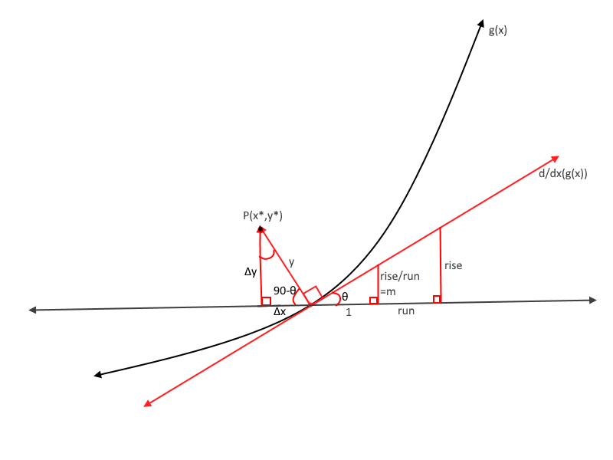 Assume that we are given a function $f\left(x\right)$ that is continuous on an interval $I$, and a function $g(x)$ that is differentiable on $I$. For the purposes of this proof, we will choose a generic point $P\left(x,y\right)∈S≔\left\{f\left(x\right)\right\}$. The projected point will be treating the function as the new axis, from there the point will the point will then be shifted from the new axis by some amount in both the x and y direction with a total shift magnitude of $f(x)$. Therefore:

$$x_{final}=x-Δx$$

$y_{final}=g\left(x\right)+Δy$

We subtract the $Δx$ from the initial value, as if we are projecting a positive point along a increasing function, the resultant x point will be *less than* the initial value. The process for both the $Δx$ and $Δy$ is very similar, so we will do them simultaneously. We begin by drawing the function $g(x)$ and the line tangent to it at the point $x$. From there, we draw the line normal to the curve at that point, and a line through that point, parallel to the axis. We will define the angle between this parallel line, and the normal line as $α$, and the angle between the tangent and the parallel line as $θ$ (note that in the diagram I labeled $α$ as $\frac{π}{2}-θ$, this is for the next step). Since $α$ and $θ$, are on the same line, we know that the sum of all angles on that side of the line must equal $π$. A normal line is defined as a line at a right angle to the tangent line, so we know:

$$π=α+θ+\frac{π}{2}⇒\frac{π}{2}=α+θ⇒\frac{π}{2}-θ=α$$

The tangent line at a point is a line, meaning the slope of it across all intervals of it is the same. From this we can say, cheesily, that the slope of the tangent line is the “rise” divided by the “run”. We also know the slope of the line is equal to the derivative of the function at the point, as well as the tangent of the angle. With all of this, we can write out that:

$$\tan\left(θ\right)=\frac{opposite}{adjacent}=\frac{rise}{run}=m=\frac{d}{dξ}{\left[g\left(ξ\right)\right]}_{x}$$

I evaluate the derivative with respect to a dummy variable $ξ$, as to evaluate it at any arbitrary x within the interval. We will then construct a second right triangle between the parallel and tangent line, such that the “run” side is of length 1. Since all angles are the same, we know that these triangles are similar, and their tangents of $θ$ are equivalent. From this we know:

$$\tan\left(θ\right)=\frac{rise}{run}=\frac{\frac{rise}{run}}{1}$$

As such, the length of the “rise” section of this triangle is equal to the prior “rise” over “run”, however we have already shown that the “rise” over the “run” is equivalent to the derivative at a point x:

$$\tan\left(θ\right)=\frac{\frac{d}{dξ}{\left[g\left(ξ\right)\right]}_{x}}{1}$$

From this we have proven that the triangle has side length 1, and $\frac{d}{dξ}{\left[g\left(ξ\right)\right]}_{x}$.

To get the values of $Δx$ and $Δy$, we perform basic trigonometric operations of the hypotenuse of the triangle between the parallel and normal lines; this hypotenuse has a value of y, or $f(k)$. We will soon get into the exact value of $k$, but for now we can say that:

$$x_{final}=x-f\left(k\right)∙cos⁡(α)$$

$$y_{final}=y+f\left(k\right)∙sin⁡(α)$$

Substituting for $α$:

$$x_{final}=x-f\left(k\right)∙\cos\left(\frac{π}{2}-θ\right)=x-f\left(k\right)∙sin⁡(θ)$$

$$y_{final}=g\left(x\right)+f\left(k\right)∙\sin\left(\frac{π}{2}-θ\right)=g\left(x\right)+f\left(k\right)∙cos⁡(θ)$$

Using the triangle between the parallel and tangent lines to solve for the sine and cosine of $θ$, we get:

$$x_{final}=x-f\left(k\right)∙\frac{\frac{d}{dξ}{\left[g\left(ξ\right)\right]}_{x}}{\sqrt{1+{\left(\frac{d}{dξ}{\left[g\left(ξ\right)\right]}_{x}\right)}^{2}}}$$

$$y_{final}=g\left(x\right)+f\left(k\right)∙\frac{1}{\sqrt{1+{\left(\frac{d}{dξ}{\left[g\left(ξ\right)\right]}_{x}\right)}^{2}}}$$

Now the final portion is to choose the point $k$ from which we will evaluate our projected function. When we choose a point on the normal cartesian, we say that the point is the distance from the origin. Since we know a line is a type of curve, and the origin is just a reference point, we can generalize this to that an x value is the length of the curve from some reference point. For functions that are not straight lines, we can say that this distance from the reference point is the arc length of the curve up to the x value we are working at. This arc length is defined as:

$$L=\int_{a}^{b}{\sqrt{1+{\left(\frac{dy}{dx}\right)}^{2}}dx}$$

For the axis $g(x)$ at some point x on the interval, we will say:

$$k=\int_{a}^{x}{\sqrt{1+{\left(\frac{d}{dξ}\left[g\left(ξ\right)\right]\right)}^{2}}dξ}$$

Again note that we are using $ξ$ as a dummy variable. Also note that $a$ does not only not have to be an end or midpoint of the interval, but that it will also act as the origin of the new coordinate system. Inserting this value of $k$ into our equations we get that:

$$x_{final}=x-f\left(\int_{a}^{x}{\sqrt{1+{\left(\frac{d}{dξ}\left[g\left(ξ\right)\right]\right)}^{2}}dξ}\right)∙\frac{\frac{d}{dξ}{\left[g\left(ξ\right)\right]}_{x}}{\sqrt{1+{\left(\frac{d}{dξ}{\left[g\left(ξ\right)\right]}_{x}\right)}^{2}}}$$

$$y_{final}=g\left(x\right)+f\left(\int_{a}^{x}{\sqrt{1+{\left(\frac{d}{dξ}\left[g\left(ξ\right)\right]\right)}^{2}}dξ}\right)∙\frac{1}{\sqrt{1+{\left(\frac{d}{dξ}{\left[g\left(ξ\right)\right]}_{x}\right)}^{2}}}$$

Which are the equations we initially set out to prove.

Q.E.D.

Further Notes:

Since the set of equations are technically parametric equations, all manners of normal parametric calculus could be done, including integrals, derivatives, and rotations. This type of projection also has potential applications in series.

Even more importantly, these types of equations can describe the motion of objects that are moving along two different functions. For example, we can use these curves can describe a object moving in a circle with a rack and pinion on the edge; this will form a curve of a

Nevertheless, this model is far from perfect. Work still must be done to account for forms of discontinuities and non-continuous functions. Besides that, there begs the question of expanding this to higher order dimensions.

Picture examples:

$$b\left(\sin\left(x\right),\ln\left(x\right)\right)$$

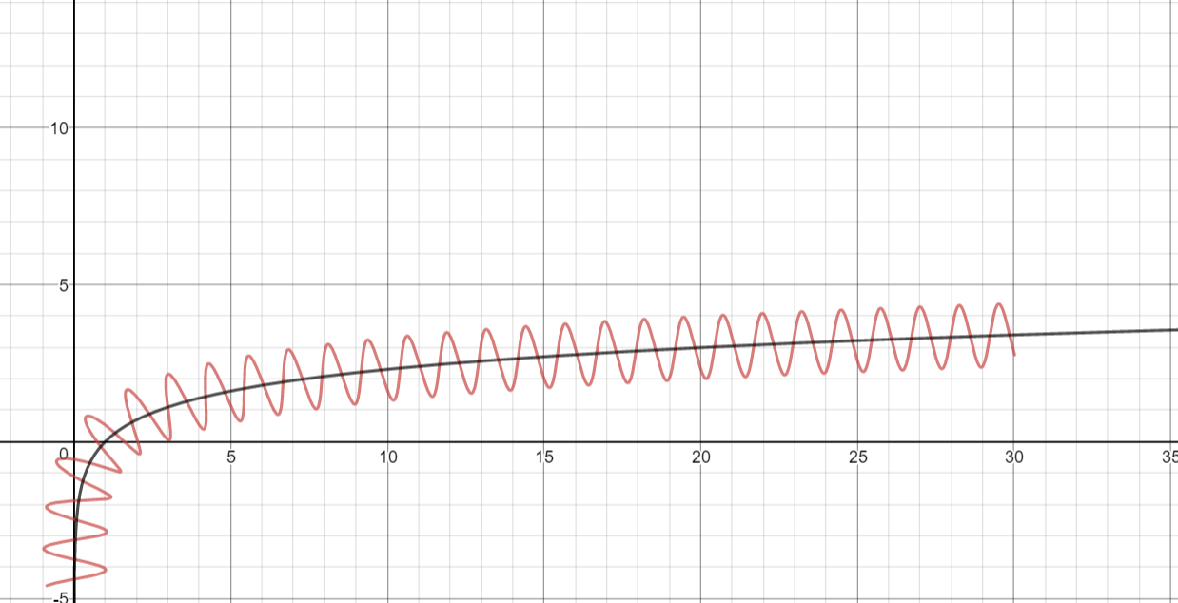

$$b(\sin\left(x\right), .01x^{2})$$

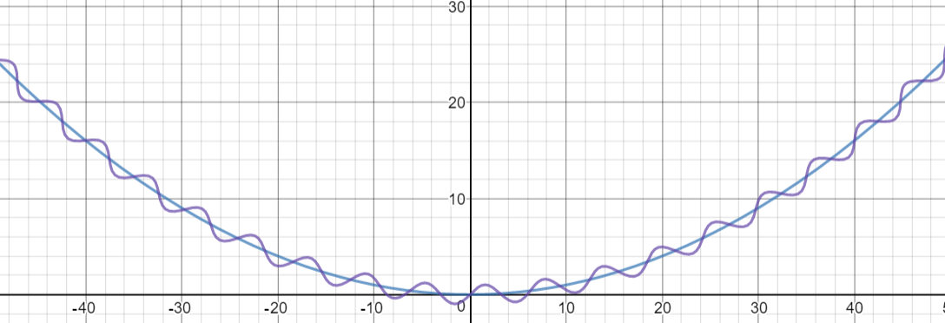

$$b\left(\sin\left(x\right),\tan\left(x\right)\right) from-π≤x≤π$$

