Peer2Peer 2.0

By M00905343

Contents:

* Screenshots (Pg. 2-3)
  + Login (Pg. 2)
  + Signup (Pg. 2)
  + Home (Pg. 3)
* Database design (Pg. 4-5)

# Screen Shots:

Login/Sign-Up:

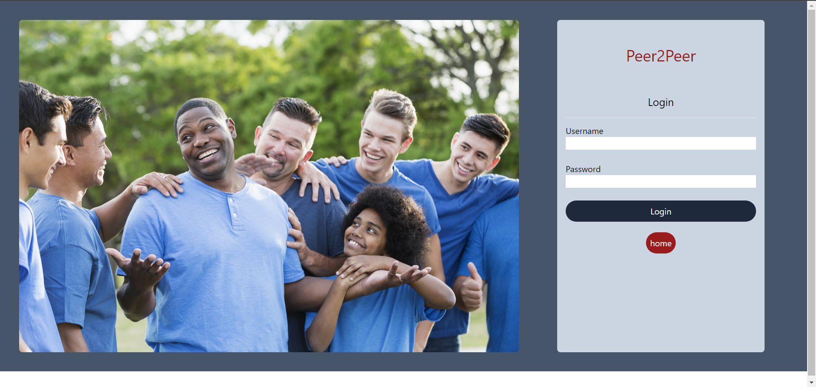

Sign up:

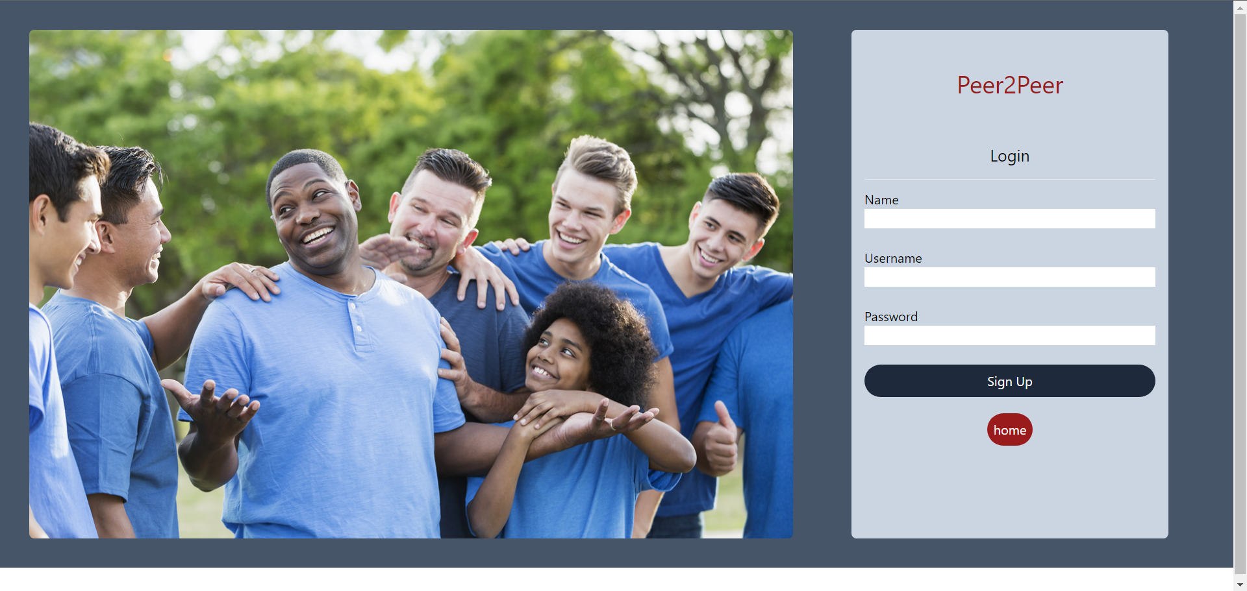

Home:

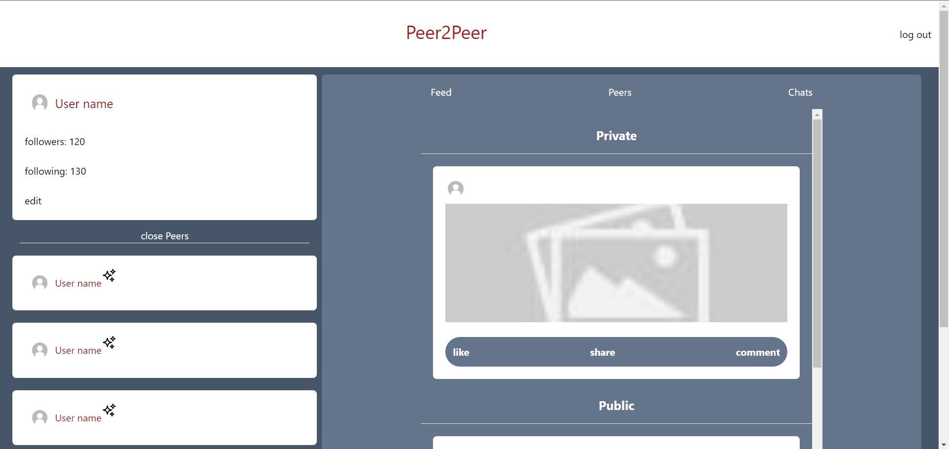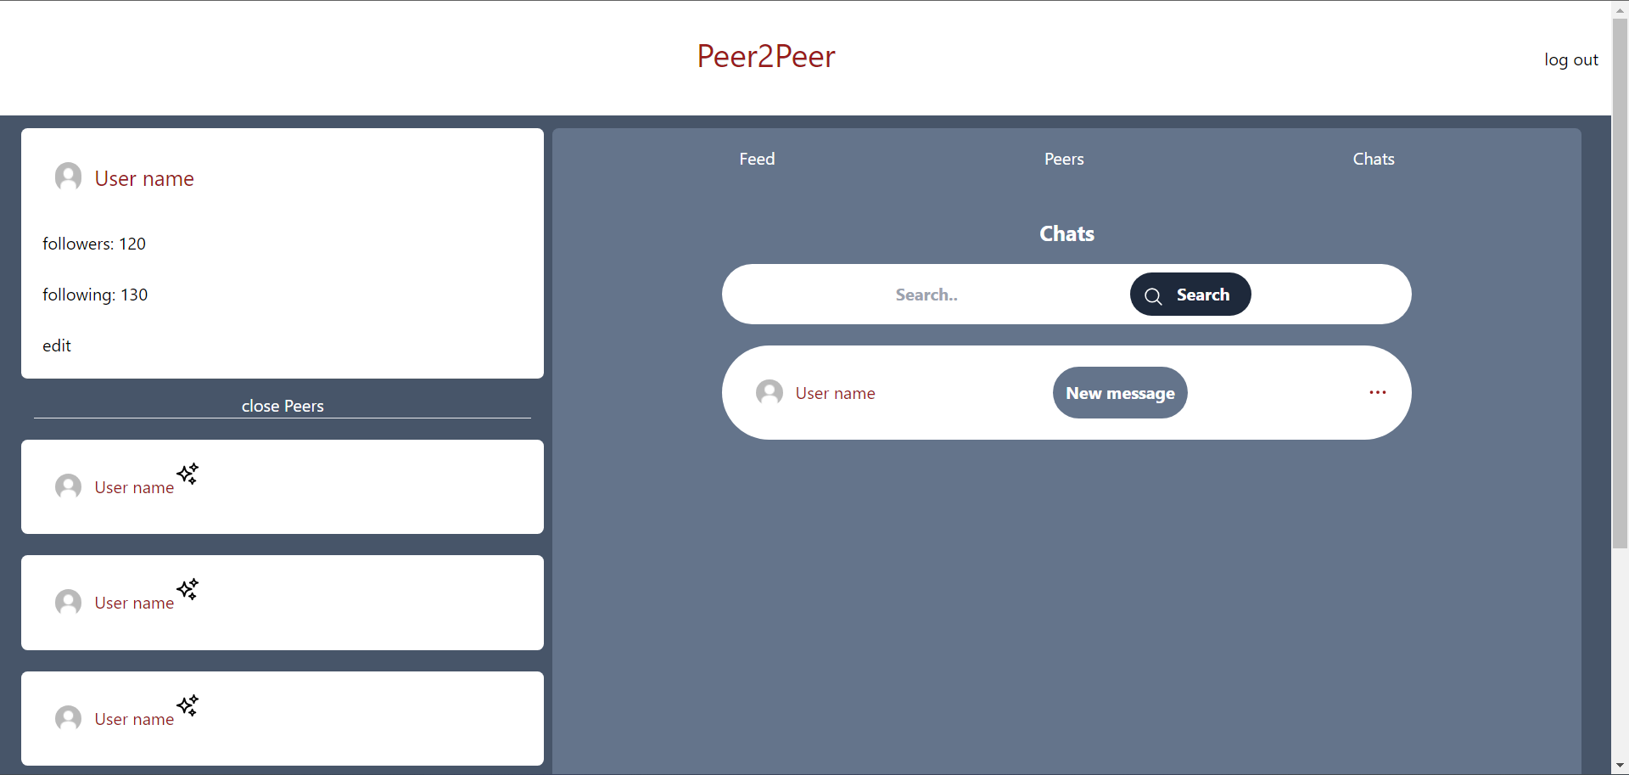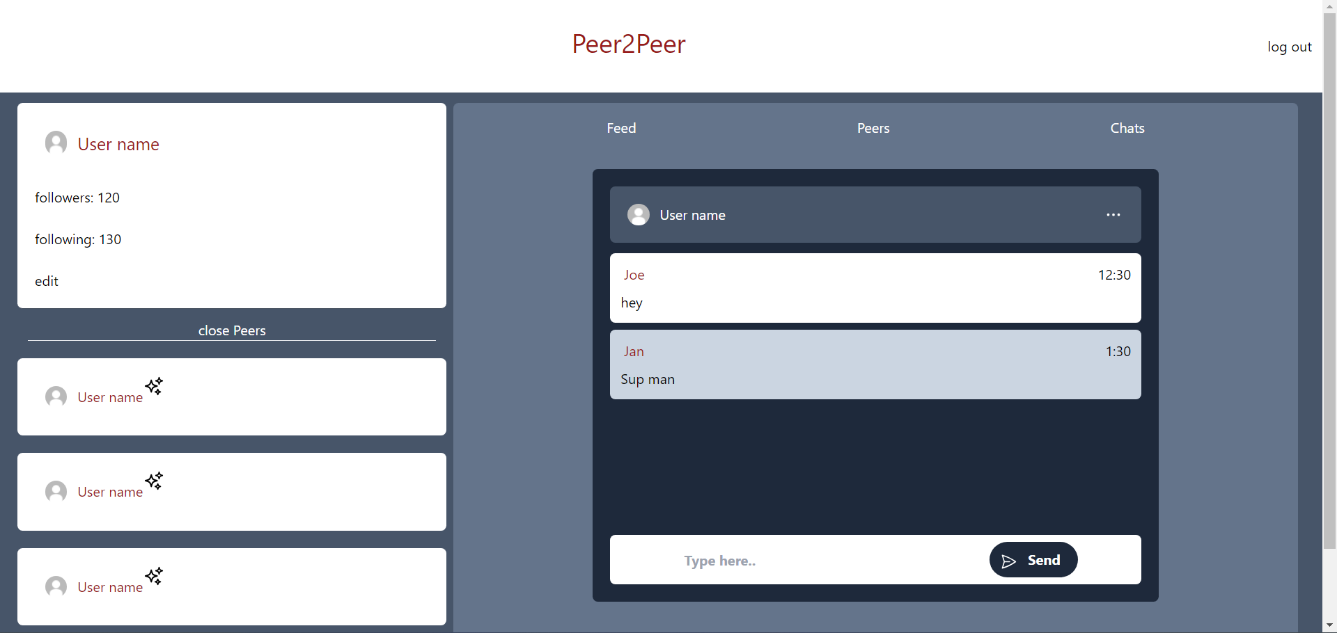

Database Design:

Database:

**Peer2Peer**:



Collections:

**Users:**

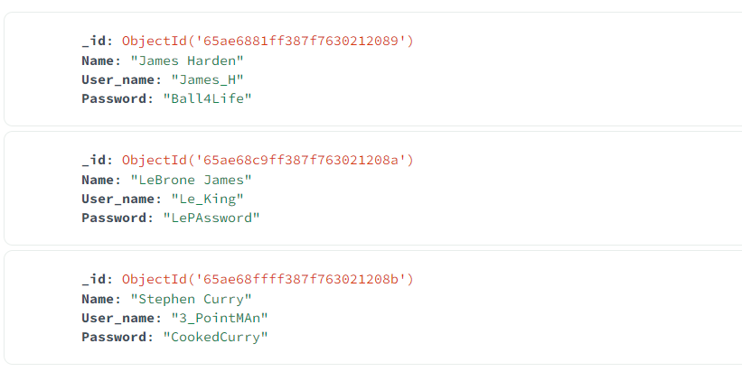

**Posts:**

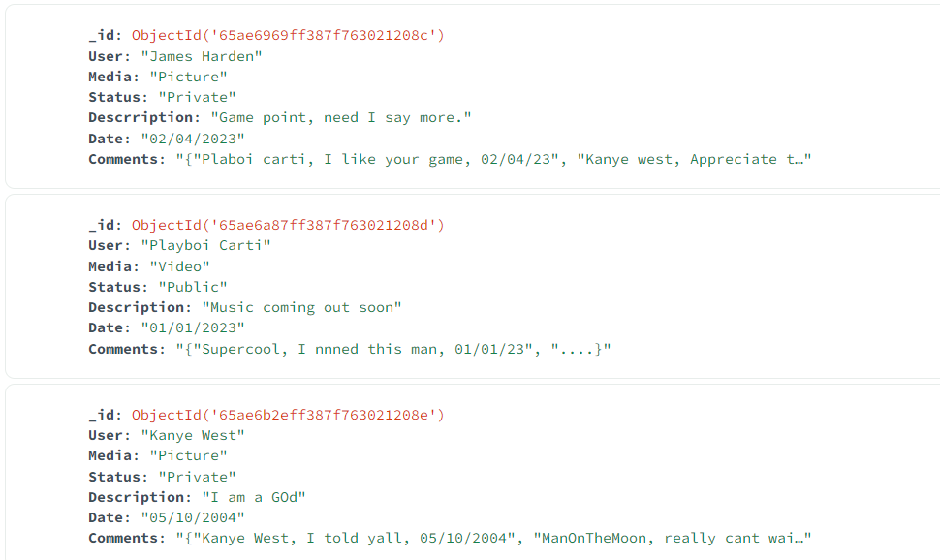

**Chats:**

