C950 Task-2 WGUPS Write-Up

(Task-2: The implementation phase of the WGUPS Routing Program).
(Zip your source code and upload it with this file)

Joseph Newman
ID #012380140
WGU Email: jnewma16@wgu.edu
11/30/2025

C950 Data Structures and Algorithms II

A. Hash Table
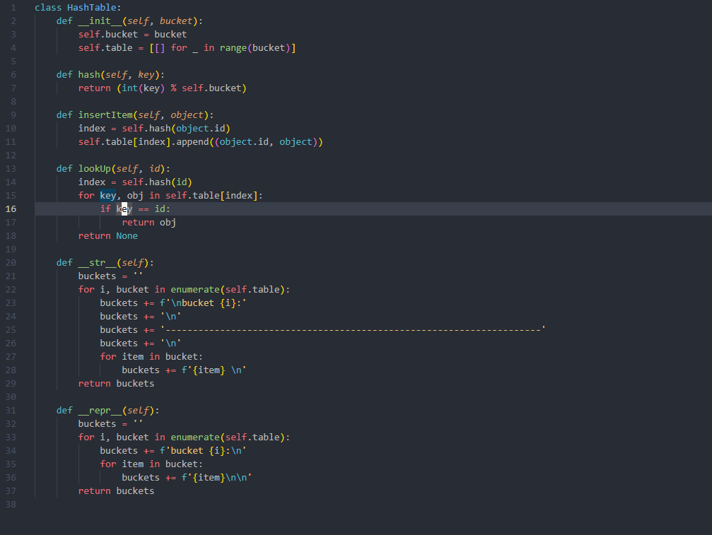

B. Look-Up Functions
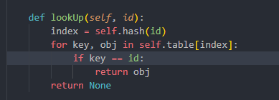

C. Original Code

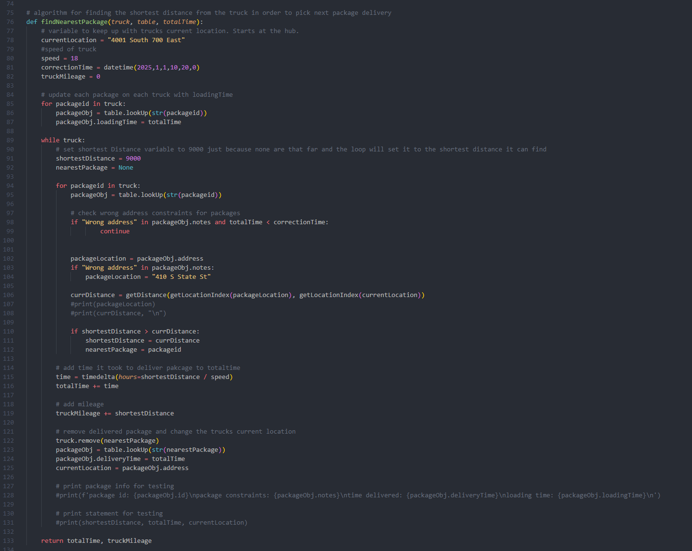C1. Identification Information


C2. Process and Flow Comments
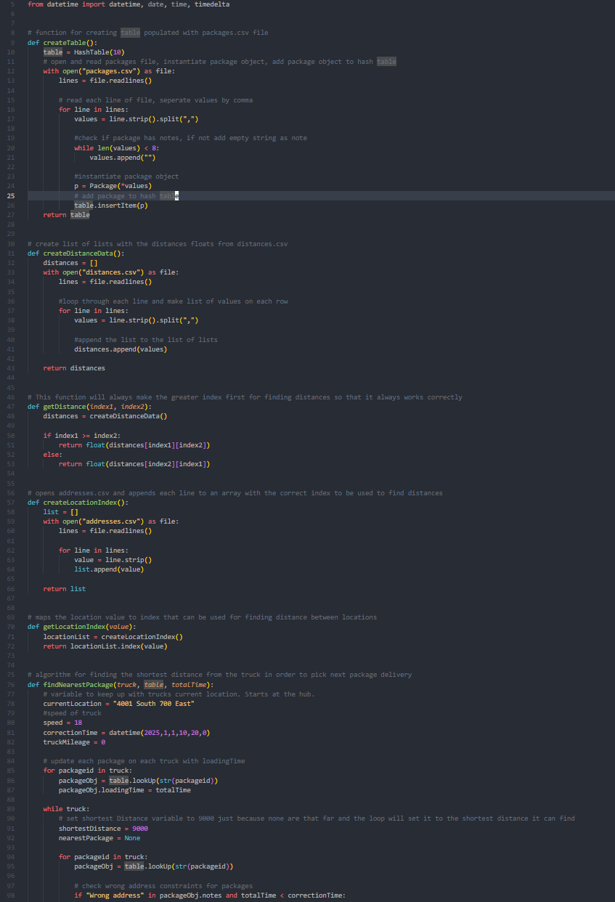

D. Interface
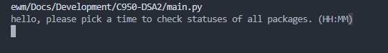

D1. First Status Check
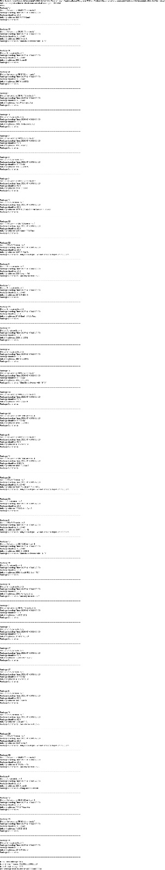

D2. Second Status Check
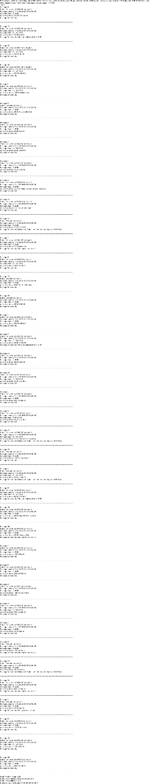

D3. Third Status Check
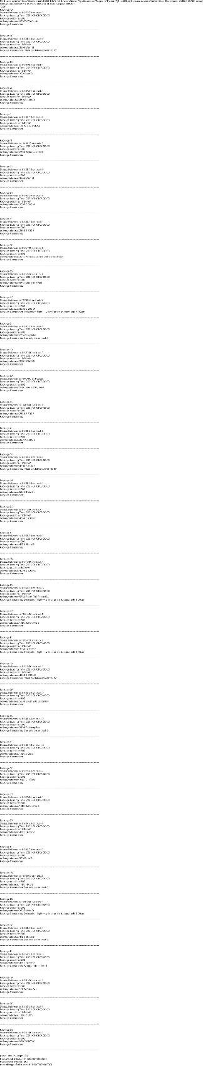

E. Screenshot of Code Execution
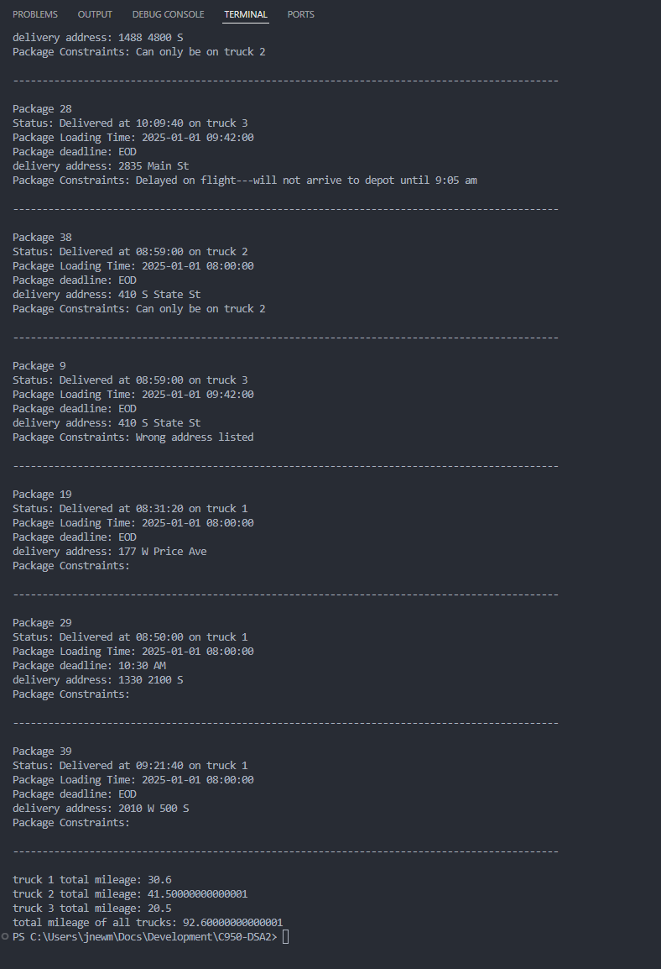

F1. Strengths of the Chosen Algorithm
The nearest neighbor algorithm is simple and straightforward to understand. By using this algorithm it will cut down on total delivery time by optimizing the next shortest path after each delivery. It is also an efficient algorithm to use on small to medium sized data.

F2. Verification of Algorithm
The algorithm completes all requirements of the scenario by addressing the next shortest path and saving time for each truck.

F3. Other Possible Algorithms
- Dijkstra’s Algorithm
- A* Search Algorithm

F3a. Algorithm Differences
Dijkstra’s Algorithm would work for this project as it calculates the shortest paths by considering the total distance to all possible locations rather than making only local decisions. Another is A* search algorithm which uses actual distance traveled and an estimate of the remaining distance to choose the next path. Unlike nearest neighbor, this algorithm evaluates future paths and can find more optimal routes.

G. Different Approach
If I were to complete this project again, I would improve the overall design by adding a truck class with attributes such as current location, total time, etc. I would also love to make some sort of GUI for a better user interface. Also adding an algorithm that can load the packages based off their constraints would be nice as well.

H. Verification of Data Structure
The Data Structures used in this project such as hash table meet all requirements.

H1. Other Data Structures
- Binary Search Tree
- Array

H1a. Data Structure Differences
A binary Search Tree stores data in a hierarchical, sorted structure based on a key value, such as package ID. The binary search tree would maintain order and provide ordered traversal and range-based searches. Another data structure would be a graph which represents locations as vertices and distances between them as weighted edges. Unlike a hash table, which is used primarily for fast lookup of package information by ID, a graph would model the locations and allow efficient distance calculations.

I. Sources
N/A

J. Professional Communication
N/A

