# Baseline

RHS_Upr_OB_pickup = [538.53,351]; #RHS Upper OB pickup point

RHS_Lwr_OB_pickup = [564.85,171.5]; #RHS Lower OB pickup point

static_camber = -1.5; #In degrees

UWB_length = 234.254625; #Upper wishbone length in front view

LWB_length = 418.9412262; #Lower wishbone length in front view

UWB_angle = 0.6408328324; #Upper wishbone angle to horizontal. Anti-clockwise positive

LWB_angle = -7.910191806; #Lower wishbone angle to horizontal. Anti-clockwise positive

Baseline kingpin angle is: -8.34˚.

Baseline scrub radius is: 10.0 mm.

Baseline roll centre height is: 164.46 mm.

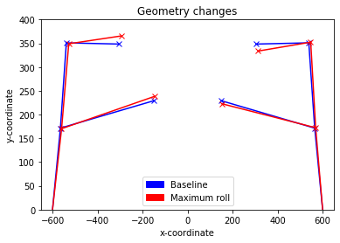

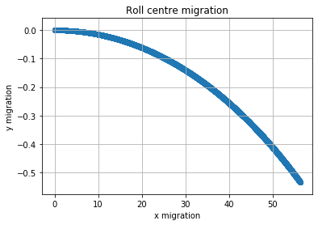

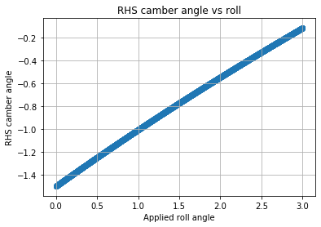

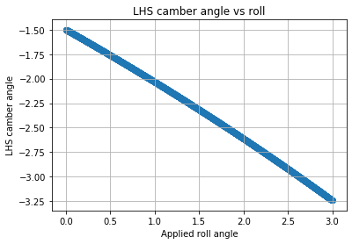

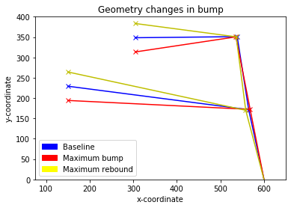

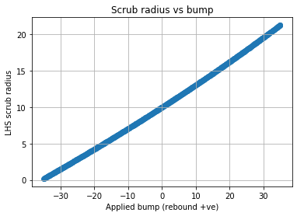

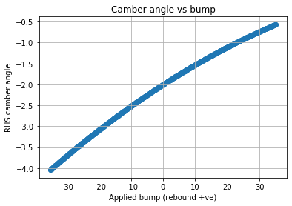

# FBR 2020 Front Geometry 1

The baseline geometry is FBR 2020 Front Baseline. The change in this geometry is translating the suspension 20mm downwards.

RHS_Upr_OB_pickup = [538.53,331]; #RHS Upper OB pickup point

RHS_Lwr_OB_pickup = [564.85,151.5]; #RHS Lower OB pickup point

static_camber = -1.5; #In degrees

UWB_length = 234.254625; #Upper wishbone length in front view

LWB_length = 418.9412262; #Lower wishbone length in front view

UWB_angle = 0.6408328324; #Upper wishbone angle to horizontal. Anti-clockwise positive

LWB_angle = -7.910191806; #Lower wishbone angle to horizontal. Anti-clockwise positive

|  |  |  |
| --- | --- | --- |
|  | **Baseline** | **New** |
| Suspension Data | Baseline kingpin angle is: -8.34˚.  Baseline scrub radius is: 10.0 mm.  Baseline roll centre height is: 164.46 mm. | Baseline kingpin angle is: -8.34˚.  Baseline scrub radius is: 12.94 mm.  Baseline roll centre height is: 154.73 mm. |
| Geometry Changes in Roll |  |  |
| Roll Centre Migration |  |  |
| RHS Camber Angle vs Roll |  |  |
| LHS Camber Angle vs Roll |  |  |
| Geometry Changes in Bump |  |  |
| Scrub Radius vs Bump |  |  |
| Camber Angle vs Bump |  |  |

## Conclusion

* Not the most effective way of lowering the roll centre
* Camber changes and scrub radius changes are mostly unaffected (slight increase in scrub radius)
* Strange roll centre migration

# FBR 2020 Front Geometry 2

The baseline geometry is FBR 2020 Front Baseline. The change in this geometry is

RHS_Upr_OB_pickup = [538.53,351]; #RHS Upper OB pickup point

RHS_Lwr_OB_pickup = [564.85,171.5]; #RHS Lower OB pickup point

static_camber = -1.5; #In degrees

UWB_length = 234.254625; #Upper wishbone length in front view

LWB_length = 418.9412262; #Lower wishbone length in front view

UWB_angle = 0.6408328324; #Upper wishbone angle to horizontal. Anti-clockwise positive

LWB_angle = -7.910191806; #Lower wishbone angle to horizontal. Anti-clockwise positive

|  |  |  |
| --- | --- | --- |
|  | **Baseline** | **New** |
| Suspension Data | Baseline kingpin angle is: -8.34˚.  Baseline scrub radius is: 10.0 mm.  Baseline roll centre height is: 164.46 mm. |  |
| Geometry Changes in Roll |  |  |
| Roll Centre Migration |  |  |
| RHS Camber Angle vs Roll |  |  |
| LHS Camber Angle vs Roll |  |  |
| Geometry Changes in Bump |  |  |
| Scrub Radius vs Bump |  |  |
| Camber Angle vs Bump |  |  |

## Conclusion