

Floor Plan for P_one

02/10/2026

1. Equipment List

· Equipment
The cable length is a theoretical straight-line distance for reference only.
 | Type | Description | Quantity | Backup | Total | Unit Price | Discount | Total Price
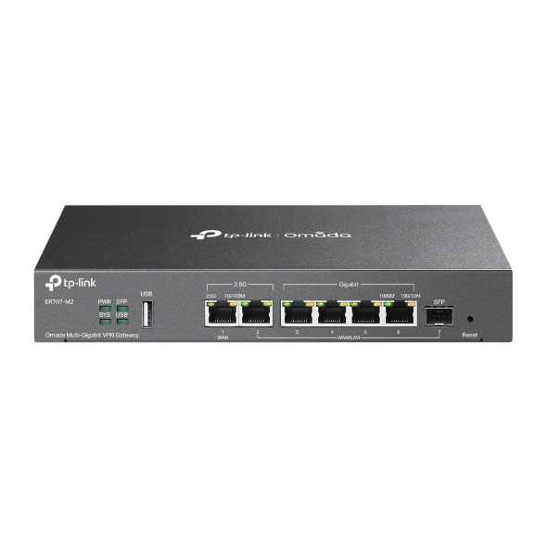 | ER707-M2 | Omada Multi-Gigabit VPN Gateway | 2 | 0 | 2 | IRR 0.00 | 0.00% | IRR 0.00
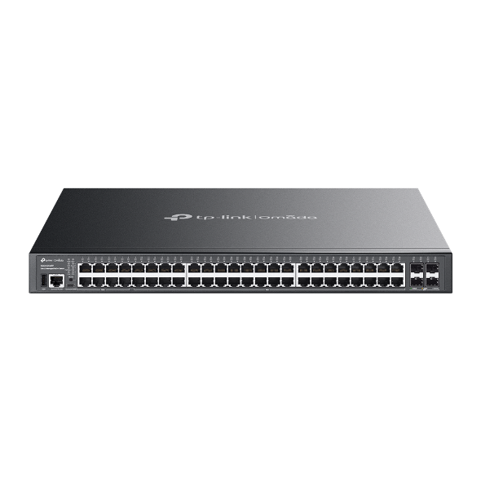 | SG5452XMPP | Omada 48-Port Gigabit Stackable Lite L3 Managed PoE++ Switch with 4× 10G Slots | 4 | 0 | 4 | IRR 0.00 | 0.00% | IRR 0.00
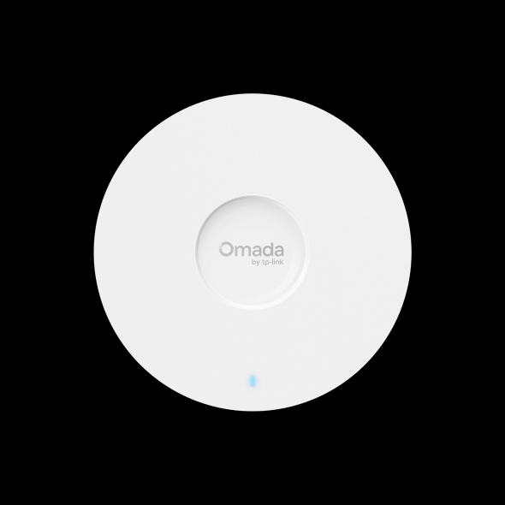 | EAP613 | AX1800 Ceiling Mount WiFi 6 Access Point | 2 | 0 | 2 | IRR 0.00 | 0.00% | IRR 0.00
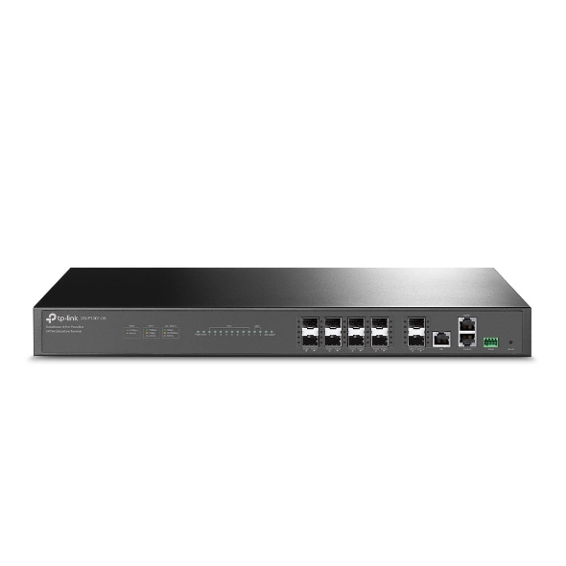 | DS-P7001-08 | DeltaStream 8-port Pizza-box GPON Optical Line Terminal | 1 | 0 | 1 | IRR 0.00 | 0.00% | IRR 0.00
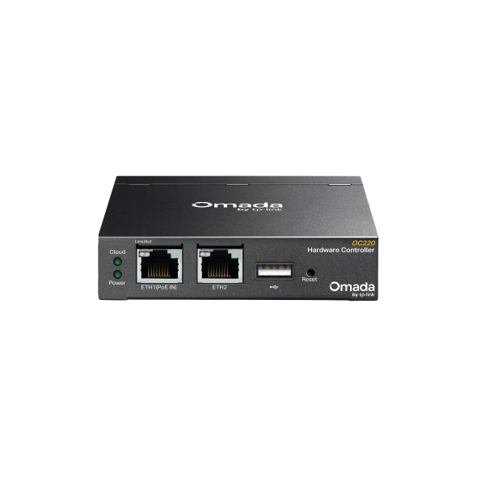 | OC220 | Omada Hardware Controller | 1 | 0 | 1 | IRR 0.00 | 0.00% | IRR 0.00
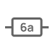 | CAT.6A | Supports 10 Gbps rate within 100 m / 328 ft | 275 m (903 ft) | 0 | 275 m (903 ft) | IRR 0.00 | 0.00% | IRR 0.00
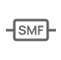 | SMF | Supports 100 Gbps rate within 40 km / 131,234 ft (high-speed, long-distance transmission) | 30 m (99 ft) | 0 | 30 m (99 ft) | IRR 0.00 | 0.00% | IRR 0.00

· Additional Fees

Fee Name | Description | Quantity | Unit Price | Discount | Total Price
Remote Maintenance | Remote maintenance fees cover the charges for maintaining you devices remotely. The fees are based on the number of devices and are charged annually. | 0 | 0.00 | 0.0% | IRR 0.00
Health Check Report | Health check reports are available to keep you informed of your devices’ status. The fees are based on the number of reports you receive and are charged annually. | 0 | 0.00 | 0.0% | IRR 0.00
Travel Expenses and Remote Support Fees | The fees cover the costs of on-site maintenance travel and remote supports charged per visit or call. | 0 | 0.00 | 0.0% | IRR 0.00
Installation and Commissioning | The fees are one-time fees for successful on-site installation and commissioning. | 0 | 0.00 | 0.0% | IRR 0.00
On-Site Maintenance (Annual) | The annual fees cover unlimited on-site maintenance visits for the year. | 0 | 0.00 | 0.0% | IRR 0.00

 |  | Equipment Fees  0.00 | + | Additional Fees  0.00 | + | Taxes (Tax Points 0.0%)  0.00

Total Price (IRR)
0.00

2. Topology
Go to the following link (valid for 7 days) for a more detailed topology:
https://aps1-design.tplinkcloud.com/#/share/topology/019c4651-3aa6-7107-a221-3bb6242d06f3

3. Floor Plan for map

· Placement Map

· Device List
AP
 |  | Device Name | Model | Mounting | Height | Angle | Channel (2.4 GHz/5 GHz/6 GHz) | Power (2.4 GHz/5 GHz/6 GHz)
(1) |  | EAP613 | EAP613 | Ceiling Mount | 5.0 m | -- | 1/36/- | 20 dBm/23 dBm/-
(2) |  | EAP613 | EAP613 | Ceiling Mount | 5.0 m | -- | 1/36/- | 20 dBm/23 dBm/-

· Device List (Continue Table)
Others
 |  | Device Name | Category | Model
(1) |  | SG5452XMPP | Switch | SG5452XMPP
(2) |  | SG5452XMPP | Switch | SG5452XMPP
(3) |  | SG5452XMPP | Switch | SG5452XMPP
(4) |  | SG5452XMPP | Switch | SG5452XMPP
(5) |  | ER707-M2 | Gateway | ER707-M2
(6) |  | ER707-M2 | Gateway | ER707-M2
(7) |  | DS-P7001-08 | PON | DS-P7001-08
(8) |  | OC220 | Controller | OC220

· 2.4G WI-FI Coverage

· 5G WI-FI Coverage

· 6G WI-FI Coverage

· Cabling Diagram

