Joseph W Thornton

ITS3102-SQL Development

Professor Robert Chubbuck

March 18, 2024

**Part Two: Course Project**

When I begin to work on week 4 project, I realized how important it is to choose the correct syntax and primary key. I had to research the terminology related to the primary key, such as: Foreign key which is an attribute of a relationship or a group of attributes that can work as the primary of additional relationship to which it is joined through a relationship. Unique key is the primary key in which value can’t be copied in other roles in the relation table. While comparable to a primary, a unique key doesn’t need to serve as the primary identifier for the table.

My approach to database planning, from forming a concept or a database idea to outlining the System Development Life Cycle (SDLC), mirrors an in-depth understanding of the steps required to create a functional and efficient database system. I used the foundational work to lay the groundwork for a successful implementation of logical business models into physical database designs, highlighting my growing skills in database architecture and design.

The database used in this section follows the business logic and the designs I created because it demonstrates the following verifications:

1. I divided my information into tables based on the subject and that helped reduced redundant data.
2. I double checked data input to ensure accuracy and correctness in my information.
3. My tables accumulated data processing and reported correct input data.
4. My charts provided a breakdown with the information it enjoins in the tables.
5. The data was put into tables and produced a faster, more accurate way of storing data.
6. Create statements specific to my company’s tables

**Queries that demonstrate that database is useful and meaningful:**

SQL statements for each of the tasks mentioned:

1. To display all the information from the customer table:

SELECT * FROM Customer;

1. To display all the information from the barber table:

SELECT * FROM Barber;

1. To display all the information from the appointment table:

SELECT * FROM Appointment table;

1. To display all the information from the service table;

SELECT * FROM Service table;

1. To display all the information from the product table;

SELECT * FROM Product table;

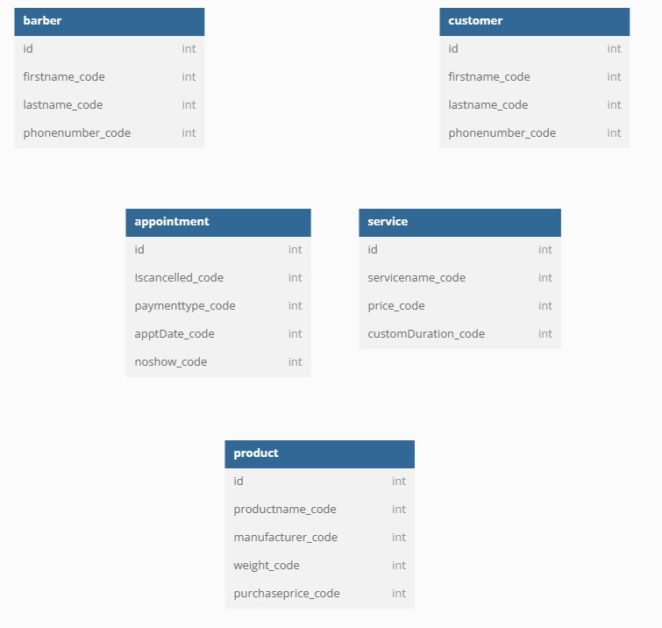

**Summary – SQL Development Course Project**

The objective of the SQL Development course (ITS3102) is to provide students with a foundation that is solid in designing, creating, and managing relational databases using Structured Query Language (SQL). Database architecture was emphasized in course, data normalization, and crafting SQL queries to retrieve, manipulate, and manage data successfully.

This course project is extremely relevant because it required applying key concepts such as primary keys, foreign keys, and the System Development Life Cycle (SDLC) to generate a functional and normalized database for a real-world business scenario. I developed a multi-table structure based on business logic, lowering data redundancy, and making sure there was referential integrity between tables. I then created custom CREATE statements and used SELECT queries to confirm the effectiveness of the design.

Many public sectors rely on well-structured databases to support citizen services, case management, reporting, and internal operations. Demonstrating the ability to design normalized databases and writing accurate SQL queries is essential for enabling data- decision-making and maintaining a strong backend system that organizations require.