Part 2 — Scaling Entity Extraction to 1M+ Documents per Day
System design, concept level. Companion to the Part 1 implementation.
First, the constraints in plain numbers. One million documents a day is about 12 documents per second on average; a 3x spike is about 35 per second. Neither number is frightening for a queue-and-workers system. The two things that make this hard are LLM spend, which dominates every other cost at this volume, and keeping entity names consistent enough that dashboard aggregates mean something. The 15-minute freshness window rules out nightly batch jobs but comfortably allows micro-batching, so the design optimizes for cost and consistency first and raw throughput second.
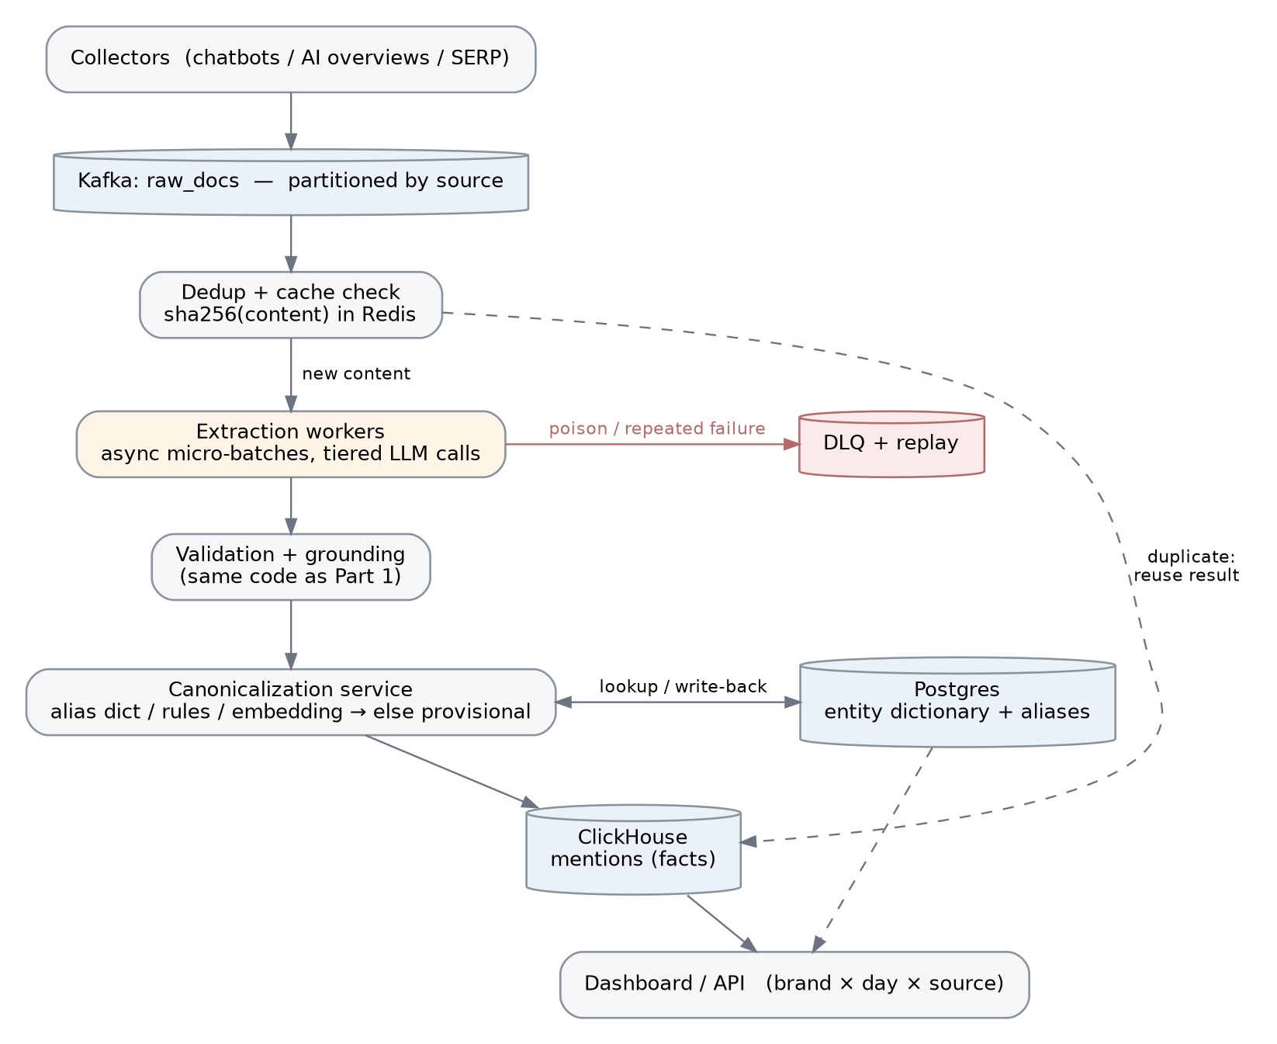
Figure 1 — end-to-end flow. The extraction box runs the exact Part 1 code; everything around it is plumbing that makes it cheap, consistent, and recoverable.

1. Ingestion and queuing
Collectors (chatbot probes, AI-overview scrapers, SERP monitors) publish raw documents to a Kafka topic partitioned by source; the raw text also lands in object storage keyed by content hash so anything can be reprocessed later. I would pick Kafka over a simpler managed queue mainly for replay: being able to re-consume a time range by offset is the backbone of the failure and rollback story below, and partitioning by source keeps one misbehaving crawler from starving the rest. To be honest about the trade-off, at 12 docs/second SQS would also work fine; Kafka is a bet on the replay property, not on throughput.

2. Processing
Workers pull micro-batches of a few dozen documents. The first step is not the LLM — it is a dedup check: sha256 of the content against a Redis cache. Scraped corpora repeat heavily (the same AI overview gets served to many probes), and a cache hit reuses the stored result and skips the model entirely. New content then passes a cheap prescreen — does this even look like it mentions a brand? A small model, or honestly even a keyword-and-URL heuristic, routes empty documents away from the expensive call.
Extraction itself is exactly the Part 1 code: one LLM call wrapped in grounding, alias, DNS and merge layers. Those layers are pure functions, so scaling is just adding workers; the only concurrency that matters lives at the async API-call layer. Every write is an idempotent upsert keyed by (doc_id, model_version), so retries and replays cannot double-count. Micro-batching and queuing add a few seconds of latency, which is irrelevant under a 15-minute SLA and buys most of the cost reduction below.

3. Cost, sized at 10M documents/day
The naive version — 10M documents times roughly 1.5k tokens each through a frontier model — lands somewhere around $15–20k per day, which is a non-starter. The levers, in the order I would pull them: dedup (20–40% of scraped content repeats, so this part is free); prescreen routing (skip or downgrade documents with no brand signal); batch or off-peak API pricing (about half price, and nothing here is user-facing, so backlog and reprocessing all qualify); prompt caching (the system prompt is a constant); and model tiering (a small model for short, unambiguous documents, the large one only for long or messy ones). Stacked, these bring a realistic landing zone of $1–3k per day at 10M/day.
The end state, once the pipeline has accumulated a few million validated extractions, is distilling them into a small self-hosted model, after which marginal cost approaches GPU depreciation. The pipeline is deliberately model-agnostic, so that migration is a configuration change, not a redesign.

4. Entity canonicalization
This is the part that decides whether the product is trustworthy, because every dashboard number is an aggregate over a canonical entity. Resolution runs cheapest-first: exact alias lookup (seeded from the Part 1 curated map and grown continuously); normalization rules (case, punctuation, possessives, legal suffixes); embedding nearest-neighbour against canonical names for fuzzy variants; and below a confidence threshold the system creates a provisional entity instead of guessing a merge. Provisionals are adjudicated asynchronously — an LLM with web evidence for the long tail, a human for anything high-traffic — and the decision is written back to the dictionary, so coverage improves with volume.
The resolved domain doubles as a natural join key: two mentions resolving to the same registrable domain are the same entity, which is what merges “ITI” and “Industrial Training International” across documents. Rebrands and acquisitions are handled in data, not code: aliases carry validity dates and an entity can point at what it merged into, so Twitter and X aggregate correctly across the boundary. The deliberate trade-off is conservative merging. A wrong merge silently corrupts a customer’s chart; a missed merge is visible and fixable by replay. So the system auto-merges only above high confidence and parks everything else as provisional.

5. Storage
Three stores, each doing the one thing it is good at. Postgres holds the entity dictionary and aliases — it is small (hundreds of thousands of rows), relational, and merging entities wants transactions. ClickHouse holds the mentions fact table — append-heavy, and every dashboard question is a columnar scan of brand by day by source over months. Object storage keeps raw text by content hash, which is what makes full reprocessing cheap. The shapes, roughly:
entities(entity_id, canonical_name, domain UNIQUE, status: live|provisional|merged,
merged_into, created_at) -- Postgres
entity_aliases(alias_norm, entity_id, valid_from, valid_to) -- Postgres
mentions(day, entity_id, doc_id, source, sentiment, confidence,
model_version, extracted_at) -- ClickHouse, partitioned by day
mentions_daily(day, entity_id, source, pos, neg, neu) -- materialized rollup
The default dashboard reads the daily rollup and never touches raw facts. Could this all live in one Postgres? At 1M/day, yes, and for an MVP I would accept that for operational simplicity — but the query shape is columnar, and I would plan the ClickHouse migration rather than discover the need for it.

6. Failure handling
Assume the LLM provider will have a bad day. Transient errors retry with backoff; sustained errors fail over to a second provider (the Part 1 client already abstracts both). A document that fails repeatedly goes to a dead-letter queue with its full context instead of blocking its partition. Because every write is idempotent, the recovery story for any incident is the same verb: replay — from Kafka offsets for recent windows, from object storage by date range for anything older. That also makes rollback boring: pin the previous model_version, replay the affected window, and the upserts overwrite the bad rows. Adversarial documents deserve a mention, since prompt injection lives in this corpus by definition: the grounding check bounds the blast radius (an injected instruction can only distort the document that contains it), and repeat parse-breakers end up in the DLQ where a human can look at them.

7. Observability
One on-call dashboard with four numbers. First, end-to-end lag age against the 15-minute SLA — the age of the oldest unprocessed document, which is a more honest signal than queue depth. Second, cost per thousand documents, split by model tier. Third, DLQ rate. Fourth, and the only one that quietly rots if you don’t watch it: accuracy — a nightly run of the golden labeled set (the Part 1 eval harness promoted into CI) plus a small daily sample routed to human review. Throughput problems announce themselves; quality regressions don’t, which is why the accuracy trend is the alert I would actually page on.

What breaks first beyond ~10M/day
Three things, in the order I expect them: write contention on the canonicalization dictionary (shard it and cache aggressively); rollup query fan-out as sources multiply (pre-aggregate per source); and provider rate limits, which is less a failure than the forcing function to accelerate the distillation plan from section 3.

