When Does a Regulatory Edge Become Causal?

Cell-state and chromatin dependence of gene regulation in a single-cell perturbation atlas
Yuqi Tao
Independent Researcher, Manchester, United Kingdom
Manuscript status: Initial full draft, 20 August 2026
Correspondence: to be confirmed before submission

Abstract
Single-cell transcriptomes support the inference of large gene regulatory networks, but an observational transcription factor (TF)-to-target association does not establish that the target will respond when the TF is perturbed. Here, we asked why some regulatory edges survive intervention whereas others are restricted to observational single-cell data. We re-analysed a human Perturb-multiome atlas of haematopoietic differentiation, separating controls-only edge discovery from CRISPR-based validation, cell-state heterogeneity, chromatin mechanism, and external temporal validation. Among 43,740 candidate edges from six erythroid TFs, the top 1% of a residualized signed association ranking was enriched 2.44-fold for published intervention-responsive targets relative to expression- and detection-matched null edges (empirical P=0.001), whereas GRNBoost2 showed no enrichment. Strict late-erythroid pseudobulk validation identified only 13 E1 edges, emphasizing that observational confidence was concentrated in a narrow upper tail. Across four collection times, 53 of 619 stable observational edges showed significant perturbation-by-time interactions, but 25 coincided with perturbation-induced movement along a controls-defined differentiation axis. Targeted paired RNA and ATAC analysis identified 11 motif-supported E2 peaks across four GATA1 edges (CPEB4, ALAS2, SLC25A37, and SPTA1). None remained significant after conditioning on post-perturbation erythroid state. Contrary to a simple permissive-gate model, baseline accessibility correlated negatively with both ATAC and RNA perturbation-effect magnitude. In an independent adult erythroid time course, 8 of 11 E2 peaks, but 0 of 10 linked non-E2 peaks, became accessible before target-RNA activation; three of four E2 edges passed the prespecified temporal criterion versus zero of six comparison edges (edge-level Fisher's exact P=0.033). These results support an establishment-versus-maintenance model in which regulatory dependence is strongest while a lineage programme is being established and can attenuate after the chromatin state has formed. More generally, causal credibility is an edge-, state-, and developmental-stage property rather than an intrinsic attribute of an observational network.

Introduction
Single-cell RNA sequencing has made it possible to infer regulatory structure from thousands to millions of heterogeneous cells. Methods based on co-expression, tree-based prediction, cis-regulatory motif enrichment, dynamic trajectories, and joint RNA–chromatin measurements can nominate TF–target relationships at scale [1–5]. These networks have become central to analyses of cell identity, differentiation, disease, and in silico perturbation. Yet the word “regulatory” often carries a stronger interpretation than the underlying data support. A TF and a target can covary because one regulates the other, but also because both follow differentiation, cell-cycle, stress, batch, or an unmeasured upstream programme. Even a reproducible, motif-supported edge can therefore fail to predict the response to intervention.
Pooled CRISPR screens with single-cell readouts provide a direct route from association to intervention [6–8]. Perturb-seq identifies the molecular response to a genetic perturbation in individual cells, while perturbational epigenomic assays can connect transcriptional responses to changes in chromatin accessibility [9]. However, intervention does not automatically make every downstream comparison simple. Perturbations can change which cell states are occupied, alter the rate of progression along a developmental trajectory, or produce different molecular effects in different states. Cell labels observed after perturbation can themselves be mediators or colliders. Thus, an atlas-wide perturbation response, a response within a terminal cell state, and a response after conditioning on post-treatment state correspond to different estimands.
Chromatin introduces a second layer of context. A common model proposes that a TF–target edge is effective when the relevant cis-regulatory element is open. Joint single-cell RNA and ATAC measurements make this model testable by asking whether a candidate element is accessible, linked to target expression, TF-sensitive under intervention, and supported by the TF motif [4,10]. But the relationship between accessibility and regulatory dependence need not be monotonic. A TF may be required to establish an accessible state but become less important once that state is maintained by additional factors or lineage memory. Under this alternative, perturbation effects should be strongest early, when baseline accessibility is still low, and decline as the locus opens.
Human erythropoiesis provides a useful system in which to distinguish these possibilities. It follows an ordered differentiation trajectory, is controlled by well-studied TFs including GATA1, NFE2, KLF1, TAL1, GFI1B and BCL11A, and is represented by both perturbational multiome data and independent stage-resolved RNA/ATAC datasets [11–13]. The Perturb-multiome atlas generated by Martin-Rufino and colleagues profiled 19 master TF perturbations across human haematopoietic differentiation with paired gene-expression and chromatin accessibility readouts [11]. This design permits observational network inference and intervention testing within the same experimental system, while independent fetal and adult atlases provide tests of temporal transport [12,13].
Here, we developed a deliberately staged analysis. Candidate edges were first inferred from non-targeting cells only (E0). Perturbed cells were then used to test transcriptomic response (E1), collection-time dependence, movement along a controls-defined differentiation axis, and local chromatin mechanism (E2). Finally, E2 peaks were frozen and evaluated in independent differentiation datasets. The analysis was not designed as a benchmark of many machine-learning models, nor as a universal causal score. It addressed a biological question: when does an observational regulatory relationship remain valid under real intervention?

Results

A staged framework separates observational confidence, intervention, context, and mechanism
We analysed GSE274113, the single-cell Perturb-multiome component of a human haematopoietic TF perturbation study [11]. All 14 RNA/ATAC libraries opened successfully, and all 137,604 cells passing the authors' quality-control filters were matched to their corresponding 10x matrices. The libraries contained an identically ordered set of 36,601 RNA features and between 93,574 and 100,809 ATAC features. Public metadata did not identify library replicates as independent donors; throughout, they were therefore treated as library or batch strata rather than units of donor-level replication.
The primary TF panel comprised GATA1, NFE2, GFI1B, BCL11A, TAL1 and KLF1. These TFs were selected before network inference because of their central roles in erythroid differentiation and sufficient guide representation at day 14. The late-erythroid primary analysis contained 22,437 cells (13,317 orthochromatic and 9,120 polychromatic erythroblasts), including 1,304 cells carrying the non-targeting NT_1, NT_2 or NT_3 guides for strict observational discovery. AAVS1 guides were reserved as cutting controls for intervention comparisons.
The workflow comprised five layers (Figure 1): controls-only observational discovery; perturbational RNA validation; dependence across collection time and erythroid state; targeted chromatin mechanism; and external temporal transport. We use E0 for a stable controls-only TF–target association, E1 for an E0 edge with guide-consistent target-RNA response, and E2 for an edge linked through a specific local accessibility element with concordant perturbational and motif evidence. These labels describe evidence in the present analysis and are not claimed as universal ontological categories.
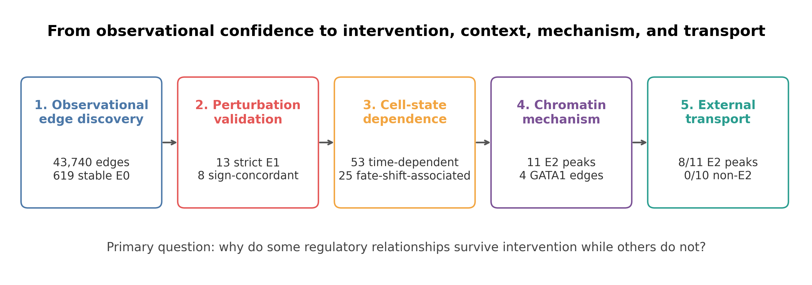

Intervention support is concentrated at the extreme top of the observational ranking
We compared two observational strategies across 43,740 possible edges from the six TFs to 7,291 eligible expressed genes. The first was a signed association after residualizing target and TF expression for library depth, batch and late erythroid state. The second was GRNBoost2, a scalable gradient-boosting method for network inference [2]. The residualized network was bootstrapped 100 times within batch and cell-state strata. An edge was called stable if it appeared in the top 5% of the TF-specific ranking in at least 70 bootstraps.
This procedure retained 619 stable E0 edges: 171 for NFE2, 135 for BCL11A, 83 for KLF1, 82 for GATA1, 81 for GFI1B and 67 for TAL1. Agreement with GRNBoost2 was incomplete: 41 stable residualized edges also occurred in the GRNBoost2 top 1%, 192 in the top 5%, and 293 in the top 10%.
We calibrated the complete observational rankings against the source study's published atlas-level TF-sensitive gene table. Among all 43,740 edges, 11,468 linked a TF to a published TF-sensitive gene, 1,833 also exceeded an absolute published log2 fold-change of 0.25, and 1,041 were directionally compatible with the observational sign. This comparison is a within-dataset calibration rather than an independent validation, but it permits an intervention-based test of ranking quality.
The strongest residualized edges were selectively enriched for intervention support. In the top 1%, 12.0% of residualized edges linked to an effect-size-qualified published response, compared with 4.9% in TF-, expression- and detection-matched null samples (2.44-fold enrichment; empirical P=0.001; Figure 2A). Directionally concordant support was enriched 2.75-fold (P=0.001). Enrichment remained at the top 5% (1.82-fold) and top 10% (1.51-fold), but declined with rank. GRNBoost2 showed no enrichment at the same cut-offs (top-1% enrichment 1.02; P=0.490). A simple average consensus diluted the strongest residualized signal (top-1% enrichment 1.47; P=0.017).
Genome-wide discrimination remained modest: for effect-size-qualified intervention support, the residualized ranking had AUROC 0.526 and AUPRC 0.048. Thus, the key result was local rather than global. Observational confidence was useful in a narrow upper tail, but neither ranking supported broad causal validity of the inferred network.

Strict late-erythroid E1 validation is sparse and exposes guide-efficacy heterogeneity
To obtain an internal, state-matched intervention test, we aggregated guide × library × late-erythroid-state pseudobulks and compared targeting guides with AAVS1 controls. Guide efficacy was assessed using a cross-fitted, Mixscale-style score: the perturbation signature for each held-out guide was learned only from the other guides targeting the same TF and standardized against locally matched control cells. NFE2 and KLF1 had three effective guides; BCL11A had two; GATA1 and GFI1B had one; and TAL1 had none under the frozen screen.
An E1 call required FDR<0.05, |log2 fold-change|≥0.25, at least two effective guides, agreement of guide-specific directions, and preservation of direction under leave-one-guide-out analysis. Only 13 of 619 E0 edges passed, of which eight were directionally concordant with the observational edge under TF loss (Figure 2C). All 13 involved NFE2. This low count did not meet the initial planning target and no threshold was relaxed. It reflects a deliberately strict within-day-14 estimand, guide-efficacy heterogeneity, and the absence of independent donor replication. The contrast with the broader published atlas-level responses motivated an explicit test of developmental context.
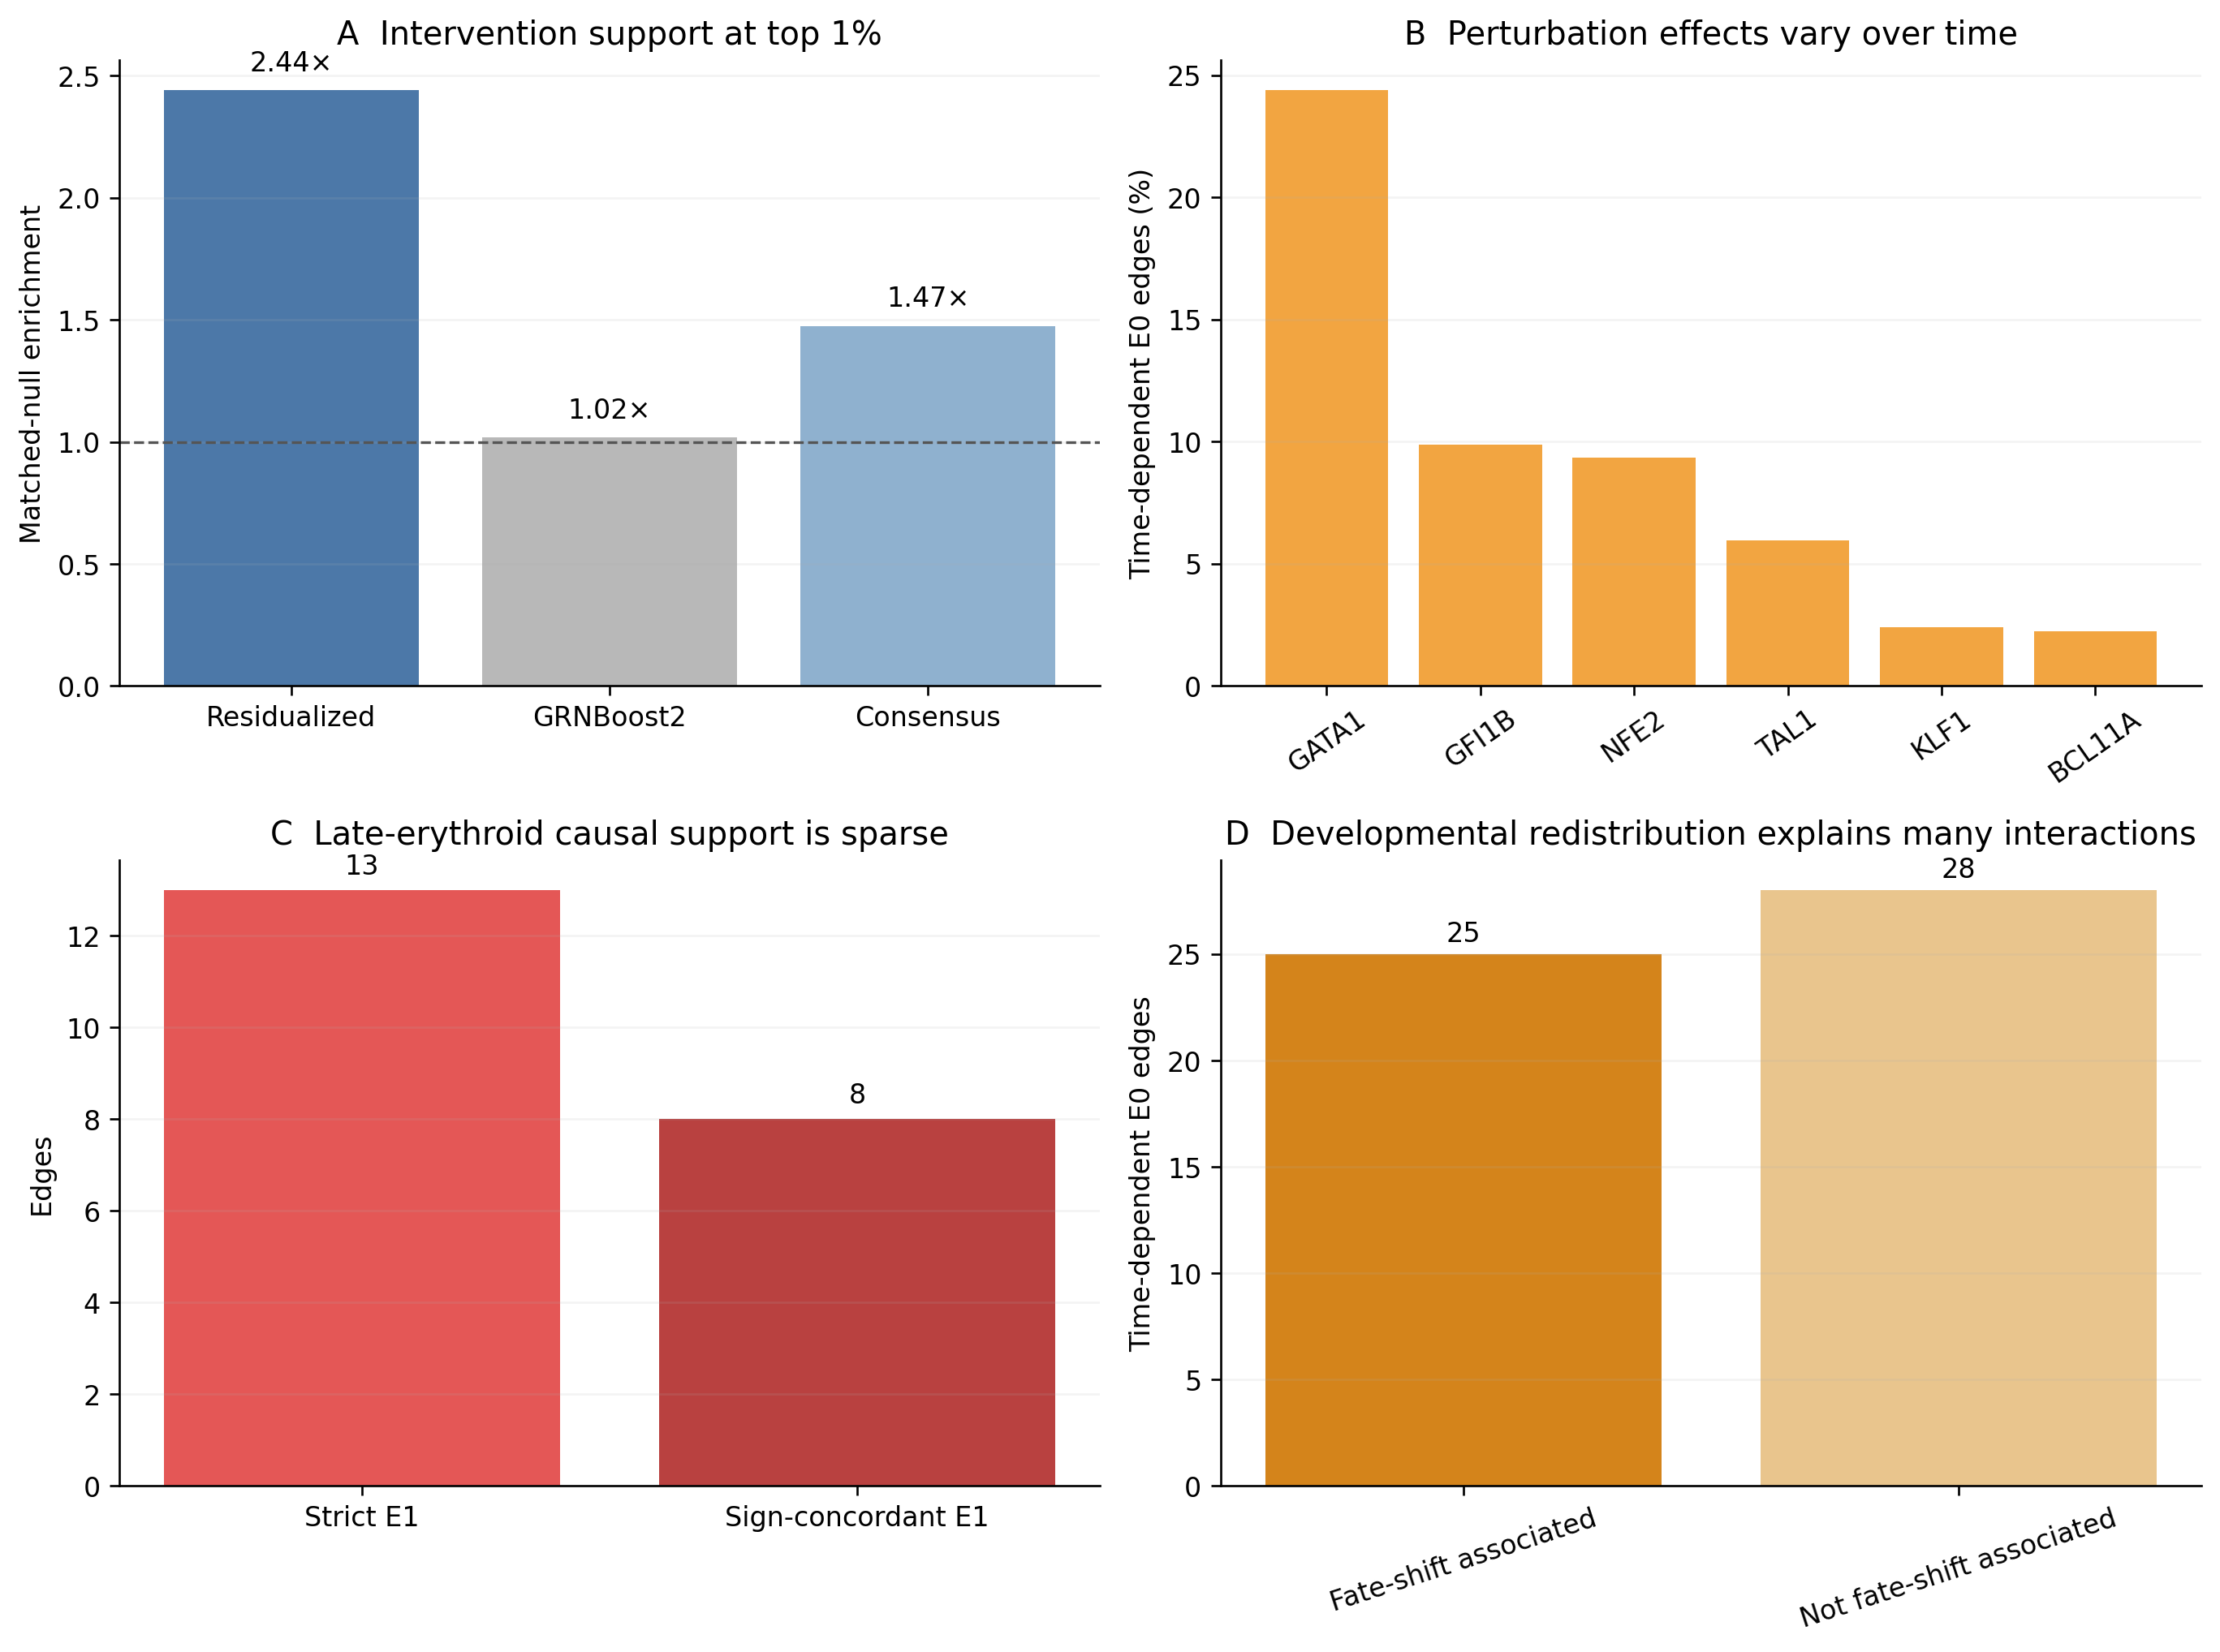

Collection-time dependence is common, but developmental redistribution explains many apparent edge failures
We next tested the 619 E0 edges across days 7, 9, 11 and 14. Collection time was assigned before perturbation and was therefore used as the primary context. Weighted pseudobulk models included perturbation, library, and perturbation-by-time interactions. Fifty-three edges (8.6%) had a joint interaction FDR<0.05. The fraction varied substantially by TF: 24.4% for GATA1, 9.9% for GFI1B, 9.4% for NFE2, 6.0% for TAL1, 2.4% for KLF1 and 2.2% for BCL11A (Figure 2B).
The prespecified effect-shape classifier assigned 29 edges as gated, one as reversed, 23 as other state-dependent patterns, 15 as guide-unstable, one as constitutive, and 550 as having no detected interaction. “No detected interaction” denotes an absence of evidence, not evidence of invariance.
Atlas-supported edges that failed strict day-14 E1 were over-represented among time-dependent edges. Fifteen of 62 such edges (24.2%) were time dependent, compared with 38 of 557 other E0 edges (6.8%; odds ratio 4.36; Fisher's exact P=6.32×10⁻⁵). On its own, this pattern could be interpreted as a late-state gate. However, a perturbation may also change the developmental states occupied by the cells.
We therefore trained a differentiation axis using only NT_1/2/3 control pseudobulks. Two thousand variable genes were scaled and represented by ten principal components, and a ridge model predicted collection time under leave-one-library-out validation. The axis explained 96.4% of variance in the selected PCs and recovered time with R²=0.987 and mean absolute error 0.23 days. The 95th percentile of control-guide shifts was 0.547 days.
Eight TF-by-timepoint shifts passed the frozen FDR, effect-size and guide-consistency criteria: GATA1 at days 7, 9 and 11; GFI1B at days 7, 9 and 11; NFE2 at day 11; and TAL1 at day 11. Of the 53 time-dependent E0 edges, 25 were associated with a supported TF-level trajectory shift at the edge's strongest timepoint (Figure 2D). All 15 atlas-supported/day-14-unsupported time-dependent edges fell in this group. After excluding fate-shift-associated edges, the original enrichment disappeared (odds ratio 0; Fisher's exact P=0.100).
This negative-control analysis changed the interpretation. The 4.36-fold enrichment did not demonstrate a purely cell-intrinsic chromatin gate. Instead, many observational edges failed in terminal erythroid cells because TF perturbation altered developmental progression and because the total molecular effect was concentrated in an earlier context.

Within-state analysis leaves two heterogeneous candidates but no unambiguous cell-intrinsic edge
As a secondary diagnostic, we fitted perturbation-by-author-erythroid-state interactions across CFU-E, proerythroblast, basophilic, polychromatic and orthochromatic erythroblast pseudobulks. These labels were assigned after perturbation and may lie on the causal path; the analysis was therefore treated as a persistence sensitivity analysis rather than the primary causal test.
Nine of 619 edges showed a within-erythroid-state interaction FDR<0.05. Only two were also among the 53 collection-time-dependent edges. GATA1→OSBP2 changed from a −0.867 total effect at day 7 to +0.037 at day 14, and from −0.685 in CFU-E to +0.088 in orthochromatic erythroblasts. This was the cleaner RNA candidate because the early perturbation response was compatible with the positive observational association and the authors' reported direction. Nevertheless, it was also fate-shift-associated. NFE2→DCAF11 increased from +0.028 at day 7 to +0.398 at day 14 and from −0.058 in CFU-E to +0.454 in orthochromatic erythroblasts, but its perturbation sign conflicted with the observational edge.
Held-out GATA2 and SPI1 perturbations produced 126 and 59 transcriptome-wide time-interaction genes, respectively, without passing the stronger global trajectory-shift criterion. Thus, the framework could detect context-dependent responses that were not reducible to a large differentiation delay. For the E0 panel, however, no edge could yet be called a clean, state-intrinsic causal relationship.

Paired chromatin analysis supports four developmental-program edges but rejects a simple open-gate model
We froze eight candidates before inspecting local ATAC results: the primary GATA1→OSBP2 edge; the sign-conflict NFE2→DCAF11 edge; four fate-shift comparisons (GATA1→SPTA1, ALAS2, SLC25A37, and EPOR); and two positive controls (GATA1→CPEB4 and GATA1→GATA2). Within GRCh38 TSS±50-kb windows, library-specific 10x peaks were merged to 193 consensus accessible chromatin regions (ACRs). The targeted paired matrix contained 24,071 QC-passing cells: 4,403 GATA1-perturbed, 8,221 NFE2-perturbed and 11,447 controls.
E2 evidence required four layers. First, a controls-only peak–gene link was tested after residualizing RNA and ATAC values for depth, library and author cell type; the frozen criterion was FDR<0.05, |r|≥0.03 and at least 0.80 same-sign frequency in 200 library-stratified bootstraps. Second, the ACR had to respond to TF perturbation in guide-consistent pseudobulk analysis (timepoint-specific FDR<0.05, |log2 effect|≥0.20 and at least two concordant guides). Third, the target-RNA effect at the strongest ATAC timepoint had to be directionally compatible and have magnitude ≥0.25. Fourth, the peak had to contain the cognate GATA1 or NFE2 motif at a relative JASPAR 2024 PWM score ≥0.85 [14].
Of 193 peaks, 21 passed the controls-only link criterion and 31 were ATAC-sensitive. Eleven peaks across four edges passed the link, ATAC and RNA criteria, and all 11 contained the cognate motif. These total-effect E2 peaks comprised two at GATA1→SPTA1, one at GATA1→ALAS2, five at GATA1→SLC25A37, and three at GATA1→CPEB4. Motifs were common across the candidate set (159/193 peaks passed the score threshold), and motif enrichment among E2 peaks was not significant (P=0.111). Motif occurrence therefore served as supporting annotation rather than discriminating evidence of binding.
The known CPEB4 mechanism provided a positive calibration. Peak chr5:173860317–173861249, 27.5 kb upstream of the CPEB4 TSS, had a controls-only correlation of 0.0495 (FDR=6.93×10⁻⁴), a day-7 GATA1 perturbation ATAC effect of −0.814 (FDR=8.34×10⁻⁷), a concordant RNA effect of −0.289, and a GATA1 motif score of 0.898. This recapitulated the source study's experimentally validated GATA1-sensitive element approximately 25 kb upstream of CPEB4 [11].
Neither Chapter-2 RNA candidate reached E2. For GATA1→OSBP2, one upstream peak linked to OSBP2 in controls, while five different peaks were ATAC-sensitive; no single ACR joined the evidence chain. NFE2→DCAF11 had no passing controls-only local peak–gene link. These edges remained unresolved or state-dependent RNA responses rather than chromatin-resolved mechanisms.
Crucially, the direction of the E2 trajectories opposed a simple model in which more-open chromatin permits a stronger edge. Across all 11 E2 peaks, baseline accessibility increased during differentiation while ATAC and RNA perturbation effects were strongest at day 7 and weakened later. The median correlation between baseline accessibility and absolute ATAC effect was −0.872 (range −0.963 to −0.255); the median correlation with absolute RNA effect was −0.714 (range −0.830 to −0.466). By contrast, ATAC- and RNA-effect trajectories moved together (median correlation +0.950; range 0.848 to 0.999; Figure 3).
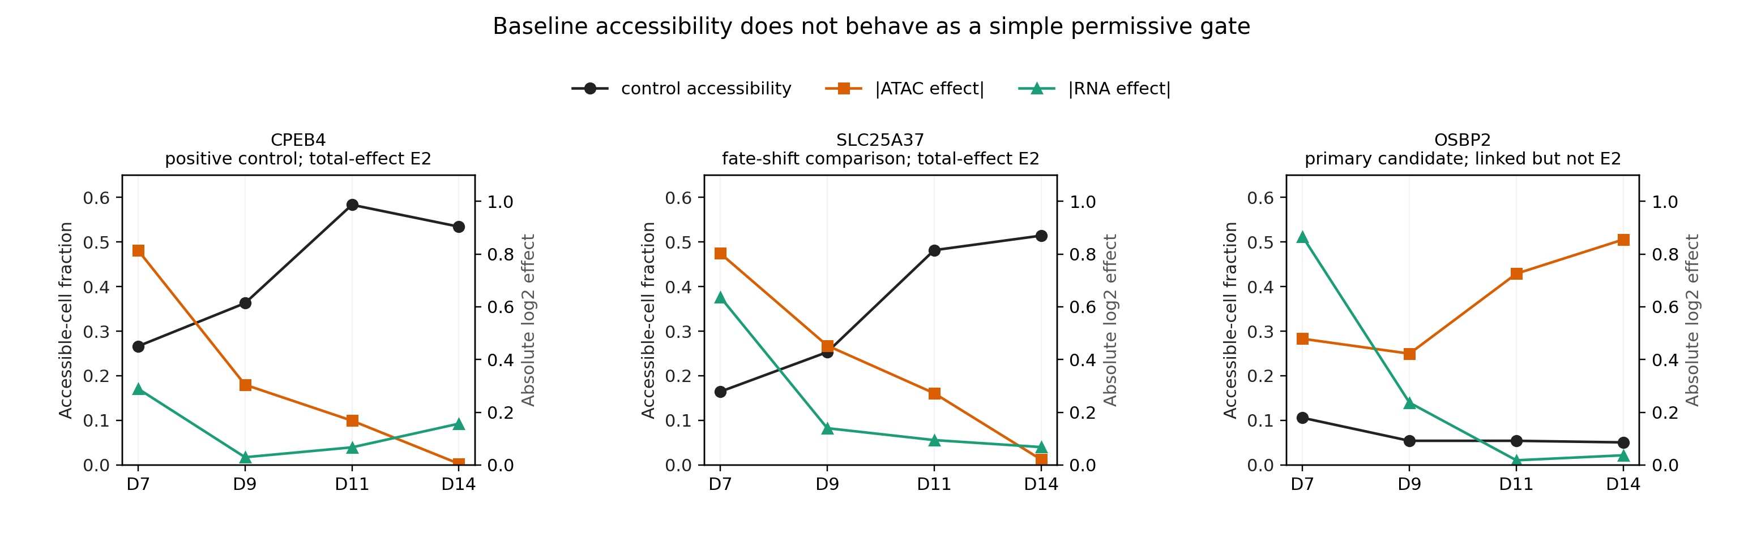
None of the 11 E2 peaks remained significant after conditioning on six post-perturbation erythroid states; median absolute-effect attenuation was 41.6%. The known CPEB4 positive control also failed this stringent analysis. Because post-treatment state may mediate the effect, state adjustment can remove biologically real developmental mechanisms and can introduce selection bias. The defensible conclusion was therefore that four edges had total intervention-supported chromatin effects, but no candidate had demonstrated a state-robust direct chromatin gate.
Together, these findings suggested an establishment-versus-maintenance model. Early GATA1 activity may help establish an erythroid accessibility programme; after the locus is broadly open, redundant factors, chromatin memory or the stable differentiated state may reduce the acute marginal dependence on GATA1. This model generated a prospective external prediction: E2 peaks should become accessible before, or earlier than, the major induction of their linked targets during independent erythroid differentiation.

Independent differentiation data support chromatin establishment before target activation
We first evaluated the frozen Chapter-3 peaks in the Ranzoni fetal human haematopoiesis atlas [12]. The official processed dataset contained 4,504 RNA cells and 3,611 ATAC cells; the modalities were unpaired. Primary non-cycling comparisons were HSC–MPP→MEMP→erythroid cells for RNA and MPP→common-progenitor (Comm-Prog) for ATAC. Four of 11 E2 peaks and five of ten linked non-E2 peaks directly overlapped the independently called fetal ATAC peak set. None of the four mapped E2 peaks reached the prespecified MPP-to-Comm-Prog accessibility threshold. However, mean GATA1 chromVAR activity rose from −0.300 in MPP to 1.418 in Comm-Prog (standardized effect 1.005; batch-stratified bootstrap 95% CI 0.794–1.219), and ALAS2, SLC25A37 and SPTA1 showed strong delayed RNA induction in erythroid cells. Because the ATAC sample did not include an annotated mature erythroid state, we interpreted 0/4 as a coverage-limited non-replication rather than evidence for temporal ordering.
We therefore applied the frozen temporal rule to the Ludwig adult human CD34+ terminal erythroid time course [13]. This dataset contains 28 paired bulk RNA/ATAC libraries spanning eight sorted populations from two or three healthy adult donors: P1 MyP, P2 CFU-E, P3 ProE1, P4 ProE2, P5 BasoE, P6 PolyE, P7 OrthoE and P8 Orth/Ret. Chapter-3 GRCh38 peaks were lifted to hg19, the genome build used by Ludwig and colleagues, and only direct overlaps with independently called ATAC peaks were retained. All 21 frozen E2 and linked non-E2 peaks lifted successfully and overlapped an external peak.
For each feature, activation was defined before inspecting the profiles as the first post-P1 population reaching 50% of the increase from P1 to the maximum. Both ATAC and RNA required a dynamic range of at least 1.0 log2 CPM. A peak passed when ATAC activation preceded RNA activation by at least one population and this lead occurred in at least 80% of 1,000 within-population bootstrap draws.
Eight of 11 E2 peaks passed, compared with 0 of 10 linked non-E2 peaks (peak-level Fisher's exact P=0.00103). Because peaks linked to the same target are not independent, the primary enrichment test used edges: three of four E2 edges passed versus zero of six linked non-E2 comparison edges (Fisher's exact P=0.0333; Figure 4).
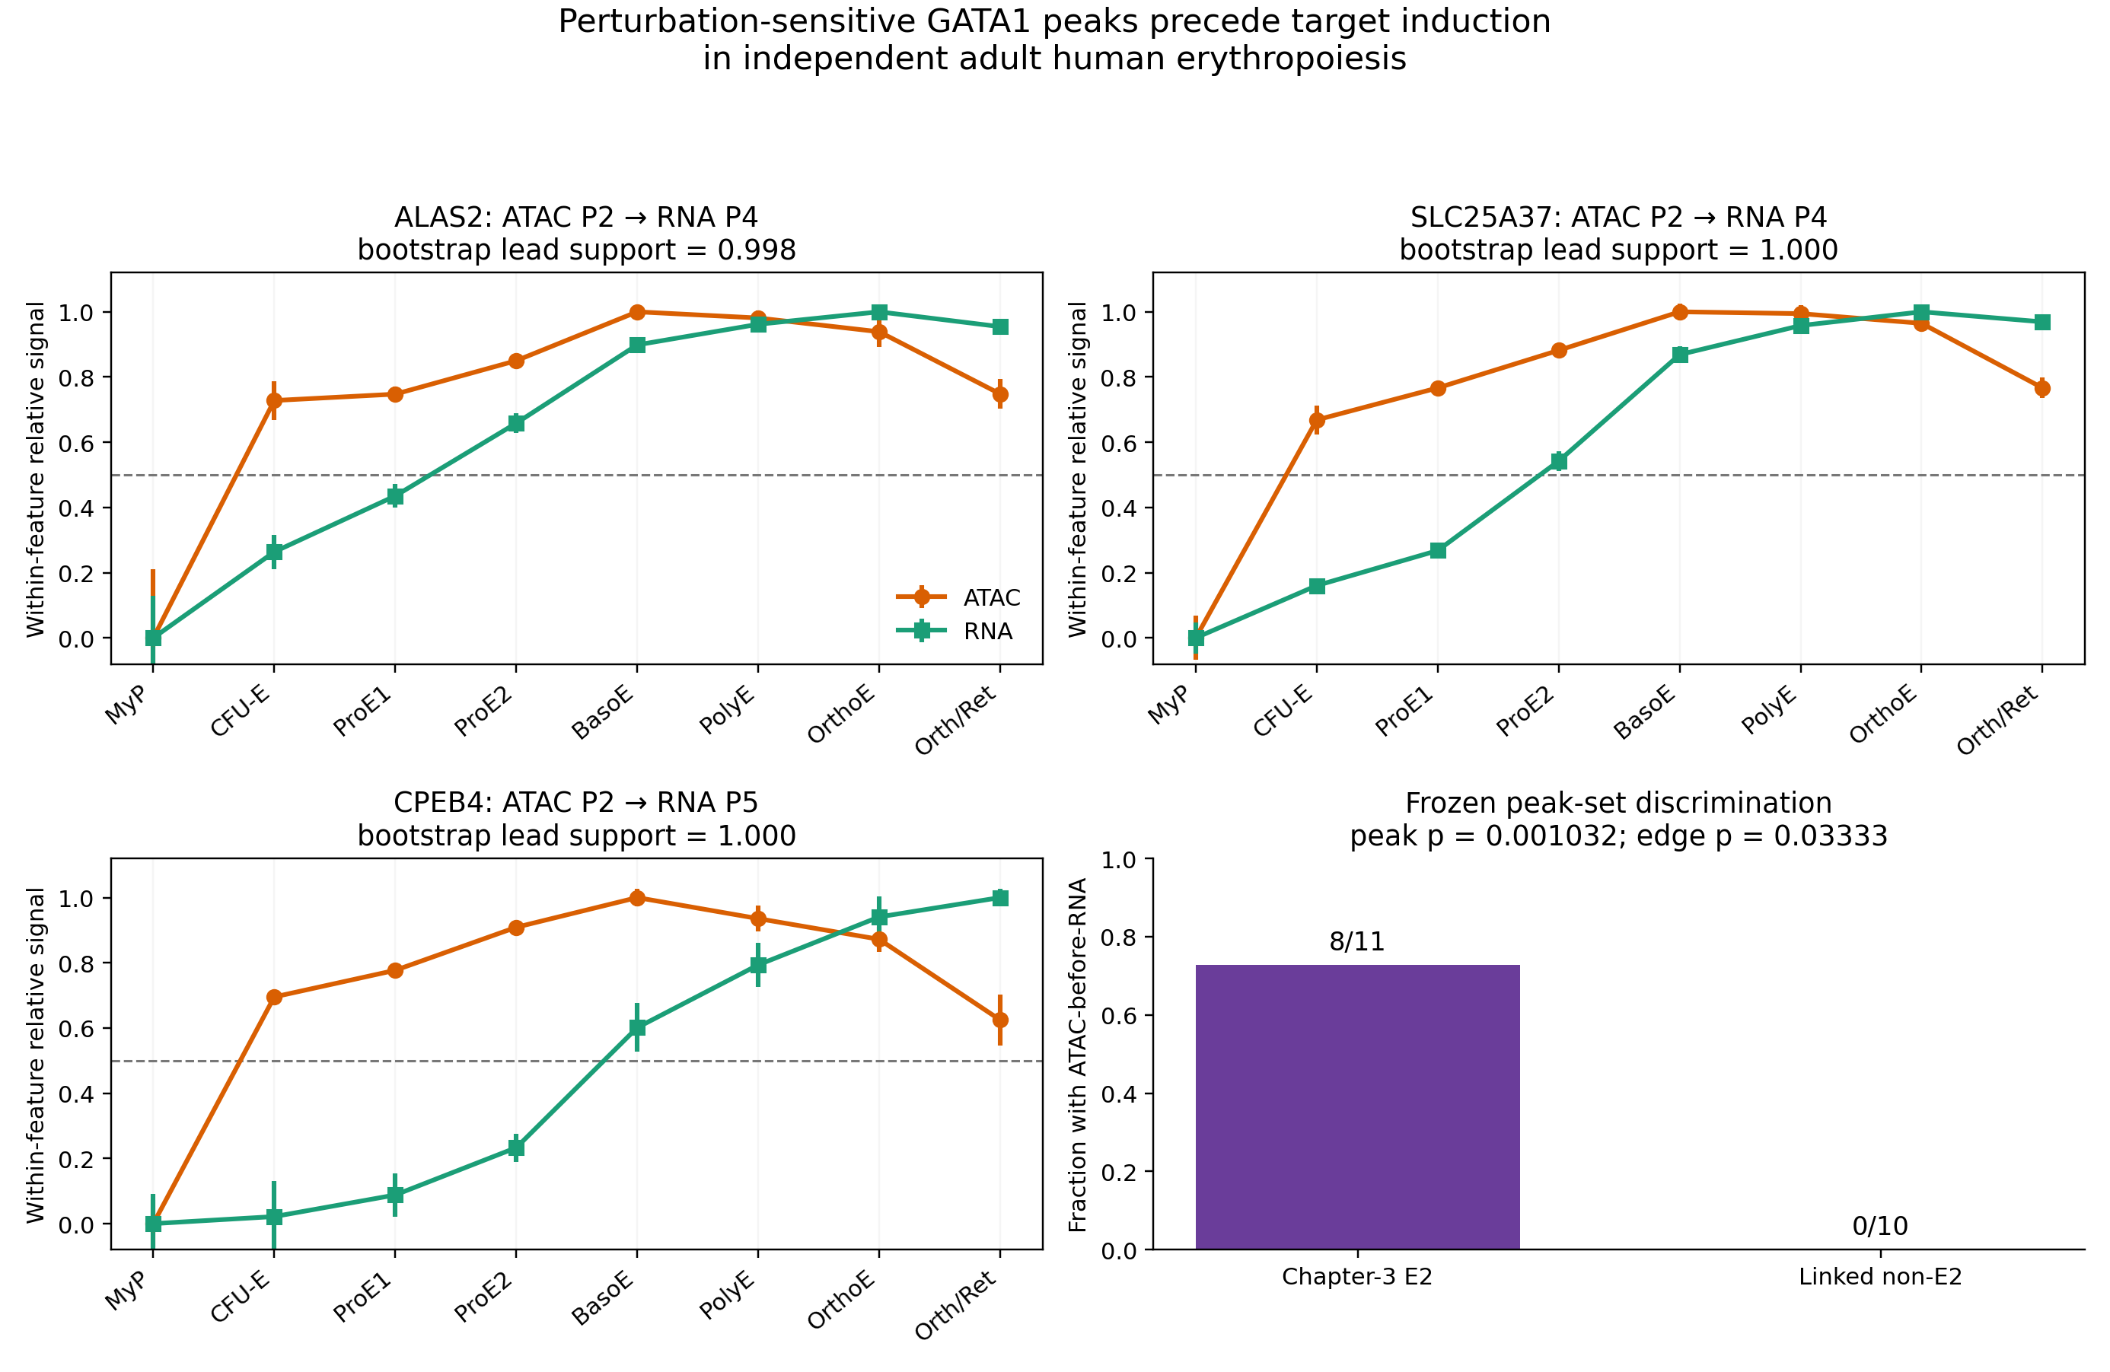
The GATA1→ALAS2 E2 peak activated at P2 (CFU-E), whereas ALAS2 RNA reached its midpoint at P4 (ProE2; bootstrap lead support 0.998). Four of five GATA1→SLC25A37 peaks activated at P2–P3 before the P4 RNA midpoint (support 0.998–1.000); the fifth peak was a genuine exception and opened at P5. All three GATA1→CPEB4 E2 peaks activated at P2, three stages before the P5 RNA midpoint (support 1.000). GATA1→SPTA1 was a near miss: both E2 peaks had the expected P2 ATAC and P3 RNA point estimate, but bootstrap support of 0.717 and 0.742 did not meet the frozen 0.80 threshold.
The linked non-E2 peaks failed for informative reasons. OSBP2 and one CPEB4 comparison peak lacked sufficient accessibility dynamics. The linked non-E2 ALAS2 peak opened at the same stage as RNA, and non-E2 SPTA1 and SLC25A37 peaks opened at or after the RNA midpoint. Thus, temporal ordering was not a generic property of nearby accessible or expression-linked peaks; it preferentially marked the elements that had joined the complete perturbational E2 evidence chain.

Discussion
This study began with a simple question: when does an observational regulatory edge become causal? The answer was not a single score. Causal credibility was concentrated in the extreme top of one observational ranking, sparse under strict terminal-state intervention, dependent on developmental context, and mechanistically strongest during chromatin establishment. These layers identify distinct reasons why an edge can be present in observational single-cell data yet fail under intervention.
First, network rank mattered, but the inference method mattered as much as the rank. The top 1% of residualized associations was enriched 2.44-fold for intervention support, whereas GRNBoost2 was indistinguishable from a matched null. This does not imply that residualized correlation is generally superior to tree-based inference. The result is specific to this cell population, TF panel, covariate structure and validation target. It does show that algorithmic importance is not equivalent to intervention credibility, and that averaging an informative and an uninformative ranking can reduce rather than improve the signal. Evaluating GRNs only by agreement with other observational methods would have missed this distinction.
Second, cell-state dependence had at least two separable components. Some perturbation effects genuinely varied across matched erythroid states, but many time-dependent edges coincided with TF-induced displacement along the differentiation axis. The latter is not merely a technical confounder. If a TF controls differentiation, then changing state occupancy is part of its total biological effect. However, it changes the meaning of the edge. An atlas-level TF→target response may reflect a developmental programme that becomes weak in a terminal state, rather than a direct cell-intrinsic regulatory interaction that is switched on or off by local chromatin. The distinction is essential for predictive models intended to simulate perturbations in a specified starting state.
Third, paired chromatin data rejected the intuitive but incomplete proposition that an edge becomes causal simply when its regulatory element is open. The 11 E2 peaks showed the opposite relationship: dependence on GATA1 was greatest when baseline accessibility was lowest, and the marginal ATAC and RNA effects declined as the elements opened. ATAC and RNA responses remained tightly coupled, arguing that the effect was molecularly coherent even though it was not stronger in the open state. We therefore propose that the relevant distinction is between establishment and maintenance. A TF can be necessary to establish a regulatory state without remaining the sole factor required to maintain it.
The independent adult erythroid time course supplied the most important test of this interpretation. E2 peaks were not selected from the external data, and the thresholds, coordinate mapping and comparison set were frozen before their profiles were inspected. Eight of 11 E2 peaks, but none of ten linked non-E2 peaks, showed accessibility activation before target induction. The separation remained significant at the edge level, which reduces the dependence among multiple peaks assigned to one gene. The results therefore transport the temporal signature, not merely the presence of accessible chromatin, across a different experiment, donor structure, genome build and assay resolution.
The fetal atlas result provides an equally useful caution. Global GATA1 motif activity increased strongly and late target induction was visible in RNA, yet the sampled ATAC states ended too early to capture the predicted terminal locus dynamics. A dataset can be biologically relevant but structurally unable to test a specific temporal hypothesis. Treating absence of replication as evidence against the mechanism without auditing state coverage would have been misleading.
Several limitations constrain the conclusions. The primary Perturb-multiome libraries are not documented as independent donors, so FDR values describe within-screen evidence rather than population-level donor replication. Guide efficacy varied substantially; strict E1 analysis could test only TFs with at least two effective guides, and all strict hits were NFE2 edges. The source study used single-cell genotyping because transcript abundance is not a reliable proxy for editing; the present re-analysis used public guide and author-QC annotations and did not recreate the complete genotype model. The E2 analysis was targeted to eight candidates and cannot estimate the genome-wide prevalence of establishment-type edges. Peak–gene correlation and motif occurrence do not prove physical enhancer–promoter contact or TF binding. Conditioning on post-perturbation state can attenuate a mediated causal effect or induce collider bias, so the absence of state-robust E2 peaks does not prove that all 11 total effects are indirect. Finally, the adult external validation was stage-resolved bulk data. It provides donor and terminal-stage coverage but cannot test cell-level co-variation.
These limitations also define the next experiments. CUT&RUN or CUT&Tag for GATA1 across early erythroid stages would test occupancy at the 11 E2 peaks. Targeted CRISPRi or base editing of individual elements could separate local enhancer dependence from TF-induced fate shifts. Paired time-resolved perturbation with lineage tracing would help distinguish changes in state transition rates from within-state molecular responses. Applying the frozen framework to non-erythroid lineages will determine whether establishment-before- maintenance is a general property or a feature of erythroid regulatory programmes.
In summary, an observational edge does not become causal merely because it is stable, highly ranked or located in open chromatin. It gains causal credibility when the TF perturbation changes the target in a defined context, a specific cis-regulatory element joins the RNA and chromatin evidence chain, and the mechanistic temporal signature transports to independent differentiation. For the GATA1 edges identified here, dependence is greatest during the establishment of the erythroid chromatin programme and attenuates during maintenance. This provides a biologically interpretable answer to why regulatory relationships learned from one single-cell context do not always survive real intervention.

Methods

Study design and reproducibility safeguards
All analysis thresholds, primary TFs, candidate roles and external validation rules are recorded in config/mvp.yaml. Observational edge discovery used only non-targeting cells. Perturbed cells were introduced after rankings and candidate sets were fixed. Chapter-specific outputs were generated by command- line modules in the edge_causality Python package. The project-wide random seed was 20260820. At the time of this draft, 37 unit tests covered barcode handling, residualization, perturbation scoring, interaction models, peak mapping, motif support and external temporal validation.

Perturb-multiome data and cell selection
Processed 10x HDF5 matrices and author metadata for GSE274113 were used. Blank interleaved rows in the metadata file were removed explicitly. Each author-QC barcode was required to occur in its stated HDF5 library, and RNA feature order was checked across all 14 libraries. Day-14 late erythroid cells were defined by the authors' polychromatic and orthochromatic erythroblast labels. NT_1, NT_2 and NT_3 cells formed the discovery controls. AAVS1_1, AAVS1_2 and AAVS1_3 were the intervention reference guides.

Cross-fitted guide perturbation scores
RNA counts were library-normalized. Cells carrying AAVS1_1 were used as a reference population, and local control profiles were obtained from nearest neighbours in a 30-component PCA representation of 2,000 variable genes. For a held-out guide, a 100-gene perturbation signature was learned from cells carrying the other guides targeting the same TF. The held-out cells were projected onto that signature and standardized relative to control-guide cells. Guide significance, direction consistency and the control-guide null distribution were used to define effective guides before E1 analysis.

Controls-only observational networks
Genes were required to have detection fraction ≥0.05 and mean CPM ≥1, and mitochondrial-prefix genes were excluded. For each TF–target pair, log-normalized expression was residualized against log library depth, library indicators and late erythroid state. Pearson correlation between TF and target residuals defined the signed association. One hundred bootstraps sampled cells within library and state strata. Stable E0 edges occurred in the top 5% of a TF-specific absolute-association ranking in at least 70% of bootstraps.
GRNBoost2 was run on the same controls-only expression universe. Rankings were retained separately because their intervention calibration differed. For descriptive overlap, residualized E0 edges were annotated by occurrence in the GRNBoost2 top 1%, 5% and 10%.

Calibration against published intervention responses
The authors' Table S3 TF-sensitive gene sheet was restricted to the six primary TFs and joined to the 43,740-edge observational universe by TF and gene symbol. Published support required a reported response and, for the primary truth label, |log2 fold-change|≥0.25. Directional concordance accounted for the orientation of the source perturbation score: a positive observational edge was expected to decrease as loss of TF function increased.
AUROC and AUPRC were calculated over the complete ranking. For top-k enrichment, selected edges were compared with 1,000 null samples matched by TF, target mean-expression decile and detection-fraction decile. The empirical one-sided P value was
[ P_{emp}=\frac{1+\sum_{b=1}^{B}I(r_b\ge r_{obs})}{B+1}, ]
where (r_{obs}) is the selected-edge support rate and (r_b) is the rate in null draw (b).

Strict late-erythroid E1 validation
RNA counts were aggregated by guide, library and late erythroid state. Features were converted to log2(CPM+0.5). For each TF, a weighted least-squares model included an intercept, targeting-guide condition, library and cell-state indicators; weights were proportional to pseudobulk cell count and scaled to a median of one. The condition coefficient estimated the pooled perturbation effect. Guide-specific effects compared each guide with AAVS1 controls in the same library and state. Leave-one-guide-out models were refitted after omitting each effective guide. P values were adjusted by the Benjamini–Hochberg method [15]. E1 required FDR<0.05, |effect|≥0.25, at least two effective guides, complete guide-direction agreement, and complete leave-one-guide-out direction agreement.

Perturbation-by-collection-time analysis
All-timepoint RNA counts were aggregated by guide and library, retaining pseudobulks with at least 15 cells. For each TF, the full weighted least-squares model contained perturbation, library and perturbation interactions with days 9, 11 and 14; day 7 was the reference. A reduced model omitted the interaction terms. A joint F test compared models, and interaction P values were adjusted across E0 edges. Time-specific contrasts estimated effects at each collection time. The frozen shape classifier used effect magnitude, effect range and guide-direction consistency to label gated, reversed, amplified, constitutive, unstable or other patterns.

Controls-defined differentiation-axis diagnostic
The differentiation score was trained exclusively on NT_1/2/3 pseudobulks. The 2,000 most variable eligible genes were standardized and represented with ten principal components. Ridge regression predicted numeric collection day. Model performance was evaluated with leave-one-library-out cross-validation, after which a final model projected all targeting and control pseudobulks. Within each library and timepoint, each targeting guide was compared with AAVS1 guides. A TF shift required an interaction FDR<0.05, a timepoint effect FDR<0.05, magnitude above the 95th-percentile absolute control-guide shift and at least two direction-consistent guides. An edge was called fate-shift-associated when its strongest timepoint coincided with a supported shift of its TF.

Within-erythroid-state interaction analysis
RNA counts for the 419 genes represented by E0 edges were aggregated by guide, library and author erythroid state. BFU-E was excluded from modelling because no AAVS1 pseudobulk passed the 15-cell minimum. The model included perturbation, library, state and perturbation-by-state interactions across CFU-E, proerythroblast, basophilic, polychromatic and orthochromatic erythroblast states. Because state was observed after perturbation, results were interpreted as persistence diagnostics and not substituted for the collection-time total effect.

Targeted paired RNA/ATAC candidate construction
Eight edges and their roles were frozen before local peak results were inspected. For each target, ATAC peaks within ±50 kb of the GRCh38 TSS were collected from all 14 libraries and merged into consensus intervals. Only author-QC GATA1, NFE2 and control cells were retained. Library-specific presence was tracked for each consensus peak so comparisons were restricted to libraries in which a source peak was observed.
For controls-only peak–gene links, gene and peak values were normalized for RNA and ATAC depth, respectively. Both were residualized against depth, library and author cell type. Pearson correlation, BH FDR and 200 library-stratified bootstraps were used to apply the frozen link rule. ATAC perturbation effects were estimated in guide × library pseudobulks using the collection-time interaction framework; at least two guide-consistent directions were required. The target-RNA effect was estimated from the same TF and timepoint.

Motif analysis and E2 definitions
GRCh38 peak sequences were retrieved through Ensembl resources. Both strands were scanned using JASPAR 2024 GATA1 MA0035.5 and NFE2 MA0841.2 matrices [14]. A relative score ≥0.85 denoted motif support. A total-effect E2 peak required a passing controls-only link, a passing TF perturbation effect on accessibility, a directionally compatible target-RNA response of at least 0.25 at the strongest ATAC timepoint, and motif support. A state-robust E2 peak additionally required the ATAC effect to remain significant after adjustment for six post-perturbation erythroid states.

Fetal external validation
Processed RNA and ATAC data were obtained from the official repository of Ranzoni et al. [12]. RNA used the authors' annotated PAGA object, including the stored diffusion pseudotime [16,17]. Primary RNA states were HSC–MPP, MEMP and erythroid cells; primary ATAC states were label-transferred MPP and Comm-Prog. Cycling states were reserved for sensitivity analysis. Only direct overlap of GRCh38 intervals was considered primary mapping. Per-peak ATAC profiles were standardized across MPP and Comm-Prog cells; establishment required a committed minus early standardized effect ≥0.25 and a batch-stratified bootstrap 95% CI above zero. Target RNA was summarized as sample × state pseudobulk CPM. Delayed induction required late-versus-committed log2 fold-change ≥0.5, no more than 50% of the early-to-late dynamic range reached at commitment, and a sample-bootstrap CI above zero. GATA1 chromVAR activity was analysed as global context, not edge-specific evidence.

Adult terminal erythroid external validation
Processed ATAC peaks and counts were downloaded from GSE115672 and RNA counts from GSE115678 [13]. Sample names encoded donor, population and replicate. Frozen GRCh38 intervals were mapped to hg19 with the UCSC hg38-to-hg19 chain; both interval endpoints had to map compatibly, and a direct overlap with a Ludwig ATAC peak was required. Counts were converted to log2(CPM+0.5).
Population means followed P1–P8. For ATAC or RNA, activation was the earliest post-P1 population reaching 50% of the feature's increase from P1 to its maximum, conditional on ≥1.0 log2-CPM dynamic range. Within each population, libraries were resampled with replacement 1,000 times. A peak passed when ATAC activation preceded RNA by at least one population in the point estimate and in ≥80% of bootstrap draws. An edge passed if any frozen E2 peak passed. Fisher's exact tests compared E2 and linked non-E2 sets; the edge-level test was primary because multiple peaks assigned to one target are dependent.

Data and code availability
All analysis code, frozen configuration, unit tests, compact result tables and figures are provided in the accompanying GitHub repository. Raw GSE274113 10x matrices are not redistributed. The repository documents source accessions and expected paths for GSE274113, E-MTAB-9067/E-MTAB-9068, GSE115672 and GSE115678. The official Perturb-multiome and Ranzoni analysis repositories are linked in the data manifest. A permanent archival DOI should be generated before submission.

Acknowledgements
This independent computational re-analysis used public datasets generated by the Martin-Rufino, Ranzoni and Ludwig studies. The author thanks the original study participants, experimental teams and data maintainers. Additional scientific and supervisory acknowledgements should be confirmed before submission.

Author contributions
Y.T. conceived the re-analysis, implemented the computational workflow, analysed the data, interpreted the results and drafted the manuscript. This statement should be revised if collaborators contribute to subsequent versions.

Competing interests
The author declares no competing interests.

References
- Aibar, S. et al. SCENIC: single-cell regulatory network inference and clustering. Nature Methods 14, 1083–1086 (2017). https://doi.org/10.1038/nmeth.4463
- Moerman, T. et al. GRNBoost2 and Arboreto: efficient and scalable inference of gene regulatory networks. Bioinformatics 35, 2159–2161 (2019). https://doi.org/10.1093/bioinformatics/bty916
- Huynh-Thu, V. A., Irrthum, A., Wehenkel, L. & Geurts, P. Inferring regulatory networks from expression data using tree-based methods. PLoS ONE 5, e12776 (2010). https://doi.org/10.1371/journal.pone.0012776
- Bravo González-Blas, C. et al. SCENIC+: single-cell multiomic inference of enhancers and gene regulatory networks. Nature Methods 20, 1355–1367 (2023). https://doi.org/10.1038/s41592-023-01938-4
- Wang, L. et al. Dictys: dynamic gene regulatory network dissects developmental continuum with single-cell multiomics. Nature Methods 20, 1368–1378 (2023). https://doi.org/10.1038/s41592-023-01971-3
- Dixit, A. et al. Perturb-Seq: dissecting molecular circuits with scalable single-cell RNA profiling of pooled genetic screens. Cell 167, 1853–1866.e17 (2016). https://doi.org/10.1016/j.cell.2016.11.038
- Adamson, B. et al. A multiplexed single-cell CRISPR screening platform enables systematic dissection of the unfolded protein response. Cell 167, 1867–1882.e21 (2016). https://doi.org/10.1016/j.cell.2016.11.048
- Replogle, J. M. et al. Combinatorial single-cell CRISPR screens by direct guide RNA capture and targeted sequencing. Nature Biotechnology 38, 954–961 (2020). https://doi.org/10.1038/s41587-020-0470-y
- Rubin, A. J. et al. Coupled single-cell CRISPR screening and epigenomic profiling reveals causal gene regulatory networks. Cell 176, 361–376.e17 (2019). https://doi.org/10.1016/j.cell.2018.11.022
- Schep, A. N., Wu, B., Buenrostro, J. D. & Greenleaf, W. J. chromVAR: inferring transcription-factor-associated accessibility from single-cell epigenomic data. Nature Methods 14, 975–978 (2017). https://doi.org/10.1038/nmeth.4401
- Martin-Rufino, J. D. et al. Transcription factor networks disproportionately enrich for heritability of blood cell phenotypes. Science (2025). https://doi.org/10.1126/science.ads7951
- Ranzoni, A. M. et al. Integrative single-cell RNA-seq and ATAC-seq analysis of human developmental hematopoiesis. Cell Stem Cell 28, 472–487.e7 (2021). https://doi.org/10.1016/j.stem.2020.11.015
- Ludwig, L. S. et al. Transcriptional states and chromatin accessibility underlying human erythropoiesis. Cell Reports 27, 3228–3240.e7 (2019). https://doi.org/10.1016/j.celrep.2019.05.046
- Rauluseviciute, I. et al. JASPAR 2024: 20th anniversary of the open-access database of transcription factor binding profiles. Nucleic Acids Research 52, D174–D182 (2024). https://doi.org/10.1093/nar/gkad1059
- Benjamini, Y. & Hochberg, Y. Controlling the false discovery rate: a practical and powerful approach to multiple testing. Journal of the Royal Statistical Society Series B 57, 289–300 (1995). https://doi.org/10.1111/j.2517-6161.1995.tb02031.x
- Wolf, F. A., Angerer, P. & Theis, F. J. SCANPY: large-scale single-cell gene expression data analysis. Genome Biology 19, 15 (2018). https://doi.org/10.1186/s13059-017-1382-0
- Wolf, F. A. et al. PAGA: graph abstraction reconciles clustering with trajectory inference through a topology preserving map of single cells. Genome Biology 20, 59 (2019). https://doi.org/10.1186/s13059-019-1663-x

Figure legends
Figure 1 | Staged study design. Observational TF–target edges were inferred from non-targeting cells, challenged with CRISPR intervention, stratified by collection time and erythroid state, connected to local chromatin elements, and then evaluated for temporal transport in independent differentiation data. Numbers summarize the principal evidence retained at each stage and should not be interpreted as a single entity-level attrition funnel.
Figure 2 | Observational confidence, strict intervention support, and developmental context. (A) Matched-null enrichment for effect-size-qualified published intervention support among the top 1% of each observational ranking. (B) Fraction of stable E0 edges with perturbation-by-collection-time interaction FDR<0.05 for each TF. (C) Number of strict late-erythroid E1 edges and the subset directionally concordant with TF loss. (D) Time-dependent E0 edges separated by whether the strongest effect coincided with a supported perturbation-induced shift along the controls-defined differentiation axis.
Figure 3 | Baseline accessibility does not behave as a simple permissive gate. Control accessibility and absolute GATA1 perturbation effects on ATAC and RNA are shown across days 7–14 for the CPEB4 positive-control E2 peak, a SLC25A37 E2 peak, and the linked but non-E2 OSBP2 peak. Across E2 peaks, accessibility increased as marginal perturbation effects attenuated.
Figure 4 | Perturbation-sensitive GATA1 peaks precede target induction in independent adult erythropoiesis. Within-feature normalized ATAC and RNA trajectories are shown across eight sorted populations for representative ALAS2, SLC25A37 and CPEB4 E2 peaks. Dashed lines denote the prespecified 50% activation threshold. The final panel compares the proportion of frozen E2 and linked non-E2 peaks showing reproducible ATAC-before-RNA ordering.

