Sample Size and Statistical Power
Discrete choice experiment, full survey — Developing Gender-Responsive Childcare Services in Uasin Gishu County Markets

1. Recommendation
The full survey should complete 300 trader interviews across the six sampled markets. Each respondent answers six choice tasks, giving 1,800 choice observations. This sample estimates the choice model with standard errors between 0.060 and 0.101 on the fourteen attribute parameters, detects utility differences of 0.23 at 80% power, and holds the 95% confidence interval on descriptive proportions to ±5.7 percentage points. Three independent methods set the minimum at 159 to 170 respondents; 300 provides the margin needed to model women traders as a separate stratum.

2. Basis of the calculation
The calculation is specific to the experimental design that will be fielded, not to a generic choice experiment. That design has the following structure:
Design feature | Specification
Attributes | Seven: daily cost, location within the market, opening hours, caregiver ratio and training, food provision, management model, and disability inclusion
Levels | 4, 3, 2, 3, 2, 4 and 3 respectively
Alternatives per task | Two unlabelled services plus an opt-out (“I would keep my current arrangement”)
Choice sets | 18, allocated to three blocks of six
Tasks per respondent | Six (one block)
Parameters estimated | 15 — fourteen dummy-coded attribute contrasts and one alternative-specific constant for the opt-out
Criterion | D-efficient, generated by coordinate exchange under null priors

The model is a conditional (multinomial) logit. Because priors are null, the three alternatives are equiprobable and the information matrix is exact rather than approximated, so the calculation below requires no simulation.

3. Design-based calculation
For the multinomial logit model, the asymptotic variance–covariance matrix of the parameter estimates is a function of the design (Rose and Bliemer, 2013; de Bekker-Grob et al., 2015):
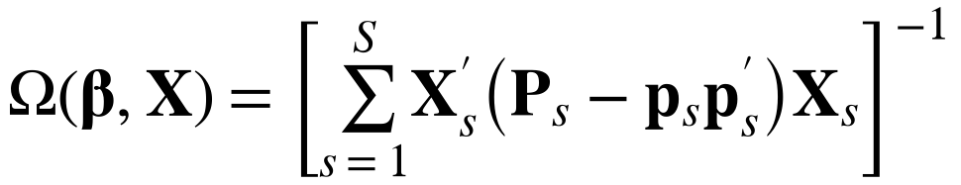
where X_{s} is the attribute matrix for choice set s, p_{s} the vector of choice probabilities and P_{s} = diag(p_{s}). With N respondents allocated equally across the B = 3 blocks:
Power for the null hypothesis β_{k} = 0 against a two-sided alternative at significance level α is:
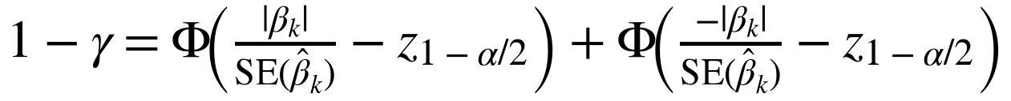
and the minimum detectable effect is:
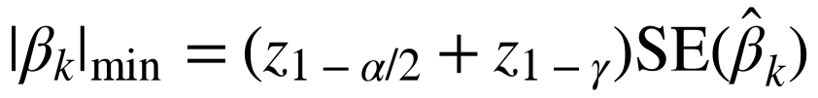
Applying this to the fielded design gives the following:
Completed interviews | Standard error, attribute parameters | Minimum detectable effect at 80% power | 95% CI half-width, proportions
150 | 0.085 – 0.209 | 0.24 – 0.58 | ±8.0 points
200 | 0.074 – 0.181 | 0.21 – 0.51 | ±6.9 points
300 | 0.060 – 0.148 | 0.17 – 0.41 | ±5.7 points
400 | 0.052 – 0.128 | 0.15 – 0.36 | ±4.9 points

At N = 300 the median standard error across the attribute parameters is 0.083 and the opt-out constant is estimated at 0.148. Power is 0.86 for a coefficient of β = 0.25, equivalent to an odds ratio of 1.28, and 0.95 for β = 0.30. The minimum detectable effect is β = 0.23 at 80% power and 0.27 at 90%.
Utility coefficient | Odds ratio | Choice share against an indifferent alternative | Power at N = 300
0.15 | 1.16 | 54 : 46 | 0.44
0.20 | 1.22 | 55 : 45 | 0.68
0.25 | 1.28 | 56 : 44 | 0.86
0.30 | 1.35 | 57 : 43 | 0.95
0.40 | 1.49 | 60 : 40 | > 0.99

4. Rule-of-thumb check
The Johnson and Orme criterion for choice experiments (Orme, 1998; Johnson and Orme, 2003) requires:
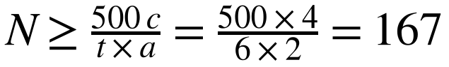
where c = 4 is the largest number of levels on any attribute (cost and management model), t = 6 the number of tasks and a = 2 the number of service alternatives per task.

5. G*Power cross-check
G*Power implements no procedure for discrete choice experiments. There is no conditional-logit option in the program and the model in section 3 cannot be specified in it. The cross-check below therefore reframes the question at the level of the individual choice observation, as a one-sample test of a binomial proportion against 0.50 — the marginal form of a single attribute contrast. It corroborates section 3; it does not replace it.
G*Power field | Entry
Test family | Exact
Statistical test | Proportion: difference from constant (binomial test, one sample)
Type of power analysis | A priori — compute required sample size
Tail(s) | Two
Effect size g | 0.06
α err prob | 0.05
Power (1 − β err prob) | 0.80
Constant proportion | 0.50

Under the normal approximation this test uses:
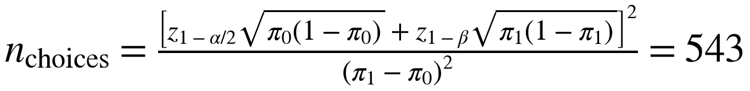
The six observations from each respondent are not independent, so this figure is inflated by a design effect, where m = 6 is the number of tasks per respondent and ρ the intra-respondent correlation:
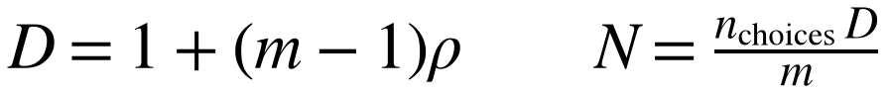
Intra-respondent correlation ρ | Design effect D | Effective choice observations | Respondents required
0.05 | 1.25 | 679 | 114
0.10 | 1.50 | 815 | 136
0.15 | 1.75 | 951 | 159
0.20 | 2.00 | 1,086 | 181

An intra-respondent correlation of 0.15 is the working assumption, giving 159 respondents.

6. Convergence of the three methods
Method | Minimum respondents | Power at N = 300
Design-based (section 3) | ≈ 170 | 0.86 at β = 0.25
Johnson and Orme (section 4) | 167 | Not a power calculation
G*Power cross-check (section 5) | 159 | 0.97

The three converge on 159 to 170. The G*Power route returns higher power at N = 300 than the design-based calculation because it evaluates a single marginal contrast, whereas section 3 accounts for estimating fifteen parameters simultaneously from a specific design. The design-based figure is the conservative one and is the figure reported.

7. Descriptive precision
For prevalence outcomes such as the share of traders who would use the service:
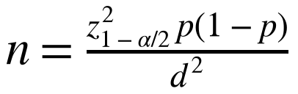
At N = 300 with p = 0.5 this gives d = ±5.7 percentage points. Within a 167-respondent stratum it widens to ±7.6 points.

8. Sample allocation
Parameter | Value | Basis
Completed interviews | 300 | 50 per market across six markets
Traders approached | 360 | Allows 15% for refusal and for screen-out at B12 and B13
Women | 200 minimum | Keeps the primary population separately modellable
Men | 100 | Described and compared descriptively, not modelled separately
Purposive disability sample | 40 – 60 | Recruited through organisations of persons with disabilities, additional to the 300
Choice observations | 1,800 | 300 respondents × 6 tasks

9. Assumptions and limitations
Null priors. The calculation assumes no prior knowledge of the coefficients, which is conservative. Priors estimated from the pilot would reduce the variance estimates, so the figures above understate the precision the full survey will achieve.
Corrected design. The figures apply to the eighteen-card design with randomised presentation order. They do not apply to the design used in the pilot, in which the cheaper alternative appeared in the first position on nine of twelve cards; price and position were confounded there to the point that the cost coefficient reversed sign when a position term was added, and no willingness-to-pay estimate could be reported.
One stratum, not two. A sample of 300 supports separate estimation for women traders but not simultaneously for men. A properly powered comparison of men and women requires approximately 167 in each group, implying a total of about 400 under a sex quota.
Purposive recruitment for disability. Traders with disabilities, and traders caring for children with disabilities, will not reach an analysable number through incidental capture at this sample size. If the inclusion objective is to be modelled rather than described, the purposive sample in section 8 is required.

References
de Bekker-Grob, E. W., Donkers, B., Jonker, M. F. and Stolk, E. A. (2015). Sample size requirements for discrete-choice experiments in healthcare: a practical guide. The Patient, 8(5), 373–384.
Faul, F., Erdfelder, E., Lang, A.-G. and Buchner, A. (2007). G*Power 3: a flexible statistical power analysis program for the social, behavioral, and biomedical sciences. Behavior Research Methods, 39(2), 175–191.
Johnson, R. and Orme, B. (2003). Getting the most from CBC. Sawtooth Software Research Paper Series.
Orme, B. (1998). Sample size issues for conjoint analysis studies. Sawtooth Software Research Paper Series.
Rose, J. M. and Bliemer, M. C. J. (2013). Sample size requirements for stated choice experiments. Transportation, 40(5), 1021–1041.

