MARKET STRUCTURE FOR MUD CRABS (Scylla serrata) IN SOUTH
COAST, KENYA

SG25/36064/19

A thesis submitted in partial fulfilment of the requirements for the award of the Master of Science in Fisheries in the Department of Biological Sciences of Pwani University.

August 2026

DECLARATION
I declare that this thesis is my original work and has not been presented for a degree in any other university or for another award.
SIGN___________________________________ DATE_____________
SG25/PU/36064/19

We confirm that the candidate did the work reported in this thesis under our supervision.

SIGN__________________________ DATE___________ _________ Prof. Andrew Wamukota

SIGN__________________________ DATE___________ _________
Dr. David O. Mirera

DEDICATION
I dedicate this work to my God who strengthens me in everything.

ACKNOWLEDGEMENT
I would like to acknowledge the contribution and support of the following people in the preparation of my thesis. Prof. Andrew Wamukota, for his supervisory role and advice. His patience was my support. Dr. Mirera from KMFRI-Mombasa is acknowledged for his intellectual advice and encouragement. I would also like to acknowledge Mr. Benrick Ogutu from the Kenya Fisheries Service (KeFS) for the immense support during the process of data collection and the officials of BMUs (Vanga, Shimoni and Majoreni) for enabling me to carry out data collection in the region. I would also like to thank my beloved husband Dr. Dan Elisha Mugubi, my son Leslie Johnson, and my parents Mr. Joseph Sangura and Ms. Christine Lusaka for being there socially and financially. Much thanks to Pwani University especially the department of Biological Sciences for giving me the opportunity to pursue my masters degree and for the support throughout my study period. Above all, may God bless and give grace to everyone who had a helping hand in my studies.

ABSTRACT
Mud crab (Scylla serrata) fishing supports coastal livelihoods on the South Coast of Kenya, and demand from hotels and export buyers has raised its commercial value. How the market is organised, and how the value of a crab is shared between the people who catch, trade and sell it, has not been documented for Kwale County, so management has had little basis for judging who carries the risk and who captures the return. Guided by the structure-conduct-performance framework, with value-chain and livelihood concepts in a supporting role, this study profiled the actors, examined the functions they perform at each market node, and assessed the constraints and opportunities each category reported.
A cross-sectional survey covered 96 respondents, 65 fishers, 22 middlemen, five hoteliers and four exporters, at Shimoni, Majoreni, Vanga and Msambweni between May 2022 and December 2023, using structured questionnaires, field observation and key-informant interviews. Analysis in IBM SPSS Statistics used valid percentages within actor category and Beach Management Unit, Monte Carlo chi-square tests on 10,000 resamples, Kruskal-Wallis tests for reported prices, and measures of concentration, marketing margin and price dispersion, at the 5% significance level.
The four categories differed in the same direction on almost every measure. Ninety-five of 96 respondents were men, no fisher or middleman had schooling beyond secondary level, and no respondent belonged to a cooperative or self-help group; 12.5% of fishers held a licence against every hotelier and exporter, and 93.8% named a middleman as their main source of credit. Mean monthly income rose from KSh 8,969 among fishers to KSh 90,000 among exporters. All 65 fishers graded on weight alone while 95.5% of middlemen and every hotelier and exporter used four criteria. Mean large-crab prices rose from KSh 604.6/kg for fishers to KSh 945.5 for middlemen, KSh 1,700.0 for exporters and KSh 2,200.0 for hoteliers, H(3) = 55.84, p < .001. First sale was concentrated at every landing site, with a Herfindahl-Hirschman Index of 2,371 overall and 8,580 at Majoreni, and 76.9% of fishers sold to a single buyer. The total gross marketing margin took 60.4% to 72.5% of the final price, and price dispersion fell from a coefficient of variation of 31.8% among fishers to 6.8% among exporters. Constraints followed function: price fluctuation and poor roads for fishers, mortality and missing aggregation facilities for middlemen, seasonality for hoteliers, freight and flight risk for exporters.
Many unorganised sellers face few buyers, the buyer controls both the grading rule and the price, and credit ties the seller to that buyer, so the harvester keeps the smallest share of a price set furthest from the water. Since no costs were collected these are gross margins and not profits. The market is therefore commercially active but institutionally uneven, with grading knowledge, logistics and access to high-value buyers held downstream, and the binding constraint on fisher earnings is the terms of exchange rather than the volume landed.
Five measures follow from these findings. Beach Management Units and county fisheries officers should publish a weekly price register by grade and buyer, and adopt a shared grade sheet using weight and visible shell condition. County government and development partners should prioritise feeder access and shaded live-holding points to cut handling loss. Buyers and lenders should record short written credit terms stating repayment and any exclusivity. Fisheries officers should run licensing and training clinics at the landing site. Further research should follow single consignments through the chain with costs and volumes attached, which is what this survey could not measure.
TABLE OF CONTENTS
LIST OF TABLES
LIST OF FIGURES
LIST OF ABBREVIATIONS
CHAPTER ONE: INTRODUCTION
1.1 Background information
1.2 Statement of the problem
1.3 Objectives of the Study
1.3.1 General Objective
1.3.2 Specific objectives
1.4 Research Questions
1.5 Significance of the study
CHAPTER TWO: LITERATURE REVIEW
2.1 Species biology and Ecological importance
2.2 Mud crab harvesting strategies
2.3 Overview of mud crab fisheries and market structure
2.4 Mud crab fishery actors and their characteristics
2.5 Functions of actors at different market levels
2.6 Business dynamics of the mud crab fishery
2.6.1 Overview of mud crab business dynamics
2.6.2 Grading of mud crabs
2.6.3 Pricing of mud crabs
2.6.4 Transport of mud crabs
2.6.5 Packaging of mud crabs
2.6.6 Modes of payment in the mud crab trade
2.7 Constraints faced by mud crab fishery actors
2.8 Opportunities in the mud crab fishery
2.9 Legal and policy frameworks governing mud crab fishery in Kenya
2.10 Critical Assessment of the Literature
2.10.1 Where the literature agrees
2.10.2 Where the literature conflicts: the role of the middleman
2.10.3 Where the literature conflicts: what grading does
2.10.4 Methodological limitations of previous studies
2.10.5 The South Coast and Kwale County: what is and is not known
2.10.6 The research gap
2.11 Theoretical Framework
2.12 Conceptual Framework
CHAPTER THREE: MATERIALS AND METHODS
3.1 Introduction
3.2 Study site
3.3 Research design
3.4 Target population
3.5 Sample size and sampling procedures
3.6 Non-Response and Sampling Limitations
3.7 Pilot study
3.8 Data collection
3.9 Alignment of objectives and analysis
3.10 Data analysis
3.10.1 Data entry and processing
3.10.2 Chi-square tests of association
3.10.3 Kruskal–Wallis tests of reported prices
3.10.4 Market structure, margin and dispersion measures
3.11 Ethical considerations
CHAPTER FOUR: RESULTS
4.1 Introduction
4.2 Distribution of Respondents
4.3 Objective One: Profile of Mud Crab Actors and Their Characteristics
4.3.1 Demographic and Personal Characteristics
4.3.2 Business and Operational Characteristics
4.3.3 Knowledge, Training and Group Membership
4.3.4 Summary of Objective One
4.3.5 Discussion of Findings in Relation to Previous Studies
4.4 Objective Two: Functions Performed by Actors at Each Market Node
4.4.1 Acquisition of Crabs and Disposal of the Catch
4.4.2 Buyers and Market Channels
4.4.3 Preparation, Packaging and Transport
4.4.4 Grading and Quality Control
4.4.5 Reported Losses
4.4.6 Payment, Price Setting and Sale Location
4.4.7 Trading Relationships and Market Information
4.4.8 Reported Mud Crab Prices
4.4.9 Prices by Study Site
4.4.10 Concentration at the Point of First Sale
4.4.11 Marketing Margins and the Distribution of Value
4.4.12 Price Dispersion and Price Transmission
4.4.13 Summary of Objective Two
4.4.14 Discussion of Findings in Relation to Previous Studies
4.5 Objective Three: Constraints and Opportunities Facing Each Actor Category
4.5.1 Operational and Infrastructure Constraints
4.5.2 Market Access, Operational Challenges and Risk
4.5.3 Regulation and Access to Information
4.5.4 Perceptions of Market Organisation and Policy
4.5.5 Opportunities, Youth Participation and Diversification
4.5.6 Summary of Objective Three
4.5.7 Discussion of Findings in Relation to Previous Studies
4.6 Actor-Specific Associations With BMU
4.7 Chapter Summary
CHAPTER FIVE: DISCUSSION
5.1 Introduction
5.2 Objective One: Profile of Mud Crab Actors
5.2.1 Key Findings
5.2.2 Gender and the Limits of the Sampling Frame
5.2.3 Experience, Licensing and the Absence of Collective Organisation
5.2.4 Credit and Dependence Within the Chain
5.2.5 Implications
5.3 Objective Two: Functions at Each Market Node and the Distribution of Value
5.3.1 Key Findings
5.3.2 Grading as a Mechanism of Value Capture
5.3.3 Handling, Packaging and Loss
5.3.4 Price Formation and the Distribution of Value
5.3.5 Site Differences and What Drives Them
5.3.6 The Hotelier Medium-Grade Anomaly
5.3.7 Implications
5.4 Objective Three: Constraints and Opportunities
5.4.1 Key Findings
5.4.2 Constraints Follow Function
5.4.3 Governance and the Direction Information Travels
5.4.4 Opposing Priorities Within One Transaction
5.4.5 Implications
5.5 Synthesis Using the Structure-Conduct-Performance Framework
5.6 What the Measures Capture and the Limitations of the Study
CHAPTER SIX: CONCLUSIONS AND RECOMMENDATIONS
6.1 Introduction
6.2 Conclusions
6.2.1 Conclusion for Objective One
6.2.2 Conclusion for Objective Two
6.2.3 Conclusion for Objective Three
6.3 Overall Conclusion
6.4 Recommendations
6.4.1 Recommendations From Objective One
6.4.2 Recommendations From Objective Two
6.4.3 Recommendations From Objective Three
6.5 Recommendations for Further Research
REFERENCES
APPENDICES

LIST OF TABLES
Table 1: Alignment of Study Objectives, Variables Measured and Analysis Applied
Table 2: Distribution of Respondents by Actor Category and BMU
Table 3: Age Group of Fishers, Middlemen, Hoteliers and Exporters by BMU
Table 4: Gender of Fishers, Middlemen, Hoteliers and Exporters by BMU
Table 5: Ethnic Group of Fishers, Middlemen, Hoteliers and Exporters by BMU
Table 6: Marital Status of Fishers, Middlemen, Hoteliers and Exporters by BMU
Table 7: Years of Experience of Fishers, Middlemen, Hoteliers and Exporters by BMU
Table 8: Primary Role and Business Ownership of Fishers, Middlemen, Hoteliers and Exporters by BMU
Table 9: Scale of Operation of Fishers, Middlemen, Hoteliers and Exporters by BMU
Table 10: Reported Monthly Income and Age of Respondents by Actor Category
Table 11: Other Income Activities, Operating Licence and Loan Use by Actor and BMU
Table 12: Main Source of Business Credit by Actor and BMU
Table 13: Knowledge Acquisition and Formal Training by Actor and BMU
Table 14: Cooperative Membership, Self-Help Group Participation and Primary Market Supplied by Actor and BMU
Table 15: How Mud Crabs Are Acquired and Source of Crabs for Sale by Actor and BMU
Table 16: Proportion of Catch Sold and Travel Time from Fishing Grounds to Market by Actor and BMU
Table 17: Primary Market Channel and Contact With Final Consumers by Actor and BMU
Table 18: Number of Buyers, State of Crabs Sold and Regularity of the Main Buyer by Actor and BMU
Table 19: Location of Sale and Knowledge of the Onward Sale by Actor and BMU
Table 20: First Buyer Location Reported by Fishers by BMU
Table 21: Second Buyer Location Reported by Fishers by BMU
Table 22: Preparation of Mud Crabs for Market and Preservation by Actor and BMU
Table 23: Grading Practice and Criteria Used to Determine Grade by Actor and BMU
Table 24: Quality Measures Before Market and Use of Formal Quality Control by Actor and BMU
Table 25: Size Label and Grade Assignment for Large Crabs by Actor and BMU
Table 26: Size Label and Grade Assignment for Medium Crabs by Actor and BMU
Table 27: Size Label and Grade Assignment for Small Crabs by Actor and BMU
Table 28: Reported Loss Through Spoilage by Actor and BMU
Table 29: Pricing Mechanism and How Prices Are Set by Actor and BMU
Table 30: Factors Influencing Price Fluctuations by Actor and BMU
Table 31: Tied Depot Owners and Arrangements With Tied Fishers and Traders by Actor and BMU
Table 32: Arrangements Used With Tied Depot Owners by Actor and BMU
Table 33: Tied Fishers, Tied Traders and Trading Agreements by Actor and BMU
Table 34: Role of Intermediaries and Negotiation Terms by Actor and BMU
Table 35: Technology Adoption and Market Research by Actor and BMU
Table 36: Reported Mud Crab Prices by Actor Category and Size Grade
Table 37: Kruskal–Wallis Comparisons of Reported Mud Crab Prices
Table 38: Mean Reported Mud Crab Price by Actor Category, BMU and Size Grade
Table 39: First-Sale Price Spread Between Fishers and Middlemen Within Each BMU
Table 40: Concentration of First-Sale Outlets Reported by Fishers, by BMU
Table 41: Buyer Options per Harvester and Harvesters per Trader, by BMU
Table 42: Marketing Margins and the Distribution of the Final Chain Price Across Actor Nodes
Table 43: Gross Marketing Margin, Total Margin and Producer’s Share by Chain
Table 44: Price Dispersion Within Each Actor Category and Price Transmission to the Fisher
Table 45: Main Operational or Marketing Constraint by Actor and BMU
Table 46: Main Infrastructure or Logistics Constraint and Need for Improvement by Actor and BMU
Table 47: Barriers to Market Access and Operational Challenges by Actor and BMU
Table 48: Risk Management Method by Actor and BMU
Table 49: Innovation, Changes in Marketing Strategy and Adaptation by Actor and BMU
Table 50: Regulation, Management-Plan Awareness and Sources of Industry Information by Actor and BMU
Table 51: Perception That Mud Crab Marketing Is Integrated With Other Fisheries by Actor and BMU
Table 52: Awareness of a Policy Framework for Crab Markets by Actor and BMU
Table 53: Statistically Significant Actor-Specific Associations With BMU

LIST OF FIGURES
Figure 1: Mangrove mud crab (Scylla serrata)
Figure 2: Structure-Conduct-Performance (SCP) linkages guiding the study
Figure 3: Descriptive framework linking the study objectives to the analysis
Figure 4: Study site (Author, 2026)
Figure 5: Highest Education Attained Within Each Actor Category
Figure 6: Monthly Mud Crab Income Band Within Each Actor Category
Figure 7: Licensing, Credit, Training and Collective Membership by Actor Category
Figure 8: Source of Crabs for Sale Within Each Actor Category
Figure 9: Fishing or Collection Gear Used by Fishers Within Each BMU
Figure 10: Daily Mud Crab Catch Reported by Fishers Within Each BMU
Figure 11: Main Buyer Category Within Each Actor Category
Figure 12: Preparation of Mud Crabs for Market by Actor Category
Figure 13: Packaging Used for Transporting Mud Crabs by Actor Category
Figure 14: Mode of Transporting Mud Crabs to Market by Actor Category
Figure 15: Criteria Used to Determine Crab Grade by Actor Category
Figure 16: Reported Daily Mortality by Actor Category
Figure 17: Mode of Payment by Actor Category
Figure 18: How Mud Crab Prices Are Set, by Actor Category
Figure 19: Main Infrastructure or Logistics Constraint by Actor Category
Figure 20: Awareness of the Crab Fishery Management Plan Among Fishers, by BMU
Figure 21: Perception That the Mud Crab Market Is Well Structured, by Actor Category
Figure 22: Priority Opportunity for Improving Mud Crab Marketing by Actor Category
Figure 23: Recommended Market-System Enhancement by Actor Category
Figure 24: Reported Involvement of Youth by Actor Category
Figure 25: Perceived Potential for Product or Market Diversification by Actor Category

LIST OF ABBREVIATIONS
Abbreviation | Meaning
BMU | Beach Management Unit
df | Degrees of freedom
FAO | Food and Agriculture Organization of the United Nations
H | Kruskal–Wallis test statistic
IBM SPSS | IBM Statistical Package for the Social Sciences
IQR | Interquartile range (reported as the first to third quartile)
IUCN | International Union for Conservation of Nature
KeFS | Kenya Fisheries Service
KMFRI | Kenya Marine and Fisheries Research Institute
KSh | Kenya Shilling
M | Mean
Mdn | Median
MSc | Master of Science
N / n | Sample size / subgroup count
p | Probability value (significance level)
SCP | Structure–Conduct–Performance (framework)
SD | Standard deviation
WIO | Western Indian Ocean
χ² | Chi-square test statistic

CHAPTER ONE: INTRODUCTION

1.1 Background information
Mud crabs (Scylla spp.), including Scylla serrata, are high-value crustaceans traded in tropical and subtropical regions. Demand for live, hard-shell and soft-shell crabs supports coastal livelihoods and aquaculture, but much of the supply still depends on wild stocks, wild-caught juveniles and mangrove habitats. Market conditions therefore matter to both income and resource use: demand, grading and price can shape harvesting decisions as directly as biological factors.
Across the Western Indian Ocean, artisanal fishers harvest mud crabs in nearshore mangroves, often on foot or from small canoes. Commercialisation has linked these fishers to traders, hotels and export markets. Those links create income opportunities, but they also determine who has market information, who sets grades and prices, and who bears the cost of keeping crabs alive.
On the Kenyan coast, Scylla serrata is one of the commercially important crustaceans available to small-scale fishers with relatively little equipment. Demand from hotels, local markets and export buyers has raised its commercial value, while reports of smaller crabs and the capture of immature animals suggest pressure on stocks and mangrove-dependent habitats. Kenyan research has examined the biology and ecology of mud crabs more closely than their markets, yet fishers also respond to the prices buyers offer, the grades buyers apply, access to alternative outlets, transport, credit and payment terms. When those conditions are poorly understood, management may address harvesting without addressing the incentives behind it.
The trade connects fishers, brokers, traders, retailers, hoteliers, exporters and consumers through grading, pricing, storage, transport, packaging and credit. At many landing sites buyers grade and price crabs informally, and fishers who lack an independent price reference or another buyer have little room to challenge those decisions. Post-harvest handling matters because mud crabs are sold alive and their value depends on size, condition and survival: poor containment, unsuitable packaging and long journeys cause mortality or reduce quality, and those losses lower returns without reducing fishing effort.
Kenya’s Blue Economy agenda has renewed interest in mud crabs as a source of food, income and coastal employment. Crab fattening, community-based aquaculture and hatchery development are among the proposed alternatives to greater pressure on wild stocks, but their value depends on the market that already exists: who controls grades and prices, how crabs reach buyers, and where actors incur losses.
Kwale County supports active mud crab harvesting in mangrove creeks and supplies traders, hotels and export-oriented markets. Even so, there is limited evidence on the roles of different actors, how grades and prices are set, how crabs are transported and packaged, the payment arrangements used, and the constraints at each market node. This study addresses that gap by examining the market structure and day-to-day business practices of the South Coast mud crab fishery.

1.2 Statement of the problem
Mud crab fishing on Kenya’s South Coast contributes to livelihoods and food security, but the marketing system is not well documented. Demand from local, tourism-linked and export markets has grown alongside concern about pressure on the resource (Fondo et al., 2020; Mirera, 2017a; Fondo & Ogutu, 2021).
Previous studies have concentrated on mud crab biology, ecology, production and aquaculture, including population structure, maturity, exploitation pressure, capture-based aquaculture and small-scale culture (Fondo et al., 2020; Mirera, 2014a; Mirera, 2017a). Much less is known about how actor characteristics vary with market roles, access to buyers, collective organisation, technology, credit, payment terms and bargaining conditions. This leaves important gaps in the evidence on where value is added and how gross returns are distributed.
Available studies point to unstable prices, weak market links, limited participation in organised groups and uneven management support (Mirera, 2014a; Mirera, 2017a; Fondo & Ogutu, 2021). These conditions may restrict income, particularly for small-scale fishers, and can reinforce harvesting pressure when demand is met mainly from wild stocks (Fondo et al., 2020; FAO, 2025). Opportunities for better handling, market access and value addition are difficult to design without evidence from the actors involved.
The practical problem is therefore an evidence gap. Without a clear account of market structure, actor functions and the constraints encountered at each node, interventions may address one part of the chain while leaving the underlying trading conditions unchanged. The study provides that account for the South Coast of Kenya.

1.3 Objectives of the Study

1.3.1 General Objective
The overall objective was to analyse the market structure of the mud crab fishery on the South Coast of Kenya.

1.3.2 Specific objectives
The study addressed the following specific objectives:
- 1. To profile mud crab fishery actors and their characteristics.
- 2. To examine the functions performed by mud crab fishery actors at each market node.
- 3. To assess the constraints and opportunities reported by each actor category.

1.4 Research Questions
- 1. What are the characteristics of mud crab fishery actors?
- 2. What functions do mud crab fishery actors perform at each market node?
- 3. What constraints and opportunities are reported by each actor category?

1.5 Significance of the study
The study documents a part of the South Coast mud crab fishery that is often discussed but rarely measured: the organisation of exchange between harvesters, traders and downstream buyers.
The analysis connects actor profiles with grading, pricing, transport, packaging and payment practices. It also identifies where respondents reported limited market access, post-harvest loss, weak infrastructure or gaps in institutional support.
For fishers and traders, the results provide a basis for clearer grades, more transparent prices and better live-crab handling, and they show where transport, packaging and payment arrangements expose actors to avoidable loss or dependence. For BMUs, county officers and national fisheries agencies, the study offers actor-specific evidence for licensing support, training, infrastructure planning and communication about management measures; the cross-sectional data do not establish causal effects, but they show where practical interventions can be tested.
The study also records opportunities for women and young people in processing, hospitality procurement, trade and crab fattening, while recognising that these groups were under-represented in the sample. Academically, it adds a South Coast case to the limited literature on small-scale fishery markets in the Western Indian Ocean.

CHAPTER TWO: LITERATURE REVIEW

2.1 Species biology and Ecological importance
The genus Scylla contains four recognised mud crab species: S. serrata, S. tranquebarica, S. olivacea and S. paramamosain (Ogawa et al., 2011). These crabs occur in mangrove estuaries and coastal waters of the Indian and Pacific oceans. Scylla serrata grows by moulting; cultured crabs weighing 33-76 g have recorded daily gains of 0.68-1.58 g, while adults can exceed 2 kg and 250 mm carapace width (Webley, 2008). Females migrate offshore to spawn. The species is a benthic predator of slow-moving crustaceans, gastropods and molluscs and is also cannibalistic (Allan & Fielder, 2003).
Figure 1
Mangrove mud crab (Scylla serrata)
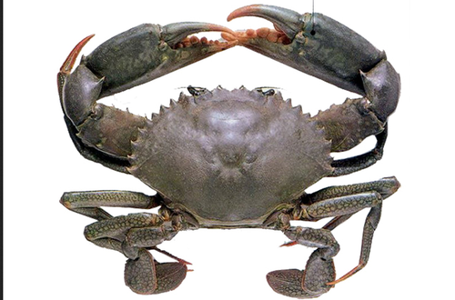

2.2 Mud crab harvesting strategies
Fishing grounds and capture methods vary with the target crab, habitat, tide, available gear and the fisher’s experience (Mirera, 2017a). Reported methods include hand collection, hooks and sticks, baited pots or traps, scoop or seine nets, and hooked metal rods (Richmond et al., 2006; Bonine et al., 2008; Mirera, 2017a). Kenyan fishers commonly remove crabs from mangrove burrows, taking market-sized animals for sale and smaller animals for culture. Harvesting is concentrated around low spring tides, when mangrove areas are accessible (Moser et al., 2005).
Along the Kenyan coast, many mud crab fishers work on foot in mangroves and rely on detailed knowledge of burrows and tidal creeks rather than specialised equipment (Fondo et al., 2020; Mirera et al., 2013). Catches may be held at home for several days until enough crabs have been accumulated for sale to a trader (Mirera et al., 2013; Ochiewo et al., 2010). The holding period makes survival and handling part of the marketing problem, not only a harvesting issue.
The Fisheries Management and Development Act, 2016 provides for designated landing and management arrangements. Mud crab fishers, however, do not always use formal landing sites or licences, so catches may remain outside routine landing records. This weakens the information available for both market planning and stock management.

2.3 Overview of mud crab fisheries and market structure
Scylla serrata is among the more valuable shellfish harvested from tropical mangroves. On Kenya’s South Coast, the fishery provides cash income to coastal households and connects small-scale harvesters with traders and downstream buyers. Its commercial growth has created a longer market chain rather than replacing small-scale production (FAO, 2025).
Demand for live crabs can increase both harvesting pressure and the value of keeping crabs alive. Evidence from the Western Indian Ocean and other regions suggests that buyer concentration, grade setting and access to markets shape prices and the distribution of gross returns (Jacinto, 2004; Crona et al., 2016). Market structure is therefore relevant to sustainability as well as livelihoods.

2.4 Mud crab fishery actors and their characteristics
The mud crab fishery involves fishers, brokers or middlemen, traders, wholesalers, retailers and final buyers. Fishers are typically small-scale operators who depend directly on mangrove habitats and use hand collection or simple gear (Mirera et al., 2013). Other actors aggregate, grade, transport, process or sell the catch.
Participation differs by age, experience, education, gender and access to finance. Along the Kenyan coast, mud crab income may support several members of a household, while harvesting and formal leadership have largely been male-dominated. Women are more visible in trade, processing and crab-fattening activities (Ochiewo et al., 2010; Mirera, 2014a). Earlier studies place many Kenyan crab fishers between 23 and 55 years of age and report that primary education is much more common than secondary education among East African crab fishers (Fulanda et al., 2009; Ndanga et al., 2013). These patterns provide useful context, but they do not show whether actor profiles are the same across BMUs or market nodes.

2.5 Functions of actors at different market levels
Functions change as crabs move through the chain. Fishers capture crabs by hand, from burrows or with baited gear. The method can affect size, condition and survival, which are relevant to the price offered at first sale (Sultana et al., 2018).
Middlemen buy from landing sites or villages, combine catches from several fishers, grade crabs and arrange temporary holding and transport. Their networks connect fishers to distant buyers, but the same position may give them an information and bargaining advantage when fishers have few alternative outlets.
Wholesalers, retailers, hotels, restaurants and exporters place greater emphasis on consistent quality and survival, especially when crabs are traded alive (FAO, 2025). The chain should therefore be examined as a sequence of distinct functions rather than as a single group of ‘traders’.

2.6 Business dynamics of the mud crab fishery

2.6.1 Overview of mud crab business dynamics
Mud crab trade depends on keeping a live, perishable product in saleable condition. Grading, price setting, transport, packaging and payment are therefore part of production economics, not secondary activities (FAO, 2025).
These practices distribute both opportunity and risk. The actor who controls grading or transport may reach a higher-value buyer, while the actor holding live crabs bears the risk of mortality, delayed payment or a rejected consignment.

2.6.2 Grading of mud crabs
Crabs are commonly graded by size, weight, sex, shell hardness and physical condition. Large hard-shell crabs are often preferred because they contain more meat and tolerate transport better. Male crabs may command higher prices, while trade in berried females may be restricted for conservation reasons (FAO, 2025).
Grading may occur at the landing site or after a middleman has aggregated several catches. When the criteria are informal or applied visually, fishers may be unable to verify why a crab was placed in a particular grade. The issue is not grading itself, which can reflect real quality differences, but whether the criteria and price consequences are transparent.

2.6.3 Pricing of mud crabs
Mud crab prices vary with grade, season, demand, distance to market and whether crabs are sold alive. Large live crabs generally receive higher prices in urban, hotel and export markets, while seasonal supply and demand can shift the amount offered (FAO, 2025).
Small-scale fishers may accept a buyer’s price when they lack holding facilities, need cash immediately or depend on that buyer for transport and credit. Informal agreements can reduce transaction costs, but they can also make the basis of a price difficult to challenge (Crona et al., 2016). This makes buyer choice and independent market information important alongside the nominal price.

2.6.4 Transport of mud crabs
Transport affects both survival and quality. Live mud crabs are vulnerable to heat, dehydration and handling stress, and deaths in transit reduce the quantity that can be sold. Traders use baskets, plastic crates or wooden boxes, often with damp material to limit dehydration.
Long distances, poor roads and limited cold-chain or live-holding facilities add to transport risk in the Western Indian Ocean. Shorter journeys and better containment may reduce mortality and protect value without increasing fishing effort. The relevant question is which actors have access to those options and who pays for them.

2.6.5 Packaging of mud crabs
Packaging controls movement, moisture and physical damage during transport. Live crabs may be tied or separated to reduce injury and cannibalism. Containers must also allow enough ventilation and protect claws and legs, which affect market acceptance.
Export markets often require consistent packaging, labels and traceability. Small-scale traders may instead use low-cost materials that are locally available. The trade-off between container cost, survival and reusability should be assessed under normal trading conditions rather than assumed.

2.6.6 Modes of payment in the mud crab trade
Cash remains common at landing sites because fishers need immediate income. Payment may also be delayed until a broker has sold the crabs, especially when the broker provides transport or holding services (Crona et al., 2016).
Buyers may advance cash or gear in return for continued or exclusive supply. Such arrangements can solve a short-term financing problem while narrowing the fisher’s choice of buyer. Buyers may also advance cash or gear in return for continued or exclusive supply, an arrangement Crona et al. (2016) describe as solving a short-term financing problem while narrowing the seller’s choice of buyer. Whether mobile money changes that balance in this fishery is an empirical question taken up in Chapter Four.

2.7 Constraints faced by mud crab fishery actors
Mud crab actors face ecological, operational and market constraints. Fishers report seasonal availability and declining catches where juvenile or berried crabs are harvested and mangrove habitats are degraded (Mirera, 2017a). Traders face the additional problem of keeping live crabs in saleable condition while assembling enough volume for buyers.
Limited credit, unstable prices, inadequate holding facilities and dependence on a small number of brokers can reduce bargaining options. Weak enforcement of size or harvest rules may also allow short-term market demand to undermine the resource on which the trade depends (Mirera, 2017a).

2.8 Opportunities in the mud crab fishery
Demand for large, healthy crabs creates room for better handling, clearer grades and higher-value products. Crab fattening can increase sale weight before marketing, although its value depends on survival, feed, labour, seed sourcing and a confirmed buyer (Mirera, 2014b).
Community participation in size limits and temporary closures has improved awareness and product quality in co-managed small-scale fisheries (Gutiérrez et al., 2011). For Kenya, the lesson is not that the same measure will transfer unchanged, but that market incentives and local enforcement need to be designed together.

2.9 Legal and policy frameworks governing mud crab fishery in Kenya
The Fisheries Management and Development Act, No. 35 of 2016 (Cap. 378) provides the main national framework for conservation, management and development of fisheries resources, including crustaceans. It recognises small-scale fisheries and co-management through Beach Management Units (Fisheries Management and Development Act, No. 35 of 2016, Cap. 378).
The Fisheries Management and Development (Safety and Quality) Regulations, 2024 address the handling, movement and marketing of fishery products. Licensing, traceability, hygiene and quality requirements are particularly relevant to traders and exporters seeking formal markets (Fisheries Management and Development (Safety and Quality) Regulations, 2024).
Fisheries governance is shared between national and county institutions. Counties can develop management plans, while the national government provides coordination and oversight. This division matters for a fishery rooted in mangrove habitats and local landing sites (Fisheries Management and Development Act, No. 35 of 2016, Cap. 378).
Kenya’s Blue Economy and sustainable-development commitments place greater emphasis on traceability, monitoring and value-chain development (Fondo & Ogutu, 2021). For small-scale mud crab actors, the practical gaps remain awareness, compliance support and consistent enforcement.

2.10 Critical Assessment of the Literature
The sections above summarise what previous studies have reported. This section asks a different question: where those studies agree, where they conflict, what their methods can and cannot support, and what remains unanswered for the South Coast.

2.10.1 Where the literature agrees
Three findings recur across settings and methods and can be treated as reasonably secure. First, mud crab chains in the Western Indian Ocean are structured as a sequence of distinct functions rather than a single trading group, with harvesting, aggregation, processing and export performed by different actors (Mirera, 2017a; Jacinto, 2004; FAO, 2025). Second, survival of a live, perishable product governs value, so handling, containment and holding time are production economics rather than incidental practice (FAO, 2025; Mirera et al., 2013). Third, small-scale harvesters in the region operate with limited finance, limited organisation and limited access to formal markets (Béné et al., 2007; Fondo & Ogutu, 2021). The present study tests all three against a single dataset rather than accepting them as background.

2.10.2 Where the literature conflicts: the role of the middleman
The clearest disagreement in this literature is whether middlemen improve or reduce the position of fishers, and it cannot be settled by preference.
One line of work treats the middleman as a net cost to the harvester. Jacinto (2004) argues that in small-scale fisheries the share of final value captured at each node follows control of information and market access rather than physical effort, which implies that an actor positioned between the harvester and the buyer captures value the harvester cannot reach. Béné et al. (2007) extend this to credit: an advance against future supply solves an immediate cash problem while narrowing where the seller may sell, and they treat such arrangements as a mechanism of persistent low returns.
A second line reaches almost the opposite conclusion. Crona et al. (2016), working in Kenya and Zanzibar, describe middlemen as a critical social-ecological link whose relational knowledge is not easily replaced, and find them blamed for outcomes settled further along the chain while operating on modest turnovers and carrying the mortality risk. On that reading, removing the middleman would not transfer their margin to the fisher but would remove a function someone has to perform.
The two positions are not reconcilable at the level of assertion, because they make different empirical claims: one about who captures the value, the other about what the middleman’s position returns once risk is accounted for. Resolving them needs the price at each node and the share each node holds, measured in the same chain. No study reports that for a Kenyan mud crab chain, which is the first gap this study addresses.

2.10.3 Where the literature conflicts: what grading does
A second, less openly stated disagreement concerns grading. FAO (2025) treats grading by size, weight, shell condition and claw size as a legitimate quality signal supporting price formation in a live-crab trade. Jacinto (2004) treats the same practice as a site of informational asymmetry, because a criterion the buyer applies and the seller cannot verify transfers value rather than signalling it. Both may hold at once, but only if the rule is applied consistently and both parties can read it. Whether that condition holds has not been tested in a Kenyan mud crab market, and testing it means recording which criteria each actor category actually uses.

2.10.4 Methodological limitations of previous studies
Four limitations recur in the work reviewed above. The first is a production focus. Much of the Kenyan mud crab literature is biological, ecological or aquacultural: stock status, nursery habitat, growth and culture performance (Mirera, 2017a, 2017b; Mirera & Mosknes, 2015; Moser et al., 2005; Webley, 2008). That work is careful within its own terms but was not designed to describe exchange, so it cannot be read as evidence about prices, margins or bargaining.
The second is a setting mismatch. Where organisation and training have been studied, the setting has often been organised community aquaculture groups rather than independent capture-fishery actors (Mirera, 2014a). Findings about what groups achieve in an organised setting should not be transferred to a capture fishery where, as this study finds, no group exists at all.
The third is aggregation. Regional and national assessments describe constraints in finance, organisation and market access for small-scale fisheries as a sector (Fondo & Ogutu, 2021; Béné et al., 2007). Because they report at sector level, they cannot say which actor category faces which constraint, and therefore cannot indicate where an intervention should be aimed.
The fourth is the absence of cost data, which is a limitation this study shares. Munga and Muthumbi (2018) show for the Tana Delta that gross price differentials between nodes narrow considerably once handling and transport are netted out. Any study reporting gross prices, including the present one, must therefore stop short of claims about profit, and Section 5.6 states explicitly which market-structure dimensions that rules out.

2.10.5 The South Coast and Kwale County: what is and is not known
The literature specific to this coast is thinner than the regional literature and is weighted towards production. Mirera et al. (2013) document fishing tactics and traditional knowledge among Kenyan mud crab fishers, including holding crabs at home for several days until enough have accumulated for sale, which makes survival part of the marketing problem rather than only a harvesting one. Ochiewo et al. (2010) and Mirera (2014a) record the gendered division of the coastal fishery, harvesting and first-tier trade male-dominated and women more visible in processing and trade. Fondo et al. (2020) describe the national status of the mangrove mud crab fishery and Fondo and Ogutu (2021) place it within the Blue Economy agenda, while Fulanda et al. (2009) and Kimani et al. (2018) supply the fisher population figures on which this study’s sampling frame rests.
Kwale County itself appears in this literature mainly as a location rather than as a subject. The one study treating its institutions directly is Njiru et al. (2021), who examine the socioeconomic factors influencing trader participation in Beach Management Units in Kwale; their finding that participation varies with the trader’s own circumstances supports communication designed for particular actor groups. Beyond that, what is known about Shimoni, Majoreni, Vanga and Msambweni as markets, rather than as landing sites, is largely undocumented.
Three things follow. Prices at each node in a Kwale mud crab chain have not been reported; the grading criteria each actor category uses have not been recorded; and no study has tested whether actor characteristics, functions or constraints differ between the BMUs of this coast. Expectations formed at sector level cannot be assumed to hold at the level of a landing beach.

2.10.6 The research gap
The gap this study addresses is specific rather than general. Previous work establishes that mud crab chains are functionally differentiated, that survival governs value and that small-scale harvesters are institutionally weak. It does not establish how the value of a South Coast mud crab is divided between the people who catch, trade and sell it, whether the grading rule behind that division is shared or asymmetric, or whether any of it varies between the Beach Management Units through which the fishery is co-managed. Those three questions are the three objectives of this study.

2.11 Theoretical Framework
This study uses the Structure-Conduct-Performance (SCP) paradigm as its main analytical framework. SCP is commonly applied in agricultural and fisheries marketing to organise evidence on market structure, actor conduct and market outcomes, and here it connects the composition and organisation of the mud crab market with the practices observed at each node. The framework guides interpretation; it is not used to claim a causal sequence.
Market structure is described through the number and types of actors, their characteristics, entry conditions, licensing, access to capital, collective organisation and buyer connections. Conduct covers sourcing, grading, handling, pricing, payment, transport and credit relationships. Performance is considered through descriptive indicators available in the dataset: reported income and prices, market access, mortality or spoilage, and perceptions of market organisation. The constraints and opportunities reported under Objective Three give the operating context.
Value-chain concepts are used as a mapping device to trace crabs from harvesting through aggregation, hospitality and export, not as a second causal theory. Livelihood research, in particular the sustainable livelihoods framework of Allison and Ellis (2001), provides background for interpreting education, experience, finance and collective membership, but the study measured no complete set of livelihood assets and estimated no livelihood effects. Keeping SCP central matches the descriptive design.
Figure 2
Structure-Conduct-Performance (SCP) linkages guiding the study
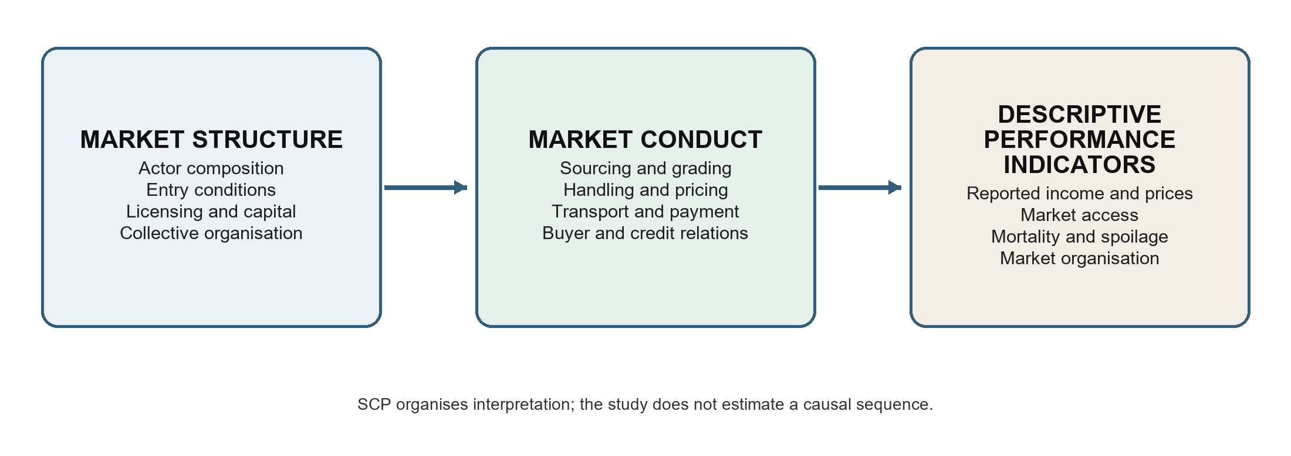

2.12 Conceptual Framework
Figure 3 organises the study variables by objective and shows how they were used in the analysis. It is a descriptive framework rather than a causal model. The arrows indicate the order in which market structure, actor conduct and observed outcomes were examined; they do not represent estimated effects.
Objective One describes market structure and actor profiles using actor category, BMU, age, gender, education, experience, scale of operation, licensing, collective membership, credit and related business characteristics, summarised by actor category and compared across BMUs where coverage allowed. Objective Two examines conduct and functions at each node: harvesting and sourcing, grading, handling, packaging, transport, pricing, payment, buyer relations and market research. Reported income, prices, market access and post-harvest losses are presented as descriptive market outcomes rather than combined into a performance index.
Objective Three describes the infrastructure, market barriers, policy awareness, risks and opportunities each actor category reported, read alongside the structure and conduct findings. No mediation or moderation model was estimated and the cross-sectional design does not support causal inference; actor category and BMU serve as grouping variables for description and for actor-specific association tests.
Figure 3
Descriptive framework linking the study objectives to the analysis
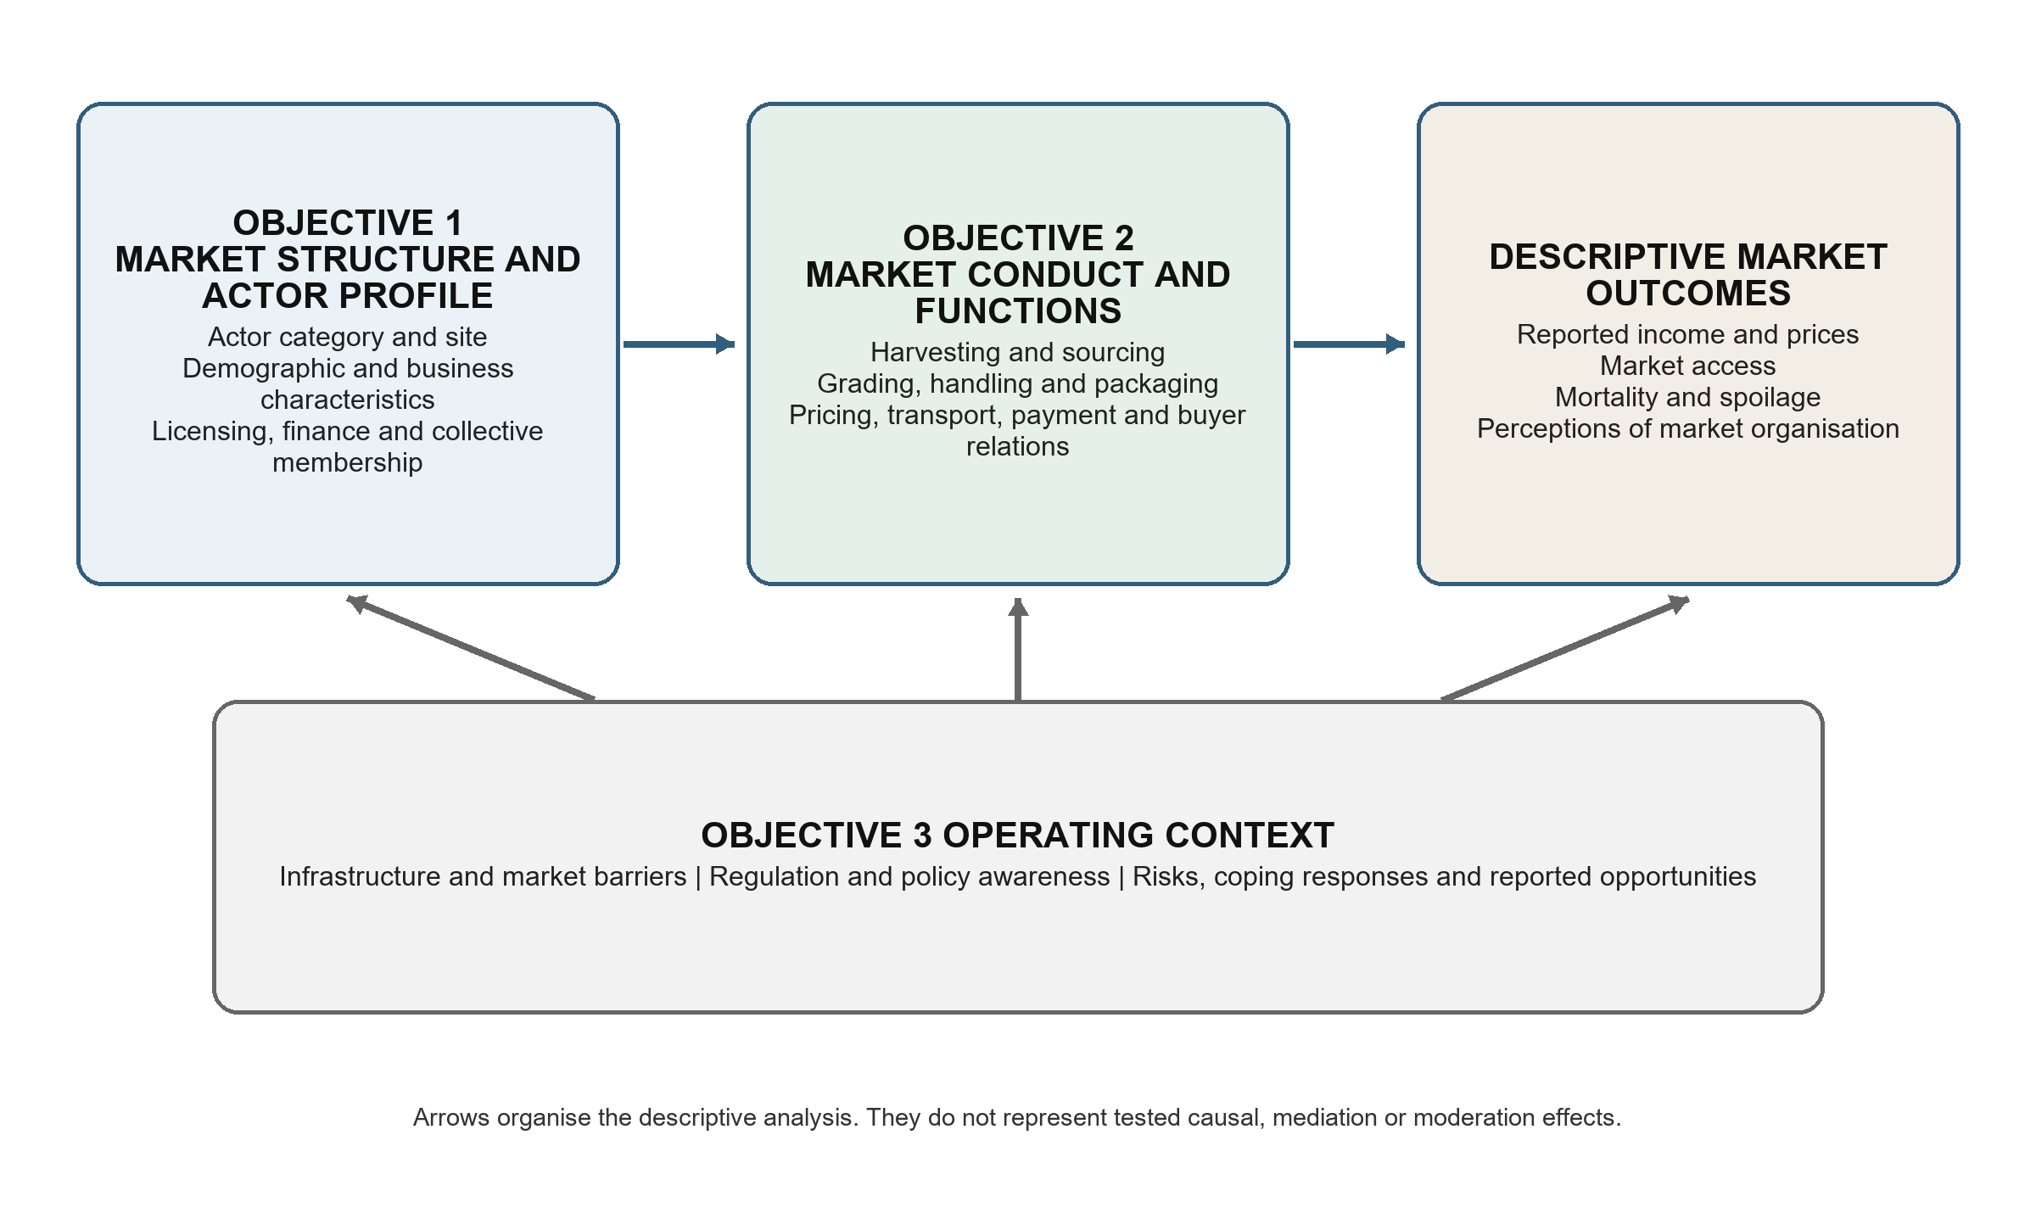

CHAPTER THREE: MATERIALS AND METHODS

3.1 Introduction
This chapter describes the study design, site, target population, sampling, data collection and analysis. The methods were selected to describe the actors, functions, constraints and opportunities in the Kwale County mud crab market and to compare selected categorical variables across BMUs where the sample allowed.

3.2 Study site
The study was conducted on the South Coast of Kenya, mainly in Kwale County, between latitudes 3.05 degrees and 4.75 degrees South and longitudes 38.52 degrees and 39.51 degrees East (Figure 4). The county covers about 8,270.2 square kilometres and includes a coastal strip from Likoni to Vanga, where mangrove forests, tidal creeks and shallow coastal waters provide breeding, feeding and shelter habitat for Scylla serrata and other species (Mirera, 2017a; Fondo et al., 2020). The South Coast was selected because it is an established harvesting and trading area. Small-scale fishers reach the mangroves on foot or by canoe using hand collection, baited traps and other simple gear, and year-round access makes mud crab fishing an important source of cash for some coastal households.
The county has 20 Beach Management Units (BMUs) and 54 landing sites, responsible for regulating fishing, managing landing sites and promoting sustainable use of fisheries resources. They are the entry points for understanding how mud crab harvesting and marketing work locally (Njiru et al., 2021). Landing sites are where fishers sell to brokers and traders, which makes them the right places to collect data on grading, pricing, transport, packaging and modes of payment.
The South Coast is also strongly influenced by tourism and urban markets, which generate high demand for premium seafood such as live mud crabs. Hotels, restaurants and urban centres within and beyond the county provide ready markets, drawing multiple actors into the value chain (FAO, 2025), so mud crab fishing here has shifted from subsistence use towards a market-oriented activity.
Figure 4
Study site (Author, 2026)
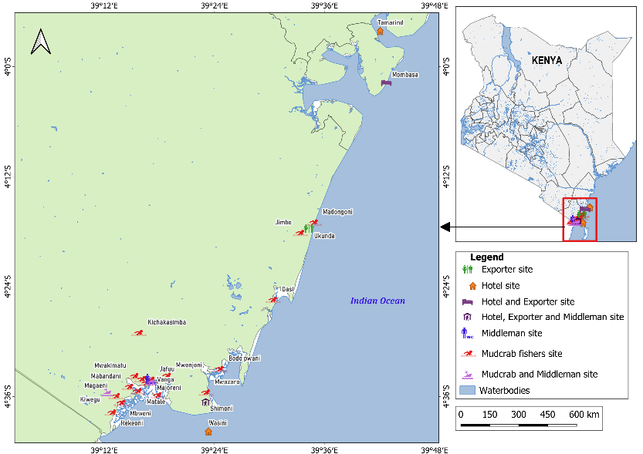

3.3 Research design
The study used a cross-sectional descriptive mixed-methods design. Each respondent was surveyed once, while field observations and key-informant interviews supplied context on handling practices, institutions and market relationships. The design supports actor profiles, comparisons among actor categories and exploratory BMU associations. It does not establish causal pathways, mediation, moderation or seasonal change.

3.4 Target population
A target population comprises every individual able to give responses pertinent to the objectives of a study (Lamm & Lamm, 2019). The target population here comprised mud crab fishers, middlemen, hoteliers and exporters operating in Kwale County. These groups were selected because they harvest, handle, aggregate, process or trade mud crabs and therefore correspond directly to the three study objectives. Consumers, restaurants that did not procure directly, input suppliers and other service providers were outside the survey scope. Their exclusion means that the study cannot describe consumer preferences or the full set of supporting services. Ministry of Fisheries records informed the fisher sampling frame. Complete lists were not available for middlemen, hoteliers and exporters, so the accessible population for these groups depended on referrals and availability during the study period.

3.5 Sample size and sampling procedures
The fisher sample was estimated from the available population information. Bowers (2017) reported mud crab fishers as about 3% of the 12,915 fishers along the Kenyan coast, and applying Kwale County’s estimated 26.9% share of the national mud crab fisher population gave a population of 104 fishers (Mirera, 2017a; Kimani et al., 2018).
- Total population of fishers in the Kenyan coast = 12,915
- Proportion of mud crab fishers in the Kenyan coast = 3%
- Total population of mud crab fishers in the Kenyan coast = 3/100 x 12,915 = 387
- Total population of mud crab fishers in Kwale County = 26.9/100 x 387 = 104
Using Yamane’s formula for sample size determination (Yamane, 1967), the sample size was computed as follows:
where:
n = required sample size
N = estimated population of mud crab fishers (104)
e = margin of error (0.05)
n = 104 / [1 + 104(0.05)^2]
n = 82.54, rounded up to a target of 83 fishers
The completed survey covered 96 actors: 65 mud crab fishers, 22 middlemen, five hoteliers and four exporters. Fishers were recruited from the selected BMUs using the available frame and field access. Because complete lists of downstream actors did not exist, respondents identified traders and buyers who could be approached, and those referrals were followed through snowball sampling.

3.6 Non-Response and Sampling Limitations
The study reached 65 of the target 83 fishers, an achieved rate of 78.3%. The shortfall arose mainly because some fishers moved among landing sites and were absent during scheduled visits. The achieved fisher sample is adequate for a descriptive account of the respondents reached, but the missing 18 fishers may differ from those interviewed. Site-level percentages, especially for BMUs with few respondents, should therefore be interpreted cautiously.
A conventional response rate could not be calculated for middlemen, hoteliers or exporters because no complete sampling frame existed. Snowball sampling was practical for locating these dispersed actors, but it may over-represent people with stronger trading connections and under-represent isolated or informal operators. The small hotelier and exporter samples and the absence of middlemen at some BMUs limit statistical generalisation beyond the surveyed actors.

3.7 Pilot study
A pilot test involving 18 respondents was used to check whether the questionnaire items were clear, relevant to the objectives and workable in the field (Lowe, 2019). Feedback from the pilot informed the wording and sequencing of the data-collection tool.

3.8 Data collection
Data were collected from May 2022 to December 2023 using structured questionnaires, field observations and key-informant interviews.
For Objective One, the questionnaire recorded actor category, age, sex, marital status, education, household size, experience, monthly income, business ownership, scale of operation, collective membership, credit, licensing and institutional affiliation, which describe the people and businesses operating at each market node.
For Objective Two, respondents described their harvesting or sourcing methods, catch or traded volumes, grading, quality control, processing, preservation, packaging, transport, market destinations, price setting, payment, technology use, market research and sources of technical knowledge. Field observation checked reported handling, grading, transport and marketing practices where they could be seen.
For Objective Three, respondents identified operational and market constraints, infrastructure gaps, price risk, access to finance, technology, institutional support, regulation and capacity needs, and the opportunities they saw in market access, value addition, infrastructure, training, credit and institutional support. Key informants, including BMU leaders and government officers, gave context on sector-wide conditions; their accounts and the field notes were used to interpret the survey findings rather than as a separate causal test.
Secondary evidence came from published studies, government reports and other documents on mud crab fisheries, actor roles and market conditions, and supplied the comparison literature used in Chapters One, Two and Five.

3.9 Alignment of objectives and analysis
Objective One was analysed with frequencies, valid percentages and actor-specific BMU cross-tabulations, with chi-square tests for selected categorical variables among fishers and middlemen. Objective Two used the same descriptive summaries for functions and market practices, together with means, medians, quartiles and ranges for reported income and prices. Objective Three used frequencies, percentages and selected actor-specific BMU associations for constraints, regulation and opportunities. Hoteliers and exporters were described by actor category because their samples were too small and uneven for BMU significance tests. This alignment keeps each conclusion within the scope of the data collected.
Table 1
Alignment of Study Objectives, Variables Measured and Analysis Applied
Objective | Variables measured | Analysis applied | Reported in
1. Profile the actors and their characteristics | Actor category, study site, age, gender, education, marital status, experience, business role, scale of operation, income, licensing, credit, training, collective membership | Frequencies and valid percentages by actor category; descriptive statistics for income and age; actor-specific Monte Carlo chi-square against study site for fishers and middlemen | Tables 3–14, Figures 5–7
2. Examine the functions performed at each market node | Sourcing, buyers, market channel, gear, catch, preparation, packaging, preservation, transport, grading practice and criteria, quality control, size and grade labels, mortality, spoilage, payment, price setting, trading relationships, reported prices by grade | Frequencies and valid percentages by actor category; descriptive statistics for prices; Kruskal–Wallis for price by actor category and by study site within actor; Herfindahl-Hirschman concentration of first-sale outlets and buyer options per harvester; gross marketing margin at each node, total marketing margin and the producer’s share gross and net of measured physical loss; price dispersion and price transmission; actor-specific Monte Carlo chi-square against study site | Tables 15–44, Figures 8–18
3. Assess the constraints and opportunities facing each actor category | Main operational constraint, infrastructure constraint, market-access barriers, risk management, innovation, adaptation, regulation, management-plan awareness, perceptions of market structure and policy, priority opportunities, youth involvement, diversification | Frequencies and valid percentages by actor category; actor-specific Monte Carlo chi-square against study site for fishers and middlemen | Tables 45–52, Figures 19–25

3.10 Data analysis

3.10.1 Data entry and processing
Questionnaires were administered on smartphones using KoBoToolbox and KoBo Collect, and submitted records were reviewed, coded and downloaded in CSV and XLSX formats. The questionnaire followed the study objectives: the first section covered demographic and business characteristics, the second actor functions and market practices, the third constraints and opportunities.
Validation rules in the KoBo form reduced missing and out-of-range responses. Cleaning therefore focused on labels, coding consistency, duplicate checks and comparison with the original records where a value appeared unusual.
After cleaning, the dataset was imported into IBM SPSS Statistics. Variables were labelled by study objective and checked against the questionnaire. Fishers and middlemen were cross-tabulated separately by BMU, while hoteliers and exporters were pooled by actor because their sample sizes were small and their site coverage was uneven.
Descriptive analysis was conducted in IBM SPSS Statistics. Categorical variables were summarised using frequencies and valid percentages within actor category. Continuous variables, including reported monthly income and mud crab prices, were summarised using the mean, standard deviation, median, first and third quartiles, minimum and maximum where valid observations were available. Every table in Chapter Four carries all four actor categories, so the four positions can be compared on the same row. Fishers and middlemen were additionally cross-tabulated by study site; hoteliers and exporters were not, because their samples were small and their site coverage uneven. All charts were generated from the same dataset.

3.10.2 Chi-square tests of association
Chi-square tests were used to assess associations between BMU and selected categorical variables separately for fishers and middlemen. The two actor categories were not pooled in the BMU tests because their functions and distributions differed across sites. Hoteliers and exporters were excluded from BMU significance testing because their numbers were small and site coverage was uneven.
The tests covered objective-linked demographic, business, functional, market and constraint variables. Because many contingency tables contained small expected counts, two-sided Monte Carlo p-values based on 10,000 samples were reported with 99% confidence intervals. Statistical significance was assessed at alpha = .05. Hoteliers and exporters were described without BMU significance tests.

3.10.3 Kruskal–Wallis tests of reported prices
Reported mud crab prices were compared with the Kruskal–Wallis H test, a rank-based alternative to one-way analysis of variance. It was chosen because the price distributions were not normal, the actor groups were very unequal in size, and the smallest groups contained four and five observations, conditions under which a parametric test would not be dependable.
Three sets of comparisons were run, one per size grade. Price was compared across the four actor categories; fisher price was compared across the four study sites; and middleman price was compared across the three sites where traders were sampled. Hoteliers and exporters were not compared across sites for the reason given above. Statistical significance was assessed at alpha = .05. Because the survey did not record transaction-level costs, volumes or mortality, price differences between nodes are reported as gross marketing margins and shares of the end-of-chain price, never as profit.

3.10.4 Market structure, margin and dispersion measures
Four measures summarise market structure. Concentration at first sale is taken over the buying points fishers named, using the concentration ratio, the share of harvesters attached to the largest point, and the Herfindahl-Hirschman Index, the sum of the squared shares on a scale to 10,000; dividing 10,000 by that index gives the numbers-equivalent, the count of equal-sized outlets that would produce the same concentration. Because the survey recorded where fishers sold rather than what each buyer handled, these are shares of harvesters and not shares of volume. The gross marketing margin at a node is the difference between that actor’s selling and buying price as a percentage of his selling price; the total marketing margin applies the same formula across the chain; and the producer’s share is the fisher mean divided by the final-node mean. Physical mortality, the one cost the survey measured, is deducted from the volume the harvester realises, giving a producer’s share net of that loss. Price dispersion is the coefficient of variation, which lets nodes whose price levels differ by a factor of three be compared directly. All four were computed from the IBM SPSS Statistics output rather than by a built-in procedure, and the formulas are in the syntax file.

3.11 Ethical considerations
The study adhered to ethical standards for statistical research. Respondents were interviewed based on their attainment of the legal age of 18 years; consent was sought from parents or guardians for those under 18. Anonymity and confidentiality were maintained, and participation was voluntary with the option to withdraw at any time. An ethical review certificate was obtained before data collection commenced.

CHAPTER FOUR: RESULTS

4.1 Introduction
This chapter presents what 96 mud crab actors on the South Coast of Kenya reported about their work, following the three objectives in turn. Every table carries all four actor categories (fisher, middleman, hotelier and exporter) so the four positions in the chain can be read against one another, and each is broken down by Beach Management Unit so site differences stay visible.
Four conventions govern how the tables should be read. Percentages are valid percentages within the actor category at that site, so the denominator is the number of respondents of that category who answered that item there, never the full 96. A hyphen means the category had no respondents at that site; a zero means it had respondents but none gave that response. The BMU p-value appears on the first row of each actor block, for fishers and middlemen only, because four of the five hoteliers and all four exporters operated outside the four BMU frames.
Categorical variables were tested against BMU using Monte Carlo chi-square with 10,000 resamples, which suits the sparse tables this sample produces. Fishers and middlemen were tested separately, because pooling a harvester with a trader would confuse site with role. Reported prices were compared with the Kruskal–Wallis test, which assumes no normality and tolerates very unequal group sizes.

4.2 Distribution of Respondents
All 96 respondent identifiers were unique and matched across the three objective worksheets. Landing sites were standardised into Shimoni, Majoreni, Vanga, Msambweni or an Other sites group. One medium-crab price recorded at Gasi was corrected from KSh 800 to KSh 650 per kilogram against the field records, and every figure in this chapter carries that correction.
Table 2
Distribution of Respondents by Actor Category and BMU
Actor category | Shimoni | Majoreni | Vanga | Msambweni | Other sites | Total
Fisher | 25 (38.5%) | 14 (21.5%) | 21 (32.3%) | 3 (4.6%) | 2 (3.1%) | 65 (100.0%)
Middleman | 11 (50.0%) | 7 (31.8%) | 4 (18.2%) | 0 (0.0%) | 0 (0.0%) | 22 (100.0%)
Hotelier | 1 (20.0%) | 0 (0.0%) | 0 (0.0%) | 0 (0.0%) | 4 (80.0%) | 5 (100.0%)
Exporter | 0 (0.0%) | 0 (0.0%) | 0 (0.0%) | 0 (0.0%) | 4 (100.0%) | 4 (100.0%)
Total | 37 (38.5%) | 21 (21.9%) | 25 (26.0%) | 3 (3.1%) | 10 (10.4%) | 96 (100.0%)
Table 2 shows that fishers accounted for 65 of the 96 respondents, middlemen for 22, hoteliers for five and exporters for four. The mix differed sharply by site. Shimoni and Majoreni were the only places where fishers and middlemen were both well represented; Vanga returned 21 fishers against four middlemen; Msambweni returned three fishers and nothing else. Hoteliers and exporters sat almost entirely in the Other sites group, which is where the hotels and packhouses buying South Coast crabs actually operate.
This distribution sets the limits of the site comparisons. No middleman was sampled at Msambweni, so middleman tests use the three sites where traders were interviewed. Msambweni is left out of those tables rather than shown as a column of zeros: that is a gap in the realised sample, not evidence that no middlemen work there.

4.3 Objective One: Profile of Mud Crab Actors and Their Characteristics
Objective One sought to profile the socio-economic and business characteristics of mud crab fishery actors. Nineteen characteristics were examined, grouped below into demographic and personal characteristics, business and operational characteristics, and knowledge, training and group membership.

4.3.1 Demographic and Personal Characteristics
Table 3
Age Group of Fishers, Middlemen, Hoteliers and Exporters by BMU
Characteristic / response | Actor | Overall | Shimoni | Majoreni | Vanga | Msambweni | Other sites | BMU p-value
Age group
Under 18 | Fisher N = 65 | 4 (6.2%) | 4 (16.0%) | 0 (0.0%) | 0 (0.0%) | 0 (0.0%) | 0 (0.0%) | .004
18-35 |  | 35 (53.8%) | 16 (64.0%) | 5 (35.7%) | 12 (57.1%) | 2 (66.7%) | 0 (0.0%)
36-49 |  | 12 (18.5%) | 5 (20.0%) | 1 (7.1%) | 6 (28.6%) | 0 (0.0%) | 0 (0.0%)
50-60 |  | 10 (15.4%) | 0 (0.0%) | 5 (35.7%) | 3 (14.3%) | 0 (0.0%) | 2 (100.0%)
Over 60 |  | 4 (6.2%) | 0 (0.0%) | 3 (21.4%) | 0 (0.0%) | 1 (33.3%) | 0 (0.0%)
Under 18 | Middleman N = 22 | 0 (0.0%) | 0 (0.0%) | 0 (0.0%) | 0 (0.0%) | - | - | .932
18-35 |  | 5 (22.7%) | 3 (27.3%) | 1 (14.3%) | 1 (25.0%) | - | -
36-49 |  | 11 (50.0%) | 6 (54.5%) | 3 (42.9%) | 2 (50.0%) | - | -
50-60 |  | 5 (22.7%) | 2 (18.2%) | 2 (28.6%) | 1 (25.0%) | - | -
Over 60 |  | 1 (4.5%) | 0 (0.0%) | 1 (14.3%) | 0 (0.0%) | - | -
Under 18 | Hotelier N = 5 | 0 (0.0%) | 0 (0.0%) | - | - | - | 0 (0.0%)
18-35 |  | 4 (80.0%) | 1 (100.0%) | - | - | - | 3 (75.0%)
36-49 |  | 1 (20.0%) | 0 (0.0%) | - | - | - | 1 (25.0%)
50-60 |  | 0 (0.0%) | 0 (0.0%) | - | - | - | 0 (0.0%)
Over 60 |  | 0 (0.0%) | 0 (0.0%) | - | - | - | 0 (0.0%)
Under 18 | Exporter N = 4 | 0 (0.0%) | - | - | - | - | 0 (0.0%)
18-35 |  | 0 (0.0%) | - | - | - | - | 0 (0.0%)
36-49 |  | 4 (100.0%) | - | - | - | - | 4 (100.0%)
50-60 |  | 0 (0.0%) | - | - | - | - | 0 (0.0%)
Over 60 |  | 0 (0.0%) | - | - | - | - | 0 (0.0%)
As shown in Table 3, the largest age band was 18–35 among fishers (35, 53.8%) and hoteliers (4, 80.0%), and 36–49 among middlemen (11, 50.0%) and all four exporters. The 18–35 band led at every fisher site except Majoreni, where it tied with the 50–60 band at 5 (35.7%) each. All four fishers under 18 were at Shimoni. Fisher age was associated with BMU (p = .004); middleman age was not (p = .932).
Table 4
Gender of Fishers, Middlemen, Hoteliers and Exporters by BMU
Characteristic / response | Actor | Overall | Shimoni | Majoreni | Vanga | Msambweni | Other sites | BMU p-value
Gender
Male | Fisher N = 65 | 65 (100.0%) | 25 (100.0%) | 14 (100.0%) | 21 (100.0%) | 3 (100.0%) | 2 (100.0%)
Female |  | 0 (0.0%) | 0 (0.0%) | 0 (0.0%) | 0 (0.0%) | 0 (0.0%) | 0 (0.0%)
Male | Middleman N = 22 | 22 (100.0%) | 11 (100.0%) | 7 (100.0%) | 4 (100.0%) | - | -
Female |  | 0 (0.0%) | 0 (0.0%) | 0 (0.0%) | 0 (0.0%) | - | -
Male | Hotelier N = 5 | 4 (80.0%) | 0 (0.0%) | - | - | - | 4 (100.0%)
Female |  | 1 (20.0%) | 1 (100.0%) | - | - | - | 0 (0.0%)
Male | Exporter N = 4 | 4 (100.0%) | - | - | - | - | 4 (100.0%)
Female |  | 0 (0.0%) | - | - | - | - | 0 (0.0%)
Table 4 shows a value chain that was almost entirely male: all 65 fishers, all 22 middlemen, four of five hoteliers (80.0%) and all four exporters. The one woman was the hotelier recorded at Shimoni. Gender varied too little among fishers and middlemen to support a test.
Figure 5 shows primary education as the commonest level among fishers (44, 67.7%) and middlemen (16, 72.7%), while hoteliers held certificates (2, 40.0%) or diplomas (3, 60.0%) and exporters diplomas (3, 75.0%) or a degree (1, 25.0%). No fisher or middleman reported schooling beyond secondary level and 17 fishers (26.2%) reported none at all. Education was not associated with BMU for fishers (p = .334) or middlemen (p = .928).
Figure 5
Highest Education Attained Within Each Actor Category
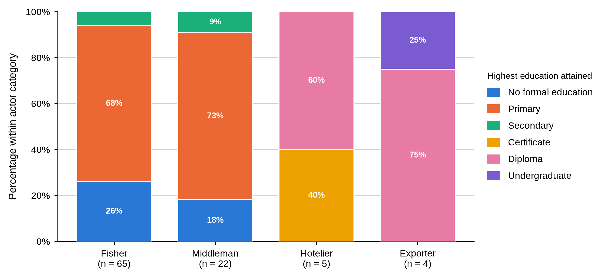
Table 5
Ethnic Group of Fishers, Middlemen, Hoteliers and Exporters by BMU
Characteristic / response | Actor | Overall | Shimoni | Majoreni | Vanga | Msambweni | Other sites | BMU p-value
Ethnic group
Digo | Fisher N = 65 | 36 (55.4%) | 12 (48.0%) | 8 (57.1%) | 13 (61.9%) | 2 (66.7%) | 1 (50.0%) | .368
Duruma |  | 17 (26.2%) | 7 (28.0%) | 6 (42.9%) | 4 (19.0%) | 0 (0.0%) | 0 (0.0%)
Vumba |  | 12 (18.5%) | 6 (24.0%) | 0 (0.0%) | 4 (19.0%) | 1 (33.3%) | 1 (50.0%)
Swahili |  | 0 (0.0%) | 0 (0.0%) | 0 (0.0%) | 0 (0.0%) | 0 (0.0%) | 0 (0.0%)
Kikuyu |  | 0 (0.0%) | 0 (0.0%) | 0 (0.0%) | 0 (0.0%) | 0 (0.0%) | 0 (0.0%)
Chinese |  | 0 (0.0%) | 0 (0.0%) | 0 (0.0%) | 0 (0.0%) | 0 (0.0%) | 0 (0.0%)
Digo | Middleman N = 22 | 15 (68.2%) | 8 (72.7%) | 5 (71.4%) | 2 (50.0%) | - | - | .508
Duruma |  | 6 (27.3%) | 3 (27.3%) | 1 (14.3%) | 2 (50.0%) | - | -
Vumba |  | 1 (4.5%) | 0 (0.0%) | 1 (14.3%) | 0 (0.0%) | - | -
Swahili |  | 0 (0.0%) | 0 (0.0%) | 0 (0.0%) | 0 (0.0%) | - | -
Kikuyu |  | 0 (0.0%) | 0 (0.0%) | 0 (0.0%) | 0 (0.0%) | - | -
Chinese |  | 0 (0.0%) | 0 (0.0%) | 0 (0.0%) | 0 (0.0%) | - | -
Digo | Hotelier N = 5 | 2 (40.0%) | 0 (0.0%) | - | - | - | 2 (50.0%)
Duruma |  | 1 (20.0%) | 0 (0.0%) | - | - | - | 1 (25.0%)
Vumba |  | 2 (40.0%) | 1 (100.0%) | - | - | - | 1 (25.0%)
Swahili |  | 0 (0.0%) | 0 (0.0%) | - | - | - | 0 (0.0%)
Kikuyu |  | 0 (0.0%) | 0 (0.0%) | - | - | - | 0 (0.0%)
Chinese |  | 0 (0.0%) | 0 (0.0%) | - | - | - | 0 (0.0%)
Digo | Exporter N = 4 | 0 (0.0%) | - | - | - | - | 0 (0.0%)
Duruma |  | 0 (0.0%) | - | - | - | - | 0 (0.0%)
Vumba |  | 0 (0.0%) | - | - | - | - | 0 (0.0%)
Swahili |  | 1 (25.0%) | - | - | - | - | 1 (25.0%)
Kikuyu |  | 1 (25.0%) | - | - | - | - | 1 (25.0%)
Chinese |  | 2 (50.0%) | - | - | - | - | 2 (50.0%)
Table 5 reports ethnic group. The Digo were the largest group among fishers (36, 55.4%) and middlemen (15, 68.2%), followed by the Duruma and the Vumba, and hoteliers split between Digo (2, 40.0%), Vumba (2, 40.0%) and Duruma (1, 20.0%). Exporters drew on groups absent upstream: Chinese (2, 50.0%), Kikuyu (1, 25.0%) and Swahili (1, 25.0%). Ethnicity was not associated with BMU for fishers (p = .368) or middlemen (p = .508).
Table 6
Marital Status of Fishers, Middlemen, Hoteliers and Exporters by BMU
Characteristic / response | Actor | Overall | Shimoni | Majoreni | Vanga | Msambweni | Other sites | BMU p-value
Marital status
Single | Fisher N = 65 | 20 (30.8%) | 12 (48.0%) | 5 (35.7%) | 3 (14.3%) | 0 (0.0%) | 0 (0.0%) | .049
Married |  | 41 (63.1%) | 12 (48.0%) | 8 (57.1%) | 18 (85.7%) | 2 (66.7%) | 1 (50.0%)
Separated / divorced |  | 3 (4.6%) | 0 (0.0%) | 1 (7.1%) | 0 (0.0%) | 1 (33.3%) | 1 (50.0%)
Widowed |  | 1 (1.5%) | 1 (4.0%) | 0 (0.0%) | 0 (0.0%) | 0 (0.0%) | 0 (0.0%)
Single | Middleman N = 22 | 2 (9.1%) | 1 (9.1%) | 0 (0.0%) | 1 (25.0%) | - | - | .665
Married |  | 20 (90.9%) | 10 (90.9%) | 7 (100.0%) | 3 (75.0%) | - | -
Separated / divorced |  | 0 (0.0%) | 0 (0.0%) | 0 (0.0%) | 0 (0.0%) | - | -
Widowed |  | 0 (0.0%) | 0 (0.0%) | 0 (0.0%) | 0 (0.0%) | - | -
Single | Hotelier N = 5 | 2 (40.0%) | 1 (100.0%) | - | - | - | 1 (25.0%)
Married |  | 3 (60.0%) | 0 (0.0%) | - | - | - | 3 (75.0%)
Separated / divorced |  | 0 (0.0%) | 0 (0.0%) | - | - | - | 0 (0.0%)
Widowed |  | 0 (0.0%) | 0 (0.0%) | - | - | - | 0 (0.0%)
Single | Exporter N = 4 | 0 (0.0%) | - | - | - | - | 0 (0.0%)
Married |  | 4 (100.0%) | - | - | - | - | 4 (100.0%)
Separated / divorced |  | 0 (0.0%) | - | - | - | - | 0 (0.0%)
Widowed |  | 0 (0.0%) | - | - | - | - | 0 (0.0%)
Table 6 shows most fishers (41, 63.1%) and almost all middlemen (20, 90.9%) married, as were all four exporters; hoteliers split two single (40.0%) to three married (60.0%). Marital status was associated with BMU among fishers at the margin (p = .049) but not among middlemen (p = .665).
Table 7
Years of Experience of Fishers, Middlemen, Hoteliers and Exporters by BMU
Characteristic / response | Actor | Overall | Shimoni | Majoreni | Vanga | Msambweni | Other sites | BMU p-value
Years of experience in the mud crab fishery
Less than 5 years | Fisher N = 65 | 1 (1.5%) | 0 (0.0%) | 1 (7.1%) | 0 (0.0%) | 0 (0.0%) | 0 (0.0%) | .204
5-10 years |  | 22 (33.8%) | 10 (40.0%) | 3 (21.4%) | 8 (38.1%) | 1 (33.3%) | 0 (0.0%)
11-20 years |  | 22 (33.8%) | 12 (48.0%) | 3 (21.4%) | 6 (28.6%) | 1 (33.3%) | 0 (0.0%)
Over 20 years |  | 20 (30.8%) | 3 (12.0%) | 7 (50.0%) | 7 (33.3%) | 1 (33.3%) | 2 (100.0%)
Less than 5 years | Middleman N = 22 | 0 (0.0%) | 0 (0.0%) | 0 (0.0%) | 0 (0.0%) | - | - | .747
5-10 years |  | 3 (13.6%) | 2 (18.2%) | 0 (0.0%) | 1 (25.0%) | - | -
11-20 years |  | 3 (13.6%) | 2 (18.2%) | 1 (14.3%) | 0 (0.0%) | - | -
Over 20 years |  | 16 (72.7%) | 7 (63.6%) | 6 (85.7%) | 3 (75.0%) | - | -
Less than 5 years | Hotelier N = 5 | 4 (80.0%) | 1 (100.0%) | - | - | - | 3 (75.0%)
5-10 years |  | 1 (20.0%) | 0 (0.0%) | - | - | - | 1 (25.0%)
11-20 years |  | 0 (0.0%) | 0 (0.0%) | - | - | - | 0 (0.0%)
Over 20 years |  | 0 (0.0%) | 0 (0.0%) | - | - | - | 0 (0.0%)
Less than 5 years | Exporter N = 4 | 2 (50.0%) | - | - | - | - | 2 (50.0%)
5-10 years |  | 2 (50.0%) | - | - | - | - | 2 (50.0%)
11-20 years |  | 0 (0.0%) | - | - | - | - | 0 (0.0%)
Over 20 years |  | 0 (0.0%) | - | - | - | - | 0 (0.0%)
Table 7 gives experience, which spread evenly across the fisher bands, 5–10 years (22, 33.8%), 11–20 years (22, 33.8%) and over 20 years (20, 30.8%), while 16 of 22 middlemen (72.7%) had more than twenty years. Hoteliers were newest, four of five (80.0%) under five years. Experience was not associated with BMU for fishers (p = .204) or middlemen (p = .747).
Read together, Tables 3 to 7 and Figure 5 show fishers and middlemen as demographically similar in some respects and distinct in others. Both were almost entirely male, primarily educated and drawn mainly from the Digo, Duruma and Vumba, and neither education nor ethnicity was associated with BMU. They diverged on age and experience: fishers concentrated in the 18–35 band, with age the only demographic characteristic significantly associated with BMU, while middlemen were older and markedly more experienced. Hoteliers and exporters held higher qualifications throughout, and exporters drew on ethnic groups absent upstream. The profile of a mud crab actor therefore follows position in the chain far more than landing site.

4.3.2 Business and Operational Characteristics
Table 8
Primary Role and Business Ownership of Fishers, Middlemen, Hoteliers and Exporters by BMU
Characteristic / response | Actor | Overall | Shimoni | Majoreni | Vanga | Msambweni | Other sites | BMU p-value
Primary role in the mud crab fishery
Crabber | Fisher N = 65 | 65 (100.0%) | 25 (100.0%) | 14 (100.0%) | 21 (100.0%) | 3 (100.0%) | 2 (100.0%)
Exporter |  | 0 (0.0%) | 0 (0.0%) | 0 (0.0%) | 0 (0.0%) | 0 (0.0%) | 0 (0.0%)
Marketer |  | 0 (0.0%) | 0 (0.0%) | 0 (0.0%) | 0 (0.0%) | 0 (0.0%) | 0 (0.0%)
Processor |  | 0 (0.0%) | 0 (0.0%) | 0 (0.0%) | 0 (0.0%) | 0 (0.0%) | 0 (0.0%)
Crabber | Middleman N = 22 | 0 (0.0%) | 0 (0.0%) | 0 (0.0%) | 0 (0.0%) | - | -
Exporter |  | 0 (0.0%) | 0 (0.0%) | 0 (0.0%) | 0 (0.0%) | - | -
Marketer |  | 22 (100.0%) | 11 (100.0%) | 7 (100.0%) | 4 (100.0%) | - | -
Processor |  | 0 (0.0%) | 0 (0.0%) | 0 (0.0%) | 0 (0.0%) | - | -
Crabber | Hotelier N = 5 | 0 (0.0%) | 0 (0.0%) | - | - | - | 0 (0.0%)
Exporter |  | 0 (0.0%) | 0 (0.0%) | - | - | - | 0 (0.0%)
Marketer |  | 0 (0.0%) | 0 (0.0%) | - | - | - | 0 (0.0%)
Processor |  | 5 (100.0%) | 1 (100.0%) | - | - | - | 4 (100.0%)
Crabber | Exporter N = 4 | 0 (0.0%) | - | - | - | - | 0 (0.0%)
Exporter |  | 4 (100.0%) | - | - | - | - | 4 (100.0%)
Marketer |  | 0 (0.0%) | - | - | - | - | 0 (0.0%)
Processor |  | 0 (0.0%) | - | - | - | - | 0 (0.0%)
Owns or manages a mud crab operation
Yes | Fisher N = 65 | 65 (100.0%) | 25 (100.0%) | 14 (100.0%) | 21 (100.0%) | 3 (100.0%) | 2 (100.0%)
Yes | Middleman N = 22 | 22 (100.0%) | 11 (100.0%) | 7 (100.0%) | 4 (100.0%) | - | -
Yes | Hotelier N = 5 | 5 (100.0%) | 1 (100.0%) | - | - | - | 4 (100.0%)
Yes | Exporter N = 4 | 4 (100.0%) | - | - | - | - | 4 (100.0%)
Table 8 shows primary role coinciding exactly with actor category, fishers recorded as crabbers, middlemen as marketers, hoteliers as processors and exporters as exporters, each at 100.0%. Every respondent in all four categories owned or managed the operation described. Neither item varied enough within fishers or middlemen to support a test.
Table 9
Scale of Operation of Fishers, Middlemen, Hoteliers and Exporters by BMU
Characteristic / response | Actor | Overall | Shimoni | Majoreni | Vanga | Msambweni | Other sites | BMU p-value
Scale of operation
Small-scale | Fisher N = 65 | 64 (98.5%) | 25 (100.0%) | 14 (100.0%) | 20 (95.2%) | 3 (100.0%) | 2 (100.0%) | .606
Medium-scale |  | 1 (1.5%) | 0 (0.0%) | 0 (0.0%) | 1 (4.8%) | 0 (0.0%) | 0 (0.0%)
Large-scale |  | 0 (0.0%) | 0 (0.0%) | 0 (0.0%) | 0 (0.0%) | 0 (0.0%) | 0 (0.0%)
Small-scale | Middleman N = 22 | 10 (45.5%) | 8 (72.7%) | 2 (28.6%) | 0 (0.0%) | - | - | .050
Medium-scale |  | 10 (45.5%) | 2 (18.2%) | 5 (71.4%) | 3 (75.0%) | - | -
Large-scale |  | 2 (9.1%) | 1 (9.1%) | 0 (0.0%) | 1 (25.0%) | - | -
Small-scale | Hotelier N = 5 | 0 (0.0%) | 0 (0.0%) | - | - | - | 0 (0.0%)
Medium-scale |  | 5 (100.0%) | 1 (100.0%) | - | - | - | 4 (100.0%)
Large-scale |  | 0 (0.0%) | 0 (0.0%) | - | - | - | 0 (0.0%)
Small-scale | Exporter N = 4 | 0 (0.0%) | - | - | - | - | 0 (0.0%)
Medium-scale |  | 0 (0.0%) | - | - | - | - | 0 (0.0%)
Large-scale |  | 4 (100.0%) | - | - | - | - | 4 (100.0%)
Table 9 shows fisher operations almost entirely small-scale (64, 98.5%), with one medium-scale exception at Vanga. Middleman scale was mixed, 10 small-scale (45.5%), 10 medium-scale (45.5%) and 2 large-scale (9.1%), and the medium-scale share rose from 2 (18.2%) at Shimoni to 5 (71.4%) at Majoreni and 3 (75.0%) at Vanga. That association approached but did not reach significance (p = .050) and is treated here as provisional. All five hoteliers operated at medium scale and all four exporters at large scale. Fisher scale was not associated with BMU (p = .606).
Figure 6 gives the monthly income band. Most fishers fell below KSh 13,900 (52, 80.0%), every middleman fell in the next band up, KSh 13,900–69,500, four of five hoteliers (80.0%) in that same band and one (20.0%) in the highest, and all three exporters who answered in the highest, KSh 69,501–139,000. Fisher income band came close to significance against BMU but did not reach it (p = .057).
Table 10
Reported Monthly Income and Age of Respondents by Actor Category
Actor category | Valid n | M | SD | Mdn | IQR (Q1–Q3) | Range
Reported monthly mud crab income (KSh)
Fisher | 65 | 8,969.2 | 6,745.3 | 6,000.0 | 5,000.0–10,000.0 | 4,000.0–50,000.0
Middleman | 22 | 27,954.5 | 11,407.9 | 25,000.0 | 20,000.0–30,000.0 | 15,000.0–50,000.0
Hotelier | 5 | 43,000.0 | 34,568.8 | 30,000.0 | 20,000.0–50,000.0 | 15,000.0–100,000.0
Exporter | 3 | 90,000.0 | 17,320.5 | 100,000.0 | 85,000.0–100,000.0 | 70,000.0–100,000.0
All actors | 95 | 17,715.8 | 19,886.7 | 10,000.0 | 5,000.0–20,000.0 | 4,000.0–100,000.0
Age in completed years
Fisher | 65 | 36 | 15 | 32 | 25–45 | 14–77
Middleman | 22 | 44 | 11 | 45 | 37–51 | 24–65
Hotelier | 5 | 33 | 9 | 29 | 28–32 | 26–48
Exporter | 4 | 44 | 5 | 45 | 41–48 | 38–48
All actors | 96 | 38 | 14 | 36 | 27–48 | 14–77
Table 10 gives the underlying figures: fishers averaged KSh 8,969.2 a month with a median of KSh 6,000.0, middlemen KSh 27,954.5, hoteliers KSh 43,000.0 and the three exporters who answered KSh 90,000.0. An exporter therefore reported roughly ten times a fisher’s monthly mud crab income. Mean age rose from 36 years among fishers to 44 among middlemen and exporters, with hoteliers at 33.
Figure 6
Monthly Mud Crab Income Band Within Each Actor Category
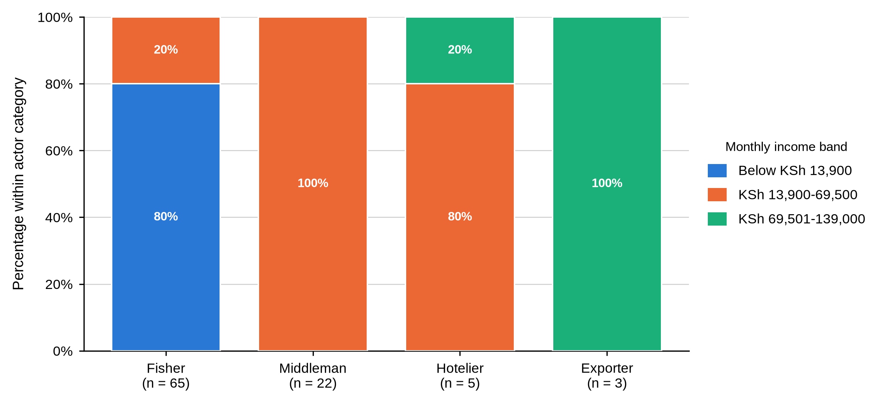
Table 11
Other Income Activities, Operating Licence and Loan Use by Actor and BMU
Characteristic / response | Actor | Overall | Shimoni | Majoreni | Vanga | Msambweni | Other sites | BMU p-value
Engages in other income activities
Yes | Fisher N = 65 | 13 (20.0%) | 7 (28.0%) | 3 (21.4%) | 1 (4.8%) | 1 (33.3%) | 1 (50.0%) | .234
No |  | 52 (80.0%) | 18 (72.0%) | 11 (78.6%) | 20 (95.2%) | 2 (66.7%) | 1 (50.0%)
Yes | Middleman N = 22 | 22 (100.0%) | 11 (100.0%) | 7 (100.0%) | 4 (100.0%) | - | -
No |  | 0 (0.0%) | 0 (0.0%) | 0 (0.0%) | 0 (0.0%) | - | -
Yes | Hotelier N = 5 | 5 (100.0%) | 1 (100.0%) | - | - | - | 4 (100.0%)
No |  | 0 (0.0%) | 0 (0.0%) | - | - | - | 0 (0.0%)
Yes | Exporter N = 4 | 4 (100.0%) | - | - | - | - | 4 (100.0%)
No |  | 0 (0.0%) | - | - | - | - | 0 (0.0%)
Holds an operating licence
Yes | Fisher N = 64 | 8 (12.5%) | 2 (8.0%) | 2 (15.4%) | 3 (14.3%) | 0 (0.0%) | 1 (50.0%) | .840
No |  | 56 (87.5%) | 23 (92.0%) | 11 (84.6%) | 18 (85.7%) | 3 (100.0%) | 1 (50.0%)
Yes | Middleman N = 22 | 6 (27.3%) | 2 (18.2%) | 2 (28.6%) | 2 (50.0%) | - | - | .580
No |  | 16 (72.7%) | 9 (81.8%) | 5 (71.4%) | 2 (50.0%) | - | -
Yes | Hotelier N = 5 | 5 (100.0%) | 1 (100.0%) | - | - | - | 4 (100.0%)
No |  | 0 (0.0%) | 0 (0.0%) | - | - | - | 0 (0.0%)
Yes | Exporter N = 4 | 4 (100.0%) | - | - | - | - | 4 (100.0%)
No |  | 0 (0.0%) | - | - | - | - | 0 (0.0%)
Uses loans to facilitate business
Yes | Fisher N = 65 | 0 (0.0%) | 0 (0.0%) | 0 (0.0%) | 0 (0.0%) | 0 (0.0%) | 0 (0.0%)
No |  | 65 (100.0%) | 25 (100.0%) | 14 (100.0%) | 21 (100.0%) | 3 (100.0%) | 2 (100.0%)
Yes | Middleman N = 22 | 16 (72.7%) | 8 (72.7%) | 4 (57.1%) | 4 (100.0%) | - | - | .311
No |  | 6 (27.3%) | 3 (27.3%) | 3 (42.9%) | 0 (0.0%) | - | -
Yes | Hotelier N = 5 | 0 (0.0%) | 0 (0.0%) | - | - | - | 0 (0.0%)
No |  | 5 (100.0%) | 1 (100.0%) | - | - | - | 4 (100.0%)
Yes | Exporter N = 4 | 2 (50.0%) | - | - | - | - | 2 (50.0%)
No |  | 2 (50.0%) | - | - | - | - | 2 (50.0%)
Table 11 covers three indicators of business formality and Figure 7 sets licensing, credit, training and collective membership side by side. Only 13 fishers (20.0%) reported another income activity, against every middleman, hotelier and exporter. Operating licences were held by 8 of 64 fishers (12.5%) and 6 of 22 middlemen (27.3%) against every hotelier and exporter. No fisher used a business loan, whereas 16 middlemen (72.7%) did, rising to all four (100.0%) at Vanga, and two of four exporters (50.0%). None of the three items was significantly associated with BMU.
Figure 7
Licensing, Credit, Training and Collective Membership by Actor Category
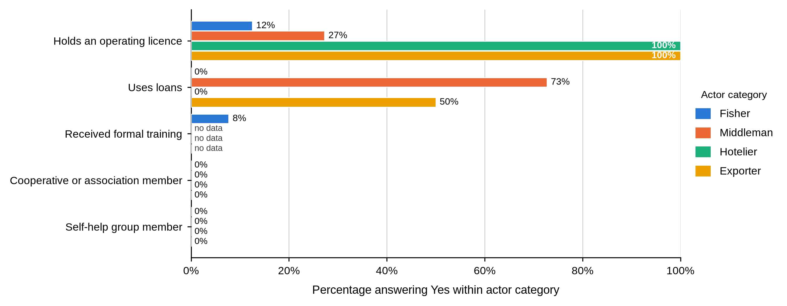
Table 12
Main Source of Business Credit by Actor and BMU
Characteristic / response | Actor | Overall | Shimoni | Majoreni | Vanga | Msambweni | Other sites | BMU p-value
Main source of business credit
Exporters | Fisher N = 65 | 0 (0.0%) | 0 (0.0%) | 0 (0.0%) | 0 (0.0%) | 0 (0.0%) | 0 (0.0%) | .124
Formal institutions |  | 0 (0.0%) | 0 (0.0%) | 0 (0.0%) | 0 (0.0%) | 0 (0.0%) | 0 (0.0%)
Middlemen |  | 61 (93.8%) | 25 (100.0%) | 13 (92.9%) | 19 (90.5%) | 2 (66.7%) | 2 (100.0%)
Middlemen and relatives |  | 4 (6.2%) | 0 (0.0%) | 1 (7.1%) | 2 (9.5%) | 1 (33.3%) | 0 (0.0%)
Exporters | Middleman N = 22 | 12 (54.5%) | 4 (36.4%) | 4 (57.1%) | 4 (100.0%) | - | - | .099
Formal institutions |  | 0 (0.0%) | 0 (0.0%) | 0 (0.0%) | 0 (0.0%) | - | -
Middlemen |  | 10 (45.5%) | 7 (63.6%) | 3 (42.9%) | 0 (0.0%) | - | -
Middlemen and relatives |  | 0 (0.0%) | 0 (0.0%) | 0 (0.0%) | 0 (0.0%) | - | -
Exporters | Hotelier N = 0 | - | - | - | - | - | -
Formal institutions |  | - | - | - | - | - | -
Middlemen |  | - | - | - | - | - | -
Middlemen and relatives |  | - | - | - | - | - | -
Exporters | Exporter N = 4 | 0 (0.0%) | - | - | - | - | 0 (0.0%)
Formal institutions |  | 4 (100.0%) | - | - | - | - | 4 (100.0%)
Middlemen |  | 0 (0.0%) | - | - | - | - | 0 (0.0%)
Middlemen and relatives |  | 0 (0.0%) | - | - | - | - | 0 (0.0%)
Table 12 shows where credit came from. Fishers who borrowed relied overwhelmingly on middlemen (61, 93.8%), with 4 (6.2%) naming middlemen and relatives together. Middlemen relied more on exporters (12, 54.5%) than on other middlemen (10, 45.5%), and all four exporters on formal institutions. No hotelier reported a credit source. Credit source was not significantly associated with BMU for fishers (p = .124) or middlemen (p = .099).
Considered together, Tables 8 to 12 and Figure 6 describe a business structure that scales and formalises down the chain. Scale rose from fishers, almost uniformly small-scale, through middlemen, whose scale varied by site, to hoteliers at medium scale and exporters at large. Income followed the same gradient and licensing was rare upstream but universal downstream. Credit traced the line in reverse: fishers borrowed from middlemen, middlemen from exporters, exporters from banks, a single chain of dependency from the landing beach to the export market.

4.3.3 Knowledge, Training and Group Membership
Table 13
Knowledge Acquisition and Formal Training by Actor and BMU
Characteristic / response | Actor | Overall | Shimoni | Majoreni | Vanga | Msambweni | Other sites | BMU p-value
How mud crab knowledge and skills were acquired
Family tradition | Fisher N = 64 | 41 (64.1%) | 19 (79.2%) | 8 (57.1%) | 11 (52.4%) | 1 (33.3%) | 2 (100.0%) | .194
Other source |  | 23 (35.9%) | 5 (20.8%) | 6 (42.9%) | 10 (47.6%) | 2 (66.7%) | 0 (0.0%)
Family tradition | Middleman N = 0 | - | - | - | - | - | -
Other source |  | - | - | - | - | - | -
Family tradition | Hotelier N = 0 | - | - | - | - | - | -
Other source |  | - | - | - | - | - | -
Family tradition | Exporter N = 0 | - | - | - | - | - | -
Other source |  | - | - | - | - | - | -
Received formal mud crab training
Yes | Fisher N = 65 | 5 (7.7%) | 1 (4.0%) | 3 (21.4%) | 0 (0.0%) | 1 (33.3%) | 0 (0.0%) | .035
No |  | 60 (92.3%) | 24 (96.0%) | 11 (78.6%) | 21 (100.0%) | 2 (66.7%) | 2 (100.0%)
Yes | Middleman N = 0 | - | - | - | - | - | -
No |  | - | - | - | - | - | -
Yes | Hotelier N = 0 | - | - | - | - | - | -
No |  | - | - | - | - | - | -
Yes | Exporter N = 0 | - | - | - | - | - | -
No |  | - | - | - | - | - | -
Table 13 covers how fishers learned the trade and whether they had been trained. Both items were put to fishers only. Family tradition was the leading route into the fishery (41 of 64, 64.1%), ranging from 19 (79.2%) at Shimoni to 1 (33.3%) at Msambweni, and was not associated with BMU (p = .194). Formal training was rare: only 5 of 65 fishers (7.7%) had received any, and training did vary by site (p = .035), with 3 of 14 trained fishers at Majoreni (21.4%) against 1 of 25 at Shimoni (4.0%) and none at Vanga.
Table 14
Cooperative Membership, Self-Help Group Participation and Primary Market Supplied by Actor and BMU
Characteristic / response | Actor | Overall | Shimoni | Majoreni | Vanga | Msambweni | Other sites | BMU p-value
Member of a cooperative or association
No | Fisher N = 65 | 65 (100.0%) | 25 (100.0%) | 14 (100.0%) | 21 (100.0%) | 3 (100.0%) | 2 (100.0%)
No | Middleman N = 22 | 22 (100.0%) | 11 (100.0%) | 7 (100.0%) | 4 (100.0%) | - | -
No | Hotelier N = 5 | 5 (100.0%) | 1 (100.0%) | - | - | - | 4 (100.0%)
No | Exporter N = 4 | 4 (100.0%) | - | - | - | - | 4 (100.0%)
Participates in a self-help group
No | Fisher N = 65 | 65 (100.0%) | 25 (100.0%) | 14 (100.0%) | 21 (100.0%) | 3 (100.0%) | 2 (100.0%)
No | Middleman N = 22 | 22 (100.0%) | 11 (100.0%) | 7 (100.0%) | 4 (100.0%) | - | -
No | Hotelier N = 5 | 5 (100.0%) | 1 (100.0%) | - | - | - | 4 (100.0%)
No | Exporter N = 4 | 4 (100.0%) | - | - | - | - | 4 (100.0%)
Primary market supplied
Local markets | Fisher N = 65 | 65 (100.0%) | 25 (100.0%) | 14 (100.0%) | 21 (100.0%) | 3 (100.0%) | 2 (100.0%)
Export markets |  | 0 (0.0%) | 0 (0.0%) | 0 (0.0%) | 0 (0.0%) | 0 (0.0%) | 0 (0.0%)
Local markets | Middleman N = 22 | 22 (100.0%) | 11 (100.0%) | 7 (100.0%) | 4 (100.0%) | - | -
Export markets |  | 0 (0.0%) | 0 (0.0%) | 0 (0.0%) | 0 (0.0%) | - | -
Local markets | Hotelier N = 5 | 5 (100.0%) | 1 (100.0%) | - | - | - | 4 (100.0%)
Export markets |  | 0 (0.0%) | 0 (0.0%) | - | - | - | 0 (0.0%)
Local markets | Exporter N = 4 | 0 (0.0%) | - | - | - | - | 0 (0.0%)
Export markets |  | 4 (100.0%) | - | - | - | - | 4 (100.0%)
As shown in Table 14, no fisher, middleman, hotelier or exporter reported membership of a cooperative or association, or participation in a self-help group. The figure was 0% in every actor category at every site. Primary market divided cleanly by actor: fishers, middlemen and hoteliers supplied local markets exclusively, while all four exporters supplied export markets exclusively.
Tables 13 and 14 point to a fishery with very little institutional support. Most fishers learned the trade at home rather than through instruction, and fewer than one in twelve had received any training. Not one respondent at any node belonged to a cooperative, an association or a self-help group. The only formal structure in the chain was the market channel itself, which divided the domestic and international segments categorically. For Objective One the absence of any collective body is the most consequential finding: every actor here negotiates alone.

4.3.4 Summary of Objective One
Objective One describes four actor categories that differ in the same direction on almost every measure. Fishers were younger, schooled to primary level or below, small-scale, minimally licensed, untrained and un-diversified, and they borrowed from the middlemen who buy from them. Middlemen were older and far more experienced. Hoteliers and exporters were formally qualified, fully licensed and operating at a scale the upstream nodes do not reach. Fisher age was the only demographic characteristic significantly associated with BMU.

4.3.5 Discussion of Findings in Relation to Previous Studies
The profile is young to middle-aged and almost entirely male, which fits accounts of the Kenyan mud crab fishery as a small-scale coastal livelihood in mangrove-dependent communities (Mirera, 2017a; Fondo & Ogutu, 2021). Fisher age was the one demographic characteristic that varied significantly by BMU, so age composition can differ from site to site even where the wider social profile does not. The near absence of women reflects a sampling frame built on landing-site registers, not an absence of women from crab-related work.
Qualifications, scale, income, licensing and formality all rise together towards the downstream end of the chain. Mirera (2014a, 2017a) draws the same line between community-level harvesting and market-facing trade, though neither study establishes education as the cause of occupational position. Ownership was universal at every node, so the earnings gradient cannot be put down to who owns the enterprise. The hotelier and exporter figures rest on five and four respondents drawn mostly from outside the four BMUs, and carry that uncertainty.
Credit runs vertically. Fishers borrowed from middlemen, middlemen from exporters, exporters from banks. Crona et al. (2016) describe such advances as enabling and constraining at once, solving an immediate cash problem while narrowing where the seller can sell; Béné et al. (2007) treat informal credit in small-scale fisheries as both safety net and a mechanism of persistent low returns. This survey did not record amounts, terms or duration, so it cannot say which description fits. It does show that the person lending to a fisher is the person buying from him.
Learning stayed informal, with family tradition the commonest route in and formal training rare. That contrasts with the organised community-group model Mirera (2014a) examined, where organisation was central to small-scale mud crab aquaculture. Not one respondent at any node belonged to a cooperative, an association or a self-help group. Gutiérrez et al. (2011) found that leadership and visible benefits, rather than the existence of a group, separate the successful cases; that nothing survives here suggests earlier attempts offered members little they could point to. Evidence from organised aquaculture groups should not be assumed to describe independent capture-fishery actors (Fondo & Ogutu, 2021).

4.4 Objective Two: Functions Performed by Actors at Each Market Node
Objective Two examined what each actor category actually does with a mud crab: how it is obtained, prepared, graded, packed, moved, priced and paid for. The results are grouped into acquisition and disposal, buyers and market channels, handling and transport, grading and quality, losses, payment and price setting, trading relationships, and reported prices.

4.4.1 Acquisition of Crabs and Disposal of the Catch
Table 15
How Mud Crabs Are Acquired and Source of Crabs for Sale by Actor and BMU
Characteristic / response | Actor | Overall | Shimoni | Majoreni | Vanga | Msambweni | Other sites | BMU p-value
How mud crabs are acquired
Catching | Fisher N = 65 | 65 (100.0%) | 25 (100.0%) | 14 (100.0%) | 21 (100.0%) | 3 (100.0%) | 2 (100.0%)
Purchasing |  | 0 (0.0%) | 0 (0.0%) | 0 (0.0%) | 0 (0.0%) | 0 (0.0%) | 0 (0.0%)
Catching | Middleman N = 22 | 0 (0.0%) | 0 (0.0%) | 0 (0.0%) | 0 (0.0%) | - | -
Purchasing |  | 22 (100.0%) | 11 (100.0%) | 7 (100.0%) | 4 (100.0%) | - | -
Catching | Hotelier N = 5 | 0 (0.0%) | 0 (0.0%) | - | - | - | 0 (0.0%)
Purchasing |  | 5 (100.0%) | 1 (100.0%) | - | - | - | 4 (100.0%)
Catching | Exporter N = 4 | 0 (0.0%) | - | - | - | - | 0 (0.0%)
Purchasing |  | 4 (100.0%) | - | - | - | - | 4 (100.0%)
Table 15 divides the chain at its first joint. All 65 fishers obtained crabs by catching them and every middleman, hotelier and exporter by purchase, at every site. Figure 8 shows the source following the same division: fishers caught personally, 21 of 22 middlemen (95.5%) bought from other middlemen, all five hoteliers bought from middlemen and all four exporters from middlemen or agents. The one middleman who caught personally was at Shimoni.
Figure 8
Source of Crabs for Sale Within Each Actor Category
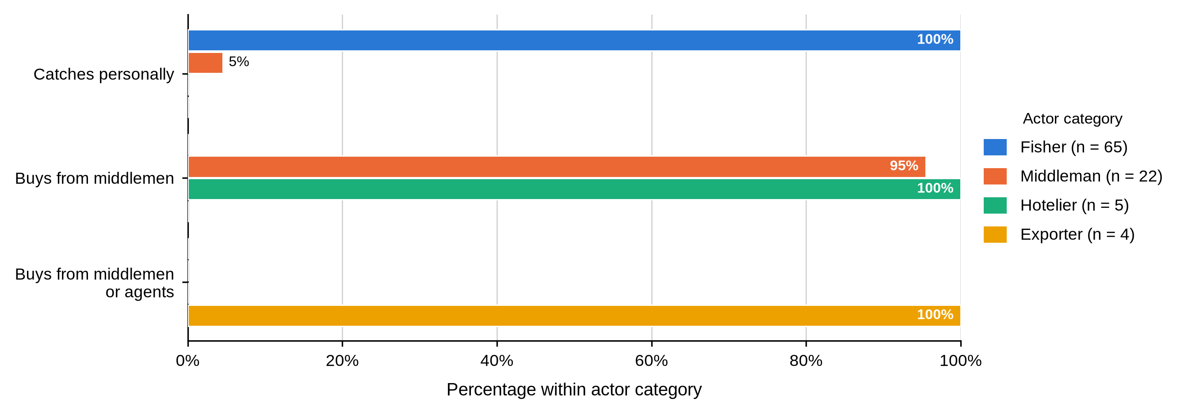
Figure 9 covers harvesting gear, answered by fishers and by the one middleman who also caught. Hand collection dominated (47 of 65, 72.3%), ranging from 8 (57.1%) at Majoreni to 2 (100.0%) in the Other sites group, followed by scoop nets (9, 13.8%) and hooked sticks (8, 12.3%), with a single report of sweep nets. Gear was not associated with BMU (p = .144).
Figure 9
Fishing or Collection Gear Used by Fishers Within Each BMU
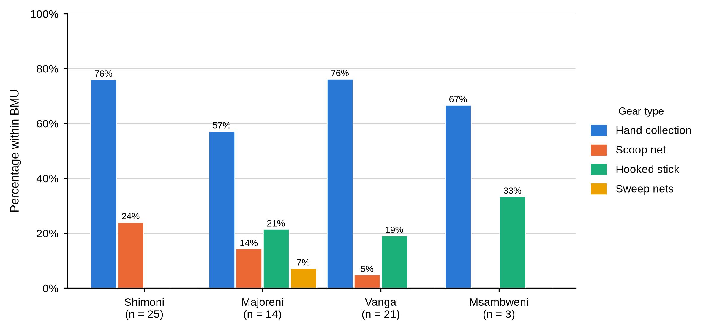
Figure 10 gives the daily catch. The commonest band was 5–10 kg (44 of 65 fishers, 67.7%), ranging from 8 (57.1%) at Majoreni to 17 (81.0%) at Vanga; 14 fishers (21.5%) reported more than 10 kg and 6 (9.2%) reported 4–5 kg, the latter concentrated at Msambweni (1, 33.3%). Daily catch was not associated with BMU (p = .453). The item was not put to middlemen, hoteliers or exporters, whose columns are blank.
Figure 10
Daily Mud Crab Catch Reported by Fishers Within Each BMU
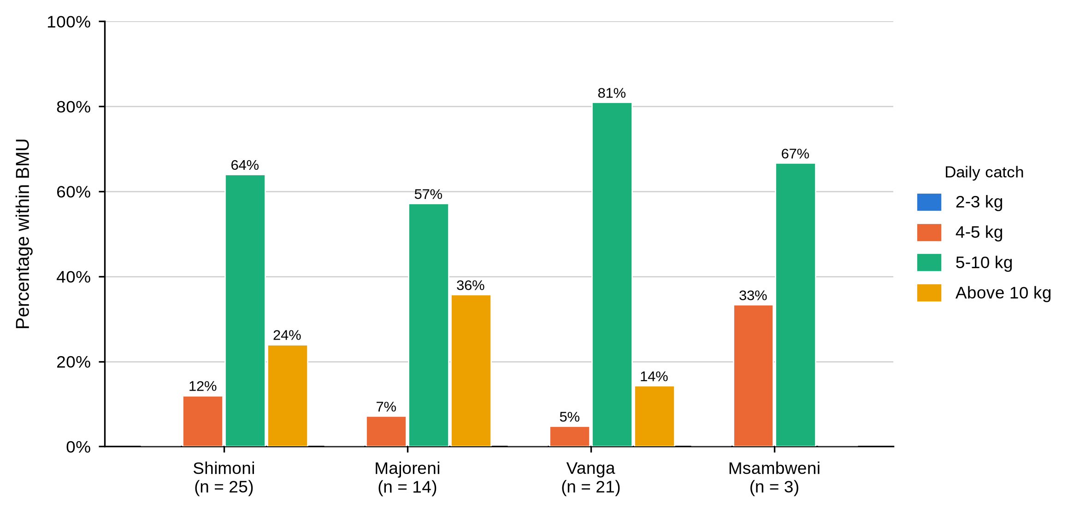
Table 16
Proportion of Catch Sold and Travel Time from Fishing Grounds to Market by Actor and BMU
Characteristic / response | Actor | Overall | Shimoni | Majoreni | Vanga | Msambweni | Other sites | BMU p-value
Proportion of catch sold
Whole catch | Fisher N = 65 | 52 (80.0%) | 20 (80.0%) | 13 (92.9%) | 15 (71.4%) | 2 (66.7%) | 2 (100.0%) | .452
Three-quarters |  | 13 (20.0%) | 5 (20.0%) | 1 (7.1%) | 6 (28.6%) | 1 (33.3%) | 0 (0.0%)
Whole catch | Middleman N = 0 | - | - | - | - | - | -
Three-quarters |  | - | - | - | - | - | -
Whole catch | Hotelier N = 0 | - | - | - | - | - | -
Three-quarters |  | - | - | - | - | - | -
Whole catch | Exporter N = 0 | - | - | - | - | - | -
Three-quarters |  | - | - | - | - | - | -
Travel time from fishing grounds to market
1 hour | Fisher N = 65 | 22 (33.8%) | 4 (16.0%) | 9 (64.3%) | 8 (38.1%) | 0 (0.0%) | 1 (50.0%) | .010
6 hours |  | 43 (66.2%) | 21 (84.0%) | 5 (35.7%) | 13 (61.9%) | 3 (100.0%) | 1 (50.0%)
1 hour | Middleman N = 0 | - | - | - | - | - | -
6 hours |  | - | - | - | - | - | -
1 hour | Hotelier N = 0 | - | - | - | - | - | -
6 hours |  | - | - | - | - | - | -
1 hour | Exporter N = 0 | - | - | - | - | - | -
6 hours |  | - | - | - | - | - | -
Table 16 reports what fishers did with the catch. Selling the whole catch was the norm (52, 80.0%), ranging from 2 (66.7%) at Msambweni to 13 (92.9%) at Majoreni, and the remaining 13 fishers (20.0%) sold three-quarters. Travel time to market was six hours for 43 fishers (66.2%) and one hour for 22 (33.8%), and it varied significantly by site (p = .010): 21 of 25 Shimoni fishers (84.0%) and all three at Msambweni reported six hours against 5 of 14 at Majoreni (35.7%). Proportion sold was not associated with BMU (p = .452).
Tables 15 and 16 and Figures 8 to 10 establish the harvesting node as a seller with no holding capacity and no alternative to immediate sale. A fisher who lands 5 to 10 kg of live crab, carries it on foot for up to six hours and disposes of the whole catch the same day cannot wait for a better offer. Majoreni fishers reached market fastest, and Majoreni also turns out to be the site where fishers received the best price.

4.4.2 Buyers and Market Channels
Figure 11 shows who each actor sold to. Every fisher, at every site, sold to a first-level middleman. Middlemen sold on to company agents (9, 40.9%), second-level middlemen (7, 31.8%) or exporters (5, 22.7%), with one selling to another first-level middleman; the company-agent share ran from 3 (27.3%) at Shimoni to 3 (75.0%) at Vanga, and buyer category was not associated with BMU (p = .656). Hoteliers sold to consumers and exporters to importers, in both cases without exception.
Figure 11
Main Buyer Category Within Each Actor Category
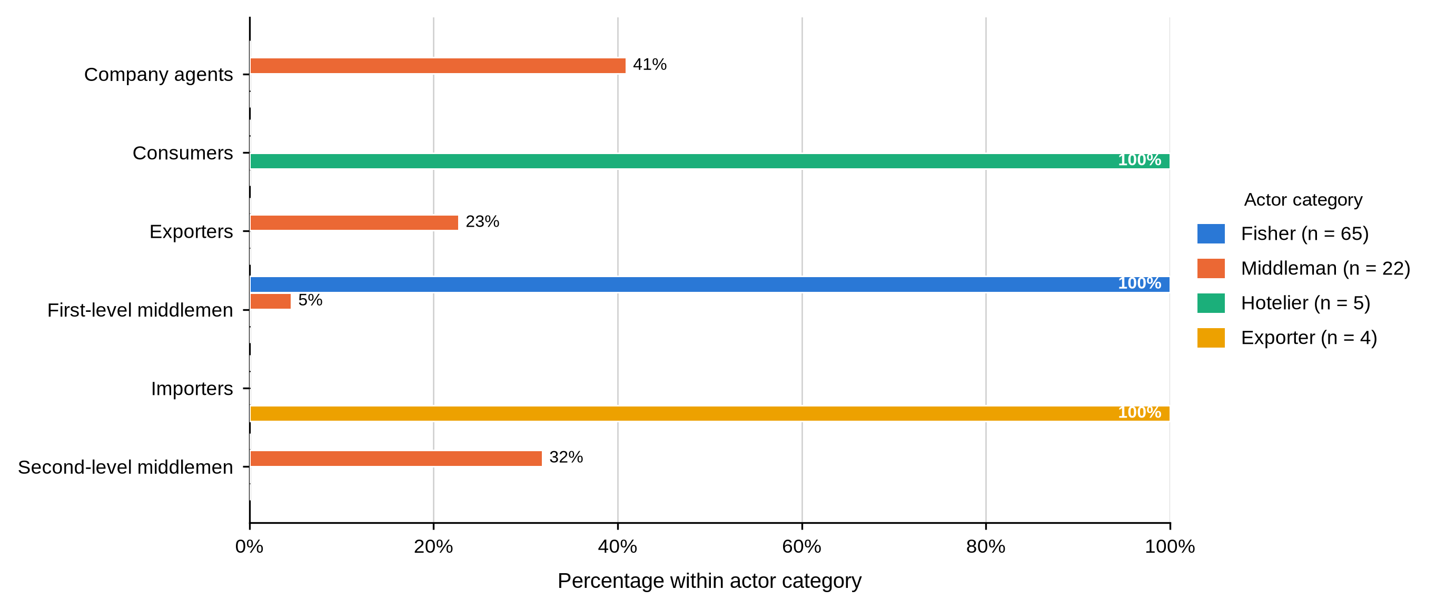
Table 17
Primary Market Channel and Contact With Final Consumers by Actor and BMU
Characteristic / response | Actor | Overall | Shimoni | Majoreni | Vanga | Msambweni | Other sites | BMU p-value
Primary market channel
Export markets | Fisher N = 65 | 0 (0.0%) | 0 (0.0%) | 0 (0.0%) | 0 (0.0%) | 0 (0.0%) | 0 (0.0%)
Local markets |  | 65 (100.0%) | 25 (100.0%) | 14 (100.0%) | 21 (100.0%) | 3 (100.0%) | 2 (100.0%)
Restaurants and hotels |  | 0 (0.0%) | 0 (0.0%) | 0 (0.0%) | 0 (0.0%) | 0 (0.0%) | 0 (0.0%)
Export markets | Middleman N = 22 | 0 (0.0%) | 0 (0.0%) | 0 (0.0%) | 0 (0.0%) | - | -
Local markets |  | 22 (100.0%) | 11 (100.0%) | 7 (100.0%) | 4 (100.0%) | - | -
Restaurants and hotels |  | 0 (0.0%) | 0 (0.0%) | 0 (0.0%) | 0 (0.0%) | - | -
Export markets | Hotelier N = 5 | 0 (0.0%) | 0 (0.0%) | - | - | - | 0 (0.0%)
Local markets |  | 0 (0.0%) | 0 (0.0%) | - | - | - | 0 (0.0%)
Restaurants and hotels |  | 5 (100.0%) | 1 (100.0%) | - | - | - | 4 (100.0%)
Export markets | Exporter N = 4 | 4 (100.0%) | - | - | - | - | 4 (100.0%)
Local markets |  | 0 (0.0%) | - | - | - | - | 0 (0.0%)
Restaurants and hotels |  | 0 (0.0%) | - | - | - | - | 0 (0.0%)
Contact with final consumers
Through intermediaries | Fisher N = 65 | 65 (100.0%) | 25 (100.0%) | 14 (100.0%) | 21 (100.0%) | 3 (100.0%) | 2 (100.0%)
Direct contact |  | 0 (0.0%) | 0 (0.0%) | 0 (0.0%) | 0 (0.0%) | 0 (0.0%) | 0 (0.0%)
Through intermediaries | Middleman N = 22 | 22 (100.0%) | 11 (100.0%) | 7 (100.0%) | 4 (100.0%) | - | -
Direct contact |  | 0 (0.0%) | 0 (0.0%) | 0 (0.0%) | 0 (0.0%) | - | -
Through intermediaries | Hotelier N = 5 | 0 (0.0%) | 0 (0.0%) | - | - | - | 0 (0.0%)
Direct contact |  | 5 (100.0%) | 1 (100.0%) | - | - | - | 4 (100.0%)
Through intermediaries | Exporter N = 4 | 0 (0.0%) | - | - | - | - | 0 (0.0%)
Direct contact |  | 4 (100.0%) | - | - | - | - | 4 (100.0%)
Table 17 completes the picture. Fishers and middlemen supplied local markets only, hoteliers restaurants and hotels, exporters export markets. Contact with the final consumer divided as cleanly: all 65 fishers and all 22 middlemen reached the consumer only through intermediaries, while all five hoteliers and all four exporters dealt with the end buyer directly. Neither item varied enough within fishers or middlemen to support a test against BMU.
Table 17 and Figure 11 answer a central part of Objective Two. The actors who know what a crab finally sells for are the two groups furthest from the water, and the two groups who catch and aggregate it never meet the person who eats it. That informational distance underlies the price results reported later in this chapter.
Table 18
Number of Buyers, State of Crabs Sold and Regularity of the Main Buyer by Actor and BMU
Characteristic / response | Actor | Overall | Shimoni | Majoreni | Vanga | Msambweni | Other sites | BMU p-value
Number of buyers reported
One buyer | Fisher N = 65 | 50 (76.9%) | 17 (68.0%) | 10 (71.4%) | 18 (85.7%) | 3 (100.0%) | 2 (100.0%) | .412
Two buyers |  | 15 (23.1%) | 8 (32.0%) | 4 (28.6%) | 3 (14.3%) | 0 (0.0%) | 0 (0.0%)
One buyer | Middleman N = 0 | - | - | - | - | - | -
Two buyers |  | - | - | - | - | - | -
One buyer | Hotelier N = 0 | - | - | - | - | - | -
Two buyers |  | - | - | - | - | - | -
One buyer | Exporter N = 0 | - | - | - | - | - | -
Two buyers |  | - | - | - | - | - | -
State of mud crabs sold
Live | Fisher N = 65 | 65 (100.0%) | 25 (100.0%) | 14 (100.0%) | 21 (100.0%) | 3 (100.0%) | 2 (100.0%)
Live | Middleman N = 0 | - | - | - | - | - | -
Live | Hotelier N = 0 | - | - | - | - | - | -
Live | Exporter N = 0 | - | - | - | - | - | -
Main buyer is regular
Yes | Fisher N = 65 | 65 (100.0%) | 25 (100.0%) | 14 (100.0%) | 21 (100.0%) | 3 (100.0%) | 2 (100.0%)
Yes | Middleman N = 22 | 22 (100.0%) | 11 (100.0%) | 7 (100.0%) | 4 (100.0%) | - | -
Yes | Hotelier N = 5 | 5 (100.0%) | 1 (100.0%) | - | - | - | 4 (100.0%)
Yes | Exporter N = 4 | 4 (100.0%) | - | - | - | - | 4 (100.0%)
Table 18 records buyer numbers and the condition in which crabs changed hands. Among fishers, 50 (76.9%) reported a single buyer and 15 (23.1%) reported two, the single-buyer share ranging from 17 (68.0%) at Shimoni to all three (100.0%) at Msambweni; the number of buyers was not associated with BMU (p = .412). The item was not put to the other three categories. All 65 fishers sold crabs live, and every respondent in all four actor categories, 96 of 96, said their main buyer was a regular one.
Those rows describe a market with almost no spot trading at the harvesting node. Three quarters of fishers dealt with one buyer, that buyer was a regular, and the crab was live and therefore perishable at the moment of sale. A seller in that position has little practical ability to decline the price offered.
Table 19
Location of Sale and Knowledge of the Onward Sale by Actor and BMU
Characteristic / response | Actor | Overall | Shimoni | Majoreni | Vanga | Msambweni | Other sites | BMU p-value
Location of sale
Landing beach | Fisher N = 65 | 65 (100.0%) | 25 (100.0%) | 14 (100.0%) | 21 (100.0%) | 3 (100.0%) | 2 (100.0%)
Market |  | 0 (0.0%) | 0 (0.0%) | 0 (0.0%) | 0 (0.0%) | 0 (0.0%) | 0 (0.0%)
Town |  | 0 (0.0%) | 0 (0.0%) | 0 (0.0%) | 0 (0.0%) | 0 (0.0%) | 0 (0.0%)
Landing beach | Middleman N = 22 | 1 (4.5%) | 1 (9.1%) | 0 (0.0%) | 0 (0.0%) | - | - | .928
Market |  | 10 (45.5%) | 4 (36.4%) | 4 (57.1%) | 2 (50.0%) | - | -
Town |  | 11 (50.0%) | 6 (54.5%) | 3 (42.9%) | 2 (50.0%) | - | -
Landing beach | Hotelier N = 5 | 0 (0.0%) | 0 (0.0%) | - | - | - | 0 (0.0%)
Market |  | 0 (0.0%) | 0 (0.0%) | - | - | - | 0 (0.0%)
Town |  | 5 (100.0%) | 1 (100.0%) | - | - | - | 4 (100.0%)
Landing beach | Exporter N = 4 | 0 (0.0%) | - | - | - | - | 0 (0.0%)
Market |  | 0 (0.0%) | - | - | - | - | 0 (0.0%)
Town |  | 4 (100.0%) | - | - | - | - | 4 (100.0%)
Knows whom the next trader sells to
No | Fisher N = 65 | 65 (100.0%) | 25 (100.0%) | 14 (100.0%) | 21 (100.0%) | 3 (100.0%) | 2 (100.0%)
No | Middleman N = 22 | 22 (100.0%) | 11 (100.0%) | 7 (100.0%) | 4 (100.0%) | - | -
No | Hotelier N = 0 | - | - | - | - | - | -
No | Exporter N = 4 | 4 (100.0%) | - | - | - | - | 4 (100.0%)
As shown in Table 19, the place of sale divided by node. Every fisher sold at the landing beach, without exception at any site. Middlemen sold in town (11, 50.0%) or at a market (10, 45.5%), with one still selling at the beach, and the pattern did not vary by BMU (p = .928). All five hoteliers and all four exporters sold in town. Every fisher, every middleman and all four exporters who answered said they did not know whom the next trader sold to; no hotelier completed the item.
Not one actor upstream of the final buyer could say where the crab went next. With the absence of market research reported later in Table 35, no actor in this chain has sight of the price two steps ahead of their own transaction.
Table 20
First Buyer Location Reported by Fishers by BMU
Characteristic / response | Actor | Overall | Shimoni | Majoreni | Vanga | Msambweni | Other sites | BMU p-value
First buyer location
Bodo Pwani | Fisher N = 63 | 1 (1.6%) | 1 (4.0%) | 0 (0.0%) | 0 (0.0%) | 0 (0.0%) | 0 (0.0%) | < .001
Gasi |  | 2 (3.2%) | 0 (0.0%) | 0 (0.0%) | 0 (0.0%) | 2 (66.7%) | 0 (0.0%)
Kiwegu |  | 16 (25.4%) | 0 (0.0%) | 1 (7.7%) | 15 (75.0%) | 0 (0.0%) | 0 (0.0%)
Majoreni / Aleni |  | 19 (30.2%) | 2 (8.0%) | 12 (92.3%) | 2 (10.0%) | 1 (33.3%) | 2 (100.0%)
Mkuyuni |  | 17 (27.0%) | 16 (64.0%) | 0 (0.0%) | 1 (5.0%) | 0 (0.0%) | 0 (0.0%)
Mwambao |  | 1 (1.6%) | 1 (4.0%) | 0 (0.0%) | 0 (0.0%) | 0 (0.0%) | 0 (0.0%)
Shimoni |  | 5 (7.9%) | 5 (20.0%) | 0 (0.0%) | 0 (0.0%) | 0 (0.0%) | 0 (0.0%)
Vanga |  | 2 (3.2%) | 0 (0.0%) | 0 (0.0%) | 2 (10.0%) | 0 (0.0%) | 0 (0.0%)
Bodo Pwani | Middleman N = 0 | - | - | - | - | - | -
Gasi |  | - | - | - | - | - | -
Kiwegu |  | - | - | - | - | - | -
Majoreni / Aleni |  | - | - | - | - | - | -
Mkuyuni |  | - | - | - | - | - | -
Mwambao |  | - | - | - | - | - | -
Shimoni |  | - | - | - | - | - | -
Vanga |  | - | - | - | - | - | -
Bodo Pwani | Hotelier N = 0 | - | - | - | - | - | -
Gasi |  | - | - | - | - | - | -
Kiwegu |  | - | - | - | - | - | -
Majoreni / Aleni |  | - | - | - | - | - | -
Mkuyuni |  | - | - | - | - | - | -
Mwambao |  | - | - | - | - | - | -
Shimoni |  | - | - | - | - | - | -
Vanga |  | - | - | - | - | - | -
Bodo Pwani | Exporter N = 0 | - | - | - | - | - | -
Gasi |  | - | - | - | - | - | -
Kiwegu |  | - | - | - | - | - | -
Majoreni / Aleni |  | - | - | - | - | - | -
Mkuyuni |  | - | - | - | - | - | -
Mwambao |  | - | - | - | - | - | -
Shimoni |  | - | - | - | - | - | -
Vanga |  | - | - | - | - | - | -
Table 20 reports where fishers said their first buyer was located, answered by 63 of the 65 fishers. Three places accounted for more than four-fifths of first sales: Majoreni or Aleni, named by 19 (30.2%), Mkuyuni by 17 (27.0%) and Kiwegu by 16 (25.4%). Shimoni was named by 5 (7.9%), and Gasi, Vanga, Mwambao and Bodo Pwani by four fishers between them. Each is the buying point nearest a particular landing site: 16 of 25 at Shimoni (64.0%) named Mkuyuni, 12 of 13 at Majoreni (92.3%) named Majoreni or Aleni, and 15 of 20 at Vanga (75.0%) named Kiwegu. The association with BMU was the strongest recorded anywhere in this study, χ²(21, N = 61) = 125.19, p < .001, 99% CI [.000, .000].
That result needs care. A near-perfect association between where a fisher lands and where his buyer sits is close to a tautology, and is reported for completeness rather than as a finding about market structure. What it establishes is that first sale is local: the buyer sits beside the landing site, not in a distant market the fisher could reach instead.
Table 21
Second Buyer Location Reported by Fishers by BMU
Characteristic / response | Actor | Overall | Shimoni | Majoreni | Vanga | Msambweni | Other sites | BMU p-value
Second buyer location
Kiwegu | Fisher N = 15 | 3 (20.0%) | 0 (0.0%) | 1 (20.0%) | 2 (100.0%) | - | -
Majoreni / Aleni |  | 4 (26.7%) | 0 (0.0%) | 4 (80.0%) | 0 (0.0%) | - | -
Mkuyuni |  | 8 (53.3%) | 8 (100.0%) | 0 (0.0%) | 0 (0.0%) | - | -
Kiwegu | Middleman N = 0 | - | - | - | - | - | -
Majoreni / Aleni |  | - | - | - | - | - | -
Mkuyuni |  | - | - | - | - | - | -
Kiwegu | Hotelier N = 0 | - | - | - | - | - | -
Majoreni / Aleni |  | - | - | - | - | - | -
Mkuyuni |  | - | - | - | - | - | -
Kiwegu | Exporter N = 0 | - | - | - | - | - | -
Majoreni / Aleni |  | - | - | - | - | - | -
Mkuyuni |  | - | - | - | - | - | -
Table 21 covers the second buyer, answered by only 15 fishers. Of those, 8 (53.3%) named Mkuyuni, 4 (26.7%) Majoreni or Aleni and 3 (20.0%) Kiwegu, each group drawn almost entirely from one landing site: all eight naming Mkuyuni fished at Shimoni and all four naming Majoreni or Aleni fished at Majoreni. The remaining 50 fishers gave no second buyer at all, which fits the single-buyer pattern in Table 18 and is reported here because an absent alternative buyer is itself the finding.

4.4.3 Preparation, Packaging and Transport
Table 22
Preparation of Mud Crabs for Market and Preservation by Actor and BMU
Characteristic / response | Actor | Overall | Shimoni | Majoreni | Vanga | Msambweni | Other sites | BMU p-value
Preserves or processes mud crabs
Yes / frozen | Fisher N = 65 | 0 (0.0%) | 0 (0.0%) | 0 (0.0%) | 0 (0.0%) | 0 (0.0%) | 0 (0.0%)
No |  | 65 (100.0%) | 25 (100.0%) | 14 (100.0%) | 21 (100.0%) | 3 (100.0%) | 2 (100.0%)
Yes / frozen | Middleman N = 22 | 0 (0.0%) | 0 (0.0%) | 0 (0.0%) | 0 (0.0%) | - | -
No |  | 22 (100.0%) | 11 (100.0%) | 7 (100.0%) | 4 (100.0%) | - | -
Yes / frozen | Hotelier N = 5 | 5 (100.0%) | 1 (100.0%) | - | - | - | 4 (100.0%)
No |  | 0 (0.0%) | 0 (0.0%) | - | - | - | 0 (0.0%)
Yes / frozen | Exporter N = 4 | 0 (0.0%) | - | - | - | - | 0 (0.0%)
No |  | 4 (100.0%) | - | - | - | - | 4 (100.0%)
Figure 12 shows that preparation became more elaborate at each step. All 65 fishers prepared crabs by tying the claws; 21 of 22 middlemen (95.5%) cleaned, sorted and graded; all five hoteliers processed for the kitchen; and all four exporters cleaned, sorted and graded for consignment. Table 22 records preservation, which was reported only by the hoteliers, all five of whom froze the product; no fisher, middleman or exporter preserved or processed at all. Preparation was not associated with BMU among middlemen (p = 1.000).
Figure 12
Preparation of Mud Crabs for Market by Actor Category
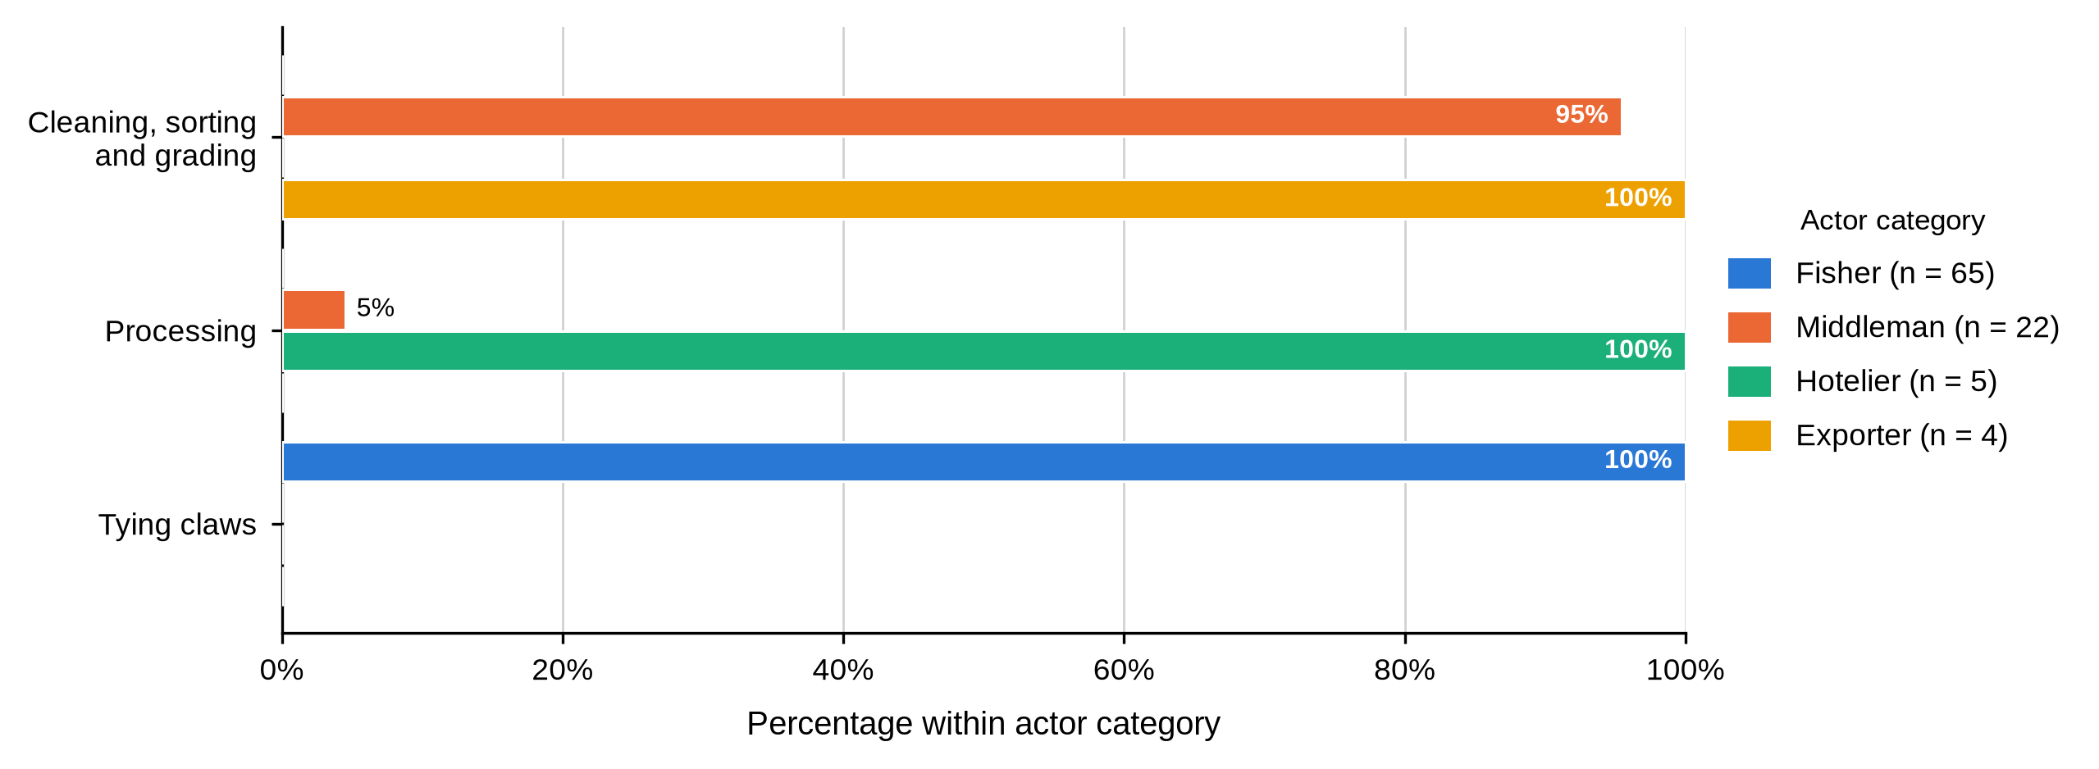
Figure 13 shows a clear ladder of containment. Fishers used sacks (44, 67.7%) or plastic containers (21, 32.3%); middlemen used crates (11, 50.0%) or baskets (10, 45.5%), with one still using a sack; and all four exporters used Styrofoam. Hoteliers did not complete this item because they bought at their own premises, so their column is left blank rather than recorded as zero. Packaging was not associated with BMU for fishers (p = .837) or middlemen (p = .924).
Figure 13
Packaging Used for Transporting Mud Crabs by Actor Category
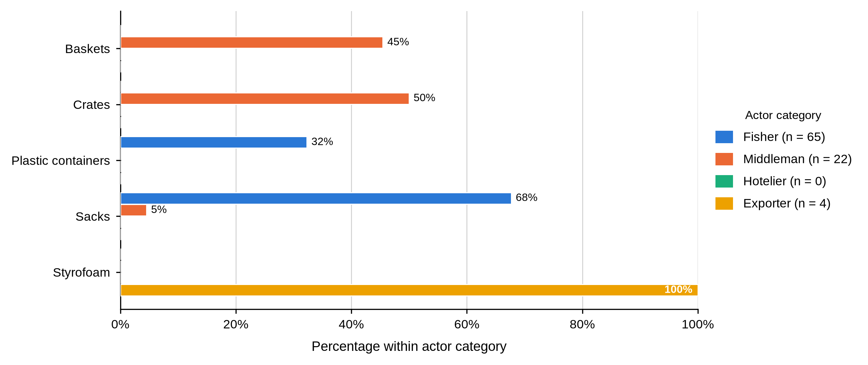
Figure 14 follows the same ladder. Fishers travelled on foot (57, 87.7%) or by motorcycle (8, 12.3%); middlemen used vehicles (17, 77.3%) or motorised boats (4, 18.2%), with one on foot; and all four exporters used air freight. Transport was not associated with BMU for fishers (p = .388) or middlemen (p = .402). Hoteliers did not complete this item because they purchased at their own premises.
Figure 14
Mode of Transporting Mud Crabs to Market by Actor Category
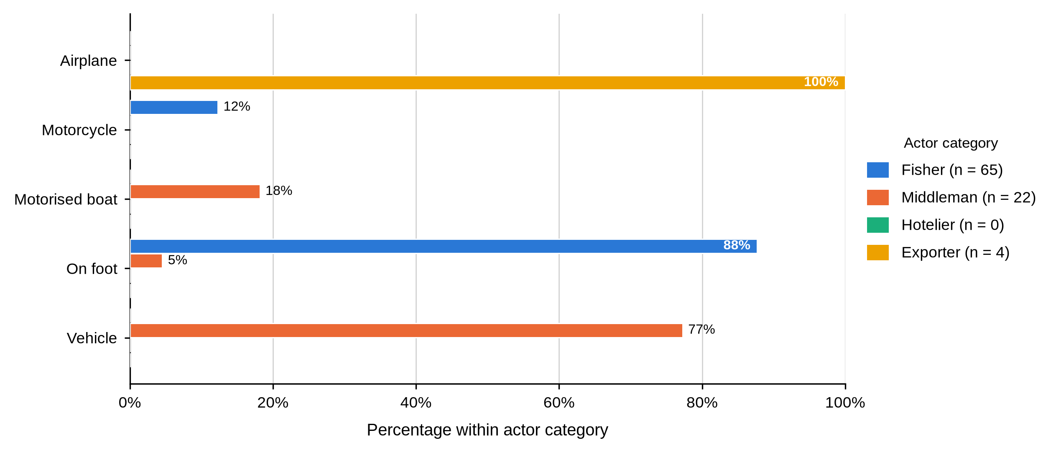
Table 22 and Figures 12 to 14 show that protection of the product rises with distance from the water, and that its cost falls on whoever holds the crab at the time. A sack carried on foot and a Styrofoam box flown out are two ends of one handling problem, and the actor least able to absorb a loss uses the least protective method.

4.4.4 Grading and Quality Control
Table 23
Grading Practice and Criteria Used to Determine Grade by Actor and BMU
Characteristic / response | Actor | Overall | Shimoni | Majoreni | Vanga | Msambweni | Other sites | BMU p-value
Engages in grading mud crabs
Yes | Fisher N = 65 | 65 (100.0%) | 25 (100.0%) | 14 (100.0%) | 21 (100.0%) | 3 (100.0%) | 2 (100.0%)
Yes | Middleman N = 22 | 22 (100.0%) | 11 (100.0%) | 7 (100.0%) | 4 (100.0%) | - | -
Yes | Hotelier N = 5 | 5 (100.0%) | 1 (100.0%) | - | - | - | 4 (100.0%)
Yes | Exporter N = 4 | 4 (100.0%) | - | - | - | - | 4 (100.0%)
Table 23 records the most consequential functional difference in the chapter. All 96 respondents, at every site, said they graded mud crabs, but not by the same rule. Figure 15 shows how far apart the criteria were: all 65 fishers graded on weight alone, while 21 of 22 middlemen (95.5%) and every hotelier and exporter combined size, weight, shell condition and claw size. The one middleman using weight alone was at Shimoni. Criteria did not vary by site among middlemen (p = 1.000) and did not vary at all among fishers.
Figure 15
Criteria Used to Determine Crab Grade by Actor Category
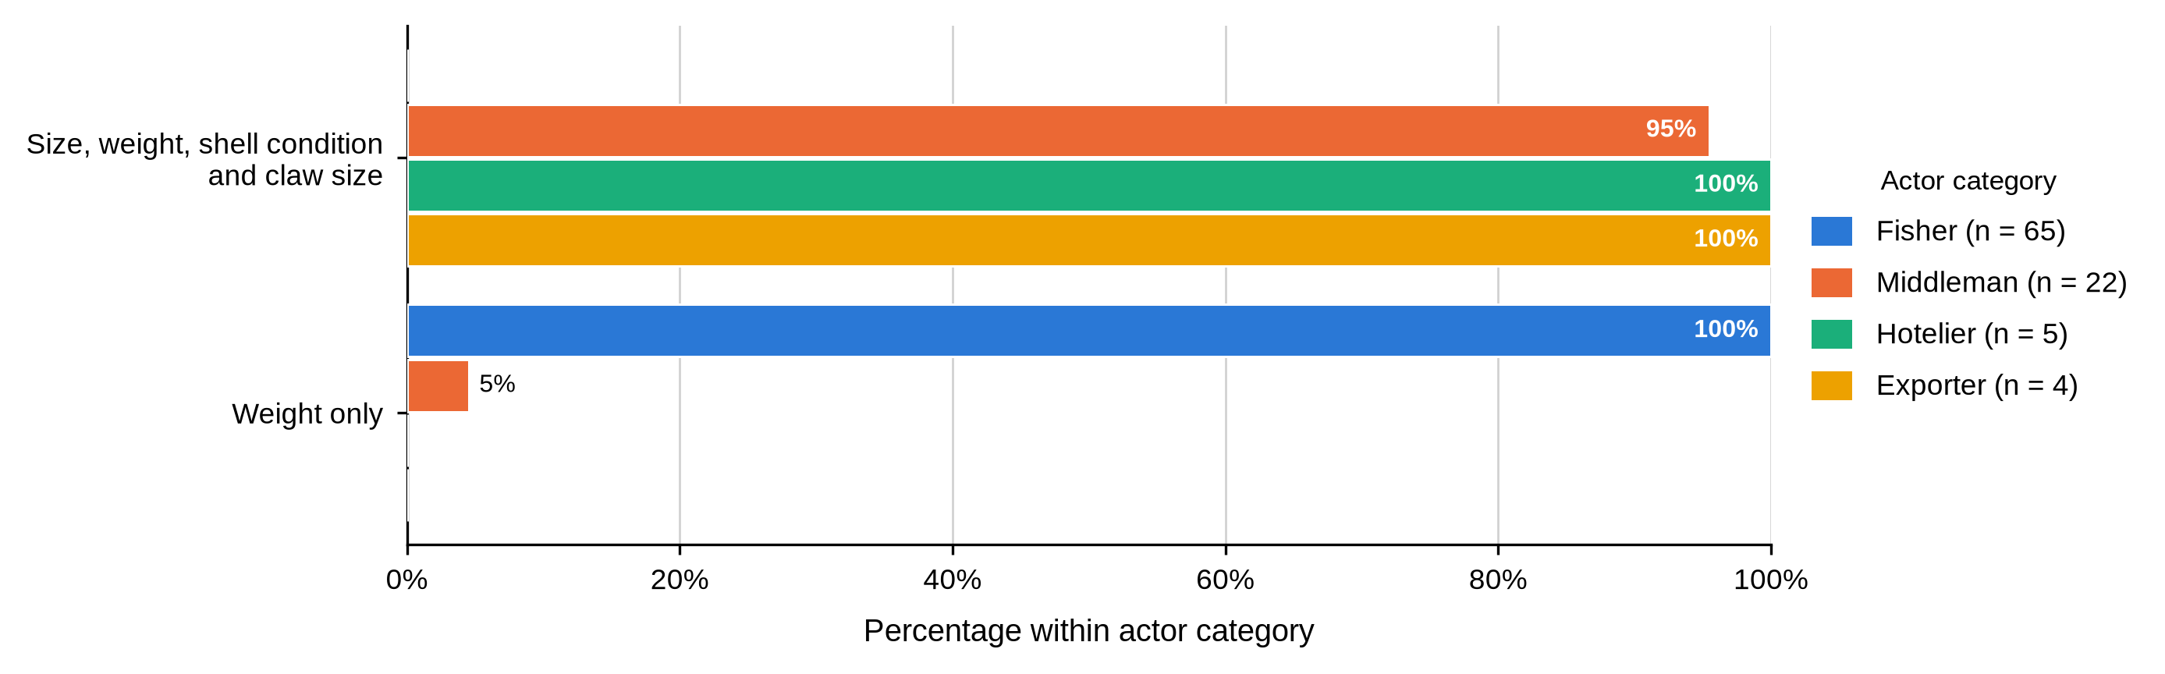
Table 24
Quality Measures Before Market and Use of Formal Quality Control by Actor and BMU
Characteristic / response | Actor | Overall | Shimoni | Majoreni | Vanga | Msambweni | Other sites | BMU p-value
Quality measure before the market
Inspections, certification and packaging standards | Fisher N = 65 | 0 (0.0%) | 0 (0.0%) | 0 (0.0%) | 0 (0.0%) | 0 (0.0%) | 0 (0.0%)
Packaging standards |  | 0 (0.0%) | 0 (0.0%) | 0 (0.0%) | 0 (0.0%) | 0 (0.0%) | 0 (0.0%)
Tying the claws |  | 65 (100.0%) | 25 (100.0%) | 14 (100.0%) | 21 (100.0%) | 3 (100.0%) | 2 (100.0%)
Inspections, certification and packaging standards | Middleman N = 22 | 0 (0.0%) | 0 (0.0%) | 0 (0.0%) | 0 (0.0%) | - | -
Packaging standards |  | 21 (95.5%) | 10 (90.9%) | 7 (100.0%) | 4 (100.0%) | - | -
Tying the claws |  | 1 (4.5%) | 1 (9.1%) | 0 (0.0%) | 0 (0.0%) | - | -
Inspections, certification and packaging standards | Hotelier N = 5 | 0 (0.0%) | 0 (0.0%) | - | - | - | 0 (0.0%)
Packaging standards |  | 5 (100.0%) | 1 (100.0%) | - | - | - | 4 (100.0%)
Tying the claws |  | 0 (0.0%) | 0 (0.0%) | - | - | - | 0 (0.0%)
Inspections, certification and packaging standards | Exporter N = 4 | 4 (100.0%) | - | - | - | - | 4 (100.0%)
Packaging standards |  | 0 (0.0%) | - | - | - | - | 0 (0.0%)
Tying the claws |  | 0 (0.0%) | - | - | - | - | 0 (0.0%)
Uses formal quality-control measures
Yes | Fisher N = 65 | 0 (0.0%) | 0 (0.0%) | 0 (0.0%) | 0 (0.0%) | 0 (0.0%) | 0 (0.0%)
No |  | 65 (100.0%) | 25 (100.0%) | 14 (100.0%) | 21 (100.0%) | 3 (100.0%) | 2 (100.0%)
Yes | Middleman N = 22 | 0 (0.0%) | 0 (0.0%) | 0 (0.0%) | 0 (0.0%) | - | -
No |  | 22 (100.0%) | 11 (100.0%) | 7 (100.0%) | 4 (100.0%) | - | -
Yes | Hotelier N = 5 | 5 (100.0%) | 1 (100.0%) | - | - | - | 4 (100.0%)
No |  | 0 (0.0%) | 0 (0.0%) | - | - | - | 0 (0.0%)
Yes | Exporter N = 4 | 4 (100.0%) | - | - | - | - | 4 (100.0%)
No |  | 0 (0.0%) | - | - | - | - | 0 (0.0%)
Table 24 shows the same asymmetry in quality assurance. Fishers tied the claws (65, 100.0%); middlemen (21, 95.5%) and hoteliers cited packaging standards; exporters cited inspections, certification and packaging standards. Formal quality-control measures were reported by all nine downstream actors and by none of the 87 fishers and middlemen.
Table 25
Size Label and Grade Assignment for Large Crabs by Actor and BMU
Characteristic / response | Actor | Overall | Shimoni | Majoreni | Vanga | Msambweni | Other sites | BMU p-value
Reported large-crab size category
Large | Fisher N = 65 | 53 (81.5%) | 14 (56.0%) | 14 (100.0%) | 20 (95.2%) | 3 (100.0%) | 2 (100.0%) | .001
All sizes / mixed |  | 12 (18.5%) | 11 (44.0%) | 0 (0.0%) | 1 (4.8%) | 0 (0.0%) | 0 (0.0%)
Large | Middleman N = 21 | 21 (100.0%) | 10 (100.0%) | 7 (100.0%) | 4 (100.0%) | - | -
All sizes / mixed |  | 0 (0.0%) | 0 (0.0%) | 0 (0.0%) | 0 (0.0%) | - | -
Large | Hotelier N = 5 | 5 (100.0%) | 1 (100.0%) | - | - | - | 4 (100.0%)
All sizes / mixed |  | 0 (0.0%) | 0 (0.0%) | - | - | - | 0 (0.0%)
Large | Exporter N = 4 | 4 (100.0%) | - | - | - | - | 4 (100.0%)
All sizes / mixed |  | 0 (0.0%) | - | - | - | - | 0 (0.0%)
Grade assigned to large crabs
Grade A | Fisher N = 65 | 50 (76.9%) | 14 (56.0%) | 14 (100.0%) | 17 (81.0%) | 3 (100.0%) | 2 (100.0%)
Mixed grade |  | 15 (23.1%) | 11 (44.0%) | 0 (0.0%) | 4 (19.0%) | 0 (0.0%) | 0 (0.0%)
Grade A | Middleman N = 22 | 22 (100.0%) | 11 (100.0%) | 7 (100.0%) | 4 (100.0%) | - | -
Mixed grade |  | 0 (0.0%) | 0 (0.0%) | 0 (0.0%) | 0 (0.0%) | - | -
Grade A | Hotelier N = 5 | 5 (100.0%) | 1 (100.0%) | - | - | - | 4 (100.0%)
Mixed grade |  | 0 (0.0%) | 0 (0.0%) | - | - | - | 0 (0.0%)
Grade A | Exporter N = 4 | 4 (100.0%) | - | - | - | - | 4 (100.0%)
Mixed grade |  | 0 (0.0%) | - | - | - | - | 0 (0.0%)
As shown in Table 25, 53 fishers (81.5%) used the Large label for their biggest crabs while 12 (18.5%) recorded all sizes or mixed, and 50 (76.9%) assigned Grade A against 15 (23.1%) assigning a mixed grade. Every middleman, hotelier and exporter who answered used the plain labels. The fisher pattern varied significantly by site (p = .001): at Shimoni only 14 of 25 (56.0%) used the Large label, against all 14 at Majoreni and 20 of 21 (95.2%) at Vanga.
Table 26
Size Label and Grade Assignment for Medium Crabs by Actor and BMU
Characteristic / response | Actor | Overall | Shimoni | Majoreni | Vanga | Msambweni | Other sites | BMU p-value
Reported medium-crab size category
Medium | Fisher N = 65 | 63 (96.9%) | 23 (92.0%) | 14 (100.0%) | 21 (100.0%) | 3 (100.0%) | 2 (100.0%) | .406
Mixed size |  | 2 (3.1%) | 2 (8.0%) | 0 (0.0%) | 0 (0.0%) | 0 (0.0%) | 0 (0.0%)
Medium | Middleman N = 22 | 22 (100.0%) | 11 (100.0%) | 7 (100.0%) | 4 (100.0%) | - | -
Mixed size |  | 0 (0.0%) | 0 (0.0%) | 0 (0.0%) | 0 (0.0%) | - | -
Medium | Hotelier N = 0 | - | - | - | - | - | -
Mixed size |  | - | - | - | - | - | -
Medium | Exporter N = 4 | 4 (100.0%) | - | - | - | - | 4 (100.0%)
Mixed size |  | 0 (0.0%) | - | - | - | - | 0 (0.0%)
Grade assigned to medium crabs
Grade B | Fisher N = 65 | 51 (78.5%) | 15 (60.0%) | 14 (100.0%) | 17 (81.0%) | 3 (100.0%) | 2 (100.0%)
Mixed grade |  | 14 (21.5%) | 10 (40.0%) | 0 (0.0%) | 4 (19.0%) | 0 (0.0%) | 0 (0.0%)
Grade B | Middleman N = 22 | 22 (100.0%) | 11 (100.0%) | 7 (100.0%) | 4 (100.0%) | - | -
Mixed grade |  | 0 (0.0%) | 0 (0.0%) | 0 (0.0%) | 0 (0.0%) | - | -
Grade B | Hotelier N = 0 | - | - | - | - | - | -
Mixed grade |  | - | - | - | - | - | -
Grade B | Exporter N = 4 | 4 (100.0%) | - | - | - | - | 4 (100.0%)
Mixed grade |  | 0 (0.0%) | - | - | - | - | 0 (0.0%)
Table 26 shows a narrower spread for medium crabs. Sixty-three fishers (96.9%) used the Medium label and 51 (78.5%) assigned Grade B, against 14 (21.5%) who assigned a mixed grade. Every middleman and exporter used the plain labels. The medium-size label was not associated with BMU (p = .406). Hoteliers did not complete the medium-crab items.
Table 27
Size Label and Grade Assignment for Small Crabs by Actor and BMU
Characteristic / response | Actor | Overall | Shimoni | Majoreni | Vanga | Msambweni | Other sites | BMU p-value
Reported small-crab size category
Small | Fisher N = 65 | 56 (86.2%) | 16 (64.0%) | 14 (100.0%) | 21 (100.0%) | 3 (100.0%) | 2 (100.0%) | .002
Mixed size |  | 9 (13.8%) | 9 (36.0%) | 0 (0.0%) | 0 (0.0%) | 0 (0.0%) | 0 (0.0%)
Small | Middleman N = 0 | - | - | - | - | - | -
Mixed size |  | - | - | - | - | - | -
Small | Hotelier N = 0 | - | - | - | - | - | -
Mixed size |  | - | - | - | - | - | -
Small | Exporter N = 0 | - | - | - | - | - | -
Mixed size |  | - | - | - | - | - | -
Grade assigned to small crabs
Grade C | Fisher N = 65 | 59 (90.8%) | 22 (88.0%) | 14 (100.0%) | 18 (85.7%) | 3 (100.0%) | 2 (100.0%)
Mixed grade |  | 6 (9.2%) | 3 (12.0%) | 0 (0.0%) | 3 (14.3%) | 0 (0.0%) | 0 (0.0%)
Grade C | Middleman N = 0 | - | - | - | - | - | -
Mixed grade |  | - | - | - | - | - | -
Grade C | Hotelier N = 0 | - | - | - | - | - | -
Mixed grade |  | - | - | - | - | - | -
Grade C | Exporter N = 0 | - | - | - | - | - | -
Mixed grade |  | - | - | - | - | - | -
Table 27 covers the small grade, reported by fishers only. Fifty-six fishers (86.2%) used the Small label and 59 (90.8%) assigned Grade C, while 9 (13.8%) recorded mixed size and 6 (9.2%) a mixed grade. Small-size labelling varied significantly by site (p = .002), with 16 of 25 Shimoni fishers (64.0%) using the plain label against all fishers at Majoreni, Vanga and Msambweni.
Tables 23 to 27 and Figure 15 identify the mechanism by which value is captured downstream. A fisher can weigh a crab as accurately as anyone; what he cannot do is price the shell condition and claw size his buyer is paying for, or verify that the grade offered is the grade the animal deserves. The site variation in labelling compounds it. The survey recorded the word used, not a measured carapace width, so this is vocabulary rather than biology, and a Shimoni fisher and his buyer may not mean the same thing by large. That is the condition under which a grading dispute resolves in favour of the better-informed party.

4.4.5 Reported Losses
Figure 16 shows that losses rise with the volume each actor holds. All 65 fishers reported daily mortality of 0.5 to 1 kg; 21 of 22 middlemen (95.5%) reported 4 to 5 kg; all four exporters reported more than 10 kg; and all five hoteliers reported no mortality because they froze the product on arrival. Mortality was not associated with BMU among middlemen (p = 1.000).
Figure 16
Reported Daily Mortality by Actor Category
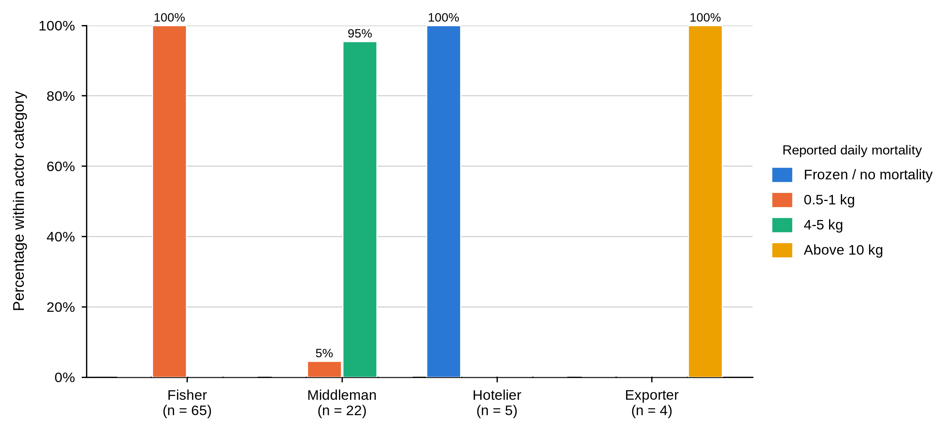
Table 28
Reported Loss Through Spoilage by Actor and BMU
Characteristic / response | Actor | Overall | Shimoni | Majoreni | Vanga | Msambweni | Other sites | BMU p-value
Reported loss through spoilage
1 kg | Fisher N = 0 | - | - | - | - | - | -
3 kg |  | - | - | - | - | - | -
5 kg |  | - | - | - | - | - | -
Above 10 kg |  | - | - | - | - | - | -
1 kg | Middleman N = 22 | 0 (0.0%) | 0 (0.0%) | 0 (0.0%) | 0 (0.0%) | - | - | .066
3 kg |  | 9 (40.9%) | 7 (63.6%) | 2 (28.6%) | 0 (0.0%) | - | -
5 kg |  | 13 (59.1%) | 4 (36.4%) | 5 (71.4%) | 4 (100.0%) | - | -
Above 10 kg |  | 0 (0.0%) | 0 (0.0%) | 0 (0.0%) | 0 (0.0%) | - | -
1 kg | Hotelier N = 5 | 5 (100.0%) | 1 (100.0%) | - | - | - | 4 (100.0%)
3 kg |  | 0 (0.0%) | 0 (0.0%) | - | - | - | 0 (0.0%)
5 kg |  | 0 (0.0%) | 0 (0.0%) | - | - | - | 0 (0.0%)
Above 10 kg |  | 0 (0.0%) | 0 (0.0%) | - | - | - | 0 (0.0%)
1 kg | Exporter N = 4 | 0 (0.0%) | - | - | - | - | 0 (0.0%)
3 kg |  | 0 (0.0%) | - | - | - | - | 0 (0.0%)
5 kg |  | 0 (0.0%) | - | - | - | - | 0 (0.0%)
Above 10 kg |  | 4 (100.0%) | - | - | - | - | 4 (100.0%)
Table 28 covers spoilage, an item not put to fishers. Middlemen reported 5 kg (13, 59.1%) or 3 kg (9, 40.9%), the 5 kg share rising from 4 (36.4%) at Shimoni to all four (100.0%) at Vanga; the site difference approached but did not reach significance (p = .066). All five hoteliers reported 1 kg and all four exporters more than 10 kg.
Read together, Figure 16 and Table 28 show a chain in which every actor loses stock and none records it against a shared standard. The actor holding live crabs carries the loss, and because no one measures it consistently the cost of mortality cannot be priced into a grade or recovered through one.

4.4.6 Payment, Price Setting and Sale Location
Figure 17 shows that M-Pesa was the commonest single arrangement among fishers (30, 46.2%), but credit accounted for 18 (27.7%) and a further 7 (10.8%) combined M-Pesa with credit, so close to two fishers in five were paid at least partly on credit by the very middleman buying from them. Cash on delivery accounted for 10 (15.4%). Middlemen most often reported credit themselves (9, 40.9%), followed by M-Pesa (7, 31.8%) and cash on delivery (6, 27.3%). All five hoteliers used M-Pesa and cash together; the item was not completed by exporters. Payment was not associated with BMU for fishers (p = .515) or middlemen (p = .470).
Figure 17
Mode of Payment by Actor Category
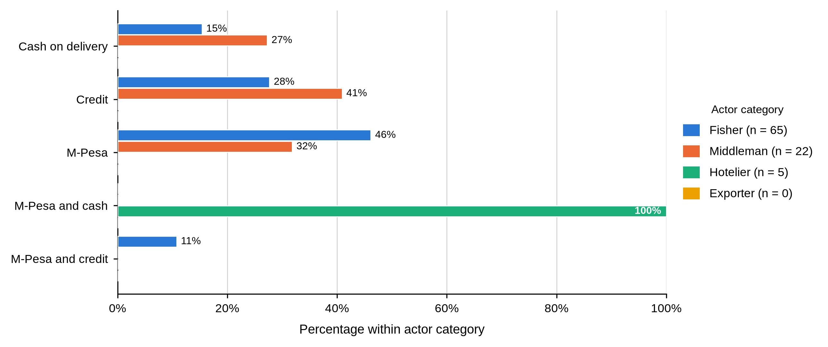
Table 29
Pricing Mechanism and How Prices Are Set by Actor and BMU
Characteristic / response | Actor | Overall | Shimoni | Majoreni | Vanga | Msambweni | Other sites | BMU p-value
Standard pricing mechanism is used
No | Fisher N = 65 | 65 (100.0%) | 25 (100.0%) | 14 (100.0%) | 21 (100.0%) | 3 (100.0%) | 2 (100.0%)
No | Middleman N = 22 | 22 (100.0%) | 11 (100.0%) | 7 (100.0%) | 4 (100.0%) | - | -
No | Hotelier N = 5 | 5 (100.0%) | 1 (100.0%) | - | - | - | 4 (100.0%)
No | Exporter N = 4 | 4 (100.0%) | - | - | - | - | 4 (100.0%)
Table 29 and Figure 18 divide the chain in two. Not one respondent in any actor category, at any site, reported using a standard pricing mechanism. All 65 fishers and all five hoteliers described the price as fixed, meaning the buyer set it and told them; 14 of 22 middlemen (63.6%) and all four exporters described their own pricing as competitive. Price setting was not associated with BMU among middlemen (p = .722).
Figure 18
How Mud Crab Prices Are Set, by Actor Category
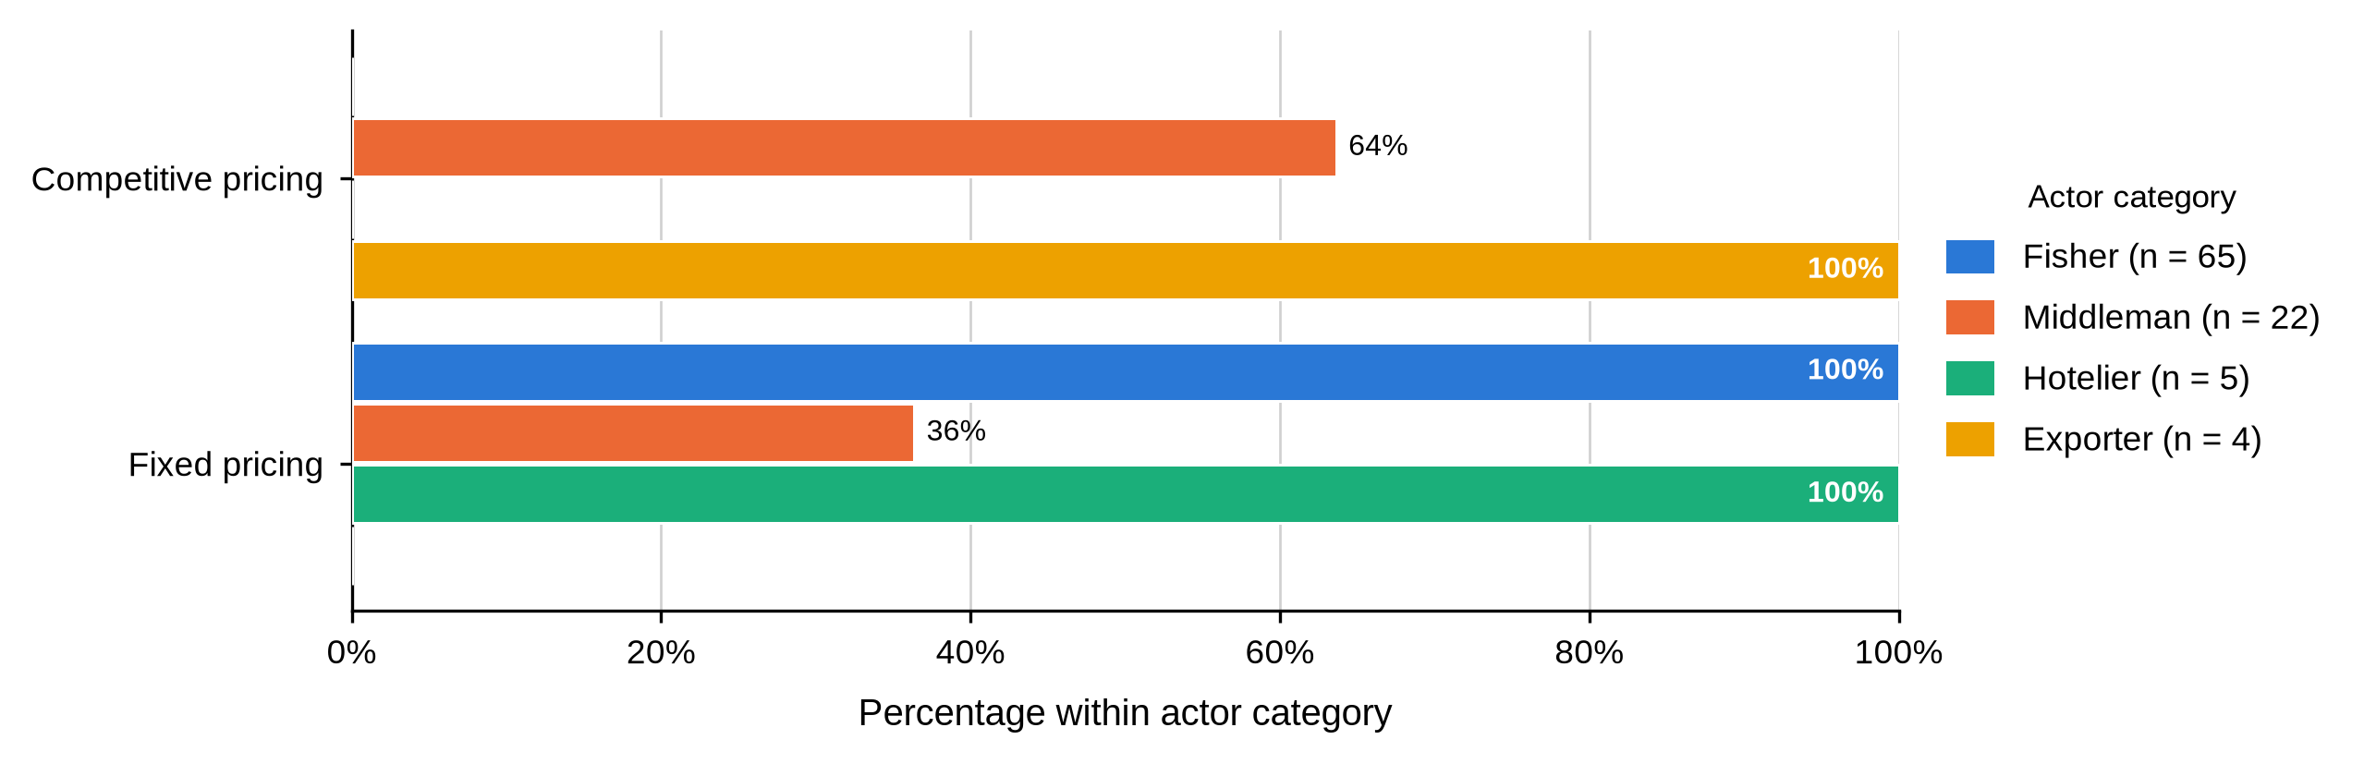
Table 30
Factors Influencing Price Fluctuations by Actor and BMU
Characteristic / response | Actor | Overall | Shimoni | Majoreni | Vanga | Msambweni | Other sites | BMU p-value
Factors influencing price fluctuations
Seasonal and economic factors | Fisher N = 65 | 0 (0.0%) | 0 (0.0%) | 0 (0.0%) | 0 (0.0%) | 0 (0.0%) | 0 (0.0%)
Seasonal factors only |  | 0 (0.0%) | 0 (0.0%) | 0 (0.0%) | 0 (0.0%) | 0 (0.0%) | 0 (0.0%)
Seasonal, weather and regulatory factors |  | 65 (100.0%) | 25 (100.0%) | 14 (100.0%) | 21 (100.0%) | 3 (100.0%) | 2 (100.0%)
Seasonal and economic factors | Middleman N = 22 | 14 (63.6%) | 5 (45.5%) | 6 (85.7%) | 3 (75.0%) | - | - | .238
Seasonal factors only |  | 0 (0.0%) | 0 (0.0%) | 0 (0.0%) | 0 (0.0%) | - | -
Seasonal, weather and regulatory factors |  | 8 (36.4%) | 6 (54.5%) | 1 (14.3%) | 1 (25.0%) | - | -
Seasonal and economic factors | Hotelier N = 5 | 0 (0.0%) | 0 (0.0%) | - | - | - | 0 (0.0%)
Seasonal factors only |  | 5 (100.0%) | 1 (100.0%) | - | - | - | 4 (100.0%)
Seasonal, weather and regulatory factors |  | 0 (0.0%) | 0 (0.0%) | - | - | - | 0 (0.0%)
Seasonal and economic factors | Exporter N = 4 | 0 (0.0%) | - | - | - | - | 0 (0.0%)
Seasonal factors only |  | 0 (0.0%) | - | - | - | - | 0 (0.0%)
Seasonal, weather and regulatory factors |  | 4 (100.0%) | - | - | - | - | 4 (100.0%)
Table 30 shows that actors attributed price movement to different causes. All 65 fishers and all four exporters cited seasonal, weather and regulatory factors; 14 of 22 middlemen (63.6%) cited seasonal and economic factors; all five hoteliers cited seasonal factors alone. Among middlemen the factor named was not associated with BMU (p = .238).
Tables 29 and 30 and Figure 17 describe the moment the terms of exchange are settled. The fisher sells at the beach, on the day, at a price the buyer sets, and is often paid at least partly in credit by that same buyer. Fixed at the fisher node and competitive at the middleman node are one transaction described from either end.

4.4.7 Trading Relationships and Market Information
Table 31
Tied Depot Owners and Arrangements With Tied Fishers and Traders by Actor and BMU
Characteristic / response | Actor | Overall | Shimoni | Majoreni | Vanga | Msambweni | Other sites | BMU p-value
Has depot owners tied to the business
Yes | Fisher N = 9 | 0 (0.0%) | 0 (0.0%) | - | 0 (0.0%) | - | -
No |  | 9 (100.0%) | 5 (100.0%) | - | 4 (100.0%) | - | -
Yes | Middleman N = 22 | 21 (95.5%) | 10 (90.9%) | 7 (100.0%) | 4 (100.0%) | - | -
No |  | 1 (4.5%) | 1 (9.1%) | 0 (0.0%) | 0 (0.0%) | - | -
Yes | Hotelier N = 5 | 0 (0.0%) | 0 (0.0%) | - | - | - | 0 (0.0%)
No |  | 5 (100.0%) | 1 (100.0%) | - | - | - | 4 (100.0%)
Yes | Exporter N = 4 | 0 (0.0%) | - | - | - | - | 0 (0.0%)
No |  | 4 (100.0%) | - | - | - | - | 4 (100.0%)
Arrangement with tied fishers
Credit | Fisher N = 0 | - | - | - | - | - | -
Credit | Middleman N = 21 | 21 (100.0%) | 10 (100.0%) | 7 (100.0%) | 4 (100.0%) | - | -
Credit | Hotelier N = 5 | 5 (100.0%) | 1 (100.0%) | - | - | - | 4 (100.0%)
Credit | Exporter N = 0 | - | - | - | - | - | -
Arrangement with tied traders
Credit | Fisher N = 65 | 38 (58.5%) | 14 (56.0%) | 9 (64.3%) | 13 (61.9%) | 2 (66.7%) | 0 (0.0%)
Fixed price |  | 9 (13.8%) | 5 (20.0%) | 0 (0.0%) | 4 (19.0%) | 0 (0.0%) | 0 (0.0%)
Frequency supply |  | 18 (27.7%) | 6 (24.0%) | 5 (35.7%) | 4 (19.0%) | 1 (33.3%) | 2 (100.0%)
Credit | Middleman N = 11 | 10 (90.9%) | 4 (80.0%) | 4 (100.0%) | 2 (100.0%) | - | -
Fixed price |  | 1 (9.1%) | 1 (20.0%) | 0 (0.0%) | 0 (0.0%) | - | -
Frequency supply |  | 0 (0.0%) | 0 (0.0%) | 0 (0.0%) | 0 (0.0%) | - | -
Credit | Hotelier N = 5 | 5 (100.0%) | 1 (100.0%) | - | - | - | 4 (100.0%)
Fixed price |  | 0 (0.0%) | 0 (0.0%) | - | - | - | 0 (0.0%)
Frequency supply |  | 0 (0.0%) | 0 (0.0%) | - | - | - | 0 (0.0%)
Credit | Exporter N = 4 | 4 (100.0%) | - | - | - | - | 4 (100.0%)
Fixed price |  | 0 (0.0%) | - | - | - | - | 0 (0.0%)
Frequency supply |  | 0 (0.0%) | - | - | - | - | 0 (0.0%)
Table 31 records depot ties and the terms attached to them. Depot owners were tied to the business for all 22 middlemen, all five hoteliers and all four exporters, but for only 1 of the 9 fishers who answered (11.1%). Where middlemen and hoteliers had tied fishers, the arrangement was credit in every case, 21 middlemen and 5 hoteliers, 100.0% of those answering. Arrangements with tied traders varied more: every fisher who answered named credit, middlemen named credit (7, 63.6%) or fixed price (4, 36.4%), and hoteliers and exporters named frequency of supply.
This is the clearest statement in the chapter of what ties an upstream actor to a downstream one. It is not a contract and not a price guarantee; it is credit. Every one of the 21 middlemen with tied fishers held them through an advance, and every fisher describing his own tie described the same instrument. Read against Table 12, where 93.8% of fishers named a middleman as their credit source, the two tables describe one mechanism from both ends.
Table 32
Arrangements Used With Tied Depot Owners by Actor and BMU
Characteristic / response | Actor | Overall | Shimoni | Majoreni | Vanga | Msambweni | Other sites | BMU p-value
Arrangement with tied depot owners
Credit | Fisher N = 56 | 0 (0.0%) | 0 (0.0%) | 0 (0.0%) | 0 (0.0%) | 0 (0.0%) | 0 (0.0%)
Frequency supply |  | 0 (0.0%) | 0 (0.0%) | 0 (0.0%) | 0 (0.0%) | 0 (0.0%) | 0 (0.0%)
Frequency supply and credit |  | 0 (0.0%) | 0 (0.0%) | 0 (0.0%) | 0 (0.0%) | 0 (0.0%) | 0 (0.0%)
Supply quantity |  | 56 (100.0%) | 20 (100.0%) | 14 (100.0%) | 17 (100.0%) | 3 (100.0%) | 2 (100.0%)
Credit | Middleman N = 21 | 15 (71.4%) | 8 (80.0%) | 3 (42.9%) | 4 (100.0%) | - | -
Frequency supply |  | 4 (19.0%) | 2 (20.0%) | 2 (28.6%) | 0 (0.0%) | - | -
Frequency supply and credit |  | 2 (9.5%) | 0 (0.0%) | 2 (28.6%) | 0 (0.0%) | - | -
Supply quantity |  | 0 (0.0%) | 0 (0.0%) | 0 (0.0%) | 0 (0.0%) | - | -
Credit | Hotelier N = 0 | - | - | - | - | - | -
Frequency supply |  | - | - | - | - | - | -
Frequency supply and credit |  | - | - | - | - | - | -
Supply quantity |  | - | - | - | - | - | -
Credit | Exporter N = 0 | - | - | - | - | - | -
Frequency supply |  | - | - | - | - | - | -
Frequency supply and credit |  | - | - | - | - | - | -
Supply quantity |  | - | - | - | - | - | -
As shown in Table 32, arrangements with tied depot owners were reported by 56 fishers and 21 middlemen. Fishers named frequency of supply (31, 55.4%) or credit (25, 44.6%); middlemen named supply quantity (10, 47.6%), frequency of supply and credit together (7, 33.3%) or credit alone (4, 19.0%). No hotelier or exporter completed the item.
Obligations become more commercial further down the chain. A fisher is held by an advance; a middleman by a quantity he has undertaken to deliver. Neither is a written contract in the ordinary sense, and Table 33 shows that only one of the ten fishers who answered had any trading agreement at all.
Table 33
Tied Fishers, Tied Traders and Trading Agreements by Actor and BMU
Characteristic / response | Actor | Overall | Shimoni | Majoreni | Vanga | Msambweni | Other sites | BMU p-value
Has fishers tied to the business
Yes | Fisher N = 65 | 0 (0.0%) | 0 (0.0%) | 0 (0.0%) | 0 (0.0%) | 0 (0.0%) | 0 (0.0%)
No |  | 65 (100.0%) | 25 (100.0%) | 14 (100.0%) | 21 (100.0%) | 3 (100.0%) | 2 (100.0%)
Yes | Middleman N = 22 | 21 (95.5%) | 10 (90.9%) | 7 (100.0%) | 4 (100.0%) | - | -
No |  | 1 (4.5%) | 1 (9.1%) | 0 (0.0%) | 0 (0.0%) | - | -
Yes | Hotelier N = 5 | 5 (100.0%) | 1 (100.0%) | - | - | - | 4 (100.0%)
No |  | 0 (0.0%) | 0 (0.0%) | - | - | - | 0 (0.0%)
Yes | Exporter N = 4 | 0 (0.0%) | - | - | - | - | 0 (0.0%)
No |  | 4 (100.0%) | - | - | - | - | 4 (100.0%)
Has traders tied to the business
Yes | Fisher N = 65 | 65 (100.0%) | 25 (100.0%) | 14 (100.0%) | 21 (100.0%) | 3 (100.0%) | 2 (100.0%)
No |  | 0 (0.0%) | 0 (0.0%) | 0 (0.0%) | 0 (0.0%) | 0 (0.0%) | 0 (0.0%)
Yes | Middleman N = 22 | 11 (50.0%) | 5 (45.5%) | 4 (57.1%) | 2 (50.0%) | - | -
No |  | 11 (50.0%) | 6 (54.5%) | 3 (42.9%) | 2 (50.0%) | - | -
Yes | Hotelier N = 5 | 5 (100.0%) | 1 (100.0%) | - | - | - | 4 (100.0%)
No |  | 0 (0.0%) | 0 (0.0%) | - | - | - | 0 (0.0%)
Yes | Exporter N = 4 | 4 (100.0%) | - | - | - | - | 4 (100.0%)
No |  | 0 (0.0%) | - | - | - | - | 0 (0.0%)
Has a formal or informal trading agreement
Yes | Fisher N = 10 | 1 (10.0%) | 0 (0.0%) | 1 (100.0%) | 0 (0.0%) | - | -
No |  | 9 (90.0%) | 5 (100.0%) | 0 (0.0%) | 4 (100.0%) | - | -
Yes | Middleman N = 22 | 21 (95.5%) | 10 (90.9%) | 7 (100.0%) | 4 (100.0%) | - | -
No |  | 1 (4.5%) | 1 (9.1%) | 0 (0.0%) | 0 (0.0%) | - | -
Yes | Hotelier N = 5 | 5 (100.0%) | 1 (100.0%) | - | - | - | 4 (100.0%)
No |  | 0 (0.0%) | 0 (0.0%) | - | - | - | 0 (0.0%)
Yes | Exporter N = 4 | 4 (100.0%) | - | - | - | - | 4 (100.0%)
No |  | 0 (0.0%) | - | - | - | - | 0 (0.0%)
Table 33 shows tied relationships running downward. No fisher had a fisher tied to him, yet every fisher had a trader tied to his business; 21 of 22 middlemen (95.5%) and all five hoteliers had fishers tied to theirs, while middlemen split evenly on whether they had tied traders (11 and 11). Trading agreements, formal or informal, covered 21 middlemen (95.5%) and every hotelier and exporter, against 1 of the 10 fishers who answered the item (10.0%).
Table 34
Role of Intermediaries and Negotiation Terms by Actor and BMU
Characteristic / response | Actor | Overall | Shimoni | Majoreni | Vanga | Msambweni | Other sites | BMU p-value
Role of intermediaries
Marketing | Fisher N = 65 | 24 (36.9%) | 10 (40.0%) | 6 (42.9%) | 7 (33.3%) | 1 (33.3%) | 0 (0.0%) | .925
Negotiation |  | 41 (63.1%) | 15 (60.0%) | 8 (57.1%) | 14 (66.7%) | 2 (66.7%) | 2 (100.0%)
Negotiation and marketing |  | 0 (0.0%) | 0 (0.0%) | 0 (0.0%) | 0 (0.0%) | 0 (0.0%) | 0 (0.0%)
Marketing | Middleman N = 22 | 1 (4.5%) | 1 (9.1%) | 0 (0.0%) | 0 (0.0%) | - | - | 1.000
Negotiation |  | 7 (31.8%) | 4 (36.4%) | 2 (28.6%) | 1 (25.0%) | - | -
Negotiation and marketing |  | 14 (63.6%) | 6 (54.5%) | 5 (71.4%) | 3 (75.0%) | - | -
Marketing | Hotelier N = 5 | 5 (100.0%) | 1 (100.0%) | - | - | - | 4 (100.0%)
Negotiation |  | 0 (0.0%) | 0 (0.0%) | - | - | - | 0 (0.0%)
Negotiation and marketing |  | 0 (0.0%) | 0 (0.0%) | - | - | - | 0 (0.0%)
Marketing | Exporter N = 4 | 0 (0.0%) | - | - | - | - | 0 (0.0%)
Negotiation |  | 0 (0.0%) | - | - | - | - | 0 (0.0%)
Negotiation and marketing |  | 4 (100.0%) | - | - | - | - | 4 (100.0%)
Terms used with intermediaries
Flexible terms | Fisher N = 65 | 65 (100.0%) | 25 (100.0%) | 14 (100.0%) | 21 (100.0%) | 3 (100.0%) | 2 (100.0%)
Flexible terms and competitive bidding |  | 0 (0.0%) | 0 (0.0%) | 0 (0.0%) | 0 (0.0%) | 0 (0.0%) | 0 (0.0%)
Flexible terms | Middleman N = 22 | 22 (100.0%) | 11 (100.0%) | 7 (100.0%) | 4 (100.0%) | - | -
Flexible terms and competitive bidding |  | 0 (0.0%) | 0 (0.0%) | 0 (0.0%) | 0 (0.0%) | - | -
Flexible terms | Hotelier N = 5 | 5 (100.0%) | 1 (100.0%) | - | - | - | 4 (100.0%)
Flexible terms and competitive bidding |  | 0 (0.0%) | 0 (0.0%) | - | - | - | 0 (0.0%)
Flexible terms | Exporter N = 4 | 0 (0.0%) | - | - | - | - | 0 (0.0%)
Flexible terms and competitive bidding |  | 4 (100.0%) | - | - | - | - | 4 (100.0%)
As shown in Table 34, fishers saw the intermediary mainly as a negotiator (41, 63.1%) rather than a marketer (24, 36.9%); middlemen described their own role as negotiation and marketing together (14, 63.6%); hoteliers saw intermediaries as marketers and exporters as both. Terms were flexible for every fisher, middleman and hotelier, while all four exporters combined flexible terms with competitive bidding. Neither item was associated with BMU (p = .925 for fishers, p = 1.000 for middlemen).
Table 35
Technology Adoption and Market Research by Actor and BMU
Characteristic / response | Actor | Overall | Shimoni | Majoreni | Vanga | Msambweni | Other sites | BMU p-value
Adopted technology or modern equipment
No | Fisher N = 65 | 65 (100.0%) | 25 (100.0%) | 14 (100.0%) | 21 (100.0%) | 3 (100.0%) | 2 (100.0%)
No | Middleman N = 22 | 22 (100.0%) | 11 (100.0%) | 7 (100.0%) | 4 (100.0%) | - | -
No | Hotelier N = 5 | 5 (100.0%) | 1 (100.0%) | - | - | - | 4 (100.0%)
No | Exporter N = 4 | 4 (100.0%) | - | - | - | - | 4 (100.0%)
Conducts market research
No | Fisher N = 65 | 65 (100.0%) | 25 (100.0%) | 14 (100.0%) | 21 (100.0%) | 3 (100.0%) | 2 (100.0%)
No | Middleman N = 22 | 22 (100.0%) | 11 (100.0%) | 7 (100.0%) | 4 (100.0%) | - | -
No | Hotelier N = 5 | 5 (100.0%) | 1 (100.0%) | - | - | - | 4 (100.0%)
No | Exporter N = 4 | 4 (100.0%) | - | - | - | - | 4 (100.0%)
Table 35 carries no variation at all, and is the more striking for it. Not one respondent in any actor category, at any site, had adopted modern equipment or conducted market research, a figure of 0% on both items across all 96 respondents.
Tables 31 to 35 close the functional account. In a chain where the buyer sets the price and controls the grading rule, no actor invests in equipment and no actor gathers independent market information. Every respondent said they kept up to date by networking, so information travels along the same commercial relationships that set the terms of trade.

4.4.8 Reported Mud Crab Prices
Prices were collected for three size grades in Kenya shillings per kilogram of live crab. Every figure is a gross price at the point of sale; nothing was recorded about transport, holding, mortality, ice, packaging or the cost of money tied up between buying and selling.
Table 36
Reported Mud Crab Prices by Actor Category and Size Grade
Actor category | Valid n | M | SD | Mdn | IQR (Q1–Q3) | Range
Large (Grade A)
Fisher | 65 | 604.6 | 192.2 | 650.0 | 500.0–800.0 | 300.0–800.0
Middleman | 22 | 945.5 | 140.5 | 1,000.0 | 800.0–1,000.0 | 800.0–1,200.0
Hotelier | 5 | 2,200.0 | 570.1 | 2,000.0 | 2,000.0–2,500.0 | 1,500.0–3,000.0
Exporter | 4 | 1,700.0 | 115.5 | 1,700.0 | 1,600.0–1,800.0 | 1,600.0–1,800.0
Medium (Grade B)
Fisher | 65 | 514.6 | 163.4 | 500.0 | 400.0–600.0 | 300.0–800.0
Middleman | 22 | 718.2 | 100.6 | 800.0 | 600.0–800.0 | 600.0–800.0
Hotelier | 5 | 380.0 | 109.5 | 300.0 | 300.0–500.0 | 300.0–500.0
Exporter | 4 | 1,300.0 | 115.5 | 1,300.0 | 1,200.0–1,400.0 | 1,200.0–1,400.0
Small (Grade C)
Fisher | 65 | 309.2 | 50.7 | 300.0 | 300.0–300.0 | 250.0–500.0
Middleman | — | — | — | — | — | —
Hotelier | — | — | — | — | — | —
Exporter | — | — | — | — | — | —
As shown in Table 36, the large-crab price climbed at every step of the chain. Fishers averaged KSh 604.6 per kilogram, middlemen KSh 945.5, exporters KSh 1,700.0 and hoteliers KSh 2,200.0. Medium crabs ran KSh 514.6 for fishers and KSh 718.2 for middlemen, with exporters at KSh 1,300.0. Only fishers priced small crabs, averaging KSh 309.2; no middleman, hotelier or exporter reported a small-grade price at all, which points to the smallest crabs being absorbed locally rather than moving up the chain.
Table 37
Kruskal–Wallis Comparisons of Reported Mud Crab Prices
Comparison | H | df | N | p
Price compared across the four actor categories
Large (Grade A) | 55.84 | 3 | 96 | < .001
Medium (Grade B) | 38.00 | 3 | 96 | < .001
Small (Grade C) | — | — | — | —
Fisher price compared across the four BMUs
Large (Grade A) | 20.32 | 3 | 63 | < .001
Medium (Grade B) | 20.07 | 3 | 63 | < .001
Small (Grade C) | 5.85 | 3 | 63 | .119
Middleman price compared across the three BMUs with traders
Large (Grade A) | 5.33 | 2 | 22 | .070
Medium (Grade B) | 3.78 | 2 | 22 | .151
Small (Grade C) | — | — | — | —
Hoteliers and exporters were not compared across BMUs because four of the five hoteliers and all four exporters operated outside the four BMU frames
Table 37 tests those differences. The comparison across the four actor categories was significant for large crabs, H(3) = 55.84, p < .001, and for medium crabs, H(3) = 38.00, p < .001. Actor category therefore does influence the price received, at both grades for which more than one category reported a price. The small grade could not be compared across actors because only fishers reported it.
One value breaks the pattern. Hoteliers reported a mean of KSh 380.0 per kilogram for medium crabs, which is below the fisher price for the same grade and far below their own large-grade mean of KSh 2,200.0. All five records were retained exactly as entered. The figure may be correct if those entries refer to a different product form, unit or transaction, but it may equally be a field-entry problem. It is excluded from the chain calculation that follows and should be checked against the questionnaires before it is used to support any argument about value addition.

4.4.9 Prices by Study Site
Holding the actor role constant and comparing sites answers a different question: whether a fisher at one landing site receives a different price from a fisher at another.
Table 38
Mean Reported Mud Crab Price by Actor Category, BMU and Size Grade
BMU | Fisher  M KSh/kg (n) | Middleman  M KSh/kg (n) | Hotelier  M KSh/kg (n) | Exporter  M KSh/kg (n)
Large (Grade A)
Shimoni | 540.0 (25) | 981.8 (11) | 1,500.0 (1) | -
Majoreni | 785.7 (14) | 857.1 (7) | - | -
Vanga | 535.7 (21) | 1,000.0 (4) | - | -
Msambweni | 650.0 (3) | - | - | -
Other sites | 800.0 (2) | - | 2,375.0 (4) | 1,700.0 (4)
All sites | 604.6 (65) | 945.5 (22) | 2,200.0 (5) | 1,700.0 (4)
Medium (Grade B)
Shimoni | 404.0 (25) | 745.5 (11) | 300.0 (1) | -
Majoreni | 600.0 (14) | 657.1 (7) | - | -
Vanga | 576.2 (21) | 750.0 (4) | - | -
Msambweni | 616.7 (3) | - | - | -
Other sites | 500.0 (2) | - | 400.0 (4) | 1,300.0 (4)
All sites | 514.6 (65) | 718.2 (22) | 380.0 (5) | 1,300.0 (4)
Table 38 shows that fisher prices varied considerably by site. Majoreni fishers reported the highest large-crab mean at KSh 785.7 per kilogram, well above Shimoni at KSh 540.0 and Vanga at KSh 535.7, with Msambweni at KSh 650.0 on three respondents. Middleman means were much closer together, from KSh 857.1 at Majoreni to KSh 1,000.0 at Vanga. Returning to Table 37, fisher prices differed significantly across sites for large crabs, H(3) = 20.32, p < .001, and for medium crabs, H(3) = 20.07, p < .001, while middleman prices did not, H(2) = 5.33, p = .070 and H(2) = 3.78, p = .151. Small-grade prices did not differ across sites either, H(3) = 5.85, p = .119.
Table 39
First-Sale Price Spread Between Fishers and Middlemen Within Each BMU
BMU | Fisher M  (KSh/kg) | Middleman M  (KSh/kg) | Spread  (KSh/kg) | Spread as % of  the fisher price | Fisher price as % of  the middleman price
Large (Grade A)
Shimoni | 540.0 | 981.8 | 441.8 | 81.8 | 55.0
Majoreni | 785.7 | 857.1 | 71.4 | 9.1 | 91.7
Vanga | 535.7 | 1,000.0 | 464.3 | 86.7 | 53.6
Msambweni | 650.0 | - | - | - | -
Other sites | 800.0 | - | - | - | -
Medium (Grade B)
Shimoni | 404.0 | 745.5 | 341.5 | 84.5 | 54.2
Majoreni | 600.0 | 657.1 | 57.1 | 9.5 | 91.3
Vanga | 576.2 | 750.0 | 173.8 | 30.2 | 76.8
Msambweni | 616.7 | - | - | - | -
Other sites | 500.0 | - | - | - | -
Table 39 sets the two upstream node prices side by side at each landing site. Majoreni stands apart: its fishers held 91.7% of the local middleman price for large crabs and 91.3% for medium crabs, leaving spreads of only KSh 71.4 and KSh 57.1 per kilogram. At Shimoni and Vanga the same comparison gave 55.0% and 53.6% for large crabs, spreads of KSh 441.8 and KSh 464.3, or between 82% and 87% on top of what the fisher was paid. Vanga sat in between for medium crabs at 76.8%. The pattern holds in both grades, which makes it unlikely to be an artefact of one unusual price. The single Shimoni hotelier and the Other sites group rest on very small numbers.
The two nodes did not move together, and that is where the difference comes from. Fisher prices varied significantly across sites; middleman prices did not. The narrow Majoreni gap is therefore built on the fisher side of the transaction rather than on Majoreni traders charging less than their counterparts: Majoreni middlemen sold at KSh 857.1, within KSh 143 of the other two sites, while Majoreni fishers were paid KSh 785.7 against roughly KSh 537 at Shimoni and Vanga. The gap a fisher faces is set at his own landing site. It is also worth recalling from Table 16 that Majoreni fishers reached the point of sale fastest, which is consistent with, though not proof of, a shorter and more competitive first-sale market there. Msambweni and the Other sites group are absent because no middleman was sampled there.

4.4.10 Concentration at the Point of First Sale
Objective Two asks how the market is organised, and concentration is the standard way of answering that. A textbook concentration ratio needs a census of the buyers at each landing site and the volume each handles; this survey recorded neither. What it did record is where each fisher took his catch for first sale, which supports a measure of a different kind: how far the harvesters at a site are spread across buying points, or gathered at one. The shares below are shares of harvesters, not of volume.
Table 40
Concentration of First-Sale Outlets Reported by Fishers, by BMU
BMU | Fishers  answering | Buying points  named | Largest point | Share at the  largest point | HHI | Numbers  equivalent
Shimoni | 25 | 5 | Mkuyuni | 64.0% | 4,592 | 2.18
Majoreni | 13 | 2 | Majoreni / Aleni | 92.3% | 8,580 | 1.17
Vanga | 20 | 4 | Kiwegu | 75.0% | 5,850 | 1.71
Msambweni | 3 | 2 | Gasi | 66.7% | 5,556 | 1.80
All four BMUs | 63 | 8 | Majoreni / Aleni | 30.2% | 2,371 | 4.22
Table 40 shows that first sale is concentrated at every landing site. Across the four BMUs the 63 fishers who answered named only 8 buying points between them, with an HHI of 2,371 and a numbers-equivalent of 4.22 outlets. Within a site the picture is tighter still. Majoreni fishers named two points and 92.3% of them went to one, giving an HHI of 8,580 and a numbers-equivalent of 1.17: in practice a single outlet. Vanga returned 5,850, Msambweni 5,556 and Shimoni, the least concentrated, 4,592. Competition authorities commonly treat a market above 2,500 as highly concentrated. Every BMU in this study sits above that line, and three of the four sit above 4,500.
Table 41
Buyer Options per Harvester and Harvesters per Trader, by BMU
BMU | Fishers  answering | Selling to one  buyer only | Mean buyers  per fisher | Fishers  sampled | Middlemen  sampled | Fishers per  middleman
Shimoni | 25 | 17 (68.0%) | 1.32 | 25 | 11 | 2.27 : 1
Majoreni | 14 | 10 (71.4%) | 1.29 | 14 | 7 | 2.00 : 1
Vanga | 21 | 18 (85.7%) | 1.14 | 21 | 4 | 5.25 : 1
Msambweni | 3 | 3 (100.0%) | 1.00 | 3 | 0 | no trader sampled
All four BMUs | 65 | 50 (76.9%) | 1.23 | 65 | 22 | 2.95 : 1
Table 41 approaches the same structure from the seller’s side. 50 of the 65 fishers who answered (76.9%) sold to a single buyer, and the mean across all fishers was 1.23 buyers. The single-buyer share ran from 68.0% at Shimoni to 85.7% at Vanga and all three fishers at Msambweni. Set against that, 65 fishers were sampled against 22 middlemen, 2.95 harvesters for every trader, rising to 5.25 at Vanga and falling to 2.00 at Majoreni. Every fisher in the sample also described his main buyer as a regular one and reported being tied to a trader, so the single-buyer figure is not a matter of convenience on the day.
Two cautions belong with these numbers. They measure where harvesters take their catch, not how much crab each buying point handles, so a point many fishers name but that buys little from each would be overweighted; and they rest on the fishers sampled at a site rather than every fisher working there. Neither changes the direction: at three of the four BMUs more than two thirds of the harvesters interviewed carried their catch to one place, and more than three quarters dealt with one buyer when they got there.

4.4.11 Marketing Margins and the Distribution of Value
Reading the four node prices as one chain shows where the final price accumulates. Two end points were available: large crabs leaving the middleman for an exporter finished at KSh 1,700.0 per kilogram and those going to a hotel kitchen at KSh 2,200.0. The margin at a node is what an actor adds between buying and selling, expressed against his own selling price; the producer’s share asks how much of the final price reaches the person who caught the crab.
Table 42
Marketing Margins and the Distribution of the Final Chain Price Across Actor Nodes
Market node | Mean price  (KSh/kg) | Value retained or  margin added (KSh/kg) | Margin as % of the  fisher price | % of the final  chain price
Large (Grade A) sold on to exporters
Fisher (first sale) | 604.6 | 604.6 | — | 35.6
Middleman | 945.5 | 340.8 | 56.4 | 20.0
Exporter (end of chain) | 1,700.0 | 754.5 | 124.8 | 44.4
Hotelier (not in this chain) | — | — | — | —
Large (Grade A) sold on to hoteliers
Fisher (first sale) | 604.6 | 604.6 | — | 27.5
Middleman | 945.5 | 340.8 | 56.4 | 15.5
Hotelier (end of chain) | 2,200.0 | 1,254.5 | 207.5 | 57.0
Exporter (not in this chain) | — | — | — | —
Medium (Grade B) sold on to exporters
Fisher (first sale) | 514.6 | 514.6 | — | 39.6
Middleman | 718.2 | 203.6 | 39.6 | 15.7
Exporter (end of chain) | 1,300.0 | 581.8 | 113.1 | 44.8
Hotelier (not in this chain) | — | — | — | —
As shown in Table 42, the fisher kept between a quarter and two fifths of the end price. Large crabs sold on to an exporter left 35.6% with the harvester; the same crabs sold to a hotel left 27.5%. Medium crabs going for export were the fisher’s best case at 39.6%. In every chain the largest single share was added at the last step, 44.4% between the middleman and the exporter and 57.0% between the middleman and the hotel, while the middleman, the actor most often identified with the low beach price, took the smallest share of the three, between 15.5% and 20.0%.
Table 43
Gross Marketing Margin, Total Margin and Producer’s Share by Chain
Chain | Fisher  KSh/kg | Middleman  KSh/kg | Final node  KSh/kg | Middleman  GMM | Final node  GMM | Total  GMM | Producer’s  share | Producer’s share  net of loss
Large (Grade A) sold on to exporters | 604.6 | 945.5 | 1,700.0 | 36.1% | 44.4% | 64.4% | 35.6% | 31.9%
Large (Grade A) sold on to hoteliers | 604.6 | 945.5 | 2,200.0 | 36.1% | 57.0% | 72.5% | 27.5% | 24.6%
Medium (Grade B) sold on to exporters | 514.6 | 718.2 | 1,300.0 | 28.3% | 44.8% | 60.4% | 39.6% | 35.5%
Table 43 states the same chain as margins. The middleman’s gross marketing margin was 36.1% of his own selling price for large crabs and 28.3% for medium, the final node took 44.4% or 57.0% of his, and the total marketing margin ran from 60.4% to 72.5% of the final price. An exporter paying KSh 945.5 and selling at KSh 1,700.0 works on a spread of KSh 754.5 per kilogram, roughly one and a quarter times what the fisher received for landing the animal.
These are gross margins. The shares rest on group means rather than on one crab followed from beach to buyer, and the survey priced no transport, holding, ice, packaging or cost of capital, so nothing here is a profit. One cost was measured and belongs in the calculation: fishers reported a mean of 0.75 kg of dead crab a day against a mean daily catch of 7.68 kg, a loss of 10.4% of what they land. Carrying that through cuts the producer’s share from 35.6% to 31.9% in the export chain and from 27.5% to 24.6% in the hotel chain. Middlemen reported a larger absolute loss, a mean of 4.33 kg a day, but the survey did not record the volume they handle, so the same rate cannot be formed for them. The direction is still hard to argue away: the value is realised two steps beyond the point the harvester can reach.

4.4.12 Price Dispersion and Price Transmission
A market in which the same product fetches widely different prices on the same day is transmitting information poorly. The coefficient of variation measures that spread independently of the price level, so it can be compared across nodes whose prices differ by a factor of three.
Table 44
Price Dispersion Within Each Actor Category and Price Transmission to the Fisher
Size grade | Fisher | Middleman | Hotelier | Exporter | Shimoni | Majoreni | Vanga
Coefficient of variation of reported price, by actor category
Large (Grade A) | 31.8% | 14.9% | 25.9% | 6.8%
Medium (Grade B) | 31.8% | 14.0% | 28.8% | 8.9%
Fisher price as a percentage of the middleman price at the same BMU
Large (Grade A) |  |  |  |  | 55.0% | 91.7% | 53.6%
Medium (Grade B) |  |  |  |  | 54.2% | 91.3% | 76.8%
Table 44 shows dispersion falling steadily down the chain. For large crabs the fisher coefficient of variation was 31.8%, the middleman 14.9% and the exporter 6.8%; the medium grade gives the same ordering. Two harvesters selling the same grade on the same coast can therefore expect materially different prices, while two exporters expect nearly the same one. The lower half of the table sets the fisher mean against the middleman mean at the same site. Majoreni transmitted 91.7% of the large-grade middleman price to its fishers, against 55.0% at Shimoni and 53.6% at Vanga.
Set beside the concentration results, one finding needs care. Majoreni was the most concentrated site on every measure in Table 40, yet it transmitted the largest share of the downstream price to its harvesters, while Vanga carried the most harvesters per trader (5.25 to one) and transmitted the least. Concentration of outlets and the price a harvester receives did not move together here. Nothing causal follows from three sites and a cross-sectional design, but it suggests that how many buying points exist matters less than how many sellers compete for each buyer, and it marks a question worth designing a study around.

4.4.13 Summary of Objective Two
Objective Two shows functions dividing cleanly by node, and the information used to set value dividing with them. Fishers graded on weight alone; every other category used four criteria. Formal quality control and contact with the final buyer sat entirely downstream. Prices rose at every node and differed significantly between actor categories, first sale was concentrated at every landing site, and the harvester kept between a quarter and two fifths of the end-of-chain price.

4.4.14 Discussion of Findings in Relation to Previous Studies
Harvesting, aggregation, processing and export were each performed by a different actor category, which matches the value-chain structure described for this fishery (Mirera, 2017a; Fondo & Ogutu, 2021) and the wider account of middlemen linking dispersed harvesters to distant buyers (Crona et al., 2016). Testing each function against site rather than assuming uniformity is what this study adds: among fishers only travel time and the large- and small-crab size labels varied significantly by BMU, and among middlemen nothing did.
Grading is the clearest contribution. Every actor graded, but fishers graded on weight alone while every downstream category used four criteria. Jacinto (2004) identifies this kind of informational asymmetry as a determinant of how value is shared in small-scale fisheries, and these data give a clean instance of it in a fishery where actors and functions have been documented more thoroughly than the terms of exchange between them. The site variation in labelling has not been reported before.
Protection rises downstream while mortality rises with the volume held, which follows FAO (2025) on survival and quality in the live trade. The difference lies in measurement rather than direction: nobody in this chain records losses against a shared standard, so the cost of mortality cannot be attributed, priced or recovered.
Prices rise at every node, as expected where later actors carry aggregation, mortality, transport and buyer-access costs. Munga and Muthumbi (2018) show for the Tana Delta that gross differentials narrow considerably once handling and transport are netted out, so none of this speaks to profit. Within that limit, the producer’s share of 27.5% to 39.6% sits at the low end of what has been reported for perishable, high-value seafood, and the ordering matches Jacinto’s (2004) argument that the share captured at each node tracks control of information and market access rather than physical effort.
The middleman result cuts against the popular account. Middlemen took the smallest of the three shares in every chain, yet fishers most often identify them with the low beach price. Crona et al. (2016) reach the same conclusion for Kenya and Zanzibar, finding middlemen blamed for outcomes settled further along the chain while operating on modest turnovers and carrying the mortality risk. Green and Clark (2021) treat dispersion at first sale as an indicator of weak integration; on that criterion Shimoni and Vanga are the weaker of the three markets. Because fisher prices varied significantly across sites while middleman prices did not, the mechanism sits on the fisher side of the transaction.

4.5 Objective Three: Constraints and Opportunities Facing Each Actor Category
Objective Three assessed the constraints each actor category reported and the opportunities they identified. The results are grouped into operational and infrastructure constraints, market access and risk, regulation and information, perceptions of market organisation, and opportunities.

4.5.1 Operational and Infrastructure Constraints
Table 45
Main Operational or Marketing Constraint by Actor and BMU
Characteristic / response | Actor | Overall | Shimoni | Majoreni | Vanga | Msambweni | Other sites | BMU p-value
Main operational or marketing constraint
Price fluctuations | Fisher N = 65 | 59 (90.8%) | 24 (96.0%) | 11 (78.6%) | 19 (90.5%) | 3 (100.0%) | 2 (100.0%) | .334
Mortality |  | 6 (9.2%) | 1 (4.0%) | 3 (21.4%) | 2 (9.5%) | 0 (0.0%) | 0 (0.0%)
Market seasonality |  | 0 (0.0%) | 0 (0.0%) | 0 (0.0%) | 0 (0.0%) | 0 (0.0%) | 0 (0.0%)
High freight, flight delays and supply risk |  | 0 (0.0%) | 0 (0.0%) | 0 (0.0%) | 0 (0.0%) | 0 (0.0%) | 0 (0.0%)
Price fluctuations | Middleman N = 22 | 11 (50.0%) | 8 (72.7%) | 3 (42.9%) | 0 (0.0%) | - | - | .036
Mortality |  | 11 (50.0%) | 3 (27.3%) | 4 (57.1%) | 4 (100.0%) | - | -
Market seasonality |  | 0 (0.0%) | 0 (0.0%) | 0 (0.0%) | 0 (0.0%) | - | -
High freight, flight delays and supply risk |  | 0 (0.0%) | 0 (0.0%) | 0 (0.0%) | 0 (0.0%) | - | -
Price fluctuations | Hotelier N = 5 | 0 (0.0%) | 0 (0.0%) | - | - | - | 0 (0.0%)
Mortality |  | 0 (0.0%) | 0 (0.0%) | - | - | - | 0 (0.0%)
Market seasonality |  | 5 (100.0%) | 1 (100.0%) | - | - | - | 4 (100.0%)
High freight, flight delays and supply risk |  | 0 (0.0%) | 0 (0.0%) | - | - | - | 0 (0.0%)
Price fluctuations | Exporter N = 4 | 0 (0.0%) | - | - | - | - | 0 (0.0%)
Mortality |  | 0 (0.0%) | - | - | - | - | 0 (0.0%)
Market seasonality |  | 0 (0.0%) | - | - | - | - | 0 (0.0%)
High freight, flight delays and supply risk |  | 4 (100.0%) | - | - | - | - | 4 (100.0%)
As shown in Table 45, no constraint was shared across the chain. Price fluctuation was named by 59 fishers (90.8%) and by half the middlemen (11, 50.0%); mortality by the other half of middlemen and by 6 fishers (9.2%); market seasonality by all five hoteliers; and high freight, flight delays and supply risk by all four exporters. The middleman split varied significantly by site (p = .036): all four Vanga middlemen and 4 of 7 at Majoreni (57.1%) named mortality, while only 3 of 11 at Shimoni (27.3%) did. Fisher responses did not vary by site (p = .334).
Table 46
Main Infrastructure or Logistics Constraint and Need for Improvement by Actor and BMU
Characteristic / response | Actor | Overall | Shimoni | Majoreni | Vanga | Msambweni | Other sites | BMU p-value
Infrastructure improvements are needed
Yes | Fisher N = 65 | 65 (100.0%) | 25 (100.0%) | 14 (100.0%) | 21 (100.0%) | 3 (100.0%) | 2 (100.0%)
Yes | Middleman N = 22 | 22 (100.0%) | 11 (100.0%) | 7 (100.0%) | 4 (100.0%) | - | -
Yes | Hotelier N = 5 | 5 (100.0%) | 1 (100.0%) | - | - | - | 4 (100.0%)
Yes | Exporter N = 4 | 4 (100.0%) | - | - | - | - | 4 (100.0%)
Table 46 and Figure 19 show the same divergence in infrastructure. Poor road infrastructure dominated the fisher responses (64, 98.5%), reaching 100.0% at Shimoni, Vanga and Msambweni, while 20 of 22 middlemen (90.9%) named the lack of aggregation facilities, rising to all seven (100.0%) at Majoreni. All five hoteliers named market seasonality and all four exporters named high freight, flight delays and mortality. Every respondent in all four categories, without exception, said infrastructure improvements were needed. Neither fisher (p = .264) nor middleman (p = .339) responses varied significantly by site.
Figure 19
Main Infrastructure or Logistics Constraint by Actor Category
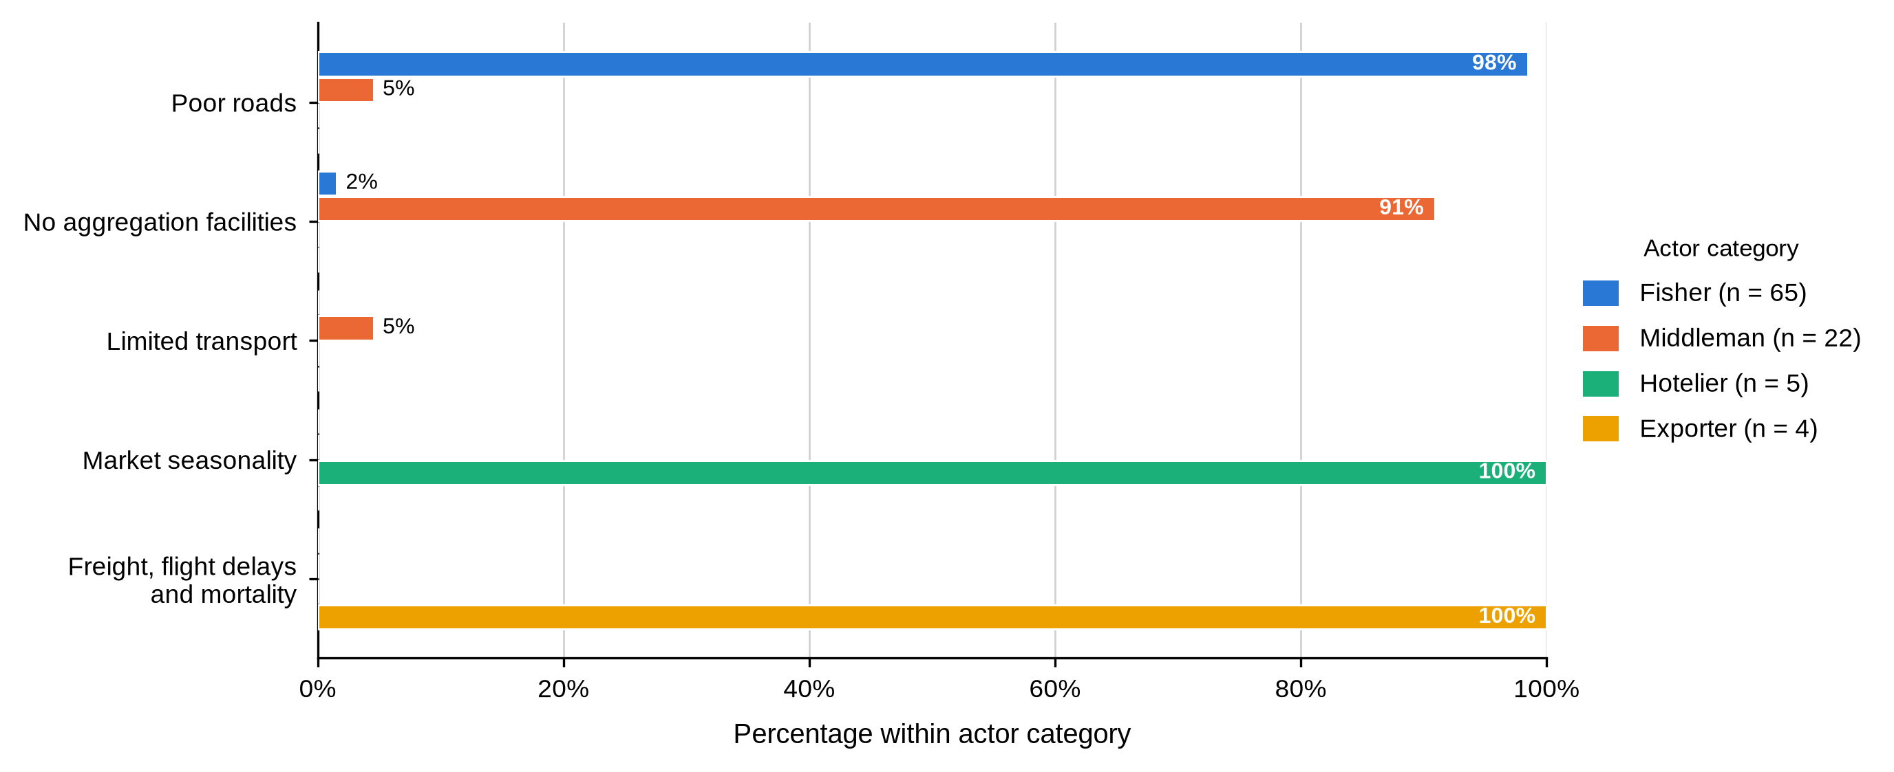
Table 45, Table 46 and Figure 19 show each constraint following from the work the actor does. The fisher sells the same day at a price he does not set, so volatility reaches him first and the road stands between him and a buyer. The middleman holds stock, so he loses crabs and needs somewhere to hold them. The hotelier lives on tourist arrivals and the exporter on cargo space. For Objective Three the consequence is that no single chain-wide measure would reach all four, which is why the recommendations in Chapter Six are written by actor category.

4.5.2 Market Access, Operational Challenges and Risk
Table 47
Barriers to Market Access and Operational Challenges by Actor and BMU
Characteristic / response | Actor | Overall | Shimoni | Majoreni | Vanga | Msambweni | Other sites | BMU p-value
Experienced barriers to market access
Yes | Fisher N = 65 | 61 (93.8%) | 23 (92.0%) | 14 (100.0%) | 19 (90.5%) | 3 (100.0%) | 2 (100.0%) | .730
No |  | 4 (6.2%) | 2 (8.0%) | 0 (0.0%) | 2 (9.5%) | 0 (0.0%) | 0 (0.0%)
Yes | Middleman N = 22 | 22 (100.0%) | 11 (100.0%) | 7 (100.0%) | 4 (100.0%) | - | -
No |  | 0 (0.0%) | 0 (0.0%) | 0 (0.0%) | 0 (0.0%) | - | -
Yes | Hotelier N = 5 | 5 (100.0%) | 1 (100.0%) | - | - | - | 4 (100.0%)
No |  | 0 (0.0%) | 0 (0.0%) | - | - | - | 0 (0.0%)
Yes | Exporter N = 4 | 4 (100.0%) | - | - | - | - | 4 (100.0%)
No |  | 0 (0.0%) | - | - | - | - | 0 (0.0%)
Experienced significant operational challenges
Yes | Fisher N = 65 | 53 (81.5%) | 19 (76.0%) | 14 (100.0%) | 16 (76.2%) | 2 (66.7%) | 2 (100.0%) | .253
No |  | 12 (18.5%) | 6 (24.0%) | 0 (0.0%) | 5 (23.8%) | 1 (33.3%) | 0 (0.0%)
Yes | Middleman N = 22 | 22 (100.0%) | 11 (100.0%) | 7 (100.0%) | 4 (100.0%) | - | -
No |  | 0 (0.0%) | 0 (0.0%) | 0 (0.0%) | 0 (0.0%) | - | -
Yes | Hotelier N = 5 | 5 (100.0%) | 1 (100.0%) | - | - | - | 4 (100.0%)
No |  | 0 (0.0%) | 0 (0.0%) | - | - | - | 0 (0.0%)
Yes | Exporter N = 4 | 4 (100.0%) | - | - | - | - | 4 (100.0%)
No |  | 0 (0.0%) | - | - | - | - | 0 (0.0%)
As shown in Table 47, barriers to market access were close to universal: 61 fishers (93.8%), all 22 middlemen, all five hoteliers and all four exporters reported them, with the fisher share reaching 100.0% at Majoreni and Msambweni. Significant operational challenges were reported by 53 fishers (81.5%) and by every respondent in the other three categories. Neither item was associated with BMU among fishers (p = .730 and p = .253).
Table 48
Risk Management Method by Actor and BMU
Characteristic / response | Actor | Overall | Shimoni | Majoreni | Vanga | Msambweni | Other sites | BMU p-value
Method used to manage risk
Diversification | Fisher N = 65 | 65 (100.0%) | 25 (100.0%) | 14 (100.0%) | 21 (100.0%) | 3 (100.0%) | 2 (100.0%)
Insurance and diversification |  | 0 (0.0%) | 0 (0.0%) | 0 (0.0%) | 0 (0.0%) | 0 (0.0%) | 0 (0.0%)
Diversification | Middleman N = 22 | 22 (100.0%) | 11 (100.0%) | 7 (100.0%) | 4 (100.0%) | - | -
Insurance and diversification |  | 0 (0.0%) | 0 (0.0%) | 0 (0.0%) | 0 (0.0%) | - | -
Diversification | Hotelier N = 5 | 5 (100.0%) | 1 (100.0%) | - | - | - | 4 (100.0%)
Insurance and diversification |  | 0 (0.0%) | 0 (0.0%) | - | - | - | 0 (0.0%)
Diversification | Exporter N = 4 | 0 (0.0%) | - | - | - | - | 0 (0.0%)
Insurance and diversification |  | 4 (100.0%) | - | - | - | - | 4 (100.0%)
Table 48 records how actors managed that risk, and the answer is uniform and thin. Diversification was the only method named by fishers, middlemen and hoteliers, at 100.0% in each category and at every site; the four exporters added insurance to diversification. No other method was reported anywhere in the sample.
Table 49
Innovation, Changes in Marketing Strategy and Adaptation by Actor and BMU
Characteristic / response | Actor | Overall | Shimoni | Majoreni | Vanga | Msambweni | Other sites | BMU p-value
Adopted an innovative response
No | Fisher N = 65 | 65 (100.0%) | 25 (100.0%) | 14 (100.0%) | 21 (100.0%) | 3 (100.0%) | 2 (100.0%)
No | Middleman N = 22 | 22 (100.0%) | 11 (100.0%) | 7 (100.0%) | 4 (100.0%) | - | -
No | Hotelier N = 5 | 5 (100.0%) | 1 (100.0%) | - | - | - | 4 (100.0%)
No | Exporter N = 4 | 4 (100.0%) | - | - | - | - | 4 (100.0%)
Changed marketing strategies
Yes | Fisher N = 65 | 0 (0.0%) | 0 (0.0%) | 0 (0.0%) | 0 (0.0%) | 0 (0.0%) | 0 (0.0%)
No |  | 65 (100.0%) | 25 (100.0%) | 14 (100.0%) | 21 (100.0%) | 3 (100.0%) | 2 (100.0%)
Yes | Middleman N = 22 | 0 (0.0%) | 0 (0.0%) | 0 (0.0%) | 0 (0.0%) | - | -
No |  | 22 (100.0%) | 11 (100.0%) | 7 (100.0%) | 4 (100.0%) | - | -
Yes | Hotelier N = 5 | 5 (100.0%) | 1 (100.0%) | - | - | - | 4 (100.0%)
No |  | 0 (0.0%) | 0 (0.0%) | - | - | - | 0 (0.0%)
Yes | Exporter N = 4 | 4 (100.0%) | - | - | - | - | 4 (100.0%)
No |  | 0 (0.0%) | - | - | - | - | 0 (0.0%)
How functions are adapted within the chain
Flexibility | Fisher N = 65 | 65 (100.0%) | 25 (100.0%) | 14 (100.0%) | 21 (100.0%) | 3 (100.0%) | 2 (100.0%)
Flexibility and collaboration |  | 0 (0.0%) | 0 (0.0%) | 0 (0.0%) | 0 (0.0%) | 0 (0.0%) | 0 (0.0%)
Flexibility | Middleman N = 22 | 22 (100.0%) | 11 (100.0%) | 7 (100.0%) | 4 (100.0%) | - | -
Flexibility and collaboration |  | 0 (0.0%) | 0 (0.0%) | 0 (0.0%) | 0 (0.0%) | - | -
Flexibility | Hotelier N = 5 | 5 (100.0%) | 1 (100.0%) | - | - | - | 4 (100.0%)
Flexibility and collaboration |  | 0 (0.0%) | 0 (0.0%) | - | - | - | 0 (0.0%)
Flexibility | Exporter N = 4 | 0 (0.0%) | - | - | - | - | 0 (0.0%)
Flexibility and collaboration |  | 4 (100.0%) | - | - | - | - | 4 (100.0%)
Table 49 completes that picture. Not one respondent in any actor category had adopted an innovative response. Only the nine downstream actors had changed their marketing strategies; no fisher and no middleman had. Flexibility was the universal adaptation, with exporters alone adding collaboration.
Read against Objective Three, Tables 47 to 49 say that upstream actors are absorbing risk rather than managing it. Diversification named as a risk strategy by a fisher who, in Table 11, reports no other income activity is an intention rather than a practice. The absence of any reported innovation across all 96 respondents also means that the constraints described above have not yet produced an adaptive response the actors themselves recognise as one.

4.5.3 Regulation and Access to Information
Table 50
Regulation, Management-Plan Awareness and Sources of Industry Information by Actor and BMU
Characteristic / response | Actor | Overall | Shimoni | Majoreni | Vanga | Msambweni | Other sites | BMU p-value
Regulations affect marketing activities
Yes | Fisher N = 65 | 65 (100.0%) | 25 (100.0%) | 14 (100.0%) | 21 (100.0%) | 3 (100.0%) | 2 (100.0%)
No |  | 0 (0.0%) | 0 (0.0%) | 0 (0.0%) | 0 (0.0%) | 0 (0.0%) | 0 (0.0%)
Yes | Middleman N = 22 | 16 (72.7%) | 8 (72.7%) | 5 (71.4%) | 3 (75.0%) | - | - | 1.000
No |  | 6 (27.3%) | 3 (27.3%) | 2 (28.6%) | 1 (25.0%) | - | -
Yes | Hotelier N = 5 | 5 (100.0%) | 1 (100.0%) | - | - | - | 4 (100.0%)
No |  | 0 (0.0%) | 0 (0.0%) | - | - | - | 0 (0.0%)
Yes | Exporter N = 4 | 4 (100.0%) | - | - | - | - | 4 (100.0%)
No |  | 0 (0.0%) | - | - | - | - | 0 (0.0%)
Knows persons or organizations interested in the fishery
Yes | Fisher N = 65 | 65 (100.0%) | 25 (100.0%) | 14 (100.0%) | 21 (100.0%) | 3 (100.0%) | 2 (100.0%)
Yes | Middleman N = 22 | 22 (100.0%) | 11 (100.0%) | 7 (100.0%) | 4 (100.0%) | - | -
Yes | Hotelier N = 5 | 5 (100.0%) | 1 (100.0%) | - | - | - | 4 (100.0%)
Yes | Exporter N = 4 | 4 (100.0%) | - | - | - | - | 4 (100.0%)
How the actor remains updated on industry trends
Networking | Fisher N = 65 | 65 (100.0%) | 25 (100.0%) | 14 (100.0%) | 21 (100.0%) | 3 (100.0%) | 2 (100.0%)
Networking | Middleman N = 22 | 22 (100.0%) | 11 (100.0%) | 7 (100.0%) | 4 (100.0%) | - | -
Networking | Hotelier N = 5 | 5 (100.0%) | 1 (100.0%) | - | - | - | 4 (100.0%)
Networking | Exporter N = 4 | 4 (100.0%) | - | - | - | - | 4 (100.0%)
As shown in Table 50, regulation was felt across the chain: all 65 fishers, 16 of 22 middlemen (72.7%), all five hoteliers and all four exporters said regulations affected their marketing activities. Awareness of the instrument governing the fishery, shown in Figure 20, was far less evenly spread. Twenty-one middlemen (95.5%) and all four exporters knew of a crab fishery management plan, against only 10 fishers (15.4%) and not one hotelier. Among fishers the aware share ranged from none at Majoreni to 6 of 21 (28.6%) at Vanga, although the site difference was not significant (p = .118). Every respondent in every category said they knew of persons or organisations interested in the fishery, and every one said they stayed current by networking.
Figure 20
Awareness of the Crab Fishery Management Plan Among Fishers, by BMU
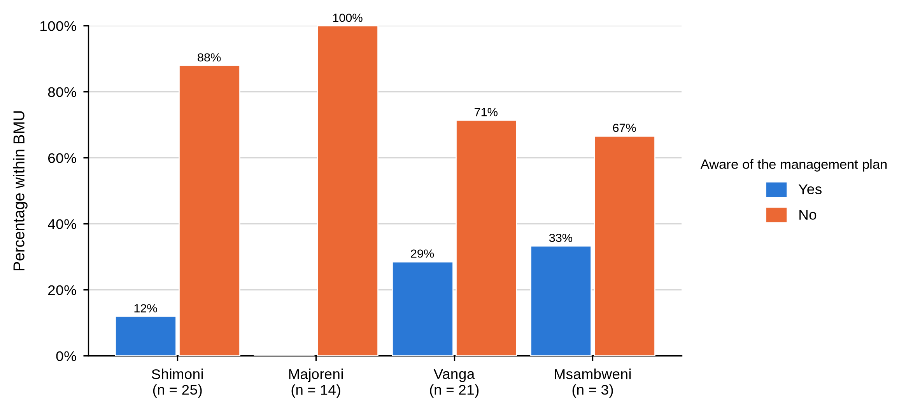
That contrast is the substantive finding here. Information about how the fishery is managed reaches the commercially connected nodes and misses the harvesting node, even though the co-management structures built to carry it are anchored at the landing site. Since every actor relied on networking, information travels by the same relationship that sets the price.

4.5.4 Perceptions of Market Organisation and Policy
Figure 21 shows steady negativity about how the market is organised. Forty-five fishers (69.2%) disagreed that the market is well structured and 14 (21.5%) agreed; 13 middlemen (59.1%) disagreed and a further 6 (27.3%) strongly disagreed; all five hoteliers and all four exporters disagreed. No hotelier or exporter agreed. Neither fisher (p = .570) nor middleman (p = .826) responses varied by site.
Figure 21
Perception That the Mud Crab Market Is Well Structured, by Actor Category
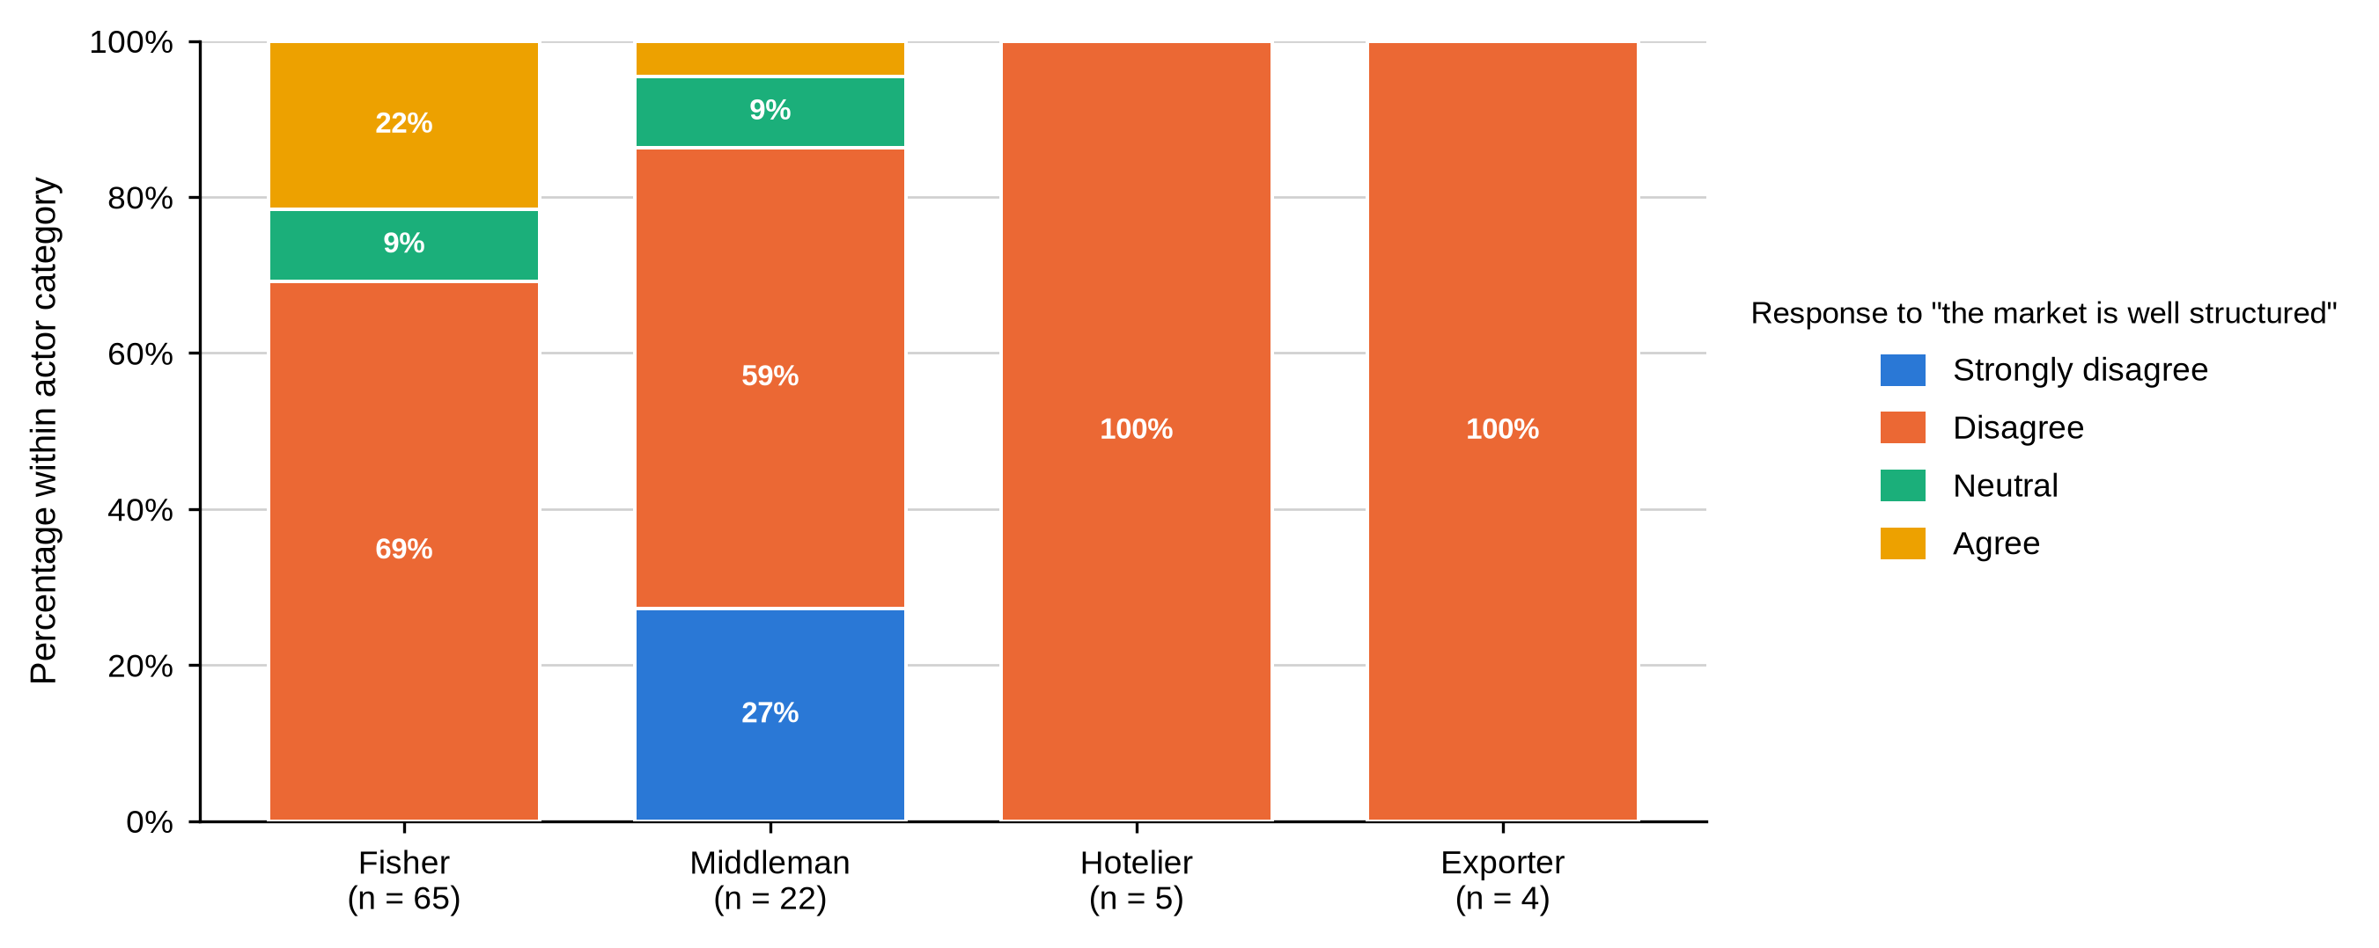
Table 51
Perception That Mud Crab Marketing Is Integrated With Other Fisheries by Actor and BMU
Characteristic / response | Actor | Overall | Shimoni | Majoreni | Vanga | Msambweni | Other sites | BMU p-value
Perception that mud crab marketing is integrated with other species
Strongly disagree | Fisher N = 65 | 0 (0.0%) | 0 (0.0%) | 0 (0.0%) | 0 (0.0%) | 0 (0.0%) | 0 (0.0%) | .541
Disagree |  | 52 (80.0%) | 22 (88.0%) | 10 (71.4%) | 16 (76.2%) | 3 (100.0%) | 1 (50.0%)
Neutral |  | 11 (16.9%) | 3 (12.0%) | 4 (28.6%) | 4 (19.0%) | 0 (0.0%) | 0 (0.0%)
Agree |  | 2 (3.1%) | 0 (0.0%) | 0 (0.0%) | 1 (4.8%) | 0 (0.0%) | 1 (50.0%)
Strongly disagree | Middleman N = 22 | 14 (63.6%) | 6 (54.5%) | 4 (57.1%) | 4 (100.0%) | - | - | .366
Disagree |  | 8 (36.4%) | 5 (45.5%) | 3 (42.9%) | 0 (0.0%) | - | -
Neutral |  | 0 (0.0%) | 0 (0.0%) | 0 (0.0%) | 0 (0.0%) | - | -
Agree |  | 0 (0.0%) | 0 (0.0%) | 0 (0.0%) | 0 (0.0%) | - | -
Strongly disagree | Hotelier N = 5 | 0 (0.0%) | 0 (0.0%) | - | - | - | 0 (0.0%)
Disagree |  | 5 (100.0%) | 1 (100.0%) | - | - | - | 4 (100.0%)
Neutral |  | 0 (0.0%) | 0 (0.0%) | - | - | - | 0 (0.0%)
Agree |  | 0 (0.0%) | 0 (0.0%) | - | - | - | 0 (0.0%)
Strongly disagree | Exporter N = 4 | 0 (0.0%) | - | - | - | - | 0 (0.0%)
Disagree |  | 4 (100.0%) | - | - | - | - | 4 (100.0%)
Neutral |  | 0 (0.0%) | - | - | - | - | 0 (0.0%)
Agree |  | 0 (0.0%) | - | - | - | - | 0 (0.0%)
Judgements on integration were harsher still, as Table 51 shows. Fifty-two fishers (80.0%) disagreed and only 2 (3.1%) agreed; among middlemen, 14 (63.6%) strongly disagreed and the remaining 8 (36.4%) disagreed, so not one middleman was neutral or positive. All hoteliers and exporters disagreed. Neither group varied significantly by site.
Table 52
Awareness of a Policy Framework for Crab Markets by Actor and BMU
Characteristic / response | Actor | Overall | Shimoni | Majoreni | Vanga | Msambweni | Other sites | BMU p-value
Awareness of a policy framework for crab markets
Strongly disagree | Fisher N = 65 | 6 (9.2%) | 3 (12.0%) | 1 (7.1%) | 2 (9.5%) | 0 (0.0%) | 0 (0.0%) | .933
Disagree |  | 11 (16.9%) | 4 (16.0%) | 2 (14.3%) | 5 (23.8%) | 0 (0.0%) | 0 (0.0%)
Neutral |  | 48 (73.8%) | 18 (72.0%) | 11 (78.6%) | 14 (66.7%) | 3 (100.0%) | 2 (100.0%)
Strongly disagree | Middleman N = 22 | 14 (63.6%) | 5 (45.5%) | 5 (71.4%) | 4 (100.0%) | - | - | .427
Disagree |  | 7 (31.8%) | 5 (45.5%) | 2 (28.6%) | 0 (0.0%) | - | -
Neutral |  | 1 (4.5%) | 1 (9.1%) | 0 (0.0%) | 0 (0.0%) | - | -
Strongly disagree | Hotelier N = 5 | 0 (0.0%) | 0 (0.0%) | - | - | - | 0 (0.0%)
Disagree |  | 0 (0.0%) | 0 (0.0%) | - | - | - | 0 (0.0%)
Neutral |  | 5 (100.0%) | 1 (100.0%) | - | - | - | 4 (100.0%)
Strongly disagree | Exporter N = 4 | 0 (0.0%) | - | - | - | - | 0 (0.0%)
Disagree |  | 0 (0.0%) | - | - | - | - | 0 (0.0%)
Neutral |  | 4 (100.0%) | - | - | - | - | 4 (100.0%)
Table 52 shows a sharp difference in how the policy environment was read. Forty-eight fishers (73.8%) were neutral on whether a policy framework exists, with 11 (16.9%) disagreeing and 6 (9.2%) strongly disagreeing. Middlemen were far more emphatic: 14 (63.6%) strongly disagreed and 7 (31.8%) disagreed. All hoteliers and exporters were neutral. Neither fisher (p = .933) nor middleman (p = .427) responses varied by site.
The large neutral response among fishers is not approval. Set beside the 15.4% management-plan awareness in Table 50, it more plausibly reflects unfamiliarity with the policy environment than a settled judgement. The middlemen, aware of the management plan almost to a person, were also the group most willing to say the framework does not work, so the negative judgements here come from knowledge rather than ignorance.

4.5.5 Opportunities, Youth Participation and Diversification
Nothing in this chapter expresses the structure of the chain more clearly than Figure 22. Market-access improvement was the priority for 56 fishers (86.2%) and for every hotelier and exporter, while price stability was the priority for 21 of 22 middlemen (95.5%). On what would improve the system, shown in Figure 23, every fisher named government support alone, while middlemen split between government support (12, 54.5%) and government support with industry collaboration (8, 36.4%); hoteliers and exporters named the combined option. Neither item varied significantly by site.
Figure 22
Priority Opportunity for Improving Mud Crab Marketing by Actor Category
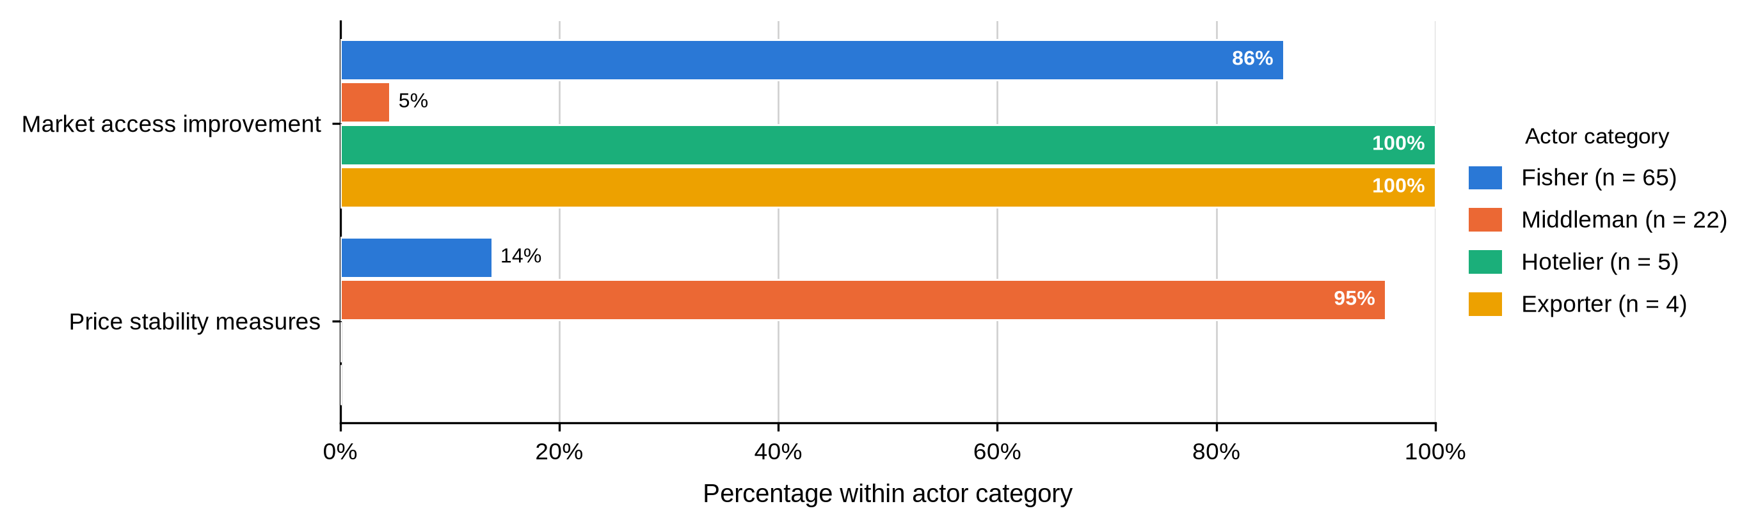
Figure 23
Recommended Market-System Enhancement by Actor Category
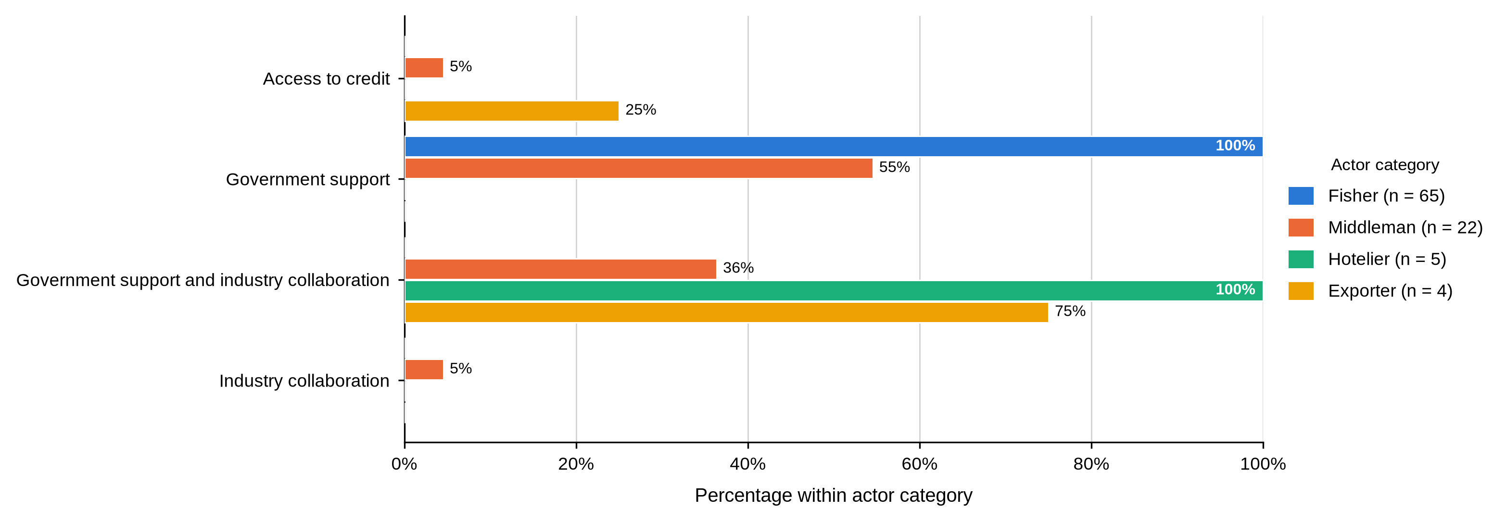
These are two views of one transaction. The fisher wants an alternative to the buyer in front of him; the middleman wants the price he pays and receives to hold still while he carries stock and credit risk. Splitting the difference will not reconcile them, because better market access for fishers means more competition for middlemen. Better price information and clearer grades reduce uncertainty for both without fixing a price.
Figure 24 shows that youth involvement was rated low or very low by every respondent who expressed a view: 58 fishers (89.2%) and 16 middlemen (72.7%) said low, while 6 middlemen (27.3%), 3 hoteliers (60.0%) and 3 exporters (75.0%) said very low. Not one respondent in any category rated it high. Diversification potential, in Figure 25, divided the chain: 26 fishers (40.0%) said it had not been explored and 8 (12.3%) were negative, while 14 middlemen (63.6%) were positive. All hoteliers and exporters said it had not been explored. Neither item varied significantly by site.
Figure 24
Reported Involvement of Youth by Actor Category
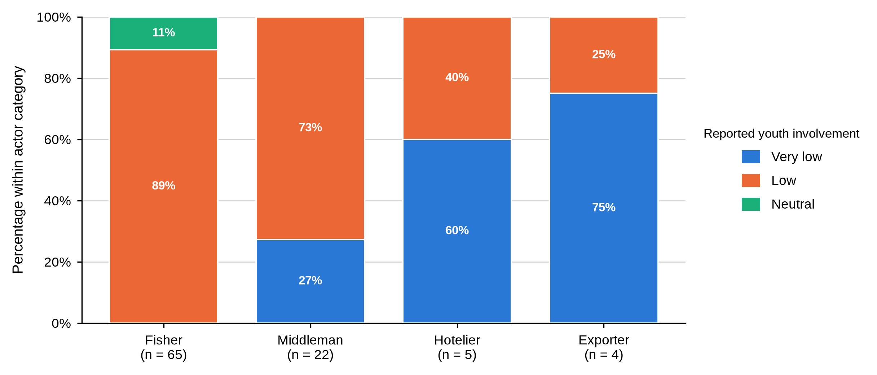
Figure 25
Perceived Potential for Product or Market Diversification by Actor Category
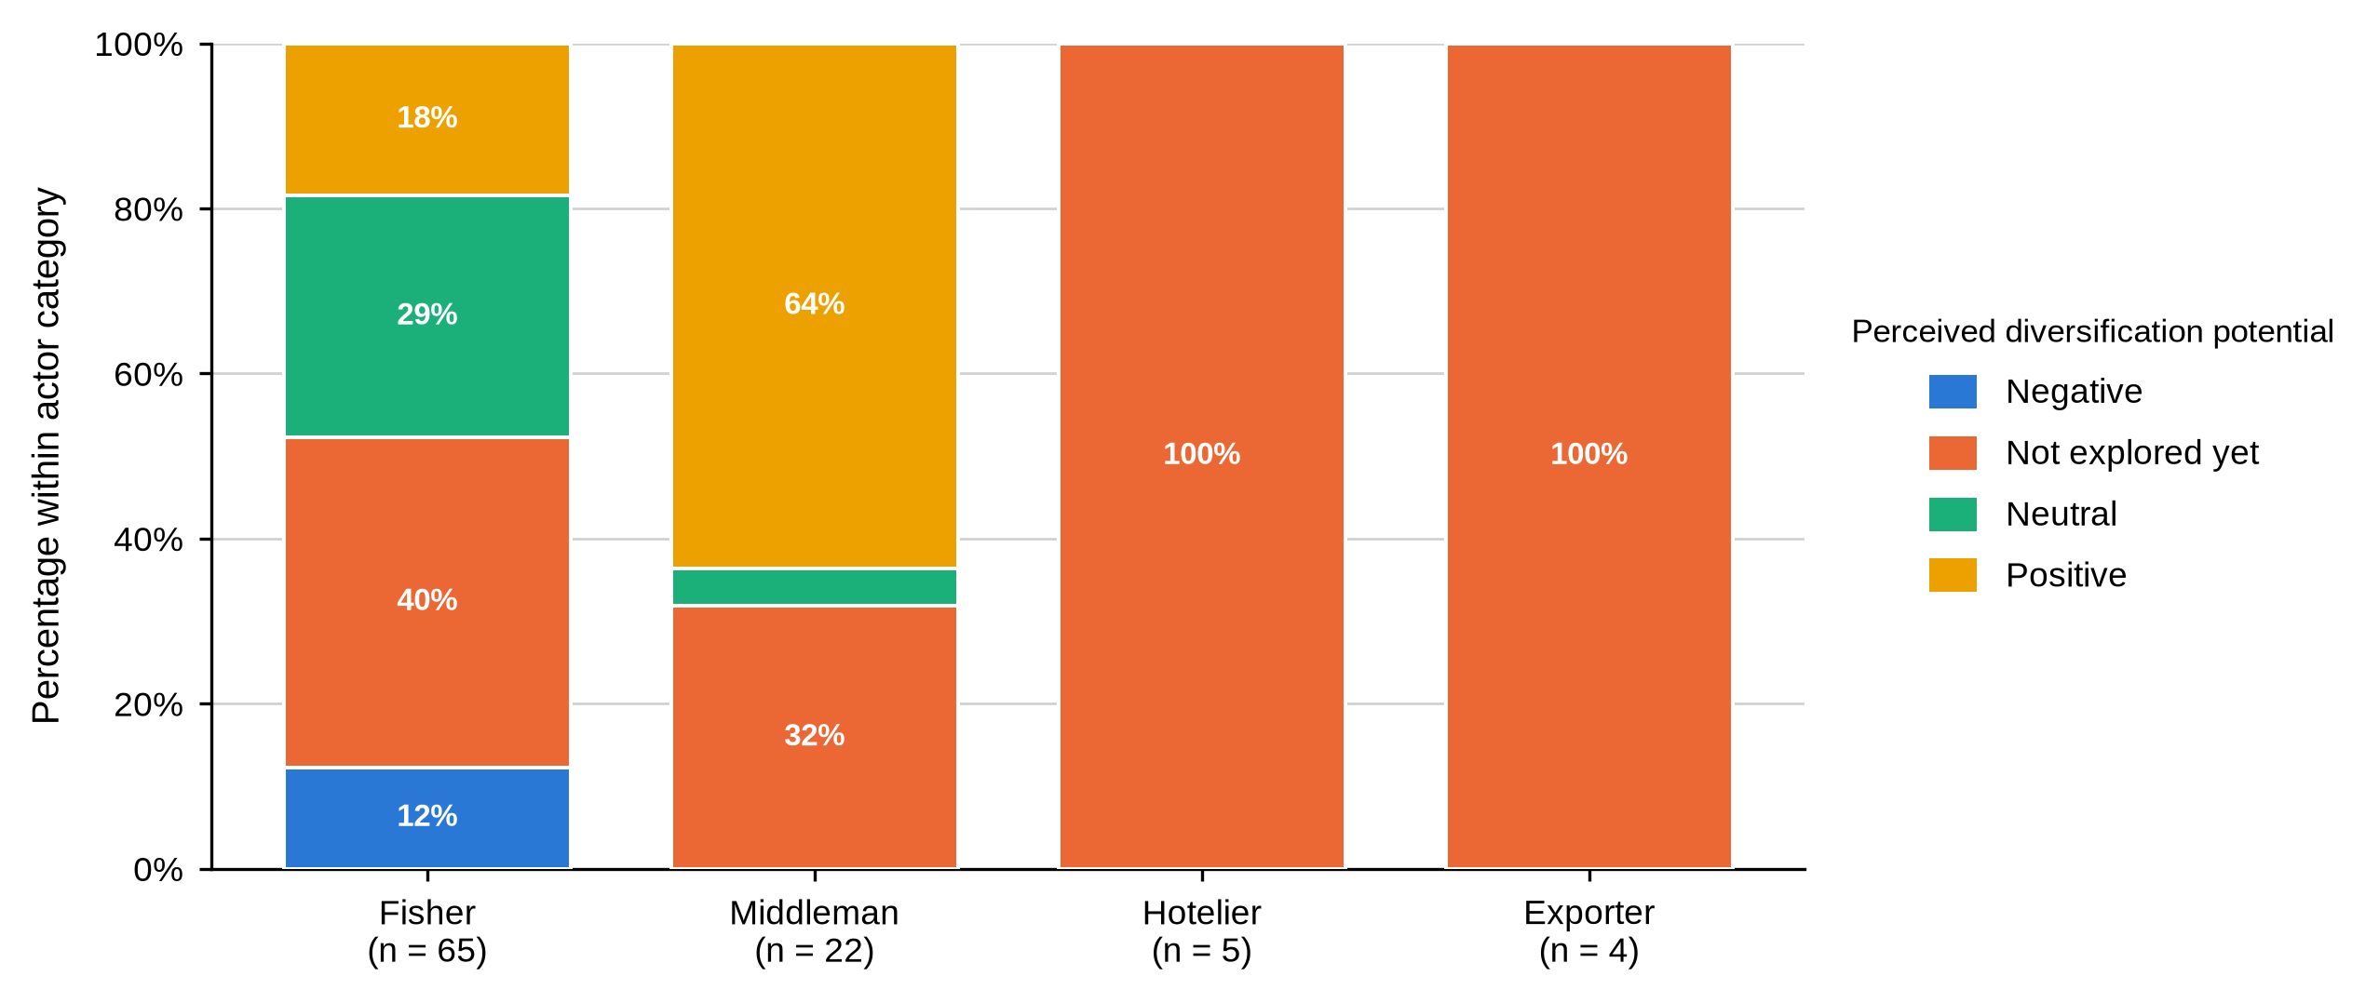
The youth result sits oddly against Table 3, where more than half the fishers were aged 18 to 35 and four were under 18. Respondents may have understood youth involvement as formal participation, commitment or ownership rather than mere presence in the fishery. The question should be defined directly in future work, and the presence of minors in harvesting raises safeguarding and schooling questions this study was not designed to answer but should not pass over.

4.5.6 Summary of Objective Three
Objective Three shows constraints following the work each actor does: unstable prices and poor roads for fishers, mortality and inadequate aggregation facilities for middlemen, seasonality for hoteliers, freight cost and flight risk for exporters. Barriers to market access were close to universal, no actor had adopted new equipment or conducted market research, and management-plan awareness reached the trading node but missed the harvesting node.

4.5.7 Discussion of Findings in Relation to Previous Studies
Constraints differ by actor category rather than by location, which fits treatments of the value chain as a sequence of distinct risk positions rather than one system with a single binding constraint (Jacinto, 2004; Crona et al., 2016). Only the middleman constraint varied significantly by site, mortality dominating at Vanga and Majoreni and price at Shimoni. That split follows the sites where middlemen hold stock longest, which FAO (2025) identifies as a determinant of loss.
Barriers to market access were near universal and no actor reported innovation or market research, consistent with national assessments of constraints in finance, organisation and formal market participation (Fondo & Ogutu, 2021). Locating those constraints by actor category rather than treating them as a general condition is the more useful form for designing an intervention.
Management-plan awareness reached 95.5% of middlemen and 15.4% of fishers, the clearest institutional finding here. Njiru et al. (2021) found socioeconomic factors shaping trader participation in Beach Management Units in Kwale County, which argues for communication aimed at particular actor groups. The gap runs along the chain rather than across the map: it was not significantly associated with site.
What fishers and middlemen want pulls in opposite directions, market access against price stability, and that opposition has not been reported in the Kenyan mud crab literature. It follows from the structure documented under Objective Two and means the two upstream groups cannot both be satisfied by one measure. The uniformly low rating of youth involvement also sits oddly beside the demographic evidence in this chapter, where over half the fishers were aged 18 to 35; respondents most likely read the question as formal participation rather than presence. Ndanga et al. (2013) make the same point about women in Kenyan aquaculture chains, whose participation is understated when the measure captures only formally recognised roles.

4.6 Actor-Specific Associations With BMU
Sixty-eight categorical variables were tested against Beach Management Unit, separately for fishers and for middlemen. Nine associations reached the .05 level.
Table 53
Statistically Significant Actor-Specific Associations With BMU
Objective | Actor | Variable | χ² | df | N | p | 99% CI
Objective 1 | Fisher | Age group | 30.91 | 12 | 63 | .004 | [.002, .005]
Objective 1 | Fisher | Received formal mud crab training | 8.48 | 3 | 63 | .035 | [.030, .040]
Objective 1 | Fisher | Marital status | 20.06 | 9 | 63 | .049 | [.044, .055]
Objective 1 | Middleman | Scale of operation | 9.41 | 4 | 22 | .050 | [.044, .055]
Objective 2 | Fisher | First buyer location | 125.19 | 21 | 61 | < .001 | [.000, .000]
Objective 2 | Fisher | Reported large-crab size category | 16.87 | 3 | 63 | .001 | [.000, .002]
Objective 2 | Fisher | Reported small-crab size category | 15.96 | 3 | 63 | .002 | [.001, .004]
Objective 2 | Fisher | Travel time from fishing grounds to market | 11.13 | 3 | 63 | .010 | [.007, .012]
Objective 3 | Middleman | Main operational or marketing constraint | 6.42 | 2 | 22 | .036 | [.032, .041]
No association with BMU reached the .05 level for hoteliers or exporters; neither group was sampled across enough BMUs for the test to be run
Three points belong with Table 53. The tests carry no correction for multiple comparisons, so associations close to .05 are exploratory rather than established, and the Monte Carlo confidence interval is given alongside each p-value. The nine significant results cluster in three areas: who fishes where (age, marital status, training), how far and how they describe their catch (travel time, large- and small-crab size labels, first buyer location), and what middlemen worry about (main constraint). The absence of hoteliers and exporters is a limit of the frame, not a finding.

4.7 Chapter Summary
Across the three objectives the same pattern recurs. Differences between actor categories were large and present on nearly every measure, from education and licensing through grading and quality control to price and the constraint each group names. Differences between Beach Management Units were far fewer: nine significant associations from sixty-eight tests, confined to age, marital status, training, travel time, size labelling, first buyer location and the middleman constraint.
The one site difference with a direct economic consequence was in price. Fisher prices differed significantly across sites while middleman prices did not, so the gap a fisher faces at first sale is set locally: Majoreni fishers held 91.7% of the local middleman price for large crabs against close to 54% at Shimoni and Vanga. Read alongside the chain-share result, where the fisher retained between 27.5% and 39.6% of the end price, the chapter describes a market whose value is realised where the grading rule, the logistics and the connection to the final buyer sit together, and whose harvesters reach none of those things.

CHAPTER FIVE: DISCUSSION

5.1 Introduction
This chapter interprets the findings of Chapter Four against the literature reviewed in Chapter Two. It takes the three objectives in turn, setting out the key findings, comparing them with previous research and drawing out the theoretical and practical implications. Section 5.5 brings the three objectives together under the structure-conduct-performance framework, and Section 5.6 states what the measures do and do not capture, along with the limitations that bound every claim made here.

5.2 Objective One: Profile of Mud Crab Actors

5.2.1 Key Findings
Four actor categories differed systematically and in the same direction on almost every measure. Fishers were younger, schooled to primary level or below, largely unlicensed, untrained, small-scale and un-diversified. Middlemen were older and far more experienced, with 72.7% carrying more than twenty years in the trade. Hoteliers and exporters held certificates, diplomas or degrees, were fully licensed, and operated at medium or large scale. Reported monthly income rose from KSh 8,969 among fishers to KSh 90,000 among exporters. No respondent in any category belonged to a cooperative, an association or a self-help group.

5.2.2 Gender and the Limits of the Sampling Frame
Ninety-five of the 96 respondents were men, and the one woman was a hotelier rather than a harvester. That matches what has been reported along the Kenyan coast, where harvesting and much of the first-tier trade are male-dominated while women appear more often in processing, retail and culture activities (Mirera, 2014a; Ochiewo et al., 2010).
Why men dominate harvesting here is not something these data can settle, but three mechanisms in the literature fit the setting. Harvesting is done on foot in mangrove creeks at low spring tides, often at night and at a distance from the village, which carries mobility and safety costs that fall unequally on women (Mirera et al., 2013; Moser et al., 2005). Landing-site registers and BMU membership, the routes by which a harvester becomes visible to officials and buyers, have historically enrolled men. And the credit relationship documented in Chapter Four runs through established trading ties that new entrants do not have.
The consequence is methodological before it is substantive. Because the fisher sampling frame drew on landing-site registers, women working in processing, hospitality procurement, retail or crab fattening were unlikely to be reached. Ndanga et al. (2013) show that women in Kenyan aquaculture value chains concentrate in exactly the nodes landing-site sampling does not cover, which is both a plausible explanation for the pattern here and a brief for future work. The finding describes the respondents reached, not an absence of women from the chain. Hospitality procurement and crab fattening are the two openings, and respondents named both as opportunities.

5.2.3 Experience, Licensing and the Absence of Collective Organisation
Experience accumulated at the trading node rather than the harvesting node. This fits Mirera et al. (2013), where local knowledge and repeated relationships shape how crabs are found, handled and moved, and it helps explain why middlemen reported regular buyers, competitive price setting and standing trading agreements while fishers did not. Crona et al. (2016) describe middlemen in Kenya and Zanzibar as a critical social-ecological link precisely because that relational knowledge is not easily replaced, and Cinner et al. (2012) found age and accumulated experience shaping how artisanal fishers responded to livelihood pressure, which fits the age gap recorded here between the two nodes. Licensing showed the same upstream weakness: a small share of fishers and middlemen held one, against every hotelier and exporter. Pomeroy and Andrew (2011) argue that co-management works best where local rules are tied to a service users can see, which points to licensing support delivered through the BMUs rather than enforcement alone.
The complete absence of collective membership matters more than a single percentage suggests. Groups are the normal vehicle for price information, savings, training, traceability and dealings with government, and the literature ties organised groups and local leadership to better fishery outcomes (Gutiérrez et al., 2011; Mirera, 2014a). Without one, a fisher negotiates alone against a buyer with twenty years in the trade who knows what crabs fetch further up the chain.
Forming groups is not itself the remedy. Gutiérrez et al. (2011) found that leadership and clear incentives, not the existence of a group, separate the successful cases. That nothing exists here at any node suggests earlier attempts offered members nothing they could see. Any group formed in response to this study would need a commercial purpose, transparent leadership and a service members can point to.

5.2.4 Credit and Dependence Within the Chain
No fisher used a formal loan, yet 93.8% named a middleman as their main source of credit, and close to two fishers in five were paid at least partly on credit by the buyer purchasing from them. Crona et al. (2016) describe such arrangements as enabling and constraining at once: the advance solves this week’s cash problem while narrowing where the fisher can sell. Béné et al. (2007) make a similar point about small-scale fisheries generally, treating informal credit as both safety net and mechanism of persistent low returns.
Which of the two dominates here cannot be judged from this study, because amounts, terms and duration went unrecorded. What can be said is that the person extending the credit is the same person setting the price the fisher calls fixed, and that no alternative source of working capital was reported at the harvesting node. That combination is what gives the relationship its force.

5.2.5 Implications
Theoretically, the profile results support treating actor category rather than location as the primary structural variable in this market. Differences between fishers, middlemen, hoteliers and exporters were large and consistent, while differences between landing sites were fewer and confined mostly to fishers. A market-structure account of this fishery is therefore an account of nodes, not of places.
Practically, the results identify three entry points that do not require new infrastructure: a licensing route that upstream actors can actually complete, a source of working capital that is not the buyer, and a collective body with a service attached. Each addresses a condition documented in Chapter Four rather than a general aspiration.

5.3 Objective Two: Functions at Each Market Node and the Distribution of Value

5.3.1 Key Findings
Functions divided cleanly by node and so did the information attached to them. Fishers harvested, tied claws, packed in sacks and walked to the landing site. Middlemen aggregated, cleaned, sorted and graded on a four-criterion rule and moved crabs by vehicle or boat. Hoteliers processed and froze. Exporters packed Styrofoam under inspection and certification. Prices rose at every node, differed significantly between actor categories, and among fishers differed by site as well. Multi-stage chains of this kind, in which harvesters are separated from export buyers by one or more aggregation and trading nodes, have been described for Bangladesh, the Philippines and coastal Tanzania (ACDI/VOCA, 2005; Mahmud & Mamun, 2013; Sultana et al., 2018).

5.3.2 Grading as a Mechanism of Value Capture
Every actor said they graded. They did not grade by the same rule. All 65 fishers used weight alone, while 95.5% of middlemen and every hotelier and exporter combined size, weight, shell condition and claw size. Jacinto (2004) identifies exactly this kind of informational asymmetry as a determinant of how value is distributed in small-scale fisheries value chains, and the present data supply a clean instance of it.
The site variation in grading language reinforces the point. At Shimoni, 44.0% of fishers described their large category as mixed and 36.0% did the same for the small category, while fishers at the other three sites used the plain labels, χ²(3, N = 63) = 16.87, p = .001 and χ²(3, N = 63) = 15.96, p = .002. The survey recorded the label, not a measured carapace width, so this is vocabulary rather than biology. It carries a practical cost all the same: a Shimoni fisher and his buyer may not mean the same thing by the word large, and that is the condition under which a grading dispute goes the better-informed party’s way.

5.3.3 Handling, Packaging and Loss
Packaging became more protective downstream, from sacks to crates to Styrofoam, and reported mortality rose with the volume each actor held. Survival and product quality in the live mud crab trade turn on handling, containment and transport conditions (FAO, 2025). The absence of formal quality control among fishers and middlemen does not mean no care was taken; fishers tied claws and middlemen cleaned and sorted. The weakness is that neither procedures nor losses were documented against a shared standard, so the cost of mortality cannot be priced into a grade or recovered through it.

5.3.4 Price Formation and the Distribution of Value
Reported prices rose at every node and the actor comparisons were unambiguous, H(3) = 55.84, p < .001 for large crabs and H(3) = 38.00, p < .001 for medium. Rising prices are expected where later actors carry aggregation, mortality, transport, packaging and buyer-access costs, but these are gross prices. Munga and Muthumbi (2018) draw the same distinction for the Tana Delta, where gross differentials narrowed considerably once handling and transport were netted out, so nothing here is a statement about profit. Expressed as marketing margins, the chain took between 60.4% and 72.5% of the final price before it reached the harvester, and the concentration figures in Table 40 describe the structure within which that split is settled: an HHI of 2,371 across the four BMUs, and 76.9% of harvesters dealing with a single buyer.
Within that limit, each node’s price as a share of the end-of-chain price answers how value is distributed. A large crab reaching an exporter left 35.6% with the fisher, 20.0% at the middleman step and 44.4% at the exporter step; the same crab reaching a hotel kitchen left the fisher 27.5% and the hotel 57.0%; medium crabs bound for export were the fisher’s best case at 39.6%. Values in this range sit at the low end of what has been reported for perishable, high-value seafood. Jacinto (2004) argues that the share captured at each node tracks control of information and market access more closely than physical effort, and the ordering here matches that: the actor doing the fishing takes the smallest share and the largest accrues furthest from the water.
The middleman result cuts against the usual account. Middlemen took the smallest of the three shares in every chain, between 15.5% and 20.0%, yet they are the actor fishers most often identify with the low beach price. Crona et al. (2016) reach a similar conclusion for Kenya and Zanzibar, finding middlemen blamed for outcomes settled further along the chain while operating on modest turnovers and carrying the mortality risk. Chapter Four documents that risk: 95.5% of middlemen reported daily mortality of 4 to 5 kg against 0.5 to 1 kg among fishers.

5.3.5 Site Differences and What Drives Them
The actor comparison and the site comparison answer different questions, and keeping them apart was necessary: compare sites without holding the actor constant and a site with more middlemen looks like a high-price site purely because of its respondent mix. With the role held constant, fisher prices differed significantly across sites for large crabs, H(3) = 20.32, p < .001, and medium crabs, H(3) = 20.07, p < .001, while middleman prices did not, H(2) = 5.33, p = .070 and H(2) = 3.78, p = .151.
That asymmetry produced the study’s sharpest contrast. At Majoreni the fisher price stood at 91.7% of the local middleman price for large crabs and 91.3% for medium, spreads of KSh 71.4 and KSh 57.1 per kilogram; at Shimoni and Vanga the same figures were 55.0% and 53.6% for large crabs, spreads of KSh 441.8 and KSh 464.3. Since fisher prices varied across sites and middleman prices did not, the narrow Majoreni gap is built on the fisher side: Majoreni traders sold at KSh 857.1, within KSh 143 of the other two sites, while Majoreni fishers were paid KSh 785.7 against roughly KSh 537 elsewhere.
Two readings fit. Majoreni fishers may face a less concentrated set of first buyers, so competition at the beach lifts the first-hand price; or the seven middlemen sampled there may be first-tier buyers reselling locally rather than consolidators shipping to Mombasa, in which case their price is a shorter step from the water and the comparison is not quite like for like. This study cannot separate the two, because buyer concentration and onward destination were not measured at transaction level. Green and Clark (2021) treat dispersion at first sale as one of the more reliable indicators of weak market integration, and on that criterion Shimoni and Vanga look the weaker markets. Either way the practical implication holds: the terms a fisher gets are settled at their own landing site.

5.3.6 The Hotelier Medium-Grade Anomaly
The hotelier medium-grade mean of KSh 380.0 per kilogram does not fit the pattern. It is below the fisher price for the same grade and far below the same respondents’ large-crab mean of KSh 2,200.0. Two explanations are plausible. The entries may refer to a different product form, unit or transaction, such as a processed portion rather than live weight, in which case the value is correct but not comparable with the others. Alternatively it may be a field-entry error. The values were retained to preserve fidelity to the source data and excluded from the chain calculation, but they should be confirmed against the questionnaires before being used to support any argument about value addition at the hospitality node.

5.3.7 Implications
Theoretically, these results locate the mechanism of value capture in control of the grading rule and of the connection to the final buyer, rather than in harvesting effort or in the middleman’s margin. That is the specific contribution this study makes to the value-chain literature on Kenyan mud crabs, which has so far documented actors and functions more thoroughly than the distribution of returns among them.
Practically, two interventions follow directly from the numbers and neither requires capital investment: a written grading standard that both parties to a first sale can read, and an independent record of what grades are fetching. Both attack the informational asymmetry the data identify rather than the price level, which no intervention in this study’s reach can set.

5.4 Objective Three: Constraints and Opportunities

5.4.1 Key Findings
No constraint was shared across the chain. Fishers named price fluctuation and poor roads, middlemen mortality and the lack of aggregation facilities, hoteliers seasonality, exporters freight cost and flight delays. Barriers to market access were reported by 95.8% of respondents. No actor had adopted new equipment or conducted market research. Most respondents judged the market poorly structured, and management-plan awareness reached 95.5% of middlemen and every exporter but only 15.4% of fishers and no hotelier.

5.4.2 Constraints Follow Function
Each constraint follows from the work the actor does. The fisher sells the same day at a price he does not set, so volatility reaches him first. The middleman holds stock, so he loses crabs; mortality was named by half of them and all four Vanga middlemen. The hotelier lives on tourist arrivals and feels the season. The exporter lives on cargo space and feels the freight. One chain-wide intervention will not reach all four, which is why the recommendations in Chapter Six are written by actor category.
The infrastructure answers point the same way. Poor roads dominated the fisher responses at 98.5% while 90.9% of middlemen named the lack of aggregation facilities. Better access routes would improve movement from landing areas but would not reduce holding losses; aggregation facilities would improve shade, loading and live-crab management but would not widen fisher buyer choice unless linked to transport and price information. Infrastructure planning therefore has to connect landing-site access with holding and distribution needs, not choose between them.

5.4.3 Governance and the Direction Information Travels
Negative views of market organisation sit comfortably with everything else recorded here: no collective membership, low upstream licensing, informal grading, no market research and fixed prices reported by every fisher. Awareness of the crab fishery management plan followed commercial position rather than geography. Information moves along commercial relationships instead of through the co-management structures built to carry it.
Beach Management Units remain the most practical institutions for narrowing that gap. Njiru et al. (2021) found that socioeconomic factors influence trader participation in BMUs in Kwale County, which supports communication designed for specific actor groups rather than a single general announcement. The large neutral response among fishers on the existence of a policy framework is not approval; set beside 15.4% management-plan awareness, it more likely reflects unfamiliarity.

5.4.4 Opposing Priorities Within One Transaction
Fishers chose market-access improvement, 86.2% of them, while middlemen chose price stability, 95.5%. These are two views of one exchange. The fisher wants an alternative to the buyer standing in front of him; the middleman wants the price he pays and receives to hold still while he carries stock and credit risk. Splitting the difference will not reconcile them, because better market access for fishers means more competition for middlemen. Better price information and clearer grades reduce uncertainty for both without fixing an administered price.
Reported youth involvement was low or very low throughout, even though more than half the fishers were aged 18 to 35 and four were under 18. Respondents may have understood youth involvement as formal participation, commitment or ownership rather than presence in the fishery. Future questionnaires should define the concept directly, and the presence of minors in harvesting raises safeguarding and schooling questions this study was not designed to answer but should not pass over.

5.4.5 Implications
Theoretically, the constraint results show that performance in this chain is bounded at different points for different actors, which is an argument against treating the value chain as a single system with one binding constraint. Practically, they mean that an intervention budget spent uniformly across nodes will be largely wasted, and that the sequence in which interventions are attempted matters as much as their content.

5.5 Synthesis Using the Structure-Conduct-Performance Framework
Set against the structure-conduct-performance framework, the three objectives describe a single system. The structure is concentrated at first sale: Table 40 gives an HHI of 2,371 across the four BMUs and 8,580 at the tightest, with 76.9% of harvesters selling to a single buyer and 2.95 harvesters for every trader sampled. Many small, unorganised sellers face fewer and better-capitalised buyers, entry downstream needs licences, capital and buyer contacts the upstream actors lack, and no collective body exists at any node.
Conduct follows from that structure. Buyers set prices and every fisher in the sample accepted them as fixed. Grading runs on a rule only the buyer fully controls. Credit advances tie sellers to particular buyers. Nobody conducts market research, so information travels through the same commercial relationships that set the prices in the first place.
Performance is what that structure and conduct would predict. Reported monthly income ran from KSh 8,969 among fishers to KSh 90,000 among exporters. The fisher’s share of the end-of-chain price ran between 27.5% and 39.6%, the largest single share accrued furthest from the water, and the total marketing margin ran from 60.4% to 72.5%. Price dispersion was wide at the harvesting node and narrow after aggregation, a coefficient of variation of 31.8% against 6.8% for the large grade, which Green and Clark (2021) treat as a signature of weak integration at first sale.
This has a practical edge. Measures aimed only at production, better gear or bigger catches, are unlikely to shift how value is distributed, because the binding constraint is not how many crabs come ashore but the terms on which they change hands. Three things decide those terms: the grading rule, whether a fisher has independent price information, and the credit relationship. All three operate in the moment the catch changes hands.

5.6 What the Measures Capture and the Limitations of the Study
Three dimensions of market structure that the literature treats as standard cannot be computed here as a transaction survey would compute them. Each has a counterpart these data do support, reported in Chapter Four, and what each one is and is not measuring matters more than either claiming the full measure or leaving the gap unexplained.
Concentration is measured over harvesters rather than volume. A textbook ratio needs a census of buyers and the quantity each handles, and the survey recorded neither; it did record where every fisher took his catch, so Table 40 reports concentration over buying points weighted by the share of harvesters attached to each. An HHI of 2,371 across the four BMUs and 8,580 at Majoreni, where a numbers-equivalent of 1.17 outlets means the harvesters face what is in practice a single buying point, puts every BMU above the 2,500 mark conventionally treated as high concentration. What the figures cannot say is how much crab passes through each point, so a buyer many fishers name but who takes little from each is overweighted.
Margins are measured gross, and net of one cost. Table 43 gives the gross marketing margin at each node, a total marketing margin of 60.4% to 72.5% of the final price depending on the chain, and a producer’s share of 27.5% to 39.6%. No transport, holding, ice, packaging or cost of capital was priced, so none of these is a profit. Physical mortality was measured, and carrying it through cuts the producer’s share by roughly a tenth, to between 24.6% and 35.5%.
Efficiency is approached through dispersion rather than cost, because a full efficiency measure weighs value added at a node against the cost of the services performed there and the cost side is missing. Two indicators that do not need it appear in Table 44. Price dispersion falls steadily down the chain, from a coefficient of variation of 31.8% among fishers to 14.9% among middlemen and 6.8% among exporters for the large grade, so price uncertainty is carried almost entirely at the harvesting node. Price transmission, the share of the local middleman price reaching the fisher, ran from 53.6% at Vanga to 91.7% at Majoreni.
The sample was not fully probabilistic. Reliable lists were unavailable for middlemen, hoteliers and exporters, so referral and convenience procedures were used downstream, and the findings describe the respondents reached rather than population estimates for all Kwale County mud crab actors. The achieved fisher sample of 65 fell short of the calculated target of 83, a coverage rate of 78.3%, and the 18 fishers not reached may differ from those interviewed. Snowball sampling may over-represent actors with stronger trading connections. Only five hoteliers and four exporters were sampled, no middleman was sampled at Msambweni, and only three fishers were interviewed there, which limits site-level precision.
The design was cross-sectional and covered a single survey period, so seasonal variation in price, catch and mortality is not captured and no causal direction can be established. Prices, income and losses were self-reported and not verified against transaction records. Sixty-eight categorical tests were run without a correction for multiple comparisons, so associations close to .05 are exploratory. What remains genuinely unmeasured is narrower than it first appears: the volume behind each transaction, and the costs each actor carries. Both follow from an instrument designed as an actor inventory rather than a transaction survey. Section 6.5 sets out the data collection that would close them.

CHAPTER SIX: CONCLUSIONS AND RECOMMENDATIONS

6.1 Introduction
This chapter draws conclusions from the three objectives and sets out recommendations. Each recommendation rests on evidence reported in Chapter Four and names the body best placed to act. Recommendations the data cannot support are not made.

6.2 Conclusions

6.2.1 Conclusion for Objective One
The four actor categories differ systematically and in the same direction on almost every characteristic measured. Fishers are younger, schooled to primary level or below, small-scale, minimally licensed, untrained and un-diversified, and they borrow from the middlemen who buy from them; middlemen are older, more experienced and better capitalised; hoteliers and exporters are formally qualified, fully licensed and operating at a scale upstream actors do not reach. No respondent belonged to a cooperative or a self-help group. Site mattered for fisher age, marital status and training, but the larger differences were between actor categories.

6.2.2 Conclusion for Objective Two
The chain runs as a functional sequence from harvesting through aggregation to processing and export, with the information used to assign value concentrated downstream: fishers graded on weight alone while every other category used a four-criterion rule, and formal quality control and contact with the final buyer sat entirely downstream. Reported prices rose significantly at each node. The fisher retained between 27.5% and 39.6% of the price the crab eventually fetched, the middleman added between 15.5% and 20.0%, and between 44.4% and 57.0% was added at the final buyer. The first-sale gap was set locally: Majoreni fishers held 91.7% of the middleman price for large crabs where Shimoni and Vanga fishers held close to 54%, a difference in what fishers were paid rather than what traders charged. Price here follows position in the chain, control of the grading rule and access to alternative buyers, not harvesting effort.

6.2.3 Conclusion for Objective Three
Constraints arise at different points and follow the work each actor does: unstable prices and poor roads for fishers, mortality and inadequate aggregation facilities for middlemen, seasonality for hoteliers, freight cost and flight risk for exporters. Barriers to market access were close to universal, no actor had adopted new equipment or conducted market research, and most respondents regarded the market as poorly structured. Management-plan awareness reached traders and exporters while missing fishers and hoteliers. Improvement therefore requires coordinated but actor-specific measures rather than one intervention applied uniformly.

6.3 Overall Conclusion
The South Coast mud crab market is commercially active and institutionally uneven. Fishers supply the product with almost no institutional support behind them, while middlemen and downstream actors hold the grading, the logistics and the connection to high-value buyers. Site matters for the age of the fishing population, the words used for grades, the price fishers receive and the constraint middlemen name, but the steadier divide runs between market nodes rather than between places. Improvement should start where the terms of exchange are set: a shared grading standard, a reliable public price record, better live-crab handling, infrastructure aimed at both ends of the chain, licensing people can obtain, and communication that reaches harvesters as dependably as it now reaches traders.

6.4 Recommendations
Each recommendation below states the problem, the evidence from Chapter Four, the actor responsible and the outcome that would demonstrate success.

6.4.1 Recommendations From Objective One
- Only 12.5% of fishers and 27.3% of middlemen held an operating licence, against every hotelier and exporter. The county fisheries department and BMU committees should run registration and licensing clinics at all four sites, explaining what a licence costs, what it gives and how to renew it.
- No fisher used a formal loan, yet 93.8% named a middleman as their main credit source and 38.5% were paid at least partly on credit by the same buyer. Financial institutions, development partners and buyers should separate working capital from the sale itself, so a fisher who borrows is not committed to one buyer, and any advance should carry written terms stating amount, repayment and whether exclusivity applies.
- Not one of the 96 respondents belonged to a cooperative, an association or a self-help group. BMUs and the county should support voluntary groups built around one concrete service, such as a shared price register, a savings facility or bulk purchase of containers, since Gutierrez et al. (2011) found visible benefit, not registration, keeps such groups alive.
- Only 7.7% of fishers had received formal training, and training differed significantly across sites, χ²(3, N = 63) = 8.48, p = .035. Extension officers should deliver practical training in grading, live-crab handling, record keeping and simple cost calculation at the landing site rather than at a district centre.
- Ninety-five of 96 respondents were men, and the sampling frame drew on landing-site registers. Future actor mapping should deliberately cover processing, hospitality procurement, retail and crab fattening, where women are more likely to be found, and should include safeguards for the minors recorded in harvesting.

6.4.2 Recommendations From Objective Two
- All 65 fishers graded on weight alone while 95.5% of middlemen and every hotelier and exporter used size, weight, shell condition and claw size. BMUs, fisheries officers and buyers should agree a single grading sheet for Grades A, B and C, giving weight ranges and visible quality criteria, displayed at the point of sale beside the price offered for each grade. It would be working when fewer than the present 23.1% of fishers record mixed grades for large crabs.
- Large-crab and small-crab size labels differed significantly across sites, χ²(3, N = 63) = 16.87, p = .001 and χ²(3, N = 63) = 15.96, p = .002, and 44.0% of Shimoni fishers used mixed labels. The same grading terms should apply across all four BMUs rather than being left to local usage.
- Every fisher described the price as fixed by the buyer, no actor conducted market research, and fisher large-crab prices ran from KSh 535.7 at Vanga to KSh 785.7 at Majoreni. Each BMU should keep a weekly price register by grade, buyer and site, publishing the median and the observed range rather than a guaranteed price, so a fisher has a reference to quote.
- The fisher retained 27.5% to 39.6% of the end-of-chain price while 44.4% to 57.0% was added at the final buyer, and first sale was concentrated at every landing site. BMUs and the county should test one direct-supply arrangement between an organised fisher group and a hotel or exporter, with agreed grades, volumes and payment terms, and compare the share participants receive against the site baseline recorded here.
- Fishers reported 0.5 to 1 kg of daily mortality and 95.5% of middlemen reported 4 to 5 kg, with no actor keeping records against a common standard. BMUs should pilot aggregation and live-holding facilities with shade, ventilation, secure reusable containers, safe loading space and a mortality log, and test reusable ventilated containers against sacks in normal trading.
- A hotelier mean of KSh 380.0 per kilogram for medium crabs sits below the fisher price for the same grade and far below the same respondents’ large-crab mean of KSh 2,200.0. Those five records should be checked against the original questionnaires to confirm unit, product form and transaction context before any value-addition estimate uses them.

6.4.3 Recommendations From Objective Three
- Poor roads were named by 98.5% of fishers and the lack of aggregation facilities by 90.9% of middlemen, so the county should prepare one infrastructure plan in which each investment names the actor it serves: access routes and landing facilities for fishers, aggregation and holding facilities for middlemen, demand coordination for hotels, freight-risk planning for exporters.
- Management-plan awareness reached 95.5% of middlemen and every exporter but only 15.4% of fishers and no hotelier. BMUs and fisheries officers should aim that communication at fishers and hoteliers first, record who received it and check understanding rather than counting attendance.
- Price fluctuation was the main constraint for 90.8% of fishers and half the middlemen, while 95.5% of middlemen named price stability as their priority. County and national agencies should work on stability through reliable information, consistent grading, predictable payment terms and buyer competition rather than a guaranteed price, which these data do not support and no institution here could enforce.
- Diversification was the only risk-management method fishers, middlemen and hoteliers named, yet no respondent had adopted an innovative response. Development partners and the county should run small costed pilots such as crab fattening, each tied to a confirmed buyer, reporting survival, feed and labour costs and a realised price.
- Every respondent expressing a view rated youth involvement low or very low, yet 53.8% of fishers were aged 18 to 35 and four were under 18. County youth and fisheries programmes should combine technical training with supervised market access, savings or credit and mentorship, define youth participation explicitly in any monitoring tool and include safeguards for minors.

6.5 Recommendations for Further Research
- Collect transaction-level price, quantity, grade, cost and mortality data across high and low seasons so that net marketing margins can be estimated rather than the gross price spreads reported here. This is the single most important gap in the present study.
- Repeat the survey with probability sampling wherever reliable actor lists can be built, ensuring that each target BMU contributes both fisher and middleman observations so that site comparisons rest on comparable samples.
- Oversample hoteliers, exporters, women and young people so that downstream functions and under-represented participants can be analysed with the precision the present sample does not allow.
- Measure buyer concentration and onward destination at transaction level, which would separate the two explanations offered here for the narrow first-sale gap recorded at Majoreni.
- Use qualitative interviews to clarify buyer advances, loan terms, tied-supply relationships, grading disputes and the reasons actors regard the market as poorly structured.
- Evaluate the price-register, grading-sheet and container pilots recommended in Section 6.4 with before-and-after measures of price dispersion, mortality and fisher bargaining outcomes, treating them as interventions to be tested rather than improvements to be assumed.

REFERENCES

ACDI/VOCA. (2005). Sub-sector and value chain analysis for mud crabs in the Tanga coastal belt (ACDI/VOCA project report, 58 pp.).
Allan, G., & Fielder, D. (2003). Mud crab aquaculture in Australia and Southeast Asia. In Proceedings of the ACIAR crab aquaculture scoping study and workshop (pp. 28-29). Joondoburri Conference Centre, Bribie Island, Qld, Australia. ACIAR Working Paper No. 54, 70 pp.
Allison, E. H., & Ellis, F. (2001). The livelihoods approach and management of small-scale fisheries. Marine Policy, 25(5), 377-388.
Béné, C., Macfadyen, G., & Allison, E. H. (2007). Increasing the contribution of small-scale fisheries to poverty alleviation and food security. FAO Fisheries Technical Paper, 481.
Bonine, K. M., Bjorkstedt, E. P., Ewel, K. C., & Palik, M. (2008). Population characteristics of the mangrove crab Scylla serrata (Decapoda: Portunidae) in Kosrae, Federated States of Micronesia: Effects of harvest and implications for management. Pacific Science, 62, 1-19.
Bowers, R. (2017). Mud Crab Fishers Statistics. Marine Fisheries Journal.
Cinner, J. E., Daw, T., & McClanahan, T. R. (2012). Socioeconomic factors that affect artisanal fishers’ readiness to exit a declining fishery. Conservation Biology, 26(5), 830–837.
Crona, B., Nyström, M., Folke, C., & Jiddawi, N. (2016). Middlemen, a critical social-ecological link in coastal communities of Kenya and Zanzibar. Marine Policy, 30(3), 251-268.
FAO. (2025). Status, technological innovations, and industry development needs of mud crab (Scylla spp.) aquaculture. FAO Fisheries and Aquaculture Proceedings No. 73. Rome: Food and Agriculture Organization of the United Nations.
Fisheries Management and Development Act, No. 35 of 2016 (Kenya). http://faolex.fao.org/docs/pdf/ken160880.pdf
Fondo, E. N., & Ogutu, B. (2021). Sustainable crab fishery for Blue Economy in Kenya. Aquatic Ecosystem Health & Management, 24(1), 21–26.
Fondo, E. N., Kimani, E. N., & Odongo, D. O. (2020). The status of mangrove mud crab fishery in Kenya, East Africa. African Journal of Fisheries Science, 8(3), 1–9.
Fulanda, B. C., Munga, C., Ohtomi, J., Osore, M., Mugo, R., & Hossain, M. Y. (2009). The structure and evolution of the coastal migrant fishery of Kenya. Ocean & Coastal Management, 52, 459–466.
Green, D. R., & Clark, J. R. (2021). Fisheries Economics and Market Dynamics. Oxford University Press.
Gutiérrez, N. L., Hilborn, R., & Defeo, O. (2011). Leadership, social capital and incentives promote successful fisheries. Nature, 470(7334), 386-389.
Jacinto, E. R. (2004). A research framework on value chain analysis in small-scale fisheries. Asian Fisheries Society.
Kimani, E., Mirera, D., & Wainaina, P. (2018). Mud Crab Fishery in Kenya. Fisheries Research Journal.
Lamm, A. J., & Lamm, D. A. (2019). Understanding Research Populations. Research Methods Journal.
Lowe, M. (2019). Pilot Studies in Research. Methodology Journal.
Mahmud, A. I., & Mamun, A. A. (2013). Marketing of Mud Crab Scylla serrata (Forksal) from Khulna district to international markets. European Journal of Agricultural Sciences, 11, 61-67.
Mirera, D. O. (2014a). Social and economic implications of small-scale mud crab (Scylla serrata) aquaculture: The case of organised community groups. Aquaculture International, 22, 1499–1514.
Mirera, D. O. (2014b). Capture-based mud crab (Scylla serrata) aquaculture and artisanal fishery in East Africa – Practical and ecological perspective. Ph.D thesis. Linnaeus University Dissertations No 159/2013, ISBN: 978-91-87427-70-1. Written in English
Mirera, D. O. (2017a). Status of the mud crab fishery in Kenya: A review. Western Indian Ocean Journal of Marine Science, 16(1), 1–12.
Mirera, D. O. (2017b). Intertidal mangrove boundary zones are nursery grounds for the mud crab Scylla serrata (Forsskal-1775). African Journal of Marine Science, 39: pp. 3, 315-325
Mirera, D. O., & Moksnes, P. O. (2015). Comparative performance of wild juvenile Scylla serrata (Forsskål) in different culture systems: Net cages, mangrove pens and earthen ponds. Aquaculture International, 23, 155–173.
Mirera, D. O., Ochiewo, J., Munyi, F., & Muriuki, T. (2013). Heredity or traditional knowledge: Fishing tactics and dynamics of artisanal mangrove crab (Scylla serrata) fishery. Ocean & Coastal Management, 84, 119–129.
Moser, S., Macintosh, D., Laoprasert, S., & Tongdee, N. (2005). Population ecology of the mud crab Scylla olivacea: A study in the Andaman Sea, Satun Province, southern Thailand. Fisheries Research, 71, 27–41.
Munga, C. N., & Muthumbi, A. W. (2018). Economic analysis of mud crab (Scylla serrata) fisheries in Tana Delta, Kenya. African Journal of Marine Science, 40(1), 101–111.
Ndanga, L. Z. B., Quagrainie, K. K. & Dennis, J. H. (2013). Economically feasible options for increased women participation in the Kenyan aquaculture value chain. Aquaculture, pp. 414–415, 183–190.
Njiru, J. M., et al. (2021). Socioeconomic factors influencing the participation of fish traders in beach management units in Kenya: A case of Kwale County. International Journal of Fisheries and Aquatic Studies, 9(1), 91-97.
Ochiewo, J., De La Torre-Castro, M., Muthama, C., Munyi, F., & Nthuta, J. M. (2010). Socioeconomic features of sea cucumber fisheries in southern coast of Kenya. Ocean & Coastal Management, 53, 192–202.
Ogawa, C. Y., Hamasaki, K., Dan, S., & Kitada, S. (2011). Fishery biology of mud crabs Scylla spp. at Iriomote Island, Japan: Species composition, catch, growth and size at sexual maturity. Fisheries Science, 77, 915–927.
Pomeroy, R., & Andrew, N. (Eds.). (2011). Small-scale fisheries management: frameworks and approaches for the developing world. CABI.
Richmond, M. D., Mohamed, A., De Villiers, A. K., Esseen, M., & Levay, L. (2006). Smallholder fisheries enterprises trials, Rufiji District, Tanzania. Rufiji Environment Management Project.
Sultana, A., Raseduzzaman, M., Arafat, S. T., & Begum, S. (2018). Value chain analysis of mud Crab (Scylla spp.) in the southwest region of Bangladesh.
Webley, J. A. C. (2008). The ecology of the mud crab (Scylla serrata): their colonization of estuaries and role as scavengers in ecosystem processes. PhD thesis, Griffith University, QLD, Australia
Yamane, T. (1967). Statistics: An introductory analysis (2nd ed.). Harper and Row.

APPENDICES

STUDY QUESTIONNAIRE

SECTION A: INTRODUCTION AND INFORMED CONSENT
My name is__ _______________, a student at Pwani University. I am collecting information to study the marketing structures of mud crabs (Scylla Serrata) in South Coast, Kenya, as a project that will form part of my master's degree. I would like to ask you some questions about your involvement in the crab fishery, specifically as an actor and your role and marketing system, and its dynamic issues.
The information that you give during this research will be kept confidential. Information about you collected during the study will be put away, and no one but the researcher (I) will see it. Any information you will have a number on it instead of your name for confidentiality purposes. You can ask any questions regarding the study or your participation in this study using this contact- Mercy Sangura on +254-717-588-132
I have read the preceding information, or it has been read to me. I have had the opportunity to ask questions about it, and any questions that have been asked have been answered to my satisfaction. I consent voluntarily to participate as a respondent in this research.
Consent given Yes= [ ] No=0 [ ]
(If yes, proceed to the next question; If no, find out the reason and terminate the interview.)
Instructions
(a) Please tick in the bracket that corresponds to your response.
(b) In case of multiple responses, tick all applicable responses in their respective brackets.
(c) Use translation to Kiswahili or Local language for respondents who do not speak or understand English.
SECTION B: PRELIMINARIES

Interview start time (hh: min): | Geopoints
Interview stop time (hh: min): | Date of Interview
County: | Name of fish landing beach
Enumerator name: | Enum Tel:

Objective i: To determine the mud crab actors and their characteristics.
Demographic Information:
What is your Age Group?
- 18 – 35
- 36 – 49
- 50 – 60
- Above 60
What is your Gender?
[1] Male [2] Female
Educational Background:
[1] None [2] Primary [3] Secondary [4] Certificate [5] Diploma [6] Undergraduate [7] Postgraduate
What is your marital status?
- single
- married
- Widowed
- Separated/Divorced
[1] Single [2] Married [3] Widowed [4] Separated/Divorced
What is the size of the household?
What is your stakeholder type?
[1] Fisher [2] Trader [3] Exporter [4] hotel (5) Other (Specify)

[1] Fisher [2] Middleman [3] Hotelier [4] Transporter [5] Exporter [5] Deport owner [6 Other (specify)
How many Years of Experience do you have in the Mud Crab Fishery?
[1] Less than 5 years [2] 5-10 years [3] 11-20 years [2] Over 20 years

Role in the Mud Crab Fishery:
What is your primary role in the mud crab fishery?
[1] Fisher [2] Trader [3] Exporter [4] hotel (5) Other (Specify)

How do you acquire mud crabs?
[1] Catching [2] Purchasing [3] Both
Do you engage in crabbing, processing, marketing, or other activities related to mud crab fishery?
[1] Yes [2] No
Ownership and Control:
Do you own or manage any mud crab fishing operations or businesses?
[1] Yes [2] No
If yes, what is the scale of your operations (small-scale, medium-scale, large-scale)?
[1] Small-scale [2] Medium-scale [3] Large-scale
Are you part of any cooperative or association related to mud crab fishery?
[1] Yes [2] No
Market Engagement:
Which markets do you primarily supply mud crabs to?
[1] Local Markets [2] Regional Markets [3] Export Markets
Do you have direct contact with consumers, or do you sell through intermediaries?
[1] Direct Contact [2] Through Intermediaries
What are your main challenges in selling mud crabs?
[1] Price Fluctuations [2] Quality Control [3] Market Access [4] Other (Specify)
Socio-economic Background:
What is your household size?
[1] 1-3 [2] 4-6 [3] 7-10 [4] Over 10
What is your average monthly income from mud crab-related activities?
[1] Less than $100 [2] $100-$500 [3] $501-$1000 [4] Over $1000
Do you have any other sources of income apart from mud crab fishing?
[1] Yes [2] No
Knowledge and Skills:
How did you acquire your knowledge and skills in mud crab fishing?
[1] Family Tradition [2] Community Training [3] Formal Education [4] Other (Specify)
Have you undergone any formal training or education related to mud crab fishing?
[1] Yes [2] No
Fishing activities and operations
How much do you catch daily?
[1] Less than 1KG [2] 2 - 3KG [3] 4 - 5KG [4] 5 - 10KG [5] Above 10KG
Out of your catch, how much do you sell (not eaten) (proportion)?
[1] Whole [2] Three - Quarters [3] Half [4] Quarter [5] None
What is the mortality rate per day?
[1] 500G - 1KG [2] 2 - 3KG [3] 4 - 5KG [4] 5 - 10KG [5] Above 10KG 6. Other (specify)
Do you have licenses for the operation?
[1] YES [2] NO
Which gear do you use?
[1] Hand Collection [2] Hook and stick [3] scoop net [4] Seine nets [5] Mosquito nets
How much does the gear cost?
Where do you buy your fishing gears?
[1] Import [2] Nairobi [3] Mombasa [4] Kilifi [5] Local Artisans
What is the frequency of loss of fishing gear at sea?
[1] Daily [2] weekly [3] monthly [4] yearly
Which fishing craft do you use?
[1] Daily [2] weekly [3] monthly [4] yearly
How much does the fishing craft cost?
[1] below 1000 [2] 1000-3000 [3] 3000-5000 [4] 5000-10000 [5] Above 10000
What does the maintenance cost? Explain
[1] below 1000 [2] 1000-3000 [3] 3000-5000 [4] 5000-10000 [5] Above 10000
Are the crafts equipped to store catch for long periods?
[1] Yes [2] No
What is the material of your fishing crafts?
[1] Wood [2] Iron [3] Aluminum [4] fiberglass [5] other (specify)
What is the mode of propulsion of fishing craft?
[1] Pondo [2] Iron [3] Tanga [4] engine [5] other (specify)
How far offshore do the fishing craft go fishing
[1] Inshore [2] tidal region [3] open ocean [4] deep seas [5] other (specify)
Distance between fishing grounds and the market?
[1] 1 km [2] 3 km [3] 5 km [4] 10 km [5] 20 km
How long does it take between fishing and market?
[1] 1 hour [2] 6 hour [3] 12 hours [4] 24 hours [5] 48 hours
Objective ii: To explore the mud crab fishery actor's functions (at each market node).
Supply Chain Functions:
How do you obtain mud crabs for sale?
[1] Catching [2] Purchasing [3] Both
What are the processes involved in preparing mud crabs for the market?
[1] Cleaning [2] Sorting [3] Grading [4] Other (Specify)
How do you transport mud crabs to the market?
[1] Boats [2] Motorcycles [3] Vehicles [4] Foot 5 Air plane
To whom do you sell your crabs?

[1] Crab collectors [2] Company agents/middlemen (1st level) [3] Company agents/middlemen (2nd level) [4] Depot owners [5] Exporters [6] Others
Trade of Mud Crabs:
How do you source mud crabs for trade?
[1] Catching them personally [2] Purchasing from local fishermen [3] Buying from middlemen [4] Importing from other regions [5] Other (please specify)
What are the primary channels or markets where you sell mud crabs?
[1] Local markets [2] Export markets [3] Restaurants and hotels [4] Online platforms [5] Other (please specify)
Do you engage in direct selling or through intermediaries in the trade of mud crabs?
[1] Direct selling [2] Through intermediaries [3] Both [4] Neither
How do you ensure the quality and freshness of mud crabs for trade?
[1] Immediate transportation to market [2] Proper storage facilities [3] Regular quality checks [4] Quick processing methods [5] Other (please specify)
What are the main challenges you face in the trade of mud crabs?
[1] Seasonal fluctuations in supply [2] Competition from other suppliers [3] Transportation logistics [4] Price volatility [5] Other (please specify)
Grading:
Do you engage in grading mud crabs before sale?
[1] Yes [2] No
How do you determine the grade or quality of mud crabs for different markets?
[1] Size [2] Weight [3] Shell condition [4] Claw size [5] Other (please specify)
What factors influence your grading process for mud crabs?
[1] Market demand [2] Customer preferences [3] Regulatory standards [4] Appearance [5] Other (please specify)
How many buyers do you sell to
Name | Location | Contact

How much do you sell your mud crabs for? (Remind that that all answers will be kept confidential, and we will aggregate data).
Price (KSh) | Specify Unit: kg/bundle/individual | Size of crab(s): L, M, S | Grade of crab A, B, C

Mud Crab Size:
How do you determine the size of mud crabs before selling them?
[1] Weight measurement [2] Carapace width measurement [3] Visual inspection [4] Other (please specify)
Pricing for All Actors in Kenya:
How do you determine the price of mud crabs for sale?
[1] Market demand [2] Cost of production [3] Competition [4] Quality of crabs [5] Other (please specify)
Are there standard pricing mechanisms or guidelines followed by all actors in the mud crab trade?
[1] Yes [2] No
What factors influence fluctuations in mud crab prices?
[1] Seasonal variations [2] Weather conditions [3] Economic factors [4] Regulatory changes [5] Other (please specify)
Have you observed any disparities in pricing among different actors in the mud crab trade?
[1] Yes [2] No
Are there any regulatory or market factors that affect pricing consistency in the mud crab trade?
[1] Yes [2] No
Marketing Strategies:
How do you promote your mud crabs to potential buyers?
[1] Social media [2] Local Events [3] Flyers/Brochures [4] Other (Specify)
Do you participate in any marketing events or trade fairs?
[1] Yes [2] No
How do you set prices for your mud crabs?
[1] Fixed Pricing [2] Negotiable [3] Competitive Pricing [4] Other (Specify)
Relationships with Intermediaries: - same
Do you work with any intermediaries or middlemen in the marketing process?
[1] Yes [2] No
What role do these intermediaries play in your supply chain?
[1] Transportation [2] Negotiation [3] Marketing [4] Other (Specify)
How do you negotiate prices and terms with intermediaries?
[1] Fixed Terms [2] Flexible Terms [3] Competitive Bidding
Product Quality Control:
How do you ensure the quality of mud crabs before they reach the market?
[1] Regular Inspections [2] Certification [3] Packaging Standards [4] Other (Specify)
Do you implement any quality control measures during processing and handling?
[1] Yes [2] No
Market Research:
Do you conduct any market research to understand consumer preferences and market trends?
[1] Yes [2] No
How do you utilize market research findings to improve your marketing strategies?
[1] Adjust Marketing Strategies [2] Improve Product Quality [3] Explore New Markets [4] Other (Specify)
Technology Adoption:
Have you adopted any technology or modern equipment to enhance your mud crab fishing and marketing activities?
[1] Yes [2] No
How has technology adoption influenced your efficiency and productivity in the mud crab fishery?
[1] Increased Efficiency [2] No Significant Change [3] Decreased Efficiency
Consumer Behavior and Preferences
What would you say is yours/ your household's most important source of protein?
[1] Mudcrab [2] Chicken [3] beef [4] Fish [5] Liver [6] Goat/sheep meat
Product Handling and Transportation
How do you package crabs for transportation?
[1] cool boxes [2] sacks [3] polyethene bags [4] plastic containers [5] other(specify)
Do you preserve crab/process your crab? If yes detail
[1] YES (Specify) [2] NO
What is the approximate income from the fishery?
[1] 1000-5000 [2] 5000-10000 [3] 10000-15000 [4] 15000-20000
Do you practice value addition?
[1] Yes [2] No

Objective iii: To determine the link between the characteristics and functions of mud crab actors.
Objective iv: To assess the constraints and opportunities prevalent in the mud fishery by crab actor category.
Constraints in Marketing:
What are the main challenges you face in marketing mud crabs?
[1] Limited Market Access [2] Quality Control Issues [3] Price Fluctuations [4] Other (Specify)
Are there any regulatory or legal constraints affecting your marketing activities?
[1] Yes [2] No
Market Structure and Integration Assessment
Do you feel the crab market is well structured (level-ground) for all actors?
[1] Strongly Disagree [2] Disagree [3] Neutral [4] Agree [5] Strongly Agree
Is the target crab species well integrated into the other species' marketing structures from this area?
[1] Strongly Disagree [2] Disagree [3] Neutral [4] Agree [5] Strongly Agree
Do you know any policy framework for enhancing crab markets in this area currently?
[1] Strongly Disagree [2] Disagree [3] Neutral [4] Agree [5] Strongly Agree
Access to Credit and Financial Practices
Do you take loans to facilitate business?
[1] Yes [2] No (Specify)
Whom do you borrow loans for crab business?
[1] Borrowing from Money Lenders [2] Borrow from middlemen [3] Borrowing from exporters [4] Formal Institutions – Bank, Cooperatives,Sacco etc [5] Combination of above sources and any other source other – specify 6. Other (specify)
Mode of Payment: How do you get your payments?
[1] Mpesa [2] cash on delivery [3] Cheque [4] credit (daily, weekly, monthly) [5] Other (specify)
Is your buyer regular?
[1] Yes [2] No (specify)
Location/site of sale?
[1] Landing beach [2] Market [3] hotels [4] Hawking [5] Other (specify)
If you sell to another trader, do you know who they sell to?
[1] Yes [2] No (specify)
Do you have any fishers tied to you?
[1] Yes [2] No (specify)
What arrangements?
[1] Fixed- price [2] Supply quantity [3] Use their equipment [4] Frequency supply [5] Credit
Do you have any traders tied to you?
[1] Yes [2] No (specify)
What arrangements?
[1] Fixed- price [2] Supply quantity [3] Use their equipment [4] Frequency supply [5] Credit
Do you have any depot owner tied to you?
[1] Yes [2] No (specify)
What arrangements?
[1] Fixed- price [2] Supply quantity [3] Use their equipment [4] Frequency supply [5] Credit
Do you have formal/informal agreements with another fisher/traders/Depot owners?
[1] Yes [2] No (specify)
Opportunities for Improvement:
What opportunities do you see for improving the marketing of mud crabs?
[1] Market Access Improvement [2] Quality Enhancement [3] Price Stability Measures [4] Other (Specify)
How can the current marketing system be enhanced to benefit mud crab actors?
[1] Government Support [2] Industry Collaboration [3] Technology Adoption [4] Other (Specify) [5] Access to credit
Infrastructure and Logistics:
What infrastructure or logistical challenges do you face in transporting mud crabs from the fishing grounds to the market?
[1] Poor Road Infrastructure [2] Lack of Cold Storage Facilities [3] Limited Transportation Options [4] Other (Specify)
Are there any improvements needed in infrastructure to support the mud crab fishery?
[1] Yes [2] No
Market Access and Market Entry Barriers:
Have you encountered any barriers to accessing certain markets for selling mud crabs?
[1] Yes [2] No
What factors contribute to market entry barriers in the mud crab fishery, particularly for new entrants?
[1] Lack of Information [2] Regulatory Hurdles [3] Market Competition [4] Other (Specify)
Attitudinal statements | Very Low (1) | Low (2) | Neutral (3) | Moderately High (4) | Very High (5)
What is the level of involvement of men fishers in your fishing?
What is the level of involvement of women fishers in your fishing?
What is the level of involvement of Youth fishers in your fishing?

Value Addition and Diversification:
Do you engage in any value addition activities such as processing or packaging mud crabs?
[1] Yes [2] No
How do you perceive the potential for diversification of mud crab products or marketing channels?
[1] Positive [2] Neutral [3] Negative [4] Not Explored Yet

