CHAPTER FOUR: RESULTS

4.1 Introduction
This chapter presents what 96 mud crab actors on the South Coast of Kenya reported about their work. It follows the three objectives in turn. Every table carries all four actor categories — fisher, middleman, hotelier and exporter — so that the four positions in the chain can be read against one another, and each table is broken down by Beach Management Unit so that site differences remain visible.
Four conventions govern how the tables should be read. Percentages are valid percentages within the actor category at that site, so the denominator is the number of respondents of that actor category who answered that item at that place, never the full 96. A hyphen means the actor category had no respondents at that site at all; a zero means they had respondents there but none gave that response. The BMU p-value appears on the first row of each actor block and is reported for fishers and middlemen only. Hoteliers and exporters were not tested against site because four of the five hoteliers and all four exporters operated outside the four BMU frames, which leaves one or two respondents per cell.
Categorical variables were tested against BMU using Monte Carlo chi-square with 10,000 resamples, which suits the sparse tables this sample produces. Fishers and middlemen were tested separately, because a harvester and a trader perform different functions and pooling them would confuse site with role. Reported prices were compared with the Kruskal–Wallis test, which makes no assumption of normality and tolerates the very unequal group sizes here. Each group of tables closes with an interpretation of what the pattern means for the objective, and each objective closes with a comparison against previous studies.

4.2 Distribution of Respondents
All 96 respondent identifiers were unique and matched across the three objective worksheets. Landing sites were standardised into Shimoni, Majoreni, Vanga, Msambweni or an Other sites group. One medium-crab price recorded at Gasi was corrected from KSh 800 to KSh 650 per kilogram against the field records, and every figure in this chapter carries that correction.
Table 2
Distribution of Respondents by Actor Category and BMU
Actor category | Shimoni | Majoreni | Vanga | Msambweni | Other sites | Total
Fisher | 25 (38.5%) | 14 (21.5%) | 21 (32.3%) | 3 (4.6%) | 2 (3.1%) | 65 (100.0%)
Middleman | 11 (50.0%) | 7 (31.8%) | 4 (18.2%) | 0 (0.0%) | 0 (0.0%) | 22 (100.0%)
Hotelier | 1 (20.0%) | 0 (0.0%) | 0 (0.0%) | 0 (0.0%) | 4 (80.0%) | 5 (100.0%)
Exporter | 0 (0.0%) | 0 (0.0%) | 0 (0.0%) | 0 (0.0%) | 4 (100.0%) | 4 (100.0%)
Total | 37 (38.5%) | 21 (21.9%) | 25 (26.0%) | 3 (3.1%) | 10 (10.4%) | 96 (100.0%)
Table 2 shows that fishers accounted for 65 of the 96 respondents, middlemen for 22, hoteliers for five and exporters for four. The mix differed sharply by site. Shimoni and Majoreni were the only places where fishers and middlemen were both well represented; Vanga returned 21 fishers against four middlemen; Msambweni returned three fishers and nothing else. Hoteliers and exporters sat almost entirely in the Other sites group, which is where the hotels and packhouses buying South Coast crabs actually operate.
This distribution sets the limits of what the site comparisons can do. A four-site trader comparison was impossible because no middleman was sampled at Msambweni, so middleman tests use the three sites where traders were interviewed. Msambweni is left out of the middleman tables rather than shown as a column of zeros: that is a gap in the realised sample, not evidence that no middlemen work there. Msambweni rests on three respondents and should be read with that in mind.

4.3 Objective One: Profile of Mud Crab Actors and Their Characteristics
Objective One sought to profile the socio-economic and business characteristics of mud crab fishery actors. Nineteen characteristics were examined, grouped below into demographic and personal characteristics, business and operational characteristics, and knowledge, training and group membership.

4.3.1 Demographic and Personal Characteristics
Table 3
Age Group of Fishers, Middlemen, Hoteliers and Exporters by BMU
Characteristic / response | Actor | Overall | Shimoni | Majoreni | Vanga | Msambweni | Other sites | BMU p-value
Age group
Under 18 | Fisher N = 65 | 4 (6.2%) | 4 (16.0%) | 0 (0.0%) | 0 (0.0%) | 0 (0.0%) | 0 (0.0%) | .004
18-35 | Fisher N = 65 | 35 (53.8%) | 16 (64.0%) | 5 (35.7%) | 12 (57.1%) | 2 (66.7%) | 0 (0.0%)
36-49 | Fisher N = 65 | 12 (18.5%) | 5 (20.0%) | 1 (7.1%) | 6 (28.6%) | 0 (0.0%) | 0 (0.0%)
50-60 | Fisher N = 65 | 10 (15.4%) | 0 (0.0%) | 5 (35.7%) | 3 (14.3%) | 0 (0.0%) | 2 (100.0%)
Over 60 | Fisher N = 65 | 4 (6.2%) | 0 (0.0%) | 3 (21.4%) | 0 (0.0%) | 1 (33.3%) | 0 (0.0%)
Under 18 | Middleman N = 22 | 0 (0.0%) | 0 (0.0%) | 0 (0.0%) | 0 (0.0%) | - | - | .932
18-35 | Middleman N = 22 | 5 (22.7%) | 3 (27.3%) | 1 (14.3%) | 1 (25.0%) | - | -
36-49 | Middleman N = 22 | 11 (50.0%) | 6 (54.5%) | 3 (42.9%) | 2 (50.0%) | - | -
50-60 | Middleman N = 22 | 5 (22.7%) | 2 (18.2%) | 2 (28.6%) | 1 (25.0%) | - | -
Over 60 | Middleman N = 22 | 1 (4.5%) | 0 (0.0%) | 1 (14.3%) | 0 (0.0%) | - | -
Under 18 | Hotelier N = 5 | 0 (0.0%) | 0 (0.0%) | - | - | - | 0 (0.0%)
18-35 | Hotelier N = 5 | 4 (80.0%) | 1 (100.0%) | - | - | - | 3 (75.0%)
36-49 | Hotelier N = 5 | 1 (20.0%) | 0 (0.0%) | - | - | - | 1 (25.0%)
50-60 | Hotelier N = 5 | 0 (0.0%) | 0 (0.0%) | - | - | - | 0 (0.0%)
Over 60 | Hotelier N = 5 | 0 (0.0%) | 0 (0.0%) | - | - | - | 0 (0.0%)
Under 18 | Exporter N = 4 | 0 (0.0%) | - | - | - | - | 0 (0.0%)
18-35 | Exporter N = 4 | 0 (0.0%) | - | - | - | - | 0 (0.0%)
36-49 | Exporter N = 4 | 4 (100.0%) | - | - | - | - | 4 (100.0%)
50-60 | Exporter N = 4 | 0 (0.0%) | - | - | - | - | 0 (0.0%)
Over 60 | Exporter N = 4 | 0 (0.0%) | - | - | - | - | 0 (0.0%)
As shown in Table 3, by actor the largest age band was 18–35 among fishers (35, 53.8%) and hoteliers (4, 80.0%), and 36–49 among middlemen (11, 50.0%) and exporters, all four of whom fell in that band. By BMU, the 18–35 band was largest among fishers at every site except Majoreni, where it tied with the 50–60 band at 5 (35.7%) each. Shimoni contained all four fishers younger than 18 (4, 16.0%); Majoreni held the largest number of fishers over 60 (3, 21.4%), although Msambweni had the highest over-60 share proportionally (1, 33.3% of its three fishers). Fisher age group was associated with BMU (p = .004). Among middlemen the 36–49 band was largest at every site where traders were sampled — 6 (54.5%) at Shimoni, 3 (42.9%) at Majoreni and 2 (50.0%) at Vanga — and middleman age was not associated with BMU (p = .932).
Table 4
Gender of Fishers, Middlemen, Hoteliers and Exporters by BMU
Characteristic / response | Actor | Overall | Shimoni | Majoreni | Vanga | Msambweni | Other sites | BMU p-value
Gender
Male | Fisher N = 65 | 65 (100.0%) | 25 (100.0%) | 14 (100.0%) | 21 (100.0%) | 3 (100.0%) | 2 (100.0%)
Female | Fisher N = 65 | 0 (0.0%) | 0 (0.0%) | 0 (0.0%) | 0 (0.0%) | 0 (0.0%) | 0 (0.0%)
Male | Middleman N = 22 | 22 (100.0%) | 11 (100.0%) | 7 (100.0%) | 4 (100.0%) | - | -
Female | Middleman N = 22 | 0 (0.0%) | 0 (0.0%) | 0 (0.0%) | 0 (0.0%) | - | -
Male | Hotelier N = 5 | 4 (80.0%) | 0 (0.0%) | - | - | - | 4 (100.0%)
Female | Hotelier N = 5 | 1 (20.0%) | 1 (100.0%) | - | - | - | 0 (0.0%)
Male | Exporter N = 4 | 4 (100.0%) | - | - | - | - | 4 (100.0%)
Female | Exporter N = 4 | 0 (0.0%) | - | - | - | - | 0 (0.0%)
Table 4 shows that the value chain was almost entirely male: all 65 fishers, all 22 middlemen, four of the five hoteliers (80.0%) and all four exporters were men. The single woman in the sample was the one hotelier recorded at Shimoni. Gender showed too little variation among fishers and middlemen to support a test of association with BMU.
Figure 5 shows that primary education was the most common level among fishers (44, 67.7%) and middlemen (16, 72.7%), while hoteliers held certificates (2, 40.0%) or diplomas (3, 60.0%) and exporters held diplomas (3, 75.0%) or an undergraduate qualification (1, 25.0%). Not one fisher or middleman reported schooling beyond secondary level, and 17 fishers (26.2%) reported no formal education at all. By BMU, the primary share among fishers ranged from 13 (52.0%) at Shimoni to 3 (100.0%) at Msambweni, and among middlemen from 4 (57.1%) at Majoreni to 9 (81.8%) at Shimoni. Education was not associated with BMU for fishers (p = .334) or middlemen (p = .928).
Figure 5
Highest Education Attained Within Each Actor Category
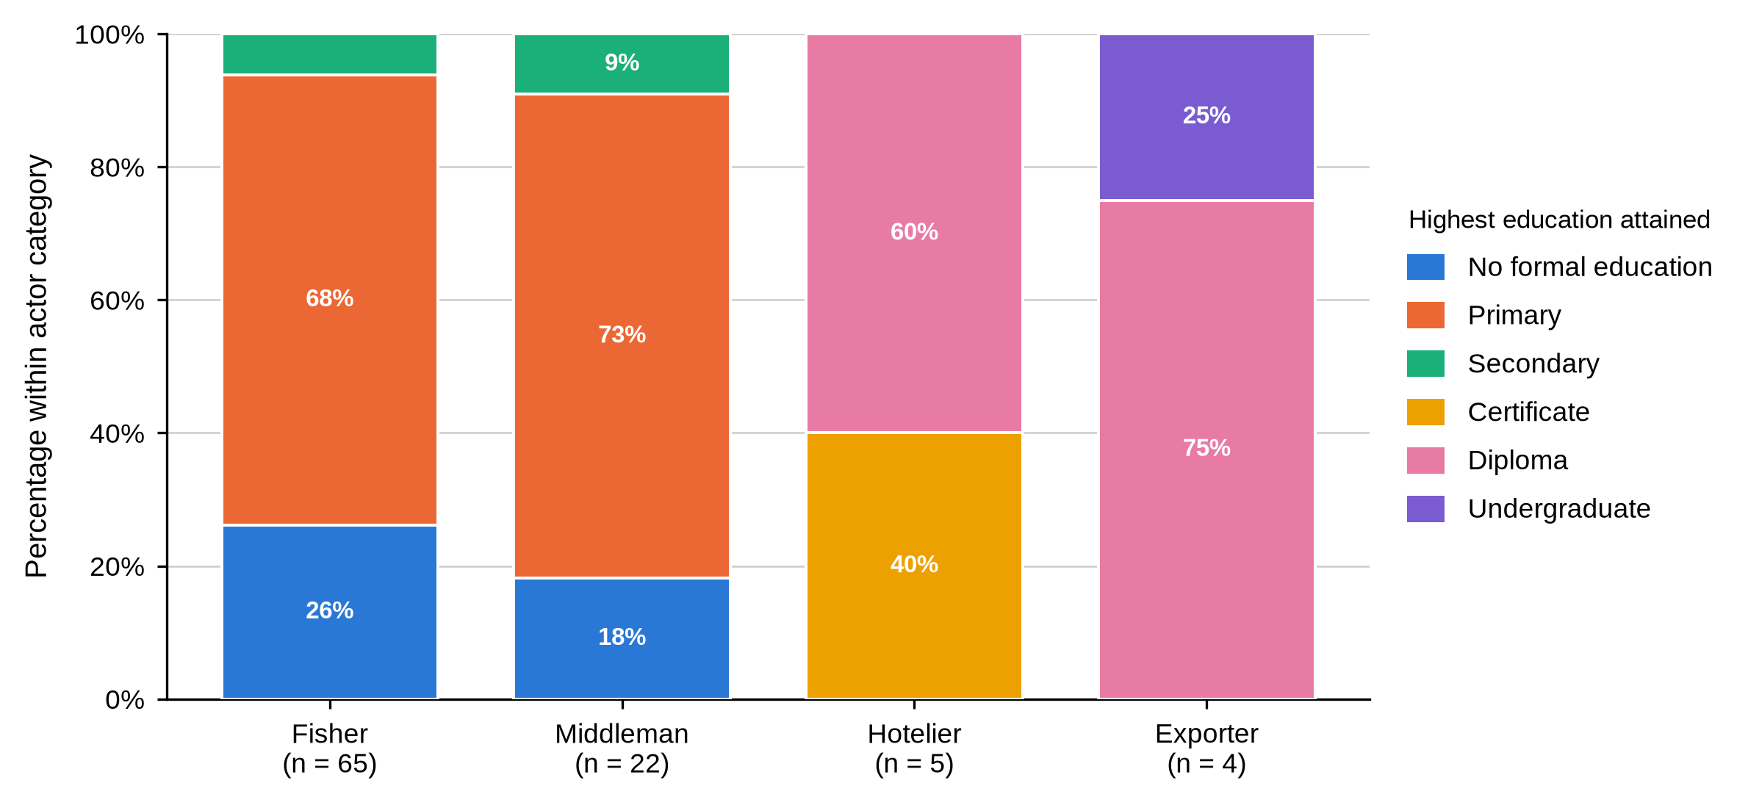
Table 5
Ethnic Group of Fishers, Middlemen, Hoteliers and Exporters by BMU
Characteristic / response | Actor | Overall | Shimoni | Majoreni | Vanga | Msambweni | Other sites | BMU p-value
Ethnic group
Digo | Fisher N = 65 | 36 (55.4%) | 12 (48.0%) | 8 (57.1%) | 13 (61.9%) | 2 (66.7%) | 1 (50.0%) | .368
Duruma | Fisher N = 65 | 17 (26.2%) | 7 (28.0%) | 6 (42.9%) | 4 (19.0%) | 0 (0.0%) | 0 (0.0%)
Vumba | Fisher N = 65 | 12 (18.5%) | 6 (24.0%) | 0 (0.0%) | 4 (19.0%) | 1 (33.3%) | 1 (50.0%)
Swahili | Fisher N = 65 | 0 (0.0%) | 0 (0.0%) | 0 (0.0%) | 0 (0.0%) | 0 (0.0%) | 0 (0.0%)
Kikuyu | Fisher N = 65 | 0 (0.0%) | 0 (0.0%) | 0 (0.0%) | 0 (0.0%) | 0 (0.0%) | 0 (0.0%)
Chinese | Fisher N = 65 | 0 (0.0%) | 0 (0.0%) | 0 (0.0%) | 0 (0.0%) | 0 (0.0%) | 0 (0.0%)
Digo | Middleman N = 22 | 15 (68.2%) | 8 (72.7%) | 5 (71.4%) | 2 (50.0%) | - | - | .508
Duruma | Middleman N = 22 | 6 (27.3%) | 3 (27.3%) | 1 (14.3%) | 2 (50.0%) | - | -
Vumba | Middleman N = 22 | 1 (4.5%) | 0 (0.0%) | 1 (14.3%) | 0 (0.0%) | - | -
Swahili | Middleman N = 22 | 0 (0.0%) | 0 (0.0%) | 0 (0.0%) | 0 (0.0%) | - | -
Kikuyu | Middleman N = 22 | 0 (0.0%) | 0 (0.0%) | 0 (0.0%) | 0 (0.0%) | - | -
Chinese | Middleman N = 22 | 0 (0.0%) | 0 (0.0%) | 0 (0.0%) | 0 (0.0%) | - | -
Digo | Hotelier N = 5 | 2 (40.0%) | 0 (0.0%) | - | - | - | 2 (50.0%)
Duruma | Hotelier N = 5 | 1 (20.0%) | 0 (0.0%) | - | - | - | 1 (25.0%)
Vumba | Hotelier N = 5 | 2 (40.0%) | 1 (100.0%) | - | - | - | 1 (25.0%)
Swahili | Hotelier N = 5 | 0 (0.0%) | 0 (0.0%) | - | - | - | 0 (0.0%)
Kikuyu | Hotelier N = 5 | 0 (0.0%) | 0 (0.0%) | - | - | - | 0 (0.0%)
Chinese | Hotelier N = 5 | 0 (0.0%) | 0 (0.0%) | - | - | - | 0 (0.0%)
Digo | Exporter N = 4 | 0 (0.0%) | - | - | - | - | 0 (0.0%)
Duruma | Exporter N = 4 | 0 (0.0%) | - | - | - | - | 0 (0.0%)
Vumba | Exporter N = 4 | 0 (0.0%) | - | - | - | - | 0 (0.0%)
Swahili | Exporter N = 4 | 1 (25.0%) | - | - | - | - | 1 (25.0%)
Kikuyu | Exporter N = 4 | 1 (25.0%) | - | - | - | - | 1 (25.0%)
Chinese | Exporter N = 4 | 2 (50.0%) | - | - | - | - | 2 (50.0%)
Table 5 reports ethnic group. The Digo were the largest group among fishers (36, 55.4%) and middlemen (15, 68.2%), followed by the Duruma and the Vumba; hoteliers split between Digo (2, 40.0%), Vumba (2, 40.0%) and Duruma (1, 20.0%). Exporters drew on ethnic groups entirely absent upstream: Chinese (2, 50.0%), Kikuyu (1, 25.0%) and Swahili (1, 25.0%). Ethnicity was not associated with BMU for fishers (p = .368) or middlemen (p = .508). No fisher or middleman reported education beyond secondary level, and no hotelier or exporter reported less than a certificate.
Table 6
Marital Status of Fishers, Middlemen, Hoteliers and Exporters by BMU
Characteristic / response | Actor | Overall | Shimoni | Majoreni | Vanga | Msambweni | Other sites | BMU p-value
Marital status
Single | Fisher N = 65 | 20 (30.8%) | 12 (48.0%) | 5 (35.7%) | 3 (14.3%) | 0 (0.0%) | 0 (0.0%) | .049
Married | Fisher N = 65 | 41 (63.1%) | 12 (48.0%) | 8 (57.1%) | 18 (85.7%) | 2 (66.7%) | 1 (50.0%)
Separated / divorced | Fisher N = 65 | 3 (4.6%) | 0 (0.0%) | 1 (7.1%) | 0 (0.0%) | 1 (33.3%) | 1 (50.0%)
Widowed | Fisher N = 65 | 1 (1.5%) | 1 (4.0%) | 0 (0.0%) | 0 (0.0%) | 0 (0.0%) | 0 (0.0%)
Single | Middleman N = 22 | 2 (9.1%) | 1 (9.1%) | 0 (0.0%) | 1 (25.0%) | - | - | .665
Married | Middleman N = 22 | 20 (90.9%) | 10 (90.9%) | 7 (100.0%) | 3 (75.0%) | - | -
Separated / divorced | Middleman N = 22 | 0 (0.0%) | 0 (0.0%) | 0 (0.0%) | 0 (0.0%) | - | -
Widowed | Middleman N = 22 | 0 (0.0%) | 0 (0.0%) | 0 (0.0%) | 0 (0.0%) | - | -
Single | Hotelier N = 5 | 2 (40.0%) | 1 (100.0%) | - | - | - | 1 (25.0%)
Married | Hotelier N = 5 | 3 (60.0%) | 0 (0.0%) | - | - | - | 3 (75.0%)
Separated / divorced | Hotelier N = 5 | 0 (0.0%) | 0 (0.0%) | - | - | - | 0 (0.0%)
Widowed | Hotelier N = 5 | 0 (0.0%) | 0 (0.0%) | - | - | - | 0 (0.0%)
Single | Exporter N = 4 | 0 (0.0%) | - | - | - | - | 0 (0.0%)
Married | Exporter N = 4 | 4 (100.0%) | - | - | - | - | 4 (100.0%)
Separated / divorced | Exporter N = 4 | 0 (0.0%) | - | - | - | - | 0 (0.0%)
Widowed | Exporter N = 4 | 0 (0.0%) | - | - | - | - | 0 (0.0%)
As shown in Table 6, most fishers (41, 63.1%) and almost all middlemen (20, 90.9%) were married, as were all four exporters; the hoteliers showed the least lopsided split, two single (40.0%) against three married (60.0%). Among fishers the married share ranged from 12 (48.0%) at Shimoni to 18 (85.7%) at Vanga, and marital status was associated with BMU at the margin (p = .049). Middleman marital status was not associated with BMU (p = .665).
Table 7
Years of Experience of Fishers, Middlemen, Hoteliers and Exporters by BMU
Characteristic / response | Actor | Overall | Shimoni | Majoreni | Vanga | Msambweni | Other sites | BMU p-value
Years of experience in the mud crab fishery
Less than 5 years | Fisher N = 65 | 1 (1.5%) | 0 (0.0%) | 1 (7.1%) | 0 (0.0%) | 0 (0.0%) | 0 (0.0%) | .204
5-10 years | Fisher N = 65 | 22 (33.8%) | 10 (40.0%) | 3 (21.4%) | 8 (38.1%) | 1 (33.3%) | 0 (0.0%)
11-20 years | Fisher N = 65 | 22 (33.8%) | 12 (48.0%) | 3 (21.4%) | 6 (28.6%) | 1 (33.3%) | 0 (0.0%)
Over 20 years | Fisher N = 65 | 20 (30.8%) | 3 (12.0%) | 7 (50.0%) | 7 (33.3%) | 1 (33.3%) | 2 (100.0%)
Less than 5 years | Middleman N = 22 | 0 (0.0%) | 0 (0.0%) | 0 (0.0%) | 0 (0.0%) | - | - | .747
5-10 years | Middleman N = 22 | 3 (13.6%) | 2 (18.2%) | 0 (0.0%) | 1 (25.0%) | - | -
11-20 years | Middleman N = 22 | 3 (13.6%) | 2 (18.2%) | 1 (14.3%) | 0 (0.0%) | - | -
Over 20 years | Middleman N = 22 | 16 (72.7%) | 7 (63.6%) | 6 (85.7%) | 3 (75.0%) | - | -
Less than 5 years | Hotelier N = 5 | 4 (80.0%) | 1 (100.0%) | - | - | - | 3 (75.0%)
5-10 years | Hotelier N = 5 | 1 (20.0%) | 0 (0.0%) | - | - | - | 1 (25.0%)
11-20 years | Hotelier N = 5 | 0 (0.0%) | 0 (0.0%) | - | - | - | 0 (0.0%)
Over 20 years | Hotelier N = 5 | 0 (0.0%) | 0 (0.0%) | - | - | - | 0 (0.0%)
Less than 5 years | Exporter N = 4 | 2 (50.0%) | - | - | - | - | 2 (50.0%)
5-10 years | Exporter N = 4 | 2 (50.0%) | - | - | - | - | 2 (50.0%)
11-20 years | Exporter N = 4 | 0 (0.0%) | - | - | - | - | 0 (0.0%)
Over 20 years | Exporter N = 4 | 0 (0.0%) | - | - | - | - | 0 (0.0%)
Table 7 reports years of experience. Fisher experience spread fairly evenly across the 5–10 year (22, 33.8%), 11–20 year (22, 33.8%) and over-20-year (20, 30.8%) bands. Middlemen were considerably more experienced, 16 of 22 (72.7%) reporting more than twenty years, rising to 6 (85.7%) at Majoreni. Hoteliers were comparatively new to the trade, four of five (80.0%) reporting under five years, and exporters split evenly between under five years and 5–10 years (2, 50.0% each). Experience was not associated with BMU for fishers (p = .204) or middlemen (p = .747).
Read together, Tables 3 to 7 and Figure 5 describe fishers and middlemen as demographically similar in some respects and distinct in others. Both groups were almost entirely male, primarily educated and drawn mainly from the Digo, Duruma and Vumba; gender showed too little variation in either group to support a test, while education and ethnicity were tested and found not to be associated with BMU. Where the two groups diverged was age and experience: fishers concentrated in the 18–35 band, with fisher age the only demographic characteristic significantly associated with BMU, while middlemen were older, concentrated in the 36–49 band, and markedly more experienced. Hoteliers and exporters stood apart from both upstream groups on education and ethnicity, holding higher qualifications throughout and, among exporters, drawing on ethnic groups entirely absent from the upstream sample. For Objective One this means the profile of a mud crab actor is determined far more by position in the chain than by the landing site at which they work.

4.3.2 Business and Operational Characteristics
Table 8
Primary Role and Business Ownership of Fishers, Middlemen, Hoteliers and Exporters by BMU
Characteristic / response | Actor | Overall | Shimoni | Majoreni | Vanga | Msambweni | Other sites | BMU p-value
Primary role in the mud crab fishery
Crabber | Fisher N = 65 | 65 (100.0%) | 25 (100.0%) | 14 (100.0%) | 21 (100.0%) | 3 (100.0%) | 2 (100.0%)
Exporter | Fisher N = 65 | 0 (0.0%) | 0 (0.0%) | 0 (0.0%) | 0 (0.0%) | 0 (0.0%) | 0 (0.0%)
Marketer | Fisher N = 65 | 0 (0.0%) | 0 (0.0%) | 0 (0.0%) | 0 (0.0%) | 0 (0.0%) | 0 (0.0%)
Processor | Fisher N = 65 | 0 (0.0%) | 0 (0.0%) | 0 (0.0%) | 0 (0.0%) | 0 (0.0%) | 0 (0.0%)
Crabber | Middleman N = 22 | 0 (0.0%) | 0 (0.0%) | 0 (0.0%) | 0 (0.0%) | - | -
Exporter | Middleman N = 22 | 0 (0.0%) | 0 (0.0%) | 0 (0.0%) | 0 (0.0%) | - | -
Marketer | Middleman N = 22 | 22 (100.0%) | 11 (100.0%) | 7 (100.0%) | 4 (100.0%) | - | -
Processor | Middleman N = 22 | 0 (0.0%) | 0 (0.0%) | 0 (0.0%) | 0 (0.0%) | - | -
Crabber | Hotelier N = 5 | 0 (0.0%) | 0 (0.0%) | - | - | - | 0 (0.0%)
Exporter | Hotelier N = 5 | 0 (0.0%) | 0 (0.0%) | - | - | - | 0 (0.0%)
Marketer | Hotelier N = 5 | 0 (0.0%) | 0 (0.0%) | - | - | - | 0 (0.0%)
Processor | Hotelier N = 5 | 5 (100.0%) | 1 (100.0%) | - | - | - | 4 (100.0%)
Crabber | Exporter N = 4 | 0 (0.0%) | - | - | - | - | 0 (0.0%)
Exporter | Exporter N = 4 | 4 (100.0%) | - | - | - | - | 4 (100.0%)
Marketer | Exporter N = 4 | 0 (0.0%) | - | - | - | - | 0 (0.0%)
Processor | Exporter N = 4 | 0 (0.0%) | - | - | - | - | 0 (0.0%)
Owns or manages a mud crab operation
Yes | Fisher N = 65 | 65 (100.0%) | 25 (100.0%) | 14 (100.0%) | 21 (100.0%) | 3 (100.0%) | 2 (100.0%)
Yes | Middleman N = 22 | 22 (100.0%) | 11 (100.0%) | 7 (100.0%) | 4 (100.0%) | - | -
Yes | Hotelier N = 5 | 5 (100.0%) | 1 (100.0%) | - | - | - | 4 (100.0%)
Yes | Exporter N = 4 | 4 (100.0%) | - | - | - | - | 4 (100.0%)
Table 8 confirms that primary role coincided exactly with actor category: fishers were uniformly recorded as crabbers, middlemen as marketers, hoteliers as processors and exporters as exporters, each at 100.0%. Business ownership was equally uniform, with every respondent in all four categories reporting that they owned or managed the operation they described. Neither item varied enough within fishers or middlemen to support a test of association with BMU.
Table 9
Scale of Operation of Fishers, Middlemen, Hoteliers and Exporters by BMU
Characteristic / response | Actor | Overall | Shimoni | Majoreni | Vanga | Msambweni | Other sites | BMU p-value
Scale of operation
Small-scale | Fisher N = 65 | 64 (98.5%) | 25 (100.0%) | 14 (100.0%) | 20 (95.2%) | 3 (100.0%) | 2 (100.0%) | .606
Medium-scale | Fisher N = 65 | 1 (1.5%) | 0 (0.0%) | 0 (0.0%) | 1 (4.8%) | 0 (0.0%) | 0 (0.0%)
Large-scale | Fisher N = 65 | 0 (0.0%) | 0 (0.0%) | 0 (0.0%) | 0 (0.0%) | 0 (0.0%) | 0 (0.0%)
Small-scale | Middleman N = 22 | 10 (45.5%) | 8 (72.7%) | 2 (28.6%) | 0 (0.0%) | - | - | .050
Medium-scale | Middleman N = 22 | 10 (45.5%) | 2 (18.2%) | 5 (71.4%) | 3 (75.0%) | - | -
Large-scale | Middleman N = 22 | 2 (9.1%) | 1 (9.1%) | 0 (0.0%) | 1 (25.0%) | - | -
Small-scale | Hotelier N = 5 | 0 (0.0%) | 0 (0.0%) | - | - | - | 0 (0.0%)
Medium-scale | Hotelier N = 5 | 5 (100.0%) | 1 (100.0%) | - | - | - | 4 (100.0%)
Large-scale | Hotelier N = 5 | 0 (0.0%) | 0 (0.0%) | - | - | - | 0 (0.0%)
Small-scale | Exporter N = 4 | 0 (0.0%) | - | - | - | - | 0 (0.0%)
Medium-scale | Exporter N = 4 | 0 (0.0%) | - | - | - | - | 0 (0.0%)
Large-scale | Exporter N = 4 | 4 (100.0%) | - | - | - | - | 4 (100.0%)
As shown in Table 9, fisher operations were almost entirely small-scale (64, 98.5%), with a single medium-scale exception at Vanga. Middleman scale was mixed — 10 small-scale (45.5%), 10 medium-scale (45.5%) and 2 large-scale (9.1%) — and varied by site, the medium-scale share rising from 2 (18.2%) at Shimoni to 5 (71.4%) at Majoreni and 3 (75.0%) at Vanga. That association approached but did not reach conventional significance (p = .050) and should not be treated as established. All five hoteliers operated at medium scale and all four exporters at large scale. Fisher scale was not associated with BMU (p = .606).
Figure 6 presents the monthly income band derived from mud crab activity. Most fishers fell below KSh 13,900 per month (52, 80.0%), a share ranging from 13 (61.9%) at Vanga to 3 (100.0%) at Msambweni. Every middleman fell in the next band up, KSh 13,900–69,500, a full band above the modal fisher. Four of five hoteliers (80.0%) fell in that same band and one (20.0%) in the highest; all three exporters who gave a valid figure fell in the highest band, KSh 69,501–139,000. Fisher income band was not significantly associated with BMU, although it came close (p = .057).
Table 10
Reported Monthly Income and Age of Respondents by Actor Category
Actor category | Valid n | M | SD | Mdn | IQR (Q1–Q3) | Range
Reported monthly mud crab income (KSh)
Fisher | 65 | 8,969.2 | 6,745.3 | 6,000.0 | 5,000.0–10,000.0 | 4,000.0–50,000.0
Middleman | 22 | 27,954.5 | 11,407.9 | 25,000.0 | 20,000.0–30,000.0 | 15,000.0–50,000.0
Hotelier | 5 | 43,000.0 | 34,568.8 | 30,000.0 | 20,000.0–50,000.0 | 15,000.0–100,000.0
Exporter | 3 | 90,000.0 | 17,320.5 | 100,000.0 | 85,000.0–100,000.0 | 70,000.0–100,000.0
All actors | 95 | 17,715.8 | 19,886.7 | 10,000.0 | 5,000.0–20,000.0 | 4,000.0–100,000.0
Age in completed years
Fisher | 65 | 36 | 15 | 32 | 25–45 | 14–77
Middleman | 22 | 44 | 11 | 45 | 37–51 | 24–65
Hotelier | 5 | 33 | 9 | 29 | 28–32 | 26–48
Exporter | 4 | 44 | 5 | 45 | 41–48 | 38–48
All actors | 96 | 38 | 14 | 36 | 27–48 | 14–77
Table 10 gives the underlying continuous figures. Fishers averaged KSh 8,969.2 a month with a median of KSh 6,000.0; middlemen averaged KSh 27,954.5; hoteliers KSh 43,000.0; and the three exporters who answered averaged KSh 90,000.0 with a median of KSh 100,000.0. An exporter therefore reported roughly ten times the monthly mud crab income of a fisher. Mean age rose from 36 years among fishers to 44 among both middlemen and exporters, while hoteliers averaged 33.
Figure 6
Monthly Mud Crab Income Band Within Each Actor Category
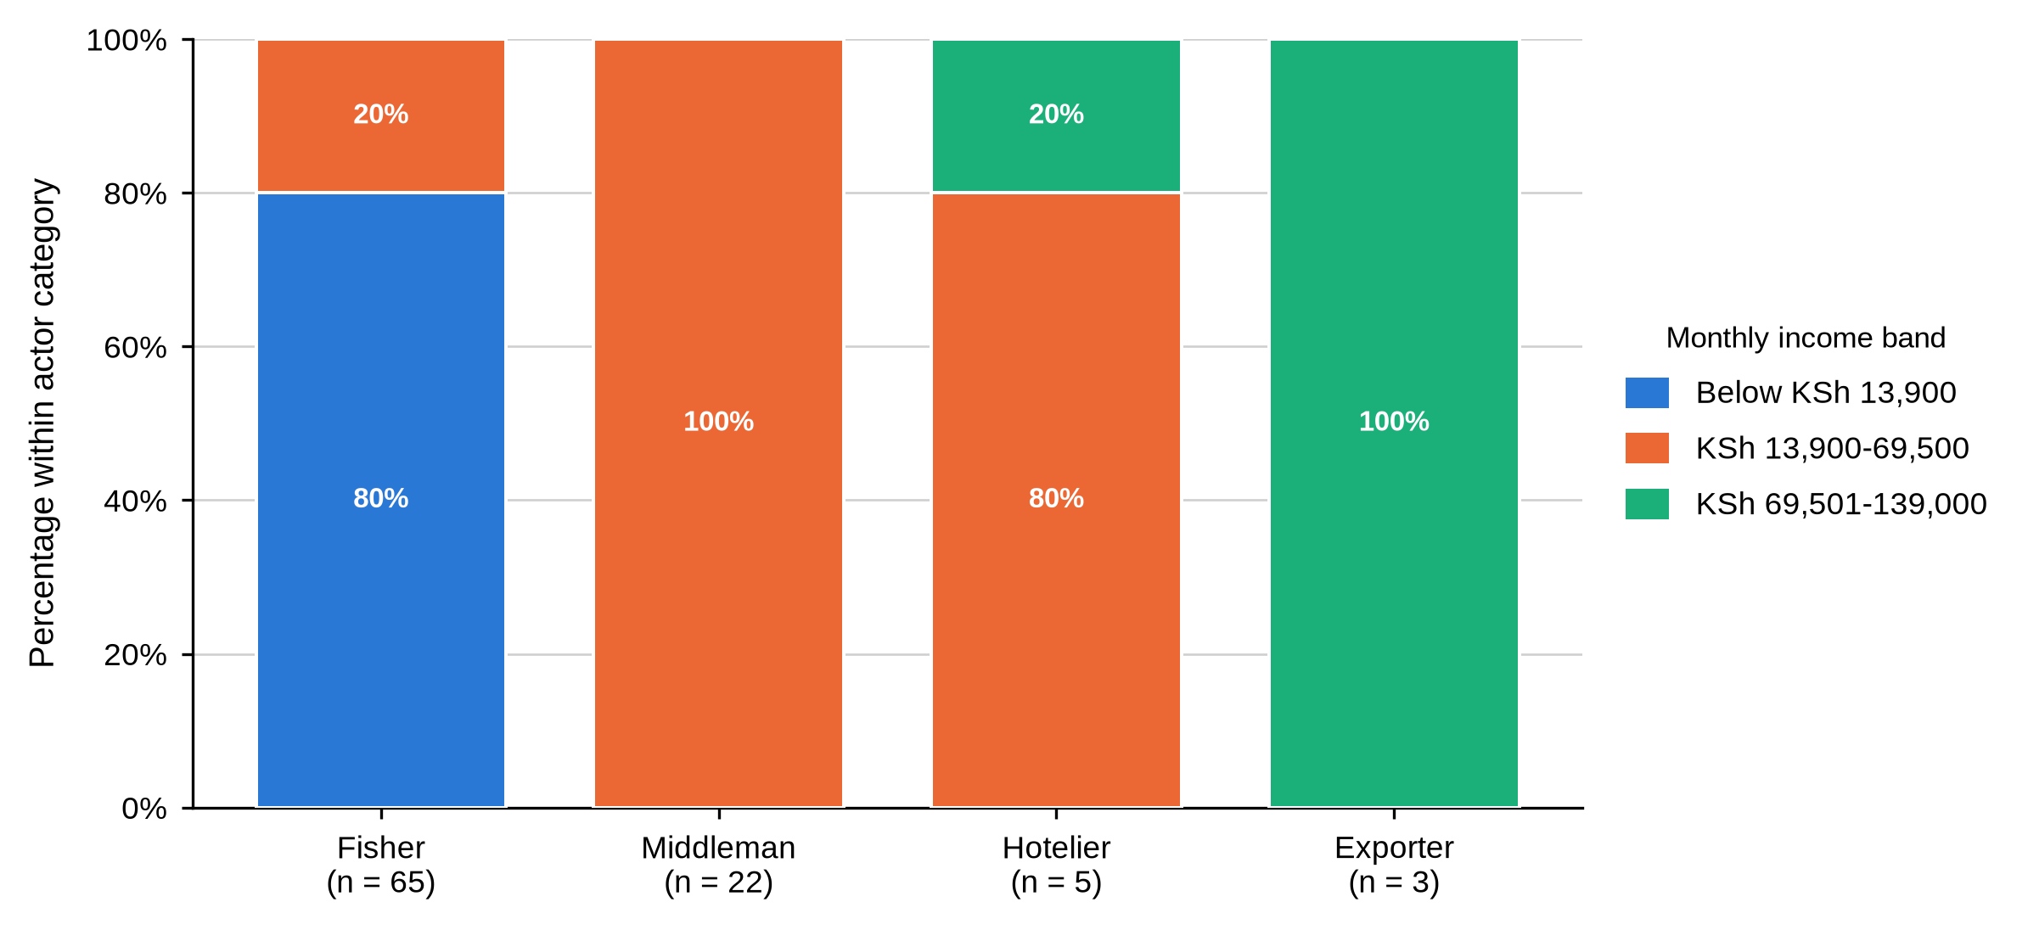
Table 11
Other Income Activities, Operating Licence and Loan Use by Actor and BMU
Characteristic / response | Actor | Overall | Shimoni | Majoreni | Vanga | Msambweni | Other sites | BMU p-value
Engages in other income activities
Yes | Fisher N = 65 | 13 (20.0%) | 7 (28.0%) | 3 (21.4%) | 1 (4.8%) | 1 (33.3%) | 1 (50.0%) | .234
No | Fisher N = 65 | 52 (80.0%) | 18 (72.0%) | 11 (78.6%) | 20 (95.2%) | 2 (66.7%) | 1 (50.0%)
Yes | Middleman N = 22 | 22 (100.0%) | 11 (100.0%) | 7 (100.0%) | 4 (100.0%) | - | -
No | Middleman N = 22 | 0 (0.0%) | 0 (0.0%) | 0 (0.0%) | 0 (0.0%) | - | -
Yes | Hotelier N = 5 | 5 (100.0%) | 1 (100.0%) | - | - | - | 4 (100.0%)
No | Hotelier N = 5 | 0 (0.0%) | 0 (0.0%) | - | - | - | 0 (0.0%)
Yes | Exporter N = 4 | 4 (100.0%) | - | - | - | - | 4 (100.0%)
No | Exporter N = 4 | 0 (0.0%) | - | - | - | - | 0 (0.0%)
Holds an operating licence
Yes | Fisher N = 64 | 8 (12.5%) | 2 (8.0%) | 2 (15.4%) | 3 (14.3%) | 0 (0.0%) | 1 (50.0%) | .840
No | Fisher N = 64 | 56 (87.5%) | 23 (92.0%) | 11 (84.6%) | 18 (85.7%) | 3 (100.0%) | 1 (50.0%)
Yes | Middleman N = 22 | 6 (27.3%) | 2 (18.2%) | 2 (28.6%) | 2 (50.0%) | - | - | .580
No | Middleman N = 22 | 16 (72.7%) | 9 (81.8%) | 5 (71.4%) | 2 (50.0%) | - | -
Yes | Hotelier N = 5 | 5 (100.0%) | 1 (100.0%) | - | - | - | 4 (100.0%)
No | Hotelier N = 5 | 0 (0.0%) | 0 (0.0%) | - | - | - | 0 (0.0%)
Yes | Exporter N = 4 | 4 (100.0%) | - | - | - | - | 4 (100.0%)
No | Exporter N = 4 | 0 (0.0%) | - | - | - | - | 0 (0.0%)
Uses loans to facilitate business
Yes | Fisher N = 65 | 0 (0.0%) | 0 (0.0%) | 0 (0.0%) | 0 (0.0%) | 0 (0.0%) | 0 (0.0%)
No | Fisher N = 65 | 65 (100.0%) | 25 (100.0%) | 14 (100.0%) | 21 (100.0%) | 3 (100.0%) | 2 (100.0%)
Yes | Middleman N = 22 | 16 (72.7%) | 8 (72.7%) | 4 (57.1%) | 4 (100.0%) | - | - | .311
No | Middleman N = 22 | 6 (27.3%) | 3 (27.3%) | 3 (42.9%) | 0 (0.0%) | - | -
Yes | Hotelier N = 5 | 0 (0.0%) | 0 (0.0%) | - | - | - | 0 (0.0%)
No | Hotelier N = 5 | 5 (100.0%) | 1 (100.0%) | - | - | - | 4 (100.0%)
Yes | Exporter N = 4 | 2 (50.0%) | - | - | - | - | 2 (50.0%)
No | Exporter N = 4 | 2 (50.0%) | - | - | - | - | 2 (50.0%)
Table 11 covers three indicators of business formality, and Figure 7 sets licensing, credit, training and collective membership side by side across the four actor categories. Most fishers relied on mud crab fishing as their sole income source, only 13 (20.0%) reporting another activity, while every middleman, hotelier and exporter reported additional income. Operating licences were held by 8 of 64 fishers (12.5%) and 6 of 22 middlemen (27.3%) against every hotelier and exporter. No fisher used a business loan at all, whereas 16 middlemen (72.7%) did, rising to all four (100.0%) at Vanga, and two of the four exporters (50.0%). None of the three items was significantly associated with BMU among fishers or middlemen. One exporter gave no valid income figure and is excluded from the exporter column.
Figure 7
Licensing, Credit, Training and Collective Membership by Actor Category
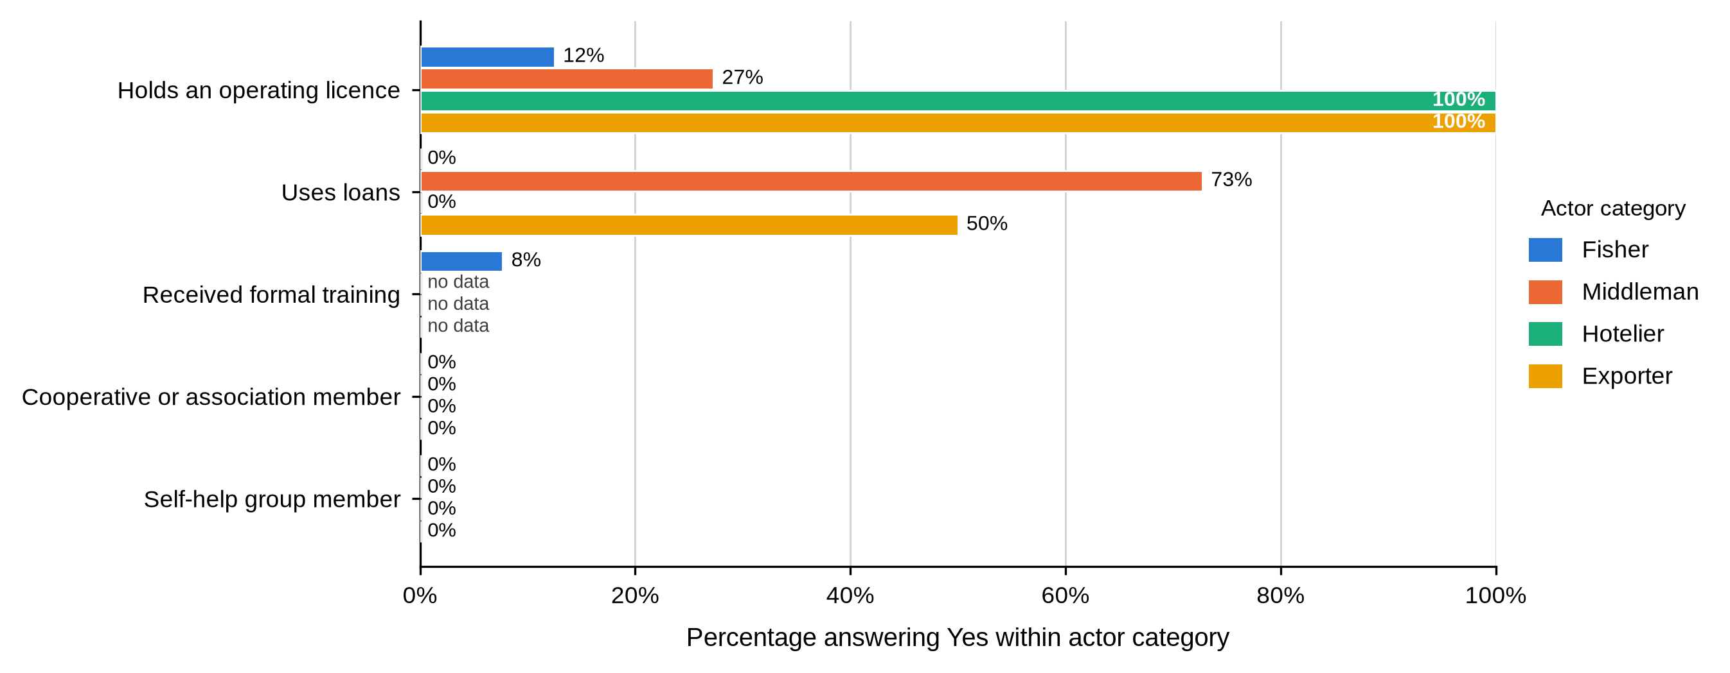
Table 12
Main Source of Business Credit by Actor and BMU
Characteristic / response | Actor | Overall | Shimoni | Majoreni | Vanga | Msambweni | Other sites | BMU p-value
Main source of business credit
Exporters | Fisher N = 65 | 0 (0.0%) | 0 (0.0%) | 0 (0.0%) | 0 (0.0%) | 0 (0.0%) | 0 (0.0%) | .124
Formal institutions | Fisher N = 65 | 0 (0.0%) | 0 (0.0%) | 0 (0.0%) | 0 (0.0%) | 0 (0.0%) | 0 (0.0%)
Middlemen | Fisher N = 65 | 61 (93.8%) | 25 (100.0%) | 13 (92.9%) | 19 (90.5%) | 2 (66.7%) | 2 (100.0%)
Middlemen and relatives | Fisher N = 65 | 4 (6.2%) | 0 (0.0%) | 1 (7.1%) | 2 (9.5%) | 1 (33.3%) | 0 (0.0%)
Exporters | Middleman N = 22 | 12 (54.5%) | 4 (36.4%) | 4 (57.1%) | 4 (100.0%) | - | - | .099
Formal institutions | Middleman N = 22 | 0 (0.0%) | 0 (0.0%) | 0 (0.0%) | 0 (0.0%) | - | -
Middlemen | Middleman N = 22 | 10 (45.5%) | 7 (63.6%) | 3 (42.9%) | 0 (0.0%) | - | -
Middlemen and relatives | Middleman N = 22 | 0 (0.0%) | 0 (0.0%) | 0 (0.0%) | 0 (0.0%) | - | -
Exporters | Hotelier N = 0 | - | - | - | - | - | -
Formal institutions | Hotelier N = 0 | - | - | - | - | - | -
Middlemen | Hotelier N = 0 | - | - | - | - | - | -
Middlemen and relatives | Hotelier N = 0 | - | - | - | - | - | -
Exporters | Exporter N = 4 | 0 (0.0%) | - | - | - | - | 0 (0.0%)
Formal institutions | Exporter N = 4 | 4 (100.0%) | - | - | - | - | 4 (100.0%)
Middlemen | Exporter N = 4 | 0 (0.0%) | - | - | - | - | 0 (0.0%)
Middlemen and relatives | Exporter N = 4 | 0 (0.0%) | - | - | - | - | 0 (0.0%)
Table 12 shows where credit came from. Fishers who accessed credit relied overwhelmingly on middlemen (61, 93.8%), with a further 4 (6.2%) naming middlemen together with relatives; the middleman share reached 25 (100.0%) at Shimoni. Middlemen themselves relied more on exporters (12, 54.5%) than on other middlemen (10, 45.5%), the exporter share rising to all four (100.0%) at Vanga. All four exporters relied on formal institutions. No hotelier reported a credit source. Credit source was not significantly associated with BMU for fishers (p = .124) or middlemen (p = .099). The label no data marks an item the actor category did not complete, which is different from a zero.
Considered together, Tables 8 to 12 and Figure 6 describe a business structure that scales and formalises further down the chain. Scale rose from fishers, almost uniformly small-scale, through middlemen, whose scale varied by site and approached significance, to hoteliers at medium scale and exporters at large scale. Income followed the same gradient, and formal licensing was rare upstream but universal downstream. Credit traced the same line in reverse: fishers who borrowed relied on middlemen, middlemen who borrowed relied on exporters, and exporters relied on banks — a single chain of credit dependency running from the landing beach to the export market. For Objective One this is the clearest evidence that the actor categories are not merely different occupations but successive positions of unequal formality and unequal access to finance.

4.3.3 Knowledge, Training and Group Membership
Table 13
Knowledge Acquisition and Formal Training by Actor and BMU
Characteristic / response | Actor | Overall | Shimoni | Majoreni | Vanga | Msambweni | Other sites | BMU p-value
How mud crab knowledge and skills were acquired
Family tradition | Fisher N = 64 | 41 (64.1%) | 19 (79.2%) | 8 (57.1%) | 11 (52.4%) | 1 (33.3%) | 2 (100.0%) | .194
Other source | Fisher N = 64 | 23 (35.9%) | 5 (20.8%) | 6 (42.9%) | 10 (47.6%) | 2 (66.7%) | 0 (0.0%)
Family tradition | Middleman N = 0 | - | - | - | - | - | -
Other source | Middleman N = 0 | - | - | - | - | - | -
Family tradition | Hotelier N = 0 | - | - | - | - | - | -
Other source | Hotelier N = 0 | - | - | - | - | - | -
Family tradition | Exporter N = 0 | - | - | - | - | - | -
Other source | Exporter N = 0 | - | - | - | - | - | -
Received formal mud crab training
Yes | Fisher N = 65 | 5 (7.7%) | 1 (4.0%) | 3 (21.4%) | 0 (0.0%) | 1 (33.3%) | 0 (0.0%) | .035
No | Fisher N = 65 | 60 (92.3%) | 24 (96.0%) | 11 (78.6%) | 21 (100.0%) | 2 (66.7%) | 2 (100.0%)
Yes | Middleman N = 0 | - | - | - | - | - | -
No | Middleman N = 0 | - | - | - | - | - | -
Yes | Hotelier N = 0 | - | - | - | - | - | -
No | Hotelier N = 0 | - | - | - | - | - | -
Yes | Exporter N = 0 | - | - | - | - | - | -
No | Exporter N = 0 | - | - | - | - | - | -
Table 13 covers how fishers learned the trade and whether they had been trained. Both items were put to fishers only. Family tradition was the leading route into the fishery (41 of 64, 64.1%), ranging from 19 (79.2%) at Shimoni to 1 (33.3%) at Msambweni, and was not associated with BMU (p = .194). Formal training was rare: only 5 of 65 fishers (7.7%) had received any, and training did vary by site (p = .035), with 3 of 14 trained fishers at Majoreni (21.4%) against 1 of 25 at Shimoni (4.0%) and none at Vanga.
Table 14
Cooperative Membership, Self-Help Group Participation and Primary Market Supplied by Actor and BMU
Characteristic / response | Actor | Overall | Shimoni | Majoreni | Vanga | Msambweni | Other sites | BMU p-value
Member of a cooperative or association
No | Fisher N = 65 | 65 (100.0%) | 25 (100.0%) | 14 (100.0%) | 21 (100.0%) | 3 (100.0%) | 2 (100.0%)
No | Middleman N = 22 | 22 (100.0%) | 11 (100.0%) | 7 (100.0%) | 4 (100.0%) | - | -
No | Hotelier N = 5 | 5 (100.0%) | 1 (100.0%) | - | - | - | 4 (100.0%)
No | Exporter N = 4 | 4 (100.0%) | - | - | - | - | 4 (100.0%)
Participates in a self-help group
No | Fisher N = 65 | 65 (100.0%) | 25 (100.0%) | 14 (100.0%) | 21 (100.0%) | 3 (100.0%) | 2 (100.0%)
No | Middleman N = 22 | 22 (100.0%) | 11 (100.0%) | 7 (100.0%) | 4 (100.0%) | - | -
No | Hotelier N = 5 | 5 (100.0%) | 1 (100.0%) | - | - | - | 4 (100.0%)
No | Exporter N = 4 | 4 (100.0%) | - | - | - | - | 4 (100.0%)
Primary market supplied
Local markets | Fisher N = 65 | 65 (100.0%) | 25 (100.0%) | 14 (100.0%) | 21 (100.0%) | 3 (100.0%) | 2 (100.0%)
Export markets | Fisher N = 65 | 0 (0.0%) | 0 (0.0%) | 0 (0.0%) | 0 (0.0%) | 0 (0.0%) | 0 (0.0%)
Local markets | Middleman N = 22 | 22 (100.0%) | 11 (100.0%) | 7 (100.0%) | 4 (100.0%) | - | -
Export markets | Middleman N = 22 | 0 (0.0%) | 0 (0.0%) | 0 (0.0%) | 0 (0.0%) | - | -
Local markets | Hotelier N = 5 | 5 (100.0%) | 1 (100.0%) | - | - | - | 4 (100.0%)
Export markets | Hotelier N = 5 | 0 (0.0%) | 0 (0.0%) | - | - | - | 0 (0.0%)
Local markets | Exporter N = 4 | 0 (0.0%) | - | - | - | - | 0 (0.0%)
Export markets | Exporter N = 4 | 4 (100.0%) | - | - | - | - | 4 (100.0%)
As shown in Table 14, no fisher, middleman, hotelier or exporter reported membership of a cooperative or association, or participation in a self-help group. The figure was 0% in every actor category at every site. Primary market divided cleanly by actor: fishers, middlemen and hoteliers supplied local markets exclusively, while all four exporters supplied export markets exclusively.
Tables 13 and 14 together point to a fishery with very little institutional support or formal organisation. Most fishers learned the trade at home rather than through instruction, and fewer than one in twelve had received any training. Not one respondent in any actor category, upstream or downstream, belonged to a cooperative, an association or a self-help group. The single point of formal structure in the chain was the market channel itself, which divided the domestic and international segments of the trade cleanly and categorically. For Objective One, the absence of any collective body at any node is the most consequential single finding: it means every actor in this chain negotiates alone.

4.3.4 Summary of Objective One
Objective One asked who the mud crab actors are and what characterises them. The answer is four groups that differ systematically and in the same direction on almost every measure. Fishers were younger, schooled to primary level or below, small-scale, minimally licensed, untrained, un-diversified and financed by the same middlemen who bought from them. Middlemen were older, far more experienced, better capitalised and connected to exporters. Hoteliers and exporters were formally qualified, fully licensed and operating at a scale upstream actors did not reach. Of the nineteen characteristics examined, only fisher age group, fisher marital status and fisher training showed a significant association with BMU, and middleman scale of operation approached one. The profile of a mud crab actor is therefore set overwhelmingly by position in the chain, not by the landing site at which they work.

4.3.5 Discussion of Findings in Relation to Previous Studies
The demographic profile indicates participation concentrated among young-to-middle-aged adults and overwhelmingly male. This broadly agrees with accounts of the Kenyan mud crab fishery as a small-scale coastal livelihood embedded in mangrove-dependent communities (Mirera, 2017a; Fondo & Ogutu, 2021). The significant association between fisher age and BMU, set against non-significant differences for the other demographic characteristics, extends that literature by showing that age composition can vary locally even where the wider social profile is comparatively uniform. The near absence of women should be read as a feature of this sampling frame rather than proof that women are absent from crab-related livelihoods, particularly because the hotelier and exporter samples were very small.
Education, ethnicity and marital status describe a socially differentiated but predominantly small-scale fishery. Fishers and middlemen were largely primary-educated whereas hoteliers and exporters held higher qualifications. This downstream rise in attainment is consistent with the distinction drawn in the literature between community-level harvesting and more formal market-facing activity, although the cited studies do not establish education as the cause of occupational position (Mirera, 2014a, 2017a). Neither ethnicity nor marital status showed a significant BMU association among middlemen, so these results should be read descriptively and not as evidence that either characteristic determines entry into the chain.
Differences in experience, role and ownership point to distinct positions along the chain. Fishers were primarily harvesters, middlemen occupied trading and aggregation roles with markedly longer experience, and hoteliers and exporters represented downstream buying and marketing functions. This role differentiation agrees with the value-chain structure described in reviews of the Kenyan fishery, which separate harvesting from aggregation and market access (Mirera, 2017a; Fondo & Ogutu, 2021). The present data extend those accounts by showing that ownership was universal at every node, so the gradient in earnings and scale cannot be explained by differences in who owns the enterprise.
Scale and income increased toward the downstream end of the chain, and middleman scale also varied by site, although the association only approached significance and should not be treated as significant. This gradient is compatible with concerns in Kenyan fisheries research about unequal access to markets, services and value addition (Fondo & Ogutu, 2021). It extends earlier work by presenting qualifications, scale, income, licensing and formalisation together as a linked downstream pattern. It does not demonstrate causality, and the hotelier and exporter estimates are especially uncertain because those samples were very small and drawn mainly from outside the four BMUs.
Credit relationships reveal vertical dependence within the chain. Fishers who accessed credit relied overwhelmingly on middlemen, middlemen more often on exporters, and exporters on formal institutions. Crona et al. (2016) describe such arrangements as enabling and constraining at once: the advance solves an immediate cash problem while narrowing where the seller can sell. Béné et al. (2007) treat informal credit in small-scale fisheries as both safety net and mechanism of persistent low returns. The present inventory cannot establish the terms of these arrangements or whether they were beneficial or exploitative, but it does show that the person extending credit to a fisher is the same person buying from him.
Knowledge transmission remained predominantly informal, with family tradition the leading route into fishing and formal training rare. This agrees with Mirera’s (2014a) account of the importance of organised community settings for learning and livelihood development, and with his review of a fishery grounded in local practice (Mirera, 2017a). The rarity of formal training diverges from the capacity-building orientation emphasised in organised aquaculture initiatives, but that is a difference between settings rather than evidence that such initiatives were ineffective.
The complete absence of cooperative or self-help-group membership contrasts sharply with the organised community-group model examined by Mirera (2014a), where organisation was integral to small-scale mud crab aquaculture, and supports policy calls for stronger institutions and coordination in fisheries development (Fondo & Ogutu, 2021). Gutiérrez et al. (2011) found that leadership and clear incentives, rather than the existence of a group, separate successful cases from the rest; that nothing at all exists here, at any node, suggests earlier attempts offered members nothing they could see. The divergence is readily explained by context: evidence from organised aquaculture groups should not be assumed to describe independent capture-fishery actors.
Taken as a whole, Objective One depicts an upstream-to-downstream gradient in qualifications, scale, income, licensing and formalisation, with fishers occupying the least formal and most livelihood-dependent position. This accords with literature identifying persistent constraints to inclusive value addition and institutional development in Kenya’s fisheries (Fondo & Ogutu, 2021), while extending it with actor-level evidence tested against site. It should not be read as a population estimate for hoteliers or exporters, nor as proof that downstream position causes higher income or formalisation.

4.4 Objective Two: Functions Performed by Actors at Each Market Node
Objective Two examined what each actor category actually does with a mud crab: how it is obtained, prepared, graded, packed, moved, priced and paid for. The results are grouped into acquisition and disposal, buyers and market channels, handling and transport, grading and quality, losses, payment and price setting, trading relationships, and reported prices.

4.4.1 Acquisition of Crabs and Disposal of the Catch
Table 15
How Mud Crabs Are Acquired and Source of Crabs for Sale by Actor and BMU
Characteristic / response | Actor | Overall | Shimoni | Majoreni | Vanga | Msambweni | Other sites | BMU p-value
How mud crabs are acquired
Catching | Fisher N = 65 | 65 (100.0%) | 25 (100.0%) | 14 (100.0%) | 21 (100.0%) | 3 (100.0%) | 2 (100.0%)
Purchasing | Fisher N = 65 | 0 (0.0%) | 0 (0.0%) | 0 (0.0%) | 0 (0.0%) | 0 (0.0%) | 0 (0.0%)
Catching | Middleman N = 22 | 0 (0.0%) | 0 (0.0%) | 0 (0.0%) | 0 (0.0%) | - | -
Purchasing | Middleman N = 22 | 22 (100.0%) | 11 (100.0%) | 7 (100.0%) | 4 (100.0%) | - | -
Catching | Hotelier N = 5 | 0 (0.0%) | 0 (0.0%) | - | - | - | 0 (0.0%)
Purchasing | Hotelier N = 5 | 5 (100.0%) | 1 (100.0%) | - | - | - | 4 (100.0%)
Catching | Exporter N = 4 | 0 (0.0%) | - | - | - | - | 0 (0.0%)
Purchasing | Exporter N = 4 | 4 (100.0%) | - | - | - | - | 4 (100.0%)
Table 15 divides the chain at its first joint. Every fisher obtained crabs by catching them and every middleman, hotelier and exporter obtained them by purchase, with no exception at any site. Figure 8 shows that the source of crabs followed the same division: all 65 fishers caught personally, 21 of 22 middlemen (95.5%) purchased from other middlemen, all five hoteliers purchased from middlemen, and all four exporters purchased from middlemen or agents. The single middleman who caught personally was at Shimoni.
Figure 8
Source of Crabs for Sale Within Each Actor Category
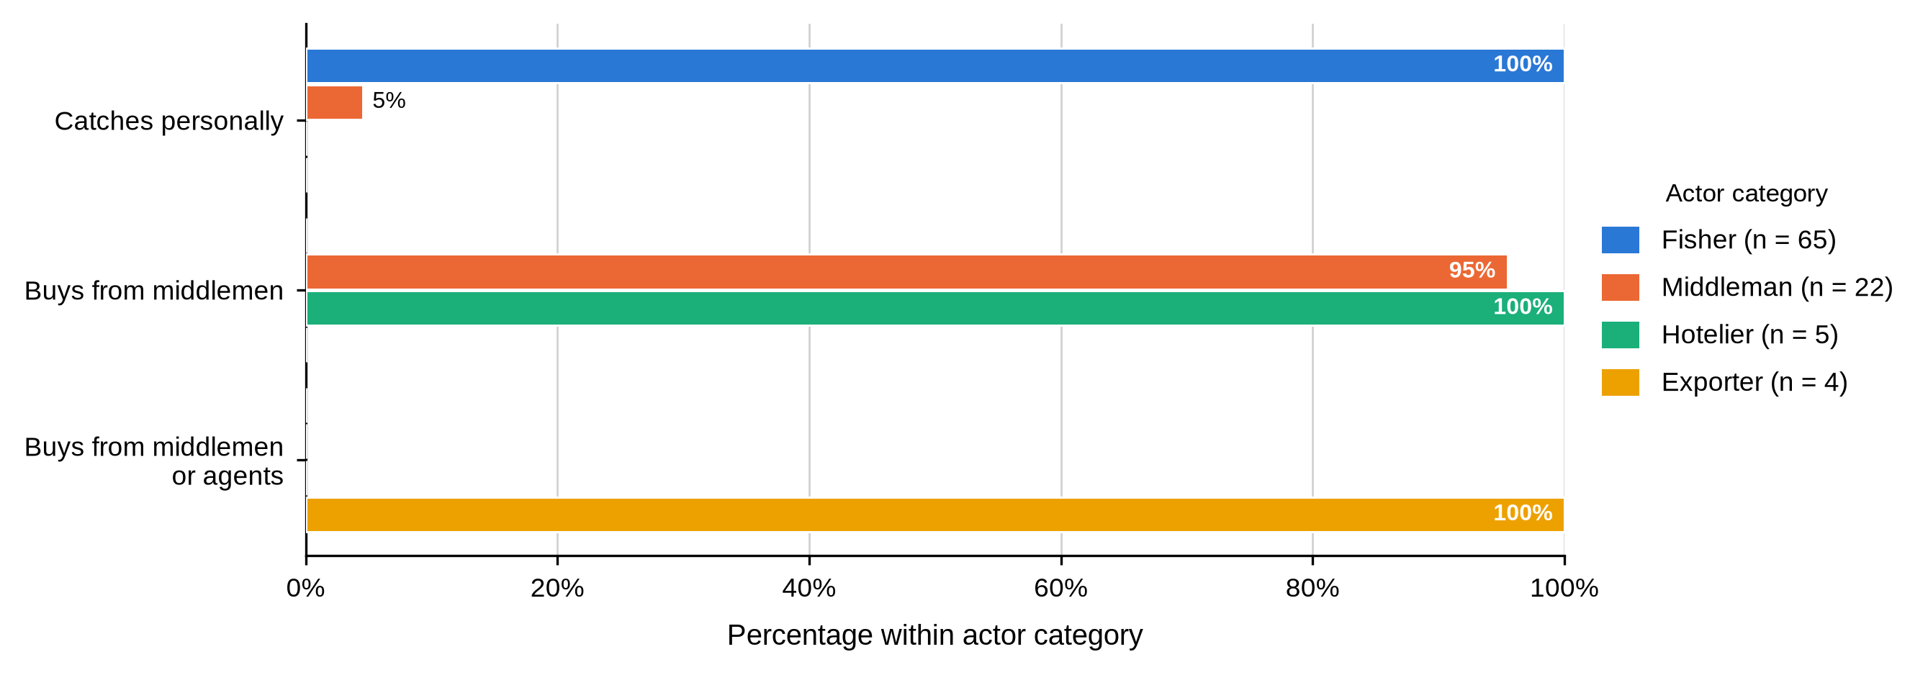
Figure 9 covers harvesting gear, an item answered by fishers and by the one middleman who also caught. Hand collection dominated (47 of 65, 72.3%), ranging from 8 (57.1%) at Majoreni to 2 (100.0%) in the Other sites group. Scoop nets accounted for 9 (13.8%) and hooked sticks for 8 (12.3%), with a single report of sweep nets. Gear was not associated with BMU (p = .144). Percentages are valid percentages within the actor category.
Figure 9
Fishing or Collection Gear Used by Fishers Within Each BMU
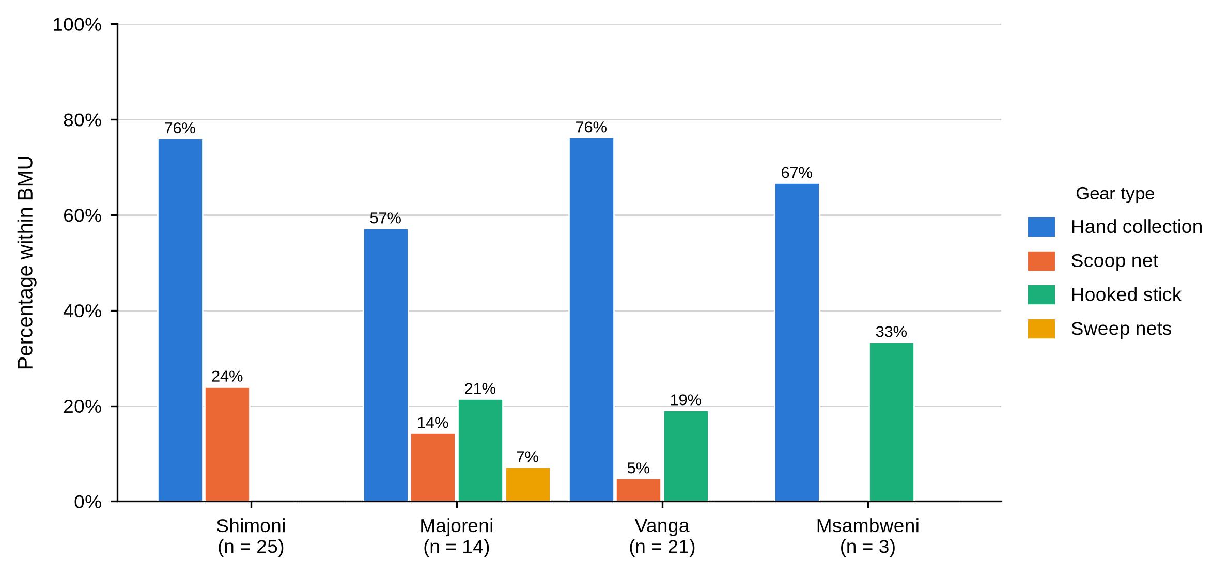
Figure 10 shows that the most commonly reported daily catch was 5–10 kg (44 of 65 fishers, 67.7%), a share ranging from 8 (57.1%) at Majoreni to 17 (81.0%) at Vanga. Catches above 10 kg were reported by 14 fishers (21.5%) and catches of 4–5 kg by 6 (9.2%), the latter concentrated at Msambweni (1, 33.3%). Daily catch was not associated with BMU (p = .453). The item was not put to middlemen, hoteliers or exporters, whose columns are therefore blank. Hand collection was the dominant method at all four sites.
Figure 10
Daily Mud Crab Catch Reported by Fishers Within Each BMU
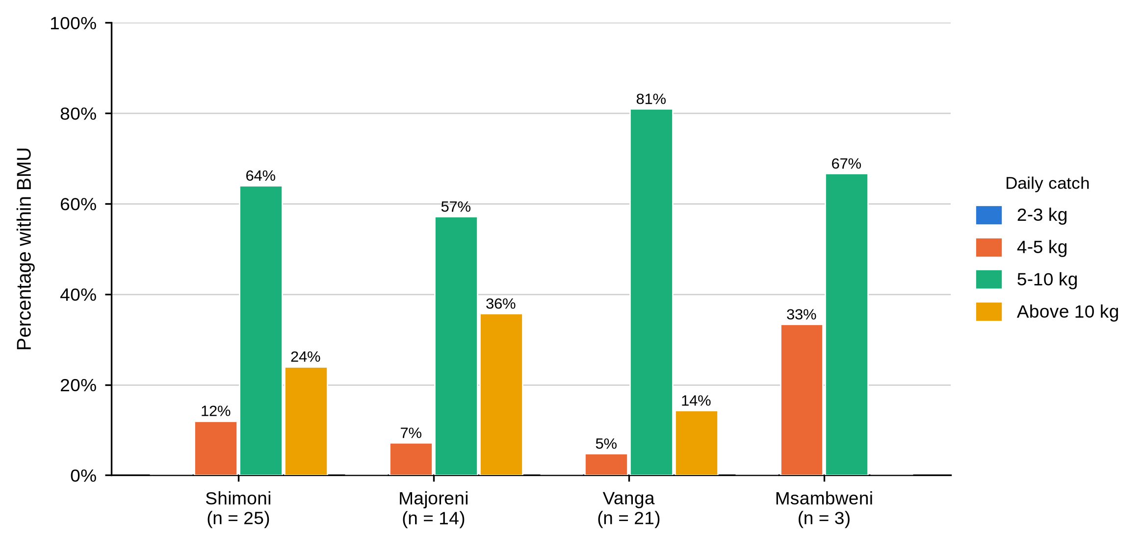
Table 16
Proportion of Catch Sold and Travel Time from Fishing Grounds to Market by Actor and BMU
Characteristic / response | Actor | Overall | Shimoni | Majoreni | Vanga | Msambweni | Other sites | BMU p-value
Proportion of catch sold
Whole catch | Fisher N = 65 | 52 (80.0%) | 20 (80.0%) | 13 (92.9%) | 15 (71.4%) | 2 (66.7%) | 2 (100.0%) | .452
Three-quarters | Fisher N = 65 | 13 (20.0%) | 5 (20.0%) | 1 (7.1%) | 6 (28.6%) | 1 (33.3%) | 0 (0.0%)
Whole catch | Middleman N = 0 | - | - | - | - | - | -
Three-quarters | Middleman N = 0 | - | - | - | - | - | -
Whole catch | Hotelier N = 0 | - | - | - | - | - | -
Three-quarters | Hotelier N = 0 | - | - | - | - | - | -
Whole catch | Exporter N = 0 | - | - | - | - | - | -
Three-quarters | Exporter N = 0 | - | - | - | - | - | -
Travel time from fishing grounds to market
1 hour | Fisher N = 65 | 22 (33.8%) | 4 (16.0%) | 9 (64.3%) | 8 (38.1%) | 0 (0.0%) | 1 (50.0%) | .010
6 hours | Fisher N = 65 | 43 (66.2%) | 21 (84.0%) | 5 (35.7%) | 13 (61.9%) | 3 (100.0%) | 1 (50.0%)
1 hour | Middleman N = 0 | - | - | - | - | - | -
6 hours | Middleman N = 0 | - | - | - | - | - | -
1 hour | Hotelier N = 0 | - | - | - | - | - | -
6 hours | Hotelier N = 0 | - | - | - | - | - | -
1 hour | Exporter N = 0 | - | - | - | - | - | -
6 hours | Exporter N = 0 | - | - | - | - | - | -
Table 16 reports what fishers did with the catch and how far they had to carry it. Selling the whole catch was the norm (52, 80.0%), ranging from 2 (66.7%) at Msambweni to 13 (92.9%) at Majoreni; the remaining 13 fishers (20.0%) sold three-quarters. Travel time to market was six hours for 43 fishers (66.2%) and one hour for 22 (33.8%). Travel time varied significantly by site (p = .010): 21 of 25 Shimoni fishers (84.0%) and all three at Msambweni reported six hours, against only 5 of 14 at Majoreni (35.7%). Proportion sold was not associated with BMU (p = .452). The 5–10 kg band was the most common at every site.
Tables 15 and 16 and Figures 9 and 10 establish the harvesting node as a seller with no holding capacity and no alternative to immediate sale. A fisher who lands 5 to 10 kg of live crab, carries it on foot for up to six hours and disposes of the entire catch the same day has no practical means of waiting for a better offer. That the Majoreni fishers reached market fastest is worth carrying forward, because Majoreni also turns out to be the site where fishers received the best price.

4.4.2 Buyers and Market Channels
Figure 11 shows who each actor sold to. Every fisher, at every site, sold to a first-level middleman. Middlemen sold on to company agents (9, 40.9%), second-level middlemen (7, 31.8%) or exporters (5, 22.7%), with one selling to another first-level middleman; the company-agent share ranged from 3 (27.3%) at Shimoni to 3 (75.0%) at Vanga, and buyer category was not associated with BMU (p = .656). Hoteliers sold to consumers and exporters to importers, in both cases without exception.
Figure 11
Main Buyer Category Within Each Actor Category
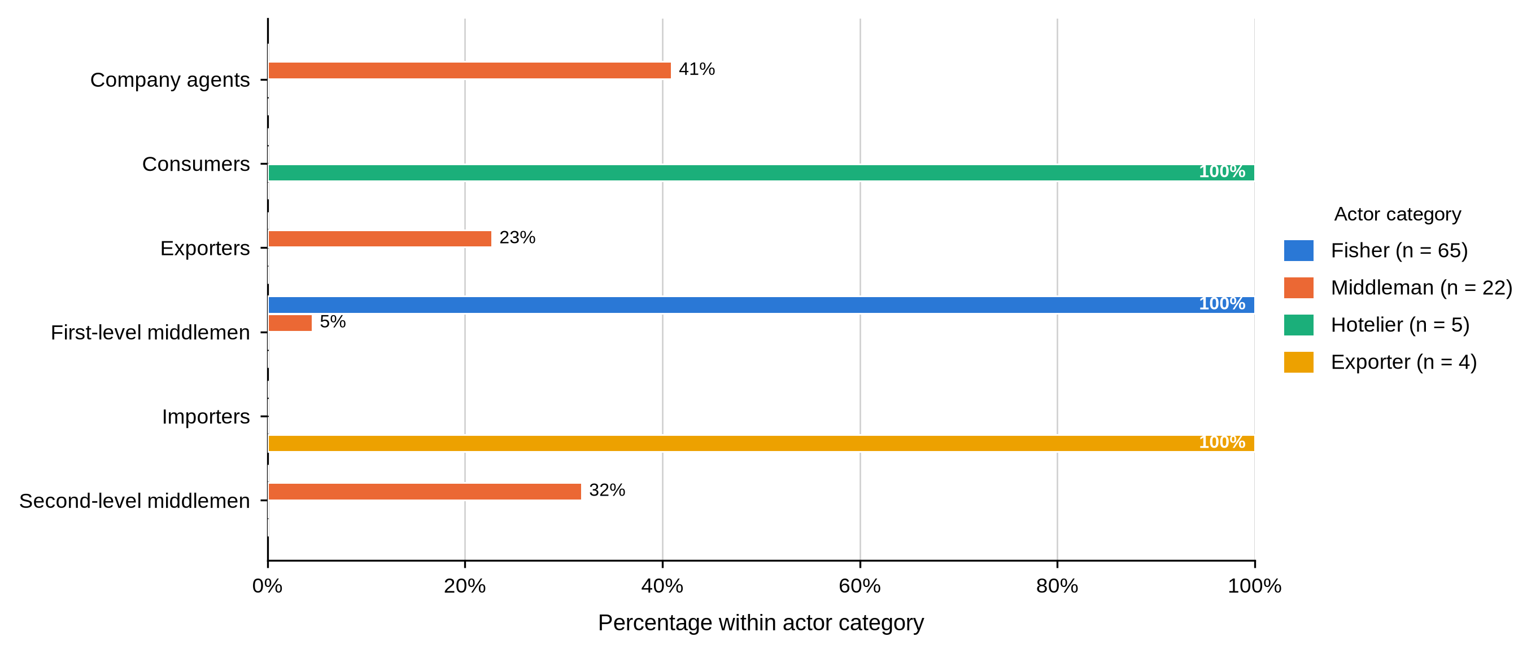
Table 17
Primary Market Channel and Contact With Final Consumers by Actor and BMU
Characteristic / response | Actor | Overall | Shimoni | Majoreni | Vanga | Msambweni | Other sites | BMU p-value
Primary market channel
Export markets | Fisher N = 65 | 0 (0.0%) | 0 (0.0%) | 0 (0.0%) | 0 (0.0%) | 0 (0.0%) | 0 (0.0%)
Local markets | Fisher N = 65 | 65 (100.0%) | 25 (100.0%) | 14 (100.0%) | 21 (100.0%) | 3 (100.0%) | 2 (100.0%)
Restaurants and hotels | Fisher N = 65 | 0 (0.0%) | 0 (0.0%) | 0 (0.0%) | 0 (0.0%) | 0 (0.0%) | 0 (0.0%)
Export markets | Middleman N = 22 | 0 (0.0%) | 0 (0.0%) | 0 (0.0%) | 0 (0.0%) | - | -
Local markets | Middleman N = 22 | 22 (100.0%) | 11 (100.0%) | 7 (100.0%) | 4 (100.0%) | - | -
Restaurants and hotels | Middleman N = 22 | 0 (0.0%) | 0 (0.0%) | 0 (0.0%) | 0 (0.0%) | - | -
Export markets | Hotelier N = 5 | 0 (0.0%) | 0 (0.0%) | - | - | - | 0 (0.0%)
Local markets | Hotelier N = 5 | 0 (0.0%) | 0 (0.0%) | - | - | - | 0 (0.0%)
Restaurants and hotels | Hotelier N = 5 | 5 (100.0%) | 1 (100.0%) | - | - | - | 4 (100.0%)
Export markets | Exporter N = 4 | 4 (100.0%) | - | - | - | - | 4 (100.0%)
Local markets | Exporter N = 4 | 0 (0.0%) | - | - | - | - | 0 (0.0%)
Restaurants and hotels | Exporter N = 4 | 0 (0.0%) | - | - | - | - | 0 (0.0%)
Contact with final consumers
Through intermediaries | Fisher N = 65 | 65 (100.0%) | 25 (100.0%) | 14 (100.0%) | 21 (100.0%) | 3 (100.0%) | 2 (100.0%)
Direct contact | Fisher N = 65 | 0 (0.0%) | 0 (0.0%) | 0 (0.0%) | 0 (0.0%) | 0 (0.0%) | 0 (0.0%)
Through intermediaries | Middleman N = 22 | 22 (100.0%) | 11 (100.0%) | 7 (100.0%) | 4 (100.0%) | - | -
Direct contact | Middleman N = 22 | 0 (0.0%) | 0 (0.0%) | 0 (0.0%) | 0 (0.0%) | - | -
Through intermediaries | Hotelier N = 5 | 0 (0.0%) | 0 (0.0%) | - | - | - | 0 (0.0%)
Direct contact | Hotelier N = 5 | 5 (100.0%) | 1 (100.0%) | - | - | - | 4 (100.0%)
Through intermediaries | Exporter N = 4 | 0 (0.0%) | - | - | - | - | 0 (0.0%)
Direct contact | Exporter N = 4 | 4 (100.0%) | - | - | - | - | 4 (100.0%)
Table 17 completes the picture. Fishers and middlemen supplied local markets exclusively, hoteliers supplied restaurants and hotels, and exporters supplied export markets. Contact with the final consumer divided just as cleanly: all 65 fishers and all 22 middlemen reached the consumer only through intermediaries, while all five hoteliers and all four exporters dealt with the end buyer directly. Neither item varied enough within fishers or middlemen to support a test against BMU. Fishers sold exclusively to first-level middlemen; each downstream category had its own distinct main buyer.
Table 17 and Figure 11 answer a central part of Objective Two. The actors who know what a crab finally sells for are the two groups furthest from the water, and the two groups who catch and aggregate it never meet the person who eats it. That informational distance is the structural fact underlying the price results reported later in this chapter.
Table 18
Number of Buyers, State of Crabs Sold and Regularity of the Main Buyer by Actor and BMU
Characteristic / response | Actor | Overall | Shimoni | Majoreni | Vanga | Msambweni | Other sites | BMU p-value
Number of buyers reported
One buyer | Fisher N = 65 | 50 (76.9%) | 17 (68.0%) | 10 (71.4%) | 18 (85.7%) | 3 (100.0%) | 2 (100.0%) | .412
Two buyers | Fisher N = 65 | 15 (23.1%) | 8 (32.0%) | 4 (28.6%) | 3 (14.3%) | 0 (0.0%) | 0 (0.0%)
One buyer | Middleman N = 0 | - | - | - | - | - | -
Two buyers | Middleman N = 0 | - | - | - | - | - | -
One buyer | Hotelier N = 0 | - | - | - | - | - | -
Two buyers | Hotelier N = 0 | - | - | - | - | - | -
One buyer | Exporter N = 0 | - | - | - | - | - | -
Two buyers | Exporter N = 0 | - | - | - | - | - | -
State of mud crabs sold
Live | Fisher N = 65 | 65 (100.0%) | 25 (100.0%) | 14 (100.0%) | 21 (100.0%) | 3 (100.0%) | 2 (100.0%)
Live | Middleman N = 0 | - | - | - | - | - | -
Live | Hotelier N = 0 | - | - | - | - | - | -
Live | Exporter N = 0 | - | - | - | - | - | -
Main buyer is regular
Yes | Fisher N = 65 | 65 (100.0%) | 25 (100.0%) | 14 (100.0%) | 21 (100.0%) | 3 (100.0%) | 2 (100.0%)
Yes | Middleman N = 22 | 22 (100.0%) | 11 (100.0%) | 7 (100.0%) | 4 (100.0%) | - | -
Yes | Hotelier N = 5 | 5 (100.0%) | 1 (100.0%) | - | - | - | 4 (100.0%)
Yes | Exporter N = 4 | 4 (100.0%) | - | - | - | - | 4 (100.0%)
Table 18 records how many buyers each actor dealt with and the condition in which crabs changed hands. Among fishers, 50 (76.9%) reported a single buyer and 15 (23.1%) reported two, with the single-buyer share ranging from 17 (68.0%) at Shimoni to all three (100.0%) at Msambweni; the number of buyers was not associated with BMU (p = .412). The item was not put to the other three categories. All 65 fishers sold crabs live, and every respondent in all four actor categories — 96 of 96 — said their main buyer was a regular one.
Those three rows together describe a market with almost no spot trading at the harvesting node. Three quarters of fishers dealt with one buyer, that buyer was a regular, and the crab was live and therefore perishable at the moment of sale. A seller in that position has little practical ability to decline the price offered, which is the condition the pricing results later in this chapter describe.
Table 19
Location of Sale and Knowledge of the Onward Sale by Actor and BMU
Characteristic / response | Actor | Overall | Shimoni | Majoreni | Vanga | Msambweni | Other sites | BMU p-value
Location of sale
Landing beach | Fisher N = 65 | 65 (100.0%) | 25 (100.0%) | 14 (100.0%) | 21 (100.0%) | 3 (100.0%) | 2 (100.0%)
Market | Fisher N = 65 | 0 (0.0%) | 0 (0.0%) | 0 (0.0%) | 0 (0.0%) | 0 (0.0%) | 0 (0.0%)
Town | Fisher N = 65 | 0 (0.0%) | 0 (0.0%) | 0 (0.0%) | 0 (0.0%) | 0 (0.0%) | 0 (0.0%)
Landing beach | Middleman N = 22 | 1 (4.5%) | 1 (9.1%) | 0 (0.0%) | 0 (0.0%) | - | - | .928
Market | Middleman N = 22 | 10 (45.5%) | 4 (36.4%) | 4 (57.1%) | 2 (50.0%) | - | -
Town | Middleman N = 22 | 11 (50.0%) | 6 (54.5%) | 3 (42.9%) | 2 (50.0%) | - | -
Landing beach | Hotelier N = 5 | 0 (0.0%) | 0 (0.0%) | - | - | - | 0 (0.0%)
Market | Hotelier N = 5 | 0 (0.0%) | 0 (0.0%) | - | - | - | 0 (0.0%)
Town | Hotelier N = 5 | 5 (100.0%) | 1 (100.0%) | - | - | - | 4 (100.0%)
Landing beach | Exporter N = 4 | 0 (0.0%) | - | - | - | - | 0 (0.0%)
Market | Exporter N = 4 | 0 (0.0%) | - | - | - | - | 0 (0.0%)
Town | Exporter N = 4 | 4 (100.0%) | - | - | - | - | 4 (100.0%)
Knows whom the next trader sells to
No | Fisher N = 65 | 65 (100.0%) | 25 (100.0%) | 14 (100.0%) | 21 (100.0%) | 3 (100.0%) | 2 (100.0%)
No | Middleman N = 22 | 22 (100.0%) | 11 (100.0%) | 7 (100.0%) | 4 (100.0%) | - | -
No | Hotelier N = 0 | - | - | - | - | - | -
No | Exporter N = 4 | 4 (100.0%) | - | - | - | - | 4 (100.0%)
As shown in Table 19, the place of sale divided by node. Every fisher sold at the landing beach, without exception at any site. Middlemen sold in town (11, 50.0%) or at a market (10, 45.5%), with one still selling at the beach, and the pattern did not vary by BMU (p = .928). All five hoteliers and all four exporters sold in town. On knowledge of the onward sale, every fisher, every middleman and all four exporters who answered said they did not know whom the next trader sold to; no hotelier completed the item.
This is the informational counterpart to Table 17. Not one actor upstream of the final buyer could say where the crab went next. Combined with the absence of market research reported later in Table 35, it means no actor in this chain has sight of the price two steps ahead of their own transaction.
Table 20
First Buyer Location Reported by Fishers by BMU
Characteristic / response | Actor | Overall | Shimoni | Majoreni | Vanga | Msambweni | Other sites | BMU p-value
First buyer location
Bodo Pwani | Fisher N = 63 | 1 (1.6%) | 1 (4.0%) | 0 (0.0%) | 0 (0.0%) | 0 (0.0%) | 0 (0.0%) | < .001
Gasi | Fisher N = 63 | 2 (3.2%) | 0 (0.0%) | 0 (0.0%) | 0 (0.0%) | 2 (66.7%) | 0 (0.0%)
Kiwegu | Fisher N = 63 | 16 (25.4%) | 0 (0.0%) | 1 (7.7%) | 15 (75.0%) | 0 (0.0%) | 0 (0.0%)
Majoreni / Aleni | Fisher N = 63 | 19 (30.2%) | 2 (8.0%) | 12 (92.3%) | 2 (10.0%) | 1 (33.3%) | 2 (100.0%)
Mkuyuni | Fisher N = 63 | 17 (27.0%) | 16 (64.0%) | 0 (0.0%) | 1 (5.0%) | 0 (0.0%) | 0 (0.0%)
Mwambao | Fisher N = 63 | 1 (1.6%) | 1 (4.0%) | 0 (0.0%) | 0 (0.0%) | 0 (0.0%) | 0 (0.0%)
Shimoni | Fisher N = 63 | 5 (7.9%) | 5 (20.0%) | 0 (0.0%) | 0 (0.0%) | 0 (0.0%) | 0 (0.0%)
Vanga | Fisher N = 63 | 2 (3.2%) | 0 (0.0%) | 0 (0.0%) | 2 (10.0%) | 0 (0.0%) | 0 (0.0%)
Bodo Pwani | Middleman N = 0 | - | - | - | - | - | -
Gasi | Middleman N = 0 | - | - | - | - | - | -
Kiwegu | Middleman N = 0 | - | - | - | - | - | -
Majoreni / Aleni | Middleman N = 0 | - | - | - | - | - | -
Mkuyuni | Middleman N = 0 | - | - | - | - | - | -
Mwambao | Middleman N = 0 | - | - | - | - | - | -
Shimoni | Middleman N = 0 | - | - | - | - | - | -
Vanga | Middleman N = 0 | - | - | - | - | - | -
Bodo Pwani | Hotelier N = 0 | - | - | - | - | - | -
Gasi | Hotelier N = 0 | - | - | - | - | - | -
Kiwegu | Hotelier N = 0 | - | - | - | - | - | -
Majoreni / Aleni | Hotelier N = 0 | - | - | - | - | - | -
Mkuyuni | Hotelier N = 0 | - | - | - | - | - | -
Mwambao | Hotelier N = 0 | - | - | - | - | - | -
Shimoni | Hotelier N = 0 | - | - | - | - | - | -
Vanga | Hotelier N = 0 | - | - | - | - | - | -
Bodo Pwani | Exporter N = 0 | - | - | - | - | - | -
Gasi | Exporter N = 0 | - | - | - | - | - | -
Kiwegu | Exporter N = 0 | - | - | - | - | - | -
Majoreni / Aleni | Exporter N = 0 | - | - | - | - | - | -
Mkuyuni | Exporter N = 0 | - | - | - | - | - | -
Mwambao | Exporter N = 0 | - | - | - | - | - | -
Shimoni | Exporter N = 0 | - | - | - | - | - | -
Vanga | Exporter N = 0 | - | - | - | - | - | -
Table 20 reports where fishers said their first buyer was located, an item answered by 63 of the 65 fishers. Three places accounted for more than four-fifths of first sales: Majoreni or Aleni, named by 19 (30.2%), Mkuyuni by 17 (27.0%) and Kiwegu by 16 (25.4%). Shimoni was named by 5 (7.9%), and Gasi, Vanga, Mwambao and Bodo Pwani by four fishers between them. Each of those places is the buying point nearest a particular landing site: of the fishers answering at each site, 16 of 25 at Shimoni (64.0%) named Mkuyuni, 12 of 13 at Majoreni (92.3%) named Majoreni or Aleni, and 15 of 20 at Vanga (75.0%) named Kiwegu. The association with BMU was the strongest recorded anywhere in this study, χ²(21, N = 61) = 125.19, p < .001, 99% CI [.000, .000].
That result needs reading with care. A near-perfect association between where a fisher lands and where his buyer sits is close to a tautology, and it is reported here for completeness rather than as a finding about market structure. What it does establish is that first sale is a local transaction: the buyer is at or beside the landing site, not in a distant market to which the fisher could take his catch instead.
Table 21
Second Buyer Location Reported by Fishers by BMU
Characteristic / response | Actor | Overall | Shimoni | Majoreni | Vanga | Msambweni | Other sites | BMU p-value
Second buyer location
Kiwegu | Fisher N = 15 | 3 (20.0%) | 0 (0.0%) | 1 (20.0%) | 2 (100.0%) | - | -
Majoreni / Aleni | Fisher N = 15 | 4 (26.7%) | 0 (0.0%) | 4 (80.0%) | 0 (0.0%) | - | -
Mkuyuni | Fisher N = 15 | 8 (53.3%) | 8 (100.0%) | 0 (0.0%) | 0 (0.0%) | - | -
Kiwegu | Middleman N = 0 | - | - | - | - | - | -
Majoreni / Aleni | Middleman N = 0 | - | - | - | - | - | -
Mkuyuni | Middleman N = 0 | - | - | - | - | - | -
Kiwegu | Hotelier N = 0 | - | - | - | - | - | -
Majoreni / Aleni | Hotelier N = 0 | - | - | - | - | - | -
Mkuyuni | Hotelier N = 0 | - | - | - | - | - | -
Kiwegu | Exporter N = 0 | - | - | - | - | - | -
Majoreni / Aleni | Exporter N = 0 | - | - | - | - | - | -
Mkuyuni | Exporter N = 0 | - | - | - | - | - | -
Table 21 covers the second buyer, an item answered by only 15 fishers. Of those, 8 (53.3%) named Mkuyuni, 4 (26.7%) Majoreni or Aleni and 3 (20.0%) Kiwegu, and each group came almost entirely from one landing site: all eight naming Mkuyuni fished at Shimoni and all four naming Majoreni or Aleni fished at Majoreni. The remaining 50 fishers gave no second buyer at all, which is consistent with the single-buyer pattern in Table 18 and is reported here rather than left out, because an absent alternative buyer is itself the finding.

4.4.3 Preparation, Packaging and Transport
Table 22
Preparation of Mud Crabs for Market and Preservation by Actor and BMU
Characteristic / response | Actor | Overall | Shimoni | Majoreni | Vanga | Msambweni | Other sites | BMU p-value
Preserves or processes mud crabs
Yes / frozen | Fisher N = 65 | 0 (0.0%) | 0 (0.0%) | 0 (0.0%) | 0 (0.0%) | 0 (0.0%) | 0 (0.0%)
No | Fisher N = 65 | 65 (100.0%) | 25 (100.0%) | 14 (100.0%) | 21 (100.0%) | 3 (100.0%) | 2 (100.0%)
Yes / frozen | Middleman N = 22 | 0 (0.0%) | 0 (0.0%) | 0 (0.0%) | 0 (0.0%) | - | -
No | Middleman N = 22 | 22 (100.0%) | 11 (100.0%) | 7 (100.0%) | 4 (100.0%) | - | -
Yes / frozen | Hotelier N = 5 | 5 (100.0%) | 1 (100.0%) | - | - | - | 4 (100.0%)
No | Hotelier N = 5 | 0 (0.0%) | 0 (0.0%) | - | - | - | 0 (0.0%)
Yes / frozen | Exporter N = 4 | 0 (0.0%) | - | - | - | - | 0 (0.0%)
No | Exporter N = 4 | 4 (100.0%) | - | - | - | - | 4 (100.0%)
Figure 12 shows that preparation became more elaborate at each step. All 65 fishers prepared crabs by tying the claws; 21 of 22 middlemen (95.5%) cleaned, sorted and graded; all five hoteliers processed for the kitchen; and all four exporters cleaned, sorted and graded for consignment. Table 22 records preservation, which was reported only by the hoteliers, all five of whom froze the product; no fisher, middleman or exporter preserved or processed at all. Preparation was not associated with BMU among middlemen (p = 1.000).
Figure 12
Preparation of Mud Crabs for Market by Actor Category
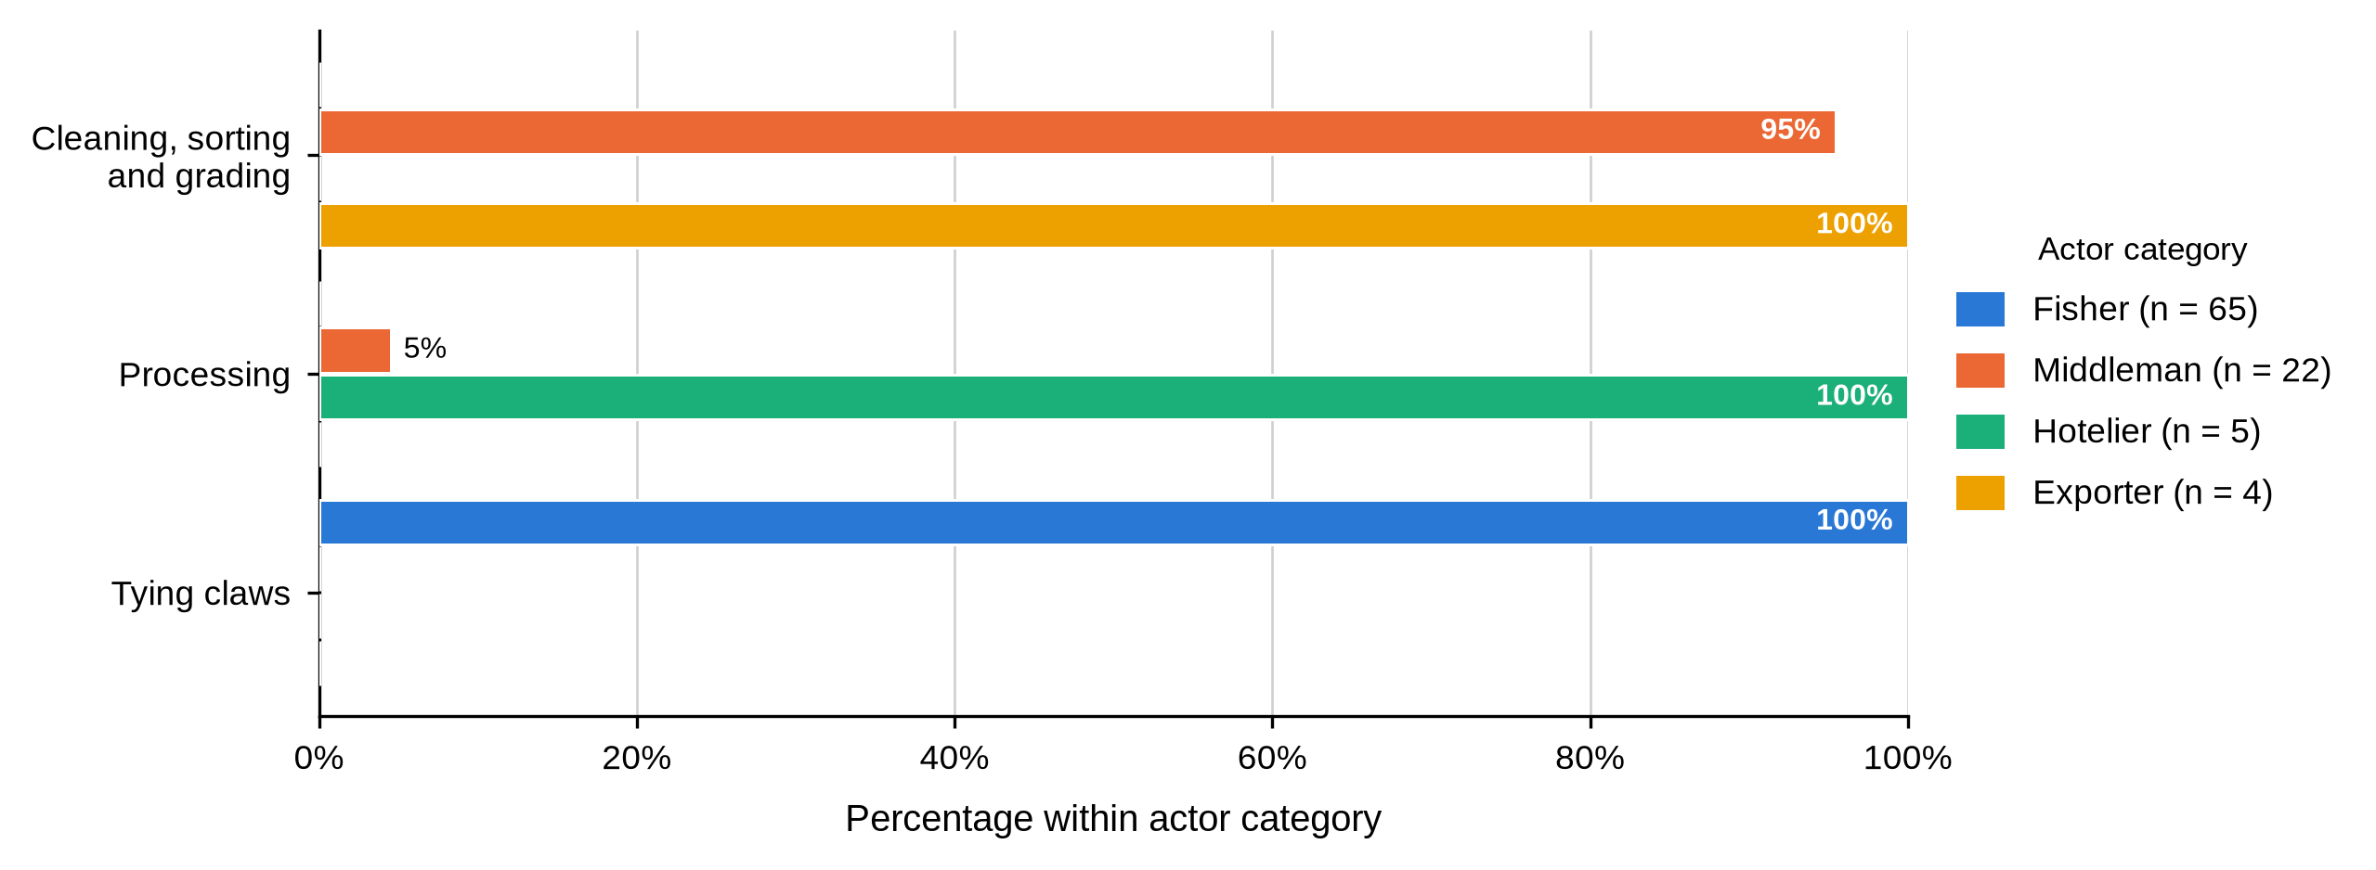
Figure 13 shows a clear ladder of containment. Fishers used sacks (44, 67.7%) or plastic containers (21, 32.3%); middlemen used crates (11, 50.0%) or baskets (10, 45.5%), with one still using a sack; and all four exporters used Styrofoam. Hoteliers did not complete this item because they bought at their own premises, so their column is left blank rather than recorded as zero. Packaging was not associated with BMU for fishers (p = .837) or middlemen (p = .924). Preparation moves from tying claws at the harvesting node to cleaning, sorting and grading downstream.
Figure 13
Packaging Used for Transporting Mud Crabs by Actor Category
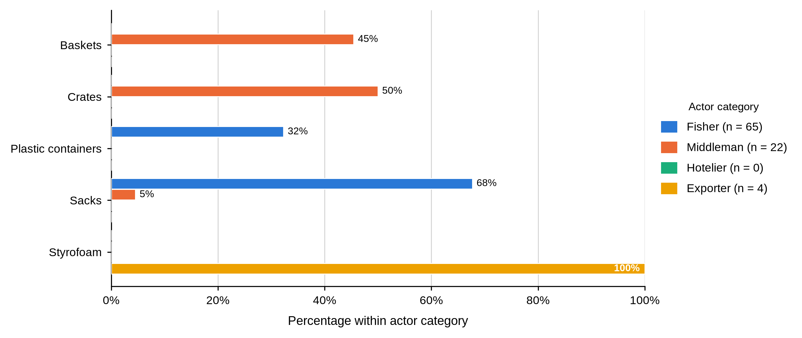
Figure 14 follows the same ladder. Fishers travelled on foot (57, 87.7%) or by motorcycle (8, 12.3%); middlemen used vehicles (17, 77.3%) or motorised boats (4, 18.2%), with one on foot; and all four exporters used air freight. Transport was not associated with BMU for fishers (p = .388) or middlemen (p = .402). Hoteliers did not complete this item because they purchased at their own premises.
Figure 14
Mode of Transporting Mud Crabs to Market by Actor Category
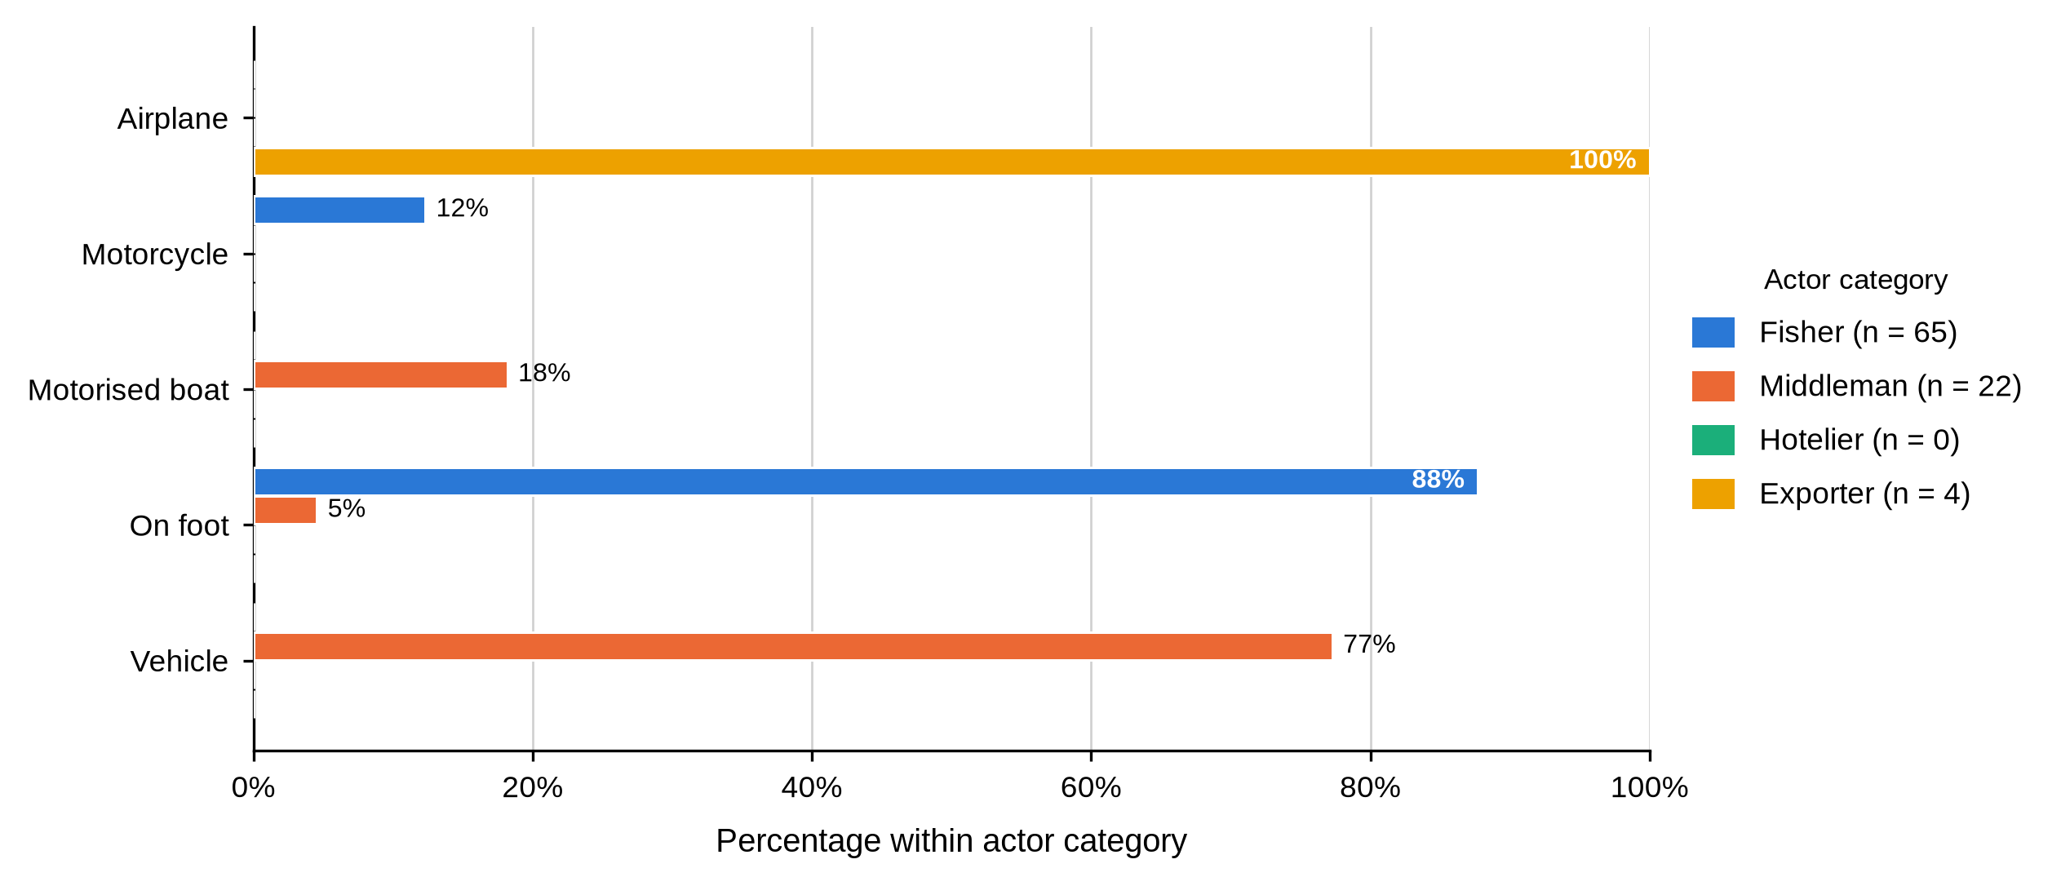
Tables 18 to 20 show that protection of the product rises with distance from the water, and that the cost of that protection is borne by whoever holds the crab at the time. A sack carried on foot and a Styrofoam box flown out are two ends of the same handling problem, and the actor least able to absorb a loss is the one using the least protective method. Hoteliers did not complete this item.

4.4.4 Grading and Quality Control
Table 23
Grading Practice and Criteria Used to Determine Grade by Actor and BMU
Characteristic / response | Actor | Overall | Shimoni | Majoreni | Vanga | Msambweni | Other sites | BMU p-value
Engages in grading mud crabs
Yes | Fisher N = 65 | 65 (100.0%) | 25 (100.0%) | 14 (100.0%) | 21 (100.0%) | 3 (100.0%) | 2 (100.0%)
Yes | Middleman N = 22 | 22 (100.0%) | 11 (100.0%) | 7 (100.0%) | 4 (100.0%) | - | -
Yes | Hotelier N = 5 | 5 (100.0%) | 1 (100.0%) | - | - | - | 4 (100.0%)
Yes | Exporter N = 4 | 4 (100.0%) | - | - | - | - | 4 (100.0%)
Table 23 records the single most consequential functional difference in the chapter. Every one of the 96 respondents, at every site, said they graded mud crabs. They did not grade by the same rule, and Figure 15 shows how far apart the criteria were. All 65 fishers graded on weight alone, while 21 of 22 middlemen (95.5%) and every hotelier and exporter combined size, weight, shell condition and claw size. The one middleman using weight alone was at Shimoni. Grading criteria did not vary by site among middlemen (p = 1.000), and did not vary at all among fishers.
Figure 15
Criteria Used to Determine Crab Grade by Actor Category
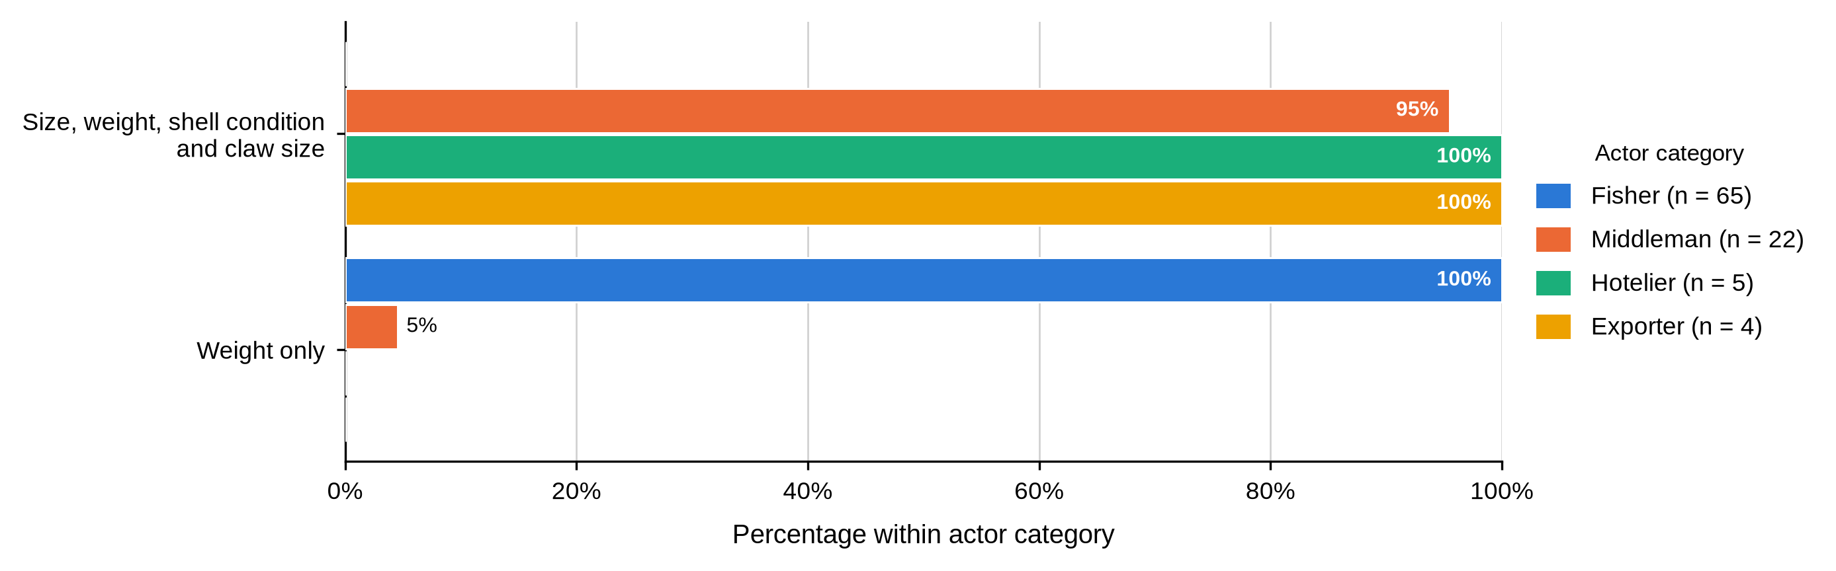
Table 24
Quality Measures Before Market and Use of Formal Quality Control by Actor and BMU
Characteristic / response | Actor | Overall | Shimoni | Majoreni | Vanga | Msambweni | Other sites | BMU p-value
Quality measure before the market
Inspections, certification and packaging standards | Fisher N = 65 | 0 (0.0%) | 0 (0.0%) | 0 (0.0%) | 0 (0.0%) | 0 (0.0%) | 0 (0.0%)
Packaging standards | Fisher N = 65 | 0 (0.0%) | 0 (0.0%) | 0 (0.0%) | 0 (0.0%) | 0 (0.0%) | 0 (0.0%)
Tying the claws | Fisher N = 65 | 65 (100.0%) | 25 (100.0%) | 14 (100.0%) | 21 (100.0%) | 3 (100.0%) | 2 (100.0%)
Inspections, certification and packaging standards | Middleman N = 22 | 0 (0.0%) | 0 (0.0%) | 0 (0.0%) | 0 (0.0%) | - | -
Packaging standards | Middleman N = 22 | 21 (95.5%) | 10 (90.9%) | 7 (100.0%) | 4 (100.0%) | - | -
Tying the claws | Middleman N = 22 | 1 (4.5%) | 1 (9.1%) | 0 (0.0%) | 0 (0.0%) | - | -
Inspections, certification and packaging standards | Hotelier N = 5 | 0 (0.0%) | 0 (0.0%) | - | - | - | 0 (0.0%)
Packaging standards | Hotelier N = 5 | 5 (100.0%) | 1 (100.0%) | - | - | - | 4 (100.0%)
Tying the claws | Hotelier N = 5 | 0 (0.0%) | 0 (0.0%) | - | - | - | 0 (0.0%)
Inspections, certification and packaging standards | Exporter N = 4 | 4 (100.0%) | - | - | - | - | 4 (100.0%)
Packaging standards | Exporter N = 4 | 0 (0.0%) | - | - | - | - | 0 (0.0%)
Tying the claws | Exporter N = 4 | 0 (0.0%) | - | - | - | - | 0 (0.0%)
Uses formal quality-control measures
Yes | Fisher N = 65 | 0 (0.0%) | 0 (0.0%) | 0 (0.0%) | 0 (0.0%) | 0 (0.0%) | 0 (0.0%)
No | Fisher N = 65 | 65 (100.0%) | 25 (100.0%) | 14 (100.0%) | 21 (100.0%) | 3 (100.0%) | 2 (100.0%)
Yes | Middleman N = 22 | 0 (0.0%) | 0 (0.0%) | 0 (0.0%) | 0 (0.0%) | - | -
No | Middleman N = 22 | 22 (100.0%) | 11 (100.0%) | 7 (100.0%) | 4 (100.0%) | - | -
Yes | Hotelier N = 5 | 5 (100.0%) | 1 (100.0%) | - | - | - | 4 (100.0%)
No | Hotelier N = 5 | 0 (0.0%) | 0 (0.0%) | - | - | - | 0 (0.0%)
Yes | Exporter N = 4 | 4 (100.0%) | - | - | - | - | 4 (100.0%)
No | Exporter N = 4 | 0 (0.0%) | - | - | - | - | 0 (0.0%)
Table 24 shows the same asymmetry in quality assurance. Fishers tied the claws (65, 100.0%); middlemen (21, 95.5%) and hoteliers cited packaging standards; exporters cited inspections, certification and packaging standards. Formal quality-control measures were reported by all nine downstream actors and by none of the 87 fishers and middlemen. Fishers graded on weight alone; every other category used a four-criterion rule.
Table 25
Size Label and Grade Assignment for Large Crabs by Actor and BMU
Characteristic / response | Actor | Overall | Shimoni | Majoreni | Vanga | Msambweni | Other sites | BMU p-value
Reported large-crab size category
Large | Fisher N = 65 | 53 (81.5%) | 14 (56.0%) | 14 (100.0%) | 20 (95.2%) | 3 (100.0%) | 2 (100.0%) | .001
All sizes / mixed | Fisher N = 65 | 12 (18.5%) | 11 (44.0%) | 0 (0.0%) | 1 (4.8%) | 0 (0.0%) | 0 (0.0%)
Large | Middleman N = 21 | 21 (100.0%) | 10 (100.0%) | 7 (100.0%) | 4 (100.0%) | - | -
All sizes / mixed | Middleman N = 21 | 0 (0.0%) | 0 (0.0%) | 0 (0.0%) | 0 (0.0%) | - | -
Large | Hotelier N = 5 | 5 (100.0%) | 1 (100.0%) | - | - | - | 4 (100.0%)
All sizes / mixed | Hotelier N = 5 | 0 (0.0%) | 0 (0.0%) | - | - | - | 0 (0.0%)
Large | Exporter N = 4 | 4 (100.0%) | - | - | - | - | 4 (100.0%)
All sizes / mixed | Exporter N = 4 | 0 (0.0%) | - | - | - | - | 0 (0.0%)
Grade assigned to large crabs
Grade A | Fisher N = 65 | 50 (76.9%) | 14 (56.0%) | 14 (100.0%) | 17 (81.0%) | 3 (100.0%) | 2 (100.0%)
Mixed grade | Fisher N = 65 | 15 (23.1%) | 11 (44.0%) | 0 (0.0%) | 4 (19.0%) | 0 (0.0%) | 0 (0.0%)
Grade A | Middleman N = 22 | 22 (100.0%) | 11 (100.0%) | 7 (100.0%) | 4 (100.0%) | - | -
Mixed grade | Middleman N = 22 | 0 (0.0%) | 0 (0.0%) | 0 (0.0%) | 0 (0.0%) | - | -
Grade A | Hotelier N = 5 | 5 (100.0%) | 1 (100.0%) | - | - | - | 4 (100.0%)
Mixed grade | Hotelier N = 5 | 0 (0.0%) | 0 (0.0%) | - | - | - | 0 (0.0%)
Grade A | Exporter N = 4 | 4 (100.0%) | - | - | - | - | 4 (100.0%)
Mixed grade | Exporter N = 4 | 0 (0.0%) | - | - | - | - | 0 (0.0%)
As shown in Table 25, 53 fishers (81.5%) used the Large label for their biggest crabs while 12 (18.5%) recorded all sizes or mixed, and 50 (76.9%) assigned Grade A while 15 (23.1%) assigned a mixed grade. Every middleman, hotelier and exporter who answered used the plain labels. The fisher pattern varied significantly by site (p = .001): at Shimoni only 14 of 25 (56.0%) used the Large label, against all 14 at Majoreni and 20 of 21 (95.2%) at Vanga.
Table 26
Size Label and Grade Assignment for Medium Crabs by Actor and BMU
Characteristic / response | Actor | Overall | Shimoni | Majoreni | Vanga | Msambweni | Other sites | BMU p-value
Reported medium-crab size category
Medium | Fisher N = 65 | 63 (96.9%) | 23 (92.0%) | 14 (100.0%) | 21 (100.0%) | 3 (100.0%) | 2 (100.0%) | .406
Mixed size | Fisher N = 65 | 2 (3.1%) | 2 (8.0%) | 0 (0.0%) | 0 (0.0%) | 0 (0.0%) | 0 (0.0%)
Medium | Middleman N = 22 | 22 (100.0%) | 11 (100.0%) | 7 (100.0%) | 4 (100.0%) | - | -
Mixed size | Middleman N = 22 | 0 (0.0%) | 0 (0.0%) | 0 (0.0%) | 0 (0.0%) | - | -
Medium | Hotelier N = 0 | - | - | - | - | - | -
Mixed size | Hotelier N = 0 | - | - | - | - | - | -
Medium | Exporter N = 4 | 4 (100.0%) | - | - | - | - | 4 (100.0%)
Mixed size | Exporter N = 4 | 0 (0.0%) | - | - | - | - | 0 (0.0%)
Grade assigned to medium crabs
Grade B | Fisher N = 65 | 51 (78.5%) | 15 (60.0%) | 14 (100.0%) | 17 (81.0%) | 3 (100.0%) | 2 (100.0%)
Mixed grade | Fisher N = 65 | 14 (21.5%) | 10 (40.0%) | 0 (0.0%) | 4 (19.0%) | 0 (0.0%) | 0 (0.0%)
Grade B | Middleman N = 22 | 22 (100.0%) | 11 (100.0%) | 7 (100.0%) | 4 (100.0%) | - | -
Mixed grade | Middleman N = 22 | 0 (0.0%) | 0 (0.0%) | 0 (0.0%) | 0 (0.0%) | - | -
Grade B | Hotelier N = 0 | - | - | - | - | - | -
Mixed grade | Hotelier N = 0 | - | - | - | - | - | -
Grade B | Exporter N = 4 | 4 (100.0%) | - | - | - | - | 4 (100.0%)
Mixed grade | Exporter N = 4 | 0 (0.0%) | - | - | - | - | 0 (0.0%)
Table 26 shows a narrower spread for medium crabs. Sixty-three fishers (96.9%) used the Medium label and 51 (78.5%) assigned Grade B, against 14 (21.5%) who assigned a mixed grade. Every middleman and exporter used the plain labels. The medium-size label was not associated with BMU (p = .406). Hoteliers did not complete the medium-crab grading items.
Table 27
Size Label and Grade Assignment for Small Crabs by Actor and BMU
Characteristic / response | Actor | Overall | Shimoni | Majoreni | Vanga | Msambweni | Other sites | BMU p-value
Reported small-crab size category
Small | Fisher N = 65 | 56 (86.2%) | 16 (64.0%) | 14 (100.0%) | 21 (100.0%) | 3 (100.0%) | 2 (100.0%) | .002
Mixed size | Fisher N = 65 | 9 (13.8%) | 9 (36.0%) | 0 (0.0%) | 0 (0.0%) | 0 (0.0%) | 0 (0.0%)
Small | Middleman N = 0 | - | - | - | - | - | -
Mixed size | Middleman N = 0 | - | - | - | - | - | -
Small | Hotelier N = 0 | - | - | - | - | - | -
Mixed size | Hotelier N = 0 | - | - | - | - | - | -
Small | Exporter N = 0 | - | - | - | - | - | -
Mixed size | Exporter N = 0 | - | - | - | - | - | -
Grade assigned to small crabs
Grade C | Fisher N = 65 | 59 (90.8%) | 22 (88.0%) | 14 (100.0%) | 18 (85.7%) | 3 (100.0%) | 2 (100.0%)
Mixed grade | Fisher N = 65 | 6 (9.2%) | 3 (12.0%) | 0 (0.0%) | 3 (14.3%) | 0 (0.0%) | 0 (0.0%)
Grade C | Middleman N = 0 | - | - | - | - | - | -
Mixed grade | Middleman N = 0 | - | - | - | - | - | -
Grade C | Hotelier N = 0 | - | - | - | - | - | -
Mixed grade | Hotelier N = 0 | - | - | - | - | - | -
Grade C | Exporter N = 0 | - | - | - | - | - | -
Mixed grade | Exporter N = 0 | - | - | - | - | - | -
Table 27 covers the small grade, reported by fishers only. Fifty-six fishers (86.2%) used the Small label and 59 (90.8%) assigned Grade C, while 9 (13.8%) recorded mixed size and 6 (9.2%) a mixed grade. Small-size labelling varied significantly by site (p = .002), with 16 of 25 Shimoni fishers (64.0%) using the plain label against all fishers at Majoreni, Vanga and Msambweni.
Tables 21 to 23 and Figures 13 and 14 identify the mechanism by which value is captured downstream. A fisher can weigh a crab as accurately as anyone; what he cannot do is price the shell condition and claw size his buyer is paying for, or verify independently that the grade offered is the grade the animal deserves. The site variation in labelling compounds the problem. The survey recorded the word used, not a measured carapace width, so this is a matter of vocabulary rather than biology — but a Shimoni fisher and his buyer may not mean the same thing by the word large, and that is precisely the condition under which a grading dispute resolves in favour of the better-informed party.

4.4.5 Reported Losses
Figure 16 shows that losses rise with the volume each actor holds. All 65 fishers reported daily mortality of 0.5 to 1 kg; 21 of 22 middlemen (95.5%) reported 4 to 5 kg; all four exporters reported more than 10 kg; and all five hoteliers reported no mortality because they froze the product on arrival. Mortality was not associated with BMU among middlemen (p = 1.000).
Figure 16
Reported Daily Mortality by Actor Category
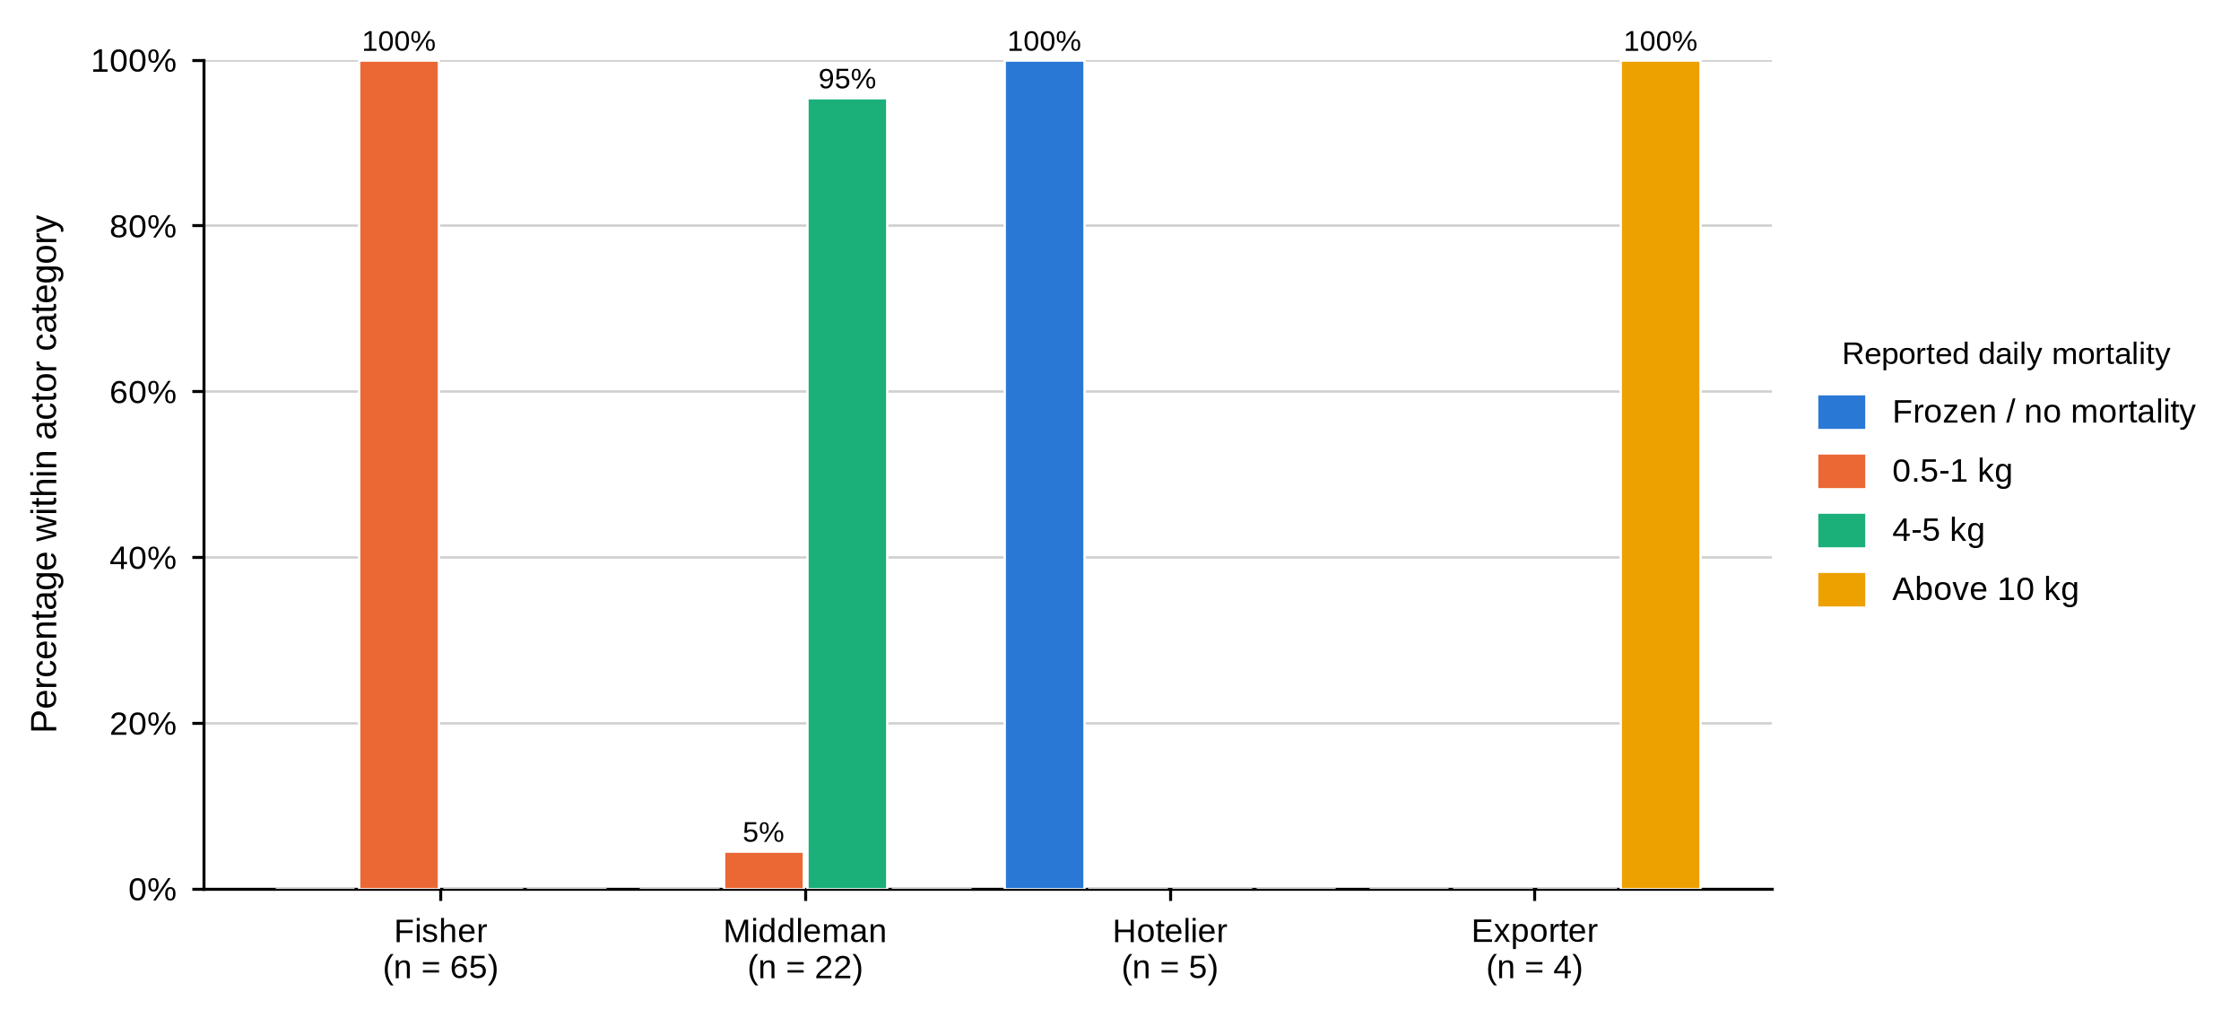
Table 28
Reported Loss Through Spoilage by Actor and BMU
Characteristic / response | Actor | Overall | Shimoni | Majoreni | Vanga | Msambweni | Other sites | BMU p-value
Reported loss through spoilage
1 kg | Fisher N = 0 | - | - | - | - | - | -
3 kg | Fisher N = 0 | - | - | - | - | - | -
5 kg | Fisher N = 0 | - | - | - | - | - | -
Above 10 kg | Fisher N = 0 | - | - | - | - | - | -
1 kg | Middleman N = 22 | 0 (0.0%) | 0 (0.0%) | 0 (0.0%) | 0 (0.0%) | - | - | .066
3 kg | Middleman N = 22 | 9 (40.9%) | 7 (63.6%) | 2 (28.6%) | 0 (0.0%) | - | -
5 kg | Middleman N = 22 | 13 (59.1%) | 4 (36.4%) | 5 (71.4%) | 4 (100.0%) | - | -
Above 10 kg | Middleman N = 22 | 0 (0.0%) | 0 (0.0%) | 0 (0.0%) | 0 (0.0%) | - | -
1 kg | Hotelier N = 5 | 5 (100.0%) | 1 (100.0%) | - | - | - | 4 (100.0%)
3 kg | Hotelier N = 5 | 0 (0.0%) | 0 (0.0%) | - | - | - | 0 (0.0%)
5 kg | Hotelier N = 5 | 0 (0.0%) | 0 (0.0%) | - | - | - | 0 (0.0%)
Above 10 kg | Hotelier N = 5 | 0 (0.0%) | 0 (0.0%) | - | - | - | 0 (0.0%)
1 kg | Exporter N = 4 | 0 (0.0%) | - | - | - | - | 0 (0.0%)
3 kg | Exporter N = 4 | 0 (0.0%) | - | - | - | - | 0 (0.0%)
5 kg | Exporter N = 4 | 0 (0.0%) | - | - | - | - | 0 (0.0%)
Above 10 kg | Exporter N = 4 | 4 (100.0%) | - | - | - | - | 4 (100.0%)
Table 28 covers spoilage, an item not put to fishers. Middlemen reported 5 kg (13, 59.1%) or 3 kg (9, 40.9%), the 5 kg share rising from 4 (36.4%) at Shimoni to all four (100.0%) at Vanga; the site difference approached but did not reach significance (p = .066). All five hoteliers reported 1 kg and all four exporters more than 10 kg. Hoteliers reported no mortality because crabs were frozen on arrival.
Read together, Tables 24 and 25 show a chain in which every actor loses stock and none records it against a shared standard. The actor holding live crabs carries the loss, and because no one measures it consistently the cost of mortality cannot be priced into a grade or recovered through one.

4.4.6 Payment, Price Setting and Sale Location
Figure 17 shows that M-Pesa was the commonest single arrangement among fishers (30, 46.2%), but credit accounted for 18 (27.7%) and a further 7 (10.8%) combined M-Pesa with credit, so close to two fishers in five were paid at least partly on credit by the very middleman buying from them. Cash on delivery accounted for 10 (15.4%). Middlemen most often reported credit themselves (9, 40.9%), followed by M-Pesa (7, 31.8%) and cash on delivery (6, 27.3%). All five hoteliers used M-Pesa and cash together; the item was not completed by exporters. Payment was not associated with BMU for fishers (p = .515) or middlemen (p = .470).
Figure 17
Mode of Payment by Actor Category
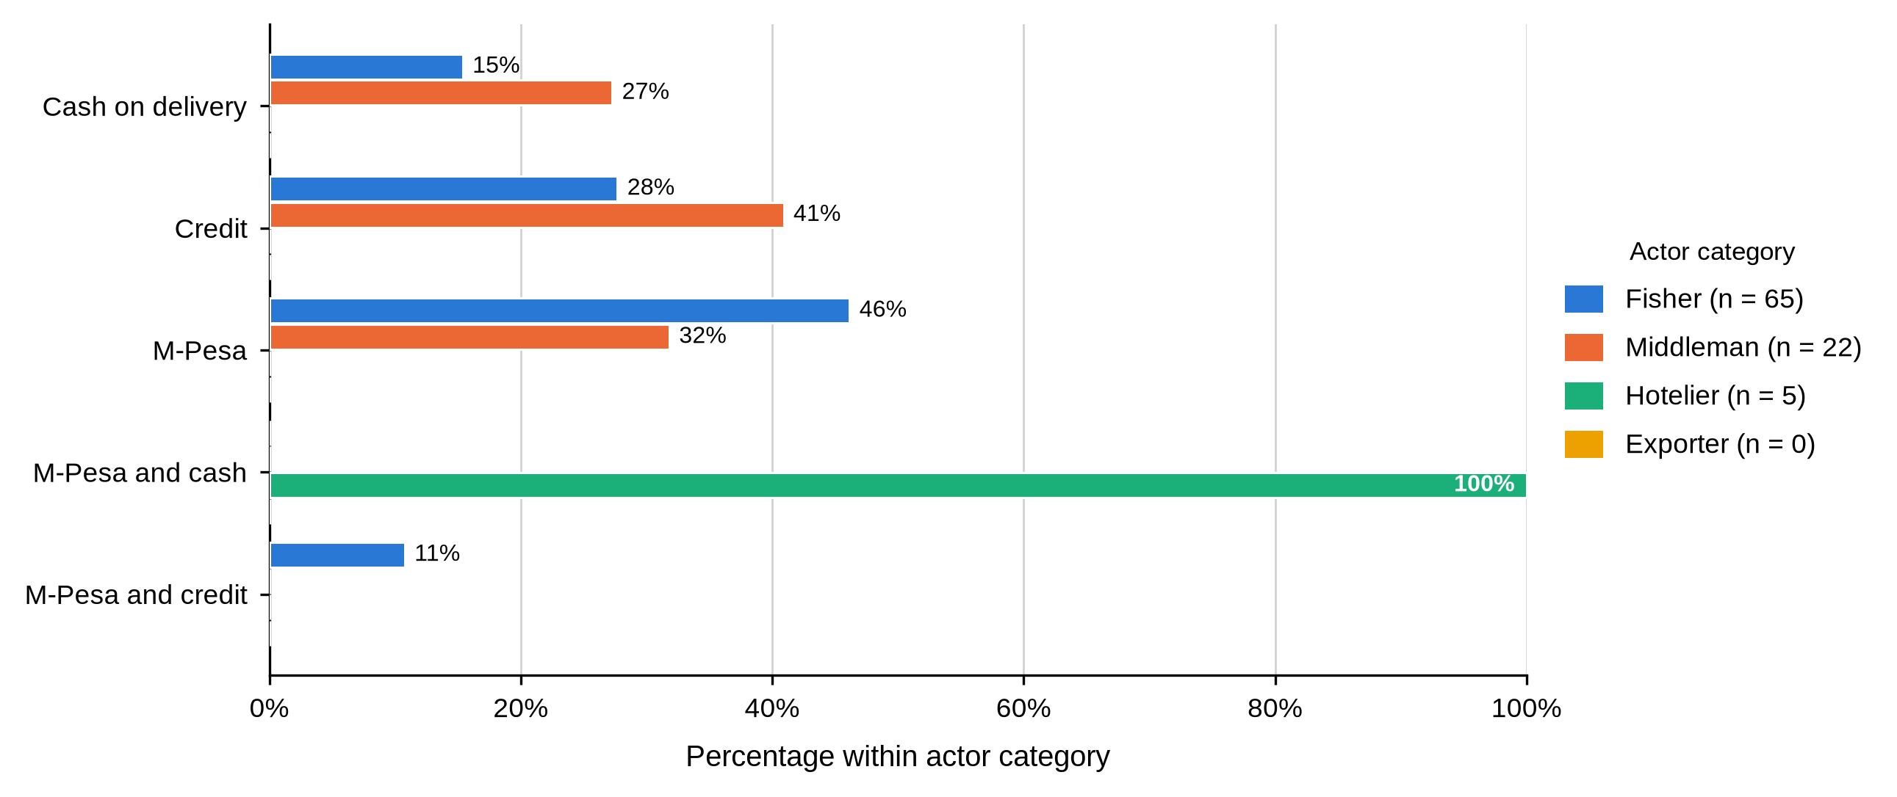
Table 29
Pricing Mechanism and How Prices Are Set by Actor and BMU
Characteristic / response | Actor | Overall | Shimoni | Majoreni | Vanga | Msambweni | Other sites | BMU p-value
Standard pricing mechanism is used
No | Fisher N = 65 | 65 (100.0%) | 25 (100.0%) | 14 (100.0%) | 21 (100.0%) | 3 (100.0%) | 2 (100.0%)
No | Middleman N = 22 | 22 (100.0%) | 11 (100.0%) | 7 (100.0%) | 4 (100.0%) | - | -
No | Hotelier N = 5 | 5 (100.0%) | 1 (100.0%) | - | - | - | 4 (100.0%)
No | Exporter N = 4 | 4 (100.0%) | - | - | - | - | 4 (100.0%)
Table 29 and Figure 18 divide the chain in two. Not one respondent in any actor category, at any site, reported using a standard pricing mechanism. All 65 fishers and all five hoteliers described the price as fixed, meaning the buyer set it and told them; 14 of 22 middlemen (63.6%) and all four exporters described their own pricing as competitive. Price setting was not associated with BMU among middlemen (p = .722). The payment item was not completed by exporters.
Figure 18
How Mud Crab Prices Are Set, by Actor Category
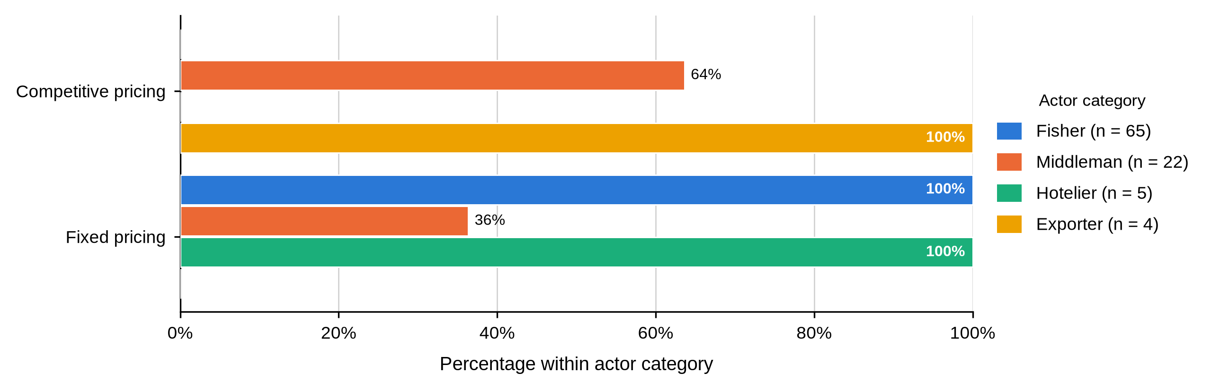
Table 30
Factors Influencing Price Fluctuations by Actor and BMU
Characteristic / response | Actor | Overall | Shimoni | Majoreni | Vanga | Msambweni | Other sites | BMU p-value
Factors influencing price fluctuations
Seasonal and economic factors | Fisher N = 65 | 0 (0.0%) | 0 (0.0%) | 0 (0.0%) | 0 (0.0%) | 0 (0.0%) | 0 (0.0%)
Seasonal factors only | Fisher N = 65 | 0 (0.0%) | 0 (0.0%) | 0 (0.0%) | 0 (0.0%) | 0 (0.0%) | 0 (0.0%)
Seasonal, weather and regulatory factors | Fisher N = 65 | 65 (100.0%) | 25 (100.0%) | 14 (100.0%) | 21 (100.0%) | 3 (100.0%) | 2 (100.0%)
Seasonal and economic factors | Middleman N = 22 | 14 (63.6%) | 5 (45.5%) | 6 (85.7%) | 3 (75.0%) | - | - | .238
Seasonal factors only | Middleman N = 22 | 0 (0.0%) | 0 (0.0%) | 0 (0.0%) | 0 (0.0%) | - | -
Seasonal, weather and regulatory factors | Middleman N = 22 | 8 (36.4%) | 6 (54.5%) | 1 (14.3%) | 1 (25.0%) | - | -
Seasonal and economic factors | Hotelier N = 5 | 0 (0.0%) | 0 (0.0%) | - | - | - | 0 (0.0%)
Seasonal factors only | Hotelier N = 5 | 5 (100.0%) | 1 (100.0%) | - | - | - | 4 (100.0%)
Seasonal, weather and regulatory factors | Hotelier N = 5 | 0 (0.0%) | 0 (0.0%) | - | - | - | 0 (0.0%)
Seasonal and economic factors | Exporter N = 4 | 0 (0.0%) | - | - | - | - | 0 (0.0%)
Seasonal factors only | Exporter N = 4 | 0 (0.0%) | - | - | - | - | 0 (0.0%)
Seasonal, weather and regulatory factors | Exporter N = 4 | 4 (100.0%) | - | - | - | - | 4 (100.0%)
Table 30 shows that actors attributed price movement to different causes. All 65 fishers and all four exporters cited seasonal, weather and regulatory factors; 14 of 22 middlemen (63.6%) cited seasonal and economic factors; all five hoteliers cited seasonal factors alone. Among middlemen the factor named was not associated with BMU (p = .238). Fishers and hoteliers described the price as fixed by the buyer; middlemen and exporters described their own pricing as competitive.
Tables 29 and 30 and Figure 17 describe the moment at which the terms of exchange are settled. The fisher sells at the beach, on the day, at a price the buyer sets, and is often paid at least partly in credit by that same buyer. Fixed at the fisher node and competitive at the middleman node are the same transaction described from either end.

4.4.7 Trading Relationships and Market Information
Table 31
Tied Depot Owners and Arrangements With Tied Fishers and Traders by Actor and BMU
Characteristic / response | Actor | Overall | Shimoni | Majoreni | Vanga | Msambweni | Other sites | BMU p-value
Has depot owners tied to the business
Yes | Fisher N = 9 | 0 (0.0%) | 0 (0.0%) | - | 0 (0.0%) | - | -
No | Fisher N = 9 | 9 (100.0%) | 5 (100.0%) | - | 4 (100.0%) | - | -
Yes | Middleman N = 22 | 21 (95.5%) | 10 (90.9%) | 7 (100.0%) | 4 (100.0%) | - | -
No | Middleman N = 22 | 1 (4.5%) | 1 (9.1%) | 0 (0.0%) | 0 (0.0%) | - | -
Yes | Hotelier N = 5 | 0 (0.0%) | 0 (0.0%) | - | - | - | 0 (0.0%)
No | Hotelier N = 5 | 5 (100.0%) | 1 (100.0%) | - | - | - | 4 (100.0%)
Yes | Exporter N = 4 | 0 (0.0%) | - | - | - | - | 0 (0.0%)
No | Exporter N = 4 | 4 (100.0%) | - | - | - | - | 4 (100.0%)
Arrangement with tied fishers
Credit | Fisher N = 0 | - | - | - | - | - | -
Credit | Middleman N = 21 | 21 (100.0%) | 10 (100.0%) | 7 (100.0%) | 4 (100.0%) | - | -
Credit | Hotelier N = 5 | 5 (100.0%) | 1 (100.0%) | - | - | - | 4 (100.0%)
Credit | Exporter N = 0 | - | - | - | - | - | -
Arrangement with tied traders
Credit | Fisher N = 65 | 38 (58.5%) | 14 (56.0%) | 9 (64.3%) | 13 (61.9%) | 2 (66.7%) | 0 (0.0%)
Fixed price | Fisher N = 65 | 9 (13.8%) | 5 (20.0%) | 0 (0.0%) | 4 (19.0%) | 0 (0.0%) | 0 (0.0%)
Frequency supply | Fisher N = 65 | 18 (27.7%) | 6 (24.0%) | 5 (35.7%) | 4 (19.0%) | 1 (33.3%) | 2 (100.0%)
Credit | Middleman N = 11 | 10 (90.9%) | 4 (80.0%) | 4 (100.0%) | 2 (100.0%) | - | -
Fixed price | Middleman N = 11 | 1 (9.1%) | 1 (20.0%) | 0 (0.0%) | 0 (0.0%) | - | -
Frequency supply | Middleman N = 11 | 0 (0.0%) | 0 (0.0%) | 0 (0.0%) | 0 (0.0%) | - | -
Credit | Hotelier N = 5 | 5 (100.0%) | 1 (100.0%) | - | - | - | 4 (100.0%)
Fixed price | Hotelier N = 5 | 0 (0.0%) | 0 (0.0%) | - | - | - | 0 (0.0%)
Frequency supply | Hotelier N = 5 | 0 (0.0%) | 0 (0.0%) | - | - | - | 0 (0.0%)
Credit | Exporter N = 4 | 4 (100.0%) | - | - | - | - | 4 (100.0%)
Fixed price | Exporter N = 4 | 0 (0.0%) | - | - | - | - | 0 (0.0%)
Frequency supply | Exporter N = 4 | 0 (0.0%) | - | - | - | - | 0 (0.0%)
Table 31 records depot ties and the terms attached to tied relationships. Depot owners were tied to the business for 22 middlemen (100.0%), all five hoteliers and all four exporters, but for only 1 of the 9 fishers who answered (11.1%). Where middlemen and hoteliers had tied fishers, the arrangement was credit in every case — 21 middlemen and 5 hoteliers, 100.0% of those answering. Arrangements with tied traders were more varied: every fisher who answered named credit, while middlemen named credit (7, 63.6%) or fixed price (4, 36.4%), and hoteliers and exporters named frequency of supply.
This is the clearest statement in the chapter of what ties an upstream actor to a downstream one. It is not a contract and not a price guarantee; it is credit. Every one of the 21 middlemen with tied fishers held them through an advance, and every fisher describing his own tie to a trader described the same instrument. Read against Table 12, where 93.8% of fishers named a middleman as their source of credit, the two tables describe a single mechanism from both ends.
Table 32
Arrangements Used With Tied Depot Owners by Actor and BMU
Characteristic / response | Actor | Overall | Shimoni | Majoreni | Vanga | Msambweni | Other sites | BMU p-value
Arrangement with tied depot owners
Credit | Fisher N = 56 | 0 (0.0%) | 0 (0.0%) | 0 (0.0%) | 0 (0.0%) | 0 (0.0%) | 0 (0.0%)
Frequency supply | Fisher N = 56 | 0 (0.0%) | 0 (0.0%) | 0 (0.0%) | 0 (0.0%) | 0 (0.0%) | 0 (0.0%)
Frequency supply and credit | Fisher N = 56 | 0 (0.0%) | 0 (0.0%) | 0 (0.0%) | 0 (0.0%) | 0 (0.0%) | 0 (0.0%)
Supply quantity | Fisher N = 56 | 56 (100.0%) | 20 (100.0%) | 14 (100.0%) | 17 (100.0%) | 3 (100.0%) | 2 (100.0%)
Credit | Middleman N = 21 | 15 (71.4%) | 8 (80.0%) | 3 (42.9%) | 4 (100.0%) | - | -
Frequency supply | Middleman N = 21 | 4 (19.0%) | 2 (20.0%) | 2 (28.6%) | 0 (0.0%) | - | -
Frequency supply and credit | Middleman N = 21 | 2 (9.5%) | 0 (0.0%) | 2 (28.6%) | 0 (0.0%) | - | -
Supply quantity | Middleman N = 21 | 0 (0.0%) | 0 (0.0%) | 0 (0.0%) | 0 (0.0%) | - | -
Credit | Hotelier N = 0 | - | - | - | - | - | -
Frequency supply | Hotelier N = 0 | - | - | - | - | - | -
Frequency supply and credit | Hotelier N = 0 | - | - | - | - | - | -
Supply quantity | Hotelier N = 0 | - | - | - | - | - | -
Credit | Exporter N = 0 | - | - | - | - | - | -
Frequency supply | Exporter N = 0 | - | - | - | - | - | -
Frequency supply and credit | Exporter N = 0 | - | - | - | - | - | -
Supply quantity | Exporter N = 0 | - | - | - | - | - | -
As shown in Table 32, arrangements with tied depot owners were reported by 56 fishers and 21 middlemen. Fishers named frequency of supply (31, 55.4%) or credit (25, 44.6%); middlemen named supply quantity (10, 47.6%), frequency of supply and credit together (7, 33.3%) or credit alone (4, 19.0%). No hotelier or exporter completed the item.
Taken with Table 31, the pattern is that obligations become more commercial further down the chain. A fisher is held by an advance; a middleman is held by a quantity he has undertaken to deliver. Neither is a written contract in the ordinary sense, and Table 33 shows that only one of the ten fishers who answered reported having any trading agreement at all.
Table 33
Tied Fishers, Tied Traders and Trading Agreements by Actor and BMU
Characteristic / response | Actor | Overall | Shimoni | Majoreni | Vanga | Msambweni | Other sites | BMU p-value
Has fishers tied to the business
Yes | Fisher N = 65 | 0 (0.0%) | 0 (0.0%) | 0 (0.0%) | 0 (0.0%) | 0 (0.0%) | 0 (0.0%)
No | Fisher N = 65 | 65 (100.0%) | 25 (100.0%) | 14 (100.0%) | 21 (100.0%) | 3 (100.0%) | 2 (100.0%)
Yes | Middleman N = 22 | 21 (95.5%) | 10 (90.9%) | 7 (100.0%) | 4 (100.0%) | - | -
No | Middleman N = 22 | 1 (4.5%) | 1 (9.1%) | 0 (0.0%) | 0 (0.0%) | - | -
Yes | Hotelier N = 5 | 5 (100.0%) | 1 (100.0%) | - | - | - | 4 (100.0%)
No | Hotelier N = 5 | 0 (0.0%) | 0 (0.0%) | - | - | - | 0 (0.0%)
Yes | Exporter N = 4 | 0 (0.0%) | - | - | - | - | 0 (0.0%)
No | Exporter N = 4 | 4 (100.0%) | - | - | - | - | 4 (100.0%)
Has traders tied to the business
Yes | Fisher N = 65 | 65 (100.0%) | 25 (100.0%) | 14 (100.0%) | 21 (100.0%) | 3 (100.0%) | 2 (100.0%)
No | Fisher N = 65 | 0 (0.0%) | 0 (0.0%) | 0 (0.0%) | 0 (0.0%) | 0 (0.0%) | 0 (0.0%)
Yes | Middleman N = 22 | 11 (50.0%) | 5 (45.5%) | 4 (57.1%) | 2 (50.0%) | - | -
No | Middleman N = 22 | 11 (50.0%) | 6 (54.5%) | 3 (42.9%) | 2 (50.0%) | - | -
Yes | Hotelier N = 5 | 5 (100.0%) | 1 (100.0%) | - | - | - | 4 (100.0%)
No | Hotelier N = 5 | 0 (0.0%) | 0 (0.0%) | - | - | - | 0 (0.0%)
Yes | Exporter N = 4 | 4 (100.0%) | - | - | - | - | 4 (100.0%)
No | Exporter N = 4 | 0 (0.0%) | - | - | - | - | 0 (0.0%)
Has a formal or informal trading agreement
Yes | Fisher N = 10 | 1 (10.0%) | 0 (0.0%) | 1 (100.0%) | 0 (0.0%) | - | -
No | Fisher N = 10 | 9 (90.0%) | 5 (100.0%) | 0 (0.0%) | 4 (100.0%) | - | -
Yes | Middleman N = 22 | 21 (95.5%) | 10 (90.9%) | 7 (100.0%) | 4 (100.0%) | - | -
No | Middleman N = 22 | 1 (4.5%) | 1 (9.1%) | 0 (0.0%) | 0 (0.0%) | - | -
Yes | Hotelier N = 5 | 5 (100.0%) | 1 (100.0%) | - | - | - | 4 (100.0%)
No | Hotelier N = 5 | 0 (0.0%) | 0 (0.0%) | - | - | - | 0 (0.0%)
Yes | Exporter N = 4 | 4 (100.0%) | - | - | - | - | 4 (100.0%)
No | Exporter N = 4 | 0 (0.0%) | - | - | - | - | 0 (0.0%)
Table 33 shows that tied relationships run downward. No fisher had a fisher tied to him, yet every fisher had a trader tied to his business; 21 of 22 middlemen (95.5%) and all five hoteliers had fishers tied to theirs, while middlemen split evenly on whether they had tied traders (11 and 11). Formal or informal trading agreements covered 21 middlemen (95.5%) and every hotelier and exporter, against 1 of the 10 fishers who answered the item (10.0%).
Table 34
Role of Intermediaries and Negotiation Terms by Actor and BMU
Characteristic / response | Actor | Overall | Shimoni | Majoreni | Vanga | Msambweni | Other sites | BMU p-value
Role of intermediaries
Marketing | Fisher N = 65 | 24 (36.9%) | 10 (40.0%) | 6 (42.9%) | 7 (33.3%) | 1 (33.3%) | 0 (0.0%) | .925
Negotiation | Fisher N = 65 | 41 (63.1%) | 15 (60.0%) | 8 (57.1%) | 14 (66.7%) | 2 (66.7%) | 2 (100.0%)
Negotiation and marketing | Fisher N = 65 | 0 (0.0%) | 0 (0.0%) | 0 (0.0%) | 0 (0.0%) | 0 (0.0%) | 0 (0.0%)
Marketing | Middleman N = 22 | 1 (4.5%) | 1 (9.1%) | 0 (0.0%) | 0 (0.0%) | - | - | 1.000
Negotiation | Middleman N = 22 | 7 (31.8%) | 4 (36.4%) | 2 (28.6%) | 1 (25.0%) | - | -
Negotiation and marketing | Middleman N = 22 | 14 (63.6%) | 6 (54.5%) | 5 (71.4%) | 3 (75.0%) | - | -
Marketing | Hotelier N = 5 | 5 (100.0%) | 1 (100.0%) | - | - | - | 4 (100.0%)
Negotiation | Hotelier N = 5 | 0 (0.0%) | 0 (0.0%) | - | - | - | 0 (0.0%)
Negotiation and marketing | Hotelier N = 5 | 0 (0.0%) | 0 (0.0%) | - | - | - | 0 (0.0%)
Marketing | Exporter N = 4 | 0 (0.0%) | - | - | - | - | 0 (0.0%)
Negotiation | Exporter N = 4 | 0 (0.0%) | - | - | - | - | 0 (0.0%)
Negotiation and marketing | Exporter N = 4 | 4 (100.0%) | - | - | - | - | 4 (100.0%)
Terms used with intermediaries
Flexible terms | Fisher N = 65 | 65 (100.0%) | 25 (100.0%) | 14 (100.0%) | 21 (100.0%) | 3 (100.0%) | 2 (100.0%)
Flexible terms and competitive bidding | Fisher N = 65 | 0 (0.0%) | 0 (0.0%) | 0 (0.0%) | 0 (0.0%) | 0 (0.0%) | 0 (0.0%)
Flexible terms | Middleman N = 22 | 22 (100.0%) | 11 (100.0%) | 7 (100.0%) | 4 (100.0%) | - | -
Flexible terms and competitive bidding | Middleman N = 22 | 0 (0.0%) | 0 (0.0%) | 0 (0.0%) | 0 (0.0%) | - | -
Flexible terms | Hotelier N = 5 | 5 (100.0%) | 1 (100.0%) | - | - | - | 4 (100.0%)
Flexible terms and competitive bidding | Hotelier N = 5 | 0 (0.0%) | 0 (0.0%) | - | - | - | 0 (0.0%)
Flexible terms | Exporter N = 4 | 0 (0.0%) | - | - | - | - | 0 (0.0%)
Flexible terms and competitive bidding | Exporter N = 4 | 4 (100.0%) | - | - | - | - | 4 (100.0%)
As shown in Table 34, fishers saw the intermediary mainly as a negotiator (41, 63.1%) rather than a marketer (24, 36.9%); middlemen described their own role as negotiation and marketing together (14, 63.6%); hoteliers saw intermediaries as marketers and exporters as both. Terms were flexible for every fisher, middleman and hotelier, while all four exporters combined flexible terms with competitive bidding. Neither item was associated with BMU (p = .925 for fishers, p = 1.000 for middlemen).
Table 35
Technology Adoption and Market Research by Actor and BMU
Characteristic / response | Actor | Overall | Shimoni | Majoreni | Vanga | Msambweni | Other sites | BMU p-value
Adopted technology or modern equipment
No | Fisher N = 65 | 65 (100.0%) | 25 (100.0%) | 14 (100.0%) | 21 (100.0%) | 3 (100.0%) | 2 (100.0%)
No | Middleman N = 22 | 22 (100.0%) | 11 (100.0%) | 7 (100.0%) | 4 (100.0%) | - | -
No | Hotelier N = 5 | 5 (100.0%) | 1 (100.0%) | - | - | - | 4 (100.0%)
No | Exporter N = 4 | 4 (100.0%) | - | - | - | - | 4 (100.0%)
Conducts market research
No | Fisher N = 65 | 65 (100.0%) | 25 (100.0%) | 14 (100.0%) | 21 (100.0%) | 3 (100.0%) | 2 (100.0%)
No | Middleman N = 22 | 22 (100.0%) | 11 (100.0%) | 7 (100.0%) | 4 (100.0%) | - | -
No | Hotelier N = 5 | 5 (100.0%) | 1 (100.0%) | - | - | - | 4 (100.0%)
No | Exporter N = 4 | 4 (100.0%) | - | - | - | - | 4 (100.0%)
Table 35 carries no variation at all, and is the more striking for it. Not one respondent in any actor category, at any site, had adopted modern equipment, and not one conducted market research. The figure was 0% on both items across all 96 respondents.
Tables 28 and 29 and Figure 17 close the functional account. In a chain where the buyer sets the price and controls the grading rule, no actor invests in equipment and no actor gathers independent market information. Every respondent said they kept up to date by networking, which means information travels along the same commercial relationships that determine the terms of trade.

4.4.8 Reported Mud Crab Prices
Prices were collected for three size grades in Kenya shillings per kilogram of live crab. Every figure is a gross price at the point of sale; nothing was recorded about transport, holding, mortality, ice, packaging or the cost of money tied up between buying and selling.
Table 36
Reported Mud Crab Prices by Actor Category and Size Grade
Actor category | Valid n | M | SD | Mdn | IQR (Q1–Q3) | Range
Large (Grade A)
Fisher | 65 | 604.6 | 192.2 | 650.0 | 500.0–800.0 | 300.0–800.0
Middleman | 22 | 945.5 | 140.5 | 1,000.0 | 800.0–1,000.0 | 800.0–1,200.0
Hotelier | 5 | 2,200.0 | 570.1 | 2,000.0 | 2,000.0–2,500.0 | 1,500.0–3,000.0
Exporter | 4 | 1,700.0 | 115.5 | 1,700.0 | 1,600.0–1,800.0 | 1,600.0–1,800.0
Medium (Grade B)
Fisher | 65 | 514.6 | 163.4 | 500.0 | 400.0–600.0 | 300.0–800.0
Middleman | 22 | 718.2 | 100.6 | 800.0 | 600.0–800.0 | 600.0–800.0
Hotelier | 5 | 380.0 | 109.5 | 300.0 | 300.0–500.0 | 300.0–500.0
Exporter | 4 | 1,300.0 | 115.5 | 1,300.0 | 1,200.0–1,400.0 | 1,200.0–1,400.0
Small (Grade C)
Fisher | 65 | 309.2 | 50.7 | 300.0 | 300.0–300.0 | 250.0–500.0
Middleman | — | — | — | — | — | —
Hotelier | — | — | — | — | — | —
Exporter | — | — | — | — | — | —
As shown in Table 36, the large-crab price climbed at every step of the chain. Fishers averaged KSh 604.6 per kilogram, middlemen KSh 945.5, exporters KSh 1,700.0 and hoteliers KSh 2,200.0. Medium crabs ran KSh 514.6 for fishers and KSh 718.2 for middlemen, with exporters at KSh 1,300.0. Only fishers priced small crabs, averaging KSh 309.2; no middleman, hotelier or exporter reported a small-grade price at all, which points to the smallest crabs being absorbed locally rather than moving up the chain.
Table 37
Kruskal–Wallis Comparisons of Reported Mud Crab Prices
Comparison | H | df | N | p
Price compared across the four actor categories
Large (Grade A) | 55.84 | 3 | 96 | < .001
Medium (Grade B) | 38.00 | 3 | 96 | < .001
Small (Grade C) | — | — | — | —
Fisher price compared across the four BMUs
Large (Grade A) | 20.32 | 3 | 63 | < .001
Medium (Grade B) | 20.07 | 3 | 63 | < .001
Small (Grade C) | 5.85 | 3 | 63 | .119
Middleman price compared across the three BMUs with traders
Large (Grade A) | 5.33 | 2 | 22 | .070
Medium (Grade B) | 3.78 | 2 | 22 | .151
Small (Grade C) | — | — | — | —
Hoteliers and exporters were not compared across BMUs because four of the five hoteliers and all four exporters operated outside the four BMU frames
Table 37 tests those differences. The comparison across the four actor categories was significant for large crabs, H(3) = 55.84, p < .001, and for medium crabs, H(3) = 38.00, p < .001. Actor category therefore does influence the price received, at both grades for which more than one category reported a price. The small grade could not be compared across actors because only fishers reported it.
One value breaks the pattern. Hoteliers reported a mean of KSh 380.0 per kilogram for medium crabs, which is below the fisher price for the same grade and far below their own large-grade mean of KSh 2,200.0. All five records were retained exactly as entered. The figure may be correct if those entries refer to a different product form, unit or transaction, but it may equally be a field-entry problem. It is excluded from the chain calculation that follows and should be checked against the questionnaires before it is used to support any argument about value addition. Small-grade prices were reported only by fishers. The hotelier medium-grade mean of KSh 380 is discussed below.

4.4.9 Marketing Margins and the Distribution of Value
Reading the four node prices as one chain shows where the final price accumulates. Two end points were available: crabs that left the middleman for an exporter finished at KSh 1,700.0 per kilogram for the large grade, and crabs that went to a hotel kitchen finished at KSh 2,200.0. Expressing each node’s contribution as a share of that end price places all four actors on a single scale.
Table 38
Marketing Margins and the Distribution of the Final Chain Price Across Actor Nodes
Market node | Mean price  (KSh/kg) | Value retained or  margin added (KSh/kg) | Margin as % of the  fisher price | % of the final  chain price
Large (Grade A) sold on to exporters
Fisher (first sale) | 604.6 | 604.6 | — | 35.6
Middleman | 945.5 | 340.8 | 56.4 | 20.0
Exporter (end of chain) | 1,700.0 | 754.5 | 124.8 | 44.4
Hotelier (not in this chain) | — | — | — | —
Large (Grade A) sold on to hoteliers
Fisher (first sale) | 604.6 | 604.6 | — | 27.5
Middleman | 945.5 | 340.8 | 56.4 | 15.5
Hotelier (end of chain) | 2,200.0 | 1,254.5 | 207.5 | 57.0
Exporter (not in this chain) | — | — | — | —
Medium (Grade B) sold on to exporters
Fisher (first sale) | 514.6 | 514.6 | — | 39.6
Middleman | 718.2 | 203.6 | 39.6 | 15.7
Exporter (end of chain) | 1,300.0 | 581.8 | 113.1 | 44.8
Hotelier (not in this chain) | — | — | — | —
As shown in Table 38, the fisher kept between a quarter and two fifths of the end price. Large crabs sold on to an exporter left 35.6% with the harvester; the same crabs sold on to a hotel left 27.5%. Medium crabs going for export were the fisher’s best case at 39.6%. In every chain the largest single share was added at the last step: 44.4% between the middleman and the exporter, 57.0% between the middleman and the hotel. The middleman, the actor most often identified with the low beach price, took the smallest share of the three, between 15.5% and 20.0%.
Two qualifications belong with that result. The shares rest on group means from different respondents rather than on a single crab followed from beach to buyer, and they would shift once handling, freight and mortality were priced in. The direction is nevertheless hard to argue away. An exporter paying KSh 945.5 and selling at KSh 1,700.0 works on a spread of KSh 754.5 per kilogram, roughly one and a quarter times what the fisher received for landing the animal. This is the evidence Objective Two requires on how value is distributed: not that any actor takes more than their costs justify, which these data cannot show, but that the value is realised two steps beyond the point the harvester can reach. Shares sum to 100% within each bar. Because no cost data were collected these are gross price spreads and not net margins. The medium grade sold on to hoteliers is not shown, for the reason given above.

4.4.10 Prices by Study Site
Holding the actor role constant and comparing sites answers a different question: whether a fisher at one landing site receives a different price from a fisher at another.
Table 39
Mean Reported Mud Crab Price by Actor Category, BMU and Size Grade
BMU | Fisher  M KSh/kg (n) | Middleman  M KSh/kg (n) | Hotelier  M KSh/kg (n) | Exporter  M KSh/kg (n)
Large (Grade A)
Shimoni | 540.0 (25) | 981.8 (11) | 1,500.0 (1) | -
Majoreni | 785.7 (14) | 857.1 (7) | - | -
Vanga | 535.7 (21) | 1,000.0 (4) | - | -
Msambweni | 650.0 (3) | - | - | -
Other sites | 800.0 (2) | - | 2,375.0 (4) | 1,700.0 (4)
All sites | 604.6 (65) | 945.5 (22) | 2,200.0 (5) | 1,700.0 (4)
Medium (Grade B)
Shimoni | 404.0 (25) | 745.5 (11) | 300.0 (1) | -
Majoreni | 600.0 (14) | 657.1 (7) | - | -
Vanga | 576.2 (21) | 750.0 (4) | - | -
Msambweni | 616.7 (3) | - | - | -
Other sites | 500.0 (2) | - | 400.0 (4) | 1,300.0 (4)
All sites | 514.6 (65) | 718.2 (22) | 380.0 (5) | 1,300.0 (4)
Table 39 shows that fisher prices varied considerably by site. Majoreni fishers reported the highest large-crab mean at KSh 785.7 per kilogram, well above Shimoni at KSh 540.0 and Vanga at KSh 535.7, with Msambweni at KSh 650.0 on three respondents. Middleman means were much closer together, from KSh 857.1 at Majoreni to KSh 1,000.0 at Vanga. Returning to Table 37, fisher prices differed significantly across sites for large crabs, H(3) = 20.32, p < .001, and for medium crabs, H(3) = 20.07, p < .001, while middleman prices did not, H(2) = 5.33, p = .070 and H(2) = 3.78, p = .151. Small-grade prices did not differ across sites either, H(3) = 5.85, p = .119.
Table 40
First-Sale Price Spread Between Fishers and Middlemen Within Each BMU
BMU | Fisher M  (KSh/kg) | Middleman M  (KSh/kg) | Spread  (KSh/kg) | Spread as % of  the fisher price | Fisher price as % of  the middleman price
Large (Grade A)
Shimoni | 540.0 | 981.8 | 441.8 | 81.8 | 55.0
Majoreni | 785.7 | 857.1 | 71.4 | 9.1 | 91.7
Vanga | 535.7 | 1,000.0 | 464.3 | 86.7 | 53.6
Msambweni | 650.0 | - | - | - | -
Other sites | 800.0 | - | - | - | -
Medium (Grade B)
Shimoni | 404.0 | 745.5 | 341.5 | 84.5 | 54.2
Majoreni | 600.0 | 657.1 | 57.1 | 9.5 | 91.3
Vanga | 576.2 | 750.0 | 173.8 | 30.2 | 76.8
Msambweni | 616.7 | - | - | - | -
Other sites | 500.0 | - | - | - | -
Table 40 sets the two upstream node prices side by side at each landing site. Majoreni stands apart: its fishers held 91.7% of the local middleman price for large crabs and 91.3% for medium crabs, leaving spreads of only KSh 71.4 and KSh 57.1 per kilogram. At Shimoni and Vanga the same comparison gave 55.0% and 53.6% for large crabs, spreads of KSh 441.8 and KSh 464.3, or between 82% and 87% on top of what the fisher was paid. Vanga sat in between for medium crabs at 76.8%. The pattern holds in both grades, which makes it unlikely to be an artefact of one unusual price. A missing bar means no respondent of that actor category was sampled at that site. The single Shimoni hotelier and the Other sites group rest on very small numbers.
Where that difference comes from is worth stating plainly, because the two nodes did not move together. Fisher prices varied significantly across sites; middleman prices did not. The narrow Majoreni gap is therefore built on the fisher side of the transaction rather than on Majoreni traders charging less than their counterparts: Majoreni middlemen sold at KSh 857.1, within KSh 143 of the other two sites, while Majoreni fishers were paid KSh 785.7 against roughly KSh 537 at Shimoni and Vanga. The gap a fisher faces is set at his own landing site. It is also worth recalling from Table 16 that Majoreni fishers reached the point of sale fastest, which is consistent with, though not proof of, a shorter and more competitive first-sale market there. A taller bar means a narrower gap between the two nodes. Msambweni and the Other sites group are absent because no middleman was sampled there.

4.4.11 Concentration at the Point of First Sale
Objective Two asks how the market is organised, and concentration is the standard way of answering that. A textbook concentration ratio needs a census of the buyers operating at each landing site and the volume each one handles; this survey interviewed actors and recorded neither. What it did record is where each fisher took his catch for first sale, and that supports a concentration measure of a different kind: how far the harvesters at a site are spread across buying points, or gathered at one. The shares below are shares of harvesters, not shares of volume, and the index is read accordingly.
Table 41
Concentration of First-Sale Outlets Reported by Fishers, by BMU
BMU | Fishers  answering | Buying points  named | Largest point | Share at the  largest point | HHI | Numbers  equivalent
Shimoni | 25 | 5 | Mkuyuni | 64.0% | 4,592 | 2.18
Majoreni | 13 | 2 | Majoreni / Aleni | 92.3% | 8,580 | 1.17
Vanga | 20 | 4 | Kiwegu | 75.0% | 5,850 | 1.71
Msambweni | 3 | 2 | Gasi | 66.7% | 5,556 | 1.80
All four BMUs | 63 | 8 | Majoreni / Aleni | 30.2% | 2,371 | 4.22
Table 41 shows that first sale is concentrated at every landing site. Across the four BMUs the 63 fishers who answered named only 8 buying points between them, with an HHI of 2,371 and a numbers-equivalent of 4.22 outlets. Within a site the picture is tighter still. Majoreni fishers named two points and 92.3% of them went to one, giving an HHI of 8,580 and a numbers-equivalent of 1.17: in practice a single outlet. Vanga returned 5,850, Msambweni 5,556 and Shimoni, the least concentrated, 4,592. Competition authorities commonly treat a market above 2,500 as highly concentrated. Every BMU in this study sits above that line, and three of the four sit above 4,500.
Table 42
Buyer Options per Harvester and Harvesters per Trader, by BMU
BMU | Fishers  answering | Selling to one  buyer only | Mean buyers  per fisher | Fishers  sampled | Middlemen  sampled | Fishers per  middleman
Shimoni | 25 | 17 (68.0%) | 1.32 | 25 | 11 | 2.27 : 1
Majoreni | 14 | 10 (71.4%) | 1.29 | 14 | 7 | 2.00 : 1
Vanga | 21 | 18 (85.7%) | 1.14 | 21 | 4 | 5.25 : 1
Msambweni | 3 | 3 (100.0%) | 1.00 | 3 | 0 | no trader sampled
All four BMUs | 65 | 50 (76.9%) | 1.23 | 65 | 22 | 2.95 : 1
Table 42 approaches the same structure from the seller’s side. 50 of the 65 fishers who answered (76.9%) sold to a single buyer, and the mean across all fishers was 1.23 buyers. The single-buyer share ran from 68.0% at Shimoni to 85.7% at Vanga and all three fishers at Msambweni. Set against that, 65 fishers were sampled against 22 middlemen, 2.95 harvesters for every trader, rising to 5.25 at Vanga and falling to 2.00 at Majoreni. Every fisher in the sample also described his main buyer as a regular one and reported being tied to a trader, so the single-buyer figure is not a matter of convenience on the day.
Two cautions belong with these numbers. They measure where harvesters take their catch, not how much crab each buying point handles, so a point that many fishers name but that buys little from each would be overweighted. They also rest on the fishers sampled at a site rather than on every fisher working there. Neither caution changes the direction: at three of the four BMUs more than two thirds of the harvesters interviewed carried their catch to one place, and more than three quarters dealt with one buyer when they got there.

4.4.12 Marketing Margins and the Distribution of Value
The margin at a node is the difference between what that actor pays and what he sells for, expressed against his own selling price. The producer’s share turns the same arithmetic round and asks how much of the final price reaches the person who caught the crab. Both are computed here from the mean reported price at each node.
Table 43
Gross Marketing Margin, Total Margin and Producer’s Share by Chain
Chain | Fisher  KSh/kg | Middleman  KSh/kg | Final node  KSh/kg | Middleman  GMM | Final node  GMM | Total  GMM | Producer’s  share | Producer’s share  net of loss
Large (Grade A) sold on to exporters | 604.6 | 945.5 | 1,700.0 | 36.1% | 44.4% | 64.4% | 35.6% | 31.9%
Large (Grade A) sold on to hoteliers | 604.6 | 945.5 | 2,200.0 | 36.1% | 57.0% | 72.5% | 27.5% | 24.6%
Medium (Grade B) sold on to exporters | 514.6 | 718.2 | 1,300.0 | 28.3% | 44.8% | 60.4% | 39.6% | 35.5%
Table 43 reads the chain three ways. Large crabs moving to an exporter left the middleman a gross margin of 36.1% of his own selling price and the exporter 44.4% of his, a total marketing margin of 64.4% and a producer’s share of 35.6%. The same crabs sold to a hotel gave a total margin of 72.5% and left the fisher 27.5%. Medium crabs going for export were the harvester’s best case at 39.6%. In every chain the largest single margin accrued at the node furthest from the water.
These are gross margins. The survey priced no transport, holding, ice, packaging or cost of capital, so nothing here is a profit. One cost was measured, however, and it belongs in the calculation: physical mortality. Fishers reported a mean of 0.75 kg of dead crab a day against a mean daily catch of 7.68 kg, a loss of 10.4% of the volume they land. Carrying that loss through reduces the producer’s share from 35.6% to 31.9% in the export chain and from 27.5% to 24.6% in the hotel chain. Middlemen reported a larger absolute loss, a mean of 4.33 kg a day, but the survey did not record the volume they handle, so the same rate cannot be formed for them and their margins stay gross.

4.4.13 Price Dispersion and Price Transmission
A market in which the same product fetches widely different prices on the same day is transmitting information poorly. The coefficient of variation measures that spread independently of the price level, so it can be compared across nodes whose prices differ by a factor of three.
Table 44
Price Dispersion Within Each Actor Category and Price Transmission to the Fisher
Size grade | Fisher | Middleman | Hotelier | Exporter | Shimoni | Majoreni | Vanga
Coefficient of variation of reported price, by actor category
Large (Grade A) | 31.8% | 14.9% | 25.9% | 6.8%
Medium (Grade B) | 31.8% | 14.0% | 28.8% | 8.9%
Fisher price as a percentage of the middleman price at the same BMU
Large (Grade A) |  |  |  |  | 55.0% | 91.7% | 53.6%
Medium (Grade B) |  |  |  |  | 54.2% | 91.3% | 76.8%
Table 44 shows dispersion falling steadily down the chain. For large crabs the fisher coefficient of variation was 31.8%, the middleman 14.9% and the exporter 6.8%; the medium grade gives the same ordering. Two harvesters selling the same grade on the same coast can therefore expect materially different prices, while two exporters expect nearly the same one. The lower half of the table sets the fisher mean against the middleman mean at the same site. Majoreni transmitted 91.7% of the large-grade middleman price to its fishers, against 55.0% at Shimoni and 53.6% at Vanga.
Set beside the concentration results this produces a finding worth stating carefully. Majoreni was the most concentrated site on every measure in Table 41, yet it transmitted the largest share of the downstream price to its harvesters, while Vanga carried the highest number of harvesters per trader (5.25 to one) and transmitted the least. Concentration of outlets and the price a harvester receives did not move together here. With three sites and a cross-sectional design nothing causal can be drawn from that, but it does suggest that how many buying points exist matters less than how many sellers compete for the attention of each buyer, and it marks a question worth designing a study around.

4.4.14 Summary of Objective Two
Objective Two asked what functions actors perform at each market node. Functions divided cleanly, and so did the information attached to them. Fishers harvested by hand, tied claws, packed into sacks, walked to the landing site and sold the whole catch to a first-level middleman at a price they called fixed. Middlemen aggregated, cleaned, sorted and graded on a four-criterion rule, then moved crabs by vehicle or boat to company agents, other middlemen or exporters. Hoteliers processed and froze for their own kitchens. Exporters packed Styrofoam for air freight under inspection and certification. Formal quality control, the fuller grading rule and contact with the final buyer sat entirely downstream.
Prices rose at every node and differed significantly between actor categories. Expressed as shares of the price the crab eventually fetched, the fisher retained between 27.5% and 39.6%, the middleman added between 15.5% and 20.0%, and between 44.4% and 57.0% was added at the final buyer. Among fishers, price also differed significantly by site, and the size of the first-sale gap was set locally: Majoreni fishers held 91.7% of the middleman price for large crabs where Shimoni and Vanga fishers held close to 54%.

4.4.15 Discussion of Findings in Relation to Previous Studies
The functional sequence documented here — harvesting, aggregation, processing and export, each performed by a distinct actor category — agrees closely with the value-chain structure described for the Kenyan mud crab fishery (Mirera, 2017a; Fondo & Ogutu, 2021) and with the broader account of small-scale fisheries chains in which middlemen supply the link between dispersed harvesters and distant buyers (Crona et al., 2016). The present study extends those accounts by testing each function against site rather than assuming uniformity: of the functional variables examined, only travel time to market, the large-crab size label and the small-crab size label showed a significant association with BMU among fishers, and none did among middlemen.
The grading result is where this study makes its clearest contribution. Every actor graded, but fishers graded on weight alone while every downstream category used a four-criterion rule. Jacinto (2004) identifies precisely this kind of informational asymmetry as a determinant of how value is distributed in small-scale fisheries value chains, and the present data supply a clean instance of it in a fishery where the literature has so far documented actors and functions more thoroughly than the terms of exchange between them. The site variation in labelling adds a local dimension that earlier work has not reported.
On handling and loss, the finding that protection rises downstream while mortality rises with the volume held is consistent with FAO (2025) on the determinants of survival and quality in the live mud crab trade. The divergence from that literature is not in the direction of the result but in its measurement: no actor in this chain recorded losses against a shared standard, so the cost of mortality cannot be attributed, priced or recovered. That is a gap in practice rather than a contradiction of previous findings.
The price results agree with the expectation that later actors, carrying aggregation, mortality, transport and buyer-access costs, will trade at higher prices. The caveat matters and is stated plainly: these are gross prices. Munga and Muthumbi (2018) draw the same distinction for the Tana Delta mud crab fishery, where gross price differentials narrowed considerably once handling and transport were netted out, so nothing here should be read as a statement about profit.
Within that limit, the distribution of the end-of-chain price is the substantive extension this study offers. The producer’s share of between 27.5% and 39.6% sits at the low end of what has been reported for perishable, high-value seafood. Jacinto (2004) argues that in small-scale fisheries the share captured at each node tracks control of information and market access more closely than physical effort, and the ordering here matches that argument exactly: the actor doing the fishing takes the smallest share, and the largest single share accrues at the step furthest from the water.
The middleman result cuts against the popular account and deserves emphasis. Middlemen took the smallest of the three shares in every chain, between 15.5% and 20.0%, yet they are the actor fishers most often identify with the low beach price. Crona et al. (2016) reach a similar conclusion for Kenya and Zanzibar, finding middlemen widely blamed for outcomes largely determined further along the chain while themselves operating on modest turnovers and carrying the mortality risk. The present data support that reading rather than the popular one, and Figure 16 documents the risk directly.
Finally, the site contrast in the first-sale gap extends the literature on market integration. Green and Clark (2021) treat dispersion at the first point of sale as one of the more reliable indicators of weak market integration; on that criterion Shimoni and Vanga look the weaker markets of the three. Because fisher prices varied significantly across sites while middleman prices did not, the mechanism sits on the fisher side of the transaction. Two readings remain open — a less concentrated set of first buyers at Majoreni, or Majoreni traders being first-tier buyers reselling locally rather than consolidators shipping to Mombasa — and this study cannot separate them, because buyer concentration and onward destination were not measured at transaction level.

4.5 Objective Three: Constraints and Opportunities Facing Each Actor Category
Objective Three assessed the constraints each actor category reported and the opportunities they identified. The results are grouped into operational and infrastructure constraints, market access and risk, regulation and information, perceptions of market organisation, and opportunities.

4.5.1 Operational and Infrastructure Constraints
Table 45
Main Operational or Marketing Constraint by Actor and BMU
Characteristic / response | Actor | Overall | Shimoni | Majoreni | Vanga | Msambweni | Other sites | BMU p-value
Main operational or marketing constraint
Price fluctuations | Fisher N = 65 | 59 (90.8%) | 24 (96.0%) | 11 (78.6%) | 19 (90.5%) | 3 (100.0%) | 2 (100.0%) | .334
Mortality | Fisher N = 65 | 6 (9.2%) | 1 (4.0%) | 3 (21.4%) | 2 (9.5%) | 0 (0.0%) | 0 (0.0%)
Market seasonality | Fisher N = 65 | 0 (0.0%) | 0 (0.0%) | 0 (0.0%) | 0 (0.0%) | 0 (0.0%) | 0 (0.0%)
High freight, flight delays and supply risk | Fisher N = 65 | 0 (0.0%) | 0 (0.0%) | 0 (0.0%) | 0 (0.0%) | 0 (0.0%) | 0 (0.0%)
Price fluctuations | Middleman N = 22 | 11 (50.0%) | 8 (72.7%) | 3 (42.9%) | 0 (0.0%) | - | - | .036
Mortality | Middleman N = 22 | 11 (50.0%) | 3 (27.3%) | 4 (57.1%) | 4 (100.0%) | - | -
Market seasonality | Middleman N = 22 | 0 (0.0%) | 0 (0.0%) | 0 (0.0%) | 0 (0.0%) | - | -
High freight, flight delays and supply risk | Middleman N = 22 | 0 (0.0%) | 0 (0.0%) | 0 (0.0%) | 0 (0.0%) | - | -
Price fluctuations | Hotelier N = 5 | 0 (0.0%) | 0 (0.0%) | - | - | - | 0 (0.0%)
Mortality | Hotelier N = 5 | 0 (0.0%) | 0 (0.0%) | - | - | - | 0 (0.0%)
Market seasonality | Hotelier N = 5 | 5 (100.0%) | 1 (100.0%) | - | - | - | 4 (100.0%)
High freight, flight delays and supply risk | Hotelier N = 5 | 0 (0.0%) | 0 (0.0%) | - | - | - | 0 (0.0%)
Price fluctuations | Exporter N = 4 | 0 (0.0%) | - | - | - | - | 0 (0.0%)
Mortality | Exporter N = 4 | 0 (0.0%) | - | - | - | - | 0 (0.0%)
Market seasonality | Exporter N = 4 | 0 (0.0%) | - | - | - | - | 0 (0.0%)
High freight, flight delays and supply risk | Exporter N = 4 | 4 (100.0%) | - | - | - | - | 4 (100.0%)
As shown in Table 45, no constraint was shared across the chain. Price fluctuation was named by 59 fishers (90.8%) and by half the middlemen (11, 50.0%); mortality by the other half of middlemen and by 6 fishers (9.2%); market seasonality by all five hoteliers; and high freight, flight delays and supply risk by all four exporters. The middleman split varied significantly by site (p = .036): all four Vanga middlemen and 4 of 7 at Majoreni (57.1%) named mortality, while only 3 of 11 at Shimoni (27.3%) did. Fisher responses did not vary by site (p = .334).
Table 46
Main Infrastructure or Logistics Constraint and Need for Improvement by Actor and BMU
Characteristic / response | Actor | Overall | Shimoni | Majoreni | Vanga | Msambweni | Other sites | BMU p-value
Infrastructure improvements are needed
Yes | Fisher N = 65 | 65 (100.0%) | 25 (100.0%) | 14 (100.0%) | 21 (100.0%) | 3 (100.0%) | 2 (100.0%)
Yes | Middleman N = 22 | 22 (100.0%) | 11 (100.0%) | 7 (100.0%) | 4 (100.0%) | - | -
Yes | Hotelier N = 5 | 5 (100.0%) | 1 (100.0%) | - | - | - | 4 (100.0%)
Yes | Exporter N = 4 | 4 (100.0%) | - | - | - | - | 4 (100.0%)
Table 46 and Figure 19 show the same divergence in infrastructure. Poor road infrastructure dominated the fisher responses (64, 98.5%), reaching 100.0% at Shimoni, Vanga and Msambweni, while 20 of 22 middlemen (90.9%) named the lack of aggregation facilities, rising to all seven (100.0%) at Majoreni. All five hoteliers named market seasonality and all four exporters named high freight, flight delays and mortality. Every respondent in all four categories, without exception, said infrastructure improvements were needed. Neither fisher (p = .264) nor middleman (p = .339) responses varied significantly by site.
Figure 19
Main Infrastructure or Logistics Constraint by Actor Category
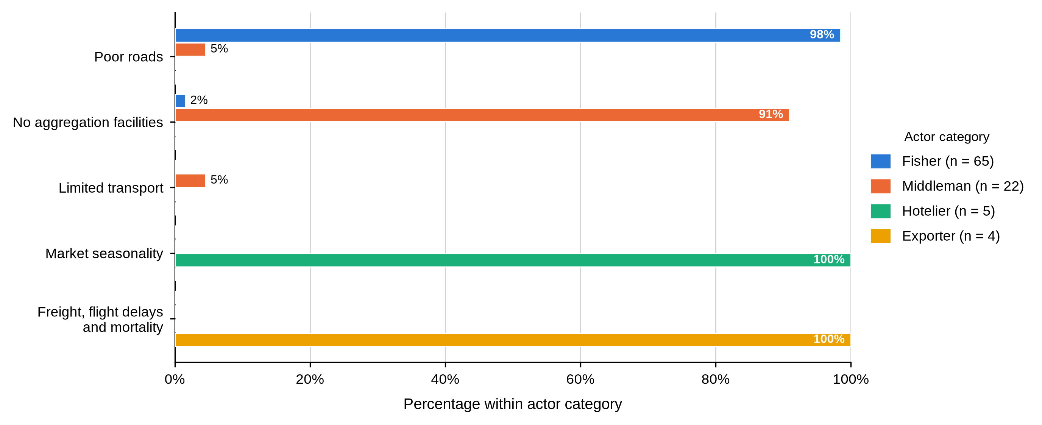
Tables 35 and 36 show that each constraint follows from the work the actor does. The fisher sells the same day at a price he does not set, so volatility reaches him first and the road is what stands between him and a buyer. The middleman holds stock, so he loses crabs and needs somewhere to hold them. The hotelier lives on tourist arrivals and feels the season. The exporter lives on cargo space and feels the freight. The practical consequence for Objective Three is that a single chain-wide intervention would not reach all four, which is why the recommendations in Chapter Six are written by actor category.

4.5.2 Market Access, Operational Challenges and Risk
Table 47
Barriers to Market Access and Operational Challenges by Actor and BMU
Characteristic / response | Actor | Overall | Shimoni | Majoreni | Vanga | Msambweni | Other sites | BMU p-value
Experienced barriers to market access
Yes | Fisher N = 65 | 61 (93.8%) | 23 (92.0%) | 14 (100.0%) | 19 (90.5%) | 3 (100.0%) | 2 (100.0%) | .730
No | Fisher N = 65 | 4 (6.2%) | 2 (8.0%) | 0 (0.0%) | 2 (9.5%) | 0 (0.0%) | 0 (0.0%)
Yes | Middleman N = 22 | 22 (100.0%) | 11 (100.0%) | 7 (100.0%) | 4 (100.0%) | - | -
No | Middleman N = 22 | 0 (0.0%) | 0 (0.0%) | 0 (0.0%) | 0 (0.0%) | - | -
Yes | Hotelier N = 5 | 5 (100.0%) | 1 (100.0%) | - | - | - | 4 (100.0%)
No | Hotelier N = 5 | 0 (0.0%) | 0 (0.0%) | - | - | - | 0 (0.0%)
Yes | Exporter N = 4 | 4 (100.0%) | - | - | - | - | 4 (100.0%)
No | Exporter N = 4 | 0 (0.0%) | - | - | - | - | 0 (0.0%)
Experienced significant operational challenges
Yes | Fisher N = 65 | 53 (81.5%) | 19 (76.0%) | 14 (100.0%) | 16 (76.2%) | 2 (66.7%) | 2 (100.0%) | .253
No | Fisher N = 65 | 12 (18.5%) | 6 (24.0%) | 0 (0.0%) | 5 (23.8%) | 1 (33.3%) | 0 (0.0%)
Yes | Middleman N = 22 | 22 (100.0%) | 11 (100.0%) | 7 (100.0%) | 4 (100.0%) | - | -
No | Middleman N = 22 | 0 (0.0%) | 0 (0.0%) | 0 (0.0%) | 0 (0.0%) | - | -
Yes | Hotelier N = 5 | 5 (100.0%) | 1 (100.0%) | - | - | - | 4 (100.0%)
No | Hotelier N = 5 | 0 (0.0%) | 0 (0.0%) | - | - | - | 0 (0.0%)
Yes | Exporter N = 4 | 4 (100.0%) | - | - | - | - | 4 (100.0%)
No | Exporter N = 4 | 0 (0.0%) | - | - | - | - | 0 (0.0%)
As shown in Table 47, barriers to market access were close to universal: 61 fishers (93.8%), all 22 middlemen, all five hoteliers and all four exporters reported them, with the fisher share reaching 100.0% at Majoreni and Msambweni. Significant operational challenges were reported by 53 fishers (81.5%) and by every respondent in the other three categories. Neither item was associated with BMU among fishers (p = .730 and p = .253).
Table 48
Risk Management Method by Actor and BMU
Characteristic / response | Actor | Overall | Shimoni | Majoreni | Vanga | Msambweni | Other sites | BMU p-value
Method used to manage risk
Diversification | Fisher N = 65 | 65 (100.0%) | 25 (100.0%) | 14 (100.0%) | 21 (100.0%) | 3 (100.0%) | 2 (100.0%)
Insurance and diversification | Fisher N = 65 | 0 (0.0%) | 0 (0.0%) | 0 (0.0%) | 0 (0.0%) | 0 (0.0%) | 0 (0.0%)
Diversification | Middleman N = 22 | 22 (100.0%) | 11 (100.0%) | 7 (100.0%) | 4 (100.0%) | - | -
Insurance and diversification | Middleman N = 22 | 0 (0.0%) | 0 (0.0%) | 0 (0.0%) | 0 (0.0%) | - | -
Diversification | Hotelier N = 5 | 5 (100.0%) | 1 (100.0%) | - | - | - | 4 (100.0%)
Insurance and diversification | Hotelier N = 5 | 0 (0.0%) | 0 (0.0%) | - | - | - | 0 (0.0%)
Diversification | Exporter N = 4 | 0 (0.0%) | - | - | - | - | 0 (0.0%)
Insurance and diversification | Exporter N = 4 | 4 (100.0%) | - | - | - | - | 4 (100.0%)
Table 48 records how actors managed that risk, and the answer is uniform and thin. Diversification was the only method named by fishers, middlemen and hoteliers, at 100.0% in each category and at every site; the four exporters added insurance to diversification. No other method was reported anywhere in the sample.
Table 49
Innovation, Changes in Marketing Strategy and Adaptation by Actor and BMU
Characteristic / response | Actor | Overall | Shimoni | Majoreni | Vanga | Msambweni | Other sites | BMU p-value
Adopted an innovative response
No | Fisher N = 65 | 65 (100.0%) | 25 (100.0%) | 14 (100.0%) | 21 (100.0%) | 3 (100.0%) | 2 (100.0%)
No | Middleman N = 22 | 22 (100.0%) | 11 (100.0%) | 7 (100.0%) | 4 (100.0%) | - | -
No | Hotelier N = 5 | 5 (100.0%) | 1 (100.0%) | - | - | - | 4 (100.0%)
No | Exporter N = 4 | 4 (100.0%) | - | - | - | - | 4 (100.0%)
Changed marketing strategies
Yes | Fisher N = 65 | 0 (0.0%) | 0 (0.0%) | 0 (0.0%) | 0 (0.0%) | 0 (0.0%) | 0 (0.0%)
No | Fisher N = 65 | 65 (100.0%) | 25 (100.0%) | 14 (100.0%) | 21 (100.0%) | 3 (100.0%) | 2 (100.0%)
Yes | Middleman N = 22 | 0 (0.0%) | 0 (0.0%) | 0 (0.0%) | 0 (0.0%) | - | -
No | Middleman N = 22 | 22 (100.0%) | 11 (100.0%) | 7 (100.0%) | 4 (100.0%) | - | -
Yes | Hotelier N = 5 | 5 (100.0%) | 1 (100.0%) | - | - | - | 4 (100.0%)
No | Hotelier N = 5 | 0 (0.0%) | 0 (0.0%) | - | - | - | 0 (0.0%)
Yes | Exporter N = 4 | 4 (100.0%) | - | - | - | - | 4 (100.0%)
No | Exporter N = 4 | 0 (0.0%) | - | - | - | - | 0 (0.0%)
How functions are adapted within the chain
Flexibility | Fisher N = 65 | 65 (100.0%) | 25 (100.0%) | 14 (100.0%) | 21 (100.0%) | 3 (100.0%) | 2 (100.0%)
Flexibility and collaboration | Fisher N = 65 | 0 (0.0%) | 0 (0.0%) | 0 (0.0%) | 0 (0.0%) | 0 (0.0%) | 0 (0.0%)
Flexibility | Middleman N = 22 | 22 (100.0%) | 11 (100.0%) | 7 (100.0%) | 4 (100.0%) | - | -
Flexibility and collaboration | Middleman N = 22 | 0 (0.0%) | 0 (0.0%) | 0 (0.0%) | 0 (0.0%) | - | -
Flexibility | Hotelier N = 5 | 5 (100.0%) | 1 (100.0%) | - | - | - | 4 (100.0%)
Flexibility and collaboration | Hotelier N = 5 | 0 (0.0%) | 0 (0.0%) | - | - | - | 0 (0.0%)
Flexibility | Exporter N = 4 | 0 (0.0%) | - | - | - | - | 0 (0.0%)
Flexibility and collaboration | Exporter N = 4 | 4 (100.0%) | - | - | - | - | 4 (100.0%)
Table 49 completes that picture. Not one respondent in any actor category had adopted an innovative response. Only the nine downstream actors had changed their marketing strategies; no fisher and no middleman had. Flexibility was the universal adaptation, with exporters alone adding collaboration.
Read against Objective Three, Tables 37 to 39 say that upstream actors are absorbing risk rather than managing it. Diversification named as a risk strategy by a fisher who, in Table 11, reports no other income activity is an intention rather than a practice. The absence of any reported innovation across all 96 respondents also means that the constraints described above have not yet produced an adaptive response the actors themselves recognise as one.

4.5.3 Regulation and Access to Information
Table 50
Regulation, Management-Plan Awareness and Sources of Industry Information by Actor and BMU
Characteristic / response | Actor | Overall | Shimoni | Majoreni | Vanga | Msambweni | Other sites | BMU p-value
Regulations affect marketing activities
Yes | Fisher N = 65 | 65 (100.0%) | 25 (100.0%) | 14 (100.0%) | 21 (100.0%) | 3 (100.0%) | 2 (100.0%)
No | Fisher N = 65 | 0 (0.0%) | 0 (0.0%) | 0 (0.0%) | 0 (0.0%) | 0 (0.0%) | 0 (0.0%)
Yes | Middleman N = 22 | 16 (72.7%) | 8 (72.7%) | 5 (71.4%) | 3 (75.0%) | - | - | 1.000
No | Middleman N = 22 | 6 (27.3%) | 3 (27.3%) | 2 (28.6%) | 1 (25.0%) | - | -
Yes | Hotelier N = 5 | 5 (100.0%) | 1 (100.0%) | - | - | - | 4 (100.0%)
No | Hotelier N = 5 | 0 (0.0%) | 0 (0.0%) | - | - | - | 0 (0.0%)
Yes | Exporter N = 4 | 4 (100.0%) | - | - | - | - | 4 (100.0%)
No | Exporter N = 4 | 0 (0.0%) | - | - | - | - | 0 (0.0%)
Knows persons or organizations interested in the fishery
Yes | Fisher N = 65 | 65 (100.0%) | 25 (100.0%) | 14 (100.0%) | 21 (100.0%) | 3 (100.0%) | 2 (100.0%)
Yes | Middleman N = 22 | 22 (100.0%) | 11 (100.0%) | 7 (100.0%) | 4 (100.0%) | - | -
Yes | Hotelier N = 5 | 5 (100.0%) | 1 (100.0%) | - | - | - | 4 (100.0%)
Yes | Exporter N = 4 | 4 (100.0%) | - | - | - | - | 4 (100.0%)
How the actor remains updated on industry trends
Networking | Fisher N = 65 | 65 (100.0%) | 25 (100.0%) | 14 (100.0%) | 21 (100.0%) | 3 (100.0%) | 2 (100.0%)
Networking | Middleman N = 22 | 22 (100.0%) | 11 (100.0%) | 7 (100.0%) | 4 (100.0%) | - | -
Networking | Hotelier N = 5 | 5 (100.0%) | 1 (100.0%) | - | - | - | 4 (100.0%)
Networking | Exporter N = 4 | 4 (100.0%) | - | - | - | - | 4 (100.0%)
As shown in Table 50, regulation was felt across the chain: all 65 fishers, 16 of 22 middlemen (72.7%), all five hoteliers and all four exporters said regulations affected their marketing activities. Awareness of the instrument governing the fishery, shown in Figure 20, was far less evenly spread. Twenty-one middlemen (95.5%) and all four exporters knew of a crab fishery management plan, against only 10 fishers (15.4%) and not one hotelier. Among fishers the aware share ranged from none at Majoreni to 6 of 21 (28.6%) at Vanga, although the site difference was not significant (p = .118). Every respondent in every category said they knew of persons or organisations interested in the fishery, and every one said they stayed current by networking.
Figure 20
Awareness of the Crab Fishery Management Plan Among Fishers, by BMU
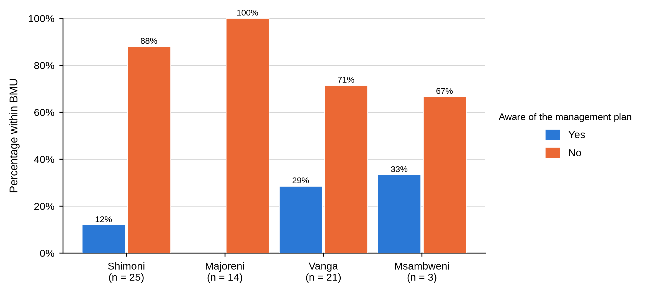
That contrast is the substantive finding of this subsection. Information about how the fishery is managed reaches the commercially connected nodes and misses the harvesting node, even though the co-management structures built to carry it are anchored at the landing site. Since every actor reported relying on networking, the route by which information travels is the same commercial relationship that sets the price. No fisher at Majoreni reported awareness of the plan.

4.5.4 Perceptions of Market Organisation and Policy
Figure 21 shows steady negativity about how the market is organised. Forty-five fishers (69.2%) disagreed that the market is well structured and 14 (21.5%) agreed; 13 middlemen (59.1%) disagreed and a further 6 (27.3%) strongly disagreed; all five hoteliers and all four exporters disagreed. No hotelier or exporter agreed. Neither fisher (p = .570) nor middleman (p = .826) responses varied by site.
Figure 21
Perception That the Mud Crab Market Is Well Structured, by Actor Category
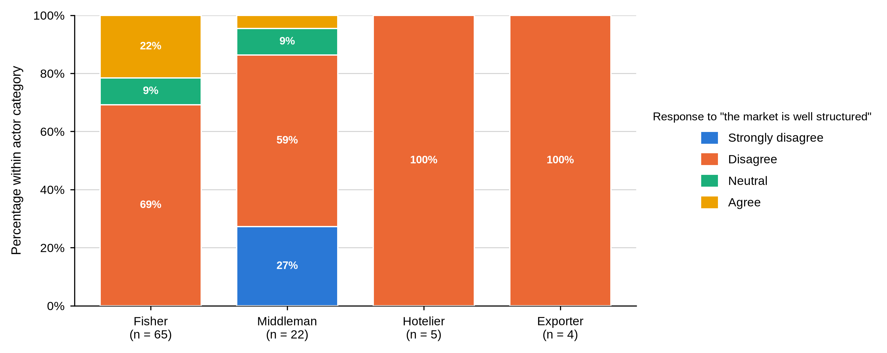
Table 51
Perception That Mud Crab Marketing Is Integrated With Other Fisheries by Actor and BMU
Characteristic / response | Actor | Overall | Shimoni | Majoreni | Vanga | Msambweni | Other sites | BMU p-value
Perception that mud crab marketing is integrated with other species
Strongly disagree | Fisher N = 65 | 0 (0.0%) | 0 (0.0%) | 0 (0.0%) | 0 (0.0%) | 0 (0.0%) | 0 (0.0%) | .541
Disagree | Fisher N = 65 | 52 (80.0%) | 22 (88.0%) | 10 (71.4%) | 16 (76.2%) | 3 (100.0%) | 1 (50.0%)
Neutral | Fisher N = 65 | 11 (16.9%) | 3 (12.0%) | 4 (28.6%) | 4 (19.0%) | 0 (0.0%) | 0 (0.0%)
Agree | Fisher N = 65 | 2 (3.1%) | 0 (0.0%) | 0 (0.0%) | 1 (4.8%) | 0 (0.0%) | 1 (50.0%)
Strongly disagree | Middleman N = 22 | 14 (63.6%) | 6 (54.5%) | 4 (57.1%) | 4 (100.0%) | - | - | .366
Disagree | Middleman N = 22 | 8 (36.4%) | 5 (45.5%) | 3 (42.9%) | 0 (0.0%) | - | -
Neutral | Middleman N = 22 | 0 (0.0%) | 0 (0.0%) | 0 (0.0%) | 0 (0.0%) | - | -
Agree | Middleman N = 22 | 0 (0.0%) | 0 (0.0%) | 0 (0.0%) | 0 (0.0%) | - | -
Strongly disagree | Hotelier N = 5 | 0 (0.0%) | 0 (0.0%) | - | - | - | 0 (0.0%)
Disagree | Hotelier N = 5 | 5 (100.0%) | 1 (100.0%) | - | - | - | 4 (100.0%)
Neutral | Hotelier N = 5 | 0 (0.0%) | 0 (0.0%) | - | - | - | 0 (0.0%)
Agree | Hotelier N = 5 | 0 (0.0%) | 0 (0.0%) | - | - | - | 0 (0.0%)
Strongly disagree | Exporter N = 4 | 0 (0.0%) | - | - | - | - | 0 (0.0%)
Disagree | Exporter N = 4 | 4 (100.0%) | - | - | - | - | 4 (100.0%)
Neutral | Exporter N = 4 | 0 (0.0%) | - | - | - | - | 0 (0.0%)
Agree | Exporter N = 4 | 0 (0.0%) | - | - | - | - | 0 (0.0%)
Judgements on integration were harsher still, as Table 51 shows. Fifty-two fishers (80.0%) disagreed and only 2 (3.1%) agreed; among middlemen, 14 (63.6%) strongly disagreed and the remaining 8 (36.4%) disagreed, so not one middleman was neutral or positive. All hoteliers and exporters disagreed. Neither group varied significantly by site. No hotelier or exporter agreed that the market is well structured.
Table 52
Awareness of a Policy Framework for Crab Markets by Actor and BMU
Characteristic / response | Actor | Overall | Shimoni | Majoreni | Vanga | Msambweni | Other sites | BMU p-value
Awareness of a policy framework for crab markets
Strongly disagree | Fisher N = 65 | 6 (9.2%) | 3 (12.0%) | 1 (7.1%) | 2 (9.5%) | 0 (0.0%) | 0 (0.0%) | .933
Disagree | Fisher N = 65 | 11 (16.9%) | 4 (16.0%) | 2 (14.3%) | 5 (23.8%) | 0 (0.0%) | 0 (0.0%)
Neutral | Fisher N = 65 | 48 (73.8%) | 18 (72.0%) | 11 (78.6%) | 14 (66.7%) | 3 (100.0%) | 2 (100.0%)
Strongly disagree | Middleman N = 22 | 14 (63.6%) | 5 (45.5%) | 5 (71.4%) | 4 (100.0%) | - | - | .427
Disagree | Middleman N = 22 | 7 (31.8%) | 5 (45.5%) | 2 (28.6%) | 0 (0.0%) | - | -
Neutral | Middleman N = 22 | 1 (4.5%) | 1 (9.1%) | 0 (0.0%) | 0 (0.0%) | - | -
Strongly disagree | Hotelier N = 5 | 0 (0.0%) | 0 (0.0%) | - | - | - | 0 (0.0%)
Disagree | Hotelier N = 5 | 0 (0.0%) | 0 (0.0%) | - | - | - | 0 (0.0%)
Neutral | Hotelier N = 5 | 5 (100.0%) | 1 (100.0%) | - | - | - | 4 (100.0%)
Strongly disagree | Exporter N = 4 | 0 (0.0%) | - | - | - | - | 0 (0.0%)
Disagree | Exporter N = 4 | 0 (0.0%) | - | - | - | - | 0 (0.0%)
Neutral | Exporter N = 4 | 4 (100.0%) | - | - | - | - | 4 (100.0%)
Table 52 shows a sharp difference in how the policy environment was read. Forty-eight fishers (73.8%) were neutral on whether a policy framework exists, with 11 (16.9%) disagreeing and 6 (9.2%) strongly disagreeing. Middlemen were far more emphatic: 14 (63.6%) strongly disagreed and 7 (31.8%) disagreed. All hoteliers and exporters were neutral. Neither fisher (p = .933) nor middleman (p = .427) responses varied by site.
The large neutral response among fishers should not be read as approval. Set beside the 15.4% management-plan awareness recorded in Table 50, it more plausibly reflects unfamiliarity with the policy environment than a settled judgement about it. The middlemen, who were aware of the management plan almost to a person, were also the group most willing to say the framework does not work — which suggests the negative judgements in this chain come from knowledge rather than from ignorance.

4.5.5 Opportunities, Youth Participation and Diversification
Nothing in this chapter expresses the structure of the chain more clearly than Figure 22. Market-access improvement was the priority for 56 fishers (86.2%) and for every hotelier and exporter, while price stability was the priority for 21 of 22 middlemen (95.5%). On what would improve the system, shown in Figure 23, every fisher named government support alone, while middlemen split between government support (12, 54.5%) and government support with industry collaboration (8, 36.4%); hoteliers and exporters named the combined option. Neither item varied significantly by site.
Figure 22
Priority Opportunity for Improving Mud Crab Marketing by Actor Category
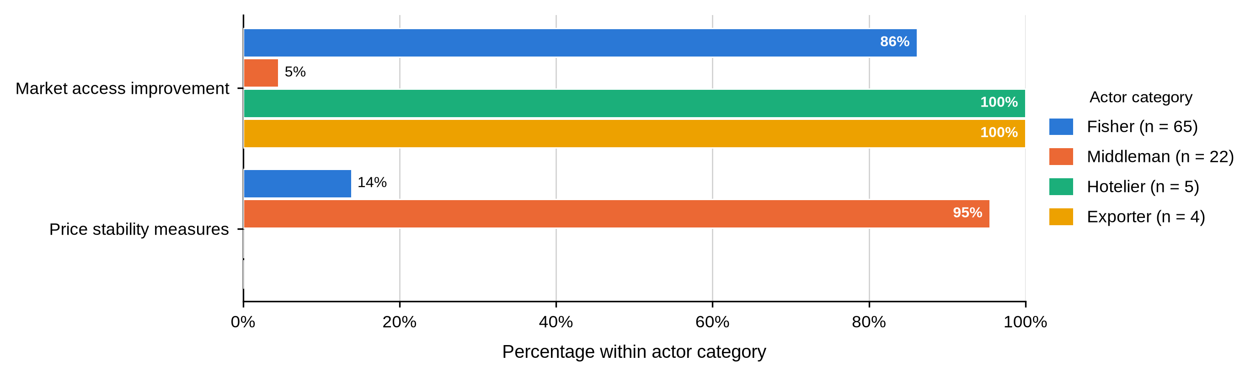
Figure 23
Recommended Market-System Enhancement by Actor Category
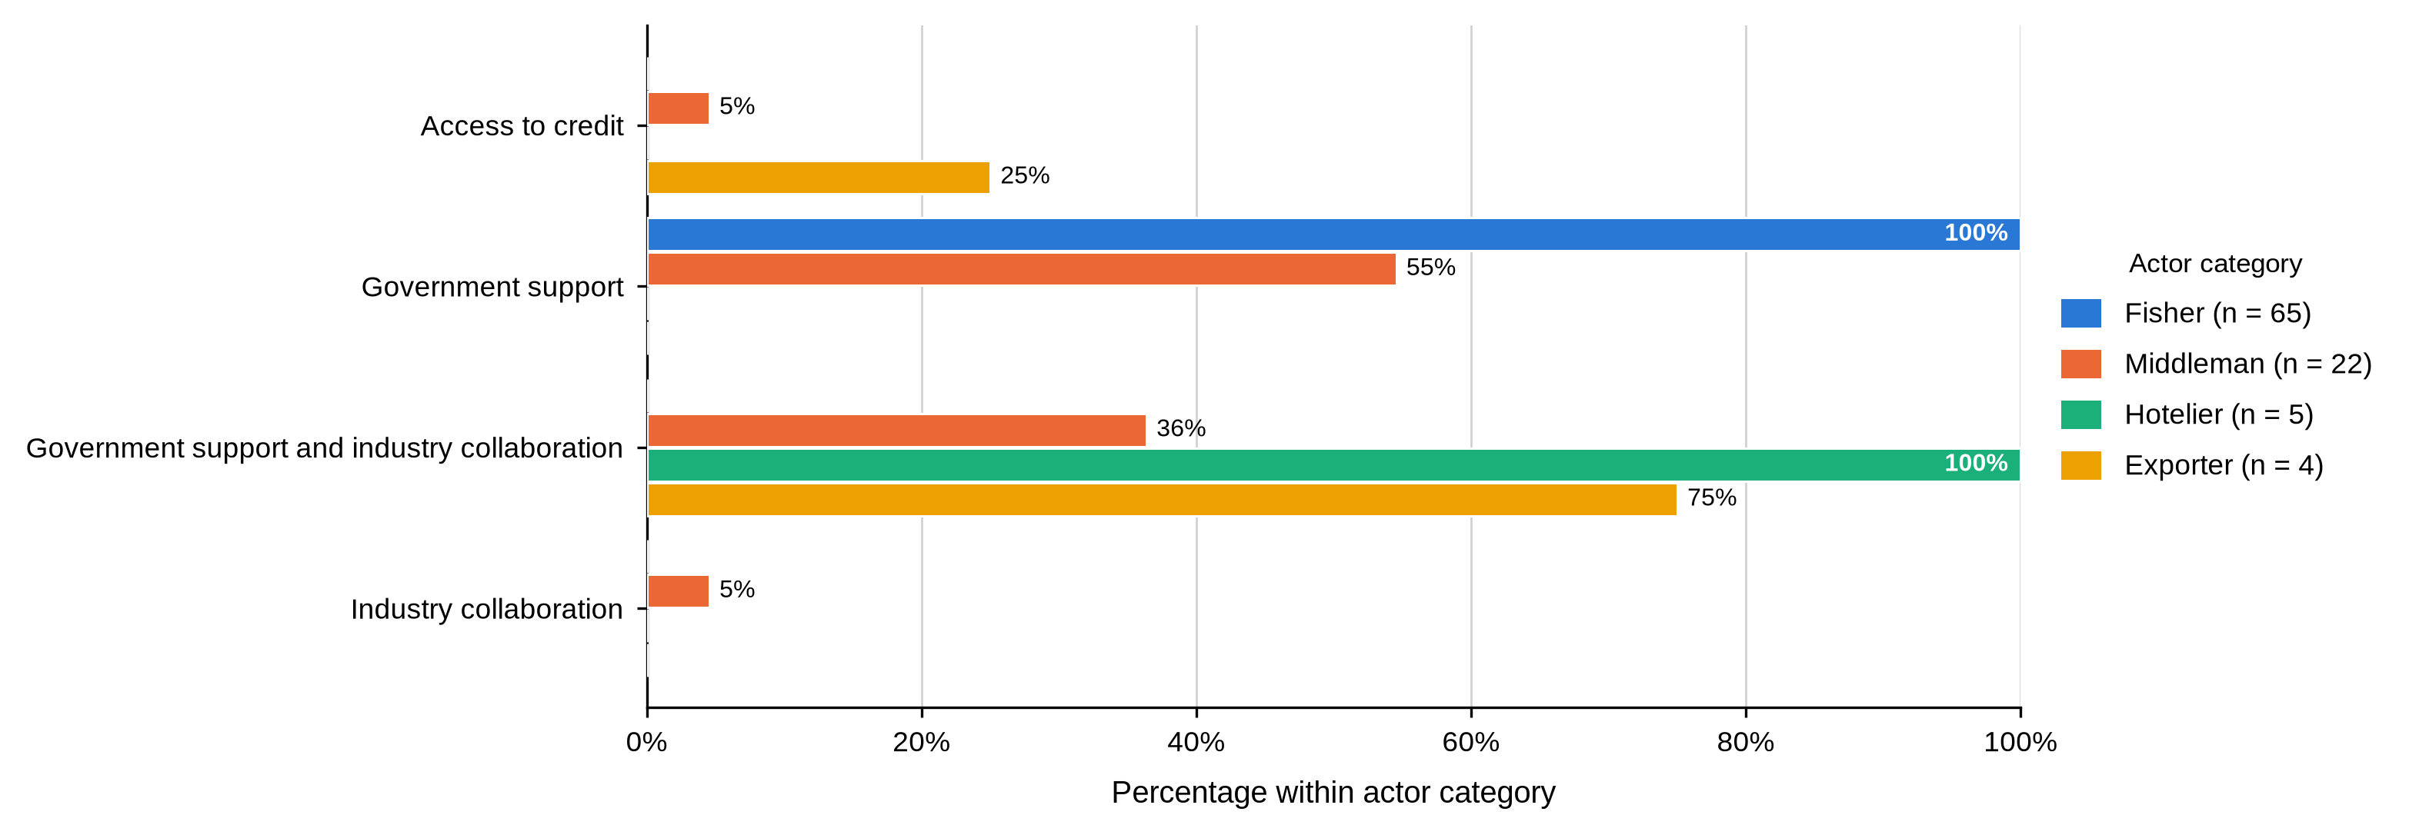
These are two views of one transaction. The fisher wants an alternative to the buyer standing in front of him; the middleman wants the price he pays and receives to hold still while he carries stock and credit risk. Splitting the difference will not reconcile them, because better market access for fishers means more competition for middlemen. Better price information and clearer grades reduce uncertainty for both without fixing an administered price. Fishers and middlemen named opposite priorities.
Figure 24 shows that youth involvement was rated low or very low by every respondent who expressed a view: 58 fishers (89.2%) and 16 middlemen (72.7%) said low, while 6 middlemen (27.3%), 3 hoteliers (60.0%) and 3 exporters (75.0%) said very low. Not one respondent in any category rated it high. Diversification potential, in Figure 25, divided the chain: 26 fishers (40.0%) said it had not been explored and 8 (12.3%) were negative, while 14 middlemen (63.6%) were positive. All hoteliers and exporters said it had not been explored. Neither item varied significantly by site.
Figure 24
Reported Involvement of Youth by Actor Category
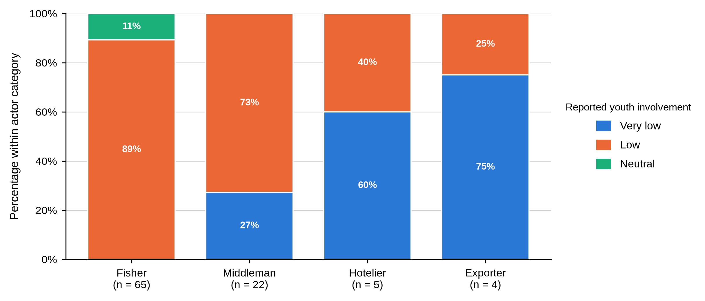
Figure 25
Perceived Potential for Product or Market Diversification by Actor Category
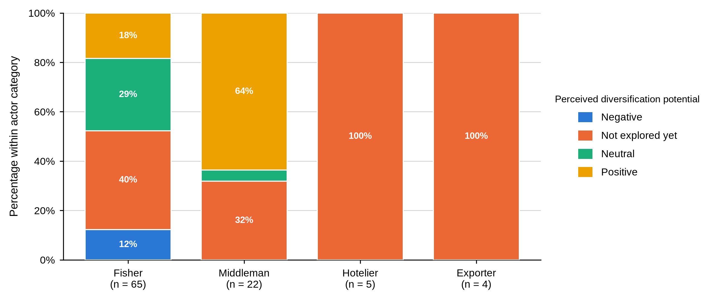
The youth result sits oddly against Table 3, where more than half the fishers were aged 18 to 35 and four were under 18. Respondents may have understood youth involvement as formal participation, commitment or ownership rather than mere presence in the fishery. The question should be defined directly in future work, and the presence of minors in harvesting raises safeguarding and schooling questions this study was not designed to answer but should not pass over. No respondent in any category rated youth involvement as high.

4.5.6 Summary of Objective Three
Objective Three asked what constrains each actor category and what opportunities they see. Constraints followed function exactly: price volatility and poor roads for fishers, mortality and missing aggregation facilities for middlemen, seasonality for hoteliers, freight cost and flight risk for exporters. Barriers to market access were close to universal, risk management was limited to diversification, and no actor had adopted new equipment, conducted market research or reported an innovation. Most respondents judged the market poorly structured and poorly integrated, and awareness of the crab fishery management plan reached traders and exporters while missing fishers and hoteliers almost entirely. Fishers put market access first and middlemen put price stability first, which is what their opposing positions in the same transaction would predict. Of all the Objective Three variables, only the middleman main constraint showed a significant association with BMU.

4.5.7 Discussion of Findings in Relation to Previous Studies
The finding that constraints differ systematically by actor category rather than by location agrees with the broader literature on small-scale fisheries, which treats the value chain as a sequence of distinct risk positions rather than a single system with one binding constraint (Jacinto, 2004; Crona et al., 2016). The present study extends that by testing each constraint against site: only the middleman main constraint varied significantly, with mortality dominating at Vanga and Majoreni and price at Shimoni. That the mortality-versus-price split follows the sites where middlemen hold stock longest is consistent with FAO (2025) on holding time as a determinant of loss.
The near-universal report of market-access barriers, and the complete absence of reported innovation or market research, align with national assessments that small-scale fisheries face constraints in finance, organisation and formal market participation (Fondo & Ogutu, 2021). This study locates those constraints unevenly across actor categories rather than treating them as a general condition, which is the more useful form for designing an intervention.
On governance, the contrast between 95.5% management-plan awareness among middlemen and 15.4% among fishers is the clearest institutional finding. Njiru et al. (2021) found that socioeconomic factors influence trader participation in Beach Management Units in Kwale County, which supports communication designed for specific actor groups rather than a single general announcement. The present result extends that work by showing that the information gap runs along the chain rather than across the map: it was not significantly associated with site.
The divergence between what fishers and middlemen want — market access against price stability — has not, to the knowledge of this study, been reported as an explicit opposition in the Kenyan mud crab literature. It follows directly from the structure documented under Objective Two, and it matters practically because it means the two upstream groups cannot both be satisfied by the same measure. Better price information and a shared grading standard reduce uncertainty for both without fixing a price, which is why those are the measures carried into Chapter Six.
Finally, the uniformly low rating of youth involvement diverges from the demographic evidence in this same chapter, where over half the fishers were aged 18 to 35. The likeliest explanation is that respondents interpreted the question as formal participation or ownership rather than presence. Ndanga et al. (2013) make a comparable point about women in Kenyan aquaculture value chains, whose participation is understated when the measure captures only formally recognised roles. Both cases argue for defining participation explicitly in future instruments.

4.6 Actor-Specific Associations With BMU
Sixty-eight categorical variables were tested against Beach Management Unit, separately for fishers and for middlemen. Nine associations reached the .05 level.
Table 53
Statistically Significant Actor-Specific Associations With BMU
Objective | Actor | Variable | χ² | df | N | p | 99% CI
Objective 1 | Fisher | Age group | 30.91 | 12 | 63 | .004 | [.002, .005]
Objective 1 | Fisher | Received formal mud crab training | 8.48 | 3 | 63 | .035 | [.030, .040]
Objective 1 | Fisher | Marital status | 20.06 | 9 | 63 | .049 | [.044, .055]
Objective 1 | Middleman | Scale of operation | 9.41 | 4 | 22 | .050 | [.044, .055]
Objective 2 | Fisher | First buyer location | 125.19 | 21 | 61 | < .001 | [.000, .000]
Objective 2 | Fisher | Reported large-crab size category | 16.87 | 3 | 63 | .001 | [.000, .002]
Objective 2 | Fisher | Reported small-crab size category | 15.96 | 3 | 63 | .002 | [.001, .004]
Objective 2 | Fisher | Travel time from fishing grounds to market | 11.13 | 3 | 63 | .010 | [.007, .012]
Objective 3 | Middleman | Main operational or marketing constraint | 6.42 | 2 | 22 | .036 | [.032, .041]
No association with BMU reached the .05 level for hoteliers or exporters; neither group was sampled across enough BMUs for the test to be run
Three points should be kept in mind when reading Table 53. The tests were run without a correction for multiple comparisons, so associations with probabilities close to .05 should be treated as exploratory rather than established; the Monte Carlo confidence interval is reported alongside each p-value so that borderline cases can be judged. The nine significant results cluster in three areas: who fishes where (age, marital status, training), how far and how they describe their catch (travel time, large- and small-crab size labels, first buyer location), and what middlemen worry about (main constraint). And the absence of hoteliers and exporters from the table is a limit of the sampling frame, not a finding: neither group was sampled across enough sites for a test to be run.

4.7 Chapter Summary
Across the three objectives the same pattern recurs. Differences between actor categories were large, consistent and present on nearly every measure, from education and licensing through grading criteria and quality control to price and the constraint each group names. Differences between Beach Management Units were far fewer: nine significant associations from sixty-eight tests, concentrated among fishers and confined to age, marital status, training, travel time, size labelling and first buyer location, plus the single middleman constraint result.
The one site difference with a direct economic consequence was in price. Fisher prices differed significantly across sites while middleman prices did not, so the gap a fisher faces at first sale is set locally: Majoreni fishers held 91.7% of the local middleman price for large crabs against close to 54% at Shimoni and Vanga. Read alongside the chain-share result, in which the fisher retained between 27.5% and 39.6% of the end price and the largest single share accrued at the node furthest from the water, the chapter describes a market whose value is realised where the grading rule, the logistics and the connection to the final buyer all sit together, and whose harvesters reach none of those things.

CHAPTER FIVE: DISCUSSION

5.1 Introduction
This chapter interprets the findings of Chapter Four against the literature reviewed in Chapter Two. It takes the three objectives in turn, and each section sets out the key findings, compares them with previous research, explains where they agree and where they differ, and draws out the theoretical and practical implications. Section 5.5 brings the three objectives together under the structure-conduct-performance framework, and Section 5.6 states the limitations that bound every claim made here.

5.2 Objective One: Profile of Mud Crab Actors

5.2.1 Key Findings
Four actor categories differed systematically and in the same direction on almost every measure. Fishers were younger, schooled to primary level or below, largely unlicensed, untrained, small-scale and un-diversified. Middlemen were older and far more experienced, with 72.7% carrying more than twenty years in the trade. Hoteliers and exporters held certificates, diplomas or degrees, were fully licensed, and operated at medium or large scale. Reported monthly income rose from KSh 8,969 among fishers to KSh 90,000 among exporters. No respondent in any category belonged to a cooperative, an association or a self-help group.

5.2.2 Gender and the Limits of the Sampling Frame
Ninety-five of the 96 respondents were men, and the single woman was a hotelier rather than a harvester. The pattern is consistent with what has been reported along the Kenyan coast, where harvesting and much of the first-tier trade are male-dominated while women appear more often in processing, retail and culture activities (Mirera, 2014a; Ochiewo et al., 2010).
Why men dominate harvesting in this fishery is not something these data can settle, but the literature suggests three mechanisms that fit the setting. Mud crab harvesting in Kenya is done on foot in mangrove creeks at low spring tides, often at night and at a distance from the village, which carries mobility and safety costs that fall unequally on women (Mirera et al., 2013; Moser et al., 2005). Landing-site registers and BMU membership, the routes through which a harvester becomes visible to officials and buyers, have historically enrolled men. And the credit relationship documented in Chapter Four, in which a buyer advances cash against future supply, tends to run through established trading ties that new entrants do not have.
The consequence for this study is methodological before it is substantive. Because the fisher sampling frame drew on landing-site registers, women working in processing, hospitality procurement, retail or crab fattening were unlikely to be reached. Ndanga et al. (2013) show that women in Kenyan aquaculture value chains concentrate precisely in the nodes that landing-site sampling does not cover, which is a plausible explanation for the pattern recorded here and a clear brief for future work. The finding should therefore be read as a description of the respondents reached, not as evidence that women are absent from the chain. Two practical openings follow: hospitality procurement and crab fattening are the nodes where women already appear in the regional literature, and both were named as opportunities by respondents in this study.

5.2.3 Experience, Licensing and the Absence of Collective Organisation
Experience accumulated at the trading node rather than the harvesting node. This fits the account in Mirera et al. (2013), where local knowledge and repeated relationships shape how crabs are found, handled and moved, and it helps explain why middlemen reported regular buyers, competitive price setting and standing trading agreements while fishers did not. Crona et al. (2016) describe middlemen in Kenya and Zanzibar as a critical social-ecological link precisely because that accumulated relational knowledge is not easily replaced, and the present findings are consistent with that reading. Cinner et al. (2012) found that age and accumulated experience shaped how artisanal fishers responded to livelihood pressure, which is consistent with the age gap recorded between the harvesting and trading nodes here. Licensing showed the same upstream weakness: only a small share of fishers and middlemen held a licence, against every hotelier and exporter. Pomeroy and Andrew (2011) argue that co-management works best where local rules are tied to a service users can see, which points to registration and licensing support delivered through the BMUs rather than to enforcement alone.
The complete absence of collective membership is a more serious finding than a single percentage suggests. Groups are the normal vehicle for price information, savings, training, traceability and dealings with government, and the literature ties organised groups and local leadership to better fishery outcomes (Gutiérrez et al., 2011; Mirera, 2014a). Without them, a fisher negotiates alone against a buyer with twenty years in the trade and knowledge of what crabs fetch further up the chain.
Forming groups is not itself the remedy. Gutiérrez et al. (2011) found that leadership and clear incentives, rather than the existence of a group, separate the successful cases from the rest. That nothing at all exists here, at any node, suggests earlier attempts offered members nothing they could see. Any group formed in response to this study would need a commercial purpose, transparent leadership and a service members can point to.

5.2.4 Credit and Dependence Within the Chain
No fisher used a formal loan, yet 93.8% named a middleman as their main source of credit, and close to two fishers in five were paid at least partly on credit by the buyer purchasing from them. Crona et al. (2016) describe such arrangements as enabling and constraining at once: the advance solves this week’s cash problem while narrowing where the fisher can sell. Béné et al. (2007) make a similar point about small-scale fisheries generally, treating informal credit as both safety net and mechanism of persistent low returns.
Which of the two dominates here cannot be judged from this study, because amounts, terms and duration went unrecorded. What can be said is that the person extending the credit is the same person setting the price the fisher calls fixed, and that no alternative source of working capital was reported at the harvesting node. That combination is what gives the relationship its force.

5.2.5 Implications
Theoretically, the profile results support treating actor category rather than location as the primary structural variable in this market. Differences between fishers, middlemen, hoteliers and exporters were large and consistent, while differences between landing sites were fewer and confined mostly to fishers. A market-structure account of this fishery is therefore an account of nodes, not of places.
Practically, the results identify three entry points that do not require new infrastructure: a licensing route that upstream actors can actually complete, a source of working capital that is not the buyer, and a collective body with a service attached. Each addresses a condition documented in Chapter Four rather than a general aspiration.

5.3 Objective Two: Functions at Each Market Node and the Distribution of Value

5.3.1 Key Findings
Functions divided cleanly by node and so did the information attached to them. Fishers harvested, tied claws, packed in sacks and walked to the landing site. Middlemen aggregated, cleaned, sorted and graded on a four-criterion rule and moved crabs by vehicle or boat. Hoteliers processed and froze. Exporters packed Styrofoam under inspection and certification. Prices rose at every node, differed significantly between actor categories, and among fishers differed by site as well. Multi-stage chains of this kind, in which harvesters are separated from export buyers by one or more aggregation and trading nodes, have been described for Bangladesh, the Philippines and coastal Tanzania (ACDI/VOCA, 2005; Mahmud & Mamun, 2013; Sultana et al., 2018).

5.3.2 Grading as a Mechanism of Value Capture
Every actor said they graded. They did not grade by the same rule. All 65 fishers used weight alone, while 95.5% of middlemen and every hotelier and exporter combined size, weight, shell condition and claw size. Jacinto (2004) identifies exactly this kind of informational asymmetry as a determinant of how value is distributed in small-scale fisheries value chains, and the present data supply a clean instance of it.
The site variation in grading language reinforces the point. At Shimoni, 44.0% of fishers described their large category as mixed and 36.0% did the same for the small category, while fishers at the other three sites used the plain labels, χ²(3, N = 63) = 16.87, p = .001 and χ²(3, N = 63) = 15.96, p = .002. The survey recorded the label, not a measured carapace width, so this is vocabulary rather than biology. It carries a practical cost all the same: a Shimoni fisher and his buyer may not mean the same thing by the word large, and that is the condition under which a grading dispute goes the better-informed party’s way.

5.3.3 Handling, Packaging and Loss
Packaging became more protective downstream, from sacks to crates to Styrofoam, and reported mortality rose with the volume each actor held. Survival and product quality in the live mud crab trade turn on handling, containment and transport conditions (FAO, 2025). The absence of formal quality control among fishers and middlemen does not mean no care was taken; fishers tied claws and middlemen cleaned and sorted. The weakness is that neither procedures nor losses were documented against a shared standard, so the cost of mortality cannot be priced into a grade or recovered through it.

5.3.4 Price Formation and the Distribution of Value
Reported prices rose at every node and the actor comparisons were unambiguous, H(3) = 55.84, p < .001 for large crabs and H(3) = 38.00, p < .001 for medium crabs. Rising prices are expected where later actors carry aggregation, mortality, transport, packaging and buyer-access costs. The caveat matters and is stated plainly: these are gross prices. Munga and Muthumbi (2018) draw the same distinction for the Tana Delta mud crab fishery, where gross price differentials narrowed considerably once handling and transport were netted out, so nothing in this section should be read as a statement about profit. Expressed as marketing margins, the chain took between 60.4% and 72.5% of the final price before it reached the harvester, and the concentration figures in Table 41 describe the structure within which that split is settled: an HHI of 2,371 across the four BMUs, and 76.9% of harvesters dealing with a single buyer.
Within that limit, expressing each node’s price as a share of the end-of-chain price answers the question of how value is distributed. A large crab reaching an exporter left 35.6% of its final price with the fisher, 20.0% at the middleman step and 44.4% at the exporter step. The same crab reaching a hotel kitchen left the fisher 27.5% and the hotel 57.0%. Medium crabs bound for export were the fisher’s best case at 39.6%. The producer’s share of the final price is a standard measure of marketing performance, and values in this range sit at the low end of what has been reported for perishable, high-value seafood. Jacinto (2004) argues that in small-scale fisheries the share captured at each node tracks control of information and market access more closely than it tracks physical effort, and the ordering here matches that: the actor doing the fishing takes the smallest share, and the largest single share accrues at the step furthest from the water.
The middleman result deserves emphasis because it cuts against the usual account. Middlemen took the smallest of the three shares in every chain, between 15.5% and 20.0%, yet they are the actor fishers most often identify with the low beach price. Crona et al. (2016) reach a similar conclusion for Kenya and Zanzibar, finding that middlemen are widely blamed for outcomes largely determined further along the chain while themselves operating on modest turnovers and carrying the mortality risk. The present data support that reading rather than the popular one, and Chapter Four documents the risk directly: 95.5% of middlemen reported daily mortality of 4 to 5 kg against 0.5 to 1 kg among fishers.

5.3.5 Site Differences and What Drives Them
The actor comparison and the site comparison answer different questions, and keeping them apart was necessary. Compare sites without holding the actor constant and a site with more middlemen looks like a high-price site purely because of its respondent mix. With the role held constant, fisher prices differed significantly across sites for large crabs, H(3) = 20.32, p < .001, and medium crabs, H(3) = 20.07, p < .001, while middleman prices did not, H(2) = 5.33, p = .070 and H(2) = 3.78, p = .151.
That asymmetry produced the study’s sharpest single contrast. At Majoreni the fisher price stood at 91.7% of the local middleman price for large crabs and 91.3% for medium crabs, spreads of KSh 71.4 and KSh 57.1 per kilogram. At Shimoni and Vanga the same figures were 55.0% and 53.6% for large crabs, spreads of KSh 441.8 and KSh 464.3. Because fisher prices varied across sites and middleman prices did not, the narrow Majoreni gap is built on the fisher side: Majoreni traders sold at KSh 857.1, within KSh 143 of the other two sites, while Majoreni fishers were paid KSh 785.7 against roughly KSh 537 elsewhere.
Two readings fit. Majoreni fishers may face a less concentrated set of first buyers, so competition at the beach lifts the first-hand price; or the seven middlemen sampled there may be first-tier buyers reselling locally rather than consolidators shipping to Mombasa, in which case their price is a shorter step from the water and the comparison is not quite like for like. This study cannot separate the two, since buyer concentration and onward destination were not measured at transaction level. Green and Clark (2021) treat dispersion at the first point of sale as one of the more reliable indicators of weak market integration, and on that criterion Shimoni and Vanga look the weaker markets of the three. The practical implication is unchanged by which reading is correct: the terms a fisher gets are settled at their own landing site.

5.3.6 The Hotelier Medium-Grade Anomaly
The hotelier medium-grade mean of KSh 380.0 per kilogram does not fit the pattern. It is below the fisher price for the same grade and far below the same respondents’ large-crab mean of KSh 2,200.0. Two explanations are plausible. The entries may refer to a different product form, unit or transaction, such as a processed portion rather than live weight, in which case the value is correct but not comparable with the others. Alternatively it may be a field-entry error. The values were retained to preserve fidelity to the source data and excluded from the chain calculation, but they should be confirmed against the questionnaires before being used to support any argument about value addition at the hospitality node.

5.3.7 Implications
Theoretically, these results locate the mechanism of value capture in control of the grading rule and of the connection to the final buyer, rather than in harvesting effort or in the middleman’s margin. That is the specific contribution this study makes to the value-chain literature on Kenyan mud crabs, which has so far documented actors and functions more thoroughly than the distribution of returns among them.
Practically, two interventions follow directly from the numbers and neither requires capital investment: a written grading standard that both parties to a first sale can read, and an independent record of what grades are fetching. Both attack the informational asymmetry the data identify rather than the price level, which no intervention in this study’s reach can set.

5.4 Objective Three: Constraints and Opportunities

5.4.1 Key Findings
No constraint was shared across the chain. Fishers named price fluctuation and poor roads, middlemen mortality and the lack of aggregation facilities, hoteliers seasonality, exporters freight cost and flight delays. Barriers to market access were reported by 95.8% of respondents. No actor had adopted new equipment or conducted market research. Most respondents judged the market poorly structured, and management-plan awareness reached 95.5% of middlemen and every exporter but only 15.4% of fishers and no hotelier.

5.4.2 Constraints Follow Function
Each constraint follows from the work the actor does. The fisher sells the same day at a price he does not set, so volatility reaches him first. The middleman holds stock, so he loses crabs; mortality was named by half of them and all four Vanga middlemen. The hotelier lives on tourist arrivals and feels the season. The exporter lives on cargo space and feels the freight. One chain-wide intervention will not reach all four, which is why the recommendations in Chapter Six are written by actor category.
The infrastructure answers point the same way. Poor roads dominated the fisher responses at 98.5% while 90.9% of middlemen named the lack of aggregation facilities. Better access routes would improve movement from landing areas but would not reduce holding losses; aggregation facilities would improve shade, loading and live-crab management but would not widen fisher buyer choice unless linked to transport and price information. Infrastructure planning therefore has to connect landing-site access with holding and distribution needs, not choose between them.

5.4.3 Governance and the Direction Information Travels
Negative views of market organisation sit comfortably with everything else recorded here: no collective membership, low upstream licensing, informal grading, no market research and fixed prices reported by every fisher. Awareness of the crab fishery management plan followed commercial position rather than geography. Information moves along commercial relationships instead of through the co-management structures built to carry it.
Beach Management Units remain the most practical institutions for narrowing that gap. Njiru et al. (2021) found that socioeconomic factors influence trader participation in BMUs in Kwale County, which supports communication designed for specific actor groups rather than a single general announcement. The large neutral response among fishers on the existence of a policy framework should not be read as approval; set beside 15.4% management-plan awareness, it more likely reflects unfamiliarity.

5.4.4 Opposing Priorities Within One Transaction
Fishers chose market-access improvement, 86.2% of them, while middlemen chose price stability, 95.5%. These are two views of one exchange. The fisher wants an alternative to the buyer standing in front of him; the middleman wants the price he pays and receives to hold still while he carries stock and credit risk. Splitting the difference will not reconcile them, because better market access for fishers means more competition for middlemen. Better price information and clearer grades reduce uncertainty for both without fixing an administered price.
Reported youth involvement was low or very low throughout, even though more than half the fishers were aged 18 to 35 and four were under 18. Respondents may have understood youth involvement as formal participation, commitment or ownership rather than presence in the fishery. Future questionnaires should define the concept directly, and the presence of minors in harvesting raises safeguarding and schooling questions this study was not designed to answer but should not pass over.

5.4.5 Implications
Theoretically, the constraint results show that performance in this chain is bounded at different points for different actors, which is an argument against treating the value chain as a single system with one binding constraint. Practically, they mean that an intervention budget spent uniformly across nodes will be largely wasted, and that the sequence in which interventions are attempted matters as much as their content.

5.5 Synthesis Using the Structure-Conduct-Performance Framework
Set against the structure-conduct-performance framework that guided this study, the three objectives describe a single system. The structure is concentrated at the point of first sale, and Table 41 puts a number on it: an HHI of 2,371 across the four BMUs and 8,580 at the tightest of them, with 76.9% of harvesters selling to a single buyer and 2.95 harvesters for every trader sampled. Many small, unorganised sellers face a smaller number of better-capitalised buyers; entry downstream requires licences, capital and buyer contacts that upstream actors do not have; and no collective body exists at any node to pool bargaining power.
Conduct follows from that structure. Buyers set prices and every fisher in the sample accepted them as fixed. Grading runs on a rule only the buyer fully controls. Credit advances tie sellers to particular buyers. Nobody conducts market research, so information travels through the same commercial relationships that set the prices in the first place.
Performance is what that structure and conduct would predict. Reported monthly income ran from KSh 8,969 among fishers to KSh 90,000 among exporters. The fisher’s share of the end-of-chain price ran between 27.5% and 39.6%, and the largest single share in every chain accrued at the node furthest from the water. The total marketing margin ran from 60.4% to 72.5% of the final price, and price dispersion was wide at the harvesting node and narrow after aggregation, a coefficient of variation of 31.8% against 6.8% for the large grade, which Green and Clark (2021) treat as a signature of weak integration at the first point of sale. Losses were reported everywhere and measured nowhere against a common standard. Value addition happened almost entirely downstream, and the actors doing it were the same ones defining the grades and setting the prices.
This has a practical edge. Interventions aimed only at production, better gear or bigger catches, are unlikely to shift how value is distributed here, because the binding constraint is not how many crabs come ashore but the terms on which they change hands. Three things decide those terms: the grading rule, whether a fisher has any independent price information, and the credit relationship. All three operate in the moment a fisher hands his catch to a first-level middleman.

5.6 What the Structure Measures Do and Do Not Capture
Three dimensions of market structure that the literature treats as standard cannot be computed here the way a transaction survey would compute them. Each has a counterpart these data do support, reported in Chapter Four, and setting out what each one is and is not measuring matters more than either claiming the full measure or leaving the gap unexplained.
Concentration is measured, but over harvesters rather than volume. A textbook concentration ratio needs a census of buyers and the quantity each handles, and the survey recorded neither. It did record where every fisher took his catch, so Table 41 reports concentration over buying points weighted by the share of harvesters attached to each. The result is unambiguous: an HHI of 2,371 across the four BMUs and 8,580 at Majoreni, where the numbers-equivalent of 1.17 outlets means the harvesters there face what is in practice a single buying point. Every BMU exceeds the 2,500 mark conventionally treated as high concentration. What these figures cannot say is how much crab passes through each point, so a buyer many fishers name but that takes little from each is overweighted. A volume-weighted index remains out of reach.
Margins are measured gross, and net of one cost. Table 43 reports the gross marketing margin at each node, the total marketing margin, which ran from 60.4% to 72.5% of the final price depending on the chain, and the producer’s share, which ran from 27.5% to 39.6%. The survey priced no transport, holding, ice, packaging or cost of capital, so none of these is a profit. It did measure physical mortality, and carrying that through cuts the producer’s share by roughly a tenth, to between 24.6% and 35.5%. A net margin in the accounting sense would still require the cost side of every transaction, which this instrument did not collect.
Efficiency is approached through dispersion rather than cost. A full efficiency measure weighs the value added at a node against the cost of the services performed there, and again the cost side is missing. Two indicators that do not need it are reported in Table 44. Price dispersion falls steadily down the chain, from a coefficient of variation of 31.8% among fishers to 14.9% among middlemen and 6.8% among exporters for the large grade, which says that price uncertainty is carried almost entirely at the harvesting node. Price transmission, the share of the local middleman price reaching the fisher, ran from 53.6% at Vanga to 91.7% at Majoreni. Both bear directly on how well the market moves information and value, without pretending to be a cost-based efficiency ratio.
What remains genuinely unmeasured is narrower than it first appears: the volume behind each transaction, and the costs each actor carries. Both follow from an instrument designed as an actor inventory rather than a transaction survey, which is the right design for Objectives One and Three and a limiting one for the value-distribution part of Objective Two. Section 6.5 sets out the data collection that would close them.

5.7 Study Limitations
The sample was not fully probabilistic. Reliable lists were unavailable for middlemen, hoteliers and exporters, so referral and convenience procedures were used downstream, and the findings describe the respondents reached rather than population estimates for all Kwale County mud crab actors. The achieved fisher sample of 65 fell short of the calculated target of 83, a coverage rate of 78.3%, and the 18 fishers not reached may differ from those interviewed.
Snowball sampling may over-represent actors with stronger trading connections and under-represent isolated or informal operators, so the middleman and exporter findings in particular should be read with that in mind. Only five hoteliers and four exporters were sampled, no middleman was sampled at Msambweni, and only three fishers were interviewed there, which limits site-level precision.
The design was cross-sectional and covered a single survey period, so seasonal variation in price, catch and mortality is not captured and no causal direction can be established. Prices, income and losses were self-reported and were not verified against transaction records. Sixty-eight categorical tests were run without a correction for multiple comparisons, so associations with probabilities close to .05 should be treated as exploratory. Finally, the survey did not collect the transaction-level cost, volume and mortality data needed to convert gross price differences into net margins, which is why this study describes how value is distributed but not how profit is distributed.

CHAPTER SIX: CONCLUSIONS AND RECOMMENDATIONS

6.1 Introduction
This chapter draws conclusions from the three objectives and sets out recommendations. Each recommendation names the problem identified in Chapter Four, the evidence behind it, the body best placed to act and the outcome that would show it had worked. Recommendations that the data cannot support are not made.

6.2 Conclusions

6.2.1 Conclusion for Objective One
The four actor categories differ systematically and in the same direction on almost every characteristic measured. Fishers are younger, schooled to primary level or below, small-scale, minimally licensed, untrained and un-diversified, and they borrow from the same middlemen who buy from them. Middlemen are older, far more experienced and better capitalised. Hoteliers and exporters are formally qualified, fully licensed and operating at a scale upstream actors do not reach. No respondent in any category belonged to a cooperative, an association or a self-help group. Study site mattered for the age of the fishing population, for marital status and for training, but the larger and more consistent differences were between actor categories.

6.2.2 Conclusion for Objective Two
The chain runs as a clear functional sequence from harvesting through aggregation to processing and export, and the information used to assign value is concentrated downstream. Fishers graded on weight alone while every other category used a four-criterion rule; formal quality control and contact with the final buyer sat entirely downstream. Reported prices rose significantly at each node. Expressed as shares of the price the crab eventually fetched, the fisher retained between 27.5% and 39.6%, the middleman added between 15.5% and 20.0%, and between 44.4% and 57.0% was added at the final buyer. The size of the first-sale gap was set locally: Majoreni fishers held 91.7% of the middleman price for large crabs where Shimoni and Vanga fishers held close to 54%, and that difference came from variation in what fishers were paid rather than from what traders charged. What determines the price of a crab in this fishery is position in the chain, control of the grading rule and access to alternative buyers, not harvesting effort.

6.2.3 Conclusion for Objective Three
Constraints arise at different points in the chain and follow the work each actor does: unstable prices and poor roads for fishers, mortality and inadequate aggregation facilities for middlemen, seasonality for hoteliers, freight cost and flight risk for exporters. Barriers to market access were close to universal, no actor had adopted new equipment or conducted market research, and most respondents regarded the market as poorly structured. Management-plan awareness reached traders and exporters while missing fishers and hoteliers. Improvement therefore requires coordinated but actor-specific measures rather than one intervention applied uniformly across all nodes.

6.3 Overall Conclusion
The South Coast mud crab market is commercially active and institutionally uneven. Fishers supply the product with almost no institutional support behind them, while middlemen and downstream actors hold the grading, the logistics and the connection to high-value buyers. Study site matters for the age of the fishing population, for the words used to describe grades, for the price fishers receive and for the constraint middlemen name, but the larger and steadier divide runs between market nodes rather than between places. Improvement should start where the terms of exchange are set: a shared grading standard, a price record that is reliable and public, better live-crab handling, infrastructure aimed at both ends of the chain, licensing people can actually obtain, and communication that reaches harvesters as dependably as it now reaches traders.

6.4 Recommendations
Each recommendation below states the problem, the evidence from Chapter Four, the actor responsible and the outcome that would demonstrate success.

6.4.1 Recommendations From Objective One
- Problem: upstream actors are largely outside the formal system. Evidence: 12.5% of fishers and 27.3% of middlemen held an operating licence, against every hotelier and exporter. Action: the county fisheries department and BMU committees should run registration and licensing clinics at Shimoni, Majoreni, Vanga and Msambweni, explaining fees, documents, benefits and renewal in plain language and helping applicants complete the forms on the day. Expected outcome: licensed fisher and middleman numbers rise measurably at the four sites within two licensing cycles.
- Problem: fishers depend on their buyers for working capital. Evidence: no fisher used a formal loan, yet 93.8% named a middleman as their main source of credit, and 38.5% were paid at least partly on credit by the buyer purchasing from them. Action: financial institutions, development partners and buyers should separate formal working-capital lending from buyer advances, and any advance should carry written terms stating amount, repayment method, duration, any deduction and whether exclusive supply is a condition. Expected outcome: fishers can state the terms of their own credit, and the share reporting a middleman as their only source of capital falls.
- Problem: no collective body exists at any node. Evidence: 0 of 96 respondents belonged to a cooperative, an association or a self-help group. Action: BMUs and the county should support voluntary groups that start from one concrete service, such as a shared price register, a savings facility or bulk purchase of containers, with accountable leadership and records open to members. Expected outcome: at least one functioning group per BMU that members can name a benefit from after twelve months.
- Problem: training does not reach harvesters. Evidence: 7.7% of fishers had received formal mud crab training, and training differed significantly across sites, χ²(3, N = 63) = 8.48, p = .035. Action: extension officers should deliver practical BMU-level training in grading, live-crab handling, record keeping, simple cost calculation and buyer negotiation, pitched to the younger fisher profile at Shimoni and the older profile at Majoreni. Expected outcome: measurable improvement in grading accuracy and reported handling practice at the trained sites.
- Problem: women and young people are invisible in the evidence base. Evidence: 95 of 96 respondents were men and the sampling frame drew on landing-site registers. Action: future actor mapping by the county and by researchers should deliberately include processing, hospitality procurement, retail and crab fattening, and safeguarding procedures are required wherever respondents younger than 18 participate in harvesting. Expected outcome: a Kwale actor register that records the nodes where women work, and a stated safeguarding policy covering minors in the fishery.

6.4.2 Recommendations From Objective Two
- Problem: fishers cannot verify the grade they are offered. Evidence: all 65 fishers graded on weight alone while 95.5% of middlemen and every hotelier and exporter used size, weight, shell condition and claw size. Action: BMUs, fisheries officers and buyers should agree one grading sheet for Grades A, B and C giving weight ranges and visible quality criteria, displayed at the point of sale with the price offered for each grade, and taught with sample crabs. Expected outcome: fishers and buyers describe the same crab with the same grade, and the share of fishers recording mixed grades falls from the current 23.1% for large crabs.
- Problem: grading vocabulary is not shared across sites. Evidence: large-crab and small-crab size labels differed significantly across sites among fishers, χ²(3, N = 63) = 16.87, p = .001 and χ²(3, N = 63) = 15.96, p = .002, with 44.0% of Shimoni fishers using mixed labels. Action: the same grading terms should be adopted across all four BMUs rather than left to local usage. Expected outcome: site differences in label use narrow at the next survey round.
- Problem: fishers have no independent price reference. Evidence: every fisher described the price as fixed by the buyer, no actor conducted market research, and fisher large-crab prices ranged from KSh 535.7 at Vanga to KSh 785.7 at Majoreni, a spread of 47%. Action: each BMU should keep a weekly price register by grade, buyer and site, publishing the median and the observed range rather than a guaranteed price. Expected outcome: dispersion in first-sale prices across sites narrows, and fishers can quote a reference price when negotiating.
- Problem: value is realised where the harvester cannot reach. Evidence: the fisher retained 27.5% to 39.6% of the end-of-chain price while 44.4% to 57.0% was added at the final buyer. Action: BMUs and the county should test one direct-supply arrangement between an organised fisher group and a hotel or exporter, with agreed grades, volumes and payment terms. Expected outcome: participating fishers receive a measurably higher share of the end price than the site baseline recorded here.
- Problem: live-crab losses are carried but not measured. Evidence: fishers reported 0.5 to 1 kg of daily mortality, 95.5% of middlemen reported 4 to 5 kg, and no actor kept records against a common standard. Action: BMUs should pilot aggregation and live-holding facilities with shade, ventilation, secure reusable containers, safe loading space and a simple mortality log, and should test reusable ventilated containers against sacks under normal trading conditions. Expected outcome: recorded mortality per consignment falls and the container trial produces a cost per kilogram saved.
- Problem: five hotelier medium-grade price records are inconsistent with every other node. Evidence: a hotelier mean of KSh 380.0 per kilogram sits below the fisher price for the same grade and far below the same respondents’ large-crab mean of KSh 2,200.0. Action: the candidate should check these five records against the original questionnaires and field notes to confirm unit, product form and transaction context. Expected outcome: the records are either corrected or confirmed, and the basis of the hospitality price is documented before any value-addition estimate uses it.

6.4.3 Recommendations From Objective Three
- Problem: infrastructure constraints differ by node. Evidence: 98.5% of fishers named poor roads while 90.9% of middlemen named the lack of aggregation facilities. Action: the county should prepare one actor-specific infrastructure plan covering access routes and landing facilities for fishers, aggregation and holding facilities for middlemen, demand coordination for hotels and freight-risk planning for exporters. Expected outcome: a costed plan in which each investment names the actor category it serves and the constraint it removes.
- Problem: management information reaches traders and misses harvesters. Evidence: 95.5% of middlemen and every exporter knew of a crab fishery management plan, against 15.4% of fishers and no hotelier. Action: BMUs and fisheries officers should target management-plan communication at fishers and hoteliers first, record who received it and check understanding rather than counting attendance. Expected outcome: fisher awareness rises substantially above the current 15.4% at the next survey round.
- Problem: price instability is the dominant complaint but an administered price is not supportable. Evidence: price fluctuation was the main constraint for 90.8% of fishers and half the middlemen, while 95.5% of middlemen named price stability as their priority. Action: county and national agencies should address stability through reliable information, consistent grading, predictable payment terms and buyer competition rather than a guaranteed price, which these data do not support and which no institution in the chain could currently enforce. Expected outcome: reported price uncertainty falls without an administered price being introduced.
- Problem: diversification is named as an opportunity but is untested. Evidence: diversification was the only risk-management method reported by fishers, middlemen and hoteliers, yet no respondent had adopted an innovative response and most fishers rated diversification potential negative or unexplored. Action: development partners and the county should run small, costed diversification pilots such as crab fattening, each linked to a confirmed buyer, with participation terms and cost-sharing agreed before investment. Expected outcome: each pilot reports survival, feed and labour costs and a realised price, so the next round can be judged on evidence.
- Problem: youth participation is rated low across the chain while minors work in harvesting. Evidence: every respondent expressing a view rated youth involvement low or very low, yet 53.8% of fishers were aged 18 to 35 and four were under 18. Action: county youth and fisheries programmes should combine technical training with supervised market access, savings or credit and mentorship, define youth participation explicitly in any monitoring tool, and include safeguards for minors. Expected outcome: a defined youth participation measure is reported at the next survey and safeguarding cases are handled under a stated procedure.

6.5 Recommendations for Further Research
- Collect transaction-level price, quantity, grade, cost and mortality data across high and low seasons so that net marketing margins can be estimated rather than the gross price spreads reported here. This is the single most important gap in the present study.
- Repeat the survey with probability sampling wherever reliable actor lists can be built, ensuring that each target BMU contributes both fisher and middleman observations so that site comparisons rest on comparable samples.
- Oversample hoteliers, exporters, women and young people so that downstream functions and under-represented participants can be analysed with the precision the present sample does not allow.
- Measure buyer concentration and onward destination at transaction level, which would separate the two explanations offered here for the narrow first-sale gap recorded at Majoreni.
- Use qualitative interviews to clarify buyer advances, loan terms, tied-supply relationships, grading disputes and the reasons actors regard the market as poorly structured.
- Evaluate the price-register, grading-sheet and container pilots recommended in Section 6.4 with before-and-after measures of price dispersion, mortality and fisher bargaining outcomes, treating them as interventions to be tested rather than improvements to be assumed.

