MARKET STRUCTURE FOR MUD CRABS (Scylla serrata) IN SOUTH
COAST, KENYA

SG25/36064/19

A thesis submitted in partial fulfilment of the requirements for the award of the Master of Science in Fisheries in the Department of Biological Sciences of Pwani University.

August 2026

DECLARATION
I declare that this thesis is my original work and has not been presented for a degree in any other university or for another award.
SIGN___________________________________ DATE_____________
SG25/PU/36064/19

We confirm that the candidate did the work reported in this thesis under our supervision.

SIGN__________________________ DATE___________ _________ Prof. Andrew Wamukota

SIGN__________________________ DATE___________ _________
Dr. David O. Mirera

DEDICATION
I dedicate this work to my God who strengthens me in everything.

ACKNOWLEDGEMENT
I would like to acknowledge the contribution and support of the following people in the preparation of my thesis. Prof. Andrew Wamukota, for his supervisory role and advice. His patience was my support. Dr. Mirera from KMFRI-Mombasa is acknowledged for his intellectual advice and encouragement. I would also like to acknowledge Mr. Benrick Ogutu from the Kenya Fisheries Service (KeFS) for the immense support during the process of data collection and the officials of BMUs (Vanga, Shimoni and Majoreni) for enabling me to carry out data collection in the region. I would also like to thank my beloved husband Dr. Dan Elisha Mugubi, my son Leslie Johnson, and my parents Mr. Joseph Sangura and Ms. Christine Lusaka for being there socially and financially. Much thanks to Pwani University especially the department of Biological Sciences for giving me the opportunity to pursue my masters degree and for the support throughout my study period. Above all, may God bless and give grace to everyone who had a helping hand in my studies.

ABSTRACT
Mud crab (Scylla serrata) fishing supports coastal livelihoods on the South Coast of Kenya, yet how the market is organised, and how the value of a crab is shared between the people who catch, trade and sell it, has not been documented in detail. This study profiled mud crab actors in Kwale County, examined the functions they perform at each market node, and assessed the constraints and opportunities each actor category reported. A cross-sectional survey of 96 respondents — 65 fishers, 22 middlemen, five hoteliers and four exporters — was carried out between May 2022 and December 2023 using structured questionnaires, field observations and key-informant interviews. Analysis in IBM SPSS Statistics used valid percentages within actor category, descriptive statistics for income and prices, Monte Carlo chi-square tests based on 10,000 resamples for associations with study site among fishers and middlemen, and Kruskal–Wallis tests for reported prices, at the 5% significance level.
The four actor categories differed systematically. Ninety-five of the 96 respondents were men. No fisher or middleman had schooling beyond secondary level while every hotelier and exporter held a certificate, diploma or degree, and no respondent in any category belonged to a cooperative, an association or a self-help group. Operating licences were held by 12.5% of fishers against every hotelier and exporter, 93.8% of fishers named a middleman as their main source of credit, and mean monthly mud crab income rose from KSh 8,969 among fishers to KSh 90,000 among exporters. Fisher age group was the clearest site difference, χ²(12, N = 63) = 30.91, p = .004.
Functions divided cleanly by node and so did the information attached to them. All 65 fishers graded on weight alone while 95.5% of middlemen and every hotelier and exporter used size, weight, shell condition and claw size; formal quality control and contact with the final buyer sat entirely downstream. Mean large-crab prices were KSh 604.6/kg for fishers, KSh 945.5/kg for middlemen, KSh 1,700.0/kg for exporters and KSh 2,200.0/kg for hoteliers, H(3) = 55.84, p < .001. Expressed as shares of the end-of-chain price, the fisher retained 27.5% to 39.6%, the middleman added 15.5% to 20.0%, and 44.4% to 57.0% was added at the final buyer. Fisher prices differed across sites, H(3) = 20.32, p < .001, while middleman prices did not, H(2) = 5.33, p = .070, so the first-sale gap was set locally: Majoreni fishers held 91.7% of the local middleman price against close to 54% at Shimoni and Vanga. Since no cost data were collected these are gross price spreads, not net margins.
Constraints followed function: price fluctuation and poor roads for fishers, mortality and missing aggregation facilities for middlemen, seasonality for hoteliers, freight cost and flight risk for exporters. Barriers to market access were reported by 95.8% of respondents, no actor had adopted new equipment or conducted market research, and management-plan awareness reached 95.5% of middlemen but only 15.4% of fishers. The market is commercially active but institutionally uneven, with grading knowledge, logistics and access to high-value buyers concentrated downstream. A shared grading standard, a public BMU price register, better live-crab handling and aggregation facilities, transparent credit terms and practical licensing support are recommended.
TABLE OF CONTENTS
DECLARATION ii
DEDICATION ii
ACKNOWLEDGEMENT ii
LIST OF FIGURES 11
CHAPTER 1: Introduction 12
1.1 Background information 12
1.2 Statement of the problem 13
1.3 Objectives of the Study 14
1.3.1 General Objective 14
1.3.2 Specific objectives 14
1.4 Research Questions 15
1.5 Significance of the study 15
CHAPTER 2: Literature review 16
2.1 Species biology and Ecological importance 16
2.2 Mud crab harvesting strategies 16
2.3 Overview of mud crab fisheries and market structure 17
2.4 Mud crab fishery actors and their characteristics 17
2.5 Functions of actors at different market levels 18
2.6 Business dynamics of the mud crab fishery 19
2.6.1 Overview of mud crab business dynamics 19
2.6.2 Grading of mud crabs 19
2.6.3 Pricing of mud crabs 19
2.6.4 Transport of mud crabs 20
2.6.5 Packaging of mud crabs 20
2.6.6 Modes of payment in the mud crab trade 21
2.7 Constraints faced by mud crab fishery actors 21
2.8 Opportunities in the mud crab fishery 21
2.9 Legal and policy frameworks governing mud crab fishery in Kenya 22
2.10 Theoretical Framework 22
2.11 Conceptual Framework 24
CHAPTER 3: Materials and methods 25
3.1 Introduction 25
3.2 Study site 26
3.3 Research design 27
3.4 Target population 27
3.5 Sample size and sampling procedures 28
3.6 Sampling coverage and nonresponse 29
3.7 Pilot study 29
3.8 Data collection 29
3.9 Alignment of objectives and analysis 30
3.10 Data analysis 30
Table 3.1
Alignment of Study Objectives, Variables Measured and Analysis Applied
Objective | Variables measured | Analysis applied | Reported in
1. Profile the actors and their characteristics | Actor category, study site, age, gender, education, marital status, experience, business role, scale of operation, income, licensing, credit, training, collective membership | Frequencies and valid percentages by actor category; descriptive statistics for income and age; actor-specific Monte Carlo chi-square against study site for fishers and middlemen | Tables 1–5, Figures 5–10
2. Examine the functions performed at each market node | Sourcing, buyers, market channel, gear, catch, preparation, packaging, preservation, transport, grading practice and criteria, quality control, size and grade labels, mortality, spoilage, payment, price setting, trading relationships, reported prices by grade | Frequencies and valid percentages by actor category; descriptive statistics for prices; Kruskal–Wallis for price by actor category and by study site within actor; gross marketing margins and share of the end-of-chain price; actor-specific Monte Carlo chi-square against study site | Tables 6–18, Figures 11–24
3. Assess the constraints and opportunities facing each actor category | Main operational constraint, infrastructure constraint, market-access barriers, risk management, innovation, adaptation, regulation, management-plan awareness, perceptions of market structure and policy, priority opportunities, youth involvement, diversification | Frequencies and valid percentages by actor category; actor-specific Monte Carlo chi-square against study site for fishers and middlemen | Tables 19–24, Figures 25–30
Note. Hoteliers and exporters were described by actor category and were not tested against study site, because four of the five hoteliers and all four exporters operated outside the four Beach Management Unit frames.
3.10.1 Data entry and processing 30
3.10.2 Chi-square test 31
3.11 Ethical considerations 32
CHAPTER FOUR: RESULTS 33
4.1 Introduction 33
4.2 Respondent distribution 33
4.3 Objective One: Profile of mud crab actors 36
4.3.1 Fishers and middlemen by BMU 36
4.3.2 Hoteliers and exporters 45
4.4 Objective Two: Functions of actors at each market node 47
4.4.1 Harvesting, sourcing and market channels 47
4.4.2 Handling, quality and grading 50
4.4.3 Pricing and market relationships 54
4.4.4 Grade assignment 60
4.4.5 Functions of hoteliers and exporters 62
4.4.6 Income, transport, payment and reported prices 67
4.5 Objective Three: Constraints and opportunities 73
4.5.1 Fishers and middlemen by BMU 73
4.5.2 Hoteliers and exporters 82
4.6 Chapter summary 84
CHAPTER FIVE: DISCUSSION 86
5.1 Introduction 86
5.2 Objective One: Profile of mud crab actors 86
5.2.1 Gender, age and education 86
5.2.2 Experience, licensing and collective organisation 87
5.2.3 Credit and dependence within the chain 88
5.3 Objective Two: Functions and the distribution of value 88
5.3.1 Functional differentiation 88
5.3.2 Grading and market information 89
5.3.3 Handling, packaging and loss 89
5.3.4 Price patterns 90
5.4 Objective Three: Constraints and opportunities 91
5.4.1 Constraints by market function 91
5.4.2 Governance and market organisation 92
5.4.3 Different priorities within the chain 92
5.5 Synthesis using the structure-conduct-performance framework 93
5.6 Study limitations 93
CHAPTER SIX: CONCLUSIONS AND RECOMMENDATIONS 95
6.1 Introduction 95
6.2 Conclusions 95
6.2.1 Conclusion for Objective One 95
6.2.2 Conclusion for Objective Two 95
6.2.3 Conclusion for Objective Three 96
6.3 Overall conclusion 96
6.4 Recommendations 96
6.4.1 Recommendations from Objective One 96
6.4.2 Recommendations from Objective Two 97
6.4.3 Recommendations from Objective Three 98
6.5 Recommendations for further research 99
REFERENCES 100
APPENDICES 111

LIST OF TABLES
Table 1: Distribution of Respondents by Actor Category and Study Site
Table 2: Demographic Profile of Mud Crab Actors by Actor Category
Table 3: Experience, Business Role, Scale of Operation and Reported Income by Actor Category
Table 4: Reported Monthly Income and Age of Respondents by Actor Category
Table 5: Licensing, Credit, Training and Collective Membership by Actor Category
Table 6: Sourcing, Buyer Category and Market Channel by Actor Category
Table 7: Harvesting Gear, Daily Catch, Proportion Sold and Travel Time by Actor Category
Table 8: Preparation, Packaging, Preservation and Transport by Actor Category
Table 9: Grading Practice, Grading Criteria and Quality Control by Actor Category
Table 10: Size Labels and Grade Assignment by Actor Category
Table 11: Reported Mortality and Spoilage by Actor Category
Table 12: Payment Arrangements, Price Setting and Sale Location by Actor Category
Table 13: Trading Relationships, Agreements, Technology and Market Research by Actor Category
Table 14: Reported Mud Crab Prices by Actor Category and Size Grade
Table 15: Kruskal–Wallis Comparisons of Reported Mud Crab Prices
Table 16: Marketing Margins and the Distribution of the Final Chain Price Across Actor Nodes
Table 17: Mean Reported Mud Crab Price by Actor Category, Study Site and Size Grade
Table 18: First-Sale Price Spread Between Fishers and Middlemen Within Each Study Site
Table 19: Operational, Infrastructure and Market-Access Constraints by Actor Category
Table 20: Risk Management, Innovation and Adaptation by Actor Category
Table 21: Regulation, Management-Plan Awareness and Information Sources by Actor Category
Table 22: Perceptions of Market Structure, Integration and Policy by Actor Category
Table 23: Priority Opportunities, System Enhancement, Youth Involvement and Diversification by Actor Category
Table 24: Statistically Significant Actor-Specific Associations With Study Site

LIST OF FIGURES
Figure 1: Mangrove mud crab (Scylla serrata)
Figure 2: Structure-Conduct-Performance (SCP) linkages guiding the study
Figure 3: Descriptive framework linking the study objectives to the analysis
Figure 4: Study site (Author, 2026)
Figure 5: Composition of the Sample by Actor Category Within Each Study Site
Figure 6: Age Distribution Within Each Actor Category
Figure 7: Highest Education Attained Within Each Actor Category
Figure 8: Age Distribution of Fishers Within Each Study Site
Figure 9: Monthly Mud Crab Income Band Within Each Actor Category
Figure 10: Licensing, Credit, Training and Collective Membership by Actor Category
Figure 11: Source of Crabs for Sale Within Each Actor Category
Figure 12: Main Buyer Category Within Each Actor Category
Figure 13: Preparation of Mud Crabs for Market by Actor Category
Figure 14: Packaging Used for Transporting Mud Crabs by Actor Category
Figure 15: Mode of Transporting Mud Crabs to Market by Actor Category
Figure 16: Criteria Used to Determine Crab Grade by Actor Category
Figure 17: Large-Crab Size Label Reported by Fishers Within Each Study Site
Figure 18: Reported Daily Mortality by Actor Category
Figure 19: Mode of Payment by Actor Category
Figure 20: How Mud Crab Prices Are Set, by Actor Category
Figure 21: Mean Reported Mud Crab Price by Actor Category and Size Grade
Figure 22: Share of the Final Chain Price Held at Each Actor Node, by Size Grade and Outlet
Figure 23: Mean Large-Crab Price by Actor Category and Study Site
Figure 24: Fisher Price as a Percentage of the Middleman Price Within Each Study Site
Figure 25: Main Operational or Marketing Constraint by Actor Category
Figure 26: Main Infrastructure or Logistics Constraint by Actor Category
Figure 27: Main Constraint Reported by Middlemen Within Each Study Site
Figure 28: Perception That the Mud Crab Market Is Well Structured, by Actor Category
Figure 29: Reported Involvement of Youth by Actor Category
Figure 30: Perceived Potential for Product or Market Diversification by Actor Category

CHAPTER ONE: INTRODUCTION

1.1 Background information
Mud crabs (Scylla spp.), including Scylla serrata, are high-value crustaceans traded in tropical and subtropical regions. Demand for live, hard-shell and soft-shell crabs supports coastal livelihoods and aquaculture, but much of the supply still depends on wild stocks, wild-caught juveniles and mangrove habitats. Market conditions therefore matter to both income and resource use: demand, grading and price can shape harvesting decisions as directly as biological factors.
Across the Western Indian Ocean, artisanal fishers harvest mud crabs in nearshore mangroves, often on foot or from small canoes. Commercialisation has linked these fishers to traders, hotels and export markets. Those links create income opportunities, but they also determine who has market information, who sets grades and prices, and who bears the cost of keeping crabs alive.
On the Kenyan coast, Scylla serrata is one of the commercially important crustaceans available to small-scale fishers with relatively little equipment. Demand from hotels, local markets and export buyers has raised its commercial value. At the same time, reports of smaller crabs and the capture of immature animals suggest pressure on stocks and mangrove-dependent habitats. Market analysis is therefore relevant to both livelihoods and management.
Kenyan research has examined the biology and ecology of mud crabs more closely than their markets. Yet fishers also respond to the prices buyers offer, the grades buyers apply, access to alternative outlets, transport, credit and payment terms. When these conditions are poorly understood, management may address harvesting without addressing the incentives that influence it.
The trade connects fishers, brokers, traders, retailers, hoteliers, exporters and consumers through grading, pricing, storage, transport, packaging and credit. At many landing sites, buyers grade and price crabs informally. Fishers who lack an independent price reference or another buyer may have little room to challenge those decisions. Market organisation can therefore affect bargaining power and the distribution of returns along the chain.
Post-harvest handling is especially important because mud crabs are usually sold alive and their value depends on size, condition and survival. Poor containment, unsuitable packaging and long journeys can cause mortality or reduce quality. These losses lower returns without reducing fishing effort and may encourage additional harvesting to replace lost income.
Kenya’s Blue Economy agenda has renewed interest in mud crabs as a source of food, income and coastal employment. Crab fattening, community-based aquaculture and hatchery development are among the proposed alternatives to greater pressure on wild stocks. Their value, however, depends on the market that already exists: who controls grades and prices, how crabs reach buyers, and where actors incur losses.
Kwale County supports active mud crab harvesting in mangrove creeks and supplies traders, hotels and export-oriented markets. Even so, there is limited evidence on the roles of different actors, the way grades and prices are set, how crabs are transported and packaged, the payment arrangements used, and the constraints faced at each market node. This study addresses that gap by examining the market structure and day-to-day business practices of the South Coast mud crab fishery.

1.2 Statement of the problem
Mud crab fishing on Kenya’s South Coast contributes to livelihoods and food security, but the marketing system is not well documented. Demand from local, tourism-linked and export markets has grown alongside concern about pressure on the resource (Fondo et al., 2020; Mirera, 2017a; Fondo & Ogutu, 2021).
Previous studies have concentrated on mud crab biology, ecology, production and aquaculture, including population structure, maturity, exploitation pressure, capture-based aquaculture and small-scale culture (Fondo et al., 2020; Mirera, 2014a; Mirera, 2017a). Much less is known about how actor characteristics vary with market roles, access to buyers, collective organisation, technology, credit, payment terms and bargaining conditions. This leaves important gaps in the evidence on where value is added and how gross returns are distributed.
Available studies point to unstable prices, weak market links, limited participation in organised groups and uneven management support (Mirera, 2014a; Mirera, 2017a; Fondo & Ogutu, 2021). These conditions may restrict income, particularly for small-scale fishers, and can reinforce harvesting pressure when demand is met mainly from wild stocks (Fondo et al., 2020; FAO, 2025). Opportunities for better handling, market access and value addition are difficult to design without evidence from the actors involved.
The practical problem is therefore an evidence gap. Without a clear account of market structure, actor functions and the constraints encountered at each node, interventions may address one part of the chain while leaving the underlying trading conditions unchanged. The study provides that account for the South Coast of Kenya.

1.3 Objectives of the Study

1.3.1 General Objective
The overall objective was to analyse the market structure of the mud crab fishery on the South Coast of Kenya.

1.3.2 Specific objectives
The study addressed the following specific objectives:
- 1. To profile mud crab fishery actors and their characteristics.
- 2. To examine the functions performed by mud crab fishery actors at each market node.
- 3. To assess the constraints and opportunities reported by each actor category.

1.4 Research Questions
- 1. What are the characteristics of mud crab fishery actors?
- 2. What functions do mud crab fishery actors perform at each market node?
- 3. What constraints and opportunities are reported by each actor category?

1.5 Significance of the study
The study documents a part of the South Coast mud crab fishery that is often discussed but rarely measured: the organisation of exchange between harvesters, traders and downstream buyers.
The analysis connects actor profiles with grading, pricing, transport, packaging and payment practices. It also identifies where respondents reported limited market access, post-harvest loss, weak infrastructure or gaps in institutional support.
For fishers and traders, the results provide a basis for clearer grades, more transparent prices and better live-crab handling. They also show where transport, packaging and payment arrangements may expose actors to avoidable loss or dependence.
For BMUs, county officers and national fisheries agencies, the study offers actor-specific evidence for licensing support, training, infrastructure planning and communication about management measures. The cross-sectional data do not establish causal effects, but they show where practical interventions can be tested.
The study also records opportunities for women and young people in processing, hospitality procurement, trade and crab fattening, while recognising that these groups were under-represented in the sample. Academically, it adds a South Coast case to the limited literature on small-scale fishery markets in the Western Indian Ocean.

CHAPTER TWO: LITERATURE REVIEW

2.1 Species biology and Ecological importance
The genus Scylla contains four recognised mud crab species: S. serrata, S. tranquebarica, S. olivacea and S. paramamosain (Ogawa et al., 2011). These crabs occur in mangrove estuaries and coastal waters of the Indian and Pacific oceans. Scylla serrata grows by moulting; cultured crabs weighing 33-76 g have recorded daily gains of 0.68-1.58 g, while adults can exceed 2 kg and 250 mm carapace width (Webley, 2008). Females migrate offshore to spawn. The species is a benthic predator of slow-moving crustaceans, gastropods and molluscs and is also cannibalistic (Allan & Fielder, 2003).
Figure 1
Mangrove mud crab (Scylla serrata)
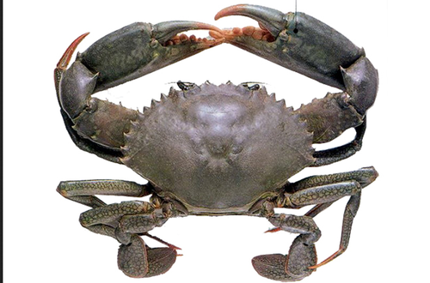

2.2 Mud crab harvesting strategies
Fishing grounds and capture methods vary with the target crab, habitat, tide, available gear and the fisher’s experience (Mirera, 2017a). Reported methods include hand collection, hooks and sticks, baited pots or traps, scoop or seine nets, and hooked metal rods (Richmond et al., 2006; Bonine et al., 2008; Mirera, 2017a). Kenyan fishers commonly remove crabs from mangrove burrows, taking market-sized animals for sale and smaller animals for culture. Harvesting is concentrated around low spring tides, when mangrove areas are accessible (Moser et al., 2005).
Along the Kenyan coast, many mud crab fishers work on foot in mangroves and rely on detailed knowledge of burrows and tidal creeks rather than specialised equipment (Fondo et al., 2020; Mirera et al., 2013). Catches may be held at home for several days until enough crabs have been accumulated for sale to a trader (Mirera et al., 2013; Ochiewo et al., 2010). The holding period makes survival and handling part of the marketing problem, not only a harvesting issue.
The Fisheries Management and Development Act, 2016 provides for designated landing and management arrangements. Mud crab fishers, however, do not always use formal landing sites or licences, so catches may remain outside routine landing records. This weakens the information available for both market planning and stock management.

2.3 Overview of mud crab fisheries and market structure
Scylla serrata is among the more valuable shellfish harvested from tropical mangroves. On Kenya’s South Coast, the fishery provides cash income to coastal households and connects small-scale harvesters with traders and downstream buyers. Its commercial growth has created a longer market chain rather than replacing small-scale production (FAO, 2025).
Demand for live crabs can increase both harvesting pressure and the value of keeping crabs alive. Evidence from the Western Indian Ocean and other regions suggests that buyer concentration, grade setting and access to markets shape prices and the distribution of gross returns (Jacinto, 2004; Crona et al., 2016). Market structure is therefore relevant to sustainability as well as livelihoods.

2.4 Mud crab fishery actors and their characteristics
The mud crab fishery involves fishers, brokers or middlemen, traders, wholesalers, retailers and final buyers. Fishers are typically small-scale operators who depend directly on mangrove habitats and use hand collection or simple gear (Mirera et al., 2013). Other actors aggregate, grade, transport, process or sell the catch.
Participation differs by age, experience, education, gender and access to finance. Along the Kenyan coast, mud crab income may support several members of a household, while harvesting and formal leadership have largely been male-dominated. Women are more visible in trade, processing and crab-fattening activities (Ochiewo et al., 2010; Mirera, 2014a). Earlier studies place many Kenyan crab fishers between 23 and 55 years of age and report that primary education is much more common than secondary education among East African crab fishers (Fulanda et al., 2009; Ndanga et al., 2013). These patterns provide useful context, but they do not show whether actor profiles are the same across BMUs or market nodes.

2.5 Functions of actors at different market levels
Functions change as crabs move through the chain. Fishers capture crabs by hand, from burrows or with baited gear. The method can affect size, condition and survival, which are relevant to the price offered at first sale (Sultana et al., 2018).
Middlemen buy from landing sites or villages, combine catches from several fishers, grade crabs and arrange temporary holding and transport. Their networks connect fishers to distant buyers, but the same position may give them an information and bargaining advantage when fishers have few alternative outlets.
Wholesalers, retailers, hotels, restaurants and exporters place greater emphasis on consistent quality and survival, especially when crabs are traded alive (FAO, 2025). The chain should therefore be examined as a sequence of distinct functions rather than as a single group of ‘traders’.

2.6 Business dynamics of the mud crab fishery

2.6.1 Overview of mud crab business dynamics
Mud crab trade depends on keeping a live, perishable product in saleable condition. Grading, price setting, transport, packaging and payment are therefore part of production economics, not secondary activities (FAO, 2025).
These practices distribute both opportunity and risk. The actor who controls grading or transport may reach a higher-value buyer, while the actor holding live crabs bears the risk of mortality, delayed payment or a rejected consignment.

2.6.2 Grading of mud crabs
Crabs are commonly graded by size, weight, sex, shell hardness and physical condition. Large hard-shell crabs are often preferred because they contain more meat and tolerate transport better. Male crabs may command higher prices, while trade in berried females may be restricted for conservation reasons (FAO, 2025).
Grading may occur at the landing site or after a middleman has aggregated several catches. When the criteria are informal or applied visually, fishers may be unable to verify why a crab was placed in a particular grade. The issue is not grading itself, which can reflect real quality differences, but whether the criteria and price consequences are transparent.

2.6.3 Pricing of mud crabs
Mud crab prices vary with grade, season, demand, distance to market and whether crabs are sold alive. Large live crabs generally receive higher prices in urban, hotel and export markets, while seasonal supply and demand can shift the amount offered (FAO, 2025).
Small-scale fishers may accept a buyer’s price when they lack holding facilities, need cash immediately or depend on that buyer for transport and credit. Informal agreements can reduce transaction costs, but they can also make the basis of a price difficult to challenge (Crona et al., 2016). This makes buyer choice and independent market information important alongside the nominal price.

2.6.4 Transport of mud crabs
Transport affects both survival and quality. Live mud crabs are vulnerable to heat, dehydration and handling stress, and deaths in transit reduce the quantity that can be sold. Traders use baskets, plastic crates or wooden boxes, often with damp material to limit dehydration.
Long distances, poor roads and limited cold-chain or live-holding facilities add to transport risk in the Western Indian Ocean. Shorter journeys and better containment may reduce mortality and protect value without increasing fishing effort. The relevant question is which actors have access to those options and who pays for them.

2.6.5 Packaging of mud crabs
Packaging controls movement, moisture and physical damage during transport. Live crabs may be tied or separated to reduce injury and cannibalism. Containers must also allow enough ventilation and protect claws and legs, which affect market acceptance.
Export markets often require consistent packaging, labels and traceability. Small-scale traders may instead use low-cost materials that are locally available. The trade-off between container cost, survival and reusability should be assessed under normal trading conditions rather than assumed.

2.6.6 Modes of payment in the mud crab trade
Cash remains common at landing sites because fishers need immediate income. Payment may also be delayed until a broker has sold the crabs, especially when the broker provides transport or holding services (Crona et al., 2016).
Buyers may advance cash or gear in return for continued or exclusive supply. Such arrangements can solve a short-term financing problem while narrowing the fisher’s choice of buyer. Mobile money can improve transaction security and create a basic record, although its use varies across coastal markets.

2.7 Constraints faced by mud crab fishery actors
Mud crab actors face ecological, operational and market constraints. Fishers report seasonal availability and declining catches where juvenile or berried crabs are harvested and mangrove habitats are degraded (Mirera, 2017a). Traders face the additional problem of keeping live crabs in saleable condition while assembling enough volume for buyers.
Limited credit, unstable prices, inadequate holding facilities and dependence on a small number of brokers can reduce bargaining options. Weak enforcement of size or harvest rules may also allow short-term market demand to undermine the resource on which the trade depends (Mirera, 2017a).

2.8 Opportunities in the mud crab fishery
Demand for large, healthy crabs creates room for better handling, clearer grades and higher-value products. Crab fattening can increase sale weight before marketing, although its value depends on survival, feed, labour, seed sourcing and a confirmed buyer (Mirera, 2014b).
Community participation in size limits and temporary closures has improved awareness and product quality in co-managed small-scale fisheries (Gutiérrez et al., 2011). For Kenya, the lesson is not that the same measure will transfer unchanged, but that market incentives and local enforcement need to be designed together.

2.9 Legal and policy frameworks governing mud crab fishery in Kenya
The Fisheries Management and Development Act, No. 35 of 2016 (Cap. 378) provides the main national framework for conservation, management and development of fisheries resources, including crustaceans. It recognises small-scale fisheries and co-management through Beach Management Units (Fisheries Management and Development Act, No. 35 of 2016, Cap. 378).
The Fisheries Management and Development (Safety and Quality) Regulations, 2024 address the handling, movement and marketing of fishery products. Licensing, traceability, hygiene and quality requirements are particularly relevant to traders and exporters seeking formal markets (Fisheries Management and Development (Safety and Quality) Regulations, 2024).
Fisheries governance is shared between national and county institutions. Counties can develop management plans, while the national government provides coordination and oversight. This division matters for a fishery rooted in mangrove habitats and local landing sites (Fisheries Management and Development Act, No. 35 of 2016, Cap. 378).
Kenya’s Blue Economy and sustainable-development commitments place greater emphasis on traceability, monitoring and value-chain development. For small-scale mud crab actors, the practical gaps remain awareness, compliance support and consistent enforcement.

2.10 Theoretical Framework
This study uses the Structure-Conduct-Performance (SCP) paradigm as its main analytical framework. SCP is commonly applied in agricultural and fisheries marketing to organise evidence on market structure, actor conduct and market outcomes. In this study, it provides a way to connect the composition and organisation of the mud crab market with the practices observed at different nodes. The framework guides interpretation; it is not used to claim a causal sequence.
Market structure is described through the number and types of actors, their characteristics, entry conditions, licensing, access to capital, collective organisation and buyer connections. Conduct covers sourcing, grading, handling, pricing, payment, transport and credit relationships. Performance is considered through descriptive indicators available in the dataset, including reported income and prices, market access, mortality or spoilage, and perceptions of market organisation. The constraints and opportunities reported under Objective Three provide the operating context in which these patterns occur.
Value-chain concepts are used as a mapping device to trace crabs from harvesting through aggregation, hospitality and export. They are not treated as a second causal theory. Livelihood research provides background for interpreting education, experience, finance and collective membership, but the study did not measure a complete set of livelihood assets or estimate livelihood effects. Keeping SCP as the central framework matches the descriptive design and the analyses reported in Chapters Four and Five.
Figure 2
Structure-Conduct-Performance (SCP) linkages guiding the study
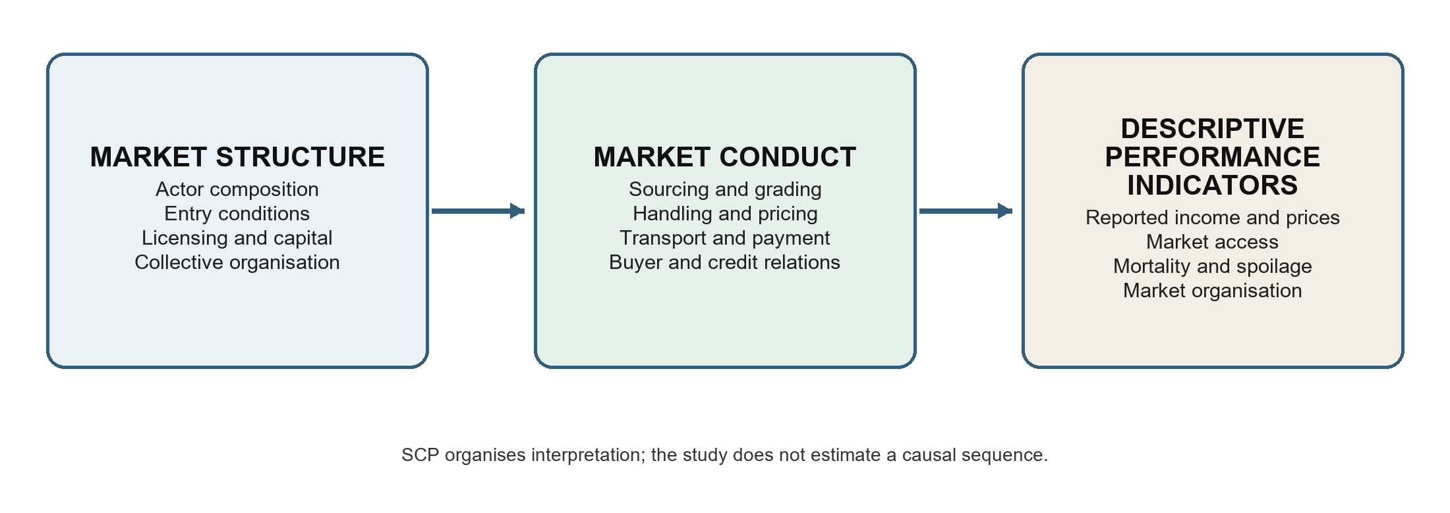

2.11 Conceptual Framework
Figure 3 organises the study variables by objective and shows how they were used in the analysis. It is a descriptive framework rather than a causal model. The arrows indicate the order in which market structure, actor conduct and observed outcomes were examined; they do not represent estimated effects.
Objective One describes market structure and actor profiles using actor category, BMU or site, age, gender, education, experience, scale of operation, licensing, collective membership, credit and related business characteristics. These variables were summarised by actor category and, where sample coverage allowed, compared across BMUs.
Objective Two examines conduct and functions at each node, including harvesting and sourcing, grading, handling, packaging, transport, pricing, payment, buyer relations and market research. Reported income, prices, market access and post-harvest losses are presented as descriptive market outcomes. They were not combined into a single performance index.
Objective Three describes the infrastructure, market barriers, policy awareness, risks and opportunities reported by each actor category. These conditions are interpreted alongside the structure and conduct findings. No mediation or moderation model was estimated, and the cross-sectional design does not support causal inference. Actor category and BMU are used as grouping variables for description and actor-specific association tests.
Figure 3
Descriptive framework linking the study objectives to the analysis
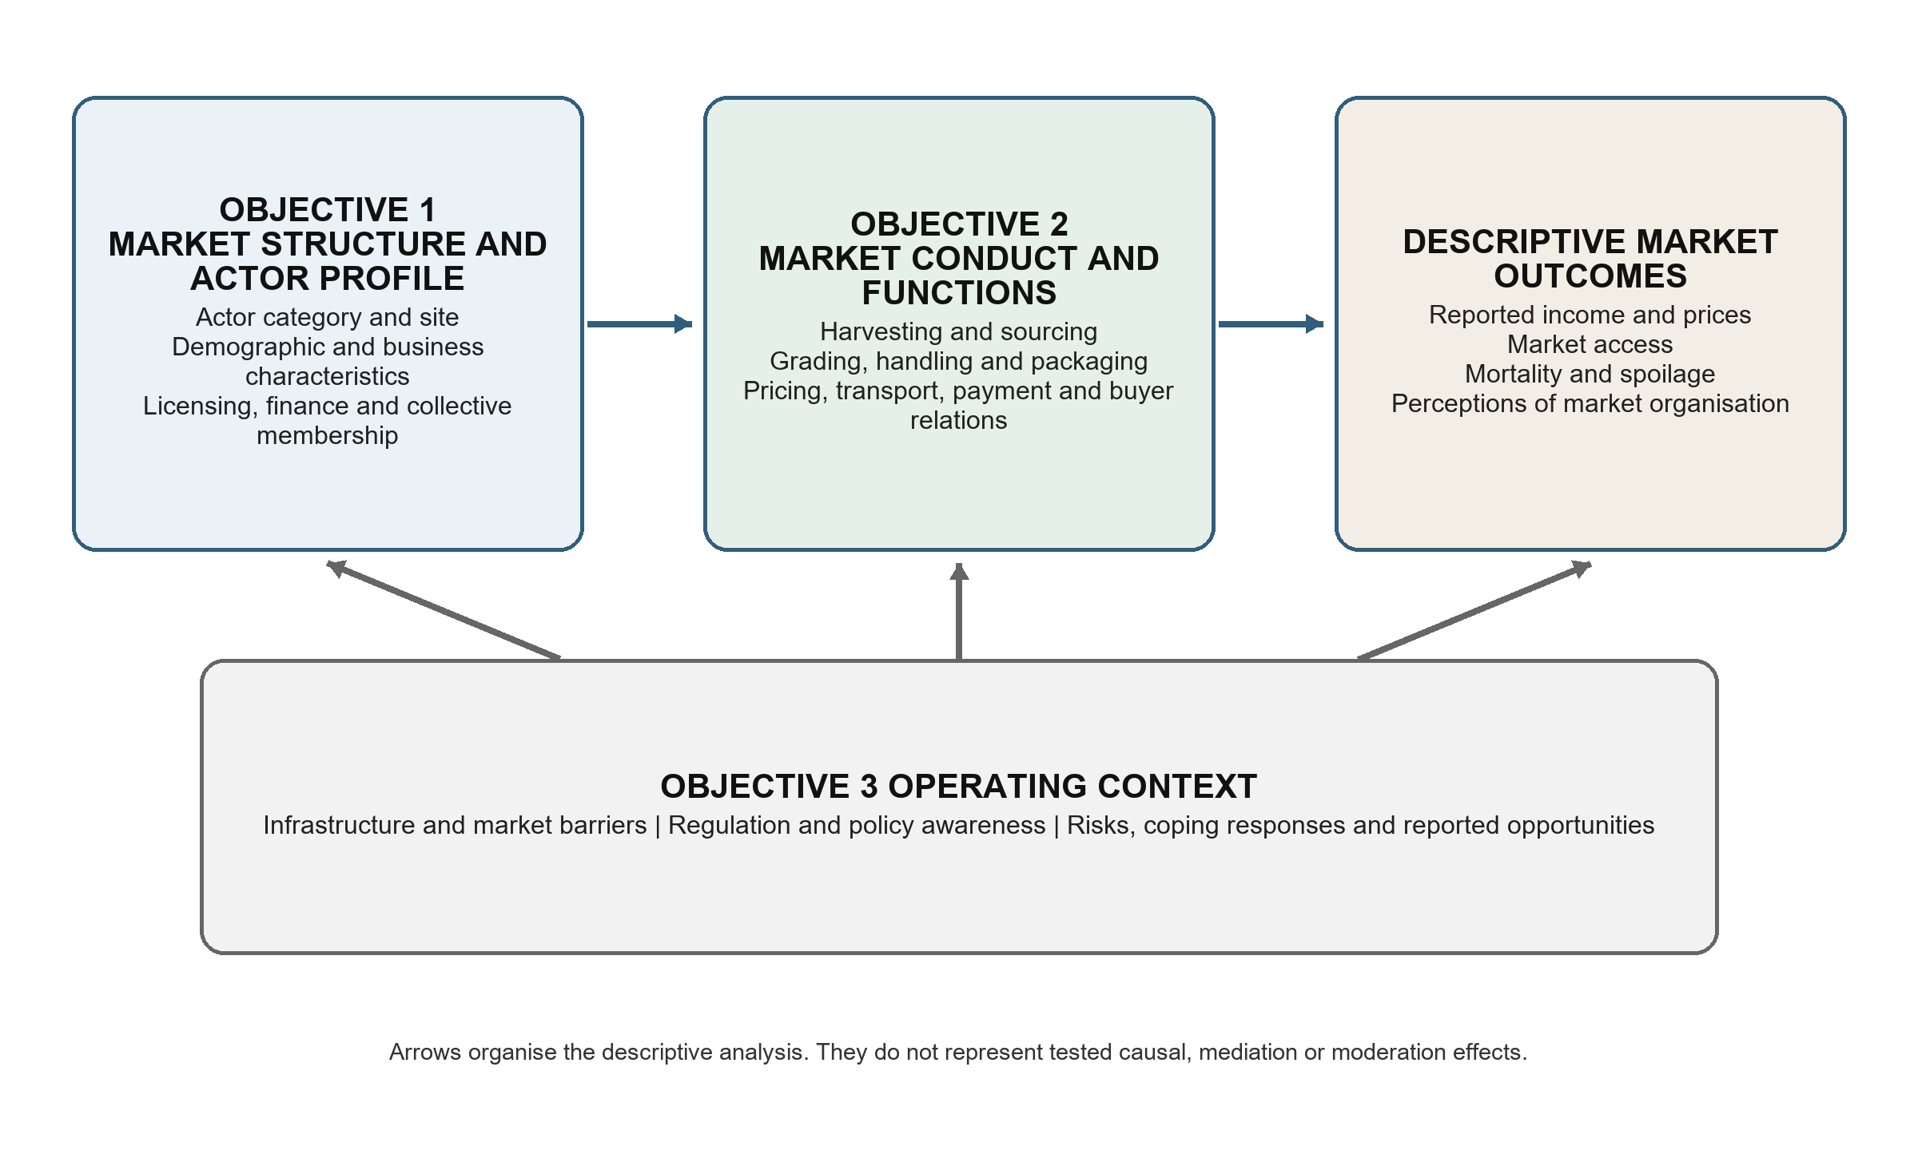

CHAPTER THREE: MATERIALS AND METHODS

3.1 Introduction
This chapter describes the study design, site, target population, sampling, data collection and analysis. The methods were selected to describe the actors, functions, constraints and opportunities in the Kwale County mud crab market and to compare selected categorical variables across BMUs where the sample allowed.

3.2 Study site
The study was conducted on the South Coast of Kenya, mainly in Kwale County, between latitudes 3.05 degrees and 4.75 degrees South and longitudes 38.52 degrees and 39.51 degrees East (Figure 4). The county covers about 8,270.2 square kilometres and includes a coastal strip extending from Likoni to Vanga. Mangrove forests, tidal creeks and shallow coastal waters provide breeding, feeding and shelter habitat for Scylla serrata and other species (Mirera, 2017a; Fondo et al., 2020). The South Coast was selected because it is an established harvesting and trading area. Small-scale fishers reach mangroves on foot or by canoe and use hand collection, baited traps and other simple gear. Year-round access to the habitat makes mud crab fishing an important source of cash income for some coastal households.
The County has 20 Beach Management Units (BMUs) and 54 landing sites, which are responsible for regulating fishing activities, managing landing sites, and promoting sustainable use of fisheries resources. These BMUs provide important entry points for understanding how mud crab harvesting and marketing take place at the local level (Njiru et al., 2021). Landing sites within the BMUs serve as major points where fishers sell their crabs to brokers and traders, making them suitable locations for collecting data on grading, pricing, transportation, packaging, and modes of payment.
The South Coast is also strongly influenced by tourism and urban markets, which generate high demand for premium seafood products such as live mud crabs. Hotels, restaurants, and urban centers within and outside the county provide ready markets, encouraging commercialization of the mud crab fishery and the involvement of multiple actors along the value chain (FAO, 2025). As a result, mud crab fishing in the area has gradually shifted from subsistence use to a market-oriented economic activity.
Figure 4
Study site (Author, 2026)
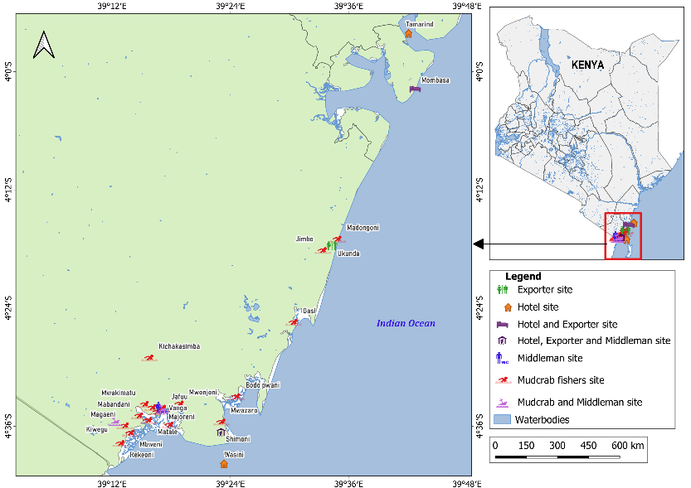

3.3 Research design
The study used a cross-sectional descriptive mixed-methods design. Each respondent was surveyed once, while field observations and key-informant interviews supplied context on handling practices, institutions and market relationships. The design supports actor profiles, comparisons among actor categories and exploratory BMU associations. It does not establish causal pathways, mediation, moderation or seasonal change.

3.4 Target population
The target population comprised mud crab fishers, middlemen, hoteliers and exporters operating in Kwale County. These groups were selected because they harvest, handle, aggregate, process or trade mud crabs and therefore correspond directly to the three study objectives. Consumers, restaurants that did not procure directly, input suppliers and other service providers were outside the survey scope. Their exclusion means that the study cannot describe consumer preferences or the full set of supporting services. Ministry of Fisheries records informed the fisher sampling frame. Complete lists were not available for middlemen, hoteliers and exporters, so the accessible population for these groups depended on referrals and availability during the study period.

3.5 Sample size and sampling procedures
The fisher sample was estimated from the available population information. Bowers (2017) reported that mud crab fishers represented about 3% of the 12,915 fishers along the Kenyan coast. Applying Kwale County’s estimated 26.9% share of the national mud crab fisher population gave an estimated population of 104 fishers (Mirera, 2017a; Kimani et al., 2018).
- Total population of fishers in the Kenyan coast = 12,915
- Proportion of mud crab fishers in the Kenyan coast = 3%
- Total population of mud crab fishers in the Kenyan coast = 3/100 x 12,915 = 387
- Total population of mud crab fishers in Kwale County = 26.9/100 x 387 = 104
Using Yamane’s formula (Yamane, 1967) for sample size determination, the sample size was computed as follows: (Yamane, 1967; Gill, 2010)
where:
n = required sample size
N = estimated population of mud crab fishers (104)
e = margin of error (0.05)
n = 104 / [1 + 104(0.05)^2]
n = 82.54, rounded up to a target of 83 fishers
The completed survey covered 96 actors: 65 mud crab fishers, 22 middlemen, five hoteliers and four exporters. Fishers were recruited from the selected BMUs using the available frame and field access. Because complete lists of downstream actors were not available, fishers and other respondents identified traders and buyers who could be approached, and these referrals were followed through snowball sampling.

3.6 Sampling coverage and nonresponse
The study reached 65 of the target 83 fishers, an achieved rate of 78.3%. The shortfall arose mainly because some fishers moved among landing sites and were absent during scheduled visits. The achieved fisher sample is adequate for a descriptive account of the respondents reached, but the missing 18 fishers may differ from those interviewed. Site-level percentages, especially for BMUs with few respondents, should therefore be interpreted cautiously.
A conventional response rate could not be calculated for middlemen, hoteliers or exporters because no complete sampling frame existed. Snowball sampling was practical for locating these dispersed actors, but it may over-represent people with stronger trading connections and under-represent isolated or informal operators. The small hotelier and exporter samples and the absence of middlemen at some BMUs limit statistical generalisation beyond the surveyed actors.

3.7 Pilot study
A pilot test involving 18 respondents was used to check whether the questionnaire items were clear, relevant to the objectives and workable in the field (Lowe, 2019). Feedback from the pilot informed the wording and sequencing of the data-collection tool.

3.8 Data collection
Data were collected from May 2022 to December 2023 using structured questionnaires, field observations and key-informant interviews.
For Objective One, the questionnaire recorded actor category, age, sex, marital status, education, household size, experience, monthly income, business ownership, scale of operation, collective membership, credit, licensing and institutional affiliation. These variables were used to describe the people and businesses operating at different market nodes.
For Objective Two, respondents described their harvesting or sourcing methods, catch or traded volumes, grading, quality control, processing, preservation, packaging, transport, market destinations, price setting, payment, technology use, market research and sources of technical knowledge. Field observations were used to check reported handling, grading, transport and marketing practices where these could be seen.
For Objective Three, respondents identified operational and market constraints, infrastructure gaps, price risk, access to finance, technology, institutional support, regulation and capacity needs. They also reported opportunities for market access, value addition, infrastructure, training, credit and institutional support. Key informants, including BMU leaders and government officers, provided context on sector-wide conditions. Their accounts and field notes were used to interpret the survey findings rather than as a separate causal test.
Secondary evidence came from published studies, government reports and other documents on mud crab fisheries, actor roles and market conditions. This material provided the background and comparison literature used in Chapters One, Two and Five.

3.9 Alignment of objectives and analysis
Objective One was analysed with frequencies, valid percentages and actor-specific BMU cross-tabulations, with chi-square tests for selected categorical variables among fishers and middlemen. Objective Two used the same descriptive summaries for functions and market practices, together with means, medians, quartiles and ranges for reported income and prices. Objective Three used frequencies, percentages and selected actor-specific BMU associations for constraints, regulation and opportunities. Hoteliers and exporters were described by actor category because their samples were too small and uneven for BMU significance tests. This alignment keeps each conclusion within the scope of the data collected.

3.10 Data analysis

3.10.1 Data entry and processing
Questionnaires were administered on smartphones using KoBoToolbox and KoBo Collect. Submitted records were reviewed, coded and downloaded in CSV and XLSX formats.
The questionnaire followed the study objectives. Its first section covered demographic and business characteristics, the second recorded actor functions and market practices, and the third covered constraints and opportunities.
Validation rules in the KoBo form reduced missing and out-of-range responses. Cleaning therefore focused on labels, coding consistency, duplicate checks and comparison with the original records where a value appeared unusual.
After cleaning, the dataset was imported into IBM SPSS Statistics. Variables were labelled by study objective and checked against the questionnaire. Fishers and middlemen were cross-tabulated separately by BMU, while hoteliers and exporters were pooled by actor because their sample sizes were small and their site coverage was uneven.
Descriptive analysis was conducted in IBM SPSS Statistics. Categorical variables were summarised using frequencies and valid percentages within actor category. Continuous variables, including reported monthly income and mud crab prices, were summarised using the mean, standard deviation, median, first and third quartiles, minimum and maximum where valid observations were available. Every table in Chapter Four carries all four actor categories, so that fishers, middlemen, hoteliers and exporters can be compared on the same row. Fishers and middlemen were additionally cross-tabulated by study site; hoteliers and exporters were not, because their samples were small and their site coverage uneven. All charts presented in Chapter Four were generated from the same dataset in IBM SPSS Statistics.

3.10.2 Chi-square tests of association
Chi-square tests were used to assess associations between BMU and selected categorical variables separately for fishers and middlemen. The two actor categories were not pooled in the BMU tests because their functions and distributions differed across sites. Hoteliers and exporters were excluded from BMU significance testing because their numbers were small and site coverage was uneven.
The tests covered objective-linked demographic, business, functional, market and constraint variables. Because many contingency tables contained small expected counts, two-sided Monte Carlo p-values based on 10,000 samples were reported with 99% confidence intervals. Statistical significance was assessed at alpha = .05. Hoteliers and exporters were described without BMU significance tests.

3.10.3 Kruskal–Wallis tests of reported prices
Reported mud crab prices were compared with the Kruskal–Wallis H test, a rank-based alternative to one-way analysis of variance. It was chosen because the price distributions were not normal, the actor groups were very unequal in size, and the smallest groups contained four and five observations, conditions under which a parametric test would not be dependable.
Three sets of comparisons were run, one per size grade. Price was compared across the four actor categories; fisher price was compared across the four study sites; and middleman price was compared across the three sites where traders were sampled. Hoteliers and exporters were not compared across sites for the reason given above. Statistical significance was assessed at alpha = .05. Because the survey did not record transaction-level costs, volumes or mortality, price differences between nodes are reported as gross marketing margins and shares of the end-of-chain price, never as profit.

3.11 Ethical considerations
The study adhered to ethical standards for statistical research. Respondents were interviewed based on their attainment of the legal age of 18 years; consent was sought from parents or guardians for those under 18. Anonymity and confidentiality were maintained, and participation was voluntary with the option to withdraw at any time. An ethical review certificate was obtained before data collection commenced.

CHAPTER FOUR: RESULTS

4.1 Introduction
This chapter reports what 96 mud crab actors on the South Coast of Kenya said about their work. It follows the three objectives in turn: who the actors are, what each one does at their point in the chain, and what stands in their way. Every table carries all four actor categories, so that a fisher, a middleman, a hotelier and an exporter can be read against one another on the same row.
Three conventions govern how the tables should be read. Percentages are valid percentages: the denominator is the number who answered that particular question within the stated actor category, not the full 96. An em dash means the actor category recorded no valid answer for that item at all, which is not the same as a zero. Where a question was put only to harvesters, such as daily catch or the small-crab price, the other three columns carry dashes and the text explains why.
Categorical variables were tested against study site with Monte Carlo chi-square based on 10,000 resamples, which suits the sparse tables this sample produces. Fishers and middlemen were tested separately, because a harvester and a trader do different work and pooling them would confuse site with role. Hoteliers and exporters were not tested against site: four of the five hoteliers and all four exporters operated outside the four Beach Management Unit frames, so a site test would have rested on one or two people per cell. Reported prices were compared with the Kruskal–Wallis test, which does not assume a normal distribution and tolerates the unequal group sizes in this sample.

4.2 Distribution of Respondents
All 96 respondent identifiers were unique and matched across the three objective worksheets. Landing sites were standardised into Shimoni, Majoreni, Vanga, Msambweni or an Other sites group. One medium-crab price recorded at Gasi was corrected from KSh 800 to KSh 650 per kilogram against the field records, and every figure in this chapter carries that correction.
Table 1
Distribution of Respondents by Actor Category and Study Site
Actor category | Shimoni | Majoreni | Vanga | Msambweni | Other sites | Total
Fisher | 25 (38.5) | 14 (21.5) | 21 (32.3) | 3 (4.6) | 2 (3.1) | 65 (100.0)
Middleman | 11 (50.0) | 7 (31.8) | 4 (18.2) | 0 (0.0) | 0 (0.0) | 22 (100.0)
Hotelier | 1 (20.0) | 0 (0.0) | 0 (0.0) | 0 (0.0) | 4 (80.0) | 5 (100.0)
Exporter | 0 (0.0) | 0 (0.0) | 0 (0.0) | 0 (0.0) | 4 (100.0) | 4 (100.0)
Total | 37 (38.5) | 21 (21.9) | 25 (26.0) | 3 (3.1) | 10 (10.4) | 96 (100.0)
Fishers made up 65 of the 96 respondents, middlemen 22, hoteliers five and exporters four. The mix differed sharply by site. Shimoni and Majoreni were the only places where fishers and middlemen were both well represented; Vanga returned four middlemen against 21 fishers; Msambweni returned three fishers and nothing else. Hoteliers and exporters sat almost entirely in the Other sites group, which is where the hotels and packhouses that buy South Coast crabs actually operate.
Figure 5
Composition of the Sample by Actor Category Within Each Study Site
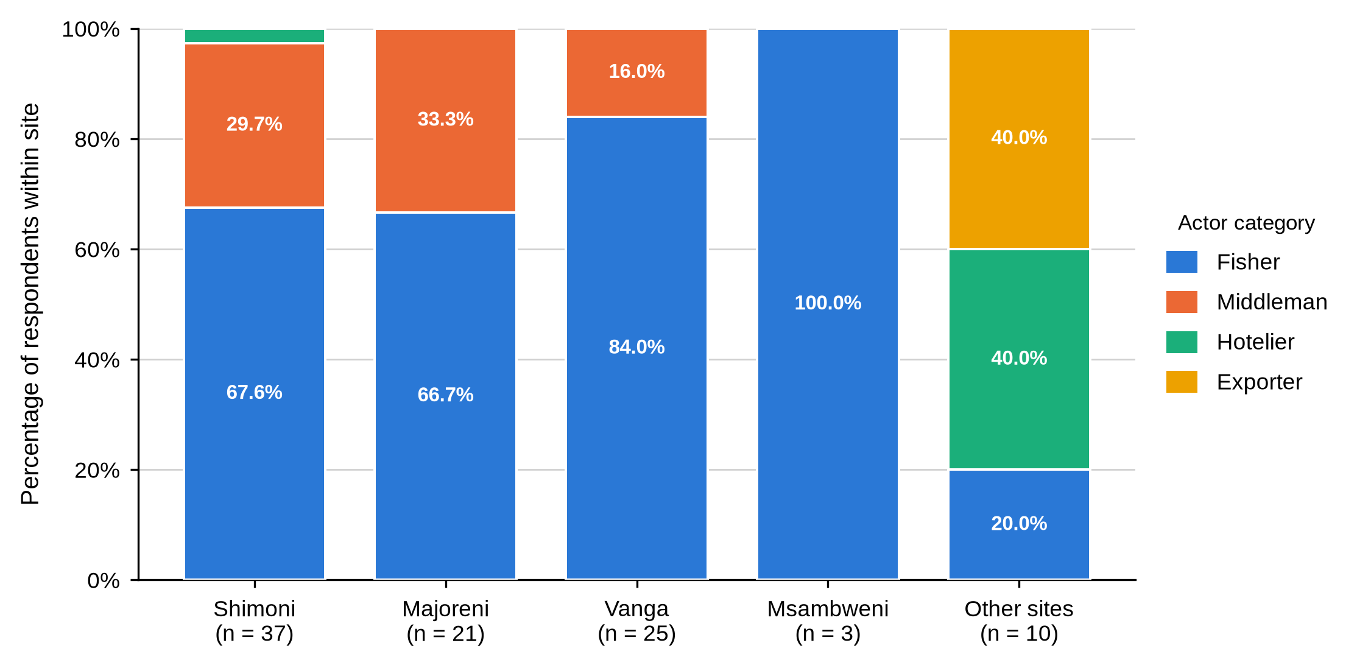
Note. Bars show the percentage of respondents at each site falling into each actor category and sum to 100% within a site. Msambweni rests on three respondents and should be read with that in mind.
This distribution sets the limits of what the site comparisons can do. A four-site trader comparison was impossible because no middleman was sampled at Msambweni, so middleman tests use the three sites where traders were interviewed. Msambweni is left out of the middleman tables rather than shown as a column of zeros: that is a gap in the realised sample, not evidence that no middlemen work there.

4.3 Objective One: Profile of Mud Crab Actors

4.3.1 Demographic Profile
Table 2
Demographic Profile of Mud Crab Actors by Actor Category
Characteristic and response | Fisher  (n = 65) | Middleman  (n = 22) | Hotelier  (n = 5) | Exporter  (n = 4) | Total  (N = 96)
Age group (valid n = 65 / 22 / 5 / 4) BMU association: fishers χ²(12, N = 63) = 30.91, p = .004; middlemen χ²(6, N = 22) = 2.80, p = .932.
Under 18 | 4 (6.2) | 0 (0.0) | 0 (0.0) | 0 (0.0) | 4 (4.2)
18-35 | 35 (53.8) | 5 (22.7) | 4 (80.0) | 0 (0.0) | 44 (45.8)
36-49 | 12 (18.5) | 11 (50.0) | 1 (20.0) | 4 (100.0) | 28 (29.2)
50-60 | 10 (15.4) | 5 (22.7) | 0 (0.0) | 0 (0.0) | 15 (15.6)
Over 60 | 4 (6.2) | 1 (4.5) | 0 (0.0) | 0 (0.0) | 5 (5.2)
Gender (valid n = 65 / 22 / 5 / 4)
Male | 65 (100.0) | 22 (100.0) | 4 (80.0) | 4 (100.0) | 95 (99.0)
Female | 0 (0.0) | 0 (0.0) | 1 (20.0) | 0 (0.0) | 1 (1.0)
Highest education attained (valid n = 65 / 22 / 5 / 4) BMU association: fishers χ²(6, N = 63) = 6.89, p = .334; middlemen χ²(4, N = 22) = 1.95, p = .928.
No formal education | 17 (26.2) | 4 (18.2) | 0 (0.0) | 0 (0.0) | 21 (21.9)
Primary | 44 (67.7) | 16 (72.7) | 0 (0.0) | 0 (0.0) | 60 (62.5)
Secondary | 4 (6.2) | 2 (9.1) | 0 (0.0) | 0 (0.0) | 6 (6.2)
Certificate | 0 (0.0) | 0 (0.0) | 2 (40.0) | 0 (0.0) | 2 (2.1)
Diploma | 0 (0.0) | 0 (0.0) | 3 (60.0) | 3 (75.0) | 6 (6.2)
Undergraduate | 0 (0.0) | 0 (0.0) | 0 (0.0) | 1 (25.0) | 1 (1.0)
Marital status (valid n = 65 / 22 / 5 / 4) BMU association: fishers χ²(9, N = 63) = 20.06, p = .049; middlemen χ²(2, N = 22) = 1.93, p = .665.
Single | 20 (30.8) | 2 (9.1) | 2 (40.0) | 0 (0.0) | 24 (25.0)
Married | 41 (63.1) | 20 (90.9) | 3 (60.0) | 4 (100.0) | 68 (70.8)
Separated / divorced | 3 (4.6) | 0 (0.0) | 0 (0.0) | 0 (0.0) | 3 (3.1)
Widowed | 1 (1.5) | 0 (0.0) | 0 (0.0) | 0 (0.0) | 1 (1.0)
The chain is young at the water and older one step inland. Just over half the fishers, 35 of 65, were aged 18 to 35, and four were under 18 — the only minors recorded anywhere in the study. Half the middlemen were aged 36 to 49 and only five were under 36. All four exporters fell in the 36 to 49 band, while four of the five hoteliers were under 36.
Education separates the chain even more cleanly than age. Not one fisher or middleman had been to school beyond secondary level: 67.7% of fishers and 72.7% of middlemen had primary schooling and 26.2% of fishers had no formal education at all. Every hotelier and exporter held a certificate, diploma or degree. This is the first indication under Objective One that the people who handle the paperwork, the grading rules and the export requirements are not the people who catch the crabs.
Figure 6
Age Distribution Within Each Actor Category
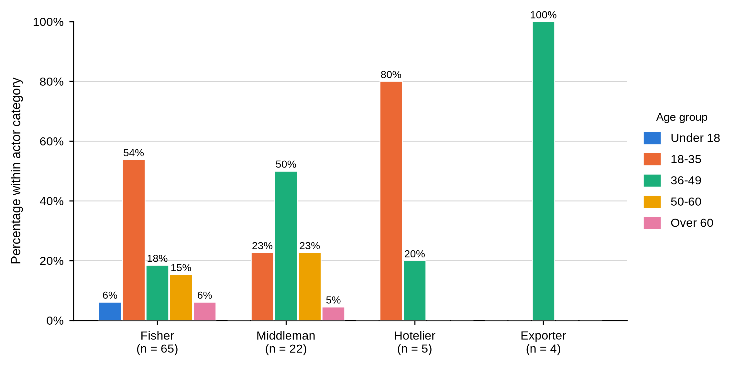
Note. Bars show the percentage of respondents within each actor category falling into each age band, so the bars for one actor sum to 100%.
Figure 7
Highest Education Attained Within Each Actor Category
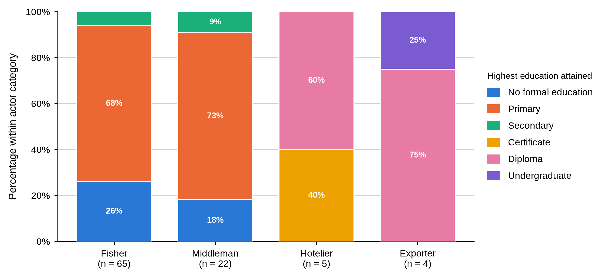
Note. Segments sum to 100% within each actor category. No fisher or middleman reported education beyond secondary level, and no hotelier or exporter reported less than a certificate.
Ninety-five of the 96 respondents were men. The single woman in the sample was a hotelier, not a harvester. This describes the sample that was reached and should not be read as proof that women are absent from the wider chain, because the sampling frame drew on landing-site registers where women are less often listed.
Age was the clearest site difference in the whole profile. Sixteen of the 25 Shimoni fishers were aged 18 to 35 and all four minors were recorded there, while Majoreni ran older, with five fishers aged 50 to 60, three over 60 and no one under 18. The association was significant, χ²(12, N = 63) = 30.91, p = .004, 99% CI [.002, .005].
Figure 8
Age Distribution of Fishers Within Each Study Site
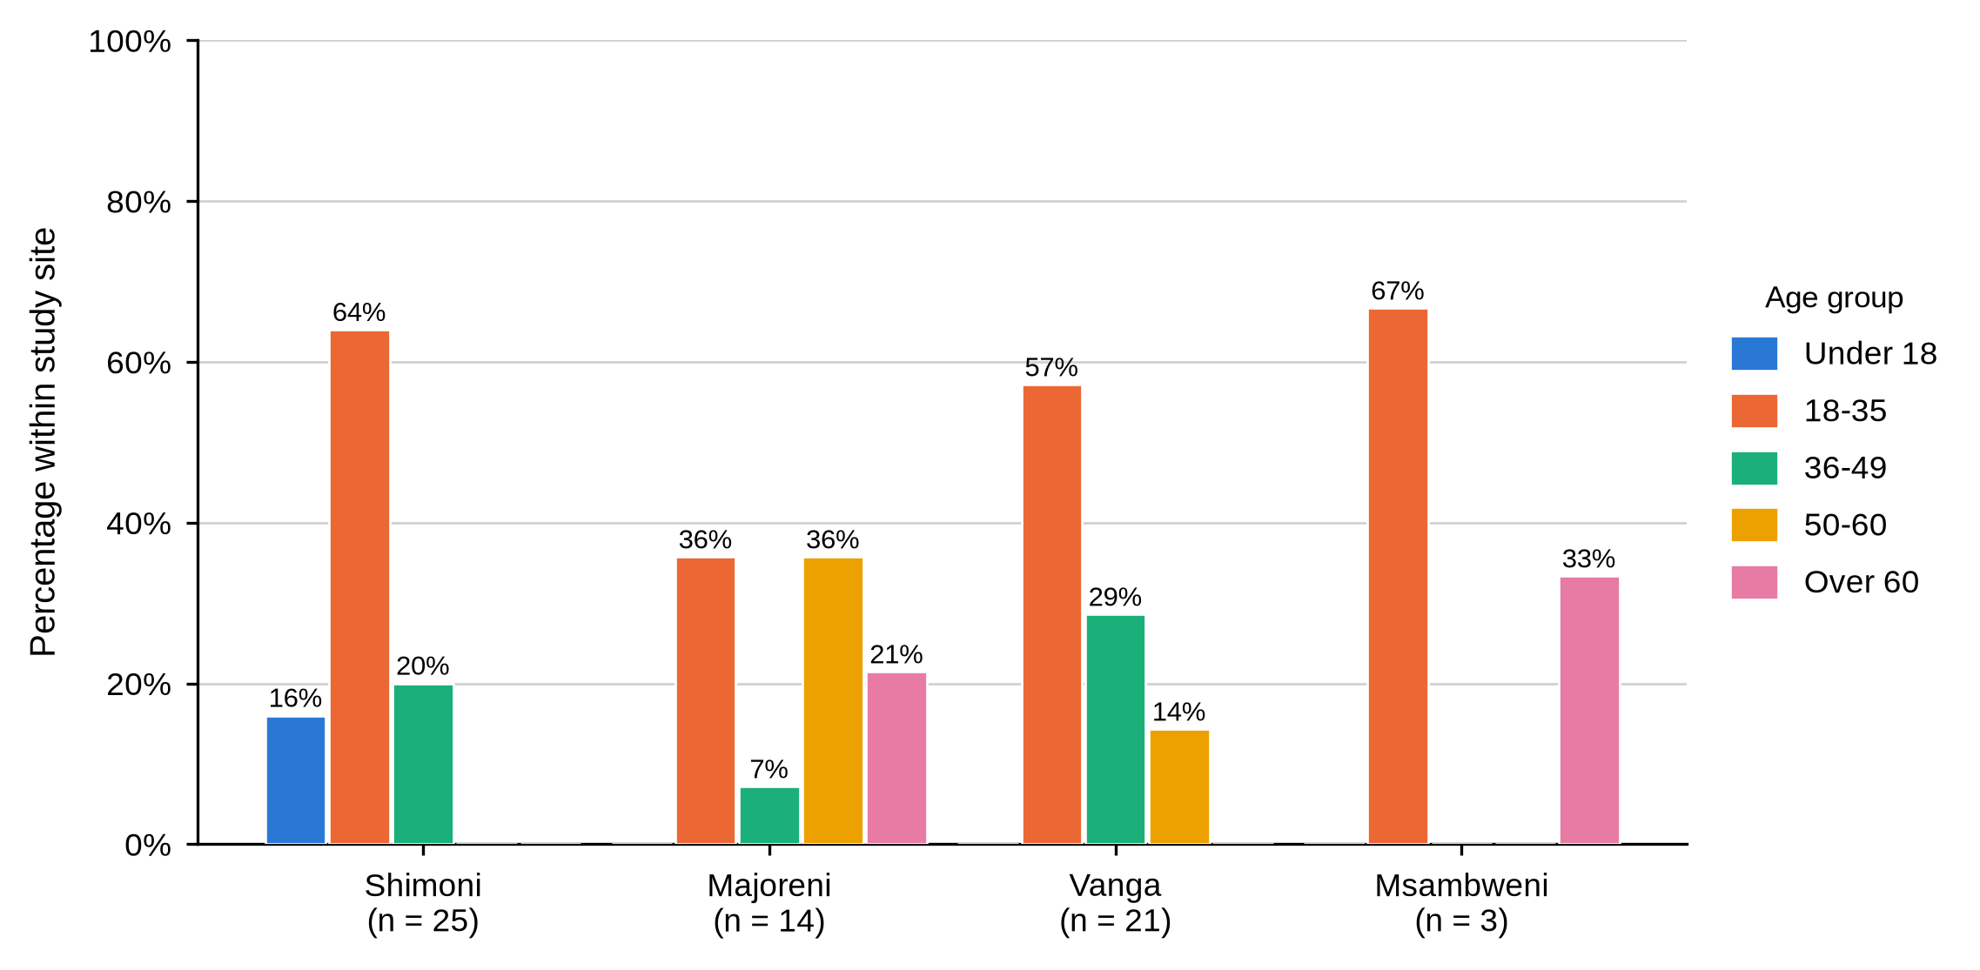
Note. Bars show the percentage of fishers within each site falling into each age band. The two fishers in the Other sites group are excluded from the site comparison.

4.3.2 Experience, Business Role, Scale of Operation and Income
Table 3
Experience, Business Role, Scale of Operation and Reported Income by Actor Category
Characteristic and response | Fisher  (n = 65) | Middleman  (n = 22) | Hotelier  (n = 5) | Exporter  (n = 4) | Total  (N = 96)
Years of experience in the mud crab fishery (valid n = 65 / 22 / 5 / 4) BMU association: fishers χ²(9, N = 63) = 11.52, p = .204; middlemen χ²(4, N = 22) = 2.50, p = .747.
Less than 5 years | 1 (1.5) | 0 (0.0) | 4 (80.0) | 2 (50.0) | 7 (7.3)
5-10 years | 22 (33.8) | 3 (13.6) | 1 (20.0) | 2 (50.0) | 28 (29.2)
11-20 years | 22 (33.8) | 3 (13.6) | 0 (0.0) | 0 (0.0) | 25 (26.0)
Over 20 years | 20 (30.8) | 16 (72.7) | 0 (0.0) | 0 (0.0) | 36 (37.5)
Primary role in the mud crab fishery (valid n = 65 / 22 / 5 / 4)
Crabber | 65 (100.0) | 0 (0.0) | 0 (0.0) | 0 (0.0) | 65 (67.7)
Exporter | 0 (0.0) | 0 (0.0) | 0 (0.0) | 4 (100.0) | 4 (4.2)
Marketer | 0 (0.0) | 22 (100.0) | 0 (0.0) | 0 (0.0) | 22 (22.9)
Processor | 0 (0.0) | 0 (0.0) | 5 (100.0) | 0 (0.0) | 5 (5.2)
Scale of operation (valid n = 65 / 22 / 5 / 4) BMU association: fishers χ²(3, N = 63) = 2.03, p = .606; middlemen χ²(4, N = 22) = 9.41, p = .050.
Small-scale | 64 (98.5) | 10 (45.5) | 0 (0.0) | 0 (0.0) | 74 (77.1)
Medium-scale | 1 (1.5) | 10 (45.5) | 5 (100.0) | 0 (0.0) | 16 (16.7)
Large-scale | 0 (0.0) | 2 (9.1) | 0 (0.0) | 4 (100.0) | 6 (6.2)
Monthly mud crab income band (valid n = 65 / 22 / 5 / 3) BMU association: fishers χ²(3, N = 63) = 7.13, p = .057.
Below KSh 13,900 | 52 (80.0) | 0 (0.0) | 0 (0.0) | 0 (0.0) | 52 (54.7)
KSh 13,900-69,500 | 13 (20.0) | 22 (100.0) | 4 (80.0) | 0 (0.0) | 39 (41.1)
KSh 69,501-139,000 | 0 (0.0) | 0 (0.0) | 1 (20.0) | 3 (100.0) | 4 (4.2)
Engages in other income activities (valid n = 65 / 22 / 5 / 4) BMU association: fishers χ²(3, N = 63) = 4.53, p = .234.
Yes | 13 (20.0) | 22 (100.0) | 5 (100.0) | 4 (100.0) | 44 (45.8)
No | 52 (80.0) | 0 (0.0) | 0 (0.0) | 0 (0.0) | 52 (54.2)
Experience accumulates at the trading node, not the harvesting node. Sixteen of the 22 middlemen, 72.7%, had more than twenty years in the fishery, against 30.8% of fishers. The downstream groups were newcomers by comparison: four of the five hoteliers and two of the four exporters had been in the trade less than five years. The long-serving actor in this chain is the middleman, and that is who a fisher negotiates against.
Scale of operation follows the same gradient. Almost every fisher, 64 of 65, described a small-scale operation. Middlemen split evenly between small and medium scale with two operating at large scale, every hotelier was medium scale and every exporter large scale. Income tracked it exactly: 80.0% of fishers earned below KSh 13,900 a month from mud crabs while every middleman, four of five hoteliers and all three exporters who answered earned above that line.
Table 4
Reported Monthly Income and Age of Respondents by Actor Category
Actor category | Valid n | M | SD | Mdn | IQR | Min | Max
Reported monthly mud crab income (KSh)
Fisher | 65 | 8,969.2 | 6,745.3 | 6,000.0 | 5,000.0–10,000.0 | 4,000.0 | 50,000.0
Middleman | 22 | 27,954.5 | 11,407.9 | 25,000.0 | 20,000.0–30,000.0 | 15,000.0 | 50,000.0
Hotelier | 5 | 43,000.0 | 34,568.8 | 30,000.0 | 20,000.0–50,000.0 | 15,000.0 | 100,000.0
Exporter | 3 | 90,000.0 | 17,320.5 | 100,000.0 | 85,000.0–100,000.0 | 70,000.0 | 100,000.0
All actors | 95 | 17,715.8 | 19,886.7 | 10,000.0 | 5,000.0–20,000.0 | 4,000.0 | 100,000.0
Age in completed years
Fisher | 65 | 36 | 15 | 32 | 25–45 | 14 | 77
Middleman | 22 | 44 | 11 | 45 | 37–51 | 24 | 65
Hotelier | 5 | 33 | 9 | 29 | 28–32 | 26 | 48
Exporter | 4 | 44 | 5 | 45 | 41–48 | 38 | 48
All actors | 96 | 38 | 14 | 36 | 27–48 | 14 | 77
The gap in reported earnings is wide enough to matter for Objective One. Fishers averaged KSh 8,969 a month with a median of KSh 6,000; middlemen averaged KSh 27,954; hoteliers KSh 43,000; and the three exporters who gave a figure averaged KSh 90,000. An exporter therefore reported roughly ten times the monthly mud crab income of a fisher. Fishers were also the only group that did not diversify: 80.0% reported no other income activity, while every middleman, hotelier and exporter did.
Figure 9
Monthly Mud Crab Income Band Within Each Actor Category
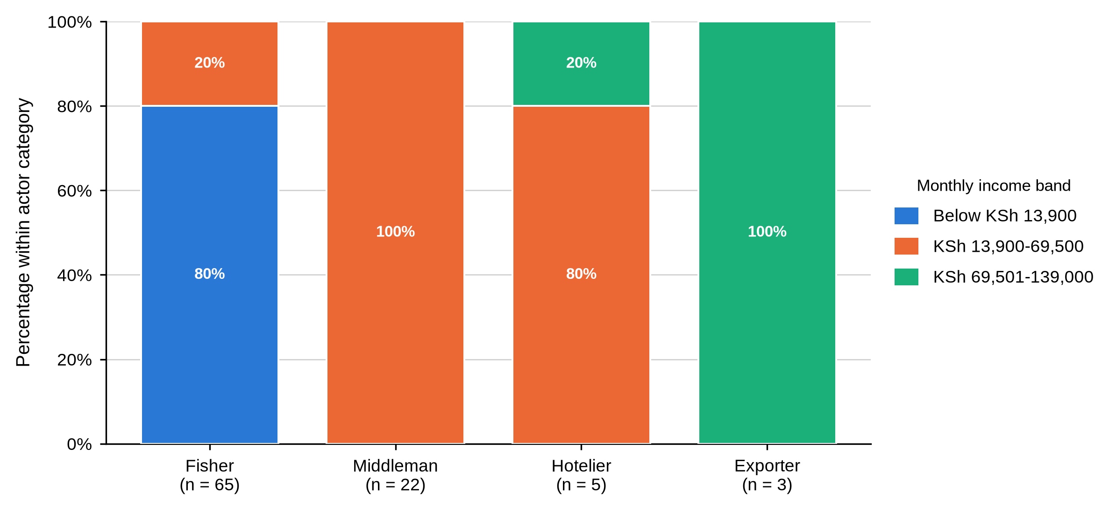
Note. Segments sum to 100% within each actor category. Income bands follow the categories used in the questionnaire. One exporter gave no valid income figure and is excluded from the exporter column.

4.3.3 Licensing, Credit, Training and Collective Membership
Table 5
Licensing, Credit, Training and Collective Membership by Actor Category
Characteristic and response | Fisher  (n = 65) | Middleman  (n = 22) | Hotelier  (n = 5) | Exporter  (n = 4) | Total  (N = 96)
Holds an operating licence (valid n = 64 / 22 / 5 / 4) BMU association: fishers χ²(3, N = 62) = 1.06, p = .840; middlemen χ²(2, N = 22) = 1.51, p = .580.
Yes | 8 (12.5) | 6 (27.3) | 5 (100.0) | 4 (100.0) | 23 (24.2)
No | 56 (87.5) | 16 (72.7) | 0 (0.0) | 0 (0.0) | 72 (75.8)
Uses loans to facilitate business (valid n = 65 / 22 / 5 / 4) BMU association: middlemen χ²(2, N = 22) = 2.36, p = .311.
Yes | 0 (0.0) | 16 (72.7) | 0 (0.0) | 2 (50.0) | 18 (18.8)
No | 65 (100.0) | 6 (27.3) | 5 (100.0) | 2 (50.0) | 78 (81.2)
Main source of business credit (valid n = 65 / 22 / 0 / 4) BMU association: fishers χ²(3, N = 63) = 5.74, p = .124; middlemen χ²(2, N = 22) = 4.82, p = .099.
Exporters | 0 (0.0) | 12 (54.5) | — | 0 (0.0) | 12 (13.2)
Formal institutions | 0 (0.0) | 0 (0.0) | — | 4 (100.0) | 4 (4.4)
Middlemen | 61 (93.8) | 10 (45.5) | — | 0 (0.0) | 71 (78.0)
Middlemen and relatives | 4 (6.2) | 0 (0.0) | — | 0 (0.0) | 4 (4.4)
Received formal mud crab training (valid n = 65 / 0 / 0 / 0) BMU association: fishers χ²(3, N = 63) = 8.48, p = .035.
Yes | 5 (7.7) | — | — | — | 5 (7.7)
No | 60 (92.3) | — | — | — | 60 (92.3)
Member of a cooperative or association (valid n = 65 / 22 / 5 / 4)
No | 65 (100.0) | 22 (100.0) | 5 (100.0) | 4 (100.0) | 96 (100.0)
Participates in a self-help group (valid n = 65 / 22 / 5 / 4)
No | 65 (100.0) | 22 (100.0) | 5 (100.0) | 4 (100.0) | 96 (100.0)
Formal standing in the fishery rises step by step along the chain. Eight of 64 fishers held an operating licence, 12.5%, against 27.3% of middlemen and every hotelier and exporter. Formal training reached 7.7% of fishers and was not recorded for the other three groups, whose questionnaires did not carry the item.
Credit runs the other way. No fisher reported using a business loan, yet 93.8% named a middleman as their main source of credit, and a further 6.2% named middlemen together with relatives. Among middlemen themselves, 72.7% used loans, drawn from exporters in 54.5% of cases and from other middlemen in 45.5%. All four exporters who borrowed used formal institutions. Credit in this chain is therefore not absent; it is supplied downward through trading relationships rather than by banks, and the actor extending it to a fisher is the same actor buying from him.
Figure 10
Licensing, Credit, Training and Collective Membership by Actor Category
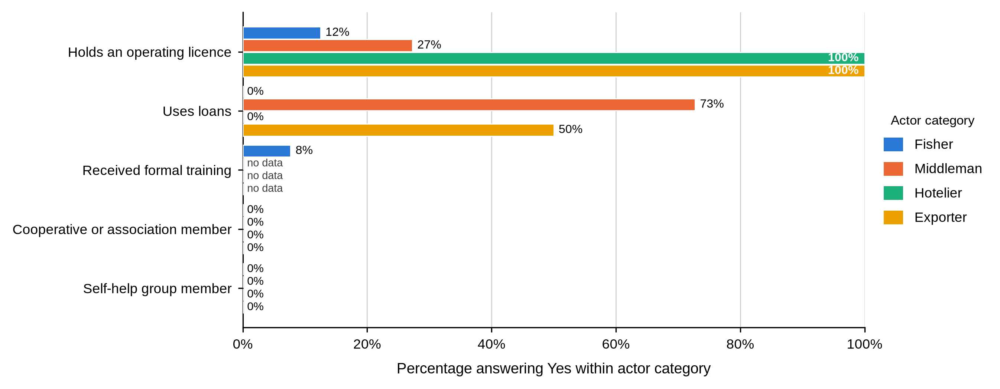
Note. Bars show the percentage answering Yes within each actor category. The label no data marks an item that the actor category did not complete, which is different from a zero.
The starkest result under Objective One needs no test. Not one respondent in any of the four actor categories belonged to a cooperative, an association or a self-help group. In a fishery organised around Beach Management Units and co-management, no collective body existed at any node to pool information, negotiate price or carry training.

4.3.4 Summary of Objective One
Objective One asked who the mud crab actors are. The answer is four groups that differ systematically and in the same direction on almost every measure. Fishers are younger, less schooled, unlicensed, untrained, small-scale, un-diversified and indebted to their own buyers. Middlemen are older, far more experienced, better capitalised and connected to exporters. Hoteliers and exporters are formally qualified, fully licensed and operating at a scale the upstream actors do not reach. Site mattered for the age of the fishing population, for marital status and for whether a fisher had been trained, but the larger and more consistent differences ran between actor categories rather than between landing sites.

4.4 Objective Two: Functions of Actors at Each Market Node

4.4.1 Sourcing, Buyers and Market Channels
Table 6
Sourcing, Buyer Category and Market Channel by Actor Category
Characteristic and response | Fisher  (n = 65) | Middleman  (n = 22) | Hotelier  (n = 5) | Exporter  (n = 4) | Total  (N = 96)
How mud crabs are acquired (valid n = 65 / 22 / 5 / 4)
Catching | 65 (100.0) | 0 (0.0) | 0 (0.0) | 0 (0.0) | 65 (67.7)
Purchasing | 0 (0.0) | 22 (100.0) | 5 (100.0) | 4 (100.0) | 31 (32.3)
Source of crabs for sale (valid n = 65 / 22 / 5 / 4)
Catching personally | 65 (100.0) | 1 (4.5) | 0 (0.0) | 0 (0.0) | 66 (68.8)
Purchasing from middlemen | 0 (0.0) | 21 (95.5) | 5 (100.0) | 0 (0.0) | 26 (27.1)
Purchasing from middlemen/agents | 0 (0.0) | 0 (0.0) | 0 (0.0) | 4 (100.0) | 4 (4.2)
Main buyer category (valid n = 65 / 22 / 5 / 4) BMU association: middlemen χ²(6, N = 22) = 4.80, p = .656.
Company agents | 0 (0.0) | 9 (40.9) | 0 (0.0) | 0 (0.0) | 9 (9.4)
Consumers | 0 (0.0) | 0 (0.0) | 5 (100.0) | 0 (0.0) | 5 (5.2)
Exporters | 0 (0.0) | 5 (22.7) | 0 (0.0) | 0 (0.0) | 5 (5.2)
First-level middlemen | 65 (100.0) | 1 (4.5) | 0 (0.0) | 0 (0.0) | 66 (68.8)
Importers | 0 (0.0) | 0 (0.0) | 0 (0.0) | 4 (100.0) | 4 (4.2)
Second-level middlemen | 0 (0.0) | 7 (31.8) | 0 (0.0) | 0 (0.0) | 7 (7.3)
Primary market channel (valid n = 65 / 22 / 5 / 4)
Export markets | 0 (0.0) | 0 (0.0) | 0 (0.0) | 4 (100.0) | 4 (4.2)
Local markets | 65 (100.0) | 22 (100.0) | 0 (0.0) | 0 (0.0) | 87 (90.6)
Restaurants and hotels | 0 (0.0) | 0 (0.0) | 5 (100.0) | 0 (0.0) | 5 (5.2)
Contact with final consumers (valid n = 65 / 22 / 5 / 4)
Direct contact | 0 (0.0) | 0 (0.0) | 5 (100.0) | 4 (100.0) | 9 (9.4)
Through intermediaries | 65 (100.0) | 22 (100.0) | 0 (0.0) | 0 (0.0) | 87 (90.6)
Primary market supplied (valid n = 65 / 22 / 5 / 4)
Local markets | 65 (100.0) | 22 (100.0) | 5 (100.0) | 0 (0.0) | 92 (95.8)
Export markets | 0 (0.0) | 0 (0.0) | 0 (0.0) | 4 (100.0) | 4 (4.2)
Each node occupies one position and only one. Every fisher caught the crabs personally; every middleman, hotelier and exporter bought them. All 65 fishers sold to a first-level middleman, while middlemen sold on to company agents (40.9%), second-level middlemen (31.8%) or exporters (22.7%). Hoteliers sold to consumers and exporters to importers.
That pattern answers part of Objective Two directly. Fishers and middlemen reached the final consumer only through intermediaries, 100% in both cases, while every hotelier and exporter dealt with the end buyer face to face. Ninety-five point eight per cent of respondents supplied local markets; only the four exporters supplied export markets. The people who know what the crab finally sells for are the people furthest from the water.
Figure 11
Source of Crabs for Sale Within Each Actor Category
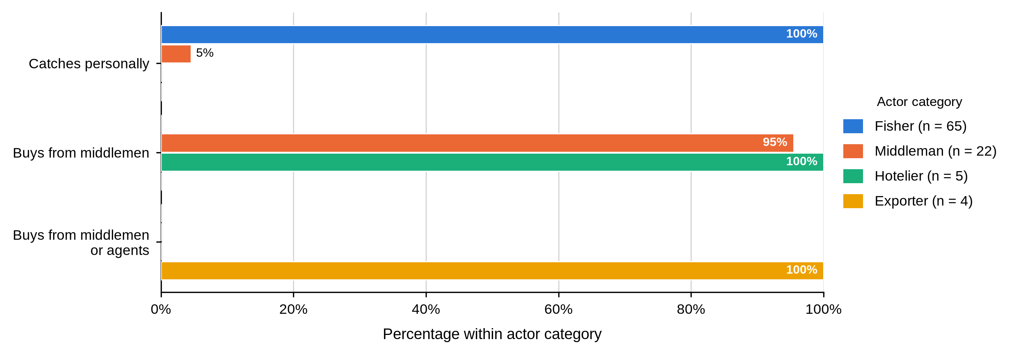
Note. Bars show the percentage within each actor category. Percentages are valid percentages within the actor category.
Figure 12
Main Buyer Category Within Each Actor Category
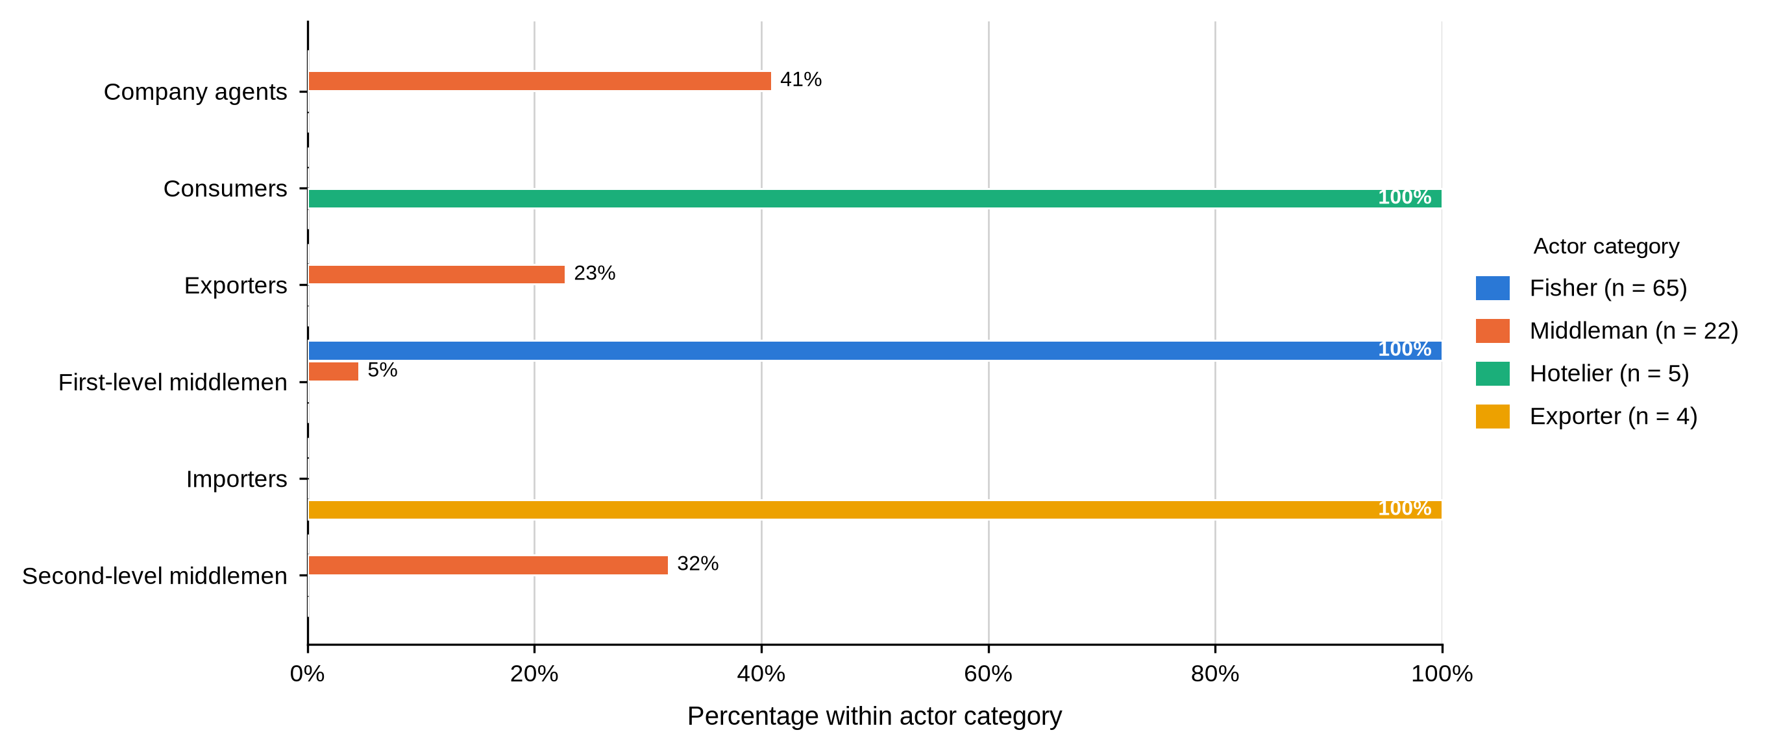
Note. Bars show the percentage within each actor category. Fishers sold exclusively to first-level middlemen; the downstream categories each had a distinct main buyer.

4.4.2 Harvesting Gear, Catch and Travel Time
Table 7
Harvesting Gear, Daily Catch, Proportion Sold and Travel Time by Actor Category
Characteristic and response | Fisher  (n = 65) | Middleman  (n = 22) | Hotelier  (n = 5) | Exporter  (n = 4) | Total  (N = 96)
Fishing or collection gear (valid n = 65 / 1 / 0 / 0) BMU association: fishers χ²(9, N = 63) = 13.15, p = .144.
Hand collection | 47 (72.3) | 1 (100.0) | — | — | 48 (72.7)
Hooked stick | 8 (12.3) | 0 (0.0) | — | — | 8 (12.1)
Scoop net | 9 (13.8) | 0 (0.0) | — | — | 9 (13.6)
Sweep nets | 1 (1.5) | 0 (0.0) | — | — | 1 (1.5)
Daily mud crab catch (valid n = 65 / 0 / 0 / 0) BMU association: fishers χ²(6, N = 63) = 5.79, p = .453.
2-3 kg | 1 (1.5) | — | — | — | 1 (1.5)
4-5 kg | 6 (9.2) | — | — | — | 6 (9.2)
5-10 kg | 44 (67.7) | — | — | — | 44 (67.7)
Above 10 kg | 14 (21.5) | — | — | — | 14 (21.5)
Proportion of catch sold (valid n = 65 / 0 / 0 / 0) BMU association: fishers χ²(3, N = 63) = 2.67, p = .452.
Three-quarters | 13 (20.0) | — | — | — | 13 (20.0)
Whole catch | 52 (80.0) | — | — | — | 52 (80.0)
Travel time from fishing grounds to market (valid n = 65 / 0 / 0 / 0) BMU association: fishers χ²(3, N = 63) = 11.13, p = .010.
1 hour | 22 (33.8) | — | — | — | 22 (33.8)
6 hours | 43 (66.2) | — | — | — | 43 (66.2)
Harvesting itself is a fisher function, and the table shows dashes for the three downstream categories because those items were not put to them. Hand collection dominated at 72.3%, with scoop nets at 13.8% and hooked sticks at 12.3%. Two-thirds of fishers reported catching 5 to 10 kg a day and 21.5% more than 10 kg. Four fifths sold the whole catch rather than retaining any, and two thirds travelled six hours from the fishing grounds to the point of sale.
These numbers matter for the rest of the chapter because they describe a seller with no holding capacity. A fisher who lands 5 to 10 kg of live crab, walks six hours and sells the entire catch the same day has no way to wait for a better price.

4.4.3 Preparation, Packaging, Preservation and Transport
Table 8
Preparation, Packaging, Preservation and Transport by Actor Category
Characteristic and response | Fisher  (n = 65) | Middleman  (n = 22) | Hotelier  (n = 5) | Exporter  (n = 4) | Total  (N = 96)
Preparation of mud crabs for market (valid n = 65 / 22 / 5 / 4) BMU association: middlemen χ²(2, N = 22) = 1.05, p = 1.000.
Cleaning, sorting and grading | 0 (0.0) | 21 (95.5) | 0 (0.0) | 4 (100.0) | 25 (26.0)
Processing | 0 (0.0) | 1 (4.5) | 5 (100.0) | 0 (0.0) | 6 (6.2)
Tying claws | 65 (100.0) | 0 (0.0) | 0 (0.0) | 0 (0.0) | 65 (67.7)
Packaging used for transportation (valid n = 65 / 22 / 0 / 4) BMU association: fishers χ²(3, N = 63) = 0.89, p = .837; middlemen χ²(4, N = 22) = 1.54, p = .924.
Baskets | 0 (0.0) | 10 (45.5) | — | 0 (0.0) | 10 (11.0)
Crates | 0 (0.0) | 11 (50.0) | — | 0 (0.0) | 11 (12.1)
Plastic containers | 21 (32.3) | 0 (0.0) | — | 0 (0.0) | 21 (23.1)
Sacks | 44 (67.7) | 1 (4.5) | — | 0 (0.0) | 45 (49.5)
Styrofoam | 0 (0.0) | 0 (0.0) | — | 4 (100.0) | 4 (4.4)
Preserves or processes mud crabs (valid n = 65 / 22 / 5 / 4)
Yes / frozen | 0 (0.0) | 0 (0.0) | 5 (100.0) | 0 (0.0) | 5 (5.2)
No | 65 (100.0) | 22 (100.0) | 0 (0.0) | 4 (100.0) | 91 (94.8)
Mode of transporting mud crabs to market (valid n = 65 / 22 / 0 / 4) BMU association: fishers χ²(3, N = 63) = 3.14, p = .388; middlemen χ²(4, N = 22) = 4.26, p = .402.
Airplane | 0 (0.0) | 0 (0.0) | — | 4 (100.0) | 4 (4.4)
Motorcycle | 8 (12.3) | 0 (0.0) | — | 0 (0.0) | 8 (8.8)
Motorised boat | 0 (0.0) | 4 (18.2) | — | 0 (0.0) | 4 (4.4)
On foot | 57 (87.7) | 1 (4.5) | — | 0 (0.0) | 58 (63.7)
Vehicle | 0 (0.0) | 17 (77.3) | — | 0 (0.0) | 17 (18.7)
Handling becomes more elaborate at every step. All 65 fishers prepared crabs by tying the claws; 95.5% of middlemen cleaned, sorted and graded; every hotelier processed for the kitchen; and all four exporters cleaned, sorted and graded for consignment. Only the hoteliers preserved or processed the product, by freezing.
Packaging and transport follow the same ladder. Fishers used sacks (67.7%) or plastic containers (32.3%) and carried crabs on foot (87.7%). Middlemen used crates (50.0%) or baskets (45.5%) and moved them by vehicle (77.3%) or motorised boat (18.2%). Exporters used Styrofoam and air freight. Hoteliers did not complete the packaging and transport items because they bought at their own premises, and the cells are left blank rather than recorded as zero.
Figure 13
Preparation of Mud Crabs for Market by Actor Category
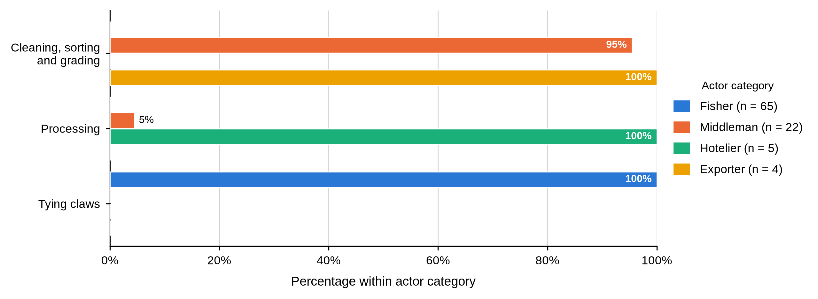
Note. Bars show the percentage within each actor category. Preparation moves from tying claws at the harvesting node to cleaning, sorting and grading downstream.
Figure 14
Packaging Used for Transporting Mud Crabs by Actor Category
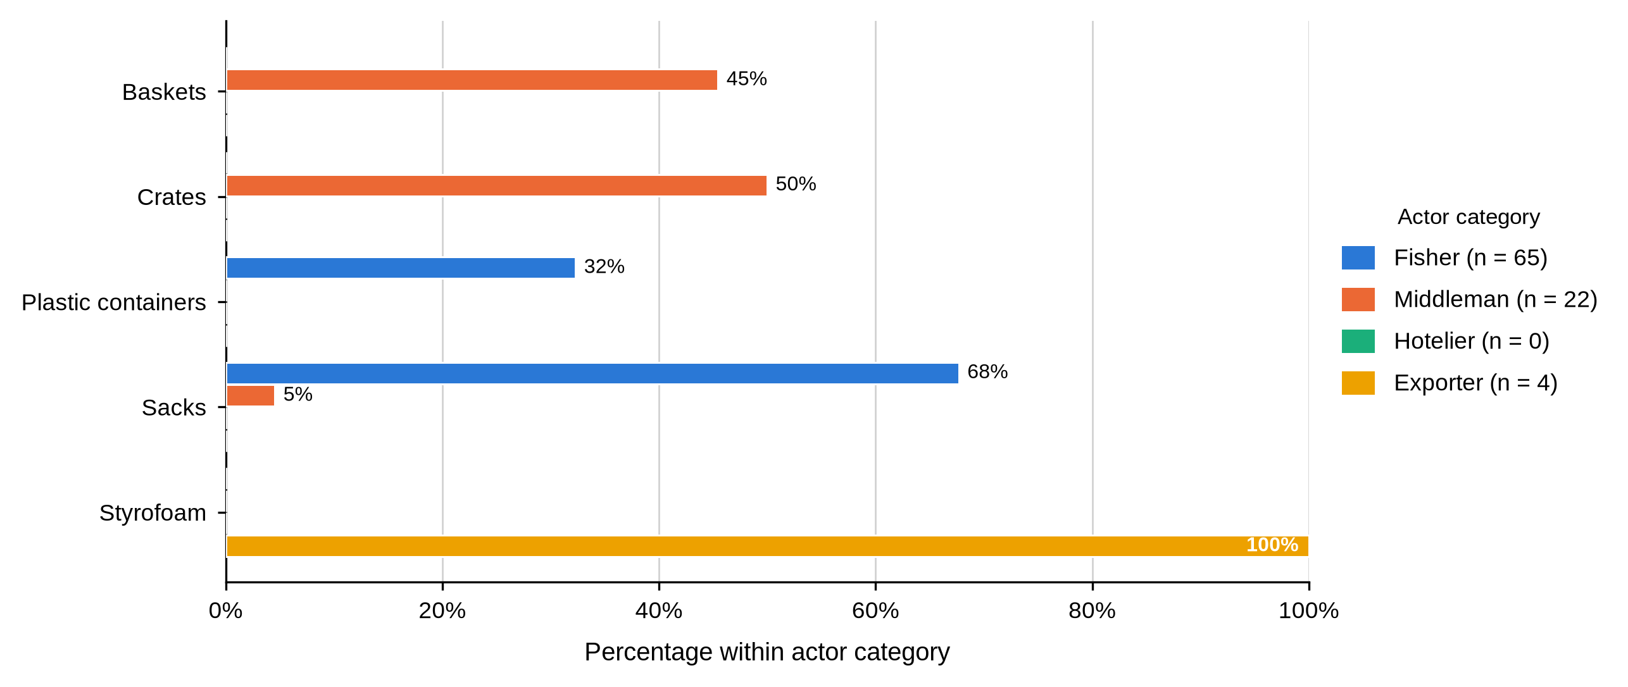
Note. Bars show the percentage within each actor category. Hoteliers did not complete this item because they purchased at their own premises.
Figure 15
Mode of Transporting Mud Crabs to Market by Actor Category
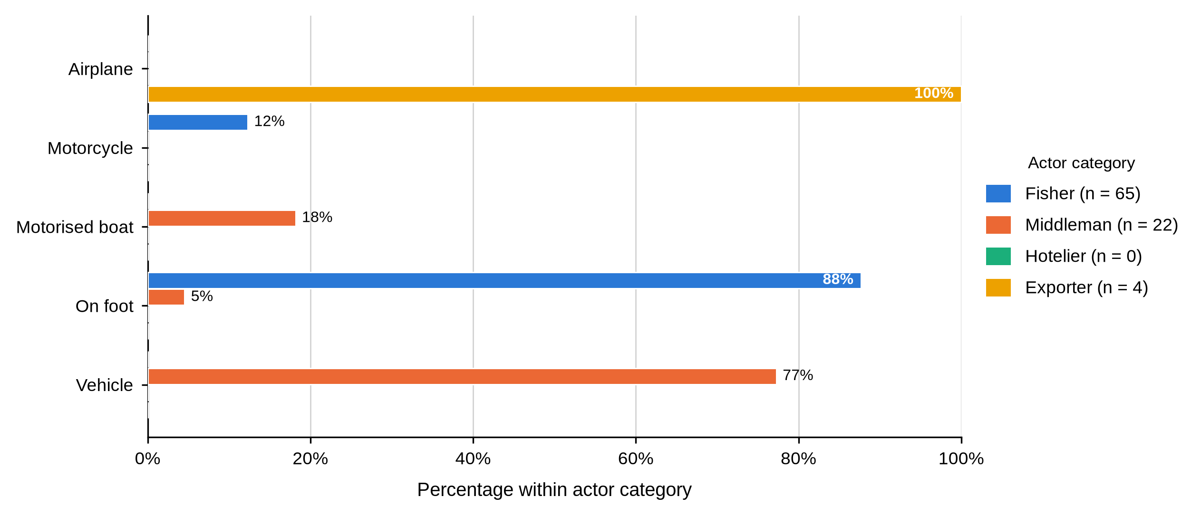
Note. Bars show the percentage within each actor category. Hoteliers did not complete this item.

4.4.4 Grading and Quality Control
Table 9
Grading Practice, Grading Criteria and Quality Control by Actor Category
Characteristic and response | Fisher  (n = 65) | Middleman  (n = 22) | Hotelier  (n = 5) | Exporter  (n = 4) | Total  (N = 96)
Engages in grading mud crabs (valid n = 65 / 22 / 5 / 4)
Yes | 65 (100.0) | 22 (100.0) | 5 (100.0) | 4 (100.0) | 96 (100.0)
Criteria used to determine grade (valid n = 65 / 22 / 5 / 4) BMU association: middlemen χ²(2, N = 22) = 1.05, p = 1.000.
Size, weight, shell condition and claw size | 0 (0.0) | 21 (95.5) | 5 (100.0) | 4 (100.0) | 30 (31.2)
Weight only | 65 (100.0) | 1 (4.5) | 0 (0.0) | 0 (0.0) | 66 (68.8)
Quality measure before the market (valid n = 65 / 22 / 5 / 4)
Inspections, certification and packaging standards | 0 (0.0) | 0 (0.0) | 0 (0.0) | 4 (100.0) | 4 (4.2)
Packaging standards | 0 (0.0) | 21 (95.5) | 5 (100.0) | 0 (0.0) | 26 (27.1)
Tying the claws | 65 (100.0) | 1 (4.5) | 0 (0.0) | 0 (0.0) | 66 (68.8)
Uses formal quality-control measures (valid n = 65 / 22 / 5 / 4)
Yes | 0 (0.0) | 0 (0.0) | 5 (100.0) | 4 (100.0) | 9 (9.4)
No | 65 (100.0) | 22 (100.0) | 0 (0.0) | 0 (0.0) | 87 (90.6)
Every one of the 96 respondents said they graded mud crabs. They did not grade by the same rule. All 65 fishers graded on weight alone, while 95.5% of middlemen and every hotelier and exporter combined size, weight, shell condition and claw size. Quality assurance split the same way: fishers tied the claws, middlemen and hoteliers cited packaging standards, and exporters cited inspections, certification and packaging standards. Formal quality-control measures were reported by the nine downstream actors and by none of the 87 fishers and middlemen.
This is the clearest functional asymmetry in the chapter and it speaks directly to Objective Two. A fisher can weigh a crab as accurately as anyone. What he cannot do is price the shell condition and claw size his buyer is paying for, or check independently whether the grade he was offered is the grade the animal deserves.
Figure 16
Criteria Used to Determine Crab Grade by Actor Category
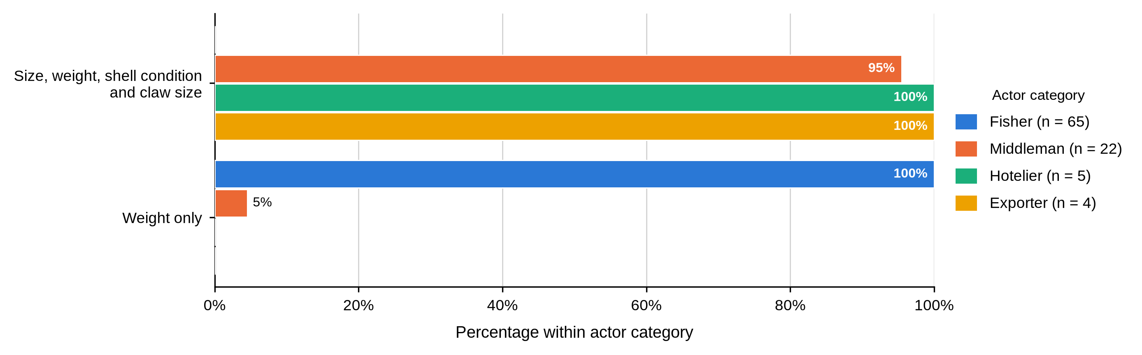
Note. Bars show the percentage within each actor category. Fishers graded on weight alone; every other category used a four-criterion rule.
Table 10
Size Labels and Grade Assignment by Actor Category
Characteristic and response | Fisher  (n = 65) | Middleman  (n = 22) | Hotelier  (n = 5) | Exporter  (n = 4) | Total  (N = 96)
Reported large-crab size category (valid n = 65 / 21 / 5 / 4) BMU association: fishers χ²(3, N = 63) = 16.87, p = .001.
All sizes / mixed | 12 (18.5) | 0 (0.0) | 0 (0.0) | 0 (0.0) | 12 (12.6)
Large | 53 (81.5) | 21 (100.0) | 5 (100.0) | 4 (100.0) | 83 (87.4)
Grade assigned to large crabs (valid n = 65 / 22 / 5 / 4)
Grade A | 50 (76.9) | 22 (100.0) | 5 (100.0) | 4 (100.0) | 81 (84.4)
Mixed grade | 15 (23.1) | 0 (0.0) | 0 (0.0) | 0 (0.0) | 15 (15.6)
Reported medium-crab size category (valid n = 65 / 22 / 0 / 4) BMU association: fishers χ²(3, N = 63) = 3.14, p = .406.
Medium | 63 (96.9) | 22 (100.0) | — | 4 (100.0) | 89 (97.8)
Mixed size | 2 (3.1) | 0 (0.0) | — | 0 (0.0) | 2 (2.2)
Grade assigned to medium crabs (valid n = 65 / 22 / 0 / 4)
Grade B | 51 (78.5) | 22 (100.0) | — | 4 (100.0) | 77 (84.6)
Mixed grade | 14 (21.5) | 0 (0.0) | — | 0 (0.0) | 14 (15.4)
Reported small-crab size category (valid n = 65 / 0 / 0 / 0) BMU association: fishers χ²(3, N = 63) = 15.96, p = .002.
Mixed size | 9 (13.8) | — | — | — | 9 (13.8)
Small | 56 (86.2) | — | — | — | 56 (86.2)
Grade assigned to small crabs (valid n = 65 / 0 / 0 / 0)
Grade C | 59 (90.8) | — | — | — | 59 (90.8)
Mixed grade | 6 (9.2) | — | — | — | 6 (9.2)
The labels themselves were not applied uniformly. While 81.5% of fishers used the Large label for their biggest crabs, 18.5% recorded all sizes or mixed, and 23.1% assigned a mixed grade rather than Grade A. Every middleman, hotelier and exporter who answered used the plain Large and Grade A labels. Small-grade labels were recorded for fishers only, since no downstream actor reported handling that grade.
Label use differed significantly across sites for fishers, for large crabs, χ²(3, N = 63) = 16.87, p = .001, and for small crabs, χ²(3, N = 63) = 15.96, p = .002, but not for medium crabs, p = .406. The survey recorded the word, not a measured carapace width, so this is a matter of vocabulary rather than biology. It still carries a cost: a Shimoni fisher and his buyer may not mean the same thing by the word large, and that is exactly the condition under which a grading dispute goes the better-informed party’s way.
Figure 17
Large-Crab Size Label Reported by Fishers Within Each Study Site
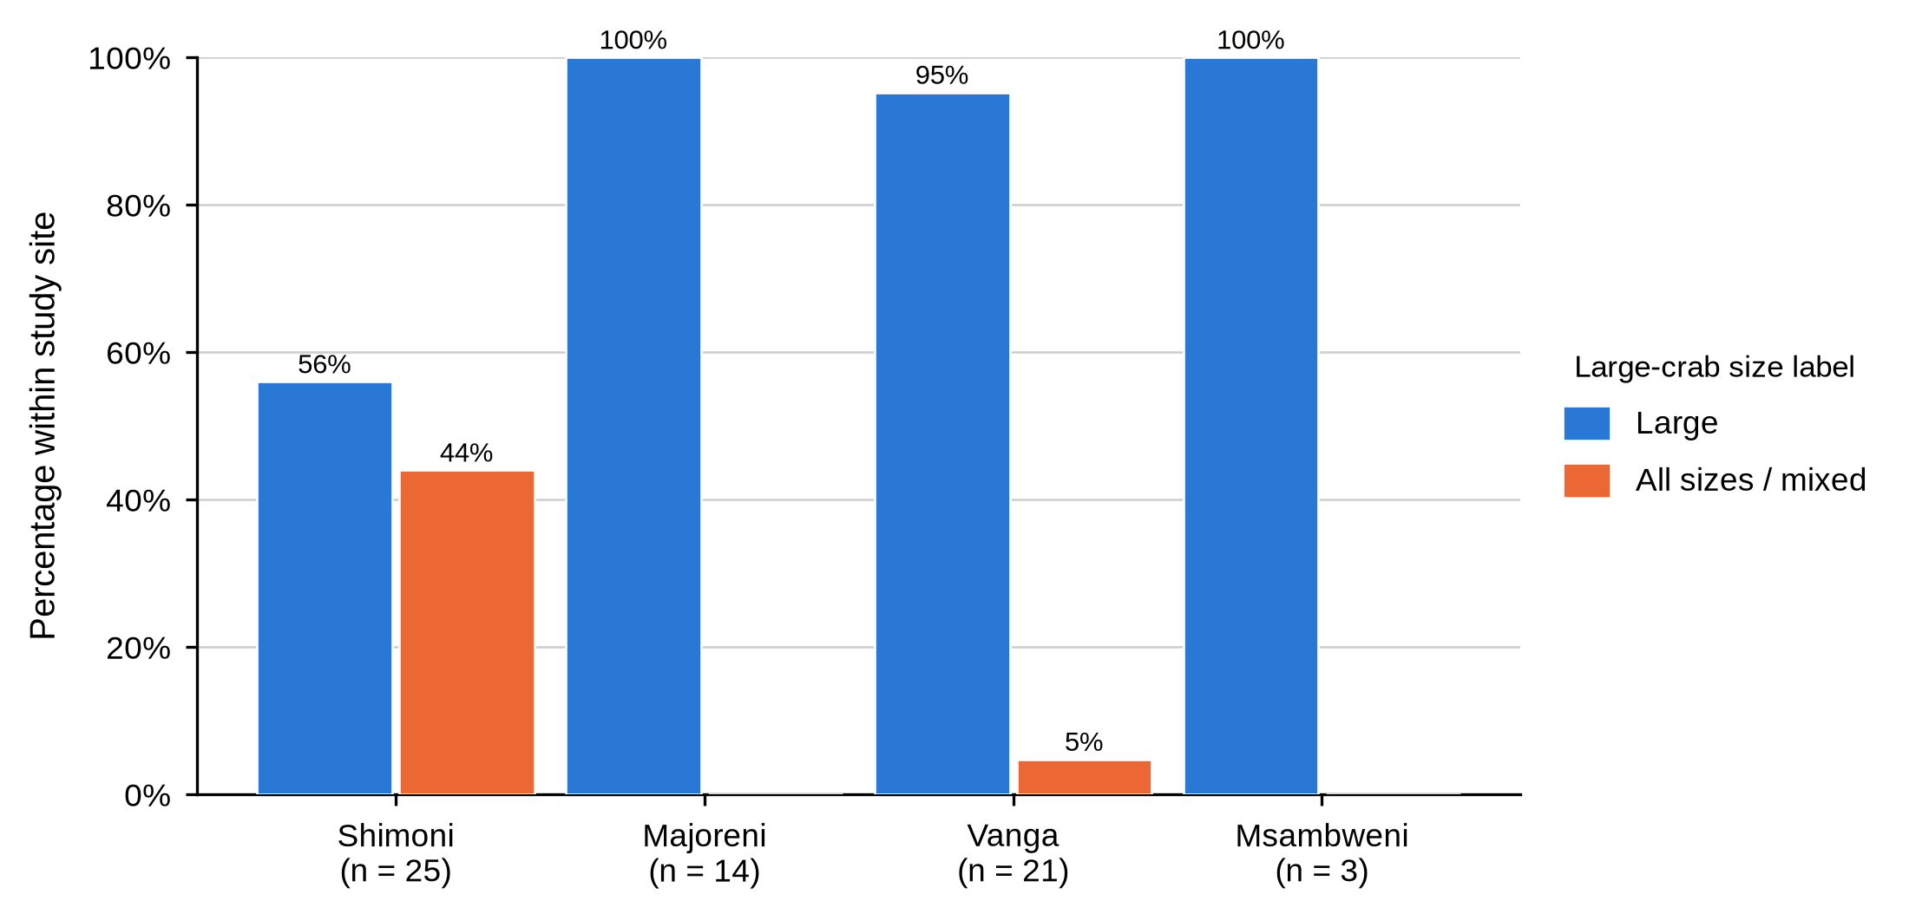
Note. Bars show the percentage of fishers within each site using each label. The Other sites group is excluded from the site comparison.

4.4.5 Mortality and Spoilage
Table 11
Reported Mortality and Spoilage by Actor Category
Characteristic and response | Fisher  (n = 65) | Middleman  (n = 22) | Hotelier  (n = 5) | Exporter  (n = 4) | Total  (N = 96)
Reported daily mortality quantity (valid n = 65 / 22 / 5 / 4) BMU association: middlemen χ²(2, N = 22) = 1.05, p = 1.000.
Frozen / no mortality | 0 (0.0) | 0 (0.0) | 5 (100.0) | 0 (0.0) | 5 (5.2)
0.5-1 kg | 65 (100.0) | 1 (4.5) | 0 (0.0) | 0 (0.0) | 66 (68.8)
4-5 kg | 0 (0.0) | 21 (95.5) | 0 (0.0) | 0 (0.0) | 21 (21.9)
Above 10 kg | 0 (0.0) | 0 (0.0) | 0 (0.0) | 4 (100.0) | 4 (4.2)
Reported loss through spoilage (valid n = 0 / 22 / 5 / 4) BMU association: middlemen χ²(2, N = 22) = 5.56, p = .066.
1 kg | — | 0 (0.0) | 5 (100.0) | 0 (0.0) | 5 (16.1)
3 kg | — | 9 (40.9) | 0 (0.0) | 0 (0.0) | 9 (29.0)
5 kg | — | 13 (59.1) | 0 (0.0) | 0 (0.0) | 13 (41.9)
Above 10 kg | — | 0 (0.0) | 0 (0.0) | 4 (100.0) | 4 (12.9)
Losses were reported everywhere and measured nowhere against a common standard. All 65 fishers reported daily mortality of 0.5 to 1 kg, 95.5% of middlemen reported 4 to 5 kg, and all four exporters reported more than 10 kg. Hoteliers reported no mortality because they froze the product on arrival. Spoilage was not put to fishers; among those who answered, 59.1% of middlemen reported 5 kg and 40.9% reported 3 kg.
The quantities rise with the volume each actor holds, which is what would be expected. The point for Objective Two is that the actor holding live stock carries the loss, and no actor in the chain recorded it against a shared measure that would let the cost be priced into a grade.
Figure 18
Reported Daily Mortality by Actor Category
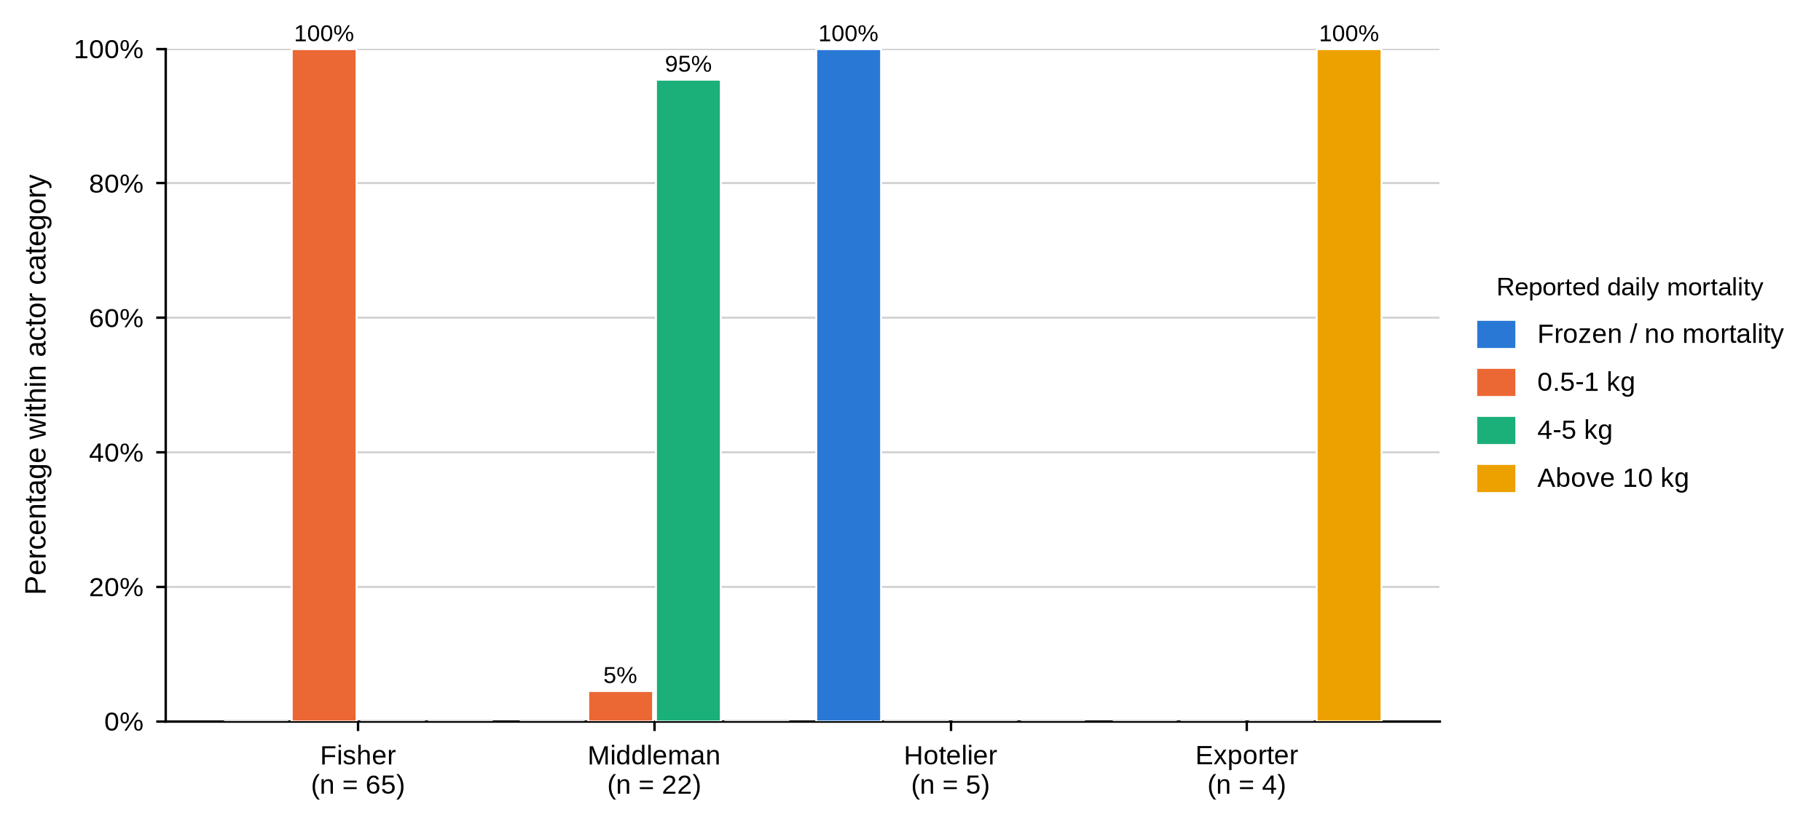
Note. Bars show the percentage within each actor category. Hoteliers reported no mortality because crabs were frozen on arrival.

4.4.6 Payment, Price Setting and Sale Location
Table 12
Payment Arrangements, Price Setting and Sale Location by Actor Category
Characteristic and response | Fisher  (n = 65) | Middleman  (n = 22) | Hotelier  (n = 5) | Exporter  (n = 4) | Total  (N = 96)
Mode of payment (valid n = 65 / 22 / 5 / 0) BMU association: fishers χ²(9, N = 63) = 8.21, p = .515; middlemen χ²(4, N = 22) = 3.92, p = .470.
Cash on delivery | 10 (15.4) | 6 (27.3) | 0 (0.0) | — | 16 (17.4)
Credit | 18 (27.7) | 9 (40.9) | 0 (0.0) | — | 27 (29.3)
M-Pesa | 30 (46.2) | 7 (31.8) | 0 (0.0) | — | 37 (40.2)
M-Pesa and cash | 0 (0.0) | 0 (0.0) | 5 (100.0) | — | 5 (5.4)
M-Pesa and credit | 7 (10.8) | 0 (0.0) | 0 (0.0) | — | 7 (7.6)
Standard pricing mechanism is used (valid n = 65 / 22 / 5 / 4)
No | 65 (100.0) | 22 (100.0) | 5 (100.0) | 4 (100.0) | 96 (100.0)
How mud crab prices are set (valid n = 65 / 22 / 5 / 4) BMU association: middlemen χ²(2, N = 22) = 0.80, p = .722.
Competitive pricing | 0 (0.0) | 14 (63.6) | 0 (0.0) | 4 (100.0) | 18 (18.8)
Fixed pricing | 65 (100.0) | 8 (36.4) | 5 (100.0) | 0 (0.0) | 78 (81.2)
Factors influencing price fluctuations (valid n = 65 / 22 / 5 / 4) BMU association: middlemen χ²(2, N = 22) = 3.27, p = .238.
Seasonal and economic factors | 0 (0.0) | 14 (63.6) | 0 (0.0) | 0 (0.0) | 14 (14.6)
Seasonal factors only | 0 (0.0) | 0 (0.0) | 5 (100.0) | 0 (0.0) | 5 (5.2)
Seasonal, weather and regulatory factors | 65 (100.0) | 8 (36.4) | 0 (0.0) | 4 (100.0) | 77 (80.2)
Location of sale (valid n = 65 / 22 / 5 / 4) BMU association: middlemen χ²(4, N = 22) = 1.54, p = .928.
Landing beach | 65 (100.0) | 1 (4.5) | 0 (0.0) | 0 (0.0) | 66 (68.8)
Market | 0 (0.0) | 10 (45.5) | 0 (0.0) | 0 (0.0) | 10 (10.4)
Town | 0 (0.0) | 11 (50.0) | 5 (100.0) | 4 (100.0) | 20 (20.8)
M-Pesa was the commonest single payment arrangement among fishers at 46.2%, but credit took 27.7% and a further 10.8% combined M-Pesa with credit. Close to two fishers in five were therefore being paid at least partly on credit by the very middleman buying from them. Middlemen most often reported credit themselves, at 40.9%. Hoteliers used M-Pesa and cash together; the payment item was not completed by exporters.
Price setting divides the chain in two. All 65 fishers and all five hoteliers called the price fixed, meaning the buyer set it and told them. Fourteen of 22 middlemen, 63.6%, and all four exporters called their own pricing competitive. Not one respondent in any category reported a standard pricing mechanism. Fixed at the fisher node and competitive at the middleman node are the same transaction described from either end.
Figure 19
Mode of Payment by Actor Category
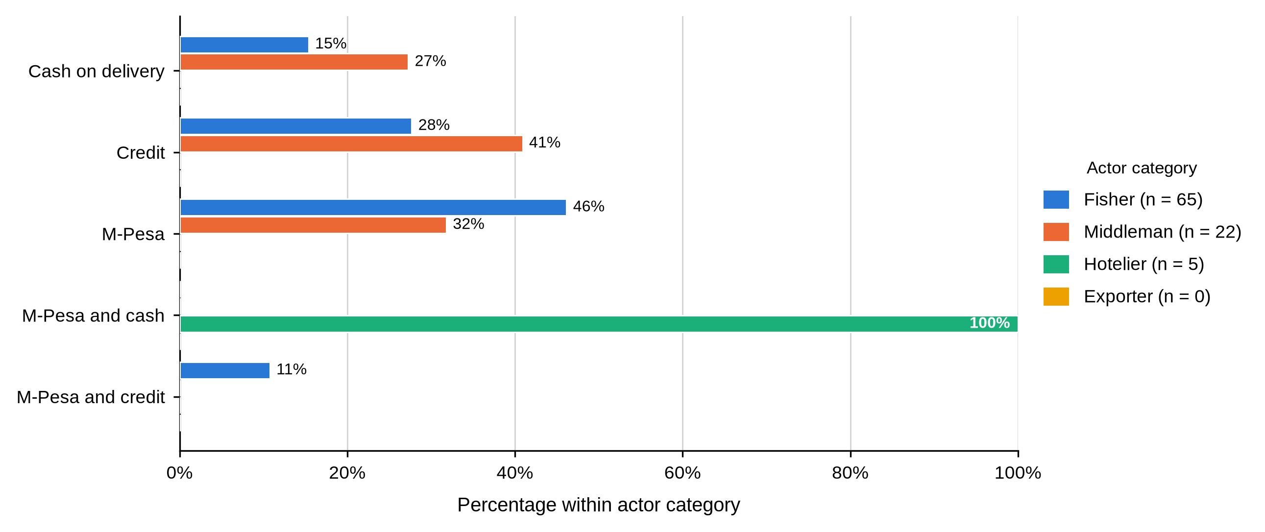
Note. Bars show the percentage within each actor category. The payment item was not completed by exporters.
Figure 20
How Mud Crab Prices Are Set, by Actor Category
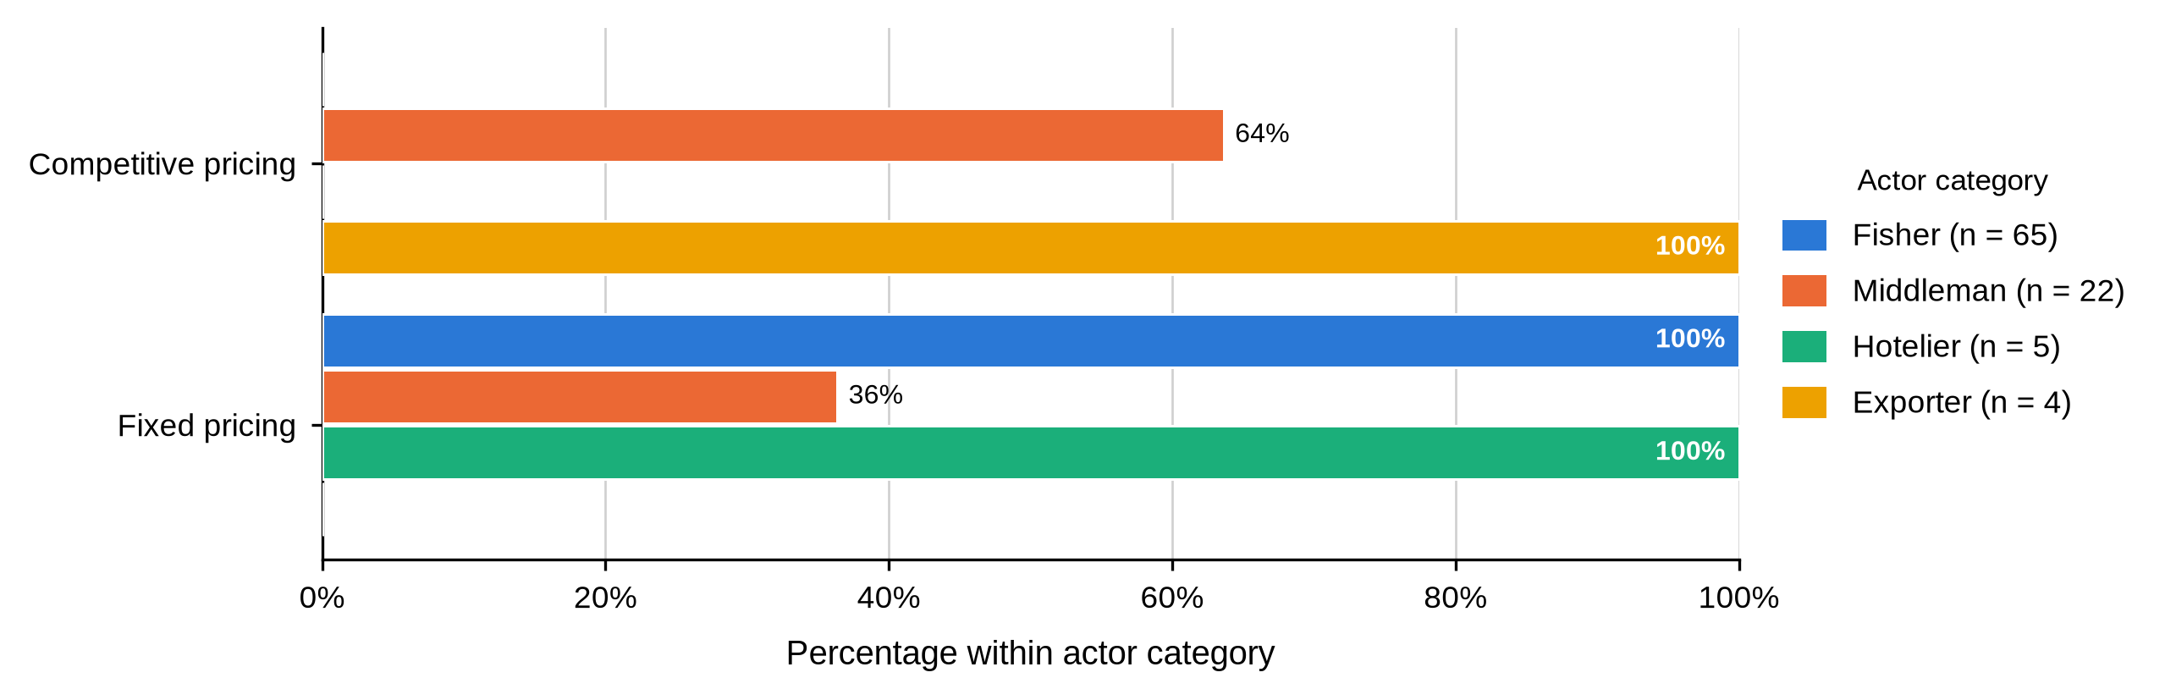
Note. Bars show the percentage within each actor category. Fishers and hoteliers described the price as fixed by the buyer; middlemen and exporters described their own pricing as competitive.

4.4.7 Trading Relationships and Market Information
Table 13
Trading Relationships, Agreements, Technology and Market Research by Actor Category
Characteristic and response | Fisher  (n = 65) | Middleman  (n = 22) | Hotelier  (n = 5) | Exporter  (n = 4) | Total  (N = 96)
Has fishers tied to the business (valid n = 65 / 22 / 5 / 4)
Yes | 0 (0.0) | 21 (95.5) | 5 (100.0) | 0 (0.0) | 26 (27.1)
No | 65 (100.0) | 1 (4.5) | 0 (0.0) | 4 (100.0) | 70 (72.9)
Has traders tied to the business (valid n = 65 / 22 / 5 / 4)
Yes | 65 (100.0) | 11 (50.0) | 5 (100.0) | 4 (100.0) | 85 (88.5)
No | 0 (0.0) | 11 (50.0) | 0 (0.0) | 0 (0.0) | 11 (11.5)
Has a formal or informal trading agreement (valid n = 10 / 22 / 5 / 4)
Yes | 1 (10.0) | 21 (95.5) | 5 (100.0) | 4 (100.0) | 31 (75.6)
No | 9 (90.0) | 1 (4.5) | 0 (0.0) | 0 (0.0) | 10 (24.4)
Role of intermediaries (valid n = 65 / 22 / 5 / 4) BMU association: fishers χ²(3, N = 63) = 0.40, p = .925; middlemen χ²(4, N = 22) = 1.44, p = 1.000.
Marketing | 24 (36.9) | 1 (4.5) | 5 (100.0) | 0 (0.0) | 30 (31.2)
Negotiation | 41 (63.1) | 7 (31.8) | 0 (0.0) | 0 (0.0) | 48 (50.0)
Negotiation and marketing | 0 (0.0) | 14 (63.6) | 0 (0.0) | 4 (100.0) | 18 (18.8)
Terms used with intermediaries (valid n = 65 / 22 / 5 / 4)
Flexible terms | 65 (100.0) | 22 (100.0) | 5 (100.0) | 0 (0.0) | 92 (95.8)
Flexible terms and competitive bidding | 0 (0.0) | 0 (0.0) | 0 (0.0) | 4 (100.0) | 4 (4.2)
Adopted technology or modern equipment (valid n = 65 / 22 / 5 / 4)
No | 65 (100.0) | 22 (100.0) | 5 (100.0) | 4 (100.0) | 96 (100.0)
Conducts market research (valid n = 65 / 22 / 5 / 4)
No | 65 (100.0) | 22 (100.0) | 5 (100.0) | 4 (100.0) | 96 (100.0)
Tied relationships run downward. No fisher had fishers tied to him, but every fisher had a trader tied to his business, while 95.5% of middlemen and every hotelier had fishers tied to theirs. Formal or informal trading agreements covered 95.5% of middlemen and every hotelier and exporter, against one of the ten fishers who answered the item.
Two rows in this table carry no variation at all and are the more striking for it. Not one respondent in any actor category had adopted modern equipment, and not one conducted market research. Every actor said they stayed current by networking. In a chain where the buyer sets the price and the grading rule, information travels through the same commercial relationships that determine the terms of trade.

4.4.8 Reported Mud Crab Prices
Prices were collected for three size grades in Kenya shillings per kilogram of live crab, and every figure is a gross price at the point of sale. Nothing was recorded about transport, holding, mortality, ice, packaging or the cost of money tied up between buying and selling.
Table 14
Reported Mud Crab Prices by Actor Category and Size Grade
Actor category | Valid n | M | SD | Mdn | IQR | Min | Max
Large (Grade A)
Fisher | 65 | 604.6 | 192.2 | 650.0 | 500.0–800.0 | 300.0 | 800.0
Middleman | 22 | 945.5 | 140.5 | 1,000.0 | 800.0–1,000.0 | 800.0 | 1,200.0
Hotelier | 5 | 2,200.0 | 570.1 | 2,000.0 | 2,000.0–2,500.0 | 1,500.0 | 3,000.0
Exporter | 4 | 1,700.0 | 115.5 | 1,700.0 | 1,600.0–1,800.0 | 1,600.0 | 1,800.0
Medium (Grade B)
Fisher | 65 | 514.6 | 163.4 | 500.0 | 400.0–600.0 | 300.0 | 800.0
Middleman | 22 | 718.2 | 100.6 | 800.0 | 600.0–800.0 | 600.0 | 800.0
Hotelier | 5 | 380.0 | 109.5 | 300.0 | 300.0–500.0 | 300.0 | 500.0
Exporter | 4 | 1,300.0 | 115.5 | 1,300.0 | 1,200.0–1,400.0 | 1,200.0 | 1,400.0
Small (Grade C)
Fisher | 65 | 309.2 | 50.7 | 300.0 | 300.0–300.0 | 250.0 | 500.0
Middleman | — | — | — | — | — | — | —
Hotelier | — | — | — | — | — | — | —
Exporter | — | — | — | — | — | — | —
For large crabs the price climbed at every step of the chain. Fishers averaged KSh 604.6 per kilogram, middlemen KSh 945.5, exporters KSh 1,700.0 and hoteliers KSh 2,200.0. Medium crabs ran KSh 514.6 for fishers and KSh 718.2 for middlemen, with exporters at KSh 1,300.0. Only fishers priced small crabs, averaging KSh 309.2. No middleman, hotelier or exporter reported a small-grade price at all, which points to the smallest crabs being absorbed locally rather than moving up the chain.
Table 15
Kruskal–Wallis Comparisons of Reported Mud Crab Prices
Comparison | H | df | N | p
Price compared across the four actor categories
Large (Grade A) | 55.84 | 3 | 96 | < .001
Medium (Grade B) | 38.00 | 3 | 96 | < .001
Small (Grade C) | — | — | — | —
Fisher price compared across the four study sites
Large (Grade A) | 20.32 | 3 | 63 | < .001
Medium (Grade B) | 20.07 | 3 | 63 | < .001
Small (Grade C) | 5.85 | 3 | 63 | .119
Middleman price compared across the three study sites with traders
Large (Grade A) | 5.33 | 2 | 22 | .070
Medium (Grade B) | 3.78 | 2 | 22 | .151
Small (Grade C) | — | — | — | —
Hoteliers and exporters were not compared across sites because they were sampled at one or two site groups only
The differences between actor categories were large and statistically reliable. Kruskal–Wallis confirmed them for large crabs, H(3) = 55.84, p < .001, and for medium crabs, H(3) = 38.00, p < .001. Actor category, in other words, does influence the price received, and it does so at both grades for which more than one category reported a price.
Figure 21
Mean Reported Mud Crab Price by Actor Category and Size Grade
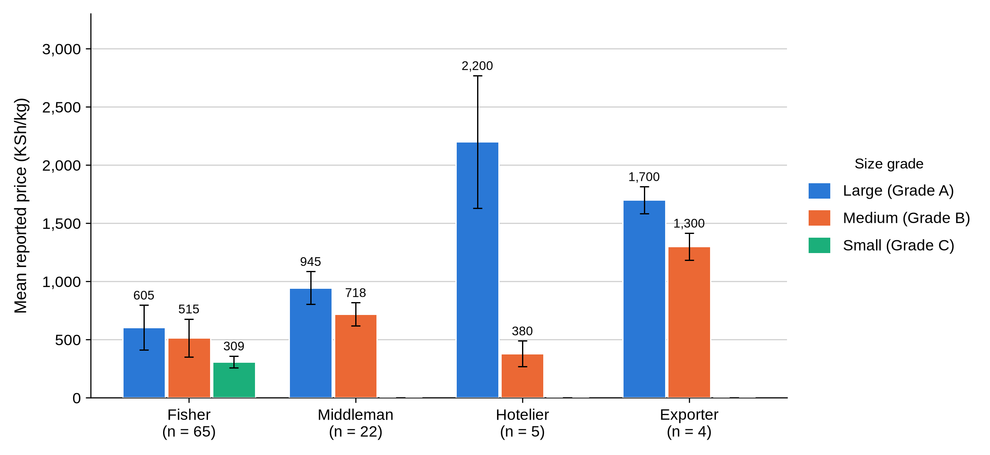
Note. Bars show the mean price in KSh per kilogram and error bars show ±1 standard deviation. Small-grade prices were reported only by fishers. The hotelier medium-grade mean of KSh 380 is discussed below.
One value breaks the pattern. Hoteliers reported a mean of KSh 380.0 per kilogram for medium crabs, which is below the fisher price for the same grade and far below their own large-grade mean of KSh 2,200.0. All five records were retained exactly as entered. The figure may be correct if those entries refer to a different product form, unit or transaction, but it may equally be a field-entry problem. It is excluded from the chain calculation that follows and should be checked against the questionnaires before it is used to support any argument about value addition.

4.4.9 Marketing Margins and the Distribution of Value
Reading the four node prices as one chain shows where the final price accumulates. Two end points were available: crabs that left the middleman for an exporter finished at KSh 1,700.0 per kilogram for the large grade, and crabs that went to a hotel kitchen finished at KSh 2,200.0. Expressing each node’s contribution as a share of that end price puts all four actors on a single scale.
Table 16
Marketing Margins and the Distribution of the Final Chain Price Across Actor Nodes
Market node | Mean price  (KSh/kg) | Value retained or  margin added (KSh/kg) | Margin as % of the  fisher price | % of the final  chain price
Large (Grade A) sold on to exporters
Fisher (first sale) | 604.6 | 604.6 | — | 35.6
Middleman | 945.5 | 340.8 | 56.4 | 20.0
Exporter (end of chain) | 1,700.0 | 754.5 | 124.8 | 44.4
Hotelier (not in this chain) | — | — | — | —
Large (Grade A) sold on to hoteliers
Fisher (first sale) | 604.6 | 604.6 | — | 27.5
Middleman | 945.5 | 340.8 | 56.4 | 15.5
Hotelier (end of chain) | 2,200.0 | 1,254.5 | 207.5 | 57.0
Exporter (not in this chain) | — | — | — | —
Medium (Grade B) sold on to exporters
Fisher (first sale) | 514.6 | 514.6 | — | 39.6
Middleman | 718.2 | 203.6 | 39.6 | 15.7
Exporter (end of chain) | 1,300.0 | 581.8 | 113.1 | 44.8
Hotelier (not in this chain) | — | — | — | —
The fisher kept between a quarter and two fifths of the end price. Large crabs sold on to an exporter left 35.6% with the harvester; the same crabs sold on to a hotel left 27.5%. Medium crabs going for export were the fisher’s best case at 39.6%. In every chain the largest single share was added at the last step: 44.4% between the middleman and the exporter, 57.0% between the middleman and the hotel. The middleman, the actor most often blamed for the low beach price, took the smallest share of the three, between 15.5% and 20.0%.
Figure 22
Share of the Final Chain Price Held at Each Actor Node, by Size Grade and Outlet
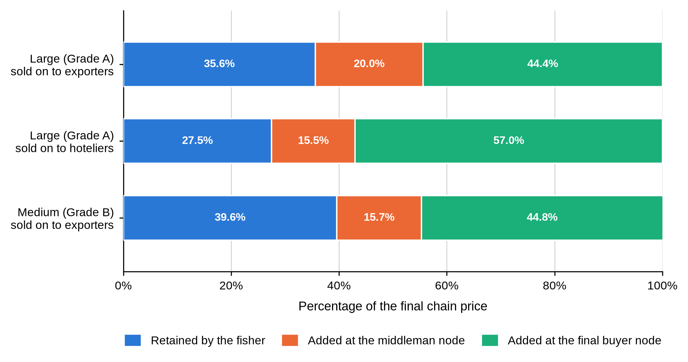
Note. Segments show the share of the end-of-chain price retained by the fisher, added between the fisher and the middleman, and added between the middleman and the final buyer. Shares sum to 100% within each bar. Because no cost data were collected these are gross price spreads and not net margins. The medium grade sold on to hoteliers is not shown, for the reason given above.
Two qualifications belong with that result. The shares rest on group means from different respondents rather than on a single crab followed from beach to buyer, and they would shift once handling, freight and mortality were priced in. The direction is nevertheless hard to argue away. An exporter paying KSh 945.5 and selling at KSh 1,700.0 works on a spread of KSh 754.5 per kilogram, roughly one and a quarter times what the fisher received for landing the animal in the first place. This is the evidence Objective Two needs on how value is distributed: not that any actor is taking more than their costs justify, which these data cannot show, but that the value is realised two steps beyond the point the harvester can reach.

4.4.10 Prices by Study Site
Holding the actor role constant and comparing sites answers a different question: whether a fisher at one landing site receives a different price from a fisher at another.
Table 17
Mean Reported Mud Crab Price by Actor Category, Study Site and Size Grade
Study site | Fisher  M KSh/kg (n) | Middleman  M KSh/kg (n) | Hotelier  M KSh/kg (n) | Exporter  M KSh/kg (n)
Large (Grade A)
Shimoni | 540.0 (25) | 981.8 (11) | 1,500.0 (1) | —
Majoreni | 785.7 (14) | 857.1 (7) | — | —
Vanga | 535.7 (21) | 1,000.0 (4) | — | —
Msambweni | 650.0 (3) | — | — | —
Other sites | 800.0 (2) | — | 2,375.0 (4) | 1,700.0 (4)
All sites | 604.6 (65) | 945.5 (22) | 2,200.0 (5) | 1,700.0 (4)
Medium (Grade B)
Shimoni | 404.0 (25) | 745.5 (11) | 300.0 (1) | —
Majoreni | 600.0 (14) | 657.1 (7) | — | —
Vanga | 576.2 (21) | 750.0 (4) | — | —
Msambweni | 616.7 (3) | — | — | —
Other sites | 500.0 (2) | — | 400.0 (4) | 1,300.0 (4)
All sites | 514.6 (65) | 718.2 (22) | 380.0 (5) | 1,300.0 (4)
Fisher prices differed significantly across sites for large crabs, H(3) = 20.32, p < .001, and for medium crabs, H(3) = 20.07, p < .001. Majoreni fishers reported the highest large-crab mean at KSh 785.7 per kilogram, well above Shimoni at KSh 540.0 and Vanga at KSh 535.7. Middleman prices, by contrast, could not be told apart across the three sites where traders were sampled, for large crabs, H(2) = 5.33, p = .070, or medium crabs, H(2) = 3.78, p = .151. Small-grade prices did not differ across sites either, H(3) = 5.85, p = .119.
Figure 23
Mean Large-Crab Price by Actor Category and Study Site
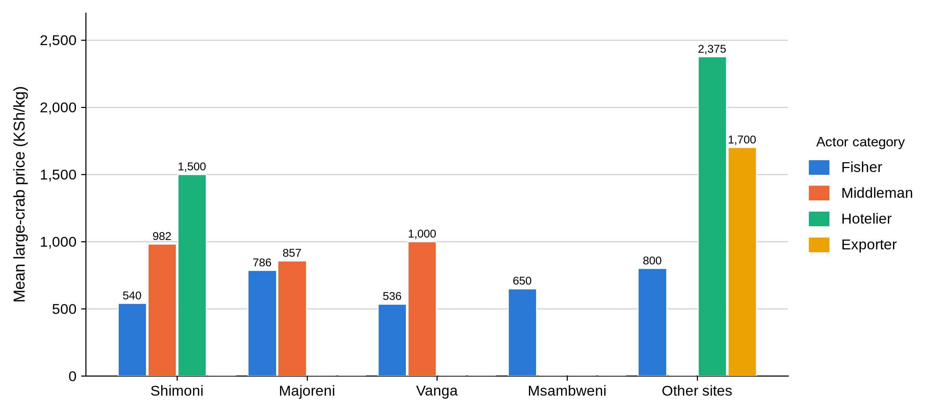
Note. Bars show the mean large-crab price in KSh per kilogram. A missing bar means no respondent of that actor category was sampled at that site. The single Shimoni hotelier and the Other sites group rest on very small numbers.
Table 18
First-Sale Price Spread Between Fishers and Middlemen Within Each Study Site
Study site | Fisher M  (KSh/kg) | Middleman M  (KSh/kg) | Spread  (KSh/kg) | Spread as % of  the fisher price | Fisher price as % of  the middleman price
Large (Grade A)
Shimoni | 540.0 | 981.8 | 441.8 | 81.8 | 55.0
Majoreni | 785.7 | 857.1 | 71.4 | 9.1 | 91.7
Vanga | 535.7 | 1,000.0 | 464.3 | 86.7 | 53.6
Msambweni | 650.0 | — | — | — | —
Other sites | 800.0 | — | — | — | —
Medium (Grade B)
Shimoni | 404.0 | 745.5 | 341.5 | 84.5 | 54.2
Majoreni | 600.0 | 657.1 | 57.1 | 9.5 | 91.3
Vanga | 576.2 | 750.0 | 173.8 | 30.2 | 76.8
Msambweni | 616.7 | — | — | — | —
Other sites | 500.0 | — | — | — | —
Setting the two upstream node prices side by side at each landing site shows how much of the first-hand trader price a fisher at that site actually keeps. Majoreni stands apart: its fishers held 91.7% of the local middleman price for large crabs and 91.3% for medium crabs, leaving spreads of KSh 71.4 and KSh 57.1 per kilogram. At Shimoni and Vanga the same comparison gave 55.0% and 53.6% for large crabs, spreads of KSh 441.8 and KSh 464.3, or between 82% and 87% on top of what the fisher was paid. Vanga sat in between for medium crabs at 76.8%. The pattern holds in both grades, which makes it unlikely to be an artefact of one odd price.
Figure 24
Fisher Price as a Percentage of the Middleman Price Within Each Study Site
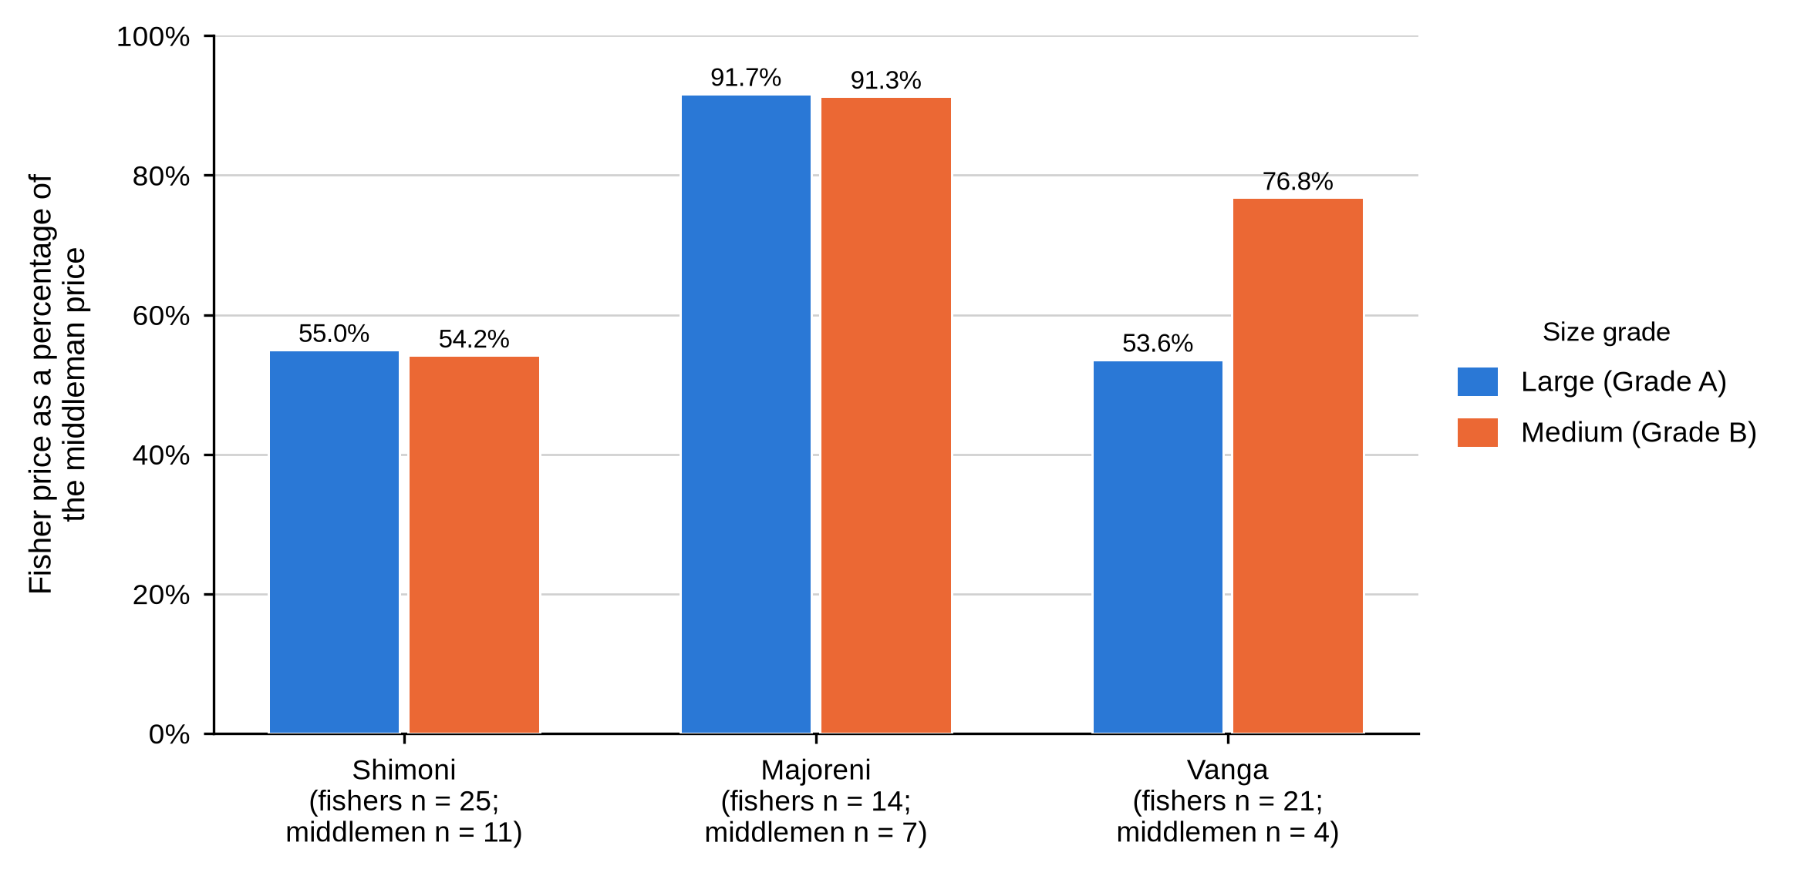
Note. Bars show the fisher mean expressed as a percentage of the middleman mean for the same grade at the same site. A taller bar means a narrower gap between the two nodes. Msambweni and the Other sites group are absent because no middleman was sampled there.
Where that difference comes from is worth stating plainly, because the two nodes did not move together. Fisher prices varied significantly across sites; middleman prices did not. The narrow Majoreni gap is therefore built on the fisher side of the transaction rather than on Majoreni traders charging less than their counterparts: Majoreni middlemen sold at KSh 857.1, within KSh 143 of the other two sites, while Majoreni fishers were paid KSh 785.7 against roughly KSh 537 at Shimoni and Vanga. The gap a fisher faces is set at their own landing site.

4.4.11 Summary of Objective Two
Objective Two asked what functions actors perform at each market node. Functions divided cleanly and so did the information attached to them. Fishers harvested by hand, tied claws, packed into sacks, walked to the landing site and sold the whole catch to a first-level middleman at a price they called fixed. Middlemen aggregated, cleaned, sorted and graded on a four-criterion rule, then moved crabs by vehicle or boat to company agents, other middlemen or exporters. Hoteliers processed and froze for their own kitchens. Exporters packed Styrofoam for air freight under inspection and certification. Formal quality control and the fuller grading rule sat entirely downstream, and so did contact with the final buyer.
Prices rose at every node. Expressed as shares of the price the crab eventually fetched, the fisher retained between 27.5% and 39.6%, the middleman added between 15.5% and 20.0%, and between 44.4% and 57.0% was added at the final buyer. Among fishers, price also differed by site, and the size of the first-sale gap was set locally: Majoreni fishers held 91.7% of the middleman price for large crabs where Shimoni and Vanga fishers held close to 54%.

4.5 Objective Three: Constraints and Opportunities

4.5.1 Operational, Infrastructure and Market-Access Constraints
Table 19
Operational, Infrastructure and Market-Access Constraints by Actor Category
Characteristic and response | Fisher  (n = 65) | Middleman  (n = 22) | Hotelier  (n = 5) | Exporter  (n = 4) | Total  (N = 96)
Main operational or marketing constraint (valid n = 65 / 22 / 5 / 4) BMU association: fishers χ²(3, N = 63) = 3.50, p = .334; middlemen χ²(2, N = 22) = 6.42, p = .036.
High freight, flight delays and supply risk | 0 (0.0) | 0 (0.0) | 0 (0.0) | 4 (100.0) | 4 (4.2)
Market seasonality | 0 (0.0) | 0 (0.0) | 5 (100.0) | 0 (0.0) | 5 (5.2)
Mortality | 6 (9.2) | 11 (50.0) | 0 (0.0) | 0 (0.0) | 17 (17.7)
Price fluctuations | 59 (90.8) | 11 (50.0) | 0 (0.0) | 0 (0.0) | 70 (72.9)
Main infrastructure or logistics constraint (valid n = 65 / 22 / 5 / 4) BMU association: fishers χ²(3, N = 63) = 3.56, p = .264; middlemen χ²(4, N = 22) = 5.67, p = .339.
High freight, flight delays and mortality | 0 (0.0) | 0 (0.0) | 0 (0.0) | 4 (100.0) | 4 (4.2)
Lack of aggregation facilities | 1 (1.5) | 20 (90.9) | 0 (0.0) | 0 (0.0) | 21 (21.9)
Limited transport | 0 (0.0) | 1 (4.5) | 0 (0.0) | 0 (0.0) | 1 (1.0)
Market seasonality | 0 (0.0) | 0 (0.0) | 5 (100.0) | 0 (0.0) | 5 (5.2)
Poor road infrastructure | 64 (98.5) | 1 (4.5) | 0 (0.0) | 0 (0.0) | 65 (67.7)
Infrastructure improvements are needed (valid n = 65 / 22 / 5 / 4)
Yes | 65 (100.0) | 22 (100.0) | 5 (100.0) | 4 (100.0) | 96 (100.0)
Experienced barriers to market access (valid n = 65 / 22 / 5 / 4) BMU association: fishers χ²(3, N = 63) = 1.62, p = .730.
Yes | 61 (93.8) | 22 (100.0) | 5 (100.0) | 4 (100.0) | 92 (95.8)
No | 4 (6.2) | 0 (0.0) | 0 (0.0) | 0 (0.0) | 4 (4.2)
Experienced significant operational challenges (valid n = 65 / 22 / 5 / 4) BMU association: fishers χ²(3, N = 63) = 4.40, p = .253.
Yes | 53 (81.5) | 22 (100.0) | 5 (100.0) | 4 (100.0) | 84 (87.5)
No | 12 (18.5) | 0 (0.0) | 0 (0.0) | 0 (0.0) | 12 (12.5)
No constraint was shared across the chain, and each one follows from the work the actor does. Price fluctuation was named by 90.8% of fishers and half the middlemen; mortality by the other half of middlemen and by 9.2% of fishers; market seasonality by every hotelier; and freight cost, flight delays and supply risk by every exporter. The fisher sells the same day at a price he does not set, so volatility reaches him first. The middleman holds stock, so he loses crabs. The hotelier lives on tourist arrivals. The exporter lives on cargo space.
Infrastructure answers split just as sharply. Poor roads dominated the fisher responses at 98.5%, while 90.9% of middlemen named the lack of aggregation facilities. Every respondent in all four categories said infrastructure improvements were needed, 95.8% reported barriers to market access, and 87.5% reported significant operational challenges. The problems are close to universal; the specific problem is not.
Figure 25
Main Operational or Marketing Constraint by Actor Category
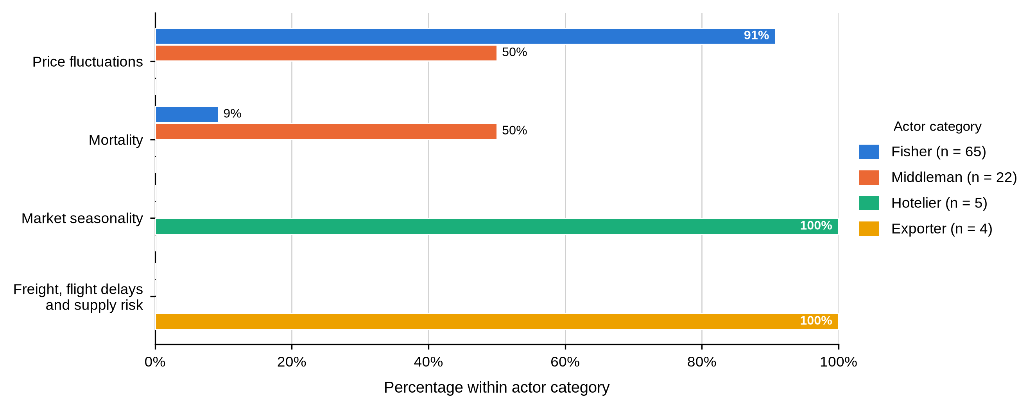
Note. Bars show the percentage within each actor category. Each actor category named a different dominant constraint.
Figure 26
Main Infrastructure or Logistics Constraint by Actor Category
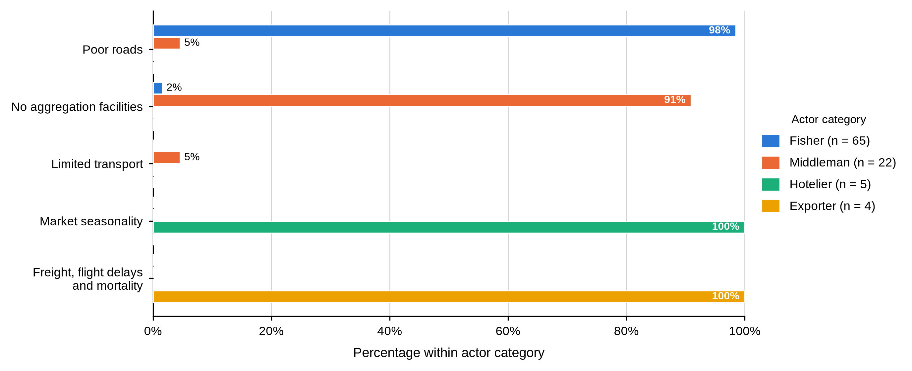
Note. Bars show the percentage within each actor category.
Among middlemen the constraint named also differed by site. All four Vanga middlemen and four of the seven at Majoreni named mortality, while Shimoni middlemen more often named price, χ²(2, N = 22) = 6.42, p = .036, 99% CI [.032, .041]. This was the only Objective Three association with site that reached the .05 level.
Figure 27
Main Constraint Reported by Middlemen Within Each Study Site
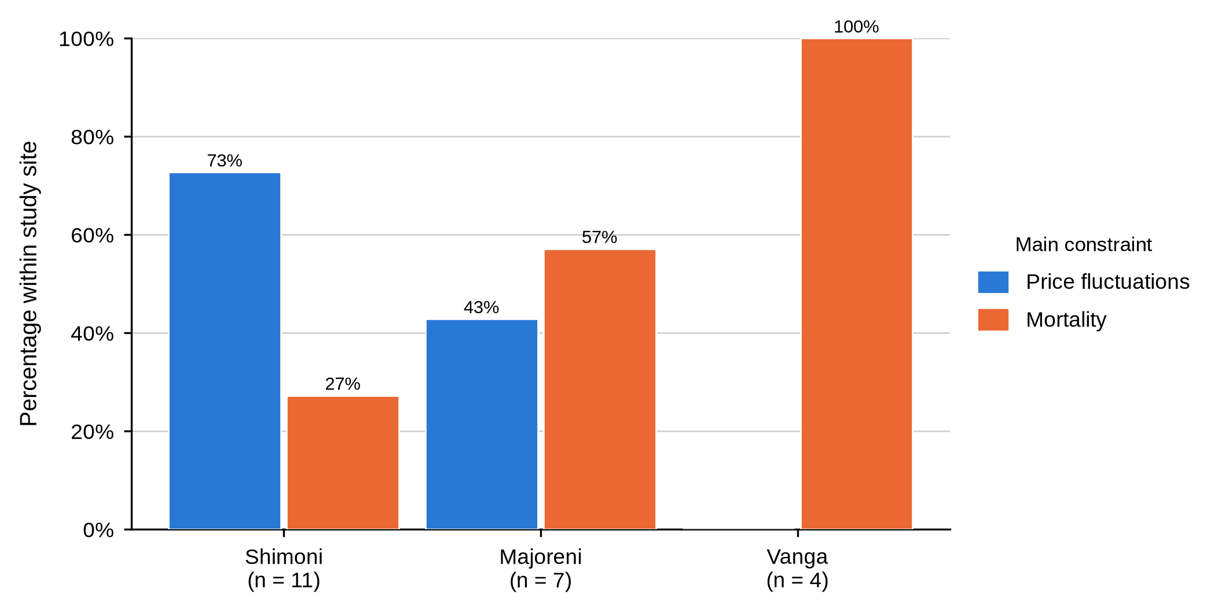
Note. Bars show the percentage of middlemen within each site. No middleman was sampled at Msambweni.

4.5.2 Risk Management, Innovation and Adaptation
Table 20
Risk Management, Innovation and Adaptation by Actor Category
Characteristic and response | Fisher  (n = 65) | Middleman  (n = 22) | Hotelier  (n = 5) | Exporter  (n = 4) | Total  (N = 96)
Method used to manage risk (valid n = 65 / 22 / 5 / 4)
Diversification | 65 (100.0) | 22 (100.0) | 5 (100.0) | 0 (0.0) | 92 (95.8)
Insurance and diversification | 0 (0.0) | 0 (0.0) | 0 (0.0) | 4 (100.0) | 4 (4.2)
Adopted an innovative response (valid n = 65 / 22 / 5 / 4)
No | 65 (100.0) | 22 (100.0) | 5 (100.0) | 4 (100.0) | 96 (100.0)
Changed marketing strategies (valid n = 65 / 22 / 5 / 4)
Yes | 0 (0.0) | 0 (0.0) | 5 (100.0) | 4 (100.0) | 9 (9.4)
No | 65 (100.0) | 22 (100.0) | 0 (0.0) | 0 (0.0) | 87 (90.6)
How functions are adapted within the chain (valid n = 65 / 22 / 5 / 4)
Flexibility | 65 (100.0) | 22 (100.0) | 5 (100.0) | 0 (0.0) | 92 (95.8)
Flexibility and collaboration | 0 (0.0) | 0 (0.0) | 0 (0.0) | 4 (100.0) | 4 (4.2)
Risk management was uniform and thin. Diversification was the only method named by fishers, middlemen and hoteliers; the four exporters added insurance. Not one respondent in any category had adopted an innovative response. Only the nine downstream actors had changed their marketing strategies; no fisher or middleman had. Flexibility was the universal adaptation, with exporters alone adding collaboration.
Read against Objective Three, this says that the upstream actors are absorbing risk rather than managing it. Diversification for a fisher who reports no other income activity is an intention, not a strategy.

4.5.3 Regulation, Management-Plan Awareness and Information
Table 21
Regulation, Management-Plan Awareness and Information Sources by Actor Category
Characteristic and response | Fisher  (n = 65) | Middleman  (n = 22) | Hotelier  (n = 5) | Exporter  (n = 4) | Total  (N = 96)
Regulations affect marketing activities (valid n = 65 / 22 / 5 / 4) BMU association: middlemen χ²(2, N = 22) = 0.02, p = 1.000.
Yes | 65 (100.0) | 16 (72.7) | 5 (100.0) | 4 (100.0) | 90 (93.8)
No | 0 (0.0) | 6 (27.3) | 0 (0.0) | 0 (0.0) | 6 (6.2)
Aware of a crab fishery management plan (valid n = 65 / 22 / 5 / 4) BMU association: fishers χ²(3, N = 63) = 6.14, p = .118; middlemen χ²(2, N = 22) = 1.05, p = 1.000.
Yes | 10 (15.4) | 21 (95.5) | 0 (0.0) | 4 (100.0) | 35 (36.5)
No | 55 (84.6) | 1 (4.5) | 5 (100.0) | 0 (0.0) | 61 (63.5)
Knows persons or organizations interested in the fishery (valid n = 65 / 22 / 5 / 4)
Yes | 65 (100.0) | 22 (100.0) | 5 (100.0) | 4 (100.0) | 96 (100.0)
How the actor remains updated on industry trends (valid n = 65 / 22 / 5 / 4)
Networking | 65 (100.0) | 22 (100.0) | 5 (100.0) | 4 (100.0) | 96 (100.0)
Regulation was felt by 93.8% of respondents, but awareness of the instrument that governs the fishery was not evenly spread. Ninety-five point five per cent of middlemen and every exporter knew of a crab fishery management plan, against 15.4% of fishers and not one hotelier. Every respondent in every category said they kept up to date by networking, and every one said they knew of persons or organisations interested in the fishery.
That contrast is the substantive finding. Information about management reaches the commercially connected nodes and misses the harvesting node, even though the co-management structures built to carry it are anchored at the landing site.

4.5.4 Perceptions of Market Structure and Policy
Table 22
Perceptions of Market Structure, Integration and Policy by Actor Category
Characteristic and response | Fisher  (n = 65) | Middleman  (n = 22) | Hotelier  (n = 5) | Exporter  (n = 4) | Total  (N = 96)
Perception that the market is well structured (valid n = 65 / 22 / 5 / 4) BMU association: fishers χ²(6, N = 63) = 4.90, p = .570; middlemen χ²(6, N = 22) = 3.71, p = .826.
Strongly disagree | 0 (0.0) | 6 (27.3) | 0 (0.0) | 0 (0.0) | 6 (6.2)
Disagree | 45 (69.2) | 13 (59.1) | 5 (100.0) | 4 (100.0) | 67 (69.8)
Neutral | 6 (9.2) | 2 (9.1) | 0 (0.0) | 0 (0.0) | 8 (8.3)
Agree | 14 (21.5) | 1 (4.5) | 0 (0.0) | 0 (0.0) | 15 (15.6)
Perception that mud crab marketing is integrated with other species (valid n = 65 / 22 / 5 / 4) BMU association: fishers χ²(6, N = 63) = 4.47, p = .541; middlemen χ²(2, N = 22) = 2.81, p = .366.
Strongly disagree | 0 (0.0) | 14 (63.6) | 0 (0.0) | 0 (0.0) | 14 (14.6)
Disagree | 52 (80.0) | 8 (36.4) | 5 (100.0) | 4 (100.0) | 69 (71.9)
Neutral | 11 (16.9) | 0 (0.0) | 0 (0.0) | 0 (0.0) | 11 (11.5)
Agree | 2 (3.1) | 0 (0.0) | 0 (0.0) | 0 (0.0) | 2 (2.1)
Awareness of a policy framework for crab markets (valid n = 65 / 22 / 5 / 4) BMU association: fishers χ²(6, N = 63) = 2.13, p = .933; middlemen χ²(4, N = 22) = 4.41, p = .427.
Strongly disagree | 6 (9.2) | 14 (63.6) | 0 (0.0) | 0 (0.0) | 20 (20.8)
Disagree | 11 (16.9) | 7 (31.8) | 0 (0.0) | 0 (0.0) | 18 (18.8)
Neutral | 48 (73.8) | 1 (4.5) | 5 (100.0) | 4 (100.0) | 58 (60.4)
Respondents were steadily negative about how the market is organised. Sixty-nine point eight per cent disagreed that the mud crab market is well structured and a further 6.2%, all middlemen, strongly disagreed; only 15.6%, almost all fishers, agreed. Judgements on integration with other fisheries were harsher still, with 63.6% of middlemen strongly disagreeing. On the existence of a policy framework, 73.8% of fishers were neutral while 63.6% of middlemen strongly disagreed.
The large neutral response among fishers should not be read as approval. Set beside the 15.4% management-plan awareness in the previous table, it more plausibly reflects unfamiliarity with the policy environment rather than a settled view of it.
Figure 28
Perception That the Mud Crab Market Is Well Structured, by Actor Category
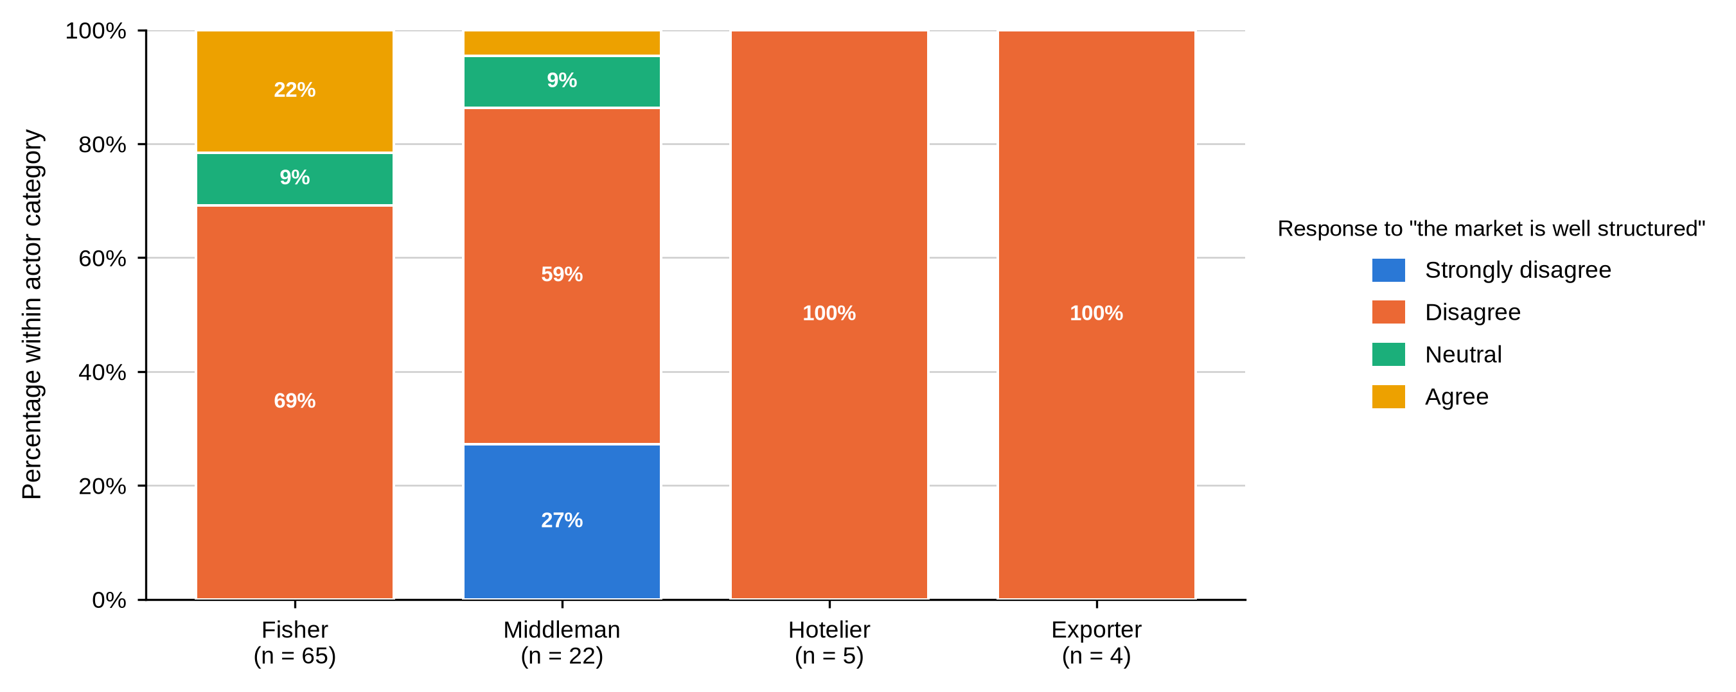
Note. Segments sum to 100% within each actor category. No hotelier or exporter agreed that the market is well structured.

4.5.5 Opportunities, Youth and Diversification
Table 23
Priority Opportunities, System Enhancement, Youth Involvement and Diversification by Actor Category
Characteristic and response | Fisher  (n = 65) | Middleman  (n = 22) | Hotelier  (n = 5) | Exporter  (n = 4) | Total  (N = 96)
Priority opportunity for improving mud crab marketing (valid n = 65 / 22 / 5 / 4) BMU association: fishers χ²(3, N = 63) = 3.89, p = .263; middlemen χ²(2, N = 22) = 1.05, p = 1.000.
Market access improvement | 56 (86.2) | 1 (4.5) | 5 (100.0) | 4 (100.0) | 66 (68.8)
Price stability measures | 9 (13.8) | 21 (95.5) | 0 (0.0) | 0 (0.0) | 30 (31.2)
Recommended market-system enhancement (valid n = 65 / 22 / 5 / 4) BMU association: middlemen χ²(6, N = 22) = 7.35, p = .277.
Access to credit | 0 (0.0) | 1 (4.5) | 0 (0.0) | 1 (25.0) | 2 (2.1)
Government support | 65 (100.0) | 12 (54.5) | 0 (0.0) | 0 (0.0) | 77 (80.2)
Government support and industry collaboration | 0 (0.0) | 8 (36.4) | 5 (100.0) | 3 (75.0) | 16 (16.7)
Industry collaboration | 0 (0.0) | 1 (4.5) | 0 (0.0) | 0 (0.0) | 1 (1.0)
Reported involvement of youth (valid n = 65 / 22 / 5 / 4) BMU association: fishers χ²(3, N = 63) = 2.94, p = .421; middlemen χ²(2, N = 22) = 1.64, p = .497.
Very low | 0 (0.0) | 6 (27.3) | 3 (60.0) | 3 (75.0) | 12 (12.5)
Low | 58 (89.2) | 16 (72.7) | 2 (40.0) | 1 (25.0) | 77 (80.2)
Neutral | 7 (10.8) | 0 (0.0) | 0 (0.0) | 0 (0.0) | 7 (7.3)
Perceived potential for product or market diversification (valid n = 65 / 22 / 5 / 4) BMU association: fishers χ²(9, N = 63) = 5.04, p = .860; middlemen χ²(4, N = 22) = 5.20, p = .277.
Negative | 8 (12.3) | 0 (0.0) | 0 (0.0) | 0 (0.0) | 8 (8.3)
Not explored yet | 26 (40.0) | 7 (31.8) | 5 (100.0) | 4 (100.0) | 42 (43.8)
Neutral | 19 (29.2) | 1 (4.5) | 0 (0.0) | 0 (0.0) | 20 (20.8)
Positive | 12 (18.5) | 14 (63.6) | 0 (0.0) | 0 (0.0) | 26 (27.1)
Nothing expresses the structure of this chain more clearly than the fact that fishers and middlemen want opposite things. Market-access improvement was the priority for 86.2% of fishers and for every hotelier and exporter, while price stability was the priority for 95.5% of middlemen. These are two views of one transaction: the fisher wants an alternative to the buyer standing in front of him, and the middleman wants the price he pays and receives to hold still. Better market access for fishers means more competition for middlemen.
On what would improve the system, every fisher named government support alone, while middlemen, hoteliers and exporters more often named government support together with industry collaboration. Youth involvement was rated low or very low by every respondent who expressed a view, even though more than half the fishers were aged 18 to 35 and four were under 18. Diversification potential was rated negative or not yet explored by most fishers, while middlemen were the only group with a substantial positive view.
Figure 29
Reported Involvement of Youth by Actor Category
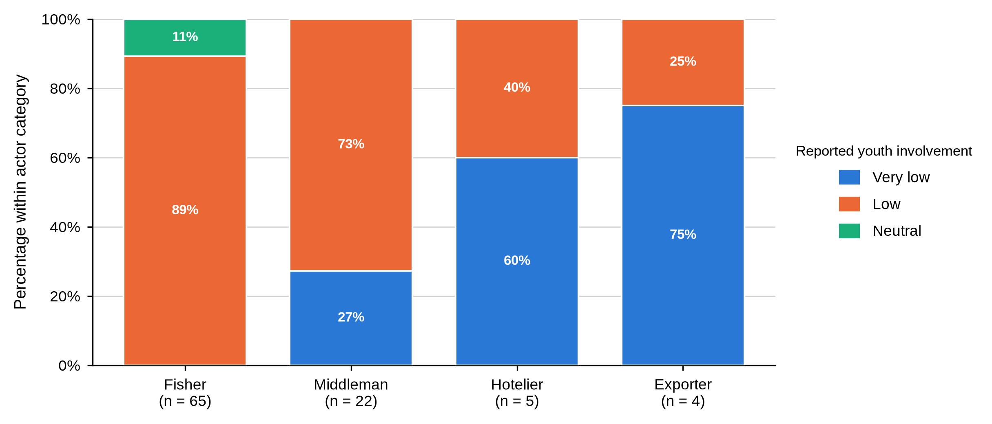
Note. Segments sum to 100% within each actor category. No respondent in any category rated youth involvement as high.
Figure 30
Perceived Potential for Product or Market Diversification by Actor Category
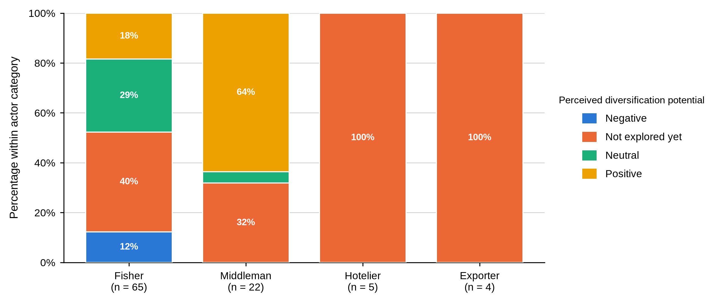
Note. Segments sum to 100% within each actor category.

4.5.6 Summary of Objective Three
Objective Three asked what constrains each actor category and what opportunities they see. Constraints followed function exactly: price volatility and poor roads for fishers, mortality and missing aggregation facilities for middlemen, seasonality for hoteliers, freight cost and flight risk for exporters. Barriers to market access were close to universal, risk management was limited to diversification, and no actor had adopted new equipment or done any market research. Most respondents judged the market poorly structured, and awareness of the crab fishery management plan reached traders and exporters while missing fishers and hoteliers. Fishers put market access first and middlemen put price stability first, which is what their opposing positions in the same transaction would predict. No single chain-wide intervention will meet these constraints, because each node is held back by something different arising from the work it does.

4.6 Actor-Specific Associations With Study Site
Sixty-eight categorical variables were tested against study site, separately for fishers and for middlemen. Nine associations reached the .05 level.
Table 24
Statistically Significant Actor-Specific Associations With Study Site
Objective | Actor | Variable | χ² | df | N | p | 99% CI
Objective 1 | Fisher | Age group | 30.91 | 12 | 63 | .004 | [.002, .005]
Objective 1 | Fisher | Received formal mud crab training | 8.48 | 3 | 63 | .035 | [.030, .040]
Objective 1 | Fisher | Marital status | 20.06 | 9 | 63 | .049 | [.044, .055]
Objective 1 | Middleman | Scale of operation | 9.41 | 4 | 22 | .050 | [.044, .055]
Objective 2 | Fisher | First buyer location | 125.19 | 21 | 61 | < .001 | [.000, .000]
Objective 2 | Fisher | Reported large-crab size category | 16.87 | 3 | 63 | .001 | [.000, .002]
Objective 2 | Fisher | Reported small-crab size category | 15.96 | 3 | 63 | .002 | [.001, .004]
Objective 2 | Fisher | Travel time from fishing grounds to market | 11.13 | 3 | 63 | .010 | [.007, .012]
Objective 3 | Middleman | Main operational or marketing constraint | 6.42 | 2 | 22 | .036 | [.032, .041]
No association with study site reached the .05 level for hoteliers or exporters; neither group was sampled across enough sites for the test to be run
Three points should be kept in mind when reading this table. The tests were run without a correction for multiple comparisons, so associations with probabilities close to .05 should be treated as exploratory rather than established. The Monte Carlo confidence interval is reported alongside each p-value so that borderline cases can be judged. And the absence of hoteliers and exporters from the table is a limit of the sampling frame, not a finding: neither group was sampled across enough sites for a test to be run.

4.7 Chapter Summary
Across the three objectives the same pattern recurs. Differences between actor categories were large, consistent and present on nearly every measure, from education and licensing to grading criteria, quality control, price and the constraint each group names. Differences between study sites were fewer and concentrated among fishers, in age, marital status, training, size labels, travel time and, most consequentially, in the price received at first sale. The value in this chain is realised at the nodes furthest from the water, where the grading rule, the logistics and the connection to the final buyer all sit together.

CHAPTER FIVE: DISCUSSION

5.1 Introduction
This chapter interprets the findings of Chapter Four against the literature reviewed in Chapter Two. It takes the three objectives in turn, and each section sets out the key findings, compares them with previous research, explains where they agree and where they differ, and draws out the theoretical and practical implications. Section 5.5 brings the three objectives together under the structure-conduct-performance framework, and Section 5.6 states the limitations that bound every claim made here.

5.2 Objective One: Profile of Mud Crab Actors

5.2.1 Key Findings
Four actor categories differed systematically and in the same direction on almost every measure. Fishers were younger, schooled to primary level or below, largely unlicensed, untrained, small-scale and un-diversified. Middlemen were older and far more experienced, with 72.7% carrying more than twenty years in the trade. Hoteliers and exporters held certificates, diplomas or degrees, were fully licensed, and operated at medium or large scale. Reported monthly income rose from KSh 8,969 among fishers to KSh 90,000 among exporters. No respondent in any category belonged to a cooperative, an association or a self-help group.

5.2.2 Gender and the Limits of the Sampling Frame
Ninety-five of the 96 respondents were men, and the single woman was a hotelier rather than a harvester. The pattern is consistent with what has been reported along the Kenyan coast, where harvesting and much of the first-tier trade are male-dominated while women appear more often in processing, retail and culture activities (Mirera, 2014a; Ochiewo et al., 2010).
Why men dominate harvesting in this fishery is not something these data can settle, but the literature suggests three mechanisms that fit the setting. Mud crab harvesting in Kenya is done on foot in mangrove creeks at low spring tides, often at night and at a distance from the village, which carries mobility and safety costs that fall unequally on women (Mirera et al., 2013; Moser et al., 2005). Landing-site registers and BMU membership, the routes through which a harvester becomes visible to officials and buyers, have historically enrolled men. And the credit relationship documented in Chapter Four, in which a buyer advances cash against future supply, tends to run through established trading ties that new entrants do not have.
The consequence for this study is methodological before it is substantive. Because the fisher sampling frame drew on landing-site registers, women working in processing, hospitality procurement, retail or crab fattening were unlikely to be reached. Ndanga et al. (2013) show that women in Kenyan aquaculture value chains concentrate precisely in the nodes that landing-site sampling does not cover, which is a plausible explanation for the pattern recorded here and a clear brief for future work. The finding should therefore be read as a description of the respondents reached, not as evidence that women are absent from the chain. Two practical openings follow: hospitality procurement and crab fattening are the nodes where women already appear in the regional literature, and both were named as opportunities by respondents in this study.

5.2.3 Experience, Licensing and the Absence of Collective Organisation
Experience accumulated at the trading node rather than the harvesting node. This fits the account in Mirera et al. (2013), where local knowledge and repeated relationships shape how crabs are found, handled and moved, and it helps explain why middlemen reported regular buyers, competitive price setting and standing trading agreements while fishers did not. Crona et al. (2016) describe middlemen in Kenya and Zanzibar as a critical social-ecological link precisely because that accumulated relational knowledge is not easily replaced, and the present findings are consistent with that reading.
The complete absence of collective membership is a more serious finding than a single percentage suggests. Groups are the normal vehicle for price information, savings, training, traceability and dealings with government, and the literature ties organised groups and local leadership to better fishery outcomes (Gutiérrez et al., 2011; Mirera, 2014a). Without them, a fisher negotiates alone against a buyer with twenty years in the trade and knowledge of what crabs fetch further up the chain.
Forming groups is not itself the remedy. Gutiérrez et al. (2011) found that leadership and clear incentives, rather than the existence of a group, separate the successful cases from the rest. That nothing at all exists here, at any node, suggests earlier attempts offered members nothing they could see. Any group formed in response to this study would need a commercial purpose, transparent leadership and a service members can point to.

5.2.4 Credit and Dependence Within the Chain
No fisher used a formal loan, yet 93.8% named a middleman as their main source of credit, and close to two fishers in five were paid at least partly on credit by the buyer purchasing from them. Crona et al. (2016) describe such arrangements as enabling and constraining at once: the advance solves this week’s cash problem while narrowing where the fisher can sell. Béné et al. (2007) make a similar point about small-scale fisheries generally, treating informal credit as both safety net and mechanism of persistent low returns.
Which of the two dominates here cannot be judged from this study, because amounts, terms and duration went unrecorded. What can be said is that the person extending the credit is the same person setting the price the fisher calls fixed, and that no alternative source of working capital was reported at the harvesting node. That combination is what gives the relationship its force.

5.2.5 Implications
Theoretically, the profile results support treating actor category rather than location as the primary structural variable in this market. Differences between fishers, middlemen, hoteliers and exporters were large and consistent, while differences between landing sites were fewer and confined mostly to fishers. A market-structure account of this fishery is therefore an account of nodes, not of places.
Practically, the results identify three entry points that do not require new infrastructure: a licensing route that upstream actors can actually complete, a source of working capital that is not the buyer, and a collective body with a service attached. Each addresses a condition documented in Chapter Four rather than a general aspiration.

5.3 Objective Two: Functions at Each Market Node and the Distribution of Value

5.3.1 Key Findings
Functions divided cleanly by node and so did the information attached to them. Fishers harvested, tied claws, packed in sacks and walked to the landing site. Middlemen aggregated, cleaned, sorted and graded on a four-criterion rule and moved crabs by vehicle or boat. Hoteliers processed and froze. Exporters packed Styrofoam under inspection and certification. Prices rose at every node, differed significantly between actor categories, and among fishers differed by site as well.

5.3.2 Grading as a Mechanism of Value Capture
Every actor said they graded. They did not grade by the same rule. All 65 fishers used weight alone, while 95.5% of middlemen and every hotelier and exporter combined size, weight, shell condition and claw size. Jacinto (2004) identifies exactly this kind of informational asymmetry as a determinant of how value is distributed in small-scale fisheries value chains, and the present data supply a clean instance of it.
The site variation in grading language reinforces the point. At Shimoni, 44.0% of fishers described their large category as mixed and 36.0% did the same for the small category, while fishers at the other three sites used the plain labels, χ²(3, N = 63) = 16.87, p = .001 and χ²(3, N = 63) = 15.96, p = .002. The survey recorded the label, not a measured carapace width, so this is vocabulary rather than biology. It carries a practical cost all the same: a Shimoni fisher and his buyer may not mean the same thing by the word large, and that is the condition under which a grading dispute goes the better-informed party’s way.

5.3.3 Handling, Packaging and Loss
Packaging became more protective downstream, from sacks to crates to Styrofoam, and reported mortality rose with the volume each actor held. Survival and product quality in the live mud crab trade turn on handling, containment and transport conditions (FAO, 2025). The absence of formal quality control among fishers and middlemen does not mean no care was taken; fishers tied claws and middlemen cleaned and sorted. The weakness is that neither procedures nor losses were documented against a shared standard, so the cost of mortality cannot be priced into a grade or recovered through it.

5.3.4 Price Formation and the Distribution of Value
Reported prices rose at every node and the actor comparisons were unambiguous, H(3) = 55.84, p < .001 for large crabs and H(3) = 38.00, p < .001 for medium crabs. Rising prices are expected where later actors carry aggregation, mortality, transport, packaging and buyer-access costs. The caveat matters and is stated plainly: these are gross prices. Munga and Muthumbi (2018) draw the same distinction for the Tana Delta mud crab fishery, where gross price differentials narrowed considerably once handling and transport were netted out, so nothing in this section should be read as a statement about profit.
Within that limit, expressing each node’s price as a share of the end-of-chain price answers the question of how value is distributed. A large crab reaching an exporter left 35.6% of its final price with the fisher, 20.0% at the middleman step and 44.4% at the exporter step. The same crab reaching a hotel kitchen left the fisher 27.5% and the hotel 57.0%. Medium crabs bound for export were the fisher’s best case at 39.6%. The producer’s share of the final price is a standard measure of marketing performance, and values in this range sit at the low end of what has been reported for perishable, high-value seafood. Jacinto (2004) argues that in small-scale fisheries the share captured at each node tracks control of information and market access more closely than it tracks physical effort, and the ordering here matches that: the actor doing the fishing takes the smallest share, and the largest single share accrues at the step furthest from the water.
The middleman result deserves emphasis because it cuts against the usual account. Middlemen took the smallest of the three shares in every chain, between 15.5% and 20.0%, yet they are the actor fishers most often identify with the low beach price. Crona et al. (2016) reach a similar conclusion for Kenya and Zanzibar, finding that middlemen are widely blamed for outcomes largely determined further along the chain while themselves operating on modest turnovers and carrying the mortality risk. The present data support that reading rather than the popular one, and Chapter Four documents the risk directly: 95.5% of middlemen reported daily mortality of 4 to 5 kg against 0.5 to 1 kg among fishers.

5.3.5 Site Differences and What Drives Them
The actor comparison and the site comparison answer different questions, and keeping them apart was necessary. Compare sites without holding the actor constant and a site with more middlemen looks like a high-price site purely because of its respondent mix. With the role held constant, fisher prices differed significantly across sites for large crabs, H(3) = 20.32, p < .001, and medium crabs, H(3) = 20.07, p < .001, while middleman prices did not, H(2) = 5.33, p = .070 and H(2) = 3.78, p = .151.
That asymmetry produced the study’s sharpest single contrast. At Majoreni the fisher price stood at 91.7% of the local middleman price for large crabs and 91.3% for medium crabs, spreads of KSh 71.4 and KSh 57.1 per kilogram. At Shimoni and Vanga the same figures were 55.0% and 53.6% for large crabs, spreads of KSh 441.8 and KSh 464.3. Because fisher prices varied across sites and middleman prices did not, the narrow Majoreni gap is built on the fisher side: Majoreni traders sold at KSh 857.1, within KSh 143 of the other two sites, while Majoreni fishers were paid KSh 785.7 against roughly KSh 537 elsewhere.
Two readings fit. Majoreni fishers may face a less concentrated set of first buyers, so competition at the beach lifts the first-hand price; or the seven middlemen sampled there may be first-tier buyers reselling locally rather than consolidators shipping to Mombasa, in which case their price is a shorter step from the water and the comparison is not quite like for like. This study cannot separate the two, since buyer concentration and onward destination were not measured at transaction level. Green and Clark (2021) treat dispersion at the first point of sale as one of the more reliable indicators of weak market integration, and on that criterion Shimoni and Vanga look the weaker markets of the three. The practical implication is unchanged by which reading is correct: the terms a fisher gets are settled at their own landing site.

5.3.6 The Hotelier Medium-Grade Anomaly
The hotelier medium-grade mean of KSh 380.0 per kilogram does not fit the pattern. It is below the fisher price for the same grade and far below the same respondents’ large-crab mean of KSh 2,200.0. Two explanations are plausible. The entries may refer to a different product form, unit or transaction, such as a processed portion rather than live weight, in which case the value is correct but not comparable with the others. Alternatively it may be a field-entry error. The values were retained to preserve fidelity to the source data and excluded from the chain calculation, but they should be confirmed against the questionnaires before being used to support any argument about value addition at the hospitality node.

5.3.7 Implications
Theoretically, these results locate the mechanism of value capture in control of the grading rule and of the connection to the final buyer, rather than in harvesting effort or in the middleman’s margin. That is the specific contribution this study makes to the value-chain literature on Kenyan mud crabs, which has so far documented actors and functions more thoroughly than the distribution of returns among them.
Practically, two interventions follow directly from the numbers and neither requires capital investment: a written grading standard that both parties to a first sale can read, and an independent record of what grades are fetching. Both attack the informational asymmetry the data identify rather than the price level, which no intervention in this study’s reach can set.

5.4 Objective Three: Constraints and Opportunities

5.4.1 Key Findings
No constraint was shared across the chain. Fishers named price fluctuation and poor roads, middlemen mortality and the lack of aggregation facilities, hoteliers seasonality, exporters freight cost and flight delays. Barriers to market access were reported by 95.8% of respondents. No actor had adopted new equipment or conducted market research. Most respondents judged the market poorly structured, and management-plan awareness reached 95.5% of middlemen and every exporter but only 15.4% of fishers and no hotelier.

5.4.2 Constraints Follow Function
Each constraint follows from the work the actor does. The fisher sells the same day at a price he does not set, so volatility reaches him first. The middleman holds stock, so he loses crabs; mortality was named by half of them and all four Vanga middlemen. The hotelier lives on tourist arrivals and feels the season. The exporter lives on cargo space and feels the freight. One chain-wide intervention will not reach all four, which is why the recommendations in Chapter Six are written by actor category.
The infrastructure answers point the same way. Poor roads dominated the fisher responses at 98.5% while 90.9% of middlemen named the lack of aggregation facilities. Better access routes would improve movement from landing areas but would not reduce holding losses; aggregation facilities would improve shade, loading and live-crab management but would not widen fisher buyer choice unless linked to transport and price information. Infrastructure planning therefore has to connect landing-site access with holding and distribution needs, not choose between them.

5.4.3 Governance and the Direction Information Travels
Negative views of market organisation sit comfortably with everything else recorded here: no collective membership, low upstream licensing, informal grading, no market research and fixed prices reported by every fisher. Awareness of the crab fishery management plan followed commercial position rather than geography. Information moves along commercial relationships instead of through the co-management structures built to carry it.
Beach Management Units remain the most practical institutions for narrowing that gap. Njiru et al. (2021) found that socioeconomic factors influence trader participation in BMUs in Kwale County, which supports communication designed for specific actor groups rather than a single general announcement. The large neutral response among fishers on the existence of a policy framework should not be read as approval; set beside 15.4% management-plan awareness, it more likely reflects unfamiliarity.

5.4.4 Opposing Priorities Within One Transaction
Fishers chose market-access improvement, 86.2% of them, while middlemen chose price stability, 95.5%. These are two views of one exchange. The fisher wants an alternative to the buyer standing in front of him; the middleman wants the price he pays and receives to hold still while he carries stock and credit risk. Splitting the difference will not reconcile them, because better market access for fishers means more competition for middlemen. Better price information and clearer grades reduce uncertainty for both without fixing an administered price.
Reported youth involvement was low or very low throughout, even though more than half the fishers were aged 18 to 35 and four were under 18. Respondents may have understood youth involvement as formal participation, commitment or ownership rather than presence in the fishery. Future questionnaires should define the concept directly, and the presence of minors in harvesting raises safeguarding and schooling questions this study was not designed to answer but should not pass over.

5.4.5 Implications
Theoretically, the constraint results show that performance in this chain is bounded at different points for different actors, which is an argument against treating the value chain as a single system with one binding constraint. Practically, they mean that an intervention budget spent uniformly across nodes will be largely wasted, and that the sequence in which interventions are attempted matters as much as their content.

5.5 Synthesis Using the Structure-Conduct-Performance Framework
Set against the structure-conduct-performance framework that guided this study, the three objectives describe a single system. The structure is concentrated at the point of first sale. Many small, unorganised sellers face a smaller number of better-capitalised buyers; entry downstream requires licences, capital and buyer contacts that upstream actors do not have; and no collective body exists at any node to pool bargaining power.
Conduct follows from that structure. Buyers set prices and every fisher in the sample accepted them as fixed. Grading runs on a rule only the buyer fully controls. Credit advances tie sellers to particular buyers. Nobody conducts market research, so information travels through the same commercial relationships that set the prices in the first place.
Performance is what that structure and conduct would predict. Reported monthly income ran from KSh 8,969 among fishers to KSh 90,000 among exporters. The fisher’s share of the end-of-chain price ran between 27.5% and 39.6%, and the largest single share in every chain accrued at the node furthest from the water. Price dispersion was wide at the harvesting node and narrow after aggregation, which Green and Clark (2021) treat as a signature of weak integration at the first point of sale. Losses were reported everywhere and measured nowhere against a common standard. Value addition happened almost entirely downstream, and the actors doing it were the same ones defining the grades and setting the prices.
This has a practical edge. Interventions aimed only at production, better gear or bigger catches, are unlikely to shift how value is distributed here, because the binding constraint is not how many crabs come ashore but the terms on which they change hands. Three things decide those terms: the grading rule, whether a fisher has any independent price information, and the credit relationship. All three operate in the moment a fisher hands his catch to a first-level middleman.

5.6 Study Limitations
The sample was not fully probabilistic. Reliable lists were unavailable for middlemen, hoteliers and exporters, so referral and convenience procedures were used downstream, and the findings describe the respondents reached rather than population estimates for all Kwale County mud crab actors. The achieved fisher sample of 65 fell short of the calculated target of 83, a coverage rate of 78.3%, and the 18 fishers not reached may differ from those interviewed.
Snowball sampling may over-represent actors with stronger trading connections and under-represent isolated or informal operators, so the middleman and exporter findings in particular should be read with that in mind. Only five hoteliers and four exporters were sampled, no middleman was sampled at Msambweni, and only three fishers were interviewed there, which limits site-level precision.
The design was cross-sectional and covered a single survey period, so seasonal variation in price, catch and mortality is not captured and no causal direction can be established. Prices, income and losses were self-reported and were not verified against transaction records. Sixty-eight categorical tests were run without a correction for multiple comparisons, so associations with probabilities close to .05 should be treated as exploratory. Finally, the survey did not collect the transaction-level cost, volume and mortality data needed to convert gross price differences into net margins, which is why this study describes how value is distributed but not how profit is distributed.

CHAPTER SIX: CONCLUSIONS AND RECOMMENDATIONS

6.1 Introduction
This chapter draws conclusions from the three objectives and sets out recommendations. Each recommendation names the problem identified in Chapter Four, the evidence behind it, the body best placed to act and the outcome that would show it had worked. Recommendations that the data cannot support are not made.

6.2 Conclusions

6.2.1 Conclusion for Objective One
The four actor categories differ systematically and in the same direction on almost every characteristic measured. Fishers are younger, schooled to primary level or below, small-scale, minimally licensed, untrained and un-diversified, and they borrow from the same middlemen who buy from them. Middlemen are older, far more experienced and better capitalised. Hoteliers and exporters are formally qualified, fully licensed and operating at a scale upstream actors do not reach. No respondent in any category belonged to a cooperative, an association or a self-help group. Study site mattered for the age of the fishing population, for marital status and for training, but the larger and more consistent differences were between actor categories.

6.2.2 Conclusion for Objective Two
The chain runs as a clear functional sequence from harvesting through aggregation to processing and export, and the information used to assign value is concentrated downstream. Fishers graded on weight alone while every other category used a four-criterion rule; formal quality control and contact with the final buyer sat entirely downstream. Reported prices rose significantly at each node. Expressed as shares of the price the crab eventually fetched, the fisher retained between 27.5% and 39.6%, the middleman added between 15.5% and 20.0%, and between 44.4% and 57.0% was added at the final buyer. The size of the first-sale gap was set locally: Majoreni fishers held 91.7% of the middleman price for large crabs where Shimoni and Vanga fishers held close to 54%, and that difference came from variation in what fishers were paid rather than from what traders charged. What determines the price of a crab in this fishery is position in the chain, control of the grading rule and access to alternative buyers, not harvesting effort.

6.2.3 Conclusion for Objective Three
Constraints arise at different points in the chain and follow the work each actor does: unstable prices and poor roads for fishers, mortality and inadequate aggregation facilities for middlemen, seasonality for hoteliers, freight cost and flight risk for exporters. Barriers to market access were close to universal, no actor had adopted new equipment or conducted market research, and most respondents regarded the market as poorly structured. Management-plan awareness reached traders and exporters while missing fishers and hoteliers. Improvement therefore requires coordinated but actor-specific measures rather than one intervention applied uniformly across all nodes.

6.3 Overall Conclusion
The South Coast mud crab market is commercially active and institutionally uneven. Fishers supply the product with almost no institutional support behind them, while middlemen and downstream actors hold the grading, the logistics and the connection to high-value buyers. Study site matters for the age of the fishing population, for the words used to describe grades, for the price fishers receive and for the constraint middlemen name, but the larger and steadier divide runs between market nodes rather than between places. Improvement should start where the terms of exchange are set: a shared grading standard, a price record that is reliable and public, better live-crab handling, infrastructure aimed at both ends of the chain, licensing people can actually obtain, and communication that reaches harvesters as dependably as it now reaches traders.

6.4 Recommendations
Each recommendation below states the problem, the evidence from Chapter Four, the actor responsible and the outcome that would demonstrate success.

6.4.1 Recommendations From Objective One
- Problem: upstream actors are largely outside the formal system. Evidence: 12.5% of fishers and 27.3% of middlemen held an operating licence, against every hotelier and exporter. Action: the county fisheries department and BMU committees should run registration and licensing clinics at Shimoni, Majoreni, Vanga and Msambweni, explaining fees, documents, benefits and renewal in plain language and helping applicants complete the forms on the day. Expected outcome: licensed fisher and middleman numbers rise measurably at the four sites within two licensing cycles.
- Problem: fishers depend on their buyers for working capital. Evidence: no fisher used a formal loan, yet 93.8% named a middleman as their main source of credit, and 38.5% were paid at least partly on credit by the buyer purchasing from them. Action: financial institutions, development partners and buyers should separate formal working-capital lending from buyer advances, and any advance should carry written terms stating amount, repayment method, duration, any deduction and whether exclusive supply is a condition. Expected outcome: fishers can state the terms of their own credit, and the share reporting a middleman as their only source of capital falls.
- Problem: no collective body exists at any node. Evidence: 0 of 96 respondents belonged to a cooperative, an association or a self-help group. Action: BMUs and the county should support voluntary groups that start from one concrete service, such as a shared price register, a savings facility or bulk purchase of containers, with accountable leadership and records open to members. Expected outcome: at least one functioning group per BMU that members can name a benefit from after twelve months.
- Problem: training does not reach harvesters. Evidence: 7.7% of fishers had received formal mud crab training, and training differed significantly across sites, χ²(3, N = 63) = 8.48, p = .035. Action: extension officers should deliver practical BMU-level training in grading, live-crab handling, record keeping, simple cost calculation and buyer negotiation, pitched to the younger fisher profile at Shimoni and the older profile at Majoreni. Expected outcome: measurable improvement in grading accuracy and reported handling practice at the trained sites.
- Problem: women and young people are invisible in the evidence base. Evidence: 95 of 96 respondents were men and the sampling frame drew on landing-site registers. Action: future actor mapping by the county and by researchers should deliberately include processing, hospitality procurement, retail and crab fattening, and safeguarding procedures are required wherever respondents younger than 18 participate in harvesting. Expected outcome: a Kwale actor register that records the nodes where women work, and a stated safeguarding policy covering minors in the fishery.

6.4.2 Recommendations From Objective Two
- Problem: fishers cannot verify the grade they are offered. Evidence: all 65 fishers graded on weight alone while 95.5% of middlemen and every hotelier and exporter used size, weight, shell condition and claw size. Action: BMUs, fisheries officers and buyers should agree one grading sheet for Grades A, B and C giving weight ranges and visible quality criteria, displayed at the point of sale with the price offered for each grade, and taught with sample crabs. Expected outcome: fishers and buyers describe the same crab with the same grade, and the share of fishers recording mixed grades falls from the current 23.1% for large crabs.
- Problem: grading vocabulary is not shared across sites. Evidence: large-crab and small-crab size labels differed significantly across sites among fishers, χ²(3, N = 63) = 16.87, p = .001 and χ²(3, N = 63) = 15.96, p = .002, with 44.0% of Shimoni fishers using mixed labels. Action: the same grading terms should be adopted across all four BMUs rather than left to local usage. Expected outcome: site differences in label use narrow at the next survey round.
- Problem: fishers have no independent price reference. Evidence: every fisher described the price as fixed by the buyer, no actor conducted market research, and fisher large-crab prices ranged from KSh 535.7 at Vanga to KSh 785.7 at Majoreni, a spread of 47%. Action: each BMU should keep a weekly price register by grade, buyer and site, publishing the median and the observed range rather than a guaranteed price. Expected outcome: dispersion in first-sale prices across sites narrows, and fishers can quote a reference price when negotiating.
- Problem: value is realised where the harvester cannot reach. Evidence: the fisher retained 27.5% to 39.6% of the end-of-chain price while 44.4% to 57.0% was added at the final buyer. Action: BMUs and the county should test one direct-supply arrangement between an organised fisher group and a hotel or exporter, with agreed grades, volumes and payment terms. Expected outcome: participating fishers receive a measurably higher share of the end price than the site baseline recorded here.
- Problem: live-crab losses are carried but not measured. Evidence: fishers reported 0.5 to 1 kg of daily mortality, 95.5% of middlemen reported 4 to 5 kg, and no actor kept records against a common standard. Action: BMUs should pilot aggregation and live-holding facilities with shade, ventilation, secure reusable containers, safe loading space and a simple mortality log, and should test reusable ventilated containers against sacks under normal trading conditions. Expected outcome: recorded mortality per consignment falls and the container trial produces a cost per kilogram saved.
- Problem: five hotelier medium-grade price records are inconsistent with every other node. Evidence: a hotelier mean of KSh 380.0 per kilogram sits below the fisher price for the same grade and far below the same respondents’ large-crab mean of KSh 2,200.0. Action: the candidate should check these five records against the original questionnaires and field notes to confirm unit, product form and transaction context. Expected outcome: the records are either corrected or confirmed, and the basis of the hospitality price is documented before any value-addition estimate uses it.

6.4.3 Recommendations From Objective Three
- Problem: infrastructure constraints differ by node. Evidence: 98.5% of fishers named poor roads while 90.9% of middlemen named the lack of aggregation facilities. Action: the county should prepare one actor-specific infrastructure plan covering access routes and landing facilities for fishers, aggregation and holding facilities for middlemen, demand coordination for hotels and freight-risk planning for exporters. Expected outcome: a costed plan in which each investment names the actor category it serves and the constraint it removes.
- Problem: management information reaches traders and misses harvesters. Evidence: 95.5% of middlemen and every exporter knew of a crab fishery management plan, against 15.4% of fishers and no hotelier. Action: BMUs and fisheries officers should target management-plan communication at fishers and hoteliers first, record who received it and check understanding rather than counting attendance. Expected outcome: fisher awareness rises substantially above the current 15.4% at the next survey round.
- Problem: price instability is the dominant complaint but an administered price is not supportable. Evidence: price fluctuation was the main constraint for 90.8% of fishers and half the middlemen, while 95.5% of middlemen named price stability as their priority. Action: county and national agencies should address stability through reliable information, consistent grading, predictable payment terms and buyer competition rather than a guaranteed price, which these data do not support and which no institution in the chain could currently enforce. Expected outcome: reported price uncertainty falls without an administered price being introduced.
- Problem: diversification is named as an opportunity but is untested. Evidence: diversification was the only risk-management method reported by fishers, middlemen and hoteliers, yet no respondent had adopted an innovative response and most fishers rated diversification potential negative or unexplored. Action: development partners and the county should run small, costed diversification pilots such as crab fattening, each linked to a confirmed buyer, with participation terms and cost-sharing agreed before investment. Expected outcome: each pilot reports survival, feed and labour costs and a realised price, so the next round can be judged on evidence.
- Problem: youth participation is rated low across the chain while minors work in harvesting. Evidence: every respondent expressing a view rated youth involvement low or very low, yet 53.8% of fishers were aged 18 to 35 and four were under 18. Action: county youth and fisheries programmes should combine technical training with supervised market access, savings or credit and mentorship, define youth participation explicitly in any monitoring tool, and include safeguards for minors. Expected outcome: a defined youth participation measure is reported at the next survey and safeguarding cases are handled under a stated procedure.

6.5 Recommendations for Further Research
- Collect transaction-level price, quantity, grade, cost and mortality data across high and low seasons so that net marketing margins can be estimated rather than the gross price spreads reported here. This is the single most important gap in the present study.
- Repeat the survey with probability sampling wherever reliable actor lists can be built, ensuring that each target BMU contributes both fisher and middleman observations so that site comparisons rest on comparable samples.
- Oversample hoteliers, exporters, women and young people so that downstream functions and under-represented participants can be analysed with the precision the present sample does not allow.
- Measure buyer concentration and onward destination at transaction level, which would separate the two explanations offered here for the narrow first-sale gap recorded at Majoreni.
- Use qualitative interviews to clarify buyer advances, loan terms, tied-supply relationships, grading disputes and the reasons actors regard the market as poorly structured.
- Evaluate the price-register, grading-sheet and container pilots recommended in Section 6.4 with before-and-after measures of price dispersion, mortality and fisher bargaining outcomes, treating them as interventions to be tested rather than improvements to be assumed.

REFERENCES

ACDI/VOCA. (2005). Sub-sector and value chain analysis for mud crabs in the Tanga coastal belt (ACDI/VOCA project report, 58 pp.).
Allan, G., & Fielder, D. (2003). Mud crab aquaculture in Australia and Southeast Asia. In Proceedings of the ACIAR crab aquaculture scoping study and workshop (pp. 28-29). Joondoburri Conference Centre, Bribie Island, Qld, Australia. ACIAR Working Paper No. 54, 70 pp.
Allison, E. H., & Ellis, F. (2001). The livelihoods approach and management of small-scale fisheries. Marine Policy, 25(5), 377-388.
Allison, E. H., & Horemans, B. (2006). Putting the principles of the sustainable livelihoods approach into fisheries development policy and practice. Marine Policy, 30(6), 757-766.
Barnes, D. K. A., Dulvy, N. K., Priestly, S. H., Darwall, W. R. T., Choisel, V., & Whittington, M. (2002). Fishery characteristics and abundance estimates of the mangrove crab Scylla serrata in southern Tanzania and northern Mozambique. South African Journal of Marine Science, 24, 19-25.
Béné, C., & Friend, R. M. (2011). Poverty in small-scale fisheries: Old issues, new analysis. Progress in Development Studies, 11(2), 119-144.
Béné, C., Hersoug, B., & Allison, E. H. (2016). Not by rent alone: Analyzing the pro-poor functions of small-scale fisheries in developing countries. Development Policy Review, 28(3), 325-358.
Béné, C., Macfadyen, G., & Allison, E. H. (2007). Increasing the contribution of small-scale fisheries to poverty alleviation and food security. FAO Fisheries Technical Paper, 481.
Berkes, F. (2012). Sacred ecology. Routledge.
Blue Life Hub. (2024). Mud crab farming revolutionised in Kenya. https://www.bluelifehub.com
Blue Ventures. (2020). Securing sustainable small-scale fisheries: Mud crab case study. https://blueventures.org
Bonine, K. M., Bjorkstedt, E. P., Ewel, K. C., & Palik, M. (2008). Population characteristics of the mangrove crab Scylla serrata (Decapoda: Portunidae) in Kosrae, Federated States of Micronesia: Effects of harvest and implications for management. Pacific Science, 62, 1-19.
Bowers, R. (2017). Mud Crab Fishers Statistics. Marine Fisheries Journal.
Christie, P., Oracion, E. G., Sabonsolin, A., Diaz, R., & White, A. T. (2017). Lessons from the Philippines: A decade of coastal resource management in the rural Philippines. Ocean & Coastal Management, 48(3–6), 324–336.
Cinner, J. E., & Barnes, M. L. (2019). Social dimensions of resilience in social-ecological systems. One Earth, 1(1), 51–56.
Cinner, J. E., Daw, T., & McClanahan, T. R. (2012). Socioeconomic factors that affect artisanal fishers’ readiness to exit a declining fishery. Conservation Biology, 26(5), 830–837.
Crona, B., Nyström, M., Folke, C., & Jiddawi, N. (2016). Middlemen, a critical social-ecological link in coastal communities of Kenya and Zanzibar. Marine Policy, 30(3), 251-268.
F.A.O. (2012). Fisheries and aquaculture information and statistics service. http://www.fao.org/fishery/statistics/en
FAO. (2016). The State of World Fisheries and Aquaculture 2016. Food and Agriculture Organization of the United Nations.
FAO. (2020). The State of World Fisheries and Aquaculture 2020. Food and Agriculture Organization of the United Nations.
FAO. (2025). Status, technological innovations, and industry development needs of mud crab (Scylla spp.) aquaculture. FAO Fisheries and Aquaculture Proceedings No. 73. Rome: Food and Agriculture Organization of the United Nations.
Fisheries Management and Development Act, 2016 (No. 35 of 2016). Retrieved From http://faolex.fao.org/docs/pdf/ken160880.pdf on 7th July 2021
Fondo, E. N., Kimani, E. N., & Odongo, D. O. (2020). The status of mangrove mud crab fishery in Kenya, East Africa. African Journal of Fisheries Science, 8(3), 1–9.
Fondo, E. N., & Ogutu, B. (2021). Sustainable crab fishery for Blue Economy in Kenya. Aquatic Ecosystem Health & Management, 24(1), 21–26.
Food and Agriculture Organization (FAO). (2012). Fisheries and aquaculture information and statistics service. http://www.fao.org/fishery/statistics/en
Food and Agriculture Organization (FAO). (2016). The state of world fisheries and aquaculture 2016 (SOFIA). http://www.fao
Food and Agriculture Organization (FAO). (2020). The state of world fisheries and aquaculture 2020. Food and Agriculture Organization of the United Nations.
Forest Conservation and Management Act, 2016 (No. 34 of 2016). Retrieved from: http://faolex.fao.org/docs/pdf/ken160882.pdf on 7th July 2021
Fulanda BC, Munga C, Ohtomi J, Osore M, Mugo R, Hossain MY (2009). The structure and evolution of the coastal migrant fishery of Kenya. Ocean and Coastal Management 52: 459-466
Gelcich, S., Hughes, T. P., Olsson, P., Folke, C., Defeo, O., Fernandez, M., ... & Castilla, J. C. (2010). Navigating transformations in governance of Chilean marine coastal resources. Proceedings of the National Academy of Sciences, 107(39), 16794-16799.
Ghosh, P., & Rahman, A. (2020). Challenges in the Transportation of Live Mud Crabs. Journal of Marine Studies.
Giasuddin M Alam MF (1991). The mud crab (Scylla serrata) fishery and its bio-economics in Bangladesh. In: Angel CA (ed) The mud crab: a report on the seminar convened in Surat Tahi, Thailand, Nov 5–8,1991, pp 29–40
Grafton, R. Q. (2005). Social capital and fisheries governance. Ocean & Coastal Management, 48(9-10), 753-766.
Green, D. R., & Clark, J. R. (2021). Fisheries Economics and Market Dynamics. Oxford University Press.
Gutiérrez, N. L., Hilborn, R., & Defeo, O. (2011). Leadership, social capital and incentives promote successful fisheries. Nature, 470(7334), 386-389.
Harris, J. M., & Miller, K. A. (2019). Environmental Influences on Fisheries: Weather and Regulatory Factors. Environmental Economics Journal, 54(1), 233-251.
I.B.M. Corp. (2017). IBM SPSS Statistics for Windows. Armonk, NY. I.B.M. Corp. Retrieved from https://hadoop.apache.org
Jacinto, E. R. (2004). A research framework on value chain analysis in small-scale fisheries. Asian Fisheries Society.
Joarder M.F. (2014). Crab (Scylla serrata) Natural Breeding Technology, MS Thesis, FMRT, Khulna University.
Johnson, D. S., Acott, T. G., Stacey, N., & Urquhart, J. (Eds.). (2022). Social well-being and the values of small-scale fisheries. Springer.
Kamata E.L., Lamtane, H.A., and Abdalla, J.M. 2013. The impact of climate change on mud crab fishery and fattening to the community's livelihood in Pangani and Rufiji estuaries in Tanzania, Department of Forest Economics, Sokoine University of Agriculture, P. O. Box 3000, Morogoro, Tanzania.
Kawarazuka, N., & Béné, C. (2010). Linking small-scale fisheries and aquaculture to household nutritional security: An overview. Food Security, 2(4), 343-357.
Kearney, R. E. (2010). Small-scale fisheries management: Frameworks and approaches for the developing world. CABI.
Keenan, C.P. (1999). Aquaculture of the mud crab, Scylla, past, present and future. In: Keenan, C.P., Blackshaw, A. (Eds.), Mud crab aquaculture and biology, ACIAR Proceedings No.78. Canberra, Australia, pp. 9–13.
Keenan, C. P., Davie, P. J. F. & Mann, D. L. (1998). A revision of the genus Scylla De Haan, 1833 (Crustacea: Decapoda: Brachyura: Portunidae). Raffles Bull. Zool. 46, 217–245.
Kimani, E., Mirera, D., & Wainaina, P. (2018). Mud Crab Fishery in Kenya. Fisheries Research Journal.
Kumar, R., & Kumar, S. (2021). Freight Charges in Marine Product Transport. Journal of Transport Economics.
Kwale County Government. (2020). Kwale County Integrated Development Plan.
Ladra FD, Lin CJ. Trade and marketing practices of mud crab in the Philippines. BOBP/REP. 1991; 51:211- 221.
Lamm, A. J., & Lamm, D. A. (2019). Understanding Research Populations. Research Methods Journal.
Lee, C., & Williams, S. (2021). Consumer Behavior and the Market Demand for Crabs. Journal of Agricultural Economics, 72(3), 789-804.
Lee, S., Kim, J., & Park, Y. (2022). Logistic Challenges in Aquatic Product Transportation. Journal of Logistics and Supply Chain Management.
Lowe, M. (2019). Pilot Studies in Research. Methodology Journal.
Ludwig D, Hilborn R, Walters C (1993). Uncertainty, resource exploitation and conservation: lessons from history. Science 260: 17-36
Mahmud, A. I., & Mamun, A. A. (2013). Marketing of Mud Crab Scylla serrata (Forksal) from Khulna district to international markets. European Journal of Agricultural Sciences, 11, 61-67.
Makolomakwa, A. M., et al. (2020). Challenges and opportunities for mud crab (Scylla serrata) farming in Kenya: A review. International Journal of Fisheries and Aquatic Studies, 8(1), 31-36.
McClanahan, T. R., Cinner, J. E., Maina, J., Graham, N. A., Daw, T. M., Stead, S. M., ... & Polunin, N. V. (2008). Conservation action in a changing climate. Conservation Letters, 1(2), 53-59.
Mirera, D. O. (2014a). Social and economic implications of small-scale mud crab (Scylla serrata) aquaculture: The case of organised community groups. Aquaculture International, 22, 1499–1514.
Mirera, D. O. (2014b). Capture-based mud crab (Scylla serrata) aquaculture and artisanal fishery in East Africa – Practical and ecological perspective. Ph.D thesis. Linnaeus University Dissertations No 159/2013, ISBN: 978-91-87427-70-1. Written in English
Mirera, D. O. (2017a). Status of the mud crab fishery in Kenya: A review. Western Indian Ocean Journal of Marine Science, 16(1), 1–12.
Mirera, D. O. (2017b). Intertidal mangrove boundary zones are nursery grounds for the mud crab Scylla serrata (Forsskal-1775). African Journal of Marine Science, 39: pp. 3, 315-325
Mirera, D. O. & Ngugi, C. C. (2009). Sustainability and Income Opportunities of Farming Milkfish (Chanos Chanos) To Local Communities in Kenya: Assessment of Initial Trials of Earthen Ponds. Ec Fp7 Project Sarnissa. P. 24.
Mirera OD (2011b). Trends in exploitation, development and management of artisanal mud crab (Scylla serrata-Forsskal-1775) fishery and small-scale culture in Kenya: an overview. Ocean Coast Management 54:844–855
Mirera OD, Mosknes PO (2015). Comparative performance of wild juvenile Scylla serrata (Forsskål) in different culture systems: net cages, mangrove pens and earthen ponds. Aquaculture International 23: 155-173
Mirera OD, Ochiewo J, Munyi F, Muriuki T (2013). Heredity or traditional knowledge: Fishing tactics and dynamics of artisanal mangrove crab (Scylla serrata) fishery. Ocean & Coastal Management. 84: 119-129
Moser S, Macintosh D, Laoprasert S, Tongdee N (2005). Population ecology of the mud crab Scylla olivacea: a study in the Ranong mangrove ecosystem, Thailand, emphasizing juvenile recruitment and mortality. Fisheries Research 71(1): 27-41
Munga, C. N., & Muthumbi, A. W. (2018). Economic analysis of mud crab (Scylla serrata) fisheries in Tana Delta, Kenya. African Journal of Marine Science, 40(1), 101–111.
Mwaluma, J. (2002). Pen culture of the mud crab Scylla serrata in Mtwapa mangrove system, Kenya. Western Indian Ocean Journal of Marine Science, pp. 1, 127–133.
Mwaluma, J. (2003). Culture experiment on the growth and production of mud crabs, mullets, milkfish and prawns in the Mtwapa mangrove system, Kenya. Final Report for WIOMSA Marg 1; 27 pp.
Ndanga, L. Z. B., Quagrainie, K. K. & Dennis, J. H. (2013). Economically feasible options for increased women participation in the Kenyan aquaculture value chain. Aquaculture, pp. 414–415, 183–190.
NEMA. (2019). Climate and Environmental Report for Kwale County.
Njiru, J. M., et al. (2021). Socioeconomic factors influencing the participation of fish traders in beach management units in Kenya: A case of Kwale County. International Journal of Fisheries and Aquatic Studies, 9(1), 91-97.
Nyawira, J. M., et al. (2019). Analysis of fish value chains in Kenya: A case of selected markets in Nairobi and Mombasa counties. International Journal of Fisheries and Aquatic Studies, 7(6), 58-64.
Ochiewo J (2006). Harvesting and sustainability of marine fisheries in Malindi-Ungwana Bay, Northern Kenya Coast. Final Report WIOMSA MARG 1, 44 pp
Ochiewo J, De La Torre-Castro M, Muthama C, Munyi F, Nthuta JM (2010). Socioeconomic features of sea cucumber fisheries on the southern coast of Kenya. Ocean & Coastal Management 53: pp. 192-202
Oduor, S. O., et al. (2020). Determinants of adoption of mud crab farming technology among small-scale farmers in Kenya. International Journal of Fisheries and Aquatic Studies, 8(6), 111-118.
Ogawa, C. Y., K. Hamasaki, S. Dan & S. Kitada, 2011. Fishery biology of mud crabs Scylla spp. At Iriomote Island, Japan: species composition, catch, growth and size at sexual maturity. Fisheries Science 77: 915–927.
Osore, M. K., et al. (2017). A review of the fishery value chain in Kenya: Opportunities for improved marketing and livelihood enhancement. African Journal of Agricultural and Resource Economics, 12(4), 295-308.
Pauly, D. (2006). Major trends in small-scale marine fisheries, with emphasis on developing countries, and some implications for the social sciences. Maritime Studies, 4(2), 7-22.
Petersen EH, Suc NX, Thanh DV, Hien TT (2011). Bioeconomic analysis of extensive mud crab farming in Vietnam and improved diets. Aquac Econ Manag 15:83–102
Pomeroy, R., & Andrew, N. (Eds.). (2011). Small-scale fisheries management: frameworks and approaches for the developing world. CABI.
Pomeroy, R. S. (2012). Managing overcapacity in small-scale fisheries in Southeast Asia. Marine Policy, 36(2), 520-528.
Pomeroy, R. S., Andrew, N., & Béné, C. (2020). The potential for integrated multi-trophic aquaculture (IMTA) to improve risk management in small-scale aquaculture. Aquaculture, 451, 340-348.
Rahman M, Islam MA, Haque SM, Wahab M. ( 2017). Mud crab aquaculture and fisheries in coastal Bangladesh. World Aquaculture. 48:47-52.
Richmond MD, Mohamed A, De Villiers AK, Esseen M, Levay L (2006). Smallholder Fisheries Enterprises Trials, Rufiji District, Tanzania. Final Report. Rufiji Environment Management Project (REMP), IUCN Eastern Africa Regional Office, Nairobi, Kenya, 114 pp
Sultana, A., Raseduzzaman, M., Arafat, S. T., & Begum, S. (2018). Value chain analysis of mud Crab (Scylla spp.) in the southwest region of Bangladesh.
Webley, J. A. C. (2008). The ecology of the mud crab (Scylla serrata): their colonization of estuaries and role as scavengers in ecosystem processes. PhD thesis, Griffith University, QLD, Australia
Yamane, T. (1967). Statistics: An introductory analysis (2nd ed.). Harper and Row.

APPENDICES

STUDY QUESTIONNAIRE

SECTION A: INTRODUCTION AND INFORMED CONSENT
My name is__ _______________, a student at Pwani University. I am collecting information to study the marketing structures of mud crabs (Scylla Serrata) in South Coast, Kenya, as a project that will form part of my master's degree. I would like to ask you some questions about your involvement in the crab fishery, specifically as an actor and your role and marketing system, and its dynamic issues.
The information that you give during this research will be kept confidential. Information about you collected during the study will be put away, and no one but the researcher (I) will see it. Any information you will have a number on it instead of your name for confidentiality purposes. You can ask any questions regarding the study or your participation in this study using this contact- Mercy Sangura on +254-717-588-132
I have read the preceding information, or it has been read to me. I have had the opportunity to ask questions about it, and any questions that have been asked have been answered to my satisfaction. I consent voluntarily to participate as a respondent in this research.
Consent given Yes= [ ] No=0 [ ]
(If yes, proceed to the next question; If no, find out the reason and terminate the interview.)
Instructions
(a) Please tick in the bracket that corresponds to your response.
(b) In case of multiple responses, tick all applicable responses in their respective brackets.
(c) Use translation to Kiswahili or Local language for respondents who do not speak or understand English.
SECTION B: PRELIMINARIES

Interview start time (hh: min): | Geopoints
Interview stop time (hh: min): | Date of Interview
County: | Name of fish landing beach
Enumerator name: | Enum Tel:

Objective i: To determine the mud crab actors and their characteristics.
Demographic Information:
What is your Age Group?
- 18 – 35
- 36 – 49
- 50 – 60
- Above 60
What is your Gender?
[1] Male [2] Female
Educational Background:
[1] None [2] Primary [3] Secondary [4] Certificate [5] Diploma [6] Undergraduate [7] Postgraduate
What is your marital status?
- single
- married
- Widowed
- Separated/Divorced
[1] Single [2] Married [3] Widowed [4] Separated/Divorced
What is the size of the household?
What is your stakeholder type?
[1] Fisher [2] Trader [3] Exporter [4] hotel (5) Other (Specify)

[1] Fisher [2] Middleman [3] Hotelier [4] Transporter [5] Exporter [5] Deport owner [6 Other (specify)
How many Years of Experience do you have in the Mud Crab Fishery?
[1] Less than 5 years [2] 5-10 years [3] 11-20 years [2] Over 20 years

Role in the Mud Crab Fishery:
What is your primary role in the mud crab fishery?
[1] Fisher [2] Trader [3] Exporter [4] hotel (5) Other (Specify)

How do you acquire mud crabs?
[1] Catching [2] Purchasing [3] Both
Do you engage in crabbing, processing, marketing, or other activities related to mud crab fishery?
[1] Yes [2] No
Ownership and Control:
Do you own or manage any mud crab fishing operations or businesses?
[1] Yes [2] No
If yes, what is the scale of your operations (small-scale, medium-scale, large-scale)?
[1] Small-scale [2] Medium-scale [3] Large-scale
Are you part of any cooperative or association related to mud crab fishery?
[1] Yes [2] No
Market Engagement:
Which markets do you primarily supply mud crabs to?
[1] Local Markets [2] Regional Markets [3] Export Markets
Do you have direct contact with consumers, or do you sell through intermediaries?
[1] Direct Contact [2] Through Intermediaries
What are your main challenges in selling mud crabs?
[1] Price Fluctuations [2] Quality Control [3] Market Access [4] Other (Specify)
Socio-economic Background:
What is your household size?
[1] 1-3 [2] 4-6 [3] 7-10 [4] Over 10
What is your average monthly income from mud crab-related activities?
[1] Less than $100 [2] $100-$500 [3] $501-$1000 [4] Over $1000
Do you have any other sources of income apart from mud crab fishing?
[1] Yes [2] No
Knowledge and Skills:
How did you acquire your knowledge and skills in mud crab fishing?
[1] Family Tradition [2] Community Training [3] Formal Education [4] Other (Specify)
Have you undergone any formal training or education related to mud crab fishing?
[1] Yes [2] No
Fishing activities and operations
How much do you catch daily?
[1] Less than 1KG [2] 2 - 3KG [3] 4 - 5KG [4] 5 - 10KG [5] Above 10KG
Out of your catch, how much do you sell (not eaten) (proportion)?
[1] Whole [2] Three - Quarters [3] Half [4] Quarter [5] None
What is the mortality rate per day?
[1] 500G - 1KG [2] 2 - 3KG [3] 4 - 5KG [4] 5 - 10KG [5] Above 10KG 6. Other (specify)
Do you have licenses for the operation?
[1] YES [2] NO
Which gear do you use?
[1] Hand Collection [2] Hook and stick [3] scoop net [4] Seine nets [5] Mosquito nets
How much does the gear cost?
Where do you buy your fishing gears?
[1] Import [2] Nairobi [3] Mombasa [4] Kilifi [5] Local Artisans
What is the frequency of loss of fishing gear at sea?
[1] Daily [2] weekly [3] monthly [4] yearly
Which fishing craft do you use?
[1] Daily [2] weekly [3] monthly [4] yearly
How much does the fishing craft cost?
[1] below 1000 [2] 1000-3000 [3] 3000-5000 [4] 5000-10000 [5] Above 10000
What does the maintenance cost? Explain
[1] below 1000 [2] 1000-3000 [3] 3000-5000 [4] 5000-10000 [5] Above 10000
Are the crafts equipped to store catch for long periods?
[1] Yes [2] No
What is the material of your fishing crafts?
[1] Wood [2] Iron [3] Aluminum [4] fiberglass [5] other (specify)
What is the mode of propulsion of fishing craft?
[1] Pondo [2] Iron [3] Tanga [4] engine [5] other (specify)
How far offshore do the fishing craft go fishing
[1] Inshore [2] tidal region [3] open ocean [4] deep seas [5] other (specify)
Distance between fishing grounds and the market?
[1] 1 km [2] 3 km [3] 5 km [4] 10 km [5] 20 km
How long does it take between fishing and market?
[1] 1 hour [2] 6 hour [3] 12 hours [4] 24 hours [5] 48 hours
Objective ii: To explore the mud crab fishery actor's functions (at each market node).
Supply Chain Functions:
How do you obtain mud crabs for sale?
[1] Catching [2] Purchasing [3] Both
What are the processes involved in preparing mud crabs for the market?
[1] Cleaning [2] Sorting [3] Grading [4] Other (Specify)
How do you transport mud crabs to the market?
[1] Boats [2] Motorcycles [3] Vehicles [4] Foot 5 Air plane
To whom do you sell your crabs?

[1] Crab collectors [2] Company agents/middlemen (1st level) [3] Company agents/middlemen (2nd level) [4] Depot owners [5] Exporters [6] Others
Trade of Mud Crabs:
How do you source mud crabs for trade?
[1] Catching them personally [2] Purchasing from local fishermen [3] Buying from middlemen [4] Importing from other regions [5] Other (please specify)
What are the primary channels or markets where you sell mud crabs?
[1] Local markets [2] Export markets [3] Restaurants and hotels [4] Online platforms [5] Other (please specify)
Do you engage in direct selling or through intermediaries in the trade of mud crabs?
[1] Direct selling [2] Through intermediaries [3] Both [4] Neither
How do you ensure the quality and freshness of mud crabs for trade?
[1] Immediate transportation to market [2] Proper storage facilities [3] Regular quality checks [4] Quick processing methods [5] Other (please specify)
What are the main challenges you face in the trade of mud crabs?
[1] Seasonal fluctuations in supply [2] Competition from other suppliers [3] Transportation logistics [4] Price volatility [5] Other (please specify)
Grading:
Do you engage in grading mud crabs before sale?
[1] Yes [2] No
How do you determine the grade or quality of mud crabs for different markets?
[1] Size [2] Weight [3] Shell condition [4] Claw size [5] Other (please specify)
What factors influence your grading process for mud crabs?
[1] Market demand [2] Customer preferences [3] Regulatory standards [4] Appearance [5] Other (please specify)
How many buyers do you sell to
Name | Location | Contact

How much do you sell your mud crabs for? (Remind that that all answers will be kept confidential, and we will aggregate data).
Price (Ksh) | Specify Unit: kg/bundle/individual | Size of crab(s): L, M, S | Grade of crab A, B, C

Mud Crab Size:
How do you determine the size of mud crabs before selling them?
[1] Weight measurement [2] Carapace width measurement [3] Visual inspection [4] Other (please specify)
Pricing for All Actors in Kenya:
How do you determine the price of mud crabs for sale?
[1] Market demand [2] Cost of production [3] Competition [4] Quality of crabs [5] Other (please specify)
Are there standard pricing mechanisms or guidelines followed by all actors in the mud crab trade?
[1] Yes [2] No
What factors influence fluctuations in mud crab prices?
[1] Seasonal variations [2] Weather conditions [3] Economic factors [4] Regulatory changes [5] Other (please specify)
Have you observed any disparities in pricing among different actors in the mud crab trade?
[1] Yes [2] No
Are there any regulatory or market factors that affect pricing consistency in the mud crab trade?
[1] Yes [2] No
Marketing Strategies:
How do you promote your mud crabs to potential buyers?
[1] Social media [2] Local Events [3] Flyers/Brochures [4] Other (Specify)
Do you participate in any marketing events or trade fairs?
[1] Yes [2] No
How do you set prices for your mud crabs?
[1] Fixed Pricing [2] Negotiable [3] Competitive Pricing [4] Other (Specify)
Relationships with Intermediaries: - same
Do you work with any intermediaries or middlemen in the marketing process?
[1] Yes [2] No
What role do these intermediaries play in your supply chain?
[1] Transportation [2] Negotiation [3] Marketing [4] Other (Specify)
How do you negotiate prices and terms with intermediaries?
[1] Fixed Terms [2] Flexible Terms [3] Competitive Bidding
Product Quality Control:
How do you ensure the quality of mud crabs before they reach the market?
[1] Regular Inspections [2] Certification [3] Packaging Standards [4] Other (Specify)
Do you implement any quality control measures during processing and handling?
[1] Yes [2] No
Market Research:
Do you conduct any market research to understand consumer preferences and market trends?
[1] Yes [2] No
How do you utilize market research findings to improve your marketing strategies?
[1] Adjust Marketing Strategies [2] Improve Product Quality [3] Explore New Markets [4] Other (Specify)
Technology Adoption:
Have you adopted any technology or modern equipment to enhance your mud crab fishing and marketing activities?
[1] Yes [2] No
How has technology adoption influenced your efficiency and productivity in the mud crab fishery?
[1] Increased Efficiency [2] No Significant Change [3] Decreased Efficiency
Consumer Behavior and Preferences
What would you say is yours/ your household's most important source of protein?
[1] Mudcrab [2] Chicken [3] beef [4] Fish [5] Liver [6] Goat/sheep meat
Product Handling and Transportation
How do you package crabs for transportation?
[1] cool boxes [2] sacks [3] polyethene bags [4] plastic containers [5] other(specify)
Do you preserve crab/process your crab? If yes detail
[1] YES (Specify) [2] NO
What is the approximate income from the fishery?
[1] 1000-5000 [2] 5000-10000 [3] 10000-15000 [4] 15000-20000
Do you practice value addition?
[1] Yes [2] No

Objective iii: To determine the link between the characteristics and functions of mud crab actors.
Objective iv: To assess the constraints and opportunities prevalent in the mud fishery by crab actor category.
Constraints in Marketing:
What are the main challenges you face in marketing mud crabs?
[1] Limited Market Access [2] Quality Control Issues [3] Price Fluctuations [4] Other (Specify)
Are there any regulatory or legal constraints affecting your marketing activities?
[1] Yes [2] No
Market Structure and Integration Assessment
Do you feel the crab market is well structured (level-ground) for all actors?
[1] Strongly Disagree [2] Disagree [3] Neutral [4] Agree [5] Strongly Agree
Is the target crab species well integrated into the other species' marketing structures from this area?
[1] Strongly Disagree [2] Disagree [3] Neutral [4] Agree [5] Strongly Agree
Do you know any policy framework for enhancing crab markets in this area currently?
[1] Strongly Disagree [2] Disagree [3] Neutral [4] Agree [5] Strongly Agree
Access to Credit and Financial Practices
Do you take loans to facilitate business?
[1] Yes [2] No (Specify)
Whom do you borrow loans for crab business?
[1] Borrowing from Money Lenders [2] Borrow from middlemen [3] Borrowing from exporters [4] Formal Institutions – Bank, Cooperatives,Sacco etc [5] Combination of above sources and any other source other – specify 6. Other (specify)
Mode of Payment: How do you get your payments?
[1] Mpesa [2] cash on delivery [3] Cheque [4] credit (daily, weekly, monthly) [5] Other (specify)
Is your buyer regular?
[1] Yes [2] No (specify)
Location/site of sale?
[1] Landing beach [2] Market [3] hotels [4] Hawking [5] Other (specify)
If you sell to another trader, do you know who they sell to?
[1] Yes [2] No (specify)
Do you have any fishers tied to you?
[1] Yes [2] No (specify)
What arrangements?
[1] Fixed- price [2] Supply quantity [3] Use their equipment [4] Frequency supply [5] Credit
Do you have any traders tied to you?
[1] Yes [2] No (specify)
What arrangements?
[1] Fixed- price [2] Supply quantity [3] Use their equipment [4] Frequency supply [5] Credit
Do you have any depot owner tied to you?
[1] Yes [2] No (specify)
What arrangements?
[1] Fixed- price [2] Supply quantity [3] Use their equipment [4] Frequency supply [5] Credit
Do you have formal/informal agreements with another fisher/traders/Depot owners?
[1] Yes [2] No (specify)
Opportunities for Improvement:
What opportunities do you see for improving the marketing of mud crabs?
[1] Market Access Improvement [2] Quality Enhancement [3] Price Stability Measures [4] Other (Specify)
How can the current marketing system be enhanced to benefit mud crab actors?
[1] Government Support [2] Industry Collaboration [3] Technology Adoption [4] Other (Specify) [5] Access to credit
Infrastructure and Logistics:
What infrastructure or logistical challenges do you face in transporting mud crabs from the fishing grounds to the market?
[1] Poor Road Infrastructure [2] Lack of Cold Storage Facilities [3] Limited Transportation Options [4] Other (Specify)
Are there any improvements needed in infrastructure to support the mud crab fishery?
[1] Yes [2] No
Market Access and Market Entry Barriers:
Have you encountered any barriers to accessing certain markets for selling mud crabs?
[1] Yes [2] No
What factors contribute to market entry barriers in the mud crab fishery, particularly for new entrants?
[1] Lack of Information [2] Regulatory Hurdles [3] Market Competition [4] Other (Specify)
Attitudinal statements | Very Low (1) | Low (2) | Neutral (3) | Moderately High (4) | Very High (5)
What is the level of involvement of men fishers in your fishing?
What is the level of involvement of women fishers in your fishing?
What is the level of involvement of Youth fishers in your fishing?

Value Addition and Diversification:
Do you engage in any value addition activities such as processing or packaging mud crabs?
[1] Yes [2] No
How do you perceive the potential for diversification of mud crab products or marketing channels?
[1] Positive [2] Neutral [3] Negative [4] Not Explored Yet

