Test Report Template Iteration1
Student | Zihao Huang | Date | 7102016
Program |  | Program #
Instructor | LuofengXu | Language | Javascript

Test Name/Number | Adding Entry Object
Test Objective | Project object should be able to add an Entry object
Test Description | This testing is using Mocha Chai testing tool
 | Firstly, I create project object and entry object, then using addEntry function
 | in project class should be able to add an entry object to the reference array
 | 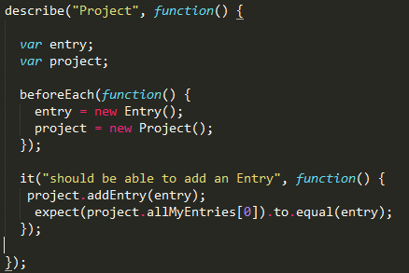
Test Conditions | Using Mocha library and Chai functions
Expected Results | Browser show” ‘tick symbol’ should be able to add an Entry”
Actual Results | 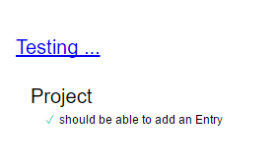
Test Name/Number | Read the start time from Entry Object
Test Objective | Entry object should be able to read the startTime and startDate attributes
Test Description | This testing is using Mocha Chai testing tool
 | Firstly, I create entry object, then read the attributes
 | 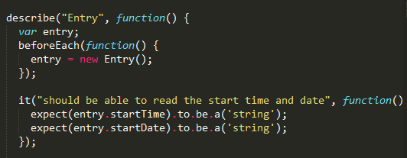
Test Conditions | Using Mocha library and Chai functions
Expected Results | Browser show” ‘tick symbol’ should be able to read the start time and date”
Actual Results | 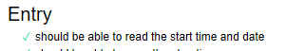

Test Report Template Instructions
General | - Expand this table or use multiple copies as needed.  - Report all the tests that were successfully run.  - Be as brief and concise as possible.
Header | - Enter your name and the date.  - Enter the program name and number.  - Enter the instructor’s name and the programming language you are using.
Test Name/Number | Uniquely identify each test for each program.  - the same tests with different data  - the same data with different tests
Test Objective | - Briefly describe the objective of the test.
Test Description | Describe each test’s data and procedures in sufficient detail to facilitate its later use as a regression test.
Test Conditions | - List any special configuration, timing, fix, or other conditions of the test.  When multiple tests are run with different parameters or under varying conditions, separately list each.
Expected Results | - List the results that the test should produce if it runs properly.
Actual Results | List the results that were actually produced.

