Test Report Template Iteration4
Student | Zihao Huang | Date | 29102016
Program |  | Program #
Instructor | LuofengXu | Language | Javascript

Test Name/Number | Save file
Test Objective | Save a file in the local storage
Test Description | This test will create a html page in order to call doSave method from SaveFile class
 | Blow code is calling the doSave method. When users click the button, the file
 | Will be download into the local storage.
 | 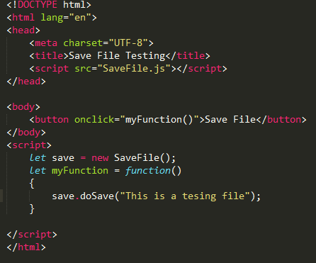
Test Conditions | Using Html page
Expected Results | When users click the save file button, the file will be downloaded
 | 
Actual Results | 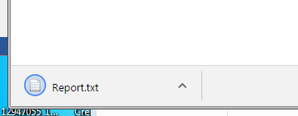

Test Report Template Instructions
General | - Expand this table or use multiple copies as needed.  - Report all the tests that were successfully run.  - Be as brief and concise as possible.
Header | - Enter your name and the date.  - Enter the program name and number.  - Enter the instructor’s name and the programming language you are using.
Test Name/Number | Uniquely identify each test for each program.  - the same tests with different data  - the same data with different tests
Test Objective | - Briefly describe the objective of the test.
Test Description | Describe each test’s data and procedures in sufficient detail to facilitate its later use as a regression test.
Test Conditions | - List any special configuration, timing, fix, or other conditions of the test.  When multiple tests are run with different parameters or under varying conditions, separately list each.
Expected Results | - List the results that the test should produce if it runs properly.
Actual Results | List the results that were actually produced.

