Test Report Template Iteration5
Student | Zihao Huang | Date | 02112016
Program |  | Program #
Instructor | LuofengXu | Language | Javascript

Test Name/Number | generateReport
Test Objective | Report hold a function can generate a string with format
Test Description | MochaChai tool is used in this test. It creates the report object and call the
 | generateReport function. The function will be checked with a string return.
 | 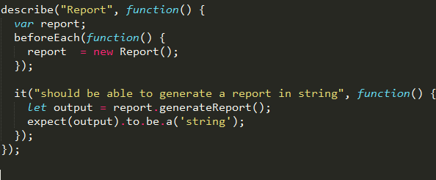
Test Conditions | Using Html MochaChai
Expected Results | Browser show” ‘tick symbol’ should be able to generate a report in string”
Actual Results | 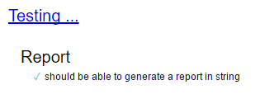

Test Report Template Instructions
General | - Expand this table or use multiple copies as needed.  - Report all the tests that were successfully run.  - Be as brief and concise as possible.
Header | - Enter your name and the date.  - Enter the program name and number.  - Enter the instructor’s name and the programming language you are using.
Test Name/Number | Uniquely identify each test for each program.  - the same tests with different data  - the same data with different tests
Test Objective | - Briefly describe the objective of the test.
Test Description | Describe each test’s data and procedures in sufficient detail to facilitate its later use as a regression test.
Test Conditions | - List any special configuration, timing, fix, or other conditions of the test.  When multiple tests are run with different parameters or under varying conditions, separately list each.
Expected Results | - List the results that the test should produce if it runs properly.
Actual Results | List the results that were actually produced.

