Test Report Template Iteration6
Student | Zihao Huang | Date | 09112016
Program |  | Program #
Instructor | LuofengXu | Language | Javascript

Test Name/Number | Read file
Test Objective | Read a file from the local storage
Test Description | This test will create a html page in order to use the customized directive
 | Blow code is using angular directive. When users click the button, user will
 | Be able to select a file from local storage and it will be console.log in the browser.
 | 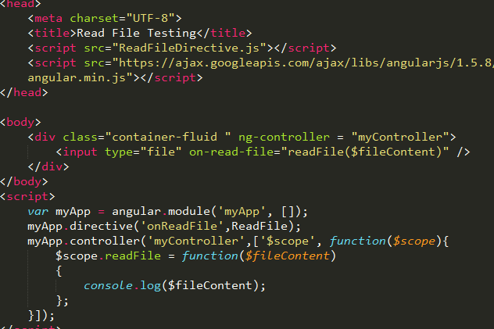
Test Conditions | Using Html page
Expected Results | When users click the choose file button and choose the helloWorld.txt file,
 | The browser will console log “Hello World!!!”
Actual Results
 | 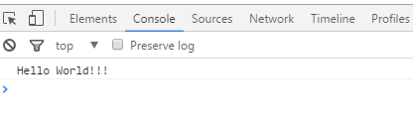

Test Report Template Instructions
General | - Expand this table or use multiple copies as needed.  - Report all the tests that were successfully run.  - Be as brief and concise as possible.
Header | - Enter your name and the date.  - Enter the program name and number.  - Enter the instructor’s name and the programming language you are using.
Test Name/Number | Uniquely identify each test for each program.  - the same tests with different data  - the same data with different tests
Test Objective | - Briefly describe the objective of the test.
Test Description | Describe each test’s data and procedures in sufficient detail to facilitate its later use as a regression test.
Test Conditions | - List any special configuration, timing, fix, or other conditions of the test.  When multiple tests are run with different parameters or under varying conditions, separately list each.
Expected Results | - List the results that the test should produce if it runs properly.
Actual Results | List the results that were actually produced.

