CS 255 System Design Document Template

This template lays out all the different sections that you need to complete for Project Two. Each section has guidance to prompt your thinking. You will need to continually reference the interview transcript as you work to make sure that you are addressing your client’s needs. There is no required length for the final document. Instead the goal is to complete each section based on what your client’s needs are. Remove this note when you are finished, and replace all bracketed text with the relevant information.

UML Diagrams

UML Use Case Diagram
[In Module Six, you were asked to complete a use case diagram based on your system design. If you would like to make any adjustments to your diagram, please do so. Please insert your use case diagram here. Check to make sure that you included appropriate components and symbols and that your design meets the client’s needs.]

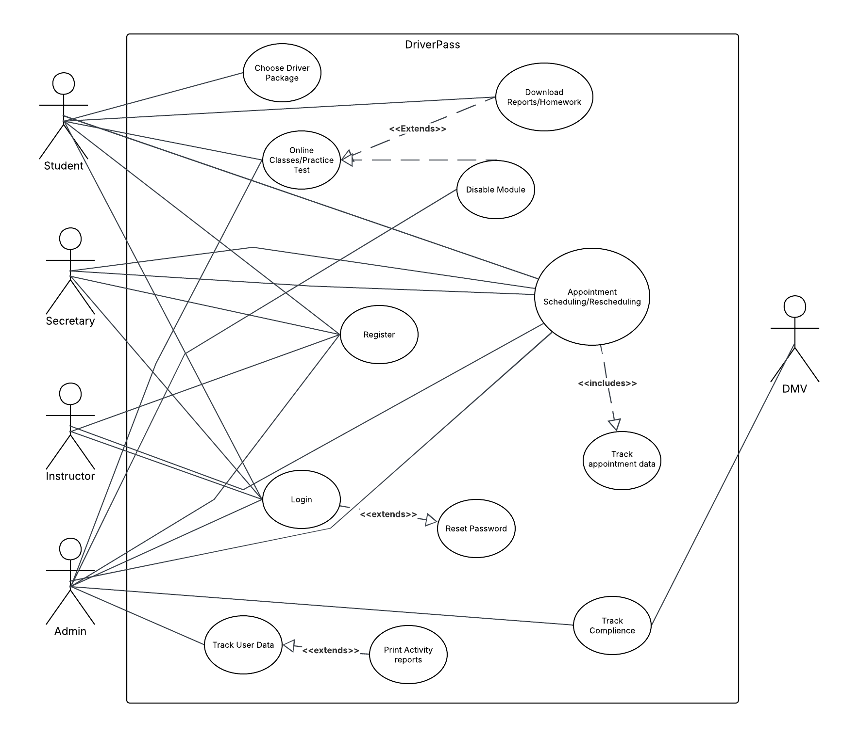

UML Activity Diagrams
[You were asked to choose two use cases and create two activity diagrams, one for each use case. Please insert both of your activity diagrams here. Check to make sure that you included appropriate components and symbols and that your design meets the client’s needs.]
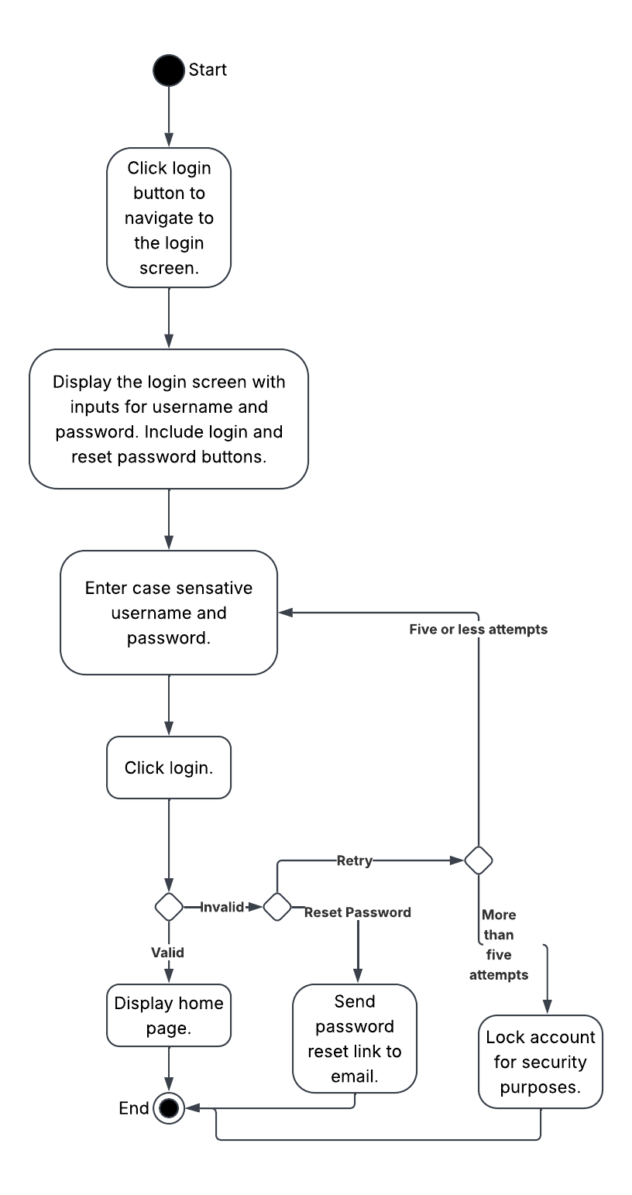
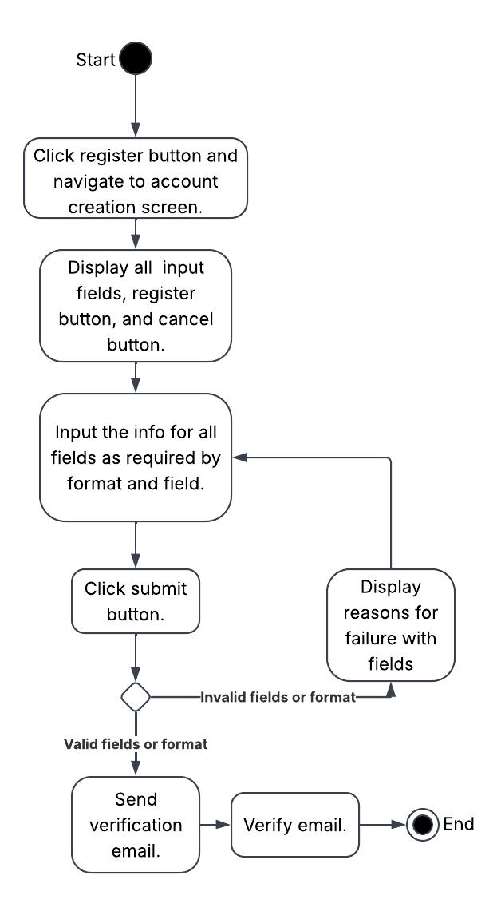

UML Sequence Diagram
[You were asked to create a sequence diagram based on one of the use cases you chose. Please insert your sequence diagram here. Check to make sure that you included appropriate components and symbols and that your design meets the client’s needs.]
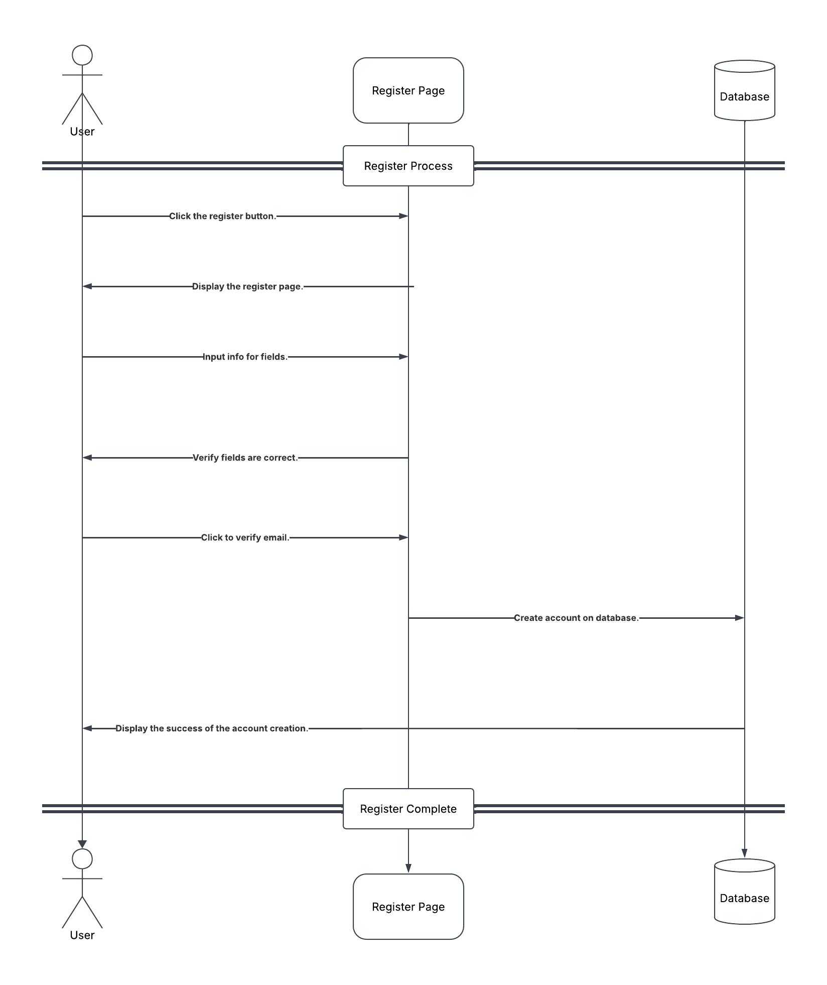

UML Class Diagram
[You were asked to create a class diagram based on the different classes and attributes needed for your system design. You are not required to include methods, but you may if you wish. Please insert your class diagram here. Check to make sure that you included appropriate components and symbols and that your design meets the client’s requirements.]

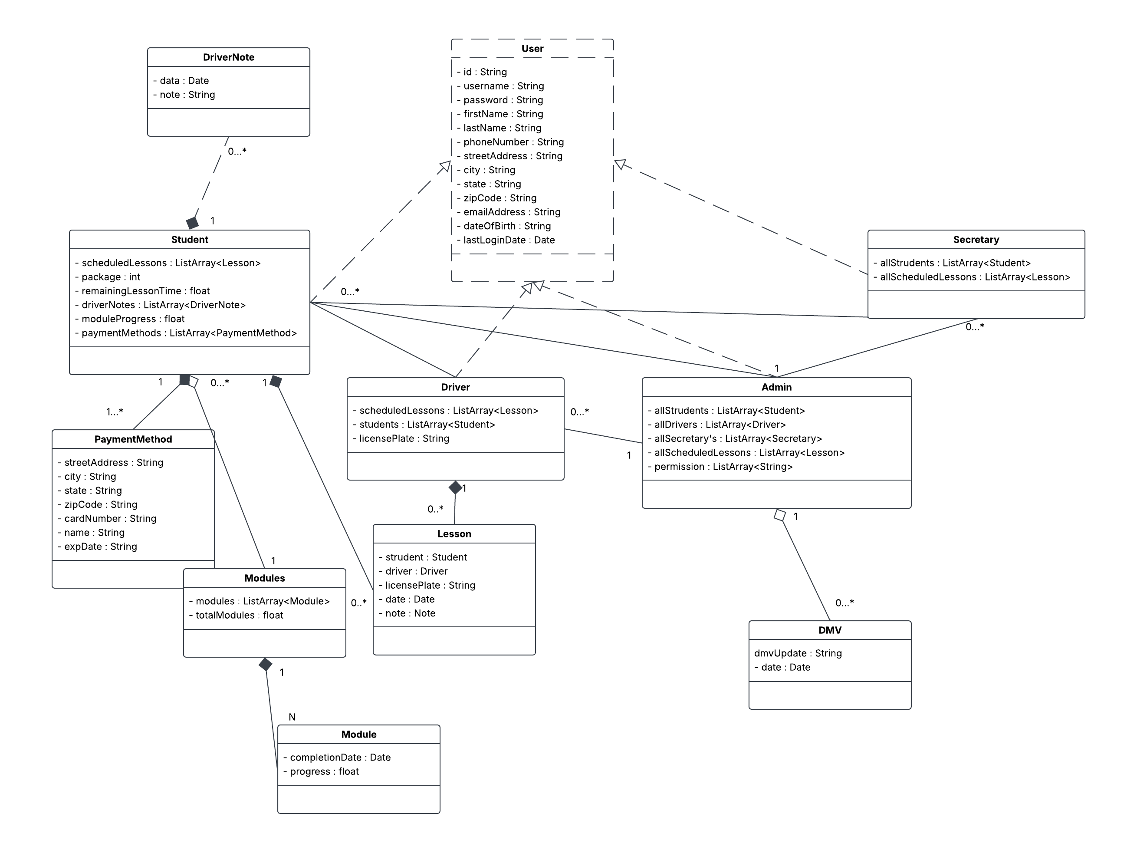

Technical Requirements
[Based on the diagrams you have created, describe the technical requirements of your system. These requirements should address the required hardware, software, tools, and infrastructure necessary for your system design.]

For the DriverPass system, there are some main points for the complete set of requirements. The main points are Frontend, Backend, Backend, Cloud Resources, Database, Security, and Deployment. Together these are some of the main points that will allow for a clean, smooth, and secure deployment of the DriverPass application. That way you will be both helping people pass their driver test and making the roads safer.
The Frontend, which is the User Interface, will be set up using modern languages with high support and capabilities. The languages will be HTML, CSS, and JavaScript for the web application. This application could also benefit from React framework to help with handling state. The mobile application should use Swift for iOS and Kotlin for Android. The backend or the logic side of the application will be handled with Java for the languages. GraphQL and JSON will be used to handle API as well as request/response. This API and formatting can be highly efficient and reduce the cloud resources used from the server. For cloud services I recommend comparing prices from various provides such as Amazon Web Services, Google Cloud Platform, and Microsoft Azure. I don’t really have a specific recommendation though.
For the database the language I would use is SQL for the language and run it on MySql. You may come across NoSql resources, but I don’t recommend that for you as it is typically used for big data. For security, the web site should use HTTPS to ensure that traffic is encrypted. Encrypt data and use secure API endpoints. The backend should manage different users with Role-Based Access Control to ensure that users can’t delete other users and such. You also want to ensure that the pages are set up to protect from things like SQL injection and cross-site scripting. Lastly, for deployment I would use something like GitHub and then adjust as you see fit. GitHub is a fantastic application that should cater to all your continuous integration and continuous deployment needs.

