

Practices for Secure Software Report

Table of Contents
Document Revision History 3
Client 3
Instructions 3
Developer 4
1. Algorithm Cipher 4
2. Certificate Generation 4
3. Deploy Cipher 4
4. Secure Communications 4
5. Secondary Testing 4
6. Functional Testing 4
7. Summary 4
8. Industry Standard Best Practices 4

Document Revision History

Version | Date | Author | Comments
1.0 | 04/17/26 | Joseph Goins

Client



Instructions

Submit this completed practices for secure software report. Replace the bracketed text with the relevant information. You must document your process for writing secure communications and refactoring code that complies with software security testing protocols.

- Respond to the steps outlined below and include your findings.
- Respond using your own words. You may also choose to include images or supporting materials. If you include them, make certain to insert them in all the relevant locations in the document.
- Refer to the Project Two Guidelines and Rubric for more detailed instructions about each section of the template.

Developer
Joseph Goins

Algorithm Cipher

Security is key for companies processing sensitive information such as financial, healthcare, and government information. All three are very high value targets for any hacker seeking to exploit data for money, justice, etc. This is why Artemis Financial needs to use a secure communication layer for its web application such as TLS. TLS will also allow for the use of encryption algorithms such as AES-256 and hash functions like SHA-256 which are recommendations that I am also giving. For AES-256 it is a gold standard right now that allows users to encrypt plain text into a cypher using a 256-bit key. It’s a symmetric encryption algorithm that’s almost impossible to break. It’s also very useful for encrypting bulk data since it’s symmetrical and will be a lot faster when being encrypted and decrypted.
SHA-256 is a great hash function that would scramble inputs into a fixed size which is 256 bits. That way when you run the check again and both hashes are the same, you know the information has been unaltered which is why it’s so useful for a checksum.
Now for the topic of symmetric vs asymmetric, the difference is how data is encrypted on both ends of the data communication. For symmetric the data is encrypted and decrypted using the same key. Asymmetric is encrypted and decrypted with two different keys. Asymmetric keys are more secure because they have two keys in the process, however, they’re slow and more expensive for computers processing data. That’s where symmetric keys have an advantage, they are quicker to process and very efficient.
Encryption algorithms have been around for thousands of years. They have been used to hide all sorts of information in various situations. Back then it might have been written on a letter being sent across battlefields, and an encryption was used in case the messenger was caught. Encryption has also been used through war, banking, games, authentication, etc. Encryption has been used for many things and modern encryption is mainly used on computers due to growing level of data and communication on the internet. So much of modern society is lived and stored on computers thus the need to protect the information has made it so encryption is such a valuable thing.

Certificate Generation
Insert a screenshot below of the CER file.
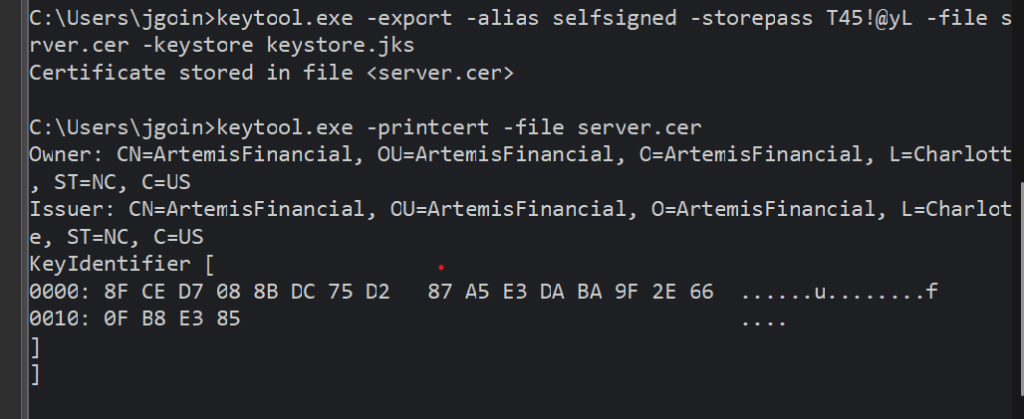
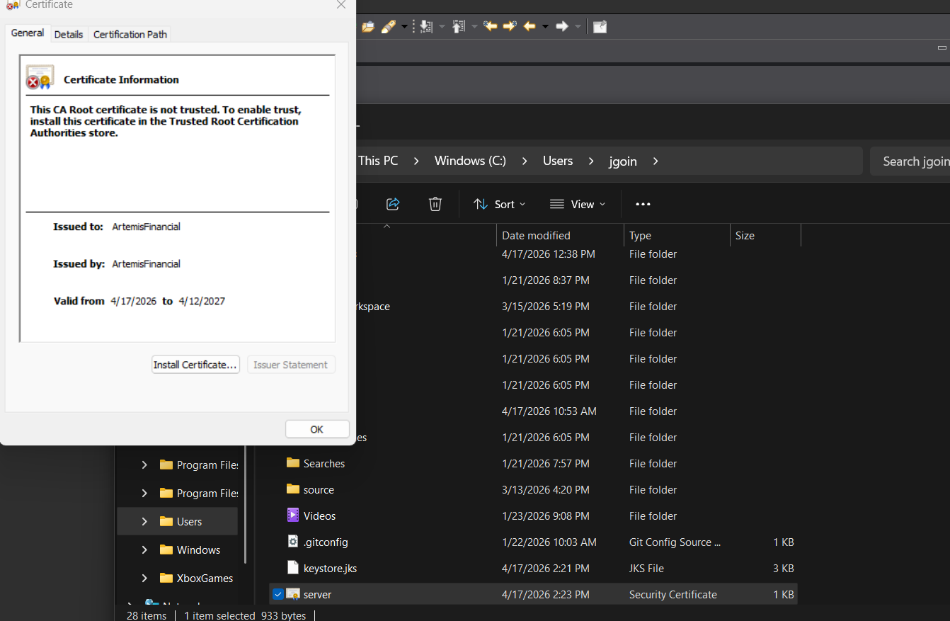

Deploy Cipher
Insert a screenshot below of the checksum verification.

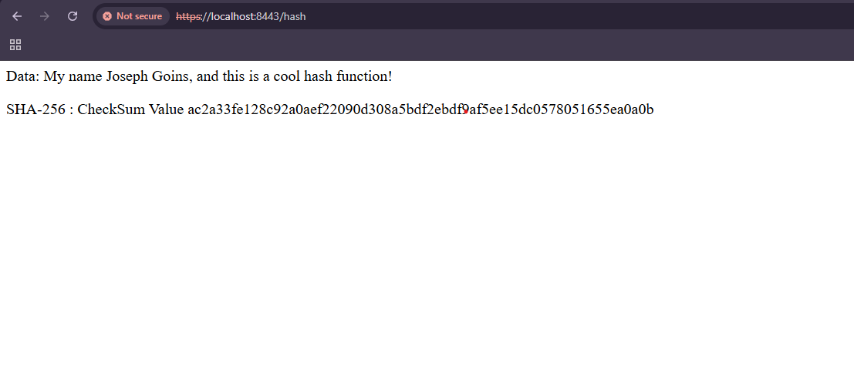

Secure Communications
Insert a screenshot below of the web browser that shows a secure webpage.

Secondary Testing
Insert screenshots below of the refactored code executed without errors and the dependency-check report.

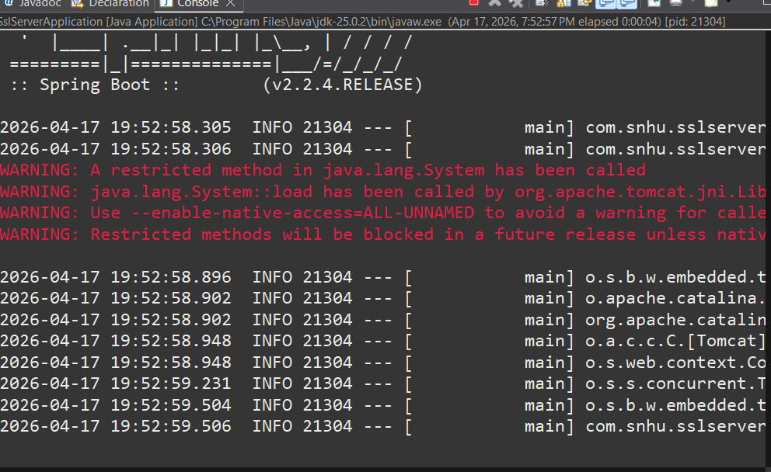

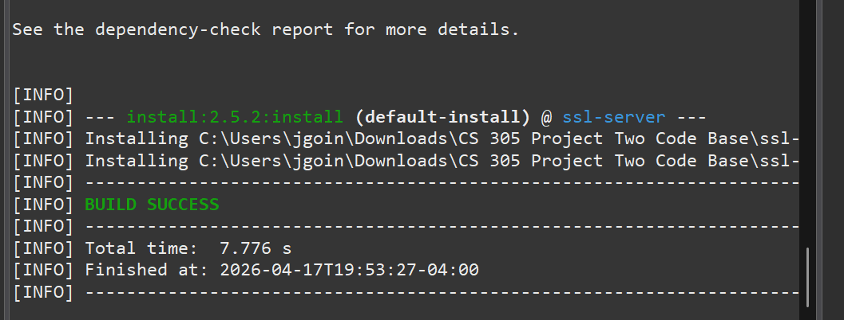

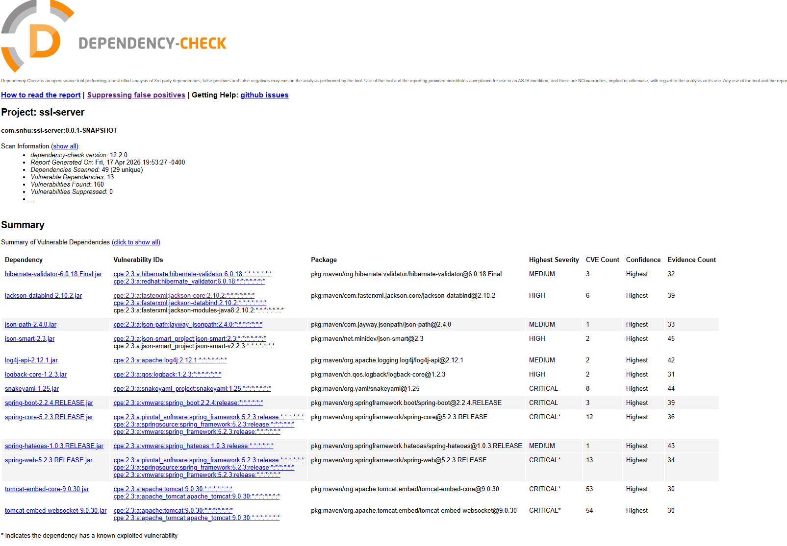

Functional Testing
Insert a screenshot below of the refactored code executed without errors.

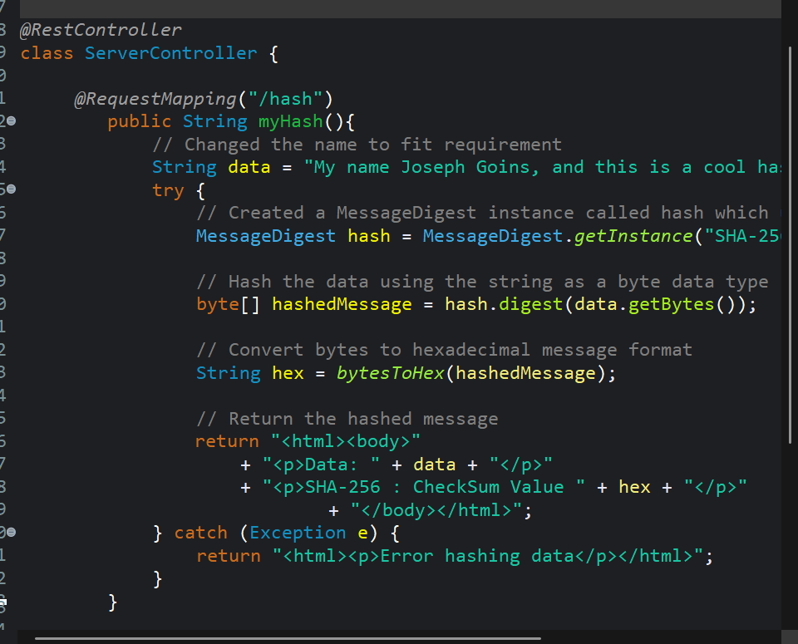

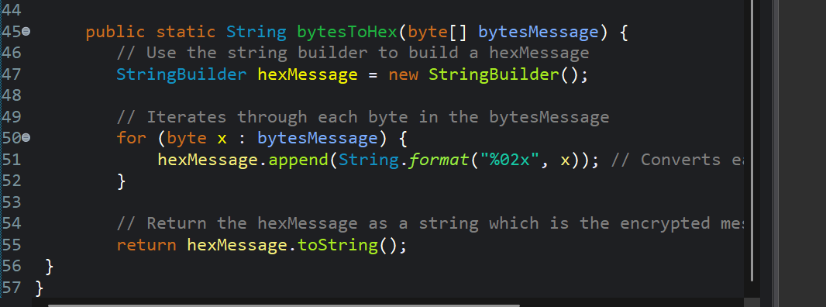

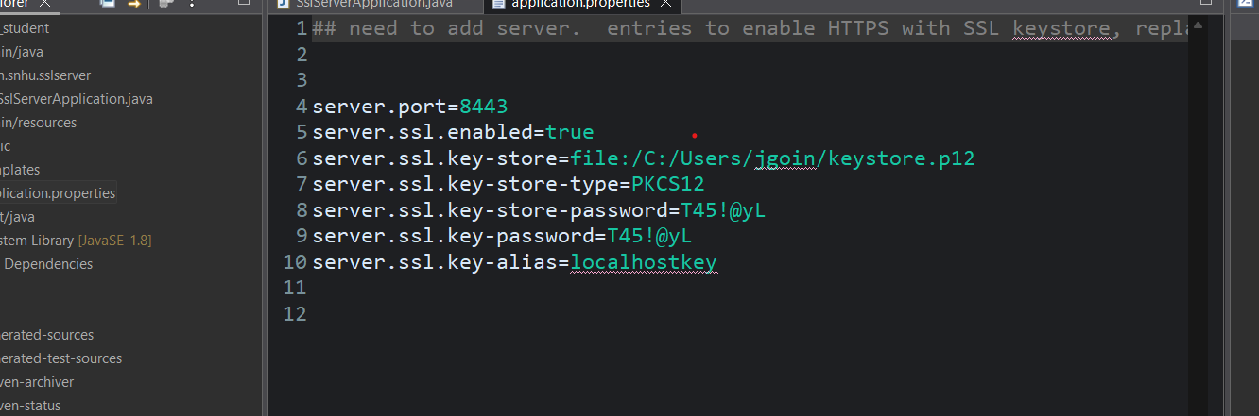

Summary

During this project I modified existing code and added in some new security procedures that will allow for more secure communication. I started by modifying the main java application to use Rest Controller, and then I created a page within the web application called hash where it would display a message being hashed. That brings me to my next modification which is where I add the use of Message Digest and this would allow me to hash in messages. Now I could take any input and create a hashed version which is great for checksum’s which ensure data has not been altered by something like a man in the middle attack. I also created a certificate and stored a key which would safely ensure that the web application was protected from various attacks. Also, by running the Maven Install I was able to run a dependency check which allows me to monitor vulnerabilities in my application based on known vulnerabilities in the National Vulnerability Database.
Security is a collection of many tools and layers guarding applications. Some layers include Input Validation, APIs, Cryptography, Client/Server, etc. Each one of those layers must have security considerations and continually be reviewed to make sure it’s still secure. Which is why each part of software development needs to have security in mind, from the ground up. And even during maintenance. That’s because vulnerabilities are always evolving and new things come out so applications must stay up to date in maintaining the most secure application possible. With all those layers added, you can prevent a lot of vulnerabilities/attacks. Nothing is 100% even with a proper setup, but great security can minimize the number of successful attacks and the impact of those attacks with proper responses put in place. Which is why Security and Functionality are the two most important components to software development.

Industry Standard Best Practices

I applied industry best practices and standards by adding reputable encryptions, certificates for secure connection, and the ability to hash messages for a checksum. This is important because not all encryptions are up to date or even powerful enough to be relevant for the near future. This is especially true for something like financial data where information is very valuable. The certificates are useful because it enables trusted and secure connections where certain types of attacks like man in the middle can be stopped. Checksum sort of does the same thing by running hash functions and comparing the two hash messages to make sure nothing has changed. This is very important because changes can be made to pages midflight leaving pages vulnerable. This is another example where using reputable algorithms helps because hashing can be vulnerable to collisions. Collisions happen when two separate messages can create the same hash output. Using large and complex hash algorithms such as SHA-256 or SHA-512 can make sure collisions are virtually impossible. That’s why I chose to use SHA-256 for my hash algorithm.
Lastly, I ran dependency check from the OWASP dependency check. I also updated the version and ran an install to gather all the latest known vulnerabilities. This ensures that I have all the latest known vulnerabilities and I can update various third-party tools making my application more secure. This is important because applications usually use third party tools and those third party tools can also have vulnerabilities, so you need to ensure everything is up to date.

