Summary and Reflection

Joseph B Goins
Southern New Hampshire University
CS-320: Software Test, Automation QA
Professor Tanisha Jacks
June 21st, 2026

Summary and Reflection
During my testing of the mobile application, I used various testing techniques to efficiently and effectively test the application. All my techniques were mainly based around Black Box Testing. All the techniques aided me in directly meeting the software requirements. I would look at the structure of each object, then I would ensure that I tested my code for each requirement. I also tested for a few similar situations outside of the requirement. An example of this is testing that the ids of the Appointment object were not null which was a direct requirement from the object’s design. However, after testing that a null value would throw an exception, I also tested things like empty strings or strings with only spaces which are technically not null but fall in a similar category. This helped ensure that every test I wrote aligned directly with every software requirement.
The quality of my code was on par with the software requirements and testing requirements such as the coverage percentage. My code tested every software requirement for both valid and invalid inputs. I also met the 80% test coverage when running the EclEmma test coverage tool in Eclipse. My test coverage hovered around the 85% marker which maintaining higher test coverage will help increase the quality of code before pushing code into production. All these tools and many more help launch software with better quality and thus happy users.
My experience with Junit testing was very positive overall, and considerably better than using the OWASP tool last semester to run dependency checks. All the tools I used including EclEmma were quite user friendly and very easy to set up and run. As for how I ensured that all my code was technically sound and efficient, I took an approach that other beginners might take. The truth is that my tests were technically sound but not very efficient at all. Take for instance this block of code from the AppointmentTest.java file, it is technically sound but could probably be more efficient if I looped through various fields being null to ensure that they can’t be null.
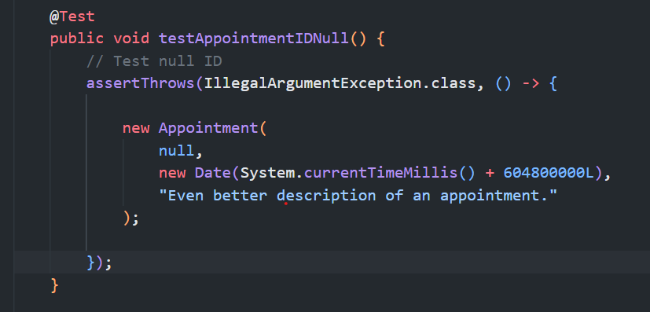
I would not do it differently though because I wanted to ensure that my tests were focused and attached to each specific field or outcome. My thought process was that a more effective strategy is to write easy direct tests. Otherwise, I felt like writing complex tests could introduce errors in my test, make it difficult to read tests files, or difficult to track failures in tests.
The main testing techniques I incorporated were from the black box testing approach. These techniques are Equivalence Partitioning, Boundary Value Analysis, Decision Table Testing, and Error Guessing. Equivalence Partitioning was used in the Customer, Task, and Appointment files by ensuring that value or characters couldn’t be null or none, but they also couldn’t be more than a certain amount such as 50 characters for a description. I used Boundary Value Analysis by ensuring that if I did just more than 10 characters for an id it would throw an error and if I did 10 it would be valid. Decision Table Testing was done in the Customer, Task, and Appointment files as well. It was taking object conditions and rejecting the object if the conditions weren’t met. Lastly, I used error guessing from previous experience in the AppointTest.java file by not only testing null values but also testing empty strings and string with only spaces. All those values fall in similar situations, so I rejected null, but I also trimmed strings and tested if empty and threw the same error.
I chose the techniques above because black box testing is all about Input-Output Validation as well as Requirement Driven Design. Thus, it was perfect for testing based on requirements and ensuring that the objects handled each input correctly and responded with the right output. Some black box techniques I didn’t use were State Transition Testing and Use Case Testing. State Transition Testing is used to test behaviors of applications in different states. The application had no state to test and so I had no use for this technique. It is great for testing features like being logged in or logged out. Use Case Testing wasn’t applicable because I didn’t have any Use Cases but would be effective for testing user experience in the functionalities of the application. An example of this would be testing Appointment Service for scheduling an appointment.
I didn’t use any white box testing techniques by technicality. I ran EclEmma for line coverage which would be under the State Coverage technique, but I only ran the test, so I didn’t want to apply as technique I planned out and tested. However, it’s a great test to run, it ensures that all code is tested, maximizing the quality of the test and software. Branch coverage is another technique that could have been useful for this block:
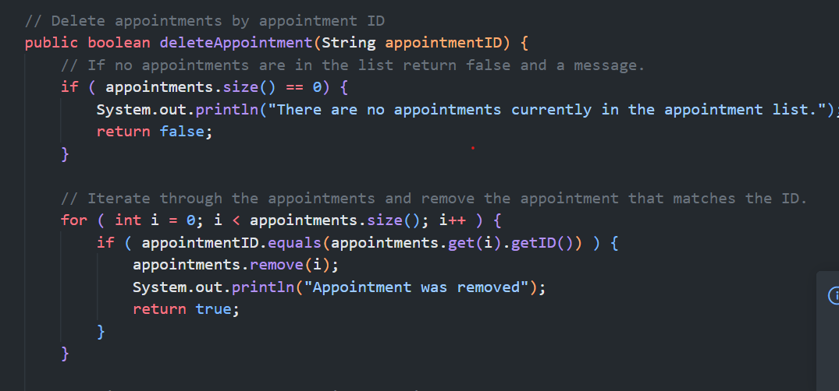
I never actually tested an appointment service with no appointments. So, it would have been nice to not make the system handled an appointment list with no appointments correctly. I also didn’t test condition coverage or loops. Condition coverage is important to ensure that no set of conditions is unhandled. Loop testing is extremely important because a bad condition in a while loop can stop an application in its tracks with an infinite loop.
Mindset was important throughout this experience because I wrote the code and then tested it for errors. One great saying I’ve carried with me is that you can’t solve your problems with the same thinking that caused them. So, when I went to test my application, I tried to think about how to break my application instead of building it. I was cautious with each assertion I made because I wanted to make sure there were no fallacies in my thought processes. This helped me appreciate the code I was writing and testing because I didn’t want to miss something.
Not wanting to miss something was also due to the fact I didn’t want my code to fail, which was my bias. Developers need to test their code but they’re not testers. I don’t think developers can truly remove bias completely. Developers should work with testers, but the two jobs should be separate. That helps development teams build quality applications with quality code. The team must stay committed to quality code and never cut corners. It’s paramount to their reputation, the company’s reputation, and a responsibility to the users of their application. Quality code makes applications function smoothly. It also makes them more secure and safe. Even if your application isn’t safety critical such as aviation software, data needs to be kept safe as well. I’m not saying developers should never make mistakes, mistakes happen and exhaustive testing is impossible. However, we can be thorough and continue to learn new things, helping keep our strategies up to date and secure, which is exactly what I will do to help reduce errors in my code.

References
Hambling, B., Morgan, P., Samaroo, A., Thompson, G., & Williams, P. (2019). Software testing : An istqb-bcs certified tester foundation guide - 4th edition. BCS Learning & Development Limited.
Defining good test coverage with unit testing and end-to-end testing. (n.d.). https://www.mabl.com/blog/defining-good-test-coverage-with-unit-testing-and-end-to-end-testing
Black box testing - software engineering - geeksforgeeks. (n.d.). https://www.geeksforgeeks.org/software-testing/software-engineering-black-box-testing/
White box testing - software engineering - geeksforgeeks. (n.d.). https://www.geeksforgeeks.org/software-testing/software-engineering-white-box-testing/

