**01.112 MACHINELEARNING (2017)**

**HW2**

ZHOU XUEXUAN 1001603

**Q1.**

1. Output screenshot below:

vX:(10,4), vY:(10,)

tX:(40,4), tY:(40,)

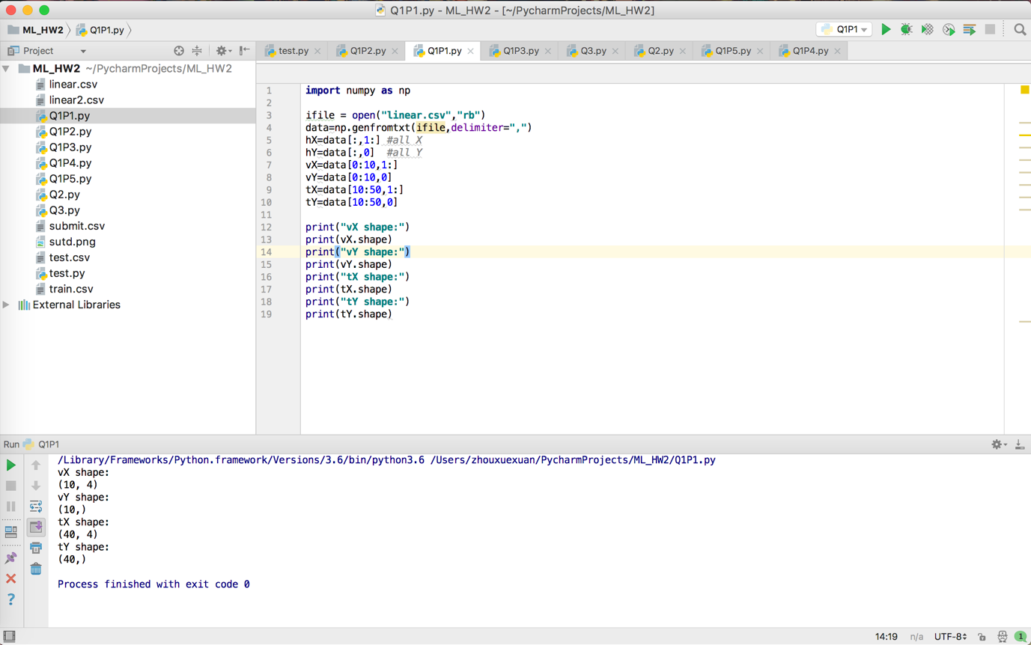

1. Down below is the output for q2

W0 will be assumed as irrelevant which is taking no penalization

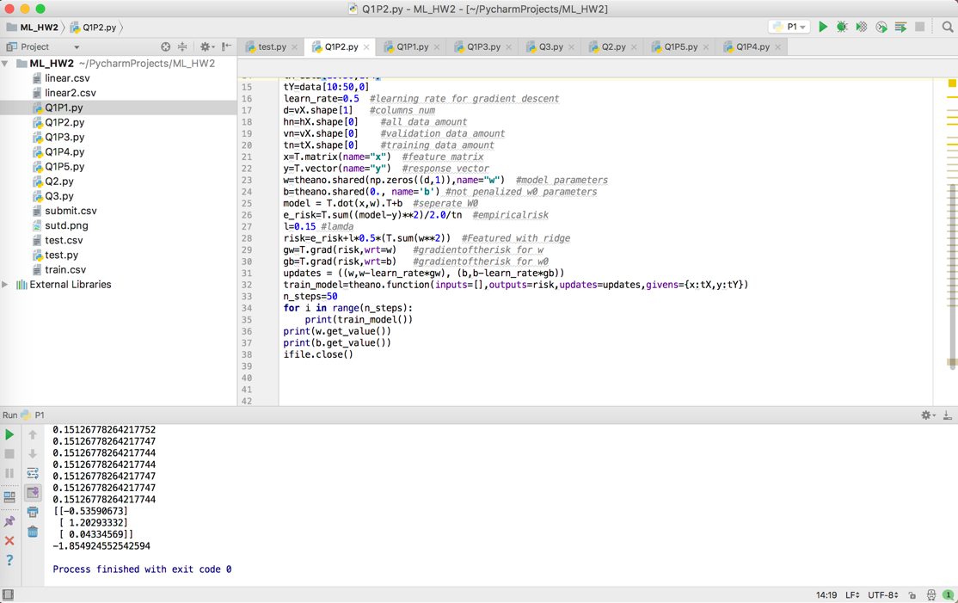

1. Scipy BFGS optimizer

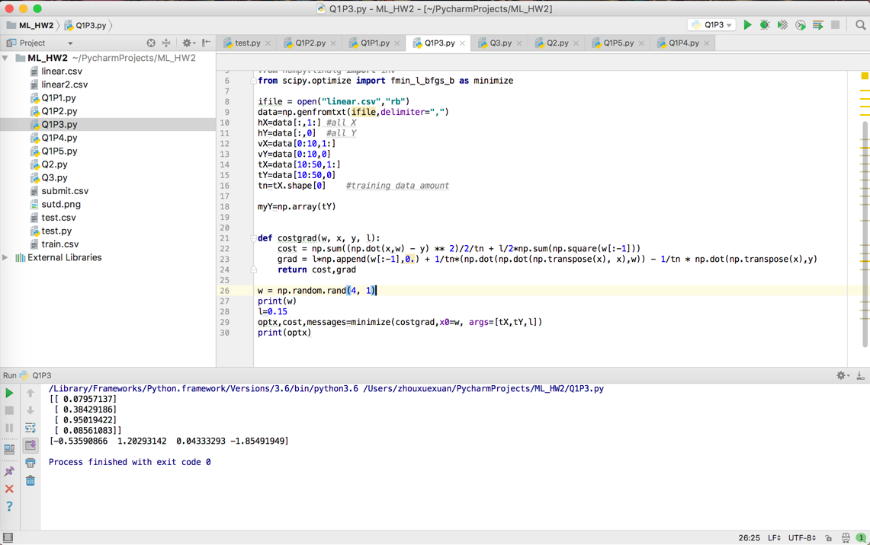

It output almost the same coef compared with w value from theano gradient decent method

1. Following is the screenshot output of the ridge_regression function

It also returns almost the same value for tX and tY

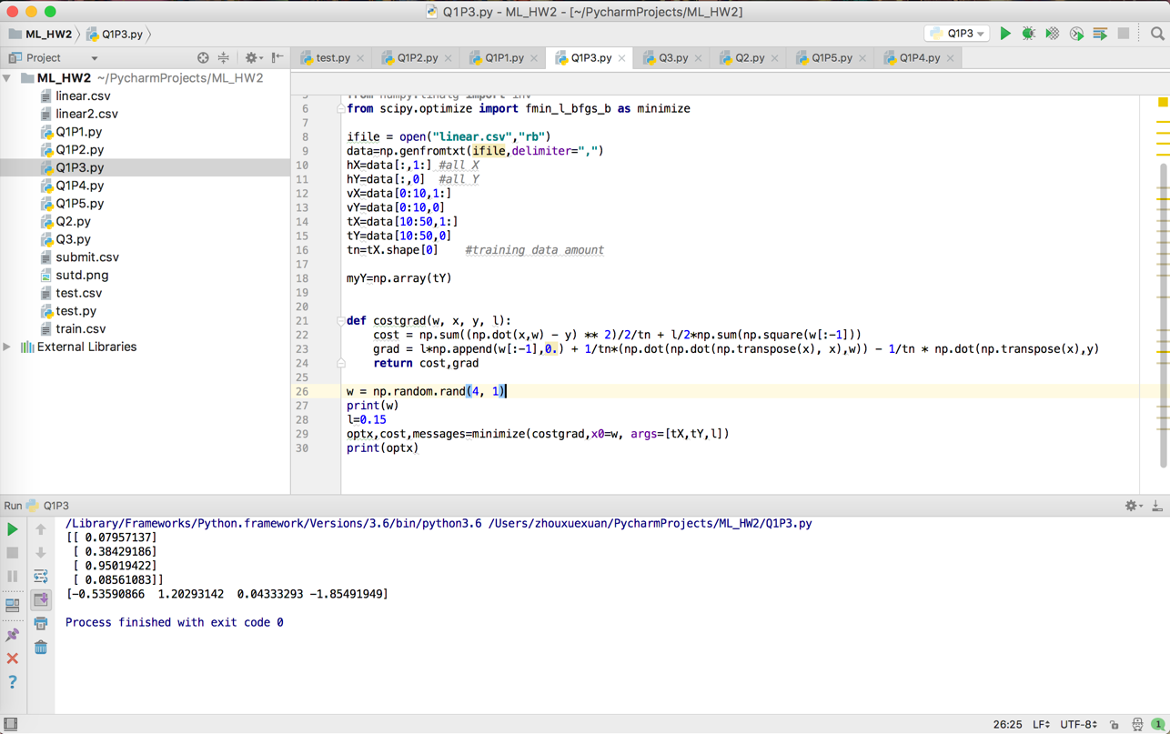

1. Following is the graph output

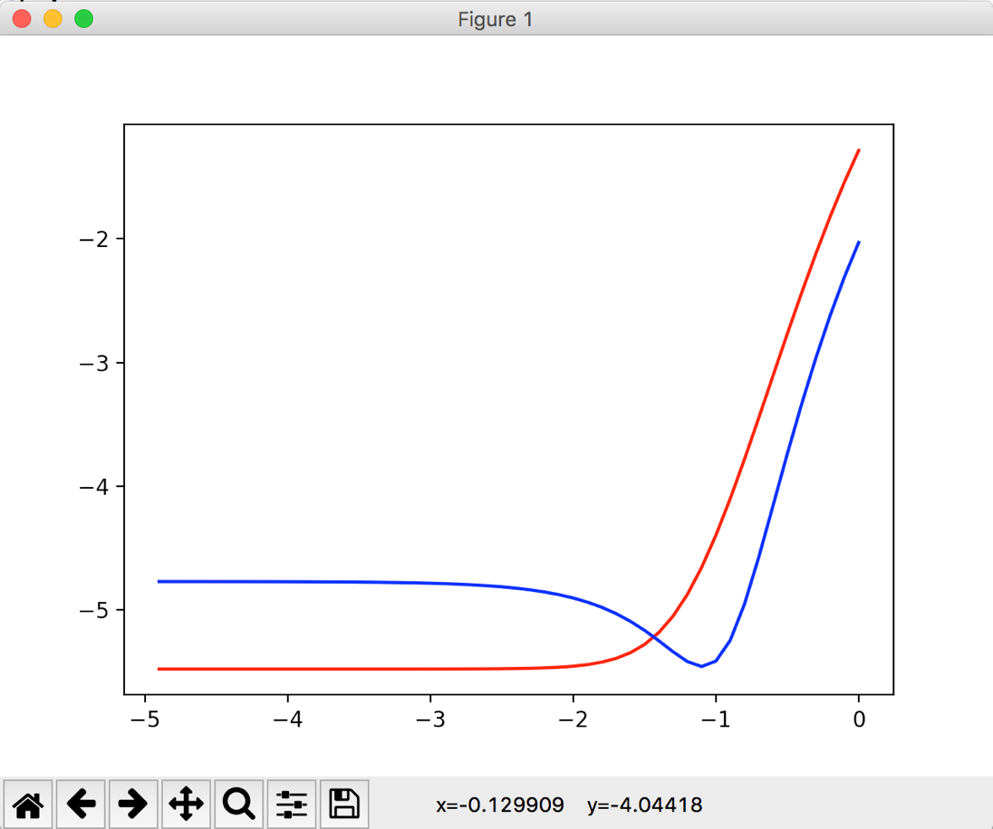

lamda = (np.log(-1))^-1 = 0.1 (which is not the exact value and lamda should be around with 0.1)

**Q2.**

Code briefing:

1. Setup variable for both methods:

Compute Kmeans and random codebooks and theirs labels.

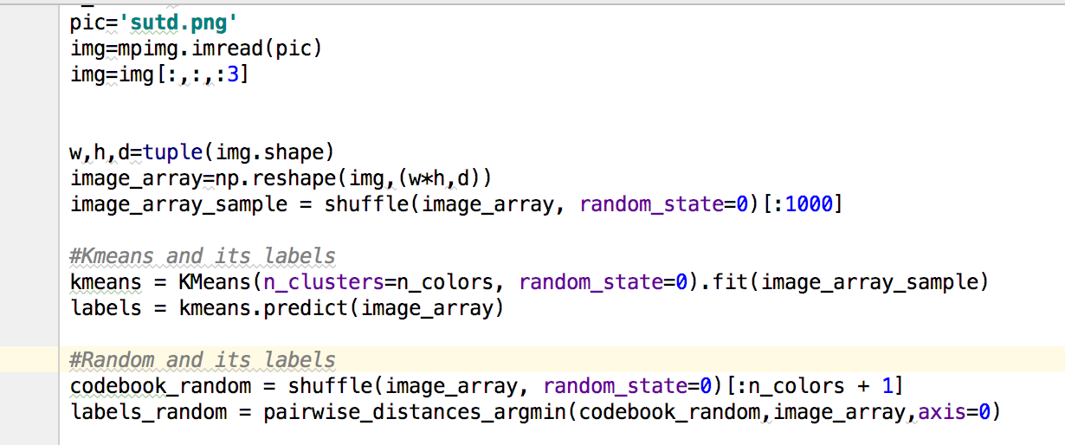

1. Plot relevant graphs:

Plot the graph with the attributed computed above

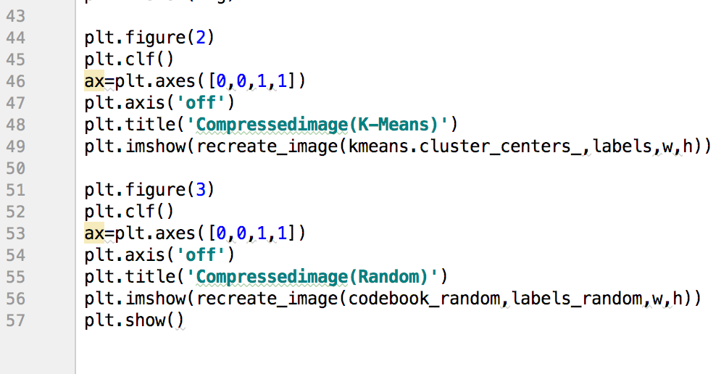

1. Following is the graph output for kmeans

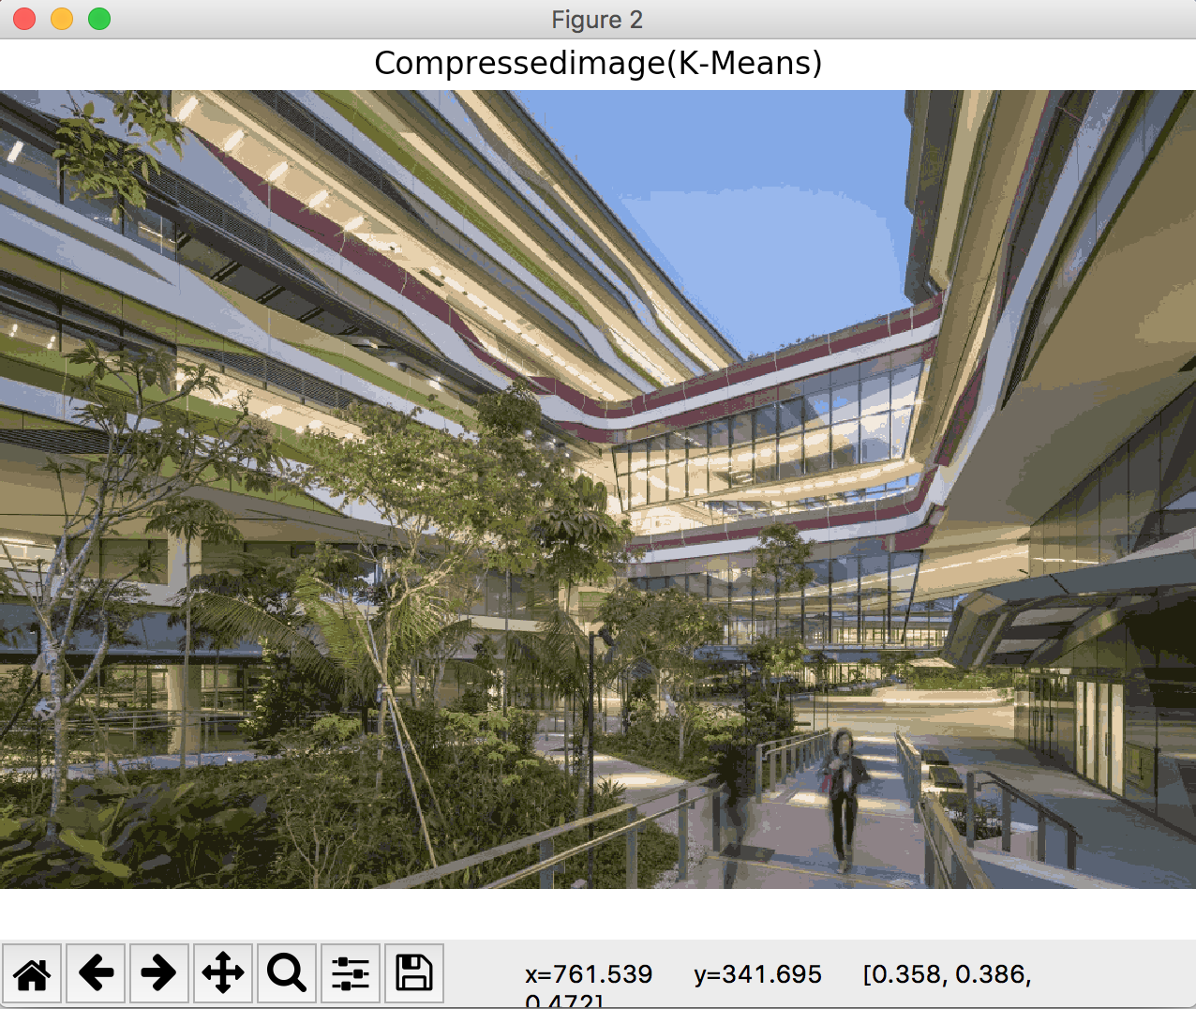

1. Following is the graph output for random

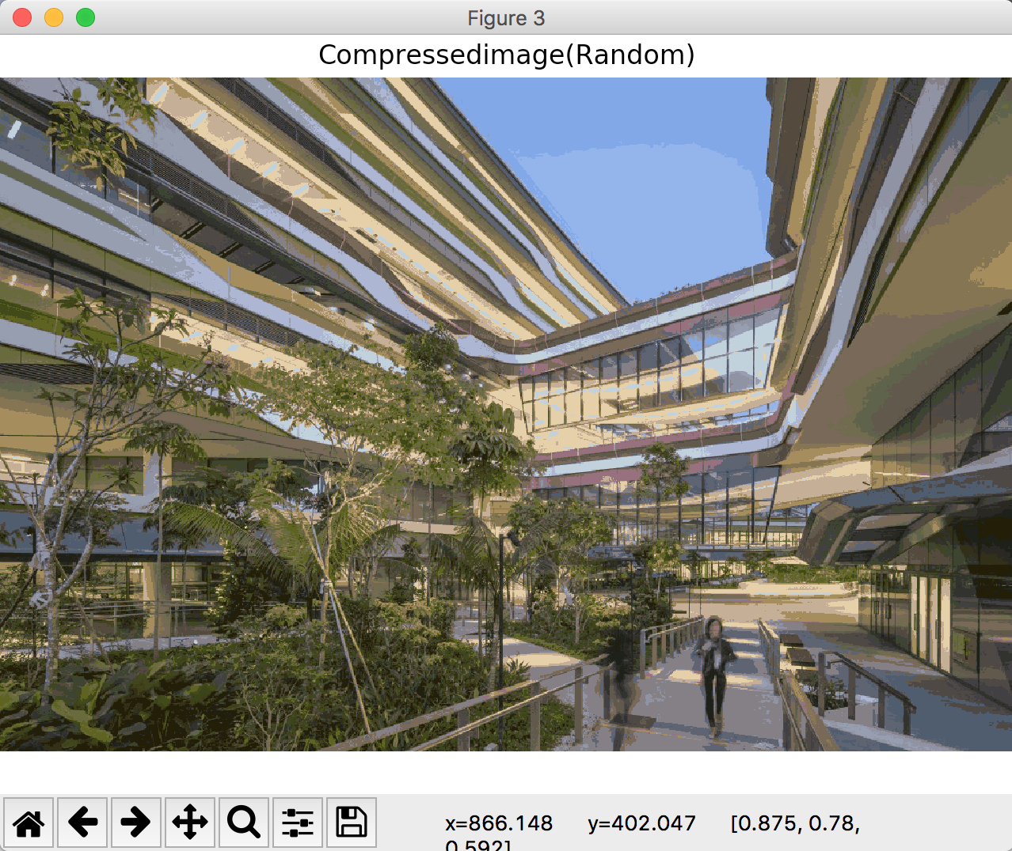

1. We can compute the derivative of the function to check the point when it goes into convergence(min)

**Q3.**

1. Out put shows below

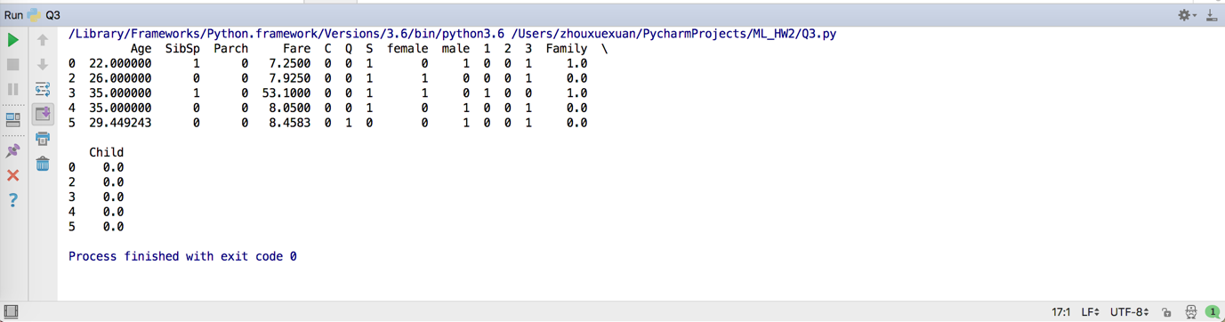

1. Score Output 78.65

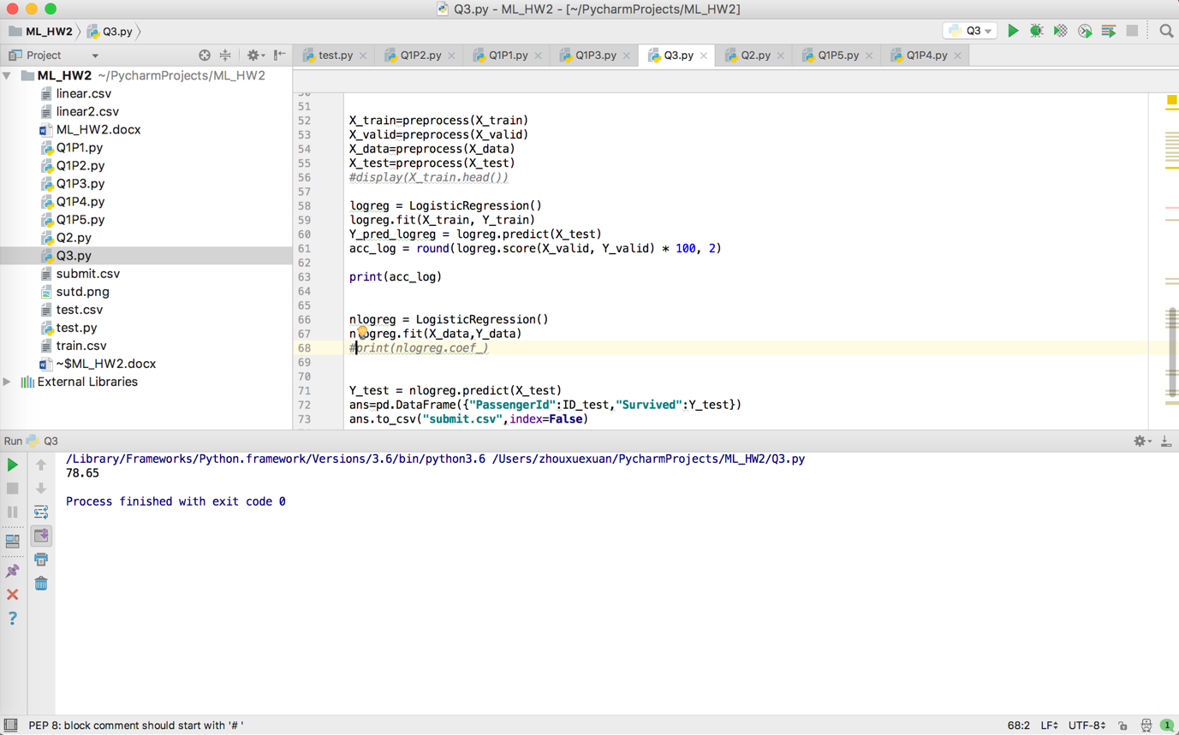

1. Output parameter theata

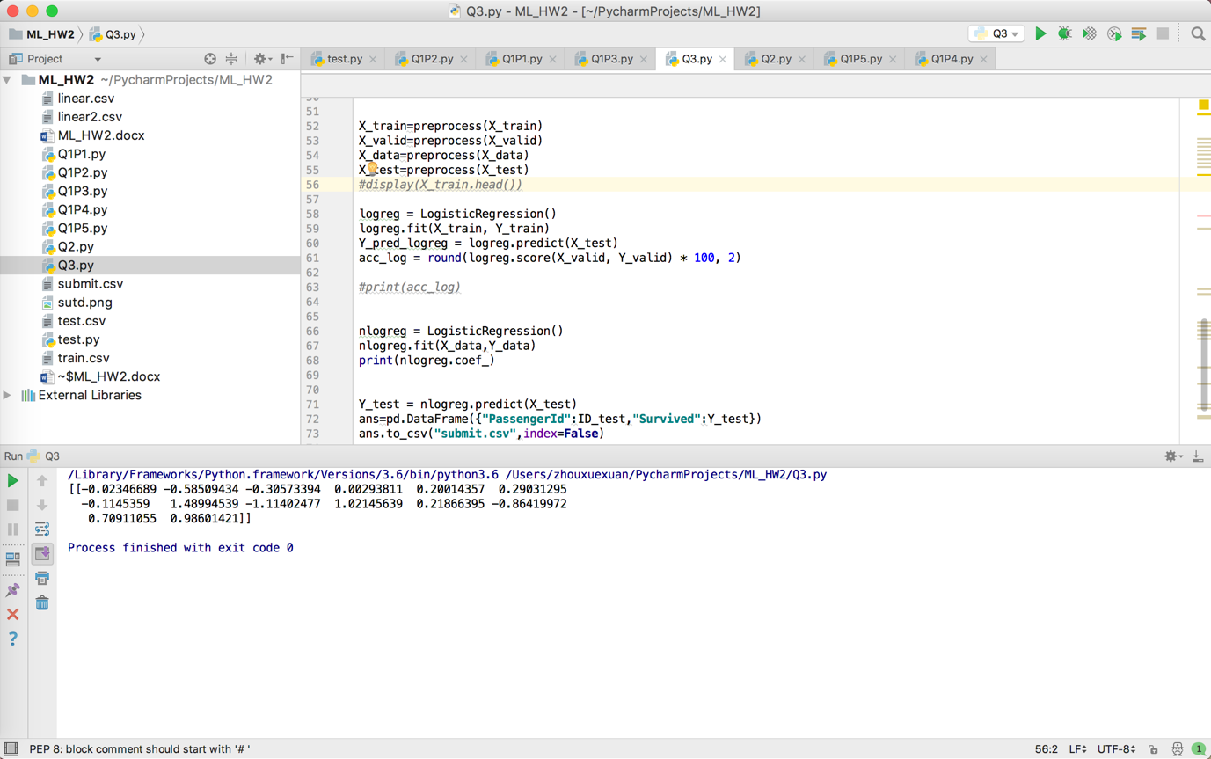

1. User ID: 1303656

Score: 0.77511