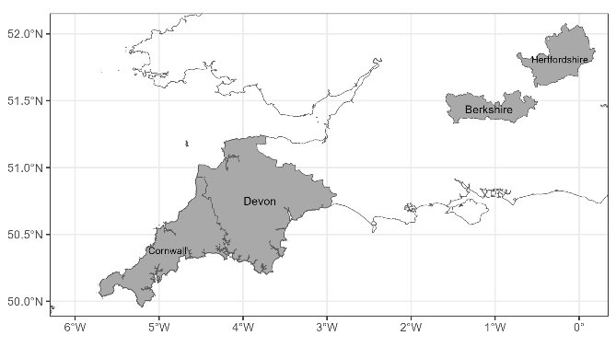

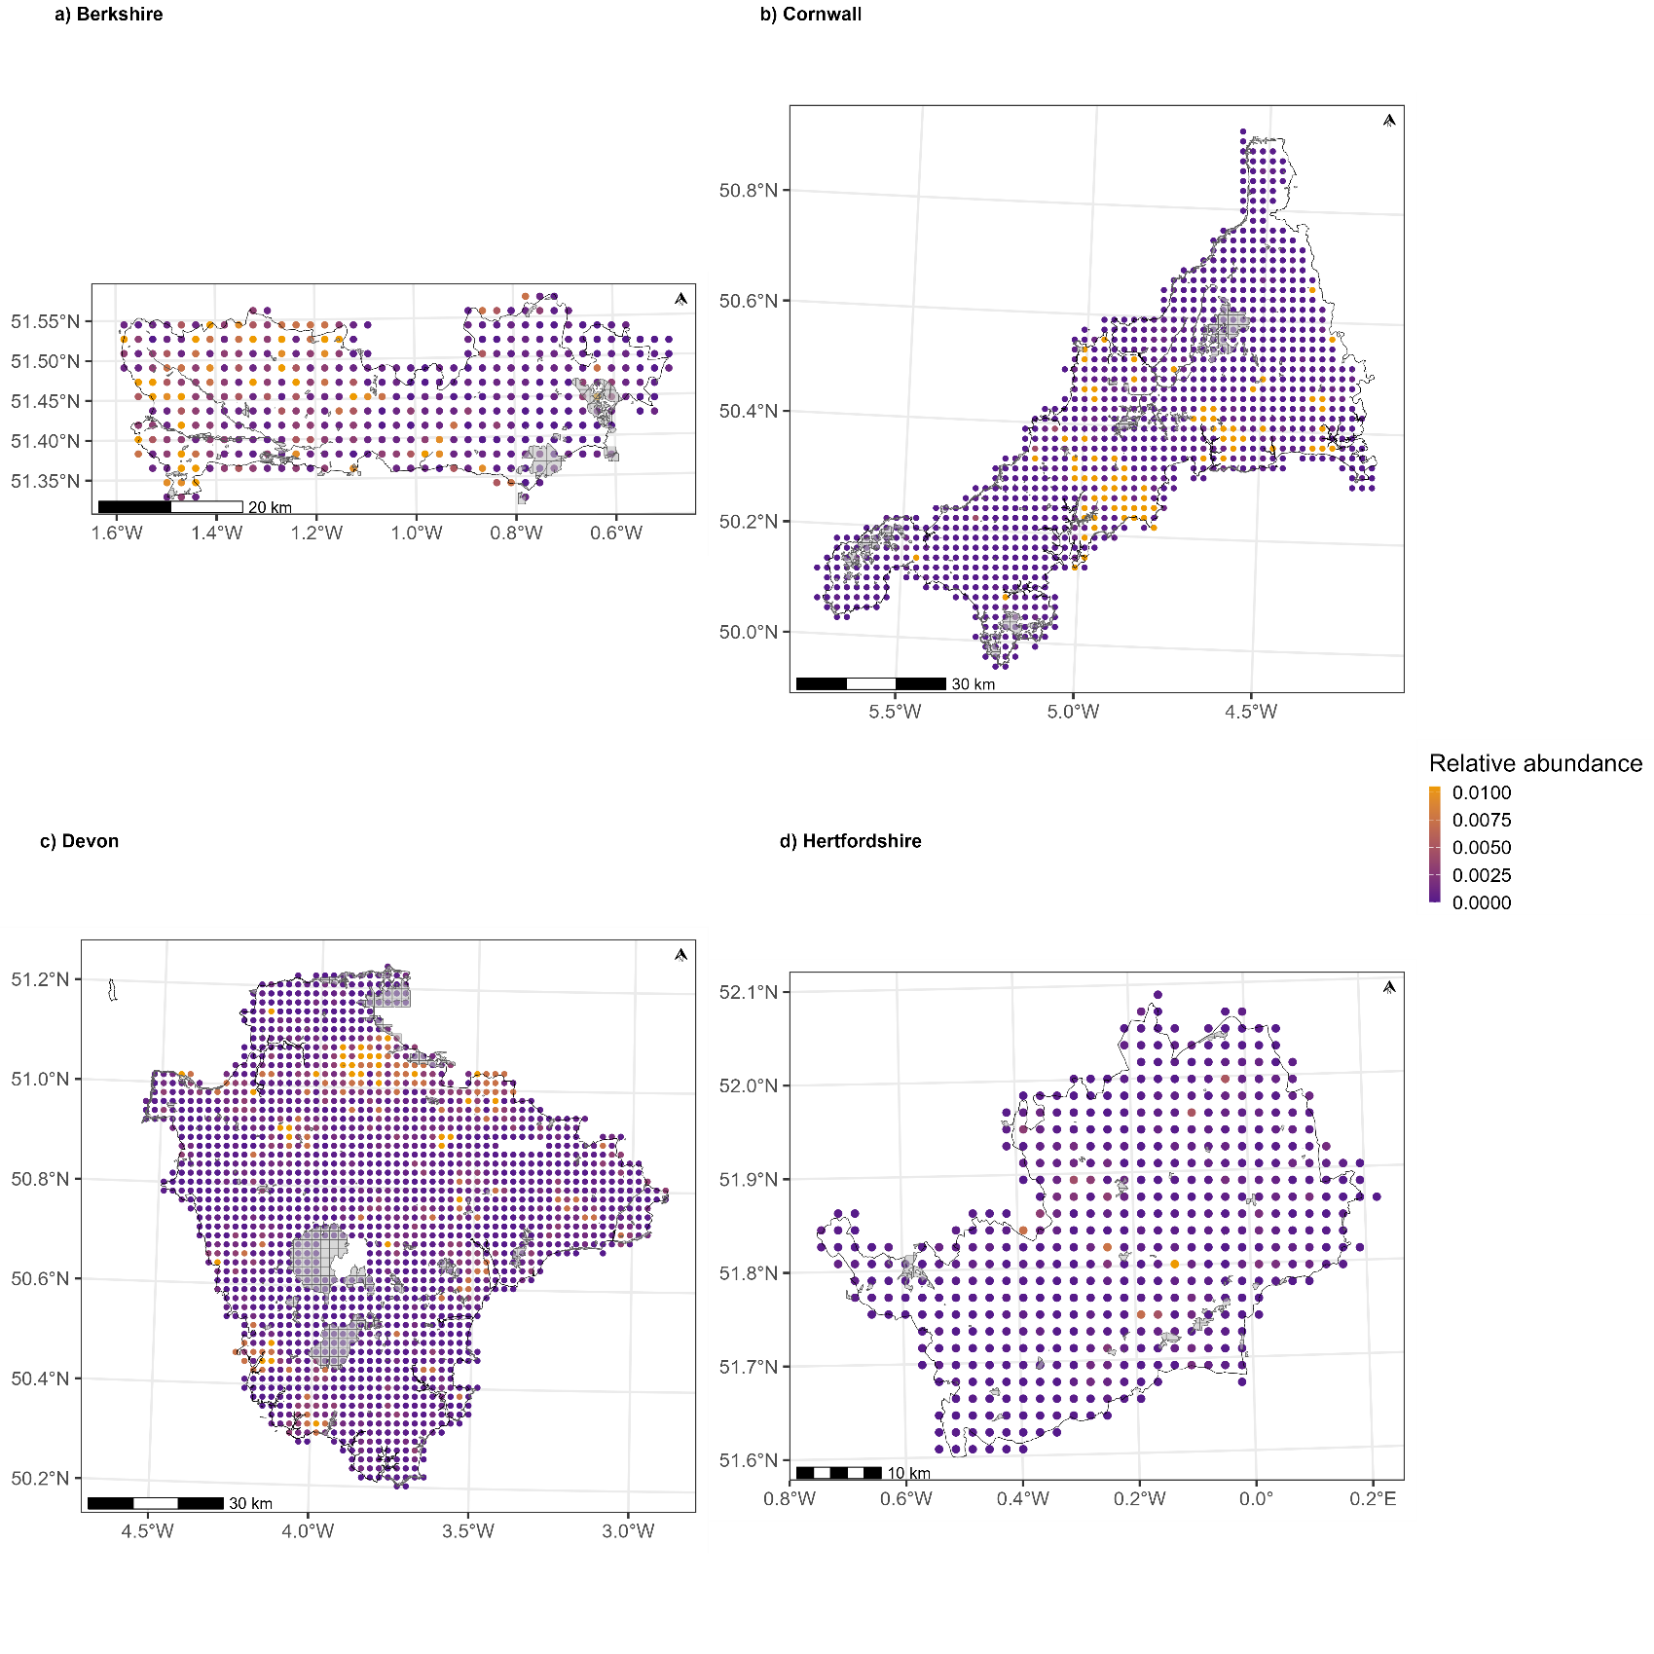
Figure 1- shows the relative abundance of pheasants in winter across counties etc etc...

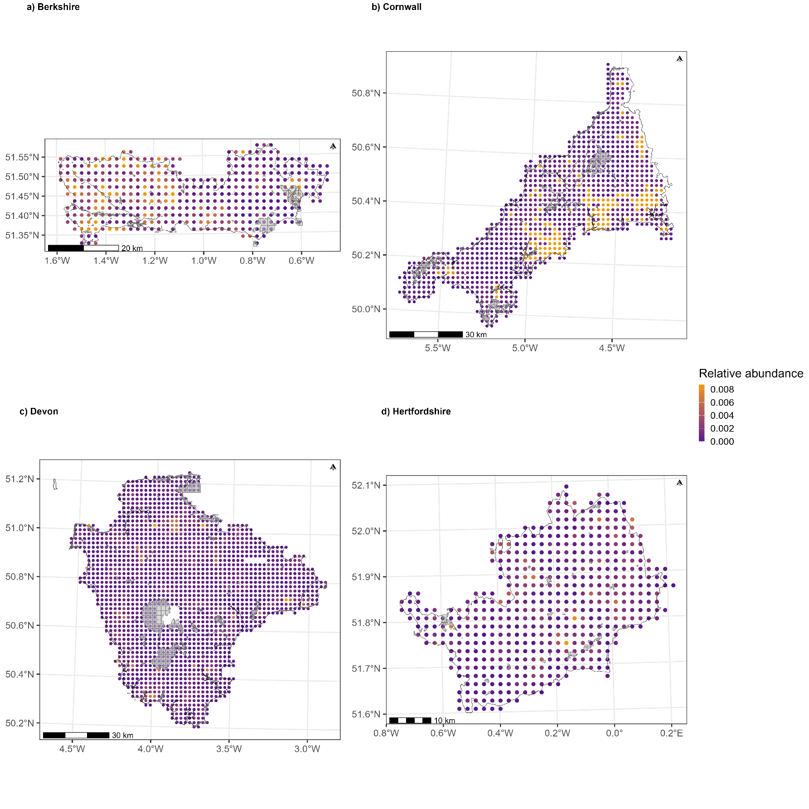
Figure 2 - shows the relative abundance of pheasants in breeding season across counties etc etc...

