Introduction
Tens of millions of common pheasants are released across the UK in late summer/early autumn for shooting (Madden, 2021). Exact numbers involved are uncertain but recent estimates range from 31.5 million pheasants (range 29.8–33.7 million; Madden, 2021) or 47 million pheasants (39-57 million 95% confidence interval; Aebischer, 2019). These releases occur across lowland UK from an estimated 7000-9000 sites (Madden, 2021) and it is estimated that 60% of the country is influenced by game management and involves 28% of English woodland (Gilbert, 2007).
Once released, pheasants can move away from release sites (Hill and Ridley, 1987) but game management aims to keep the majority of pheasants within areas where shooting will take place (Hill, 1988). Although management actions that accompany the release of these birds, such as habitat creation or maintenance, supplementary feeding, and legal pest and predator control, may provide benefits to other non-game species, the direct actions of the released birds themselves are likely to be ecologically damaging, especially if best practice advice is not followed (Madden & Sage, 2020; Mason et al., 2020; Sage et al., 2020; Madden, 2023; JNCC report/Madden mallard work in prep). Released birds may increase soil and water nutrient levels, directly damage flora, predate on local species, compete for resources with non-game species, provide a source or harbour for pathogens and parasites that may infect other species (Madden & Sage, 2020; Mason et al., 2020; Sage et al., 2020; Madden, 2023). These negative effects are likely to be stronger at higher densities of released birds (e.g. Sage et al., 2005a; Gortazar et al., 2006; Pressland, 2009; Neumann et al., 2015; Porteus, 2015; Capstick et al., 2019; but see Davey, 2008). Changes in soil chemistry and plant species richness can persist at woodland release sites for around a decade after releases cease, but this may be longer if the densities of released birds are >1000 birds/ha (Capstick et al., 2019).
The direct negative effects of released gamebirds may be of particular concern if they occur in habitats that contain ecologically important features that are susceptible to damage from gamebirds. Such habitats containing ecologically important features are commonly legally protected. In the UK, some of the most important sites include Special Areas of Conservation (SAC, designated under the Habitats Directive) and Special Protection Areas (SPA, designated under the Birds Directive). Collectively, these form part of the Natura 2000 network that spans Europe. The UK government is under obligation to prevent deterioration of habitats in Natura 2000 sites. A third set of sites, Sites of Special Scientific Interest (SSSI), may also be subject to negative direct effects if they contain designated features susceptible to gamebird activity. Although the ecological effects of gamebird release and management are reasonably well understood (Madden & Sage, 2020; Mason et al., 2020; Sage et al., 2020; Madden, 2023), the effects from gamebird releasing on species and habitats within protected areas is less known (Rothero, 2006; Bosanquet, 2019; Hand, 2020). Stakeholders (including nature reserve staff, farmers and gamekeepers) hold a variety of perceptions and opinions on what the effects of release and management might be on protected areas. However, there is broad agreement that there are benefits of hedgerow creation and management accompanied by negative effects arising from increased generalist predator populations (Minter et al. 2024).
We are aware of only one unpublished study that attempts to document the occurrence (but not abundance) of pheasants and red-legged partridges (Alectoris rufa, a gamebird also released in large numbers every year) in protected areas (https://wildjustice.org.uk/general/pheasants-everywhere/). In that work, the spatial precision of the records of the pheasants and partridges was variable, so the researchers presented three metrics describing the likely occurrence of the birds in or around the protected area. They concluded that >98% of sites (SPA and SAC) intersected with at least one 2km² tetrad in which either a pheasant or a partridge had been reported and that 66% of SPA, and 24% of both SPA and SAC sites completely contained at least one tetrad in which either a pheasant or a partridge had been reported. They concluded that individuals of these species have been reported in most Natura 2000 sites. However, the number, density or persistence of the birds in these sites was not considered, simply presence or absence. Therefore, these records may constitute a single bird passing through a site or a large flock established there for months or longer. Obviously, these two interpretations of the data have markedly different implications for the ecological effects that may be exerted on the protected area.
SPAs, SACs, and SSSIs (hereafter referred to as protected areas) may be attractive to dispersing pheasants as they may provide a refuge from shooting activities or other forms of human disturbance or contain suitable wintering/breeding habitats. Such immigration into these areas may be concerning because of the ecological change that these birds may exert. It is therefore important to determine whether released pheasants preferentially disperse into protected areas to determine the risk of ecological change in these areas.
We assessed whether pheasants are moving into protected areas by examining whether there were shifts in the relative abundance of pheasants from areas where they were released and retained by game management (in late summer to late winter) towards protected areas in the breeding season (in late spring/early summer when shooting and game management has predominantly ceased). If protected areas are attractive to released pheasants and pheasants therefore preferentially reside in them, then we might expect to find large-scale movements of pheasants from areas where they were released (and therefore reside during late summer/early winter) into protected areas, especially when game management has declined or ended in the spring following the shooting season and therefore pressures disrupting dispersal have ceased. This would be indicated by an increase in the relative number of pheasants observed in or around protected areas in late spring/summer, compared to those seen in sites where birds were present in autumn/winter during release and when game management is active.
During 2007-2011, the British Trust for Ornithology (BTO) organised volunteer surveys of all UK birds at a 2km² tetrad level. These occurred during the winter (November to February) and the breeding season (April to July; Balmer et al., 2013). Fieldwork for the survey, carried out in four winters (2007/08–2010/11) and four breeding seasons (2008–11), consisted of a pair of standardized visits to each tetrad in each of the eight survey periods (for more details on the methodology see Balmer et al., 2013; Gillings et al., 2019). These data provide an abundance estimate for pheasants during the winter and breeding season, allowing for comparison between these two time periods. Between winter and the breeding season, the number of pheasants will have decreased overall due to shooting and natural mortality to approximately 15% of those released (Madden, Hall, and Whiteside, 2018). Therefore, we are interested in changes in the abundance of pheasants relative to the population within a county at a given time. Investigating this allows us to account for changes in population size due to mortality and releases. If pheasants are dispersing towards protected areas, then we would expect a positive relationship between protected area coverage and relative pheasant abundance. This positive relationship may be consistent across both winter and the breeding season, suggesting protected areas are attractive to pheasants despite efforts from game management to limit pheasant dispersal. However, this positive relationship may only be present or especially pronounced during the breeding season (i.e. there may be an interaction between protected area coverage and time period), when efforts by game management to limit pheasant dispersal has ended. There may also be no relationship, indicating pheasants do not preferentially disperse to or reside in protected areas.

Methods

UK bird atlas data
We collated data from four counties (figure 1) who published their UK bird atlases online: Berkshire (http://berksoc.org.uk/county-atlas/), Cornwall (https://atlas.cbwps.org.uk/), Devon (http://devonbirdatlas.org/) and Hertfordshire (http://www.hertsatlas.org.uk/). For each of these atlases, the abundance of birds in 2km² tetrads during the breeding season (April to July) and winter period (November to February) was recorded following methods used by the BTO as part of their atlas surveys (Balmer et al. 2013, Gillings et al. 2019). In Berkshire, data were collected from 394 tetrads between 2007 and 2011. In Cornwall, data were collected from 1050 tetrads between 2000 and 2009. In Devon, data were collected from 1858 tetrads between 2007 and 2013. In Hertfordshire, data were collected from 491 tetrads between 2007 and 2012. Across all four counties, there were a total of 3793 tetrads.

Standardising abundance measures across counties
Since abundance was reported differently in each county, we standardised abundance measures across counties to get continuous measures (figure 2). For Devon, Berkshire and Hertfordshire, reported abundance data were categorical, and these categories were different for each of the three counties. To facilitate comparison among county data, we condensed these categories to a single midpoint value meaning each tetrad in each of these three counties had a single continuous value of abundance for winter and summer. Although this method allows us to analyse data from all four counties systematically and consistently, we acknowledge that using categorical measures in this way could be considered coarse and may lead to bias and underestimation of true uncertainty in parameter estimates. Abundance data were continuous for Cornwall and remained unaltered.

Creating a measure of relative abundance
We were interested in changes in abundance relative to the total sample of pheasants alive in each county in each season. This would account for mass releases in late summer and high levels of mortality post release. We calculated these relative abundance measures using the following equation:
$$\begin{aligned}{A^{'}}_{i, c, s}= \frac{A_{i, c, s}}{\sum_{i=1}^{N_{c}}{A_{i, c, s}}}\#1\end{aligned}$$

where:
- $A_{i, c, s}$ and ${A'}_{i, c, s}$ : the absolute and relative abundance metric for the $i$th tetrad in county $c$ during season $s$, respectively.
- $N_{c}$: the total number of tetrads in county $c$.
This relative abundance metric can be interpreted as the proportion of the total population of pheasants in a single county in a single season that reside in a given tetrad within that county. This metric would be constant for a given tetrad between time periods if there is no net immigration or emigration between tetrads, and survival is constant across the county.
If pheasants preferentially disperse to and reside in protected areas in a given season, then we would expect evidence of a positive relationship between this relative abundance metric and protected area coverage in that season, i.e. a higher proportion of a county’s population of pheasants can be found within protected areas than outside of protected areas. No relationship between relative abundance and protected area coverage suggests the same proportion of a county’s population can be found within protected areas as outside. A negative relationship suggests a smaller proportion of a county’s pheasant population can be found inside protected areas than outside.

Protected areas
Across the four counties examined, we calculated the proportion of each tetrad covered by protected areas (information on which was downloaded from the Government Digital Service’s dataset archive; https://ckan.publishing.service.gov.uk/dataset) that were ecologically relevant to pheasants. We used the 2007 United Kingdom Centre for Ecology and Hydrology (UKCEH) land cover map (25m x 25m spatial resolution; Morton et al., 2014) to determine the dominant habitat type in each protected area. Protected areas were classified as ecologically irrelevant to pheasants and removed from subsequent analysis if the dominant habitat type was one of the following: ocean, saltwater, freshwater, saltmarsh, bog, urban, suburban, inland rock, supra-littoral sediment, supra-littoral rock, littoral sediment or littoral rock. This meant protected areas mostly taken up by the following habitat types were retained: broadleaf woodland, coniferous woodland, arable/horticulture, fen/marsh/swamp, heather, heather grassland, acid grassland, rough grassland, improved grassland, neutral grassland and calcareous grassland. These remaining habitats are where pheasants are most commonly found in breeding bird surveys (Heywood et al., 2023). Occasionally a single designated site was composed of multiple distinct and disconnected polygons. In these instances, each polygon was treated as an independent protected area.

Habitat data
Using the UKCEH land cover map (25m x 25m spatial resolution), we calculated the proportion of each tetrad covered by each of ten aggregate habitat classes: broadleaf woodland, coniferous woodland, arable, improved grassland, semi-natural grassland, mountain heath & bog, saltwater, freshwater, coastal and built-up areas and gardens (Morton et al., 2014), yielding ten continuous values between zero and one for each tetrad. We also calculated the Shannon diversity index for each tetrad, calculated as $H'= -\sum_{i=1}^{N}{p_{i}×ln⁡(p_{i})}$, where $p_{i}$is the proportion of each tetrad taken up by the $i$th habitat type, and $N$ is the total number of possible habitat types (Ortiz-Burgos, 2016). Higher values of $H'$ indicate more habitat types in a tetrad.
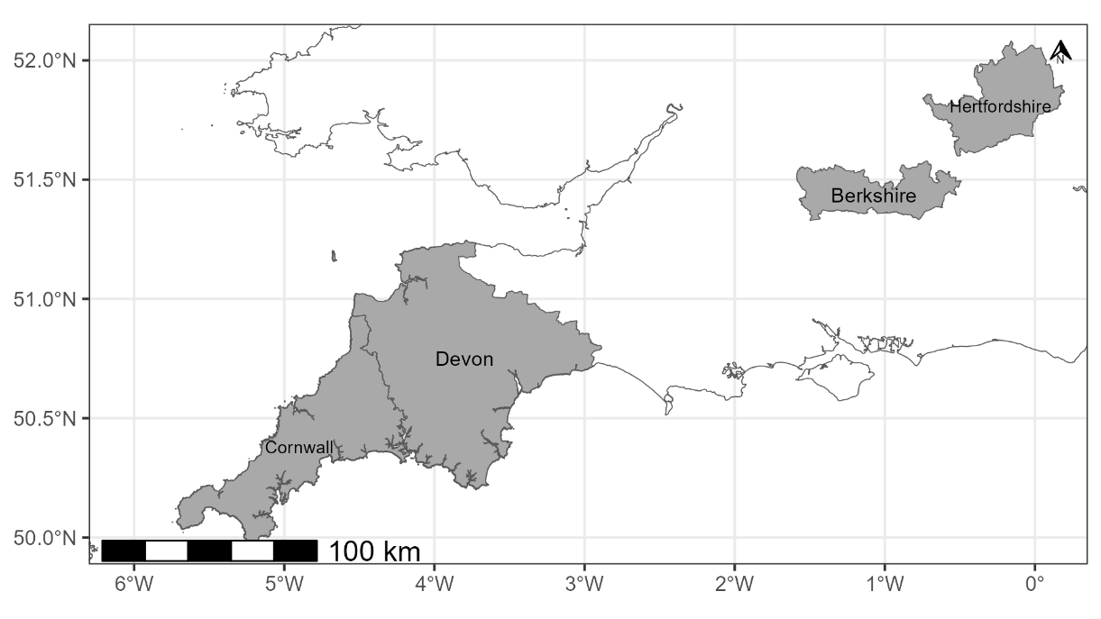

Figure 1 – map showing the location of each UK county for which the relative abundance of common pheasants was analysed. UK outline plotted using data from Countries (December 2021) Boundaries UK BUC, county outlines plotted using Counties and Unitary Authorities (May 2023) Boundaries UK BGC.

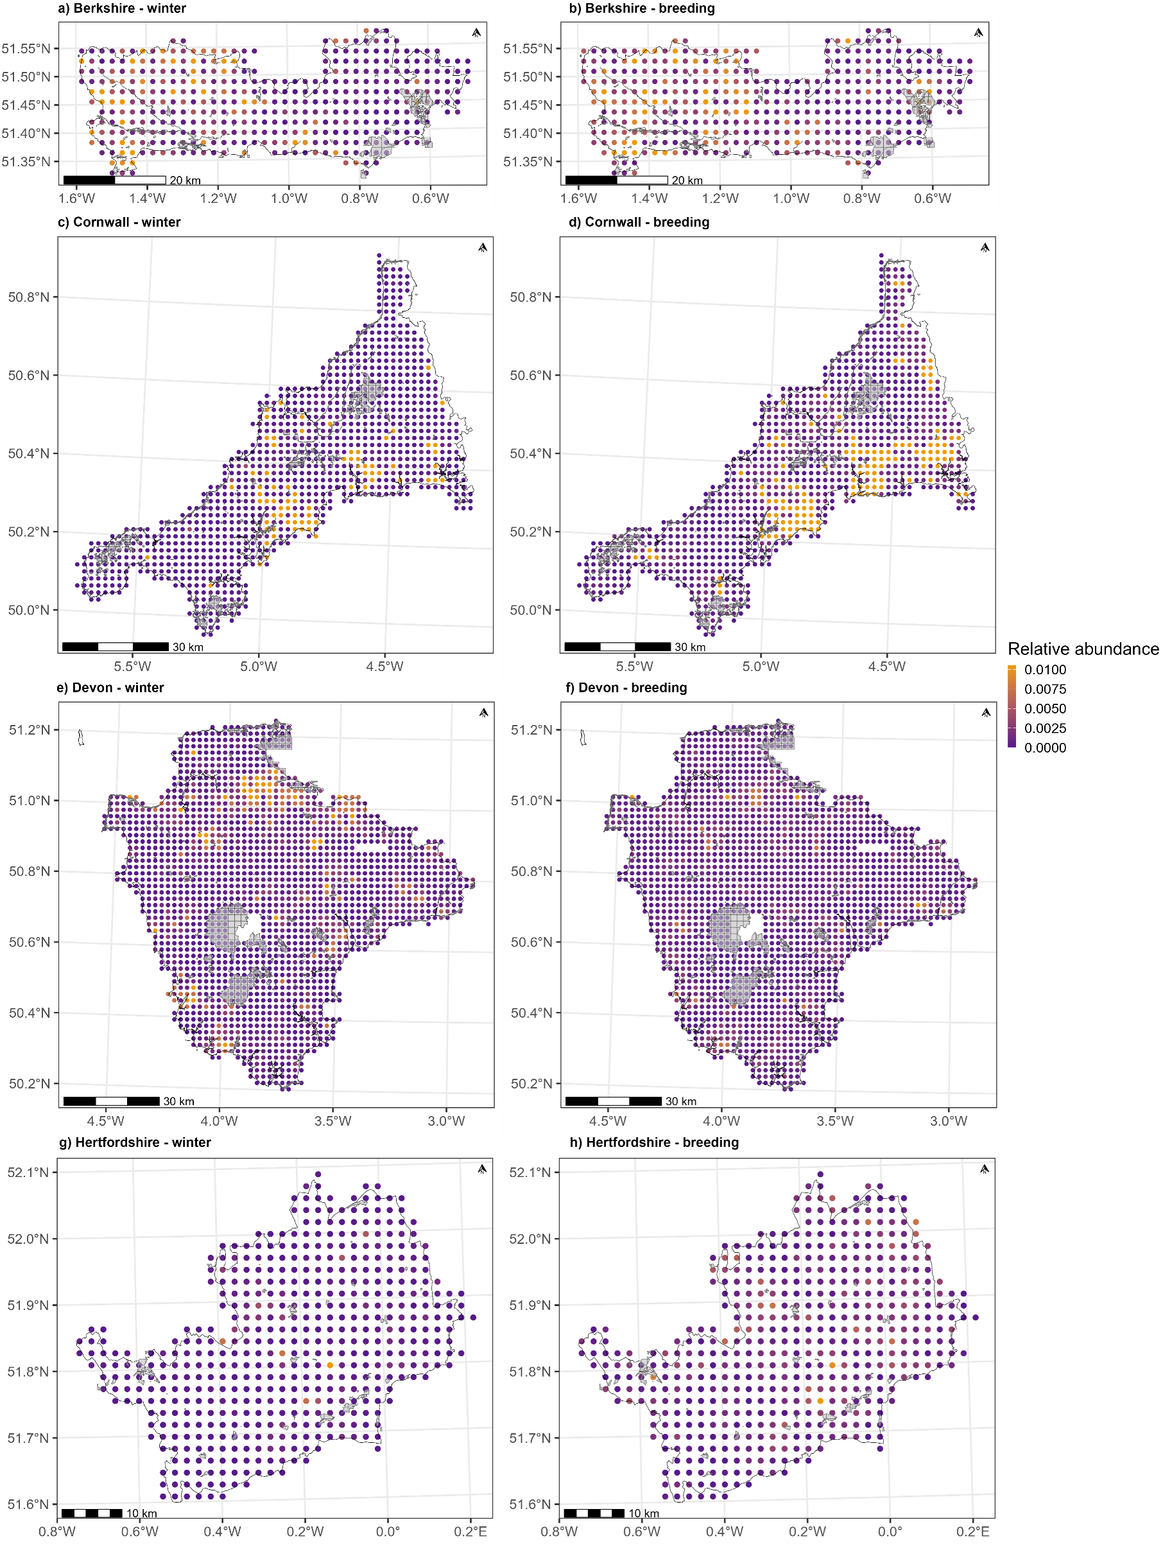
Figure 2 - The relative pheasant abundance in each 2km² tetrad in (a & b) Berkshire, (c & d) Cornwall, (e & f) Devon and (g & h) Hertfordshire. Relative abundances in winter (left column; a, c, e, g) and in the pheasant breeding season (right column; b, d, f, h) are both shown. Protected areas of ecologically relevant habitat type are overlayed in grey. The county outlines were plotted using data from Counties and Unitary Authorities (May 2023) Boundaries UK BGC.

Statistical analyses
To analyse the relationship between protected area coverage and the relative abundance of pheasants, we used an occupancy-abundance model in a Bayesian framework. These models are a mixture of 1) occupancy models, which simultaneously estimate the probability a target species occupies a given area (tetrad, in this case) and a probability the target species is detected if present, and 2) abundance models, which estimate the abundance of the target species in occupied areas (here modelled using a Beta distribution; Bailey et al., 2014; Holt et al., 2002; Potts & Elith, 2006). These models also estimate the effects covariates have on pheasant abundance to determine what features of a tetrad causes pheasant abundance to increase or decrease. Using these models allows us to estimate and account for the probability that pheasants were present in a tetrad but were not detected during surveys.
The covariates included in the model were county (Berkshire, Cornwall, Devon, Hertfordshire), time period (winter/breeding season), the proportion of a tetrad covered by each of the ten habitat types (one fixed effect for each habitat type), the Shannon habitat diversity index, and the proportion of each tetrad covered by ecologically relevant protected areas. We included a two-way interaction term between time period and protected area coverage to determine if the effect of protected area coverage differs between the winter period and breeding season. We also included a three-way interaction between county, season and protected area coverage to account for possibility that the effect of protected area coverage and its interaction with time, may be different for each county.
All models were written in Stan (Carpenter et al., 2017) and compiled using Cmdstan (Stan Development Team, 2018) and the cmdstanr package (version 0.8.0; Gabry & Johnson, 2023) in R (version 4.4.0; R Core Team, 2022) using RStudio (version 2024.09.0; RStudio Team, 2020). Weakly informative priors were used for all parameters, and model convergence was checked by inspecting trace plots and ensuring that the potential scale reduction factor ($\hat{R}$) ≈ 1. The 2.5% and 97.5% highest density limits (HDL) of posterior distributions are reported in square brackets throughout (e.g. [-0.01, 0.01]; Kruske, 2014; McElreath, 2020). More information on the priors used, as well as the full model output can be found in the supplementary materials.

Results

Habitat type
The most prevalent effect on pheasant abundance was caused by the 10 habitat types (table 1). There were positive relationships between relative abundance and the proportion of a tetrad occupied by broadleaf woodland (β = [0.05, 0.11], figure 3), and arable (β = [0.06, 0.14]). The proportion of each tetrad occupied by freshwater (β = [-0.06, -0.01]) and built-up areas and gardens (β = [-0.15, -0.07]), had a negative relationship with relative abundance.
Habitat type | 2.5% HDL of effect size | 97.5% HDL of effect size
Broadleaf woodland | 0.05 | 0.11
Coniferous woodland | -0.03 | 0.02
Arable | 0.06 | 0.14
Improved grassland | -0.03 | 0.05
Semi-natural grassland | -0.07 | 0.01
Mountain, heath and bog | -0.08 | 0.02
Saltwater | -0.03 | 0.03
Freshwater | -0.06 | -0.01
Coastal | -0.04 | 0.02
Built-up areas and gardens | -0.15 | -0.07
Shannon habitat diversity index | -0.04 | 0.02
Table 1 - The lower and upper highest density limits (HDL) of the posterior distribution of the effect size of the proportion of each tetrad occupied by all ten land-use habitat types, as well as the effect of the Shannon habitat diversity index.

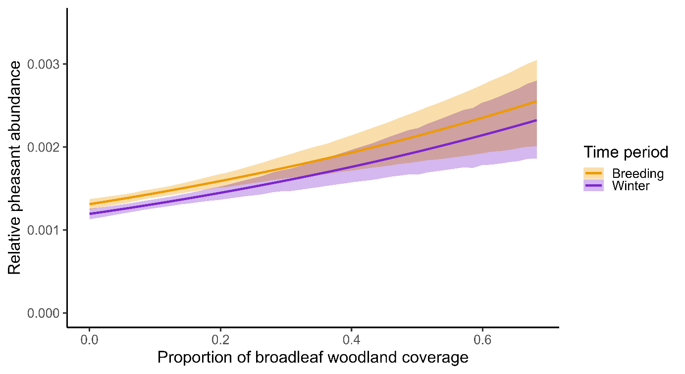
Figure 3 - The model predicted relationship between the proportion of broadleaf woodland coverage and mean relative pheasant abundance (coloured lines). The shaded areas denote the 95% highest density interval around the predicted mean for each time period.

Protected area coverage
There was evidence of a negative effect of the proportion of each tetrad occupied by protected areas on pheasant abundance (β = [-0.09, -0.01], figure 4) with lower abundances recorded in areas containing a greater proportion of protected areas. There was no evidence of a two-way interaction between protected area coverage and time period (β = [-0.80, 0.71]), suggesting the effect of protected area coverage is consistent between winter and the breeding season. There is also no evidence of a three-way interaction between protected area coverage, time period, and county (table 2), suggesting that the distribution patterns are consistent across the four counties that we considered.

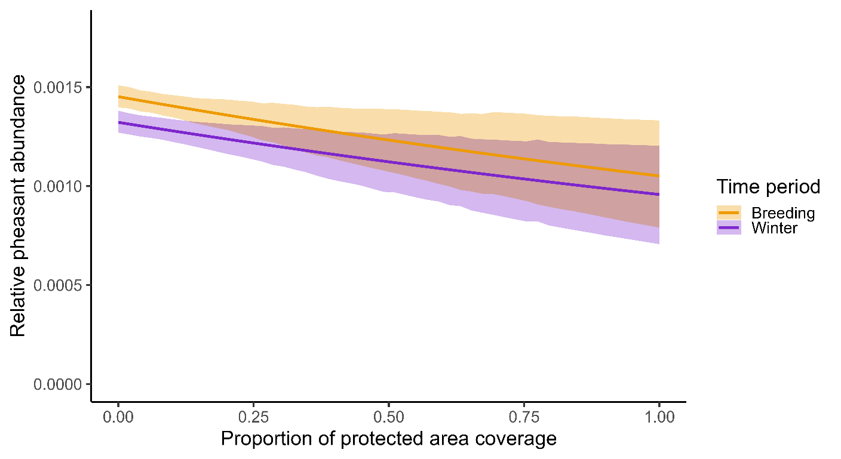
Figure 4 - The model predicted relationship between protected area coverage and mean relative abundance is shown (coloured lines). The shaded areas denote the 95% highest density interval around the predicted mean for each time period.

Fixed effect | 2.5% HDL of effect size | 97.5% HDL of effect size
Protected area (PA) coverage | -0.09 | -0.01
Time period: Winter → Breeding | 0.03 | 0.07
PA coverage × Time period: Winter → Breeding | -0.80 | 0.71
PA coverage × Time period: Winter × Berkshire | -1.65 | 1.67
PA coverage × Time period: Winter × Cornwall | -1.51 | 1.43
PA coverage × Time period: Winter × Devon | -1.48 | 1.46
PA coverage × Time period: Winter × Hertfordshire | -1.38 | 1.48
PA coverage × Time period: Breeding × Berkshire | -1.62 | 1.70
PA coverage × Time period: Breeding × Cornwall | -1.53 | 1.42
PA coverage × Time period: Breeding × Devon | -1.46 | 1.47
PA coverage × Time period: Breeding × Hertfordshire | -1.39 | 1.48
Table 2 - The highest density limits (HDL) of the posterior distribution of the effect size of the proportion of each tetrad occupied by suitable protected areas, the time period in which the abundance survey took place, as well as the two- and three-way interactions between protected area coverage, time period and county.
The full results from the occupancy-abundance model can be found in the supplementary materials.

Discussion
We used relative pheasant abundance measures calculated from tetrad survey data to determine if there was a relationship between pheasant abundance and ecologically suitable protected area coverage. We also investigated whether any relationship was consistent between seasons, and across counties. We did this to determine if there is any evidence suggesting pheasant preferentially disperse into and reside in protected areas, especially during the spring/summer once the shooting season and associated management actions have ceased or declined. This is of particular interest if pheasants intrude into protected areas and cause negative ecological effects in these sensitive areas.
The relationship between each of the ten habitat type coverages and relative pheasant abundance reflect known patterns of habitat preferences for pheasants in the UK and elsewhere, so this provides reassurance that the data manipulation techniques and models used in this study are robust enough to detect and control for the relationships under investigation. The positive relationship between relative pheasant abundance and broadleaf woodland coverage and arable coverage is expected given these habitats are where pheasants are most often released and found (Robertson et al., 2017; Heywood et al., 2023). These results demonstrate that this broad-scale approach has been able to capture known ecological drivers of pheasant abundance.
We found evidence of a negative relationship between protected area coverage and relative pheasant abundance. This negative relationship was consistent across all four counties included in the analysis, and across winter and the breeding season. This suggests that pheasants do not preferentially disperse into or reside in protected areas and instead appear to prefer areas containing less protected area coverage. This may be because pheasants are naturally sedentary and simply do not encounter the opportunity to reside in protected areas. This may also be due to a higher biodiversity within protected areas (Cooke et al., 2023), meaning a higher generalist predator presence within protected areas also. However, the main predator of pheasants in the UK is the red fox (Vulpes vulpes), which has become increasingly urbanised within the last 35 years (Scott et al., 2014) and is unlikely to have a higher prevalence within protected areas than unprotected areas. Therefore, it is unlikely that pheasants are predated at a higher rate in protected areas (and so are recorded less in those areas) or avoid protected areas due to increased predation threats. A lack of game management in protected areas (such as supplementary feeding or the creation and management of preferred species-specific habitats) may also mean pheasants are less likely to reside in these areas.
In the UK, a licence is required in order to release common pheasants or red-legged partridges within 500 metres of the boundary of a Special Area of Conservation or Special Protection Area, and the density of birds to be released within this buffer zones is limited (see above for details of GL43, GL45). Gamekeepers may avoid the need for licences by refraining from releasing in these buffer zones or releasing there at lower levels than elsewhere. It therefore seems likely that tetrads with high protected area coverage also have lower densities of pheasant release occurring. The negative relationship between protected area coverage and relative pheasant abundance we found may therefore be due to these release restrictions and may not necessarily reflect an active avoidance of protected areas by the released pheasants. To further investigate and control for this potential bias introduced by release restrictions, further work needs to be carried out using information on the number and density of pheasant releases occurring in each tetrad. Currently, such accurate and precise data on releases are lacking.
The results of our investigation suggest that pheasants are not preferentially dispersing into or residing in protected areas at any time of year. Therefore, there is no evidence to suggest that any ecological impact wrought by pheasants is likely to happen more in protected areas than non-protected areas. Furthermore, the current restrictions surrounding gamebird releases near protected area boundaries may mean that ecological impacts caused by pheasants may be less likely to occur in these areas.
It should be noted that our findings do not suggest that ecological impacts caused by released pheasants do not occur in protected areas, and these areas may still be vulnerable. The numbers and densities of pheasants in protected areas, though seemingly lower than in surrounding unprotected areas, may still lead to negative ecological impacts, though the nature of this impact is currently unknown. Future research should investigate whether these patterns hold at a finer spatial scale using information from known releases, as well as explore the implications of gamebird management practices for both pheasant populations and biodiversity within protected areas.

Acknowledgements
This work was made possible due to funding from the Animal and Plant Health Agency and the British Association for Shooting and Conservation [grant number/code?]. The Game and Wildlife Conservation Trust provided knowledge and feedback to the project. Thanks to Marnie Lovejoy, Cat McNicol, Graham Smith, and Rufus Sage for feedback on drafts of the manuscript.

Author contributions
J.R.M. and L.O-H. conceived of the presented idea. J.R.M. developed the theory and supervised the project, L.O-H developed the data cleaning pipeline, and J.A.W. developed the analysis pipeline, and data/results presentation. J.A.W. and J.R.M. wrote the final manuscript. All authors discussed and contributed to the final manuscript.

References
Aebischer, N. J. (2019). Fifty-year trends in UK hunting bags of birds and mammals, and calibrated estimation of national bag size, using GWCT’s National Gamebag Census. European Journal of Wildlife Research, 65(4), 64. https://doi.org/10.1007/s10344-019-1299-x
Bailey, L. L., MacKenzie, D. I., Nichols, J. D. (2014). Advances and applications of occupancy models. Methods in Ecology and Evolution, 5, 1269-1279. https://doi.org/10.1111/2041-210X.12100
Balmer, D. E., Gillings S., Caffrey, B. J., Swann, R. L., Downie, I. S., Fuller, R. J. (2013). 2007-11: The Breeding and Wintering Birds of Britain and Ireland. BTO Books, Thetford.
Bosanquet, S. D. S. (2019). Lichen surveys to investigate ammonia impacts. Natural Resources Wales Evidence Report No 298.
Capstick, L. A., Sage, R. B., & Hoodless, A. (2019). Ground flora recovery in disused pheasant pens is limited and affected by pheasant release density. Biological Conservation, 231, 181-188. https://doi.org/10.1016/j.biocon.2018.12.020
Carpenter, B., Gelman, A., Hoffman, M. D., Lee, D., Goodrich, B., Betancourt, M., Brubaker, M., Guo, J., Li, P., & Riddell, A. (2017). Stan: A probabilistic programming language. Journal of Statistical Software, 76. https://doi.org/10.18637/jss.v076.i01
Cooke, R., Mancini, F., Boyd, R. J., Evans, K. L., Shaw, A., Webb, T. J., Isaac, N. J. B. (2023). Protected areas support more species than unprotected areas in Great Britain, but lose them equally rapidly. Biological conservation, 278, 109884. https://doi.org/10.1016/j.biocon.2022.109884
Counties and Unitary Authorities (May 2023) Boundaries UK BGC. Accessed: 29/10/2025. https://www.data.gov.uk/dataset/85228aec-fe0e-49bf-9455-df000d61e731/counties-and-unitary-authorities-may-2023-boundaries-uk-bgc
Countries (December 2021) Boundaries UK BUC. Accessed: 29/10/2025. https://www.data.gov.uk/dataset/2e17269d-10b9-4e43-b67b-57f9b02bd0f8/countries-december-2021-boundaries-uk-buc
Davey, C. M. (2008). The impact for game management for pheasant (Phasianus colchicus) shooting on vertebrate biodiversity in British woodlands (Doctoral dissertation, University of Bristol).
Gabry, J., Cěsnovar, R., & Johnson, A. (2023). Cmdstanr: R interface to ’CmdStan’. https://mcstan.org/cmdstanr/.
Gillings, S., Balmer D. E., Caffrey, B. J., Downie, I. S., Gibbons, D. W., Lack, P. C., Reid J. B., Sharrock J. T. R., Swann, R. L., Fuller, R. J. (2019). Breeding and Wintering Bird Distributions in Britain and Ireland from Citizen Science Bird Atlases. Edited by Erica Fleishman. Global Ecology and Biogeography, 28, 866–74. https://doi.org/10.1111/geb.12906.
GL43: licence to release common pheasants or red-legged partridges on certain European sites or within 500m of their boundary. 1981. Sections 16(4) and 16(5).
Gortázar, C., Acevedo, P., Ruiz-Fons, F., & Vicente, J. (2006). Disease risks and overabundance of game species. European Journal of Wildlife Research, 52(2), 81-87. https://doi.org/10.1007/s10344-005-0022-2
Hand, N. (2020). The adder (Vipera berus) and the cultivation of the ring neck pheasant (Phasianus colchicus). Field observations from long term monitoring and adder radio telemetry projects across the Midlands and Southern England. Nigel Hand Central Ecology, Ledbury, UK.
Heywood, J. J. N, Massimino, D., Balmer, D. E., Kelly, L., Noble D. G., Pearce-Higgins J. W., Woodcock P., Gillings, S., Wotton, S., Harris S. J. (2023). The Breeding Bird Survey 2022. BTO Research Report. British Trust for Ornithology, Thetford.
Hill, D. A., & Ridley, M. W. (1987). Sexual segregation in winter, spring dispersal and habitat use in the pheasant (Phasianus colchicus). Journal of Zoology, 212(4), 657-668. https://doi.org/10.1111/j.1469-7998.1987.tb05962.x
Hill, D., & Robertson, P. (1988). The pheasant: ecology, management and conservation. Oxford: BSP Professional Books. https://doi.org/10.2307/3809229
Holt, A. R., Gaston, K. J., He, F. (2002). Occupancy-abundance relationships and spatial distribution: A review. Basic and Applied Ecology, 3, 1-13. https://doi.org/10.1078/1439-1791-00083
Kruschke, J. (2014). Doing Bayesian data analysis: A tutorial with R, JAGS, and Stan. Academic Press.
Madden J.R. (2023a). A Review of The Ecological Effects of Gamebird Release and Management in Wales. NRW Report No: 681, pp75, Natural Resources Wales, Bangor
Madden J.R. (2023b). Patterns of Gamebird Release, Management, and Shooting in Wales. NRW Report No: 680, pp37, Natural Resources Wales, Bangor.
Madden, J. R. (2021). How many gamebirds are released in the UK each year? European Journal of Wildlife Research, 67(4), 72. https://doi.org/10.1007/s10344-021-01508-z
Madden, J. R., & Sage, R. B. (2020). Ecological consequences of gamebird releasing and management on lowland shoots in England: A review by rapid evidence assessment for Natural England and the British Association of Shooting and Conservation. Natural England Evidence Review NEER016. Peterborough, UK.
Madden, J. R., Hall, A., Whiteside, M. A. (2018). Why do many pheasants released in the UK die, and how can we best reduce their natural mortality? European Journal of Wildlife Research, 64. https://doi.org/10.1007/s10344-018-1199-5
Mason, L. R., Bicknell, J. E., Smart, J., & Peach, W. J. (2020). The impacts of non-native gamebird release in the UK: An updated evidence review. RSPB Research Report No. 66. RSPB Centre for Conservation Science, Sandy, UK.
McElreath, R. (2020). Statistical rethinking: A Bayesian course with examples in R and Stan. CRC press. https://doi.org/10.1201/9780429029608
Minter, M., Mason, L. R., Burgess, M. D., Peach, W. J., & Hughes, J. (2024). Understanding stakeholder perceptions on the impacts of gamebird releasing on or near UK protected sites. Journal for Nature Conservation, 78, 126581. https://doi.org/10.1016/j.jnc.2024.126581
Morton, R. D., Rowland C. S., Wood C. M., Meek L., Marston C. G., Smith G. M. (2014). Land Cover Map 2007 (25m Raster, GB) V1.2. NERC EDS Environmental Information Data Centre. https://doi.org/10.5285/A1F88807-4826-44BC-994D-A902DA5119C2
Neumann, J. L., Holloway, G. J., Sage, R. B., & Hoodless, A. N. (2015). Releasing of pheasants for shooting in the UK alters woodland invertebrate communities. Biological Conservation, 191, 50-59. https://doi.org/10.1016/j.biocon.2015.06.022
Ortiz-Burgos, S. (2016). Shannon-Weaver Diversity Index. In: Kennish, M.J. (eds) Encyclopedia of Estuaries. Encyclopedia of Earth Sciences Series. Springer, Dordrecht. https://doi.org/10.1007/978-94-017-8801-4_233
Porteus, T. A. (2015). Evaluation of restricted-area culling strategies to control local red fox density (Doctoral dissertation, University of British Columbia).
Potts, J. M., Elith, J. (2006). Comparing species abundance models. Ecological Modelling, 199, 152–163. https://doi.org/10.1016/j.ecolmodel.2006.05.025
Pressland, C. L. (2009). The impact of releasing pheasants for shooting on invertebrates in British woodlands (Doctoral dissertation, University of Bristol).
R Core Team. (2022). R: A language and environment for statistical computing. R Foundation for Statistical Computing. Vienna, Austria. https://www.R-project.org/
Robertson, P. A., Mill, A. C., Rushton, S. P., McKenzie, A. J., Sage, R. B., Aebischer, N. J. (2017). Pheasant release in Great Britain: long-term and large-scale changes in the survival of a managed bird. European Journal of Wildlife Research, 63. https://doi.org/10.1007/s10344-017-1157-7
Rothero, G. (2006). Baseline Surveys of Tortula Leucostoma and Athalamia Hyalina on Craig Leek SSSI. Scottish Natural Heritage.
RStudio Team. (2020). RStudio: Integrated development environment for R. RStudio, PBC. http://www.rstudio.com/
Sage, R. B., Ludolf, C., & Robertson, P. A. (2005). The ground flora of ancient semi-natural woodlands in pheasant release pens in England. Biological Conservation, 122(2), 243-252. https://doi.org/10.1016/j.biocon.2004.07.014
Sage, R. B., Hoodless, A. N., Woodburn, M. I. A., Draycott, R. A. H., Madden, J. R., & Sotherton, N. W. (2020). Summary review and synthesis – Effects on habitats and wildlife of the release and management of pheasants and red-legged partridges on UK lowland shoots. Wildlife Biology, 2020, 1–12. https://doi.org/10.2981/wlb.00766
Scott, D. M., Berg, M. J., Tolhurst, B. A., Chauvenet, A. L. M., Smith, G. C., Neaves, K., Lochhead, J., Baker, P. J. (2014). Changes in the Distribution of Red Foxes (Vulpes vulpes) in Urban Areas in Great Britain: Findings and Limitations of a Media-Driven Nationwide Survey. PLoS ONE, 9, e99059. https://doi.org/10.1371/journal.pone.0099059
Stan Development Team. (2018). Cmdstan: The command-line interface to stan. Version 2.18.0.
Wild Justice. (2020, March 30th). Pheasants everywhere. https://wildjustice.org.uk/general/pheasants-everywhere/

Supplementary materials

 | Posterior values |  | 95% Highest Density Limits |  |  | Effective sample size
Parameter | Mean | SD | Lower | Upper | R-hat | Bulk | Tail | Prior distribution
Pr(detection) | 0.97 | 0.01 | 0.94 | 0.99 | 1 | 222 | 684 | Normal(0.5, 1)
Pr(occupied) (logit)
Population mean | 2.93 | 0.35 | 2.31 | 3.60 | 1 | 249 | 714 | Normal(0, 1)
Population SD | 2.72 | 0.29 | 2.22 | 3.30 | 1 | 291 | 820 | Exponential(1)
Abundance (logit)
Intercept
Population mean | -6.60 | 0.02 | -6.63 | -6.56 | 1 | 4204 | 2856 | Normal(0, 1)
Population SD | 0.02 | 0.01 | 0.00 | 0.04 | 1 | 2012 | 1891 | Normal(0, 1)
Covariates
County: Berkshire → Cornwall | -0.32 | 0.02 | -0.35 | -0.28 | 1 | 2838 | 2778 | Normal(0, 1)
County: Berkshire → Devon | -0.45 | 0.02 | -0.49 | -0.42 | 1 | 2758 | 2815 | Normal(0, 1)
County: Berkshire → Hertfordshire | -0.08 | 0.01 | -0.10 | -0.05 | 1 | 4172 | 3465 | Normal(0, 1)
Time period: winter → breeding | 0.05 | 0.01 | 0.03 | 0.07 | 1 | 6484 | 2815 | Normal(0, 1)
Habitat: Broadleaf woodland | 0.08 | 0.01 | 0.05 | 0.11 | 1 | 2495 | 2571 | Normal(0, 1)
Habitat: Coniferous woodland | -0.01 | 0.01 | -0.03 | 0.02 | 1 | 3978 | 3328 | Normal(0, 1)
Habitat: Arable | 0.10 | 0.02 | 0.06 | 0.14 | 1 | 2126 | 2720 | Normal(0, 1)
Habitat: Improved grassland | 0.01 | 0.02 | -0.03 | 0.05 | 1 | 2490 | 2938 | Normal(0, 1)
Habitat: Semi-natural grassland | -0.03 | 0.02 | -0.07 | 0.01 | 1 | 2880 | 3072 | Normal(0, 1)
Habitat: Mountain, heath and bog | -0.03 | 0.02 | -0.08 | 0.02 | 1 | 3768 | 3189 | Normal(0, 1)
Habitat: Saltwater | 0.00 | 0.01 | -0.03 | 0.03 | 1 | 5599 | 2892 | Normal(0, 1)
Habitat: Freshwater | -0.03 | 0.01 | -0.06 | -0.01 | 1 | 4119 | 3078 | Normal(0, 1)
Habitat: Coastal | -0.01 | 0.01 | -0.04 | 0.02 | 1 | 3316 | 3441 | Normal(0, 1)
Habitat: Built-up areas and gardens | -0.10 | 0.02 | -0.15 | -0.07 | 1 | 2305 | 3182 | Normal(0, 1)
Shannon habitat diversity index | 0.00 | 0.02 | -0.04 | 0.02 | 1 | 3009 | 3008 | Normal(0, 1)
Protected area (PA) coverage | -0.05 | 0.02 | -0.09 | -0.01 | 1 | 5389 | 3101 | Normal(0, 1)
Two-way interactions
PA coverage × Time period: winter | -0.01 | 0.39 | -0.80 | 0.71 | 1 | 2732 | 2591 | Normal(0, 1)
Three-way interactions
PA coverage × Time period: winter × County: Berkshire | 0.01 | 0.86 | -1.65 | 1.67 | 1 | 4283 | 2877 | Normal(0, 1)
PA coverage × Time period: winter × County: Cornwall | -0.01 | 0.75 | -1.51 | 1.43 | 1 | 3850 | 2821 | Normal(0, 1)
PA coverage × Time period: winter × County: Devon | 0.00 | 0.74 | -1.48 | 1.46 | 1 | 3712 | 2768 | Normal(0, 1)
PA coverage × Time period: winter × County: Hertfordshire | 0.00 | 0.74 | -1.38 | 1.48 | 1 | 2875 | 2201 | Normal(0, 1)
PA coverage × Time period: breeding × County: Berkshire | 0.01 | 0.85 | -1.62 | 1.69 | 1 | 4347 | 3056 | Normal(0, 1)
PA coverage × Time period: breeding × County: Cornwall | -0.02 | 0.75 | -1.53 | 1.42 | 1 | 3502 | 2721 | Normal(0, 1)
PA coverage × Time period: breeding × County: Devon | 0.00 | 0.75 | -1.46 | 1.47 | 1 | 3594 | 2753 | Normal(0, 1)
PA coverage × Time period: breeding × County: Hertfordshire | 0.01 | 0.74 | -1.39 | 1.48 | 1 | 2980 | 2428 | Normal(0, 1)
Family-specific parameters (Beta)
Phi (precision) | 517.38 | 11.66 | 493.97 | 539.00 | 1 | 4637 | 2932 | Exponential(1)

a)
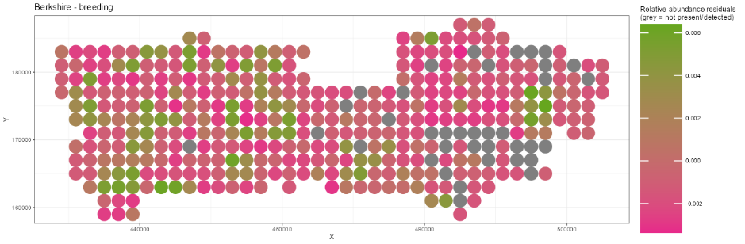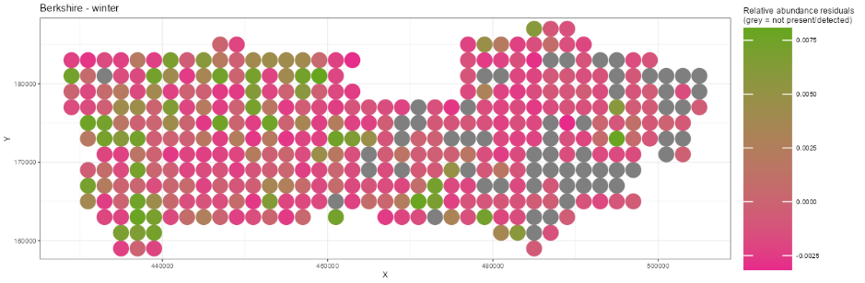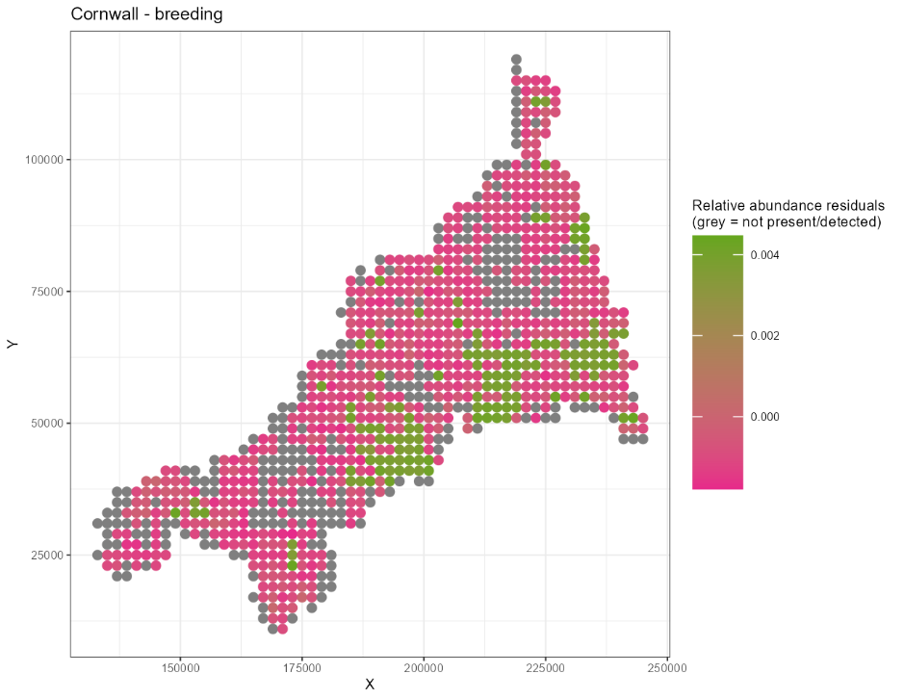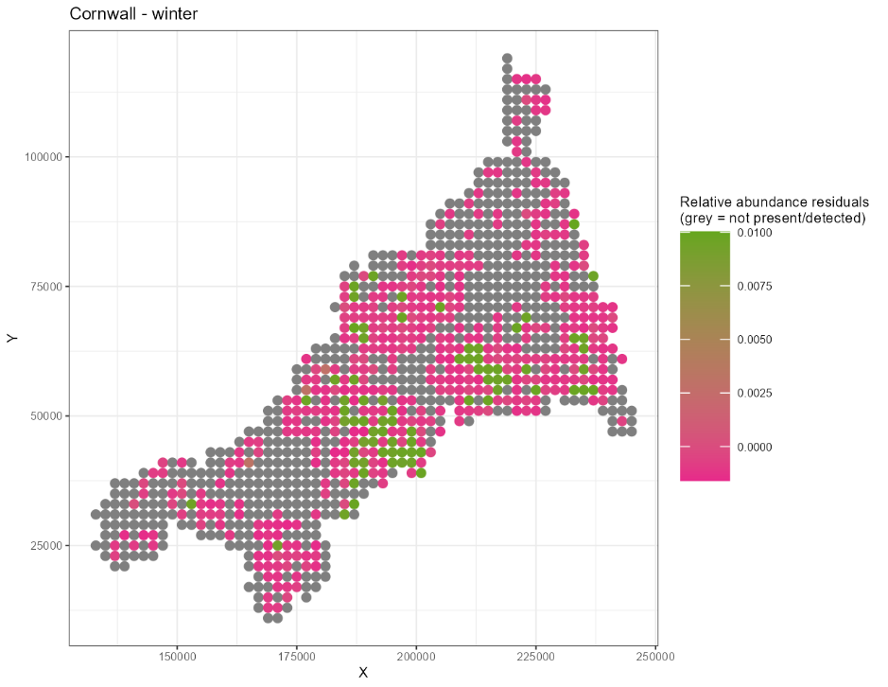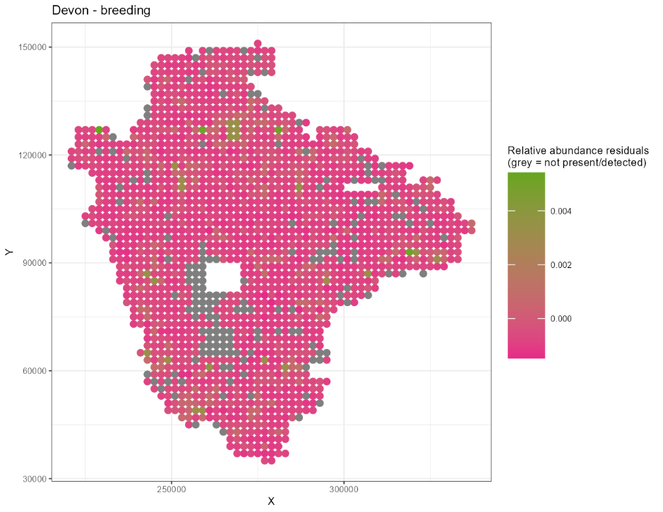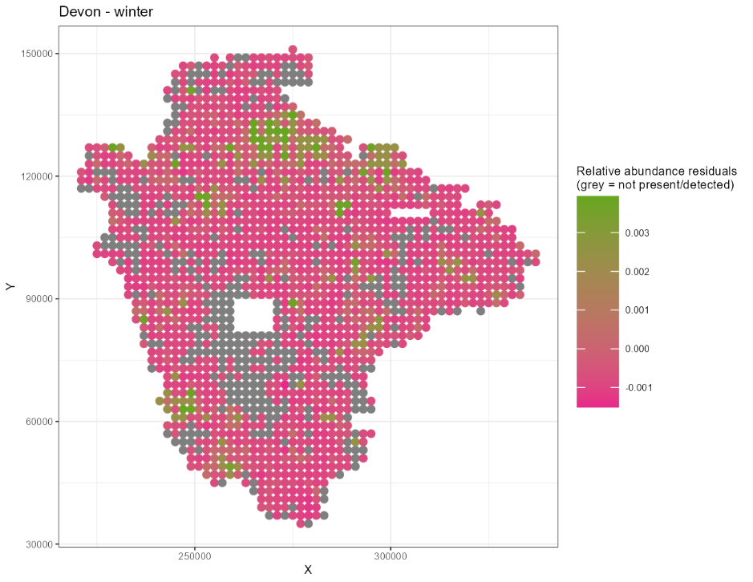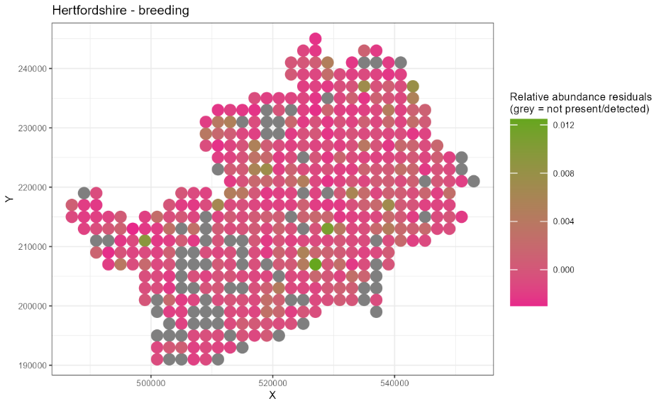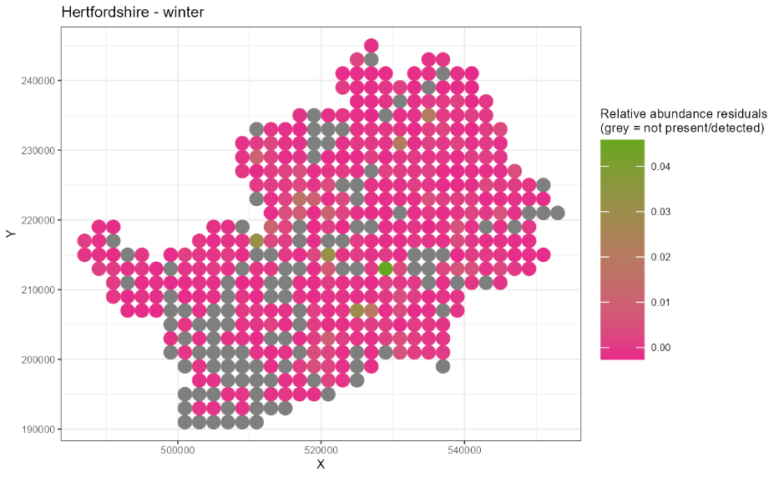
c)
b)
d)
e)
f)
h)
g)
Figure 5 – the difference between the mean of the model predicted relative abundance and the true relative abundance measure for each tetrad, plotted spatially across Berkshire (a – winter, b – breeding season), Cornwall (c – winter, d – breeding season), Devon (e – winter, f – breeding season), and Hertfordshire (g – winter, h – breeding season). Grey points indicate tetrads where pheasants were not recorded as present during the respective season.

