Final Project Report: Position Based Dynamics Football Net Simulator

Hassan Faour - Joe Abi Nassif - Mohammed Al Makdah

CMPS 299

Professor George Turkiyyah

Spring 2019/2020

**1- Introduction:**

For our final year project, our team decided to work in the field of computer graphics on Position Based Dynamics. PBD is an approach for simulating dynamics in computer graphics, it serves as an alternative for the usual force-based approach which accumulates external and internal forces, computes the object’s acceleration, and then computes and updates the new velocity and position of the object. PBD instead follows a different approach where each dynamic object is represented by vertices with mass, a position, and a velocity. PBD’s algorithm works by applying the forces on each vertex, and then projecting the desired constraints on the vertices, and finally computing and updating the position and velocity of these vertices.

For our project, we decided to implement this approach, and simulate these dynamics on cloths, so we decided to create a 3D football net simulator where we will utilize a physics engine to apply to the goal post, net, and the ball to mimic the collision of the ball and the net as it would appear in reality. We decided to use the Unity game engine which provides powerful tools to help game developers create cutting-edge, interactive games with ease.

**2- Designing the goal and net:**

Designing the goal post and the net were the first tasks we set on doing.

We used unity’s ProBuilder tool to model the goals post’s rigid body (figure 1).

As for the net, we were advised to use the Openmesh library to create a mesh out of vertices and edges. After installing Openmesh, we were able to create a simple mesh of a 3D Net resembling a goal. We then used Openflipper, which is created by the same institution as Openmesh, to model the net as an object which we exported to use in the Unity engine (figure 2).

We could have designed the mesh to be as detailed and goal-like as we would have liked, however our goal was to focus on the physics implementation. As a result, the simplistic net was later replaced by a prefabricated more eye-catching goal and net from the package “Football Goal Posts and Balls by Sim-3D” which we imported from Unity’s assets store.

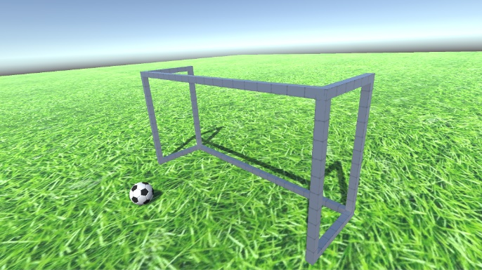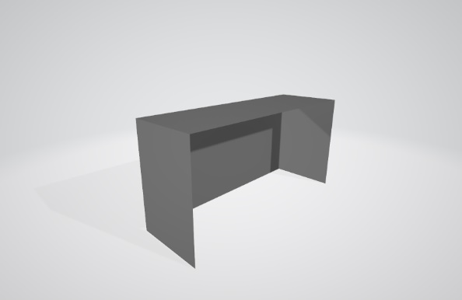

Figure : The goal post we designed using Unity’s ProBuilder

Figure : The net cloth we created using Openmesh and exported using Openflipper

**3- Implementing PBD into the mesh:**

For this step, we had several physics engines options to choose from, which were:

1. 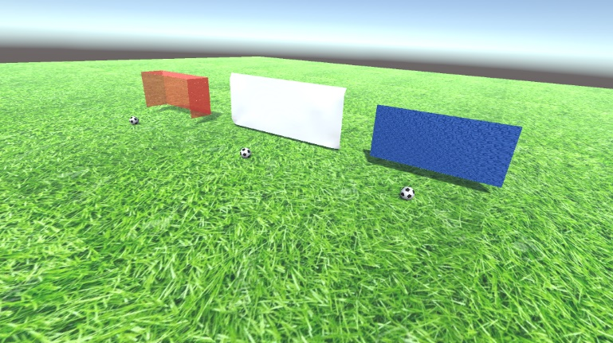Obi Physics (Obi Cloth)
2. NVIDIA FleX
3. Unity’s built-in cloth component

So, to make sure we choose the best for our project, we tested all three of them.

We created one scene where we put all 3 of them together, we created a 3D plane for each engine, and fixed these planes in their respective positions, and added a football rigid body, with a script that shoots the ball to the net when you press the space bar. (figure 3)

Figure : Testing the 3 physics engines (from left to right: Nvidia, Unity's built-in cloth, Obi)

While all three of them acted almost the same way, and performed well, mimicking the behavior of a real life cloth, we still had issues with the collision system of the net, that is when the ball moves in a big velocity or is moved by a large force, it will pass through the cloth instead of stopping or bouncing back.

We searched a lot in an attempt to solve this problem on all of these 3 cloths we were testing on.

We eventually discarded NVIDIA’s cloth as we couldn’t make any progress on it. As for obi, we were able to make the ball stop only if it was larger than the space between the vertices, and it felt more like rubber than a net. And for unity’s built-in cloth component, we realized that its collision system is somewhat buggy, as the ball would pass through sometimes, and sometimes not, even without changing anything in it or in the scene itself.

Additionally, we did some research on collision detection to fix the problem (interpenetration, AABB, reducing velocity, etc.) to no avail.

We were finally able to solve this by adding a box collider to the cloth, making it work 100% of the times, simulating a real cloth and its collisions more realistically without any problems, giving us the desired effect.

So, we settled on unity’s built-in cloth component as our physics engine for the net to simulate PBD.

**4- Putting everything together:**

After successfully creating a working cloth with the desired behavior, it was finally time for putting everything together and creating our 3D football goal simulator.

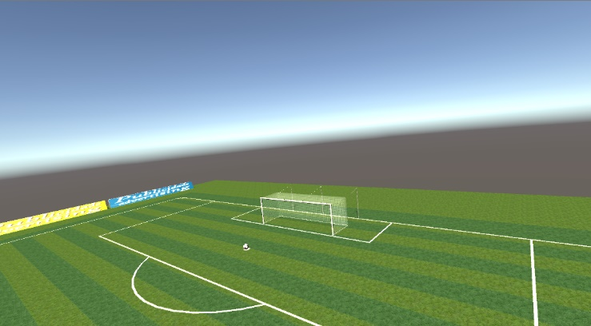We started by setting up the scene, first with unity’s default lights and camera, we then used the above mentioned package to import the stadium and the goal from it into our scene, we also added the 3D rigid ball and positioned everything in its proper place (figure 4 and 5).

Figure : The setup of the scene

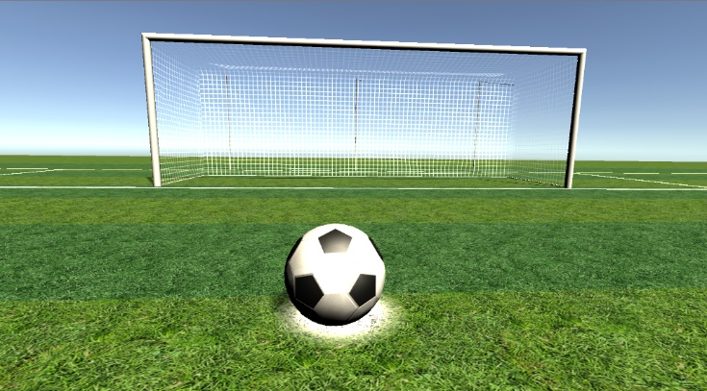

Figure : The initial camera view of our scene

Next we added the cloth component to the net of this new goal and fixed the vertices of the edges to the goal posts (figure 6).

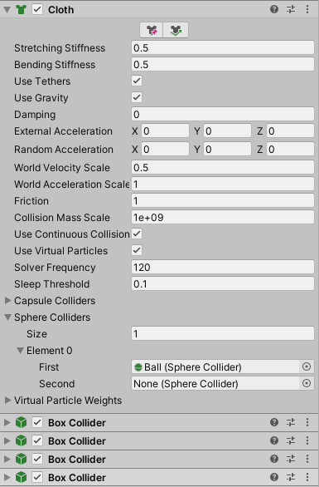We then added a sphere collider reference of the ball to the net and made it interact with the ball on collision. And we set the variables of the net (stiffness, bending, damping, …) to give it the best effect possible (figure 7)

Figure 7: The initial settings and variables of our net cloth

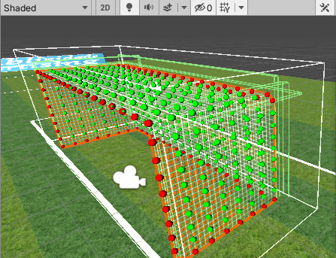We then added colliders to this net, this was tricky since this net wasn’t just a regular one-sided plane like the one we tested on earlier, this one had 4 sides. So, what we did was creating four box colliders and positioning each collider exactly over each side of the net. (figure 7)

Figure 6: The particles of the net, the red ones are fixed to their position

Now that the main part was over, we added more controls to the scene in order for us to monitor it better and control the variables without having to change it from inside the engine every time, in other words, we made the game ready to be exported into an executable game with the controls available from inside the game.

We set up a simple shooting system where the player can change each of:

* The initial position of the ball
* The direction of the shot
* The force of the shot
* The bending and stretching constraints of the net.
* The camera angle of view

That way, the player can witness the net interacting with the ball under different cloth constraints as well as ball velocities. (figure 8 and figure 9)

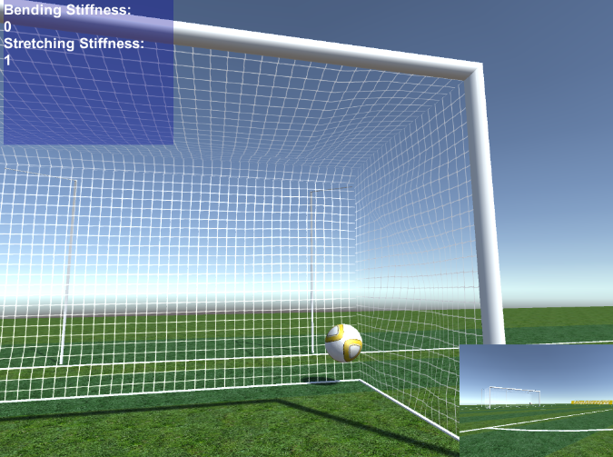

Figure 9: The ball after being shot shown in a different camera angle and with different net variables

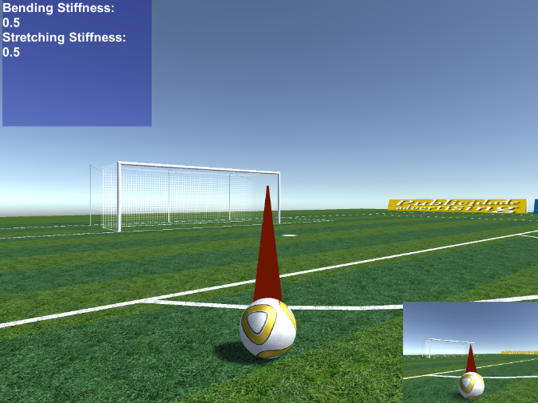

Figure 8: The shooting system of our game along with the controls and variables

**5- Limitations:**

The main limitation we faced while using unity for our simulation was mainly the collision system, our main problem was that the ball kept passing through the net, regardless of what physics engine we used. We were eventually able to solve this by adding a box collider to the net, but this wasn’t the solution we desired, as this collider still had its downside as it’s a simple collider, it has nothing to do with PBD, all it does is stopping the ball from passing through, it doesn’t work perfectly with PBD physics and interactions. A better collision system is needed which we weren’t able to achieve using any of the physics engines we used in unity. One of the suggested solutions is adding a collision script on the ball itself that allows it to interact better with the net. Another solution is increasing the number and radius of the net’s particles as well as the size of the sphere collider and the number of substeps (iterations), which sacrificed performance at times and made the ball look like it’s levitating on the ground since the collider is larger than the rendered mesh.

**6- The math behind PBD:**

The cloth being a 3D mesh consisting of vertices and edges, these vertices will be the particles that will undergo the physics simulation. Here is the main loop of the simulation (from line 4):

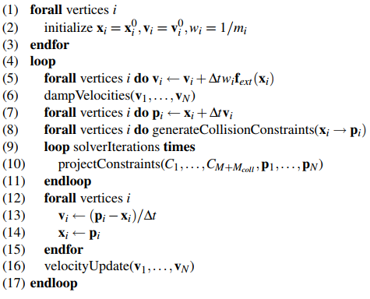

Figure 10: The main loop

Lines 1-3 are to set the initial positions, velocities and inverse masses for each particle. (Making a particle fixed would be equivalent to setting its inverse mass to 0).

In line 5, external forces (usually gravity) are added to the velocities of each particle (notice that would not change for ). In line 6, the velocities are damped when necessary.

In line 7, each position is updated according to the corresponding velocity and stored in an estimated position (it’s estimated because constraints aren’t computed yet).

In line 8, generates collision constraints.

In lines 9-11, the constraints are solved for the respective estimated positions.

In lines 12-15, the velocities are updated and the positions are set to the updated estimated positions.

In line 16, the velocities of colliding vertices are updated according to friction and restitution coefficients (how elastic the collision is).

Some of the constraints explained:

* Collision constraint:

For each vertex , let the ray coming from to .

If the ray enters an object, we check the following inequality constraint:

If the ray doesn’t penetrate another object, we check the following inequality constraint:

In general, to resolve a collision between a point and a triangle , we check the following inequality constraint:

To see on which side of the triangle is in. If , is above the triangle .

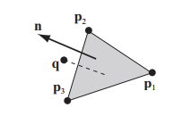

Figure 11: The point q is above the triangle (p1, p2, p3)

Additionally, we apply an impulse to a rigid body on collision with the cloth to get two-way interactions. That way, we can prevent interpenetration between the rigid body and the cloth.

* Stretching constraint:

For each pair of vertex positions forming an edge with length at rest:

* Bending constraint:

For each pair of triangles :

Let

.

.

**7- Our Experience with unity:**

**Joe:**

I wanted to use Unity as it was the game engine I am most familiar with, as I made some small games and general experiments (including football-related) with it before. This, coupled with the abundance of tutorials, a large community, and a background in graphics from CMPS 285, made using the engine not a challenge. The harder part was familiarizing myself with position-based dynamics as well as the details behind physics engines (notably PhysX which is the default for Unity). The biggest challenge was fixing the inter-penetration problem between the ball and the net.

**Mohammed:**

This wasn’t the first time I used unity, I previously tried using it to build some basic games on it, these games however barely involved using physics engines in them and I never thought of getting deep into how these engines work.

Building a real life simulation was more challenging than I thought, Starting with modeling the goal post, I created several rigid posts and had to position them perfectly in alignment with each others, and doing that in the 3D space was harder than I thought, this seemingly simple process took much time and effort and precision than I thought it would.

Testing to find the best physics engine was no easy task as well, I had to keep shooting the ball over and over and observe its behaviors on different positions and from different angles in order to understand how it behaves better.

**Hassan:**

My experience in Unity comes as an entirely new user to the engine. At first, I found it quite intimidating due to the huge amount of options there are to use. Even simple things like creating a scene looked tough at first, and there was difficulty inserting assets in the right place and navigating around the scene, it was a mess. Online videos were extremely helpful in explaining how to use the engine properly.

I found rolling updates of the engine to not be useful as we would have to re-import our project over and over. We should have stuck to one version of unity to begin with, which would have saved us a few compatibility issues.

Just from the engine itself, I found that individual features aren’t so well explained as is. Random testing of features on out project did not move me in the right direction, especially when it came to physics components. Playing with unknown features, while interesting in an of themselves, often broke things instead of helping. Tutorials online are a must.

Patience also important, as with all new things. After the steep beginner’s learning curve, it becomes easier and more intuitive to use the engine with time. Learning the correct terminology is also invaluable, and will come with time, allowing you to debug and narrow down issues online far easier.

Finally, an often overlooked goal is to enjoy development. Find a few interesting videos online and make a few test projects to try out the latest up and coming features. Fun and games are always a good method to stay stimulated and absorbed in the world of 3D animation.