

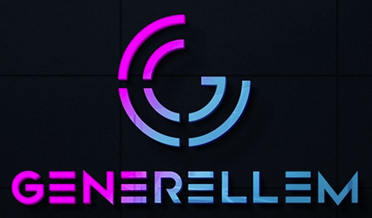

* ANY LLM  
  Plug in your own Large Language Model (LLM) that fits your company.
* ANY VECTOR STORE  
  Plug in your own vector store database for holding text embeddings.
* ANY DATA TYPE  
  In addition to available support, you can also add support for your own proprietary data formats.
* ANY DATA SOURCE  
  You can use existing sources or add your own unique data source.

simplifying **AI**

Generellem Capabilities

**5432 Any Street West, Townsville, State 54321 Tel 555.543.5432 Fax 555.543.5433**

**https://generellem.com**

Retrieval-Augmented Generation. This means you need to write code that ingests documentation and converts that and stores embeddings in a vector database. Then, to support actually doing the search, you would write the code to search the vector DB for matching text, build context, and make the LLM query. That’s a boatload of work. However, that’s exactly what Generellem is doing,

As a developer, it’s fun to attack a problem by writing your own code. However, the reality is that you don’t always have time. Imagine that people in your company have a desire to use the vast troves of IP within the company when using an LLM, like ChatGPT. If you approached this yourself, you might discover that you need to do research to find out how to do this. One direction your research might take you is a popular technique known as

USE YOUR OWN DATA FOR AI.