Lee Brunovsky

CSCI 5120, Topics in Information Security

Bonus Project

Step 1 Capture a Trace:

1. Find the computer's Ethernet address with ipconfig (Windows)



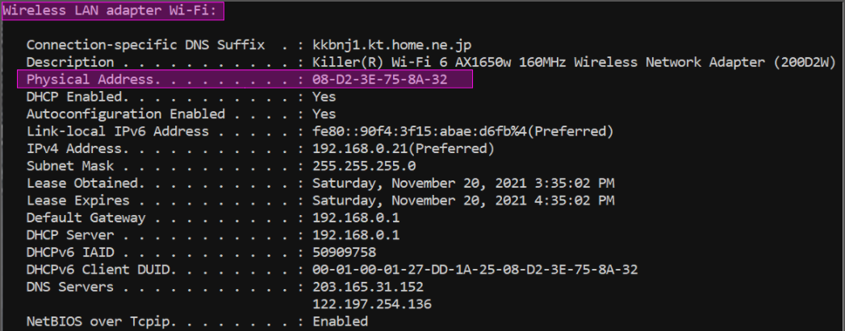

1. Find the default gateway IP address with netstat (Windows)

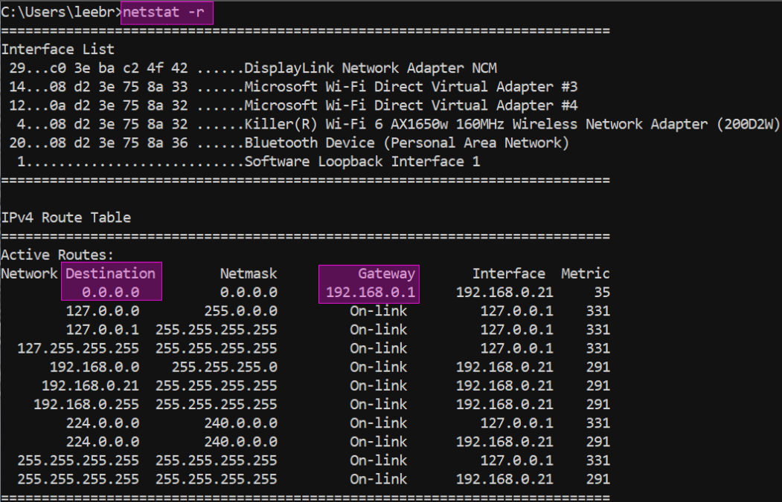

1. Launch Wireshark and start a capture with a filter of “arp”.

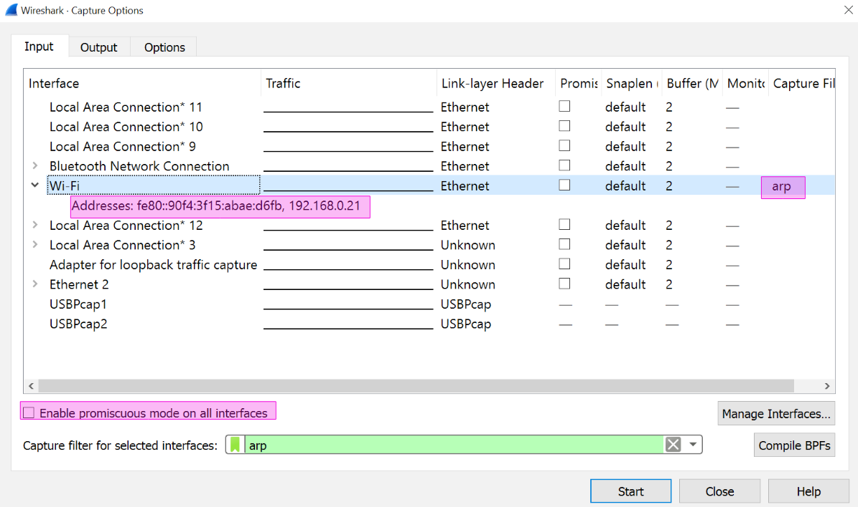

1. Use the “arp” command to clear the default gateway from the ARP cache.

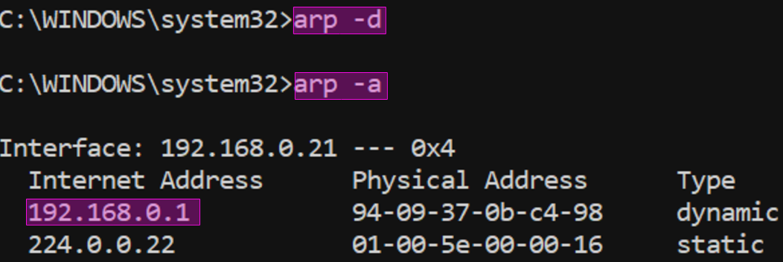

1. Fetch a remote page with your Web browser



1. Captured some ARP traffic then stop the capture

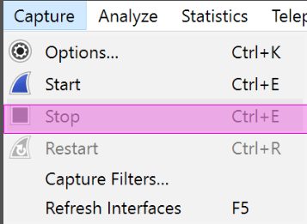

Step 2: Inspect the Trace

1. Set a display filter for packets with the Ethernet address of your computer

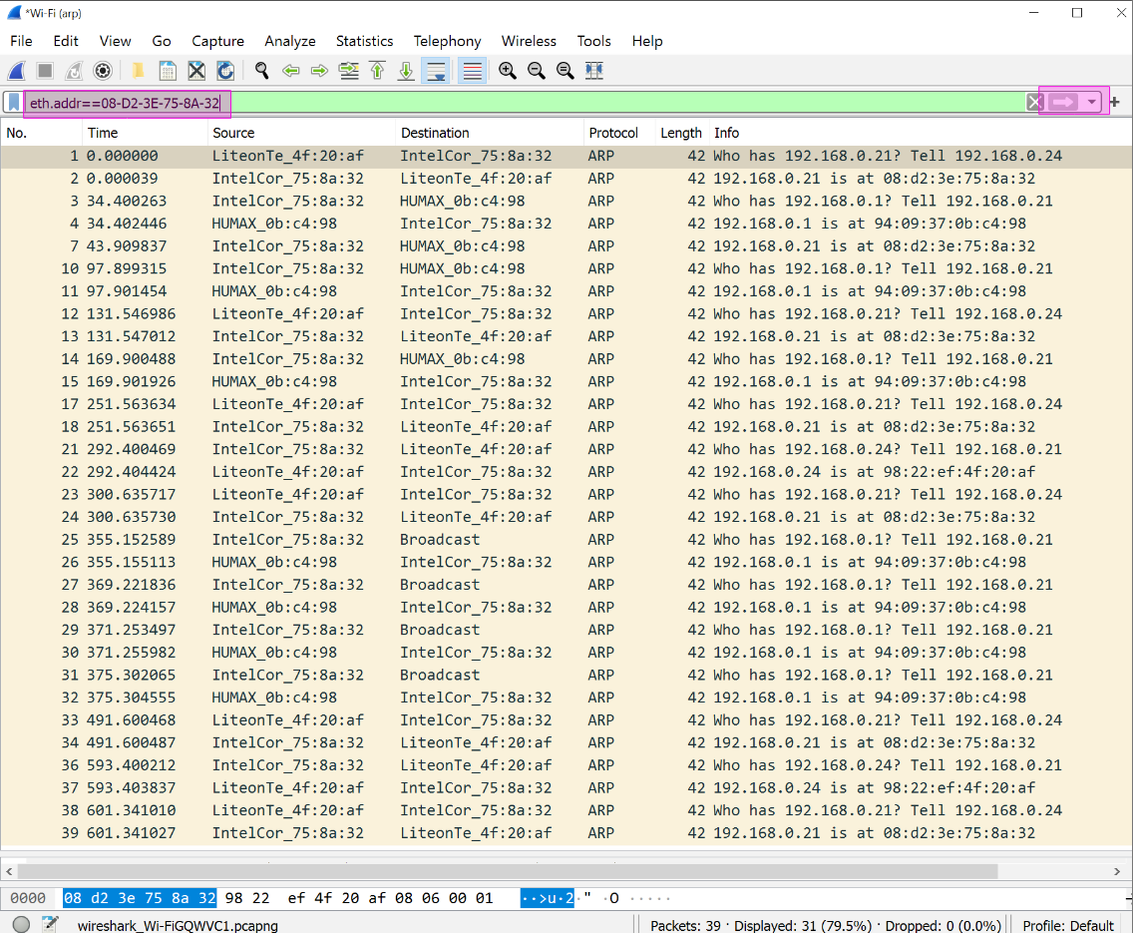

1. Find and select an ARP request for the default gateway and examine its fields

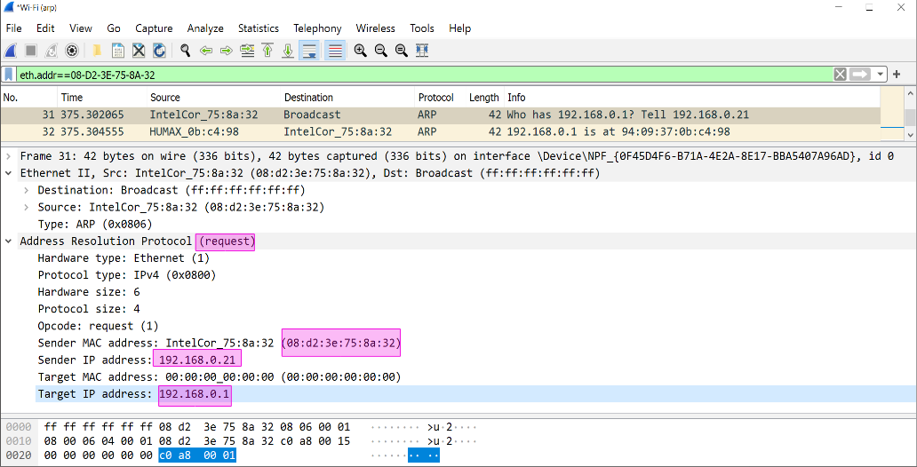

1. Select an ARP reply and examine its fields

