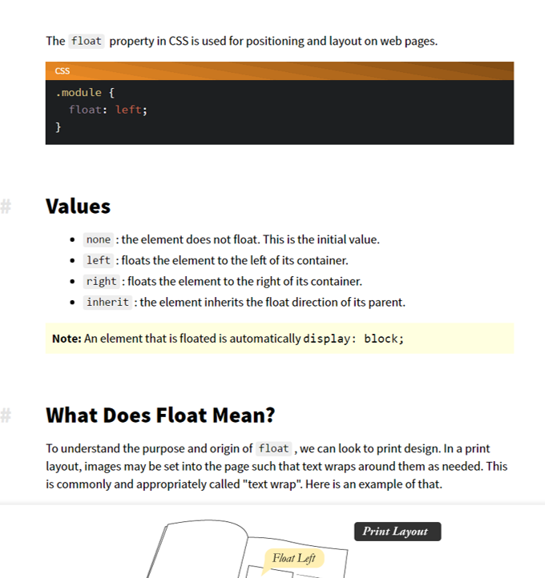**Floats**

Float is used in HTML/CSS which makes a picture or text move to any position upon the computer screen. With floats you can use, left, right, assign, top, bottom and auto. The clear property is used to control the behaviour of floating elements after a floating element will flow around it. To avoid this, you use the clear property. The property specifies on which sides of an element floating are not allowed to 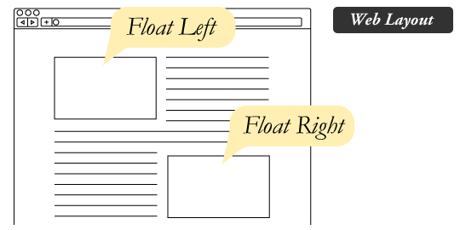float. It wraps text around images.

In the picture above it shows that the text boxes are wrapped around the images to get the text to write next to it.

Floating everything can make for a great deal of inconsistency, depending on how wide a screen is (phone, iPad, pc monitor) and how tall certain elements are rendered you will end up with your screen in a mess. Widening the screen would cause more elements to fit on top of the line, so they would jump up. Items not in the top line will slide down, and then catch on the corner of an element slightly taller than everything before it.

-<http://www.gameindustrycareerguide.com/building-artist-portfolio-site/>