**1. Introduction**

* 1. **Background**

Seattle has been and continues to be one of top grossing technological cites in the world. The headquarters of some of the most value companies such as Amazon, Google, and Microsoft attract the best talent in the world. As the population grows so does the landscape evolve for better and worse. The technological advancements bring wealth in the form of tax dollars and innovations from bright minds. At the same time Seattle’s housing prices increase nearly at the same rate as San Francisco. Many businesses struggle and homelessness is on the rise. There is no stopping technological advancement. It would be trivial to assume you can predict their net outcomes. Therefore, a company or an individual can only do what’s best with the information they are given. Information can be turned into insight and each party can choose what neighborhood best fits their situation.

* 1. **Problem**

Can you understand how similar or dissimilar are the neighborhoods of Seattle? Companies are struggling to position their businesses at the doorsteps of their target audience. Individuals even with high paying jobs have issues paying rent. The purpose of the analysis is to provide insight to both parties so they can make the best decision for them.

* 1. **Interest**

Seattleites, new hires, and growing businesses alike can extrapolate value and gain a competitive edge against their competitors or peers. A reader can find the right location for their business, seek affordable areas, or spot the top-rated restaurants nearby.

**2. Data**

**2.1 Data Acquisition and Cleaning**

A table of Seattle neighborhoods and their districts was scraped from Wikipedia via Beautiful Soup. The table included other variables deemed unhelpful for analysis such as brief descriptions and a sample photo. The neighborhood names along with the city of Seattle and the state of Washington were concatenated into a string and processed via GeoPy. The latitude and longitude for almost every neighborhood was extracted. Thus, the dataset known as ‘SN’ standing for Seattle neighborhoods was formed. It combines the neighborhood name, district, latitude, and longitude. The remainder of the data is from FourSquare. Information on nearby venues for each neighborhood was called and obtained via the free endpoint, explore. Information on the venues price tier and rating if given was called and obtained via the premium end point, details. Please see the FourSquare documentation for more information.

**Temporary table samples:** Final Draft will have better visuals.

**SN**:

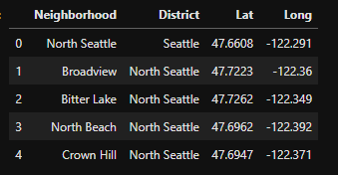

**Seattle_venues:** 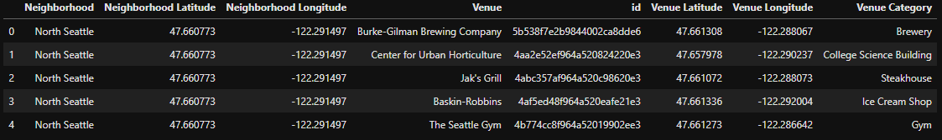

**Seattle_venues_details (snippet – they are premium calls)**



**2.2 Data Relevance**

The latitude and longitude of each Seattle neighborhood enables interactive visuals via Folium making it easy to understand for the end consumer. A company will understand its target audience and be able to see where similar priced options are located. They will be able to pick up on patterns in venue category and establish the most economical location. The same can be said with a resident. Depending on their budget, interests, and job location they can find the best neighborhood for them.

**Sneak peak at the neighborhoods prior to analysis:**

