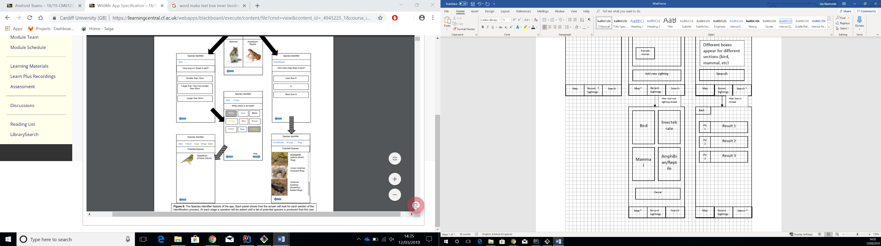

Source:

Cancel

Amphibian/Reptile

Mammal

Invertebrate

Bird

After Add new sighting clicked

Map \*

Recent Sightings

Search

Map \*

Recent Sightings

Search

Search \*

Recent Sightings

Map

Back

Pic3

Result 3

Pic2

Result 2

Pic1

Result 1

After Search Clicked

Different boxes appear for different sections (bird, mammal, etc)

Reptile

Search Bar

Search

Mammal

Bird

Search \*

Recent Sightings

Map

Example Animals

Example Animals

Add new sighting

MAP

Example Animals

Map

Recent \* Sightings

Pic3

Pic2

Pic1

Recent Sighting 3

Recent Sighting 1

Recent Sighting 2

Search