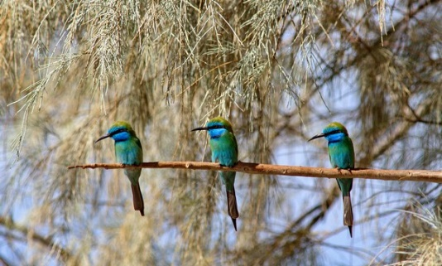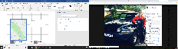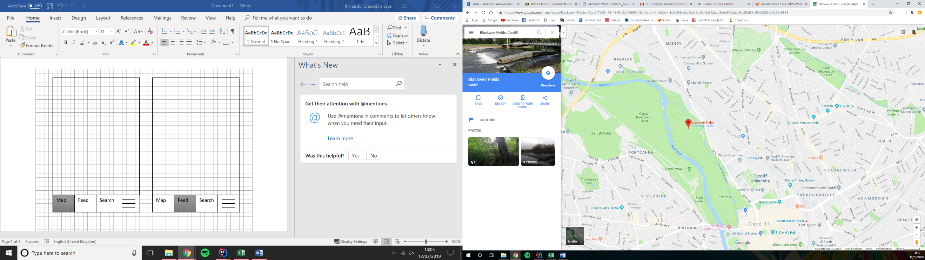

It’s a crow.

@FinlayWallis I think he knows.

Found this incredible bird in Blackweir Fields, anyone know the name?

**Rikki**

Map

Feed

Search

Search

Feed

Map

Search…

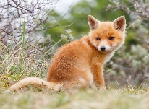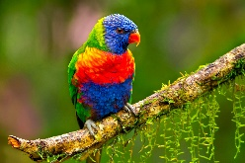

mammals

Birds

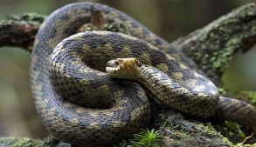

Reptiles

Map

Feed

Search