System for managing access and use of classrooms, with facial recognition, based on Raspberry Pi.

In general, our project is about a face recognition system for classroom security and teachers checking class attendance, two functions in one. All is embedded on a Raspberry Pi 4 and using its different peripherals.
The architecture is explained in figure 1. A Raspberry Pi like a CPU, sensor to activate system and camera module to take a photo; after the system connects with a biometric database to find matches. In case of the system found a match, connects with a API-rest to check attendance in the system “Reloj Checador”.Base on the previous decisions, the system could open the door or not and it will notify to the user the situation with a message.
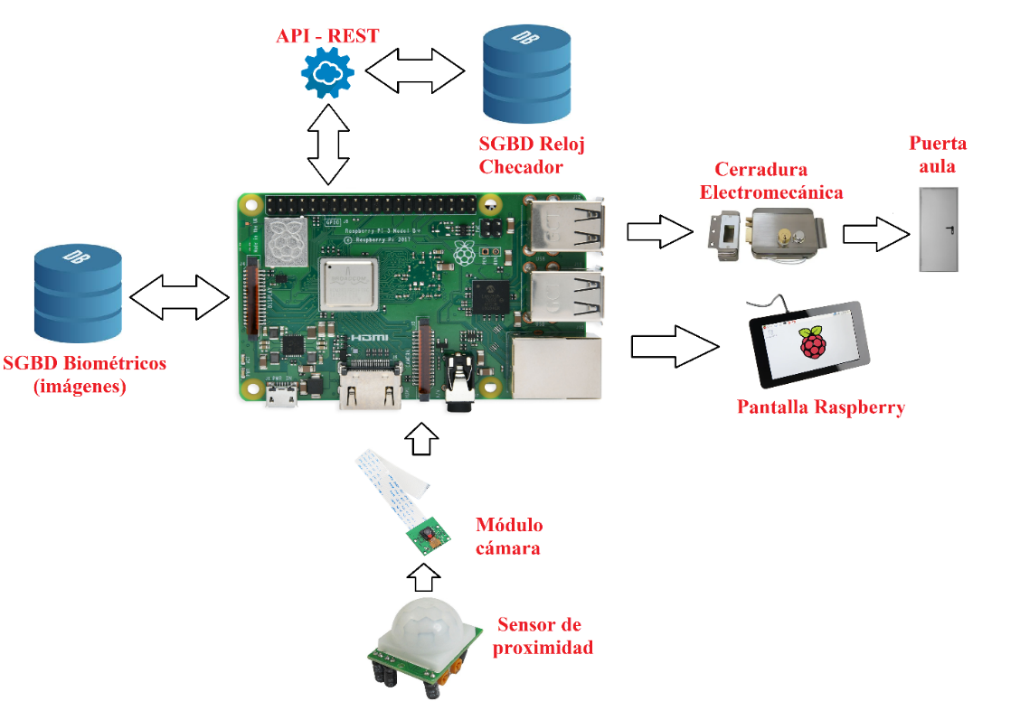
Figure 1.- Architecture general

Functional requirements are the next:
- Initialization by approximation.
- Face detection.
- Image capture.
- User recognition.
- Check teacher attendance.
- Classroom access decisión.
- Opening notice.

Not functional requirements are the next:
- Internal debug.
- API-rest to CRUD.
- Biometric database.
- Openface (framework).
- Python language.

Activity diagram as a flowchart and its process in figure 2.
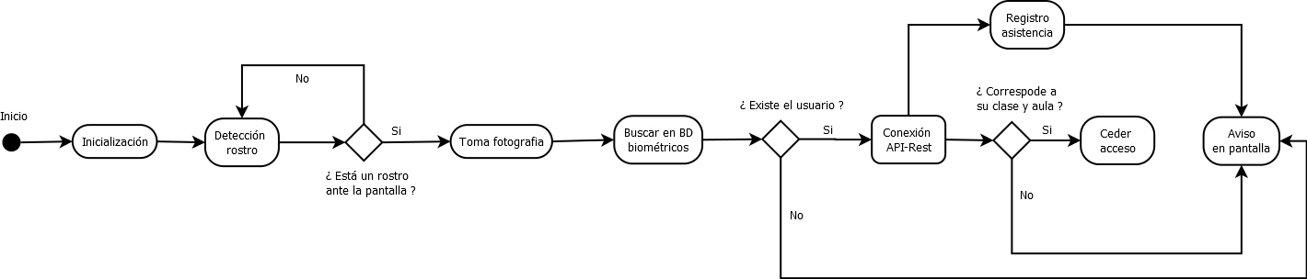
Figure 2.- Activity diagram

Class diagram according to UML

In general, we will use 6 different classes:
- Profesores: In this class, there are three different attributes: ID (primary key), clase (classroom and schedule) and rostro (bank data with teacher´s faces).
- JFrameVentanaPrincipal: everything related with graphics.
- Controlador: In this class different decisions are made.
- Imágenes: Here all the administration regarding registrations, cancellations, modifications and updates is carried out.
- Conexión: Finally, here the different connections between external and internal in the system are managed.

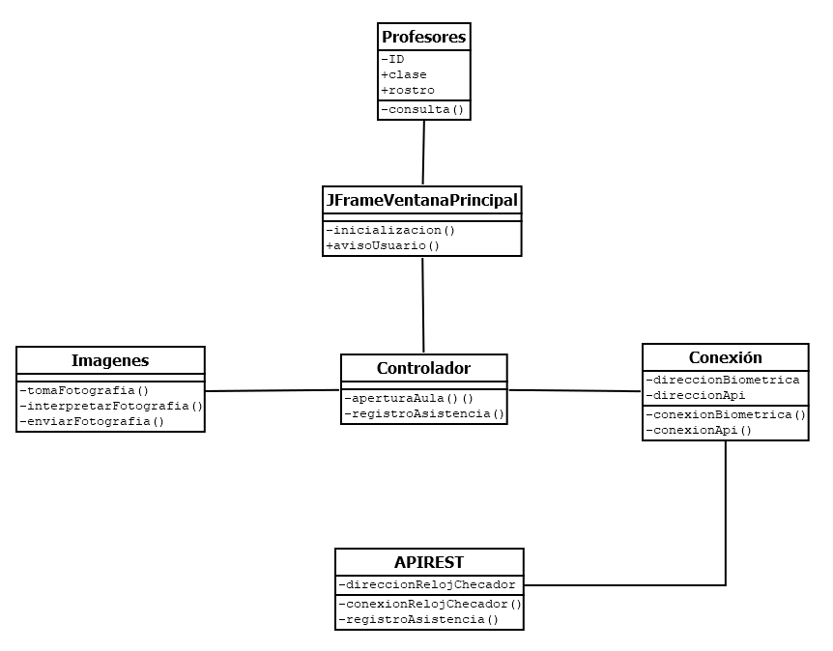
Figure 3.- Class diagram

Graphical interface for management users in the computer

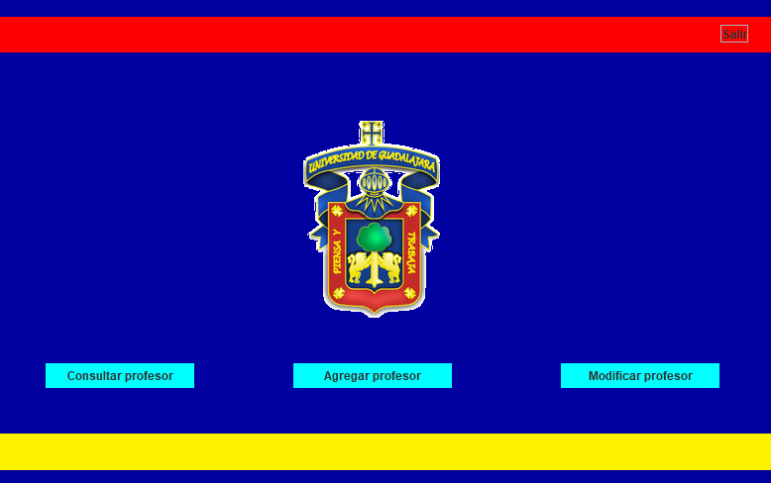
Figure 4.- Graphical window

Also, we have some test and documentation according to different IEEE standard like SRS, SDD; in these documents explain in more detail, specifications and different diagrams like: package, deployment, sequence, database and data dictionary.

Phases of a facial recognition system

Broadly speaking, we can define 4 phases in a facial recognition system: Detection, Preprocessing, Extraction of characteristics and Comparison and decision (Figure 1).

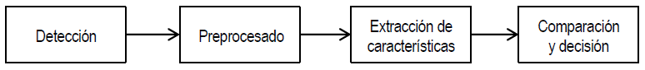
Figure 3.- General diagram of a facial recognition system.

In all phases an image is required for its operation; however, there is a previous training stage, which is executed only once. In this stage, the first 3 phases participate in the images previously captured in the database; obtaining the most relevant features and characteristics, to later achieve facial recognition in the fourth phase.

Detection
This phase consists of detecting, in an image, a human face and isolating it from the rest. There are different algorithms in charge of performing this function, some more complex than others. One of the most widely used due to its low computational cost and its "approach to object detection that minimizes computation time while achieving high detection precision" is the Viola-Jones algorithm.
The algorithm is basically based on classifiers called Haar-like features, which roughly function as a grouping of characteristics, in the form of a cascade, through an algorithm based on AdaBoost and then “achieve high performance in detection, thus as a high discriminatory capacity in the early stages ".

Preprocessed
In this stage, a process of transformation of the image is carried out, into geometric models and prepares the image, for the extraction of characteristics. In this stage four different phases are used:
Rotation: The eyes are detected, to determine the angle of rotation in an image and compensate for it.
Scaling: It is used to obtain the images of the same size, varying the distance between the eyes (in the image).
Cropping: A cropped image of the face is obtained from the original image in a new file.
Histogram equalization: It could be said that it normalizes the variability of the pixels, since at the moment of capturing the image, the light is concentrated in different points of each one. This helps to obtain a more homogeneous image quality.

