Universidad de Guadalajara
Centro Universitario de los Valles



Main Document

Subject: Administración de la configuración del software.
Teacher: Zatarain Duran Omar Ali.
Version : 0
Author: Nava Cervantes José Manuel.

Table of contents

Introduction 3
Project Summary 4
Change request 5
Terms and conditions to Change Request. 5
Configuration Identification Report 6
CR01.- Create a module that sends the attendance to an external surveillance system that fulfills a mandatory government law. 7
Identify the configuration items (CI) within the baseline due to change request (CR) 7
Swot Matrix 12
CR02.- A cryptographic method should be used to transform transmission data for privacy purposes. 13
Class diagram 13
Enact (analysis) the advantages and disadvantages for implementing the CR. 14
Swot Matrix 15
CR03.- The client asks for a resilient version of Viola-Jones algorithm to detect the face of a handicapped person who only has one eye. 16
Identify the configuration items (CI) within the baseline due to change request (CR) 16
Changes in SDD (Software Design Document) 16
General architecture 16
Changes in SRS (Specification Requirement Software) 17
Figure out the effort required to implement such CR (budget, work, human resources, time). 17
Enact (analysis) the advantages and disadvantages for implementing the CR. 17
Swot Matrix 18
Committee board 19
Policies for make a CR decision. 20

Introduction

This document explains the different ways of approaching the project named “Sistema para la gestion del acceso y uso de aulas vía reconocimiento facial, basado en Raspberry Pi” from the administration of the software configuration in the different stages of the life cycle through its previously carried out documentation. The analyzed documentation was written under different standards, such as IEEE-29148, which suggests the ways to design and apply the different system requirements.
Stakeholders propose the requisition of 3 different substantial changes in the project, with analysis at different points of the system from its documentation where different topics such as costs, human resources, delivery times, etc. Through the proposal of a committee, the different actions were taken for the different proposed changes and thus make a final decision regarding the positive or negative approval for each proposed change and the justification for each decision made.
Different supporting documents were produced to justify any decision made by the committee. Said documents contain an informative analysis of the different strengths, opportunities, weaknesses and threats in its SWOT matrix; the configuration articles are written likewise, reviewing any modification, replacement, update or remove in some of the requirements or design in the documentation. Finally, a document where in a democratic way the committee meets, debates, proposes, votes and takes the different decisions of the changes proposed by the stakeholders.

Project Summary

In general, our project is about a face recognition system for classroom security and teachers checking class attendance, two functions in one. All is embedded on a Raspberry Pi 4 and using its different peripherals.
The architecture is explained in Figure 1. A Raspberry Pi like a CPU, sensor to activate system and camera module to take a photo; after the system connects with a biometric database to find matches. In case of the system found a match, connects with an API-rest to check attendance in the system “Reloj Checador”. Based on the previous decisions, the system could open the door or not and it will notify to the user the situation with a message.

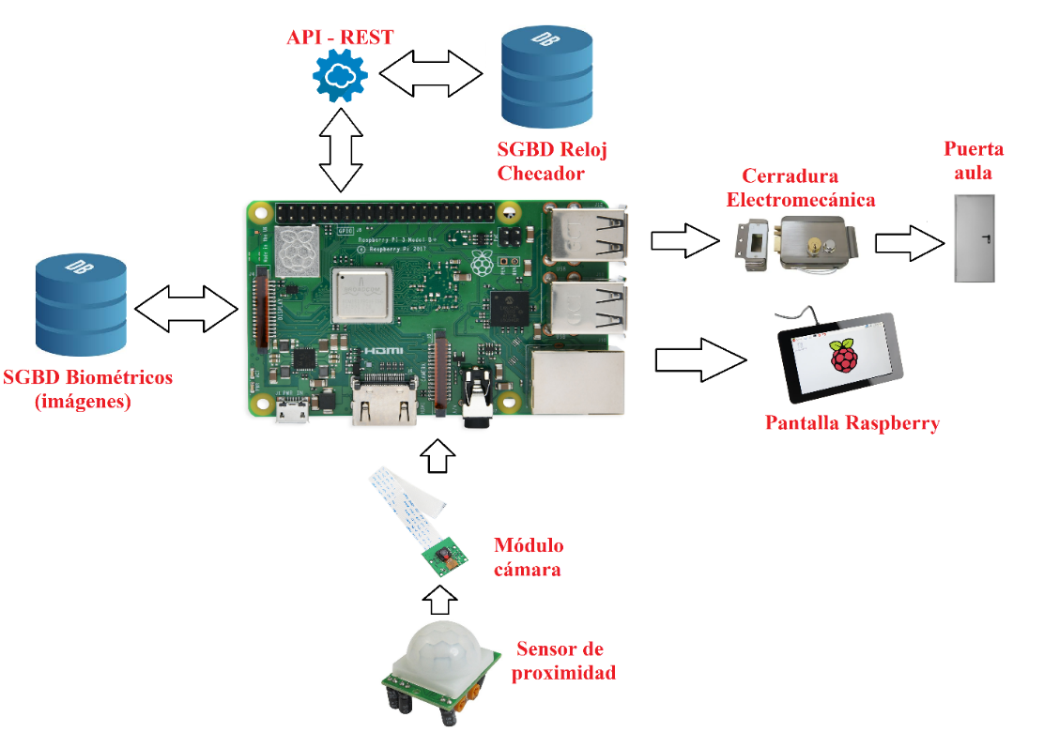

Figure 1.- General architecture.

Change request

The stakeholders want to change and implement 3 different changes in the project named “Sistema para la gestion del acceso y uso de aulas, via reconocimiento facial, basado en Raspberry Pi”. We must assign different ID for each change requirement in the project. These changes are the following:

CR01.- Create a module that sends the attendance to an external surveillance system that fulfills a mandatory government law.
CR02.- A cryptographic method should be used to transform transmission data for privacy purposes.
CR03.- The client asks for a resilient version of Viola-Jones algorithm to detect the face of a handicapped person who only has one eye.
According to steps for configuration indication, it is necessary identify 3 different points:

- Identify the configuration items (CI) within the baseline due to change request (CR).
- Figure out the effort required to implement such CR (budget, work, human resources, time).
- Enact (analysis) the advantages and disadvantages for implementing the CR.

Terms and conditions to Change Request.

What conditions can we accept?

- Policies: Changes cannot force the team to work more than 12 hours a day.
- Budget: The maximum allowed financial cost should not exceed the 20% of the total budget (previously accepted in the contract), only when the project is completed at the 60% or when the changes affect the main objective of the project.
- Development: Each requested change cannot exceed 10% of the total number of lines of code or module proposed at the contract.
- Human resources: The hiring time for extra personnel, in case of accepting the change, must be at least 7 consecutive business days.
- Time: Changes are only accepted when the project progress is less than 50% or in half the time agreed in the contract. If more than half the time agreed with the stakeholders is required, in case of accepting the change, the contract will be rewritten, modifying the clauses according to the Configuration identification report.

Configuration Identification Report

CR01.- Create a module that sends the attendance to an external surveillance system that fulfills a mandatory government law.

Identify the configuration items (CI) within the baseline due to change request (CR)

Changes in SDD (Software Design Document)

Class diagram

In this part, only it will be necessary to add another method, which we will named “conexiónModuleAttendance”. This method communicates the system with the “ModuleAttenddance” through APIREST class (Figure 2).

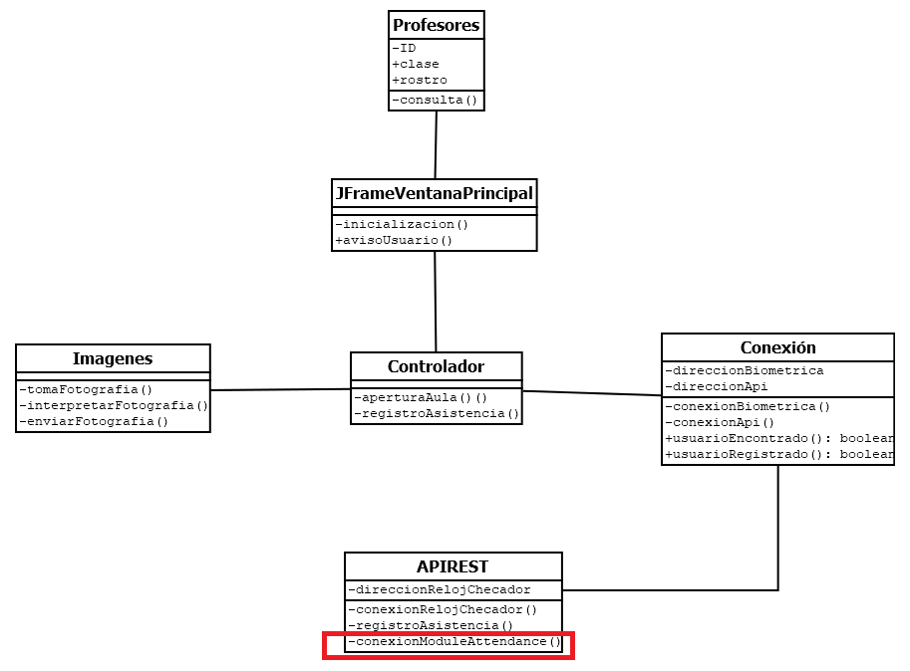
Figure 2.- Class diagram with the new “Module attendace”.

Deployment diagram

In this diagram, only we will add another module, like a physical component external through APIREST (Figure 3).
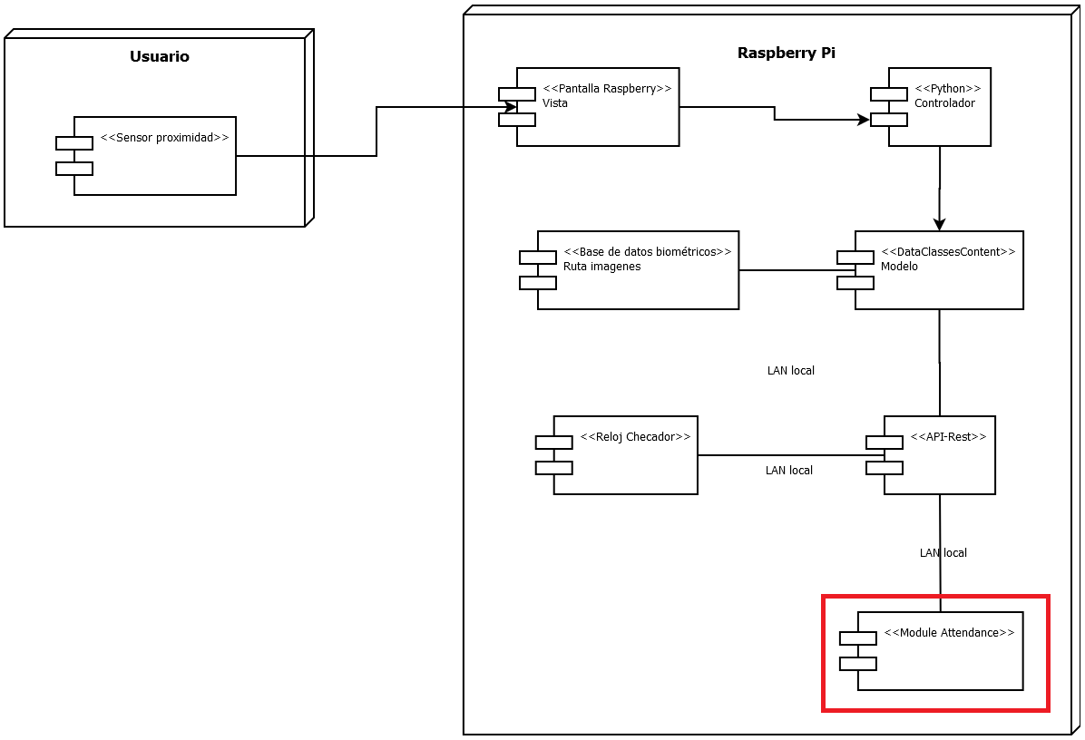
Figure 3.- Deployment diagram with the new “Module attendace”.

Activity diagram

The changes in this diagram will be to add a branch, in the module APIREST, named “conexión APIREST”, it is explained in the Figure 4.

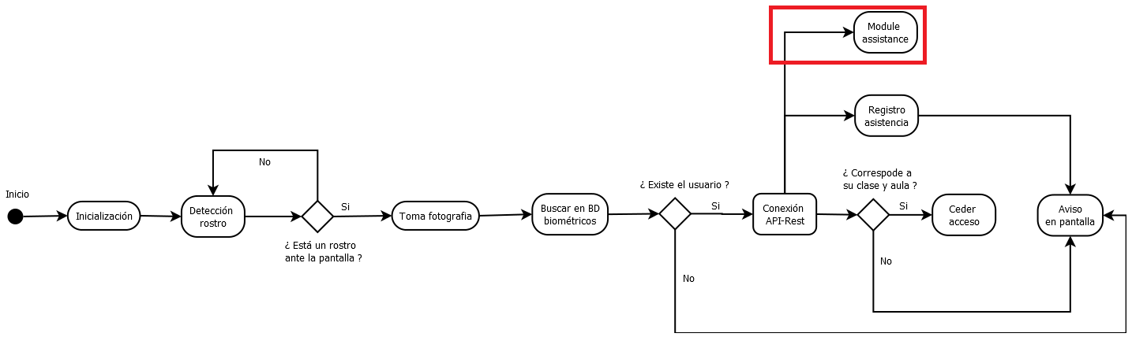
Figure 4.- Activity diagram with the new “Module attendace”

Changes in SRS (Specification Requirement Software)

In this document is only necessary to add another functional requirement. To practical situations we will named SRF-08

SRF-08 | The system should send the assistance, after the SRF-05(Registro de asistencia), to the module named “module attendance”.
External attendace

Figure out the effort required to implement such CR (budget, work, human resources, time).

The requirements to implement this project from the beginning were the next:

Budget
- $800,000.00 MXN approximately.

Work
- 1,000 line of code to Module attendance(through API REST).

Human resources
- One junior programmer.
- 2 internal senior programmers (stakeholders).
- 5 software engineering.

Time

- 2 years (January 2020 – December 2021) to develop and implement.
As in the new module, it will only be to add another extra functionality, such as the connection through the API-REST. The required effort will be as follows (It is estimated that the changes, could affect in this topic):

Budget
- $24,000.00 MXN more.

Work
- 2 months more to develop and implement the new module “Module attendance”.

Human resources
- Only a more programmer junior.

Infrastructure
- 20 MB of internet (minimum to operate).

Enact (analysis) the advantages and disadvantages for implementing the CR.

It is necessary, differentiate advantages and disadvantages of these changes, in case of we accept. The next table describe these points (Table 1):

Create a module that sends the attendance to an external surveillance system that fulfills a mandatory government law.

Advantages | Disadvantages
The system fulfills the law. | More expensive.
The system fulfills the law. | More time to design and develop.
The system fulfills the law. | More hardware and electrical cost.
The system fulfills the law. | More external modules.
Table 1.-Advantages and disadvantages to first change.

Swot Matrix

Critical / Urgent:
-The system cannot go out without this requirement because is a legal situation.
-It is another module, we need more time (2 months), code (1000 lc), changes
in design (SRS, SDD), budget (48,000), human resources (senior).

Strengths | Weaknesses
What do you do well?  What unique resources can you draw on?  What do others see are your strengths? | What could you improve?  Where do you have fewer resources than others?  What are others likely to see as weaknesses?
- It is relatively easy to design and implement this module.  - Only is necessary to hire another programmer. | - This change is obligatory for legal situation.
Opportunities | Treats
What opportunities are open to you?  What trends could you take advantage of?  How can you turn your strengths into opportunities? | What threats could harm you?  What is your competition doing?  What treats do your weaknesses exposes to you?
- We can use frameworks and libraries of open source. | - Mandatory government law. If this CR is not implemented, the system cannot operate by law.

CR02.- A cryptographic method should be used to transform transmission data for privacy purposes.

Identify the configuration items (CI) within the baseline due to change request (CR)

Changes in SDD (Software Design Document)

Class diagram

In this case only it will be necessary to add another method in the class “Conexion”, to encrypt data before of transfer through APIREST. This method will be named “encriptar”.
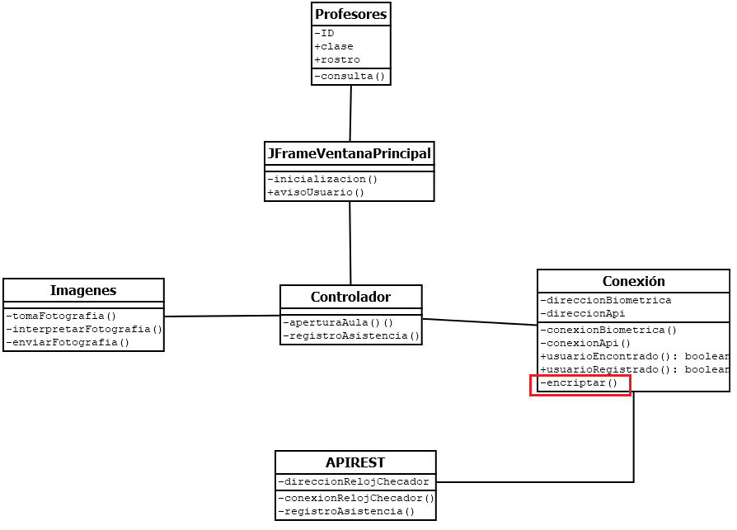
Figure 5.- Class diagram with the new method.

Changes in SRS (Specification Requirement Software)

In this document is only necessary to add another functional requirement. To practical situations we will named SRF-09

SRF-09 | The system should have a cryptography method before to storage in the database.
Encryptation data

Figure out the effort required to implement such CR (budget, work, human resources, time).

As in the new module, it will only be to add another extra method, such as encrypt data. The required effort will be as follows (It is estimated that the changes, could affect in this topic):

Budget
- $1,000.00 MXN more.

Work
- 2 days more to develop and implement the new method “Encryptation data”.

Human resources
- 1 programmer

Enact (analysis) the advantages and disadvantages for implementing the CR.

A cryptographic method should be used to transform transmission data for privacy purposes.

Advantages | Disadvantages
Stronger system | More expensive.
Stronger system | More time to design and develop.
Most reliable system. | More complex software.
Most reliable system. | More hardware and electrical cost.
Table 2.-Advantages and disadvantages to second change.

Swot Matrix

Low:
- It is necessary to implement a crypto system, as we are working with personal data.
- We need only a few changes in the documents (SRS, SDD), 2 days more, only 1 programmer, one method more (100 line of code) and 1000 extra pesos.

Strengths | Weaknesses
What do you do well?  What unique resources can you draw on?  What do others see are your strengths? | When I don’t have enough resources
-Relative ease of design and implementation.  -With 300-1000 lines of code is enough. | - We use biometric data and we don’t have biometric databases.  - Only we need to hire one more programmer.
Opportunities | Treats
When I don’t have some, but I can get it or I can improve. | What threats could harm you?  What is your competition doing?  What treats do your weaknesses exposes to you?
- Use of the framework for Encryptation are open source and free software. | -All the Encryptation methods have some vulnerability.  - Cost for implementation.  -

CR03.- The client asks for a resilient version of Viola-Jones algorithm to detect the face of a handicapped person who only has one eye.

Identify the configuration items (CI) within the baseline due to change request (CR)

Changes in SDD (Software Design Document)

General architecture

For this change requirement is necessary to use another board (instead of Raspberry Pi), because is more computational processing power to implement this algorithm.

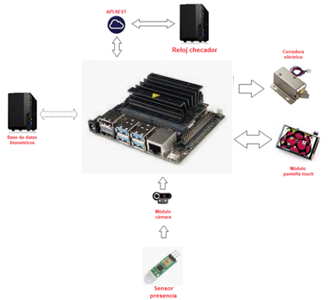

Figure 6.- General architecture with the new board NVIDIA Jetson Xavier NX.

Changes in SRS (Specification Requirement Software)

In this document is only necessary to add another functional requirement. To practical situations we will named SRF-10

SRF-10 | The system must be able to operate with facial features other than the eyes, even relying on other algorithms.
Inclusive algorithm.

Figure out the effort required to implement such CR (budget, work, human resources, time).

For this change is necessary to implement a most robust algorithm, therefore more powerful hardware is required more budget.

Budget
- 15,000.00 MXN more.

Work
- 50 days to design and implement this robust algorithm.

Enact (analysis) the advantages and disadvantages for implementing the CR.

The client asks for a resilient version of Viola-Jones algorithm to detect the face of a handicapped person who only has one eye.

Advantages | Disadvantages
Stronger system | More expensive.
Stronger system | More time to design and develop.
Inclusive system. | More complex software.
Inclusive system. | More hardware and electrical cost.
Table 3.-Advantages and disadvantages to third change.

Swot Matrix

This CR is regular because to include people is necessary and forms a socially responsible company.

Strengths | Weaknesses
What do you do well?  What unique resources can you draw on?  What do others see are your strengths? | What could you improve?  Where do you have fewer resources than others?  What are others likely to see as weaknesses?
-We will design a inclusive system.  -More robust system because we use neural network. | -This change could be expensive.  - This change could delay the planned times.
Opportunities | Treats
What opportunities are open to you?  What trends could you take advantage of?  How can you turn your strengths into opportunities? | What threats could harm you?  What is your competition doing?  What treats do your weaknesses exposes to you?
- We can use open-source frameworks and libraries.  - The new board is more robust and faster, therefore the processing speed will be increased. | - The Financial department would not authorize the budget.

Committee board

In this part explain how committee is configured, for this project. All it is based on the Agile SCRUM methodology.

Stakeholders: They are the main customers.
Software Engineer (President): He must supervise the project and communicate directly with the stakeholders.
SCRUM Master: The Scrum Master has two main functions within the framework: managing the Scrum process and helping to remove impediments that may affect the delivery of the product. In addition, he oversees mentoring and training, coaching, and facilitating meetings and events if necessary (TEACHER).
Product owner: He oversees optimizing and maximizing the value of the product, being the person in charge of managing the flow of value of the product through the Product Backlog. He should check the changes request to identify the CI.
Programmer leader: He is the team voice of programmers front the committee (ME).
Financial representative: This person oversees managing the finances of the company; authorize budgets, etc.
H.R. representative: This person oversees managing staff, hiring programmers, creating shifts, etc.

After describing the committee members, continue to explain their different roles, level of decision in the project, etc.
To determine the level of decision in the project, the following scale is created from 1 to 5 where 1 is the minimum and 5 is the maximum.

Committee member. | Role in the project. | Decision level.
Software Engineering | Collect the requirements, manage changes, supervise the project in general. | 5
SCRUM Master | He supervises any impediment that may arise with the SCRUM methodology. | 3
Product Owner | Manage the progress of the project; coding of modules, times, deliverable products. | 2
Leader programmer. | He directly supervises and directs the team of project programmers | 3
Financial representative | He or she issues opinions, authorizes, and calculates budgets, seeks the economic interests of the company. | 4
H.R. representative | He or she issues opinions on the staff, if there are sufficiently qualified personnel in the place, what are the salaries in the market. Hire or fire project staff. | 0

Steps for CR making decision in the committee board.

1.- It have the CR document, with the detailed analysis of all the possible variables that may alter the times, budget, staff, etc. The SWOT matrix gives an overview of the changes in the project.
2.- Review the document at the meeting, with all members.
3.- Each department or area analyzes their degree of responsibility and how the changes directly affect each one.
4.- Enumerate advantages and disadvantages for each CR.
4.- Each one will cast a vote, and justify the vote, why yes or no?
5.- A decision is made, and reasoning is provided.

Policies for make a CR decision.

- At all meetings there must be at least 80% committee members.
- Meetings of a maximum duration of two hours will be held at the beginning of the work shift.
- The number of meetings will be equal to the number of changes proposed plus one. Namely; If there are 3 changes requested, the number of minimum meetings will be 4.
- To make the decision it will be necessary at least 80% of the votes in one or another sense (approval or disapproval).
5) The decisions made at the meetings will be irrevocable.

