**EXPERIMENT 3 : DOOR BELL**

**DIAGRAM:-**

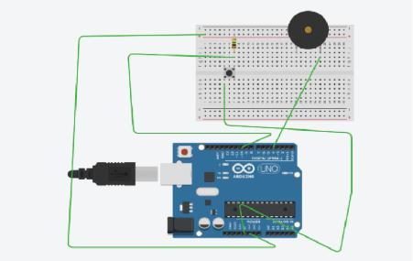

**THEORY:**

**CONCEPT USED- The concept of the following experiment is state as, when we press the switch the current will start flowing and it will flow through the path of less resistance and that will be the path through the ardiuno. And gives the input of high so it work as a informer that informs the time of on the buzzer.**

**LEARNING AND OBSERVATIONS-**

**We learn the concepts of switch that used with ardiuno and how to control the path of flow of current to get a proper input.**

**We learn how to code in ardiuno.**

**PROBLEMS AND TROUBLESHOOTING –**

**We do not precise the path of current it will directly go to the ground and never give a result high or 1 to the ardiuno for further process.**

**While during connections it is important to do all connection in a sequence manner otherwise for loop will not be used while during program.**

**PRECAUTIONS -**

**Wiring should be done properly,neatly.**

**Do not use excess wires try to reduce number of wires used.**

**Resistor of high resistance more than that of ardiuno should be used.**

**LEARNING OUTCOMES –**

**We learn to code and how to make circuit using ardiuno.**