# 7. High-level System Architecture

This subsection describes the system architecture and technology stack of fuldaflats.de. It contains the most important software components, frameworks, libraries and development tools that are used in the development process.

The overall architecture goal for fuldaflats.de is to create a multi-tier web application that uses a REST-Webservice and AJAX technology as main data exchange interfaces. We use a **Linux/Debian** virtual machine that is hosted on the **Microsoft Azure Cloud** as a server for our project.

The data-tier of the application is handled by a **MySQL Database** which can be administrated by the phpMyAdmin user interface.

The application / logic tier uses **Node.js 7.0[1]** as technology platform to enable **server-sided JavaScript** coding. Node.js itself is quite a bare software platform, but it can be extended through the package-manager **npm[2]**. Node.js modules that are mandatory for the fuldaflats.de project are **CaminteJS[3]** as an ORM library for database access and **Express[4]** to create RESTful web service endpoints and start a web server within node.js (Those two are comparable to JPA and JAX-RS in Java EE).

For the web client we use **jQuery[5]** as a standard library to enhance browser APIs, as well as <AngularJS version 2 as a framework for client-sided logic, two-way JavaScript databinding, client sided routing and event handling> <Rivets.js/KnockoutJS as library for two-way databinding and RESTful-JS as library to create AJAX-HTTP calls more confortably>. We also use **Twitter Bootstrap[6]** as a presentation framework (mainly for it’s CSS) for responsive web design.

The fuldaflats.de project uses **git[7]** as a source code management system, the code is hosted as a **private repository on** **GitHub[8]**. GitHub issues and milestones are also used for project management and team communication. We use **Visual Studio Code[9]** as development environment for web applications and node.js (which is not Visual Studio 2015, but rather just a free, enhanced text editor tool from Microsoft).

The final product will support and be tested on the following Browsers:

* **Google Chrome (Version 54.0)**
* **Mozilla Firefox (Version 42.0)**

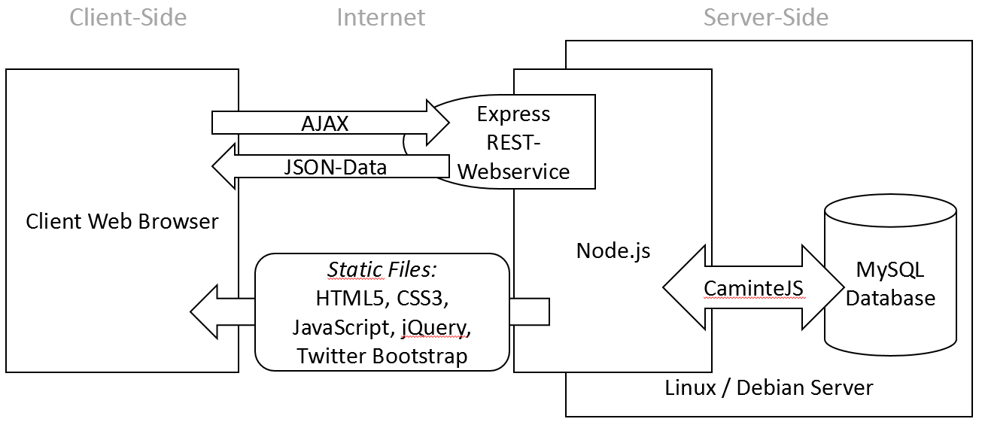

1. <https://nodejs.org>
2. <https://www.npmjs.com>
3. <http://www.camintejs.com>
4. <http://expressjs.com>
5. <https://jquery.com>
6. <http://getbootstrap.com>
7. <https://git-scm.com>
8. [https://github.com](https://github.com/)
9. <https://code.visualstudio.com>