

Master project HS Fulda Fall2016

**Single Project Specification**

**Group #1**

**22.12.16**

**Team:**

Michelle Rothenbücher

([michelle.rothenbuecher@informatik.hs-fulda.de](mailto:michelle.rothenbuecher@informatik.hs-fulda.de))

Jonas Kleinkauf

Patrick Hasenauer

Martin Herbener

Franz Weidmann

Plisam Ekpai-Laodema

~~Steffen Scholl~~

~~Ziad Benhachen~~

|  |  |
| --- | --- |
| Submission Version | Date |
| 1 | 22.12.2016 |

Fuldaflats.de - RoboFlatspection

Virtual Flat Inspection using a Raspberry Pi and a Robot Kit

1. **Executive Summary**

The goal of our single project is to create a virtual flat inspection functionality for fuldaflats.de. We plan to do this by using a Raspberry Pi Micro-Computer with a corresponding Robot Development Kit. Users will be able to receive a camera stream in their browsers from the robot, which is placed inside a flat to inspect it. Users can navigate the robot through the flat by pressing buttons in their browser or using their keyboards.

1. **Use Cases**

**Providing a RoboFlatspection system for an offer**

Howard is a computer science student at the Hochschule Fulda and found the fuldaflats.de web application on the internet. As he is currently looking for a new roommate, he created an offer on fuldaflats.de. He found the new RoboFlatspection functionality of fuldaflats.de and wants to use it to make his offer more attractive. Therefore, he assembles a camera robot, provides the documented interfaces, and adds the robots IP address to his offer for users to use it while it is active and available.

**Doing a virtual room tour with a robot**

Leonard is currently looking for a flat share as he starts to study at the Hochschule Fulda next semester. The last flat he visited was not as good as stated on the pictures of another flat website. He stumbled upon fuldaflats.de and is really excited about the new RoboFlatspection feature. He hopes, that this will prevent him from being disappointed again. So, he starts the RoboFlatspection stream of a flat share offer and navigates the robot through the flat which gives him a detailed insight already.

1. **Specifications**
2. A landlord should be able to link his robot to one of his offers, given it uses the documented interfaces for RoboFlatspection.
3. A landlord should be able to remove his robot from an offer, or set it as inactive during off-hours.
4. A visitor should be able to retrieve the robot’s camera stream on a web interface.
5. A visitor should be able to navigate the robot forwards and backwards, as well as driving curves with it through a web interface.
6. The RoboFlatspection functionality should be integrated in the main fuldaflats.de application. If an offer provides a robot, a corresponding link in the offer’s detail page should be viewed.
7. The robot should be linked to an offer and should refresh its IP-Address on the fuldaflats.de server after each boot process.
8. Only one user at a time can use the robot, it should activate a lock on the fuldaflats.de server when it is in use.
9. **System Architecture**

**Hardware**

***Raspberry Pi 3 Model B[1]***

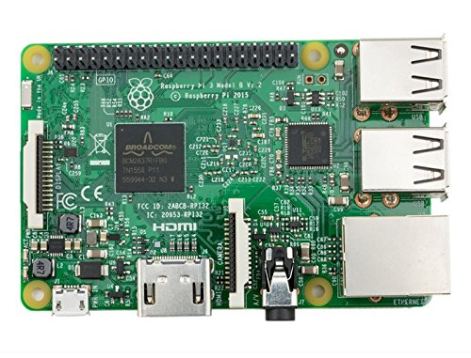

A Raspberry Pi is used as microcontroller for the robot. It is a single-chip microcomputer, which provides several hardware interfaces, mainly onboard Wi-Fi, 4 USB Ports, HDMI, Ethernet and 40 GPIO pins for electronical communication.

# *SunFounder Smart Video Car Kit[2]*

# https://images-eu.ssl-images-amazon.com/images/I/61V7vggElsL._SX522_.jpg

The SunFounder Smart Video Car Kit is a robot kit for the Raspberry Pi. It comes with a set of electric engines and circuit boards that allow developers to create wheeled robot, which can be controlled via the GPIO pins of a Raspberry Pi.

**Software**

Raspberry Pi’s usually run a special Linux distribution called Raspbian as operating systems. Raspbian comes with a Python library for accessing the Pi’s GPIO pins which will be used for this project. Next to the robot controls, the software system will also feature a websocket interface written in Python which will be used to communicate with the robot via a web interface. On the client side, websockets are a JavaScript standard in modern browsers. On the robot’s side, <http://autobahn.ws/> will be used as a python library to create websocket interfaces. The client sends controlling commands (“FORWARDS”, “BACKWARDS”, “LEFT”, “RIGHT”, etc..) via the websocket, the robot sends a constant webcam stream back to the client.

1. **Team**

|  |  |
| --- | --- |
| **Name** | **Initial Role** |
| Michelle Rothenbücher | Client interface communication, robot websocket interface |
| Jonas Kleinkauf | electronic assembly, OS setup, robot GPIO communication (navigation), application integration, client interface frontend |

1. <https://www.amazon.de/Raspberry-Pi-3-Model-B/dp/B01CEFWQFA/ref=sr_1_4?s=computers&ie=UTF8&qid=1482005622&sr=1-4&keywords=raspberry+pi+3>
2. <https://www.amazon.de/dp/B01ANIY3EC/ref=twister_B01LY7PJWB?_encoding=UTF8&th=1>