EasySXB v0.1.4 Manual

Copyright © 2016 Joe Davisson. All Rights Reserved.
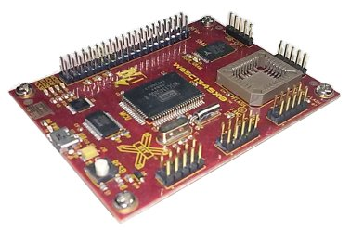

Introduction

EasySXB is a terminal emulator designed for use with Western Design Center's SXB line of development boards. In addition to supporting the PC serial interface, it provides easy access to features included in the monitor ROM. These include altering registers, starting programs, and uploading to RAM.

The following products are currently supported:
- W65C134SXB (6502-based)
- W65C265SXB (65816-based)

Command Line Options

The program may be started with the following options:

--theme=dark enable dark theme
--theme=light enable light theme (default)
--version show version information
--help show help options
Connecting

Note: On Windows, it's important to upgrade to the latest FTDI Virtual COM Port drivers from: http://www.ftdichip.com/

Upon attaching the board to a USB port, Windows will assign it a port name, like COM1. The port to use will show up in Device Manager. (On Linux, the port will have a name like /dev/ttyUSB0.)

Prior to connecting, select your product in Options/Board Model. Then choose File/Connect to SXB and connect using the port name assigned to the board by the operating system.

Upon connection, hit return. If you don't get a prompt, you'll need to press the reset button on the board.

Altering Registers

Pressing return after changing a field will update that register. Be sure to always press the Get button beforehand to retrieve the current register values. The lights for the status register flags may also be toggled, and doing so updates the status register on the board. Again, make sure to press Get first.

Uploading Programs

EasySXB supports uploading programs in Intel HEX and Motorola S19 and S28 formats. Simply choose the file you want and the terminal will begin to display a number for each line as it loads. (Large programs or data might take a long time.) Press the Escape key to cancel the operation.
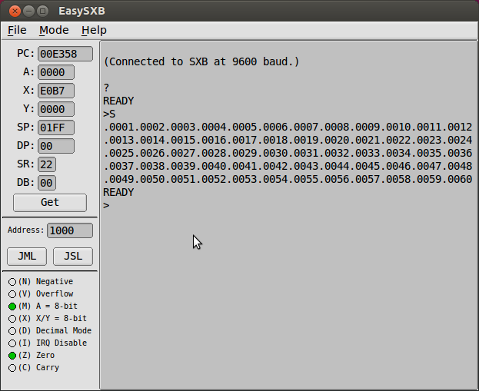

Running Programs

In the side panel, press JMP/JML to begin execution at the chosen address, or JSR/JSL to call a subroutine and return.

Going Further

While EasySXB provides a convenient interface, the built-in monitors are very user-friendly, and you may prefer to use them directly. Press H from the prompt to see the full list of options.

Also, the ROM contains many handy user-callable routines for character I/O, tone generators, and much more. Western Design Center publishes ROM manuals and assembly listings which are must-haves for anyone writing custom programs.

It's possible for a user program to change the baud rate. If this occurs, EasySXB won't know about it, and will still try to communicate at the default of 9600.

For those interested in higher-level language support, I'm working on a Java API for the java_grinder byte-code compiler, which will offer methods for input, printing text and numbers, I/O ports, and tone generation:

https://www.mikekohn.net/micro/java_grinder.php

EasySXB was written in C++ using the FLTK toolkit (http://www.fltk.org), and is licensed under the GPL. The source code and binaries for Windows and Linux are available here:

https://github.com/Mortis69/EasySXB
https://sourceforge.net/projects/easysxb/

(Special thanks to Michael Kohn for creating sample projects, which are available in the source distribution.)

