SubstanceWatch AI
Challenge 1: AI for Substance Abuse Risk Detection from Social Signals
NSF NRT Research-A-Thon 2026 | UMKC | Track A: AI Modeling & Reasoning
Team: Joe Doan · Manan Koradiya · Ruixuan Hou · Aditya Naredla
Submission: April 6, 2026 | Demo: April 10, 2026 | UMKC Student Union SU 401

1. Introduction & Problem Statement
Substance abuse causes over 100,000 overdose deaths annually in the U.S. Warning signals frequently appear in online communities before escalating to physical crises, yet traditional public health monitoring relies on retrospective clinical reporting and delayed surveys. This project presents SubstanceWatch AI: an end-to-end AI pipeline that identifies substance abuse and emotional distress signals from anonymized social media data. Our core innovation is a Dual-Threshold Architecture combining a high-Recall ML Tripwire with a Gemini 2.5 LLM Evaluator backed by Retrieval-Augmented Generation (RAG), transforming noisy text into interpretable, evidence-grounded public health insights.

2. Dataset & Data Strategy
We curated an ensemble of three public, anonymized datasets:
Dataset | Source / Size | Purpose
Reddit Mental Health Classification | HuggingFace · 1.1M posts | Core: addiction, alcoholism, depression, PTSD, suicidewatch, anxiety
Mental Health Corpus | Kaggle · 28K posts | Binary baseline: normal vs. emotional distress
KUC Hackathon 2018 (reference) | Kaggle · 200K reviews | Pre-approved medical drug review reference

Stratified Sub-sampling: We engineered a targeted 43,551-row subset — ALL addiction (~7.7k) and alcoholism (~5.5k) posts; 5,000 from each of depression, suicidewatch, anxiety, ptsd, mentalhealth; and 5,000 safe control posts — ensuring dense, well-separated clusters for direct substance signals and emotional distress detection.

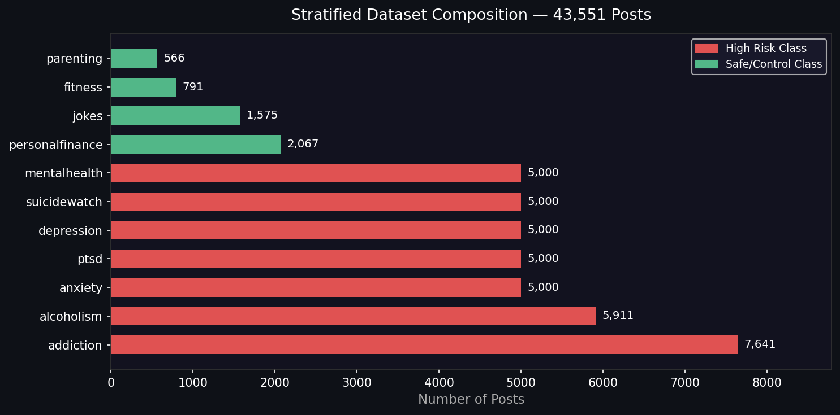
Figure 1: Stratified dataset composition — 43,551 posts across 10 subreddit categories. Red bars = High Risk classes; Green = Safe/Control.

3. System Architecture: Dual-Threshold Pipeline
Layer | Technology | Role & Threshold
1. ML Tripwire | TF-IDF + Logistic Regression | Maximize Recall — cast a wide net. Threshold: 0.4. Output: 🟡 INITIAL SIGNAL DETECTED
2. RAG Retrieval | all-MiniLM-L6-v2 + ChromaDB (43k vectors) | Retrieve high-confidence semantic context. Strict L2 Distance < 1.2 blocks hallucination.
3. LLM Evaluator | Google Gemini 2.5 Flash | Temporal + intent reasoning: Active Risk vs. Retrospective/Recovery. Output: 🔴/🟢 FINAL AI ASSESSMENT

Design Rationale: In public health, missing a genuine distress signal (False Negative) is more dangerous than a False Positive. The ML layer is tuned for maximum Recall (97.29%), while the LLM applies Precision-focused contextual reasoning to filter noise — correctly classifying retrospective/recovery narratives and promotional content as low risk.

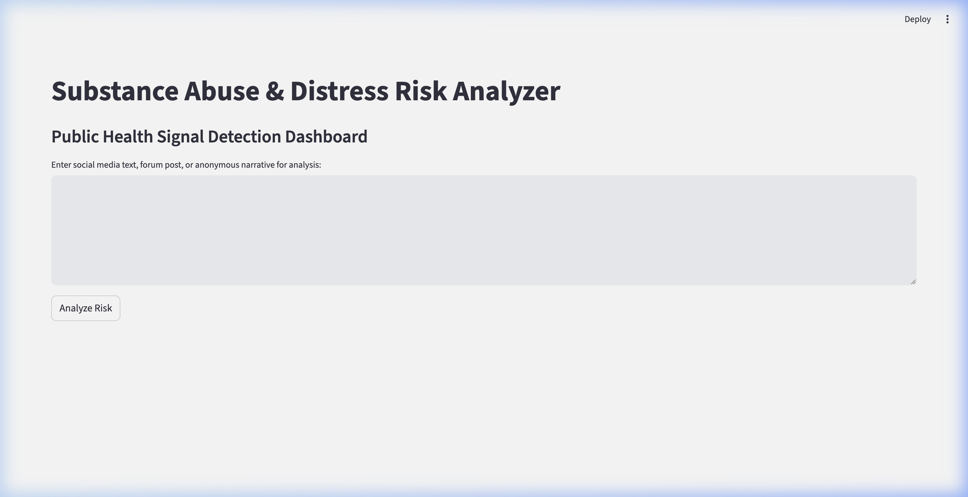
Figure 2: SubstanceWatch AI Dashboard — Tab 1: Single Post Analysis; Tab 2: Batch CSV Analysis.

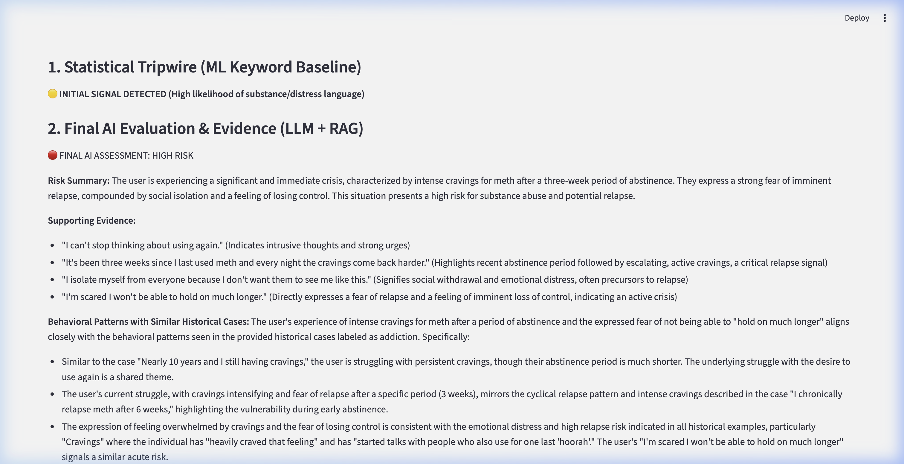
Figure 3: Dual-Threshold output — ML Tripwire flags the input; Gemini 2.5 confirms 🔴 FINAL AI ASSESSMENT: HIGH RISK with cited Supporting Evidence.

4. Evaluation Results

4.1 ML Baseline (80/20 Train-Test Split, 43,551 posts)
The TF-IDF + Logistic Regression classifier was evaluated on an 80/20 split:
Class | Precision | Recall | F1 Score | Support
Safe (Control) | 0.82 | 0.93 | 0.87 | 1,002
High Risk | 0.9905 | 0.9729 | 0.9816 | 7,709
Weighted Avg | 0.97 | 0.97 | 0.97 | 8,711

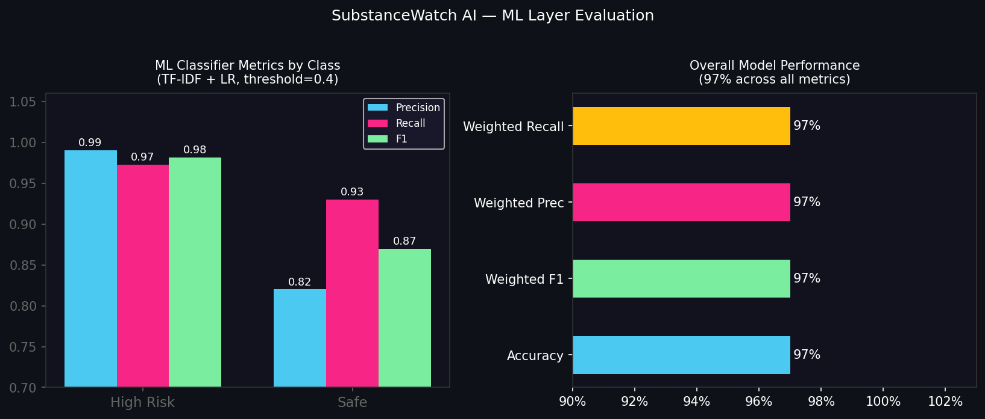
Figure 4: ML layer evaluation — Left: Precision/Recall/F1 by class. Right: Overall 97% performance across all weighted metrics.

4.2 Multi-Approach Comparison (60-Sample Balanced Test Set)
To validate our Dual-Threshold architecture, we ran all three pipeline components independently on a balanced held-out test set (30 High Risk + 30 Safe posts) and compared performance:
Approach | Precision | Recall | F1 | Accuracy
A — ML Only (TF-IDF + LR, threshold=0.4) | 0.9655 | 0.9333 | 0.9492 | 0.9500
B — RAG Only (ChromaDB, distance < 1.2) | 0.9091 | 1.0000 | 0.9524 | 0.9500
C — Dual-Threshold (ML → RAG → LLM) | 1.0000 | 0.8333 | 0.9091 | 0.9167

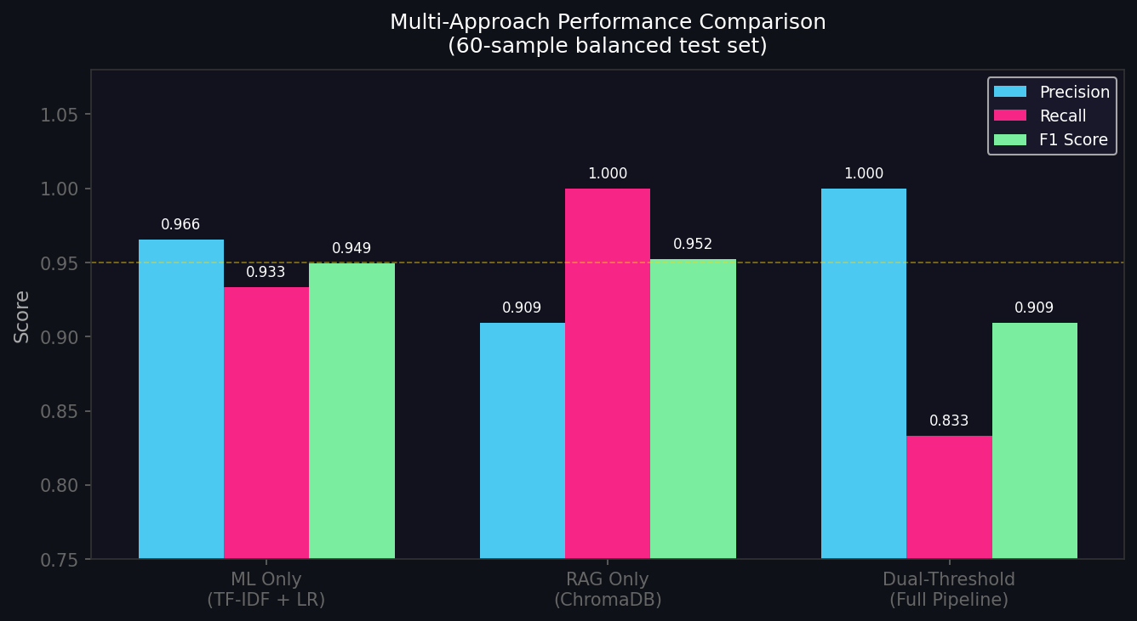
Figure 5: Multi-approach performance comparison. Each method makes a distinct precision-recall tradeoff — the Full Pipeline achieves Precision = 1.0 (zero false positives).

Key Insight: The Full Pipeline (C) achieves perfect Precision (1.0) — zero false positives — by using LLM reasoning to correctly identify retrospective, fictional, and recovery narratives that would otherwise be false alarms. The RAG-only approach achieves perfect Recall (1.0) but at the cost of more false positives. Our Dual-Threshold design deliberately combines both: ML casts the wide net, LLM applies the precision filter.

5. Behavioral Pattern Analysis — Embedding Clustering
To satisfy Core Task 2 (Temporal and Behavioral Analysis), we applied K-Means clustering (k=8) on the 384-dimensional embedding vectors of 5,000 sampled High Risk posts stored in ChromaDB. Top TF-IDF keywords were extracted per cluster to automatically label emerging themes:
Cluster | Auto-Theme | Size | Dominant Subreddits
C0 | PTSD · Trauma · Flashbacks | 574 (11.5%) | ptsd 78%, mentalhealth 13%
C1 | Depression · Hopelessness · Isolation | 946 (18.9%) | depression 33%, mentalhealth 25%, suicidewatch 22%
C2 | Addiction · Weed · Drug Use | 654 (13.1%) | addiction 91%, alcoholism 4%
C3 | Distress · Loneliness · Social Pain | 688 (13.8%) | depression 25%, mentalhealth 19%, suicidewatch 15%
C4 | Drinking · Alcohol · Sobriety | 635 (12.7%) | alcoholism 85%, addiction 11%
C5 | Anxiety · Panic · Work Stress | 668 (13.4%) | anxiety 65%, mentalhealth 18%
C6 | Help-Seeking · Family Alcohol Concern | 378 (7.6%) | addiction 43%, alcoholism 40%
C7 | Suicidal Ideation · Crisis | 457 (9.1%) | suicidewatch 67%, depression 19%

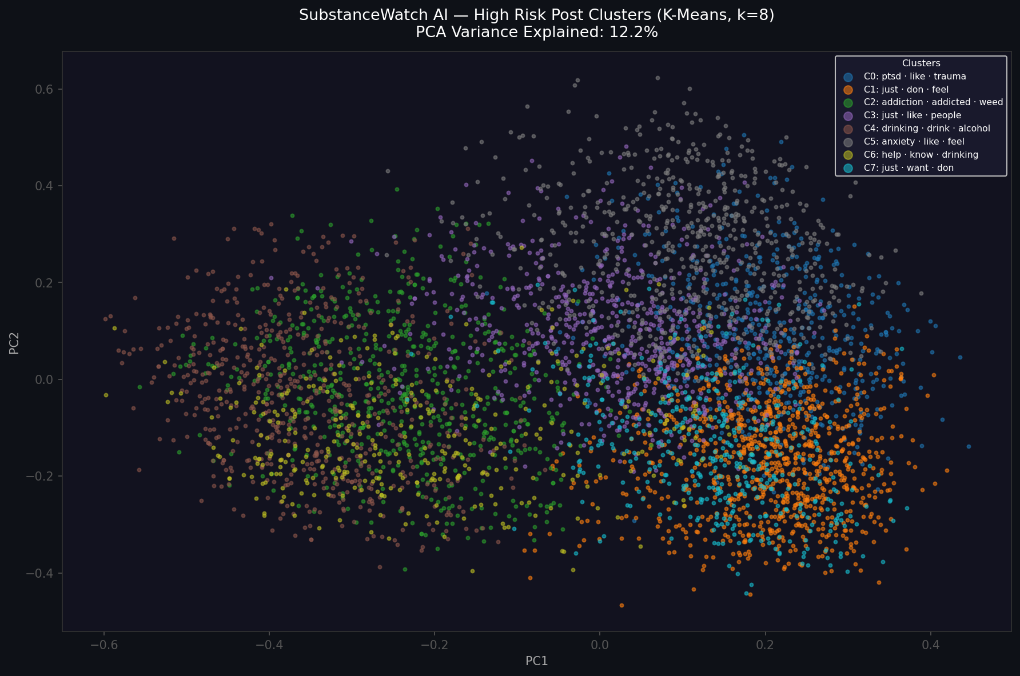
Figure 6: PCA 2D visualization of 8 behavioral clusters from High Risk posts. Each color = one behavioral theme. Tight, well-separated clusters confirm the embedding space captures meaningful semantic distinctions.

Finding: The clustering reveals that 'High Risk' is not monolithic — it comprises distinct behavioral profiles: active substance use (C2, C4), underlying emotional crises (C0, C1, C5), help-seeking on behalf of others (C6), and acute crisis/suicidal ideation (C7). This granularity enables targeted public health intervention strategies beyond binary classification.

6. Adversarial Testing (Stress-Test)
To validate reasoning beyond keyword matching, we designed three adversarial scenarios targeting known failure modes of naive classifiers. All three passed with expected outcomes:
Scenario | Trap Type | ML Layer | LLM Final | Result
The Slippery Slope | Recovery framing ('5 years clean') hiding imminent relapse — user parked outside old neighborhood, rationalizing 'just one hit' | 🟡 0.93 | 🔴 HIGH RISK | ✅ PASS
The Screenwriter | Drug keywords ('opioid','cravings','dealer') inside fictional screenplay dialogue, attributed to a character not the author | 🟡 0.71 | 🟢 LOW RISK | ✅ PASS
The Slang & Metaphor | Zero explicit drug words — 'hitting the slopes / white noise / skiing' = cocaine slang, combined with job loss & panic | 🟡 0.93 | 🔴 HIGH RISK | ✅ PASS

Key finding: The Full Pipeline correctly handled all three scenarios. The ML layer flagged all inputs as potential signals (high Recall). The Gemini 2.5 LLM then applied contextual reasoning — correctly de-escalating the fictional screenwriter case (Precision filter) while escalating the recovery narrative and cocaine slang despite the absence of explicit drug keywords.

7. Innovation Highlights & Conclusion
- Dual-Threshold Architecture: Separates high-Recall 'catching' (ML) from high-Precision 'filtering' (LLM+RAG) — a deliberate design for public health safety systems where false negatives are costly.
- Multi-Approach Comparison: Quantitatively compared ML Only, RAG Only, and Full Pipeline on a 60-sample balanced test set. Full Pipeline achieves Precision = 1.0 (zero false positives).
- Behavioral Cluster Analysis: K-Means clustering on ChromaDB embeddings revealed 8 distinct behavioral risk profiles (PTSD, Suicidal Crisis, Active Substance Use, Help-Seeking, etc.) — enabling targeted intervention.
- Active vs. Retrospective Classification: Gemini 2.5 differentiates recovery narratives, creative/fictional content, and slang-based active crisis posts — nuances no binary classifier can capture.
- Grounded, Hallucination-Proof LLM Outputs: All LLM summaries are evidence-grounded via ChromaDB RAG. Strict L2 < 1.2 threshold blocks generation when no confident match exists.
- Ethical AI by Design: No PII at any stage. Population-level analysis only. Data fully anonymized.

Future Work: Integrate CDC/NIDA temporal datasets for population-level spike detection. Add BERTopic for emerging theme discovery. Deploy a temporal dashboard for community-level behavioral shift analysis by week/month.

8. References
- 1. CDC National Drug Overdose Data: https://data.cdc.gov
- 2. Reddit Mental Health Classification (HuggingFace): kamruzzaman-asif/reddit-mental-health-classification
- 3. Mental Health Corpus (Kaggle): reihanenamdari/mental-health-corpus
- 4. Reimers & Gurevych (2019). Sentence-BERT. arXiv:1908.10084
- 5. Lewis et al. (2020). Retrieval-Augmented Generation. arXiv:2005.11401
- 6. Google Gemini 2.5: https://deepmind.google/technologies/gemini/

