Phase 3 Report
LexGuard: Neuro-Symbolic Compliance Auditor
for Contract Risk Analysis

CS 5542 — Big Data Analytics & Applications
University of Missouri–Kansas City
Spring 2026

Team Members:
Joe Doan • Manan Koradiya • Aditya Naredla • Ruixuan Hou

GitHub: https://github.com/JoeDoan/Lab9_BigData

What Changed in Phase 3
Phase 3 builds on the Phase 2 foundation with three major architectural and interface improvements, driven by evaluation results:

Key Changes
1. Extraction Pipeline: BERT → Full-Document LLM
We initially fine-tuned a BERT QA model (doandune/LexGuard-CUAD-BERT) on CUAD data for clause-level extraction. However, end-to-end evaluation revealed that BERT achieved only 53.8% accuracy with near-zero recall — it almost never detected clauses that actually exist. The root cause: BERT processes only small 512-token sentence windows, missing clauses that span multiple paragraphs. We replaced it with Gemini 2.5 Flash using full-document extraction (up to 200,000 characters in a single pass), which achieved 86.3% accuracy. See Section 3.3 for the full evaluation comparison.
2. Retrieval Strategy: Chunking + RAG → Direct Full-Document Input
We tested a hybrid retrieval pipeline (FAISS dense search + BM25 sparse search + cross-encoder reranking) to retrieve relevant chunks before passing them to the LLM. However, evaluation showed that chunking the documents led to fragmented context, causing the model to miss clauses split across chunk boundaries. Since Gemini 2.5 Flash supports a 1-million-token context window, we found that passing the entire document directly to the LLM without chunking produced significantly better extraction accuracy. The production pipeline now feeds the full contract text to Gemini for both the 12-clause risk audit and the 8-entity metadata extraction.
3. UI Enhancements: Chat History & Theme System
We implemented persistent chat history backed by Snowflake (CHAT_SESSIONS + CHAT_MESSAGES tables) with LLM-generated session titles, delete functionality, and session reload including expandable source annotations. We also added a dark/light theme toggle with full CSS variable support across all components.

1. Dataset & Knowledge Base Documentation

1.1 Dataset Overview
Dataset Name: Contract Understanding Atticus Dataset (CUAD) v1
Modality: Text (extracted from PDF legal contracts) and structured CSV annotations with 41 labeled clause categories.
Source: https://www.atticusprojectai.org/cuad — A publicly available, expert-labeled dataset of 510 real-world legal contracts curated by the Atticus Project, annotated by 27 law-student volunteers.
Domain Relevance: The CUAD dataset is directly aligned with LexGuard's mission of automated contract risk auditing. It contains ground-truth labels for 41 critical legal clauses—including Non-Compete, Uncapped Liability, Change of Control, and Indemnification—enabling both supervised fine-tuning and end-to-end pipeline evaluation against human expert judgments.

1.2 Multimodal Ingestion
The system supports two contract ingestion modalities:
- PDF Contracts: Parsed via PyMuPDF (fitz) for text extraction with page-level metadata preservation.
- Plain Text Documents (.txt): Ingested directly through the application's file upload interface.

1.3 Data Preprocessing & Sampling Strategy
The generate_dataset.py script handles data preparation for model fine-tuning:
- Filename matching: PDF filenames from the CUAD master CSV are matched to raw text documents using exact, case-insensitive, and prefix-based strategies.
- Context truncation: Documents are capped at 20,000 characters to fit within LLM context windows while preserving full clause coverage.
- Structured output generation: Annotations across 41 CUAD fields are restructured into JSON training examples (JSONL format) pairing document text with expected extraction outputs.
- Evaluation sampling: The evaluate_extraction.py script randomly samples .txt files from the data_test/ directory and processes them through the full extraction pipeline against ground-truth labels.

2. Retrieval & Processing Pipeline

2.1 Architecture Evolution
LexGuard's retrieval pipeline evolved through three phases based on evaluation results:
Phase 1 — BERT + Sentence Windows (Deprecated): We fine-tuned a BERT QA model on CUAD for clause-level extraction, processing contracts through small sentence windows. Evaluation showed 53.8% accuracy with near-zero recall. BERT's 512-token limit caused it to miss clauses spanning multiple paragraphs.
Phase 2 — Hybrid Search + Chunking (Evaluated, Not Used in Production): We implemented a hybrid retrieval pipeline in local_store.py with FAISS dense search + BM25 sparse search + cross-encoder reranking. Documents were chunked (page-based via ingest.py, or 1500-char windows with 200-char overlap via evaluate_hybrid.py) and indexed. While the retrieval infrastructure works, evaluation showed that chunking fragmented important clause context, reducing extraction accuracy compared to direct full-document input.
Phase 3 — Full-Document LLM Extraction (Production): The production pipeline passes the entire contract text directly to Gemini 2.5 Flash (up to 200,000 characters for risk clause scanning, up to 50,000 characters for general Q&A). This leverages Gemini's 1-million-token context window and eliminates the chunking fragmentation problem. This approach achieved 86.3% accuracy on the V4 entity extraction benchmark.

2.2 Hybrid Search Infrastructure (Available for RAG Queries)
While the primary extraction pipeline uses direct full-document LLM input, the hybrid search infrastructure remains available for Snowflake-based RAG queries via the retrieve_contract_clauses() tool in tools.py. The hybrid search combines three retrieval layers:
- Dense Retrieval: FAISS index (IndexFlatIP) over all-MiniLM-L6-v2 embeddings, returning top-K vectors by cosine similarity.
- Sparse Retrieval: BM25 (rank_bm25) for keyword-level relevance scoring, capturing exact term matches missed by dense embeddings.
- Cross-Encoder Reranking: Candidate chunks from both retrieval paths are aggregated and re-scored using cross-encoder/ms-marco-MiniLM-L-6-v2, selecting the most contextually relevant passages.

2.3 Models Used in Production
The production pipeline uses the following models:
Model | Role | Source
gemini-2.5-flash | Primary LLM for full-document extraction, risk auditing, and generation | Google GenAI API
all-MiniLM-L6-v2 | Dense embeddings for FAISS indexing (hybrid search fallback) | HuggingFace / SentenceTransformers
cross-encoder/ms-marco-MiniLM-L-6-v2 | Cross-encoder reranker (hybrid search fallback) | HuggingFace / SentenceTransformers

Deprecated Model: doandune/LexGuard-CUAD-BERT — A fine-tuned BERT QA model trained on CUAD data. Removed from the production pipeline due to 53.8% accuracy with near-zero recall. The code remains in tools.py for reference but is not called by the application (app.py).

2.4 Example Outputs
Risk Clause Audit (Full-Document LLM Scan):
When a user uploads a contract, app.py calls extract_risk_clauses_llm() which passes the entire document (up to 200K chars) to Gemini to scan for 12 critical clause types simultaneously:
{"Non-Compete": {
"detected": true,
"risk_level": "High",
"excerpt": "Employee shall not, during the Term and for a period of...",
"section": "Section 8.3"
},
"Governing Law": {
"detected": true,
"risk_level": "Low",
"excerpt": "This Agreement shall be governed by the laws of California...",
"section": "Section 15"
}}
Contract Metadata Brief (Full-Document LLM Extraction):
extract_contract_brief() extracts 8 key metadata entities from the full document in a single LLM pass:
{"Document Name": "Master Services Agreement", "Parties": "Acme Corp / Widget Inc",
"Agreement Date": "May 8, 2024", "Expiration Date": "December 31, 2026",
"Governing Law": "State of California"}

3. Application Integration

3.1 Streamlit Interface
LexGuard is deployed as a Streamlit web application (app.py, ~720 lines) featuring a premium dark theme with glassmorphism aesthetics. The interface includes:
- Sidebar: File uploader (PDF/TXT), dark/light theme toggle, pipeline selector, system status indicators (Gemini API, Snowflake DB), and persistent chat history with session management.
- Main Chat Area: A conversational interface where users interact with the LexGuard agent. Uploaded contracts are displayed in a split-pane layout alongside the chat.
- Risk Audit Dashboard: Upon document upload, the system automatically performs a 12-clause risk scan using full-document LLM extraction (Gemini 2.5 Flash), displaying results in a color-coded table (🔴 High / 🟡 Medium / 🟢 Low) with expandable source annotations citing the exact contract excerpt.
- Contract Brief: Automatic extraction of 8 key metadata entities (Document Name, Parties, Agreement Date, Effective Date, Expiration Date, Renewal Term, Notice to Terminate, Governing Law) presented in a structured table.

3.2 Phase 3 UI Enhancements
Dark/Light Theme Toggle: A toggle switch in the sidebar allows users to switch between dark and light themes. The theme system uses CSS variables applied across all components (chat bubbles, cards, input fields, tables, file uploaders) for a consistent experience in both modes.
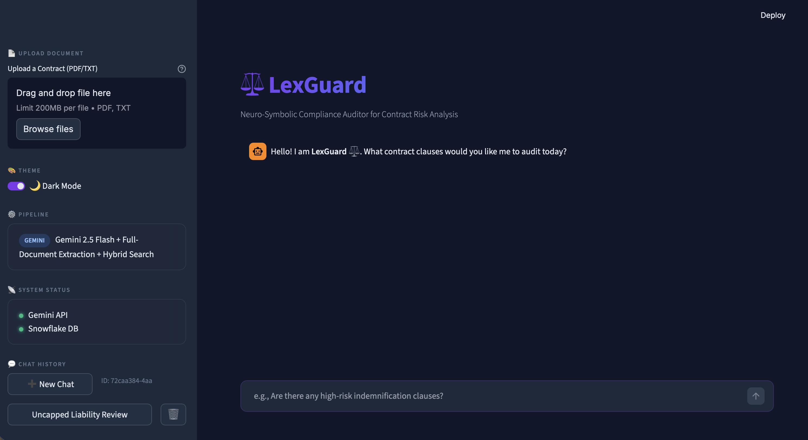
Figure 1 Theme: Dark mode

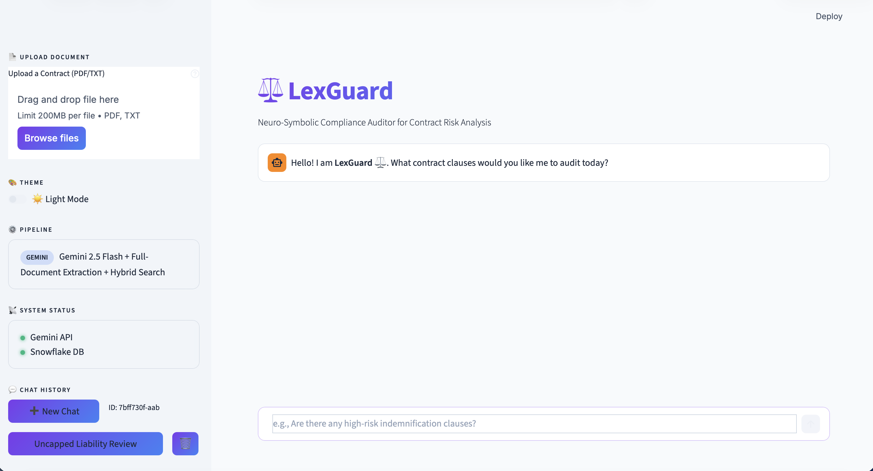
Figure 2 Theme: Light mode
Persistent Chat History: All conversations are automatically saved to Snowflake with the following features:
- LLM-generated session titles — Gemini 2.5 Flash generates a 3-6 word descriptive title from the first user message.
- Sidebar chat history panel with clickable session list for session switching.
- Delete buttons (🗑️) for removing individual sessions.
- New Chat button (➕) for starting fresh conversations.
- Full message restoration including role, content, risk level, and serialized annotation metadata (JSON) — expandable source citations are preserved across page reloads.
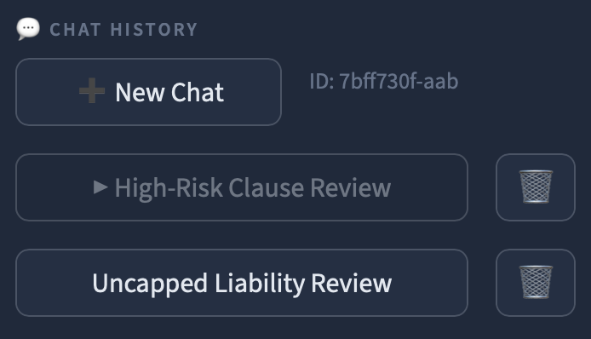
Figure 3 Chat history

3.3 Evidence Display & Grounded Generation
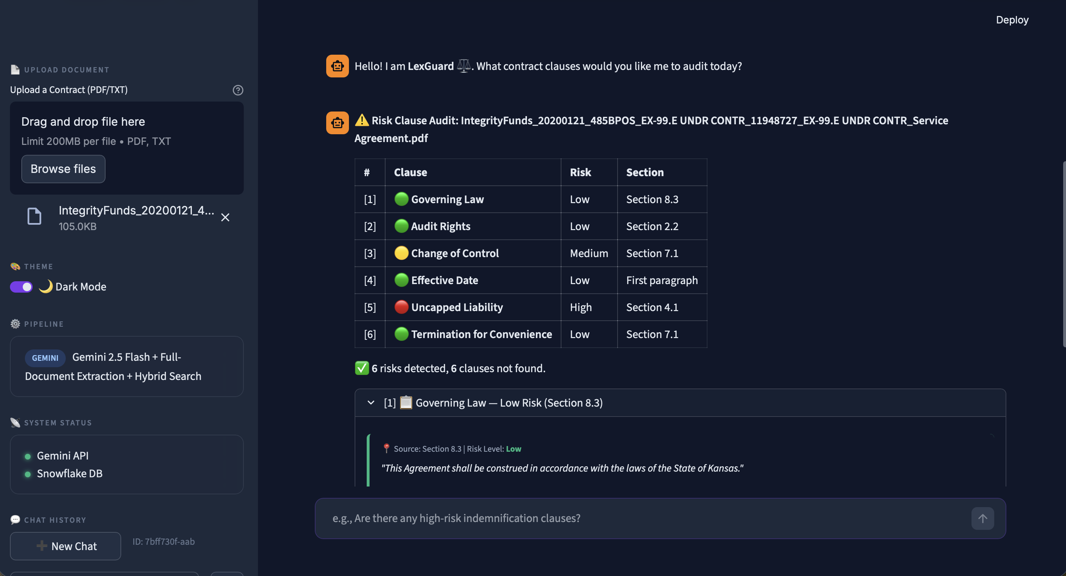
Figure 4.1 Expandable source annotations (1)
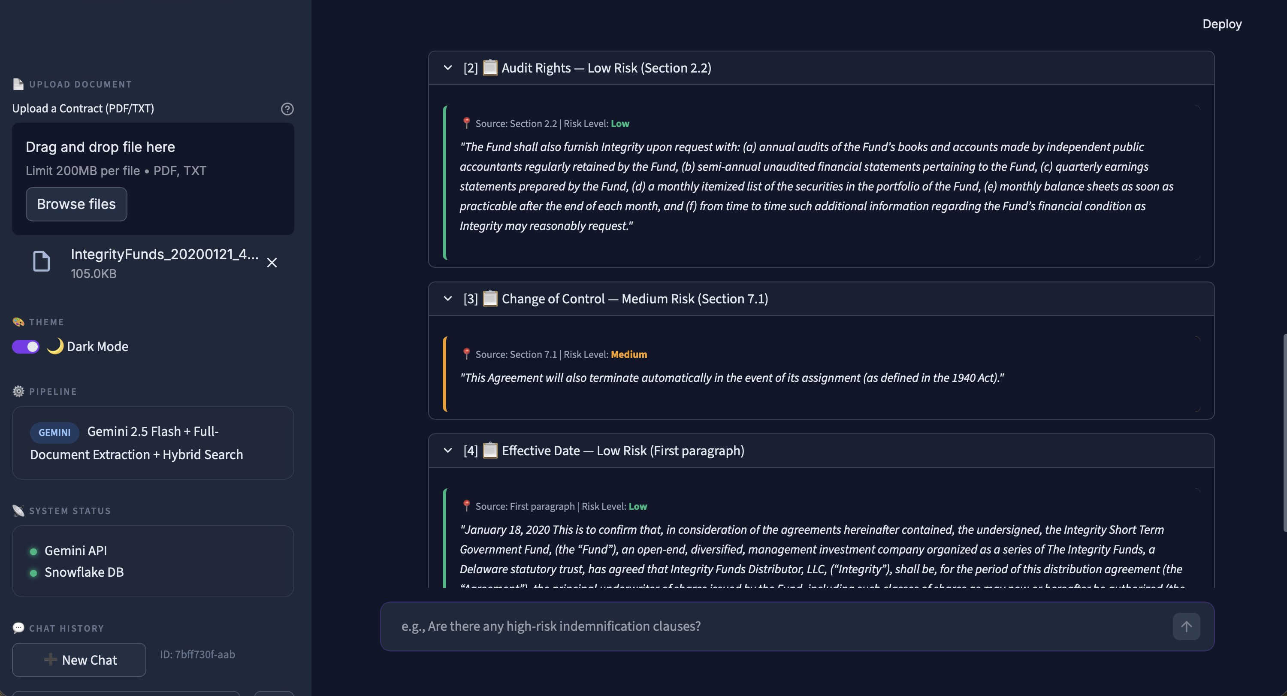
Figure 5 Expandable source annotations (2)
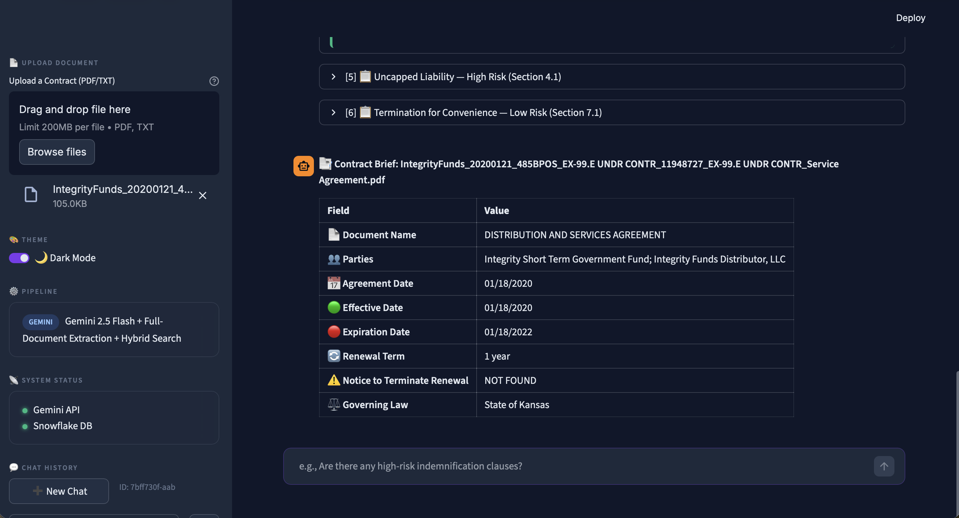
Figure 6 Expandable source annotations (3)
Every LLM response is grounded in retrieved evidence:
- Expandable source annotations ([1] 📋 clause_name — Risk Level) display the exact contract excerpt, section reference, and risk classification for each detected clause.
- Execution Trace panels (🔍 Debug Log) show the full step-by-step reasoning: Query → Intent Classification → Tool Calls → Retrieved Docs → Response, with per-step timing.

3.4 Evaluation Results & Model Comparison
A comprehensive end-to-end evaluation was conducted across three pipeline phases using 11 CUAD test contracts against expert-annotated ground truth (evaluate_e2e.py). The results directly drove the architectural decision to replace BERT with full-document LLM extraction.
BERT Risk Clause Detection — 53.8% Accuracy (Deprecated)
The fine-tuned BERT model was evaluated on 12 risk clause types. Key finding: BERT's accuracy was inflated by True Negatives (correctly saying "not found" when a clause is absent), while its recall — the ability to detect clauses that actually exist — was near zero.
Clause | Accuracy | Recall | TP | TN | FP | FN
Governing Law | 100% | N/A | 0 | 11 | 0 | 0
Source Code Escrow | 91% | 0% | 0 | 10 | 0 | 1
Liquidated Damages | 82% | 0% | 0 | 9 | 0 | 2
IP Ownership | 73% | 0% | 0 | 8 | 0 | 3
Termination for Conv. | 64% | 0% | 0 | 7 | 0 | 4
Non-Compete | 45% | 0% | 0 | 5 | 0 | 6
Uncapped Liability | 45% | 14% | 1 | 4 | 0 | 6
Change of Control | 45% | 0% | 0 | 5 | 0 | 6
Exclusivity | 36% | 0% | 0 | 4 | 0 | 7
Effective Date | 18% | 0% | 0 | 2 | 9 | 0
Cap on Liability | 18% | 0% | 0 | 2 | 0 | 9
Audit Rights | 27% | 0% | 0 | 3 | 0 | 8

Full-Document LLM Extraction — 86.3% Accuracy (Production)
Gemini 2.5 Flash with chain-of-thought prompting reads the entire contract in a single pass (up to 200K characters), eliminating the fragmentation issues inherent to BERT's sentence-window approach.
Entity | Accuracy | Detail
Document Name | 100.0% | 11/11
Governing Law | 100.0% | 11/11
Agreement Date | 90.9% | 10/11
Effective Date | 90.0% | 9/10
Parties | 81.8% | 9/11
Expiration Date | 77.8% | 7/9
Renewal Term | 77.8% | 7/9
Notice to Terminate | 66.7% | 4/6

Hybrid Search Retrieval Experiments
Five hybrid search configurations were benchmarked using evaluate_hybrid.py, comparing embedding models, top-K values, and query expansion strategies. While the retrieval infrastructure is functional, evaluation showed that chunking degraded extraction accuracy compared to direct full-document input, which led to the decision to use full-document LLM extraction in production.
Experiment | Embedding Model | Top-K | Query Expansion
Baseline | all-MiniLM-L6-v2 | 3 | No
Increased Top-K | all-MiniLM-L6-v2 | 10 | No
Query Expansion | all-MiniLM-L6-v2 | 3 | Yes
Advanced Model | BAAI/bge-small-en-v1.5 | 3 | No
Ultimate Combo | BAAI/bge-small-en-v1.5 | 10 | Yes

Summary: Model Comparison & Production Decision
Approach | Method | Accuracy | Recall | Verdict
BERT QA Model | Sentence-window extraction (512 tokens, fine-tuned on CUAD) | 53.8% | ~0% | ❌ Removed
Chunking + Hybrid Search | FAISS + BM25 + Reranker → LLM on chunks | Lower than full-doc | Fragmented | ⚠️ Available, not primary
Full-Doc LLM (V4) | Gemini 2.5 Flash, entire doc in one pass (200K chars) | 86.3% | High | ✅ Production

Root Cause Analysis: BERT's failure was structural — its 512-token window cannot capture clauses spanning multiple paragraphs. Chunking + retrieval also underperformed because important clause context was split across chunk boundaries. The full-document LLM approach solved both problems by reading the entire contract in a single pass, leveraging Gemini's 1M-token context window.

4. Snowflake Data Pipeline & Schema

4.1 Schema Design
Database: CS5542_DB
Schema: APP
The Snowflake warehouse hosts two primary table groups:
Chat History Tables (chat_history.py) — New in Phase 3
Table | Column | Type | Description
CHAT_SESSIONS | SESSION_ID | VARCHAR(64) PK | Unique session identifier (UUID)
 | TITLE | VARCHAR(500) | LLM-generated session title
 | CREATED_AT | TIMESTAMP_NTZ | Session creation timestamp
 | UPDATED_AT | TIMESTAMP_NTZ | Last activity timestamp
CHAT_MESSAGES | MESSAGE_ID | VARCHAR(64) PK | Unique message identifier (UUID)
 | SESSION_ID | VARCHAR(64) FK | References CHAT_SESSIONS
 | ROLE | VARCHAR(20) | user / assistant
 | CONTENT | VARCHAR(16M) | Full message text
 | RISK_LEVEL | VARCHAR(20) | High / Medium / Low / N/A
 | METADATA | VARCHAR(16M) | Serialized JSON (annotations, excerpts)
 | CREATED_AT | TIMESTAMP_NTZ | Message timestamp

Contract Retrieval Logs (ingest.py / legacy)
Table | Column | Type | Description
CHAT_HISTORY | id | STRING (UUID) | Unique interaction ID
 | session_id | STRING | Session identifier
 | document_name | STRING | Uploaded contract filename
 | query | STRING | User query text
 | answer | STRING | LLM response text
 | retrieved_chunks | VARIANT | JSON metadata of retrieved chunks
 | created_at | TIMESTAMP_NTZ | Interaction timestamp

4.2 Reproducible Ingestion Scripts
Table creation is automated via Python (chat_history.init_tables()) with CREATE TABLE IF NOT EXISTS statements. The system auto-provisions all required tables on first startup. Snowflake connections are managed through environment variables (SNOW_USER, SNOW_PASS, SNOW_ACCOUNT, SNOW_ROLE, SNOW_WH, SNOW_DB, SNOW_SCHEMA).

4.3 Example Queries
-- Insert a chat message with annotation metadata
INSERT INTO CHAT_MESSAGES (MESSAGE_ID, SESSION_ID, ROLE, CONTENT, RISK_LEVEL, METADATA)
VALUES ('uuid-123', 'session-456', 'assistant', 'Risk audit complete...', 'High',
'[{"clause_name":"Non-Compete","info":{"risk_level":"High"},"ref_num":1}]');
-- Retrieve recent sessions
SELECT SESSION_ID, TITLE, UPDATED_AT FROM CHAT_SESSIONS
ORDER BY UPDATED_AT DESC LIMIT 10;
-- Load session messages with annotations for UI restoration
SELECT ROLE, CONTENT, RISK_LEVEL, METADATA FROM CHAT_MESSAGES
WHERE SESSION_ID = 'session-456' ORDER BY CREATED_AT ASC;

4.4 Integration with Application
Snowflake serves as the persistent memory layer for the LexGuard application. Every user interaction triggers automatic background commits:
- Session management: MERGE-based upserts create or update sessions on each message.
- Message persistence: All user and assistant messages (including file-upload analysis results) are saved with risk levels and serialized annotation metadata for full restore on session reload.
- Chat history retrieval: The sidebar queries Snowflake for the 10 most recent sessions, enabling session switching across page reloads and browser restarts.

5. Reproducibility Plan

5.1 Environment Configuration
Dependencies are managed via requirements.txt. To reproduce:
python3 -m venv .venv
source .venv/bin/activate
pip install -r requirements.txt

5.2 Required Dependencies
Package | Version | Purpose
streamlit | ≥1.30.0 | Web application framework
google-genai | ≥1.0.0 | Gemini 2.5 Flash API client
snowflake-connector-python | ≥3.6.0 | Snowflake warehouse connectivity
sentence-transformers | ≥2.2.2 | Dense embeddings & cross-encoder reranker
rank_bm25 | ≥0.2.2 | BM25 sparse retrieval
PyMuPDF | ≥1.23.0 | PDF text extraction
python-dotenv | ≥1.0.0 | Environment variable management
pandas | ≥2.0.0 | Data manipulation
numpy | ≥1.24.0 | Numerical computation

5.3 Model Versions & Dataset Versioning
- LLM API: gemini-2.5-flash via Google GenAI API (version managed by Google). This is the primary model for all extraction.
- Embedding model: all-MiniLM-L6-v2 — auto-downloaded from HuggingFace on first run; used for hybrid search fallback.
- Reranker: cross-encoder/ms-marco-MiniLM-L-6-v2 — auto-downloaded from HuggingFace; used for hybrid search fallback.
- Dataset: CUAD v1 — version-locked via the Atticus Project distribution.
- Deprecated: doandune/LexGuard-CUAD-BERT (HuggingFace Hub) — removed from production due to low recall (see Section 3.4).

5.4 Configuration Files
A .env.example template is provided with all required API keys and credentials:
GEMINI_API_KEY=your_key_here
SNOW_USER=your_snowflake_user
SNOW_PASS=your_snowflake_password
SNOW_ACCOUNT=your_snowflake_account
SNOW_ROLE=your_role
SNOW_WH=your_warehouse
SNOW_DB=CS5542_DB
SNOW_SCHEMA=APP

5.5 Random Seeds
Deterministic seeding is managed centrally via config.py, which seeds Python's random, NumPy, and hash functions on import. The LocalStore uses seeded UUIDs for byte-identical chunk IDs across runs.

5.6 Run Instructions
- 1. Clone the repository and create a virtual environment
- 2. Install dependencies: pip install -r requirements.txt
- 3. Copy .env.example to .env and fill in API keys
- 4. Start the application: streamlit run app.py
- 5. Run evaluation: python evaluate_extraction.py
- 6. Docker deployment: docker build -t lexguard . && docker run -p 8501:8501 --env-file .env lexguard

6. GitHub Repository Structure
Lab9_BigData/
├── app.py # Streamlit application (720+ lines)
├── agent.py # Gemini multi-agent reasoning engine
├── adapted_agent.py # Adapted pipeline (Llama-3 QLoRA PEFT)
├── tools.py # LLM extraction + hybrid search tools
├── local_store.py # HyperGraphRAG-inspired local storage
├── chat_history.py # Snowflake chat persistence layer [NEW]
├── config.py # Deterministic seeding & configuration
├── monitor.py # QueryMetrics & analytics module
├── lexguard_logger.py # Structured logging
├── ingest.py # Document ingestion pipeline
├── generate_dataset.py # CUAD → JSONL training data generator
├── evaluate_extraction.py # Full-document extraction benchmark
├── evaluate_e2e.py # End-to-end evaluation pipeline
├── evaluate_hybrid.py # Hybrid retrieval evaluation
├── evaluate_llm_grader.py # LLM-as-a-judge semantic grading
├── requirements.txt # Pinned Python dependencies
├── Dockerfile # Docker deployment configuration
├── .env.example # Environment variable template
├── .streamlit/config.toml # Streamlit theme configuration
├── CONTRIBUTION.md # Team contribution summary
├── CONTRIBUTION_*.md # Individual contribution reports
├── LAB9_REPORT.md # Lab 9 development report
├── README.md # Setup and architecture overview
├── data_test/ # Test contract documents
├── notebooks/ # Training & experimentation notebooks
│ ├── phase_2.ipynb
│ ├── phase_3.ipynb
│ └── phase_4.ipynb
├── project_data_store/ # Local vector store data
└── tests/ # Unit & integration tests

7. Pipeline Architecture
The following diagram shows LexGuard's production data flow. The primary extraction path (bold) passes the full document directly to Gemini. The hybrid search path (dashed) is available as a fallback for Snowflake-based RAG queries.
┌───────────────────────────────────────────────────────────────────────┐
│ USER INTERFACE (Streamlit) │
│ ┌─────────────┐ ┌──────────────┐ ┌─────────────┐ ┌───────────┐ │
│ │ PDF/TXT │ │ Chat Input │ │ Risk Audit │ │ Chat │ │
│ │ Uploader │ │ (Queries) │ │ Dashboard │ │ History │ │
│ └──────┬──────┘ └──────┬───────┘ └──────┬──────┘ └─────┬─────┘ │
└─────────┼────────────────┼─────────────────┼────────────────┼────────┘
│ │ │ │
▼ ▼ │ ▼
┌──────────────┐ ┌─────────────────┐ │ ┌──────────────────┐
│ PyMuPDF │ │ Intent Router │ │ │ Snowflake │
│ Text Extract │ │ (Gemini Agent) │ │ │ CHAT_SESSIONS │
│ (Full Doc) │ │ │ │ │ CHAT_MESSAGES │
└──────┬───────┘ └────────┬────────┘ │ └──────────────────┘
│ │ │
│ ┌──────────────┤ │
│ │ │ │
▼ ▼ ▼ │
┌──────────────────┐ ┌─────────────────┐ │
│ PRIMARY PATH │ │ FALLBACK PATH │ │
│ ════════════ │ │ (Hybrid Search) │ │
│ │ │ ┌────────────┐ │ │
│ Full Document │ │ │ FAISS │ │ │
│ → Gemini 2.5 │ │ │ (Dense) │ │ │
│ Flash │ │ ├────────────┤ │ │
│ │ │ │ BM25 │ │ │
│ • Risk Audit │ │ │ (Sparse) │ │ │
│ (200K chars) │ │ ├────────────┤ │ │
│ • Metadata Brief │ │ │ Reranker │ │ │
│ • General Q&A │ │ │ (Cross- │ │ │
│ (50K chars) │ │ │ Encoder) │ │ │
│ │ │ └────────────┘ │ │
└────────┬─────────┘ └────────┬────────┘ │
│ │ │
└─────────┬───────────┘ │
▼ │
┌─────────────────┐ │
│ Gemini 2.5 │ │
│ Flash Response │◄────────────────┘
│ + Annotations │
└─────────────────┘

8. Individual Contribution Statement
Contributions reflect cumulative technical work across Labs 1–9, validated by commit history and implementation evidence.
Member | Role | Key Contributions | %
Joe Doan | Data Pipeline & Adaptation Lead | generate_dataset.py, adapted_agent.py pipeline, agent.py execution traces, evaluate_extraction.py (V2 full-doc), evaluate_e2e.py (unified benchmark), chat_history.py (Snowflake persistence), app.py UI enhancements (dark/light theme, sidebar, chat history), LAB9_REPORT.md | 30%
Manan Koradiya | Agent Architect & Integrator | app.py complete UI redesign (glassmorphism CSS, chat interface), RAG fallback enhancement in tools.py, end-to-end system integration, reasoning panels and query history sidebar | 25%
Aditya Naredla | Storage & Evaluation Engineer | Domain task definition, Llama-3 model selection, LexGuard_PEFT_Training.ipynb (QLoRA fine-tuning), HuggingFace Hub adapter upload, monitor.py module, live analytics dashboard | 25%
Ruixuan Hou | Reproducibility Lead | requirements.txt, Dockerfile, .streamlit/config.toml, reproduce.sh, REPRO_AUDIT.md non-determinism documentation, RUN.md setup instructions, system status panel | 20%

Total: 100%
Individual contribution reports are available as CONTRIBUTION_Joe.md, CONTRIBUTION_Manan.md, CONTRIBUTION_Aditya.md, and CONTRIBUTION_Ruixuan.md in the repository root.

