The readMe or user's manual for Animation Resit

For SS1:

1、Pess Terrain button to create the Terrain

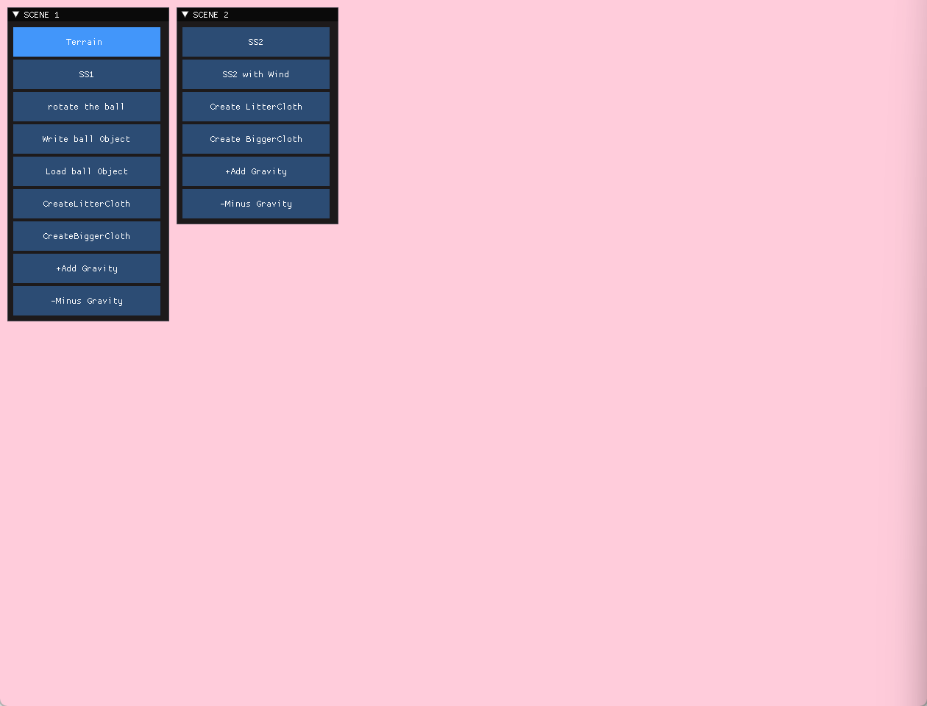

2、Press SS1 to Show the SCENE SS1

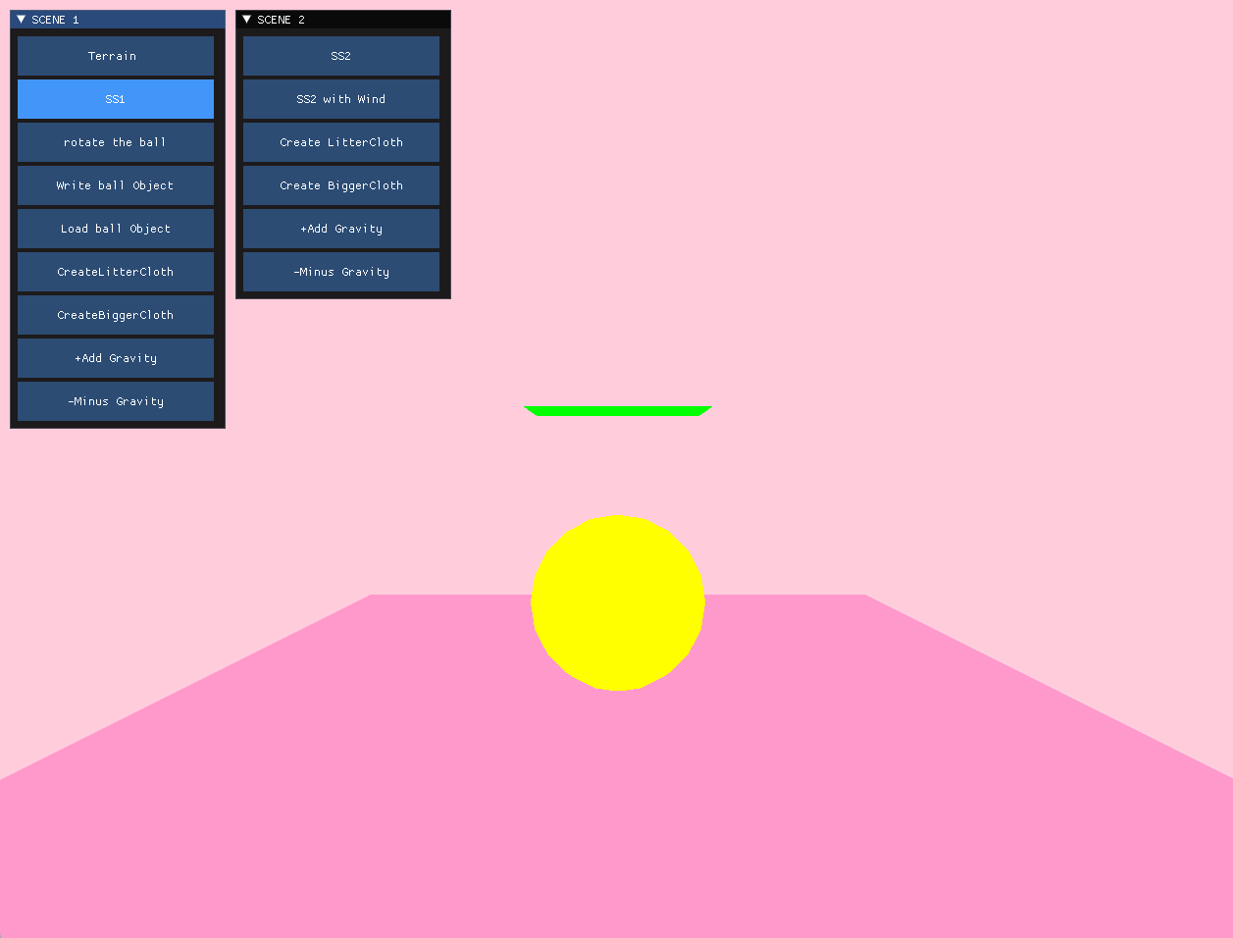

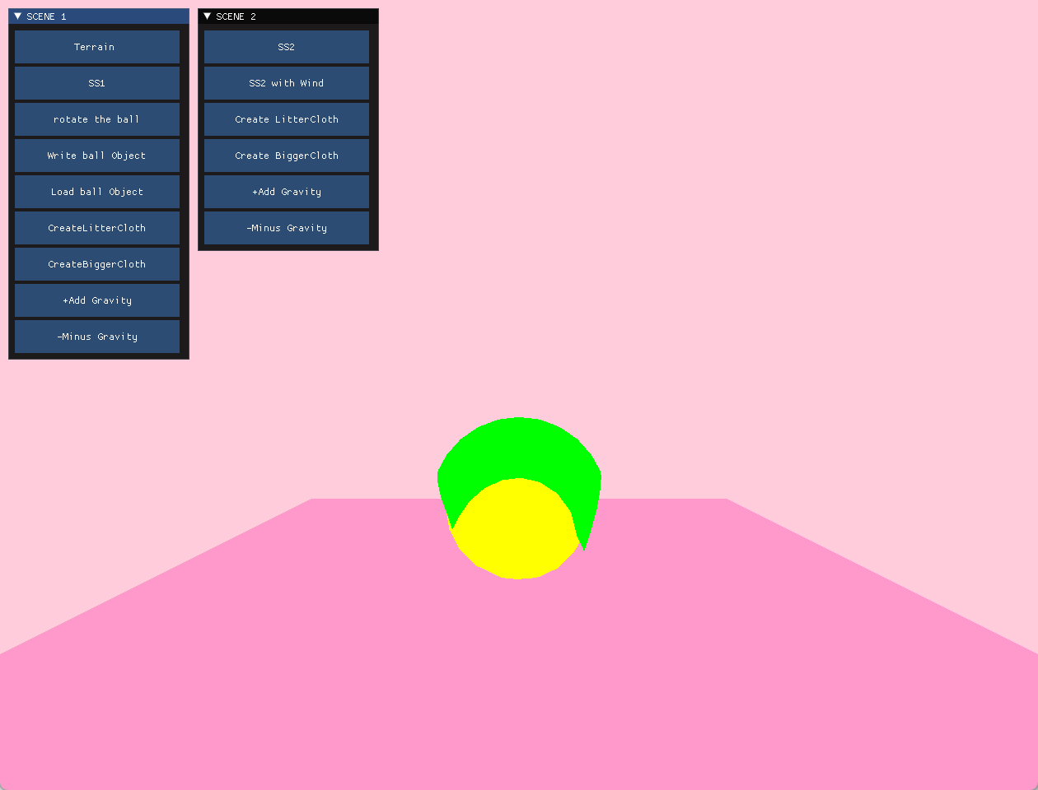

3、Prees the Rotate Button to Show SS1 with Rotation

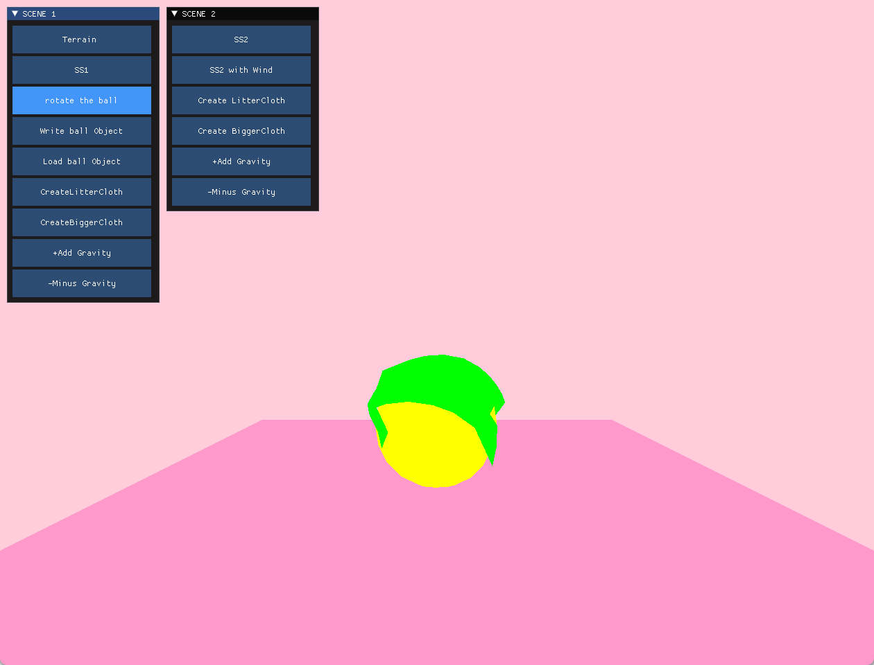

4、We could Refresh The Cloth with this button

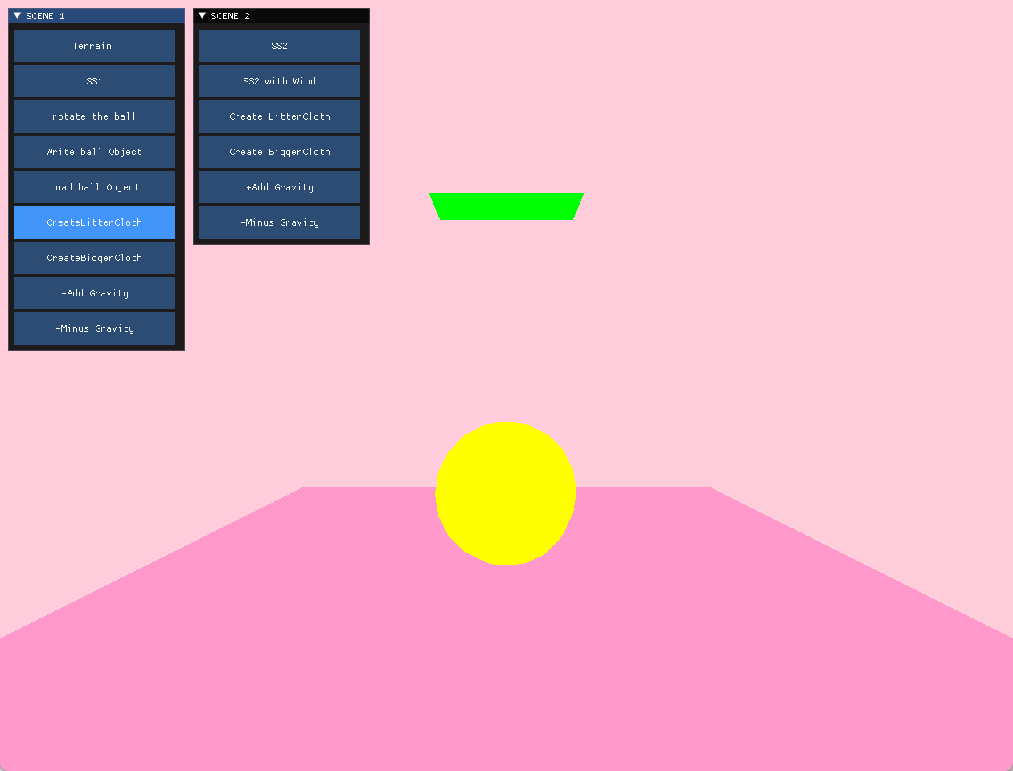

5、To accelerate or slow down we can use these two buttons

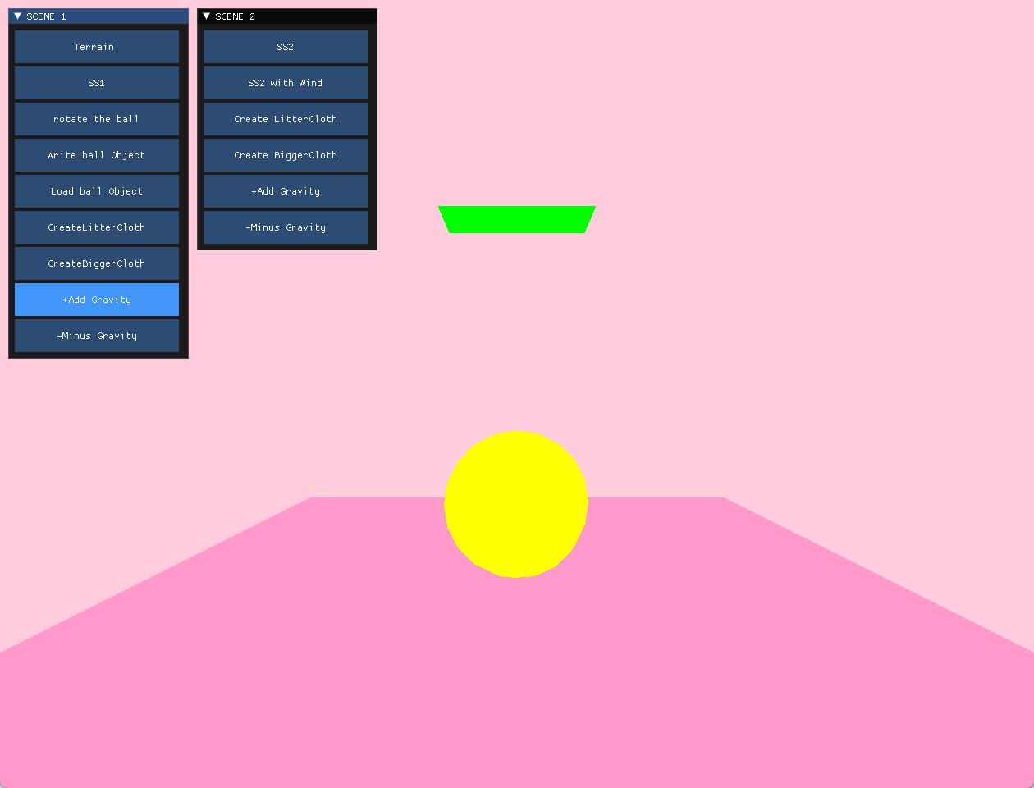

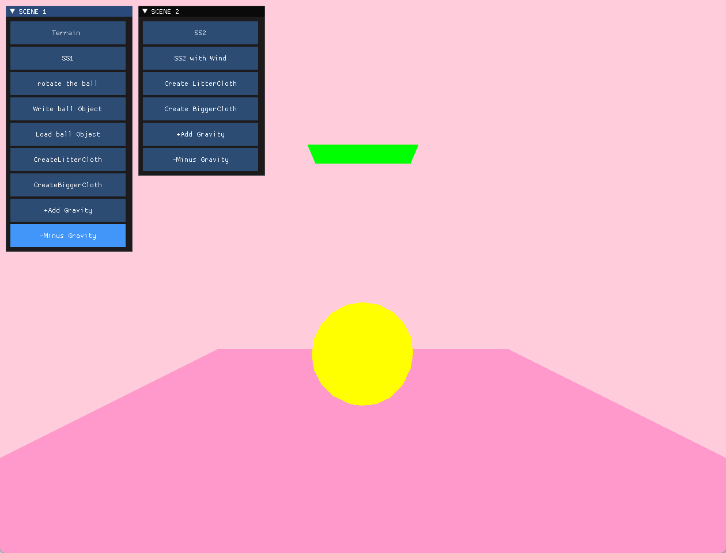

6、You could write the balloutput obj and load it in the scene

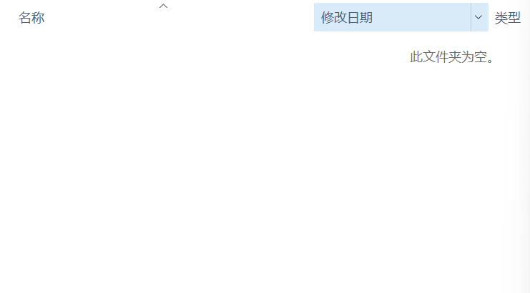

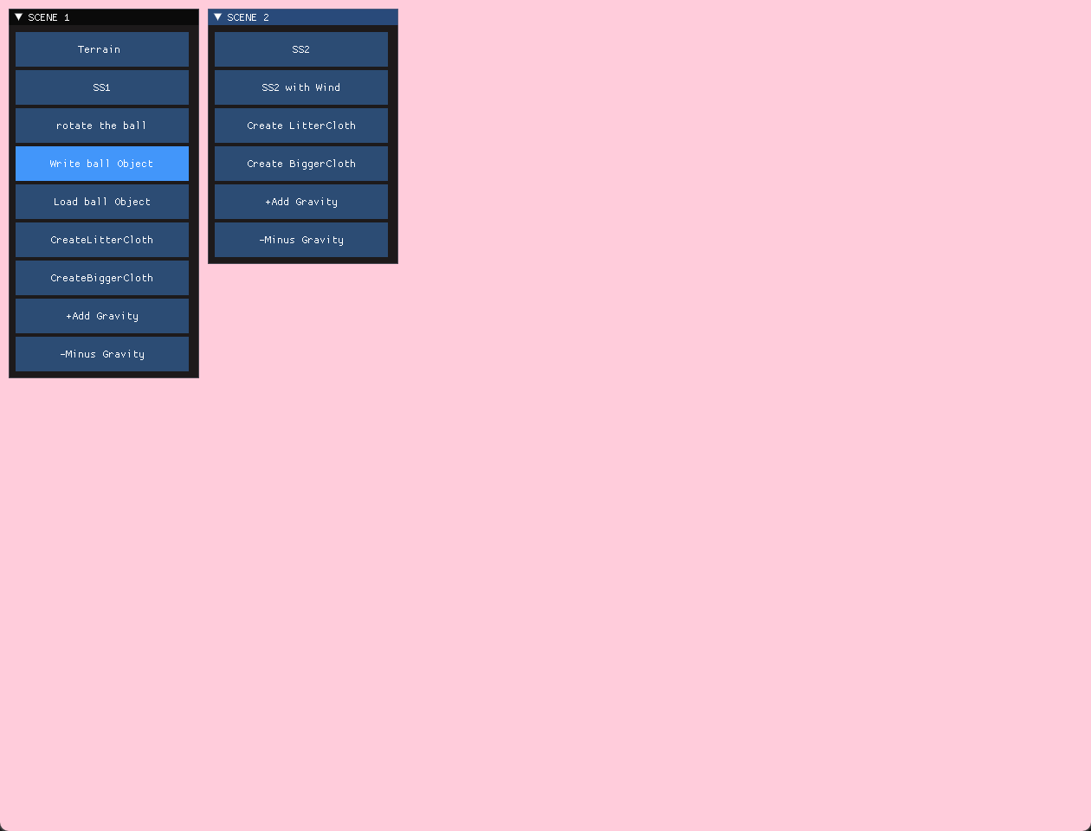

Then there will be one obj output



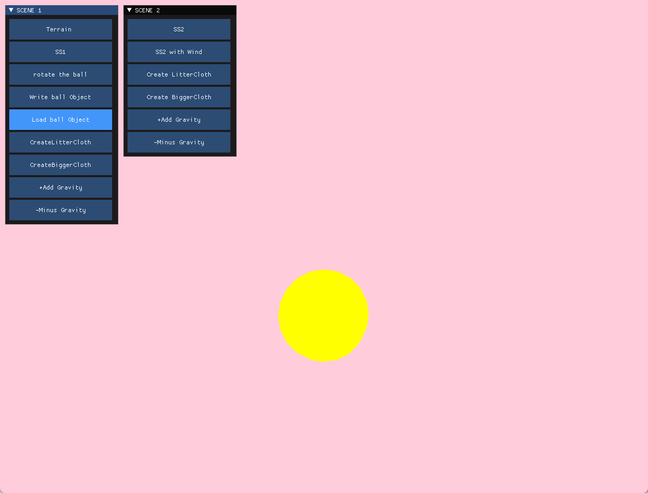

For SS2:

1、Press the SS2 to start it

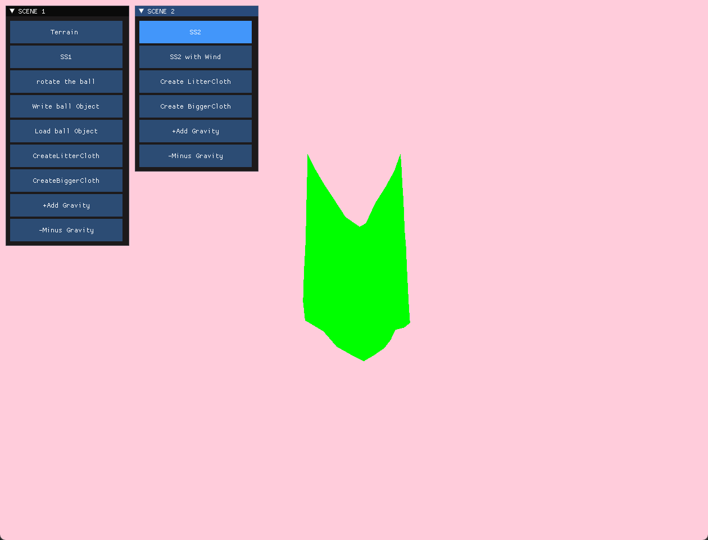2、Press the SS2 with wind to show the scene with wind(Mine is left one)

