## Warthog

## Weasel

## Iguana

## Owl

## Penguin

## porcupine

Zebra

## Moose

## Mouse

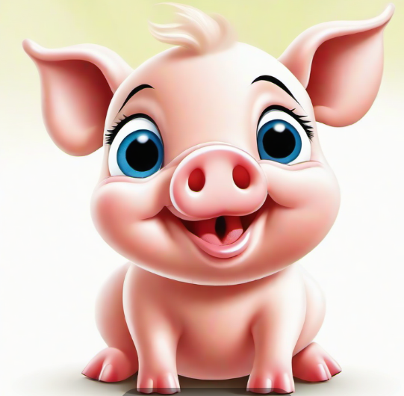

Fawn of Deer

## Horse or Pony

