Joe Florio
December 02, 2019
Kaggle Titanic Competition

Purpose

The purpose of this competition is to use the historical Titanic ship wreck data set to produce a model that will accurately predict if new passengers would survive the Titanic. This challenge is designed to help establish a basic comprehension of machine learning.

Method

In this challenge the outcome, survived or died, is a binary decision, so a logistic regression model was chosen. Logistic regression is primarily used in data analysis when the outcome is a binary decision where the model will represent probabilities between the two decisions. This model was created by iteratively using a backwards elimination analysis until all variables in the model were significant. The model was trained using the training data set and then the model predicted the outcome of the passengers in the test data set.

Extract Transfer Load (ETL)

The first step of the data analysis was to clean the data, which is done through ETL. The original csv file was run though Microsoft SSDT into a SQL database with the use of conditional statements. These statements checked for delimiter or quotation errors that would develop left or right shifts in the rows of data. After this, rows were removed that would have a value of null for one of the columns. An example would be if the age was left blank for a passenger then the passenger would be removed from the data set. This resulted in 178 rows, passengers, being removed from the data set before the model was developed.

Model

The clean data was exported to a csv file and uploaded into Gretl. Gretl is the software that was used to develop the logistic regression model over the data set. Backwards elimination was then used to eliminate variables that did not significantly contribute to the outcome of the model. These variables were eliminated one at a time to see how the coefficients of other variables would change from each iteration. The p value of each coefficient was used to determine the significance level of the variable. An alpha value of 0.05 was used as a threshold and any p value greater than the alpha value would be eliminated. The final model was determined to only be effected by a passenger's class, age, gender, and the amount of siblings they had. The results of each iteration is shown below.
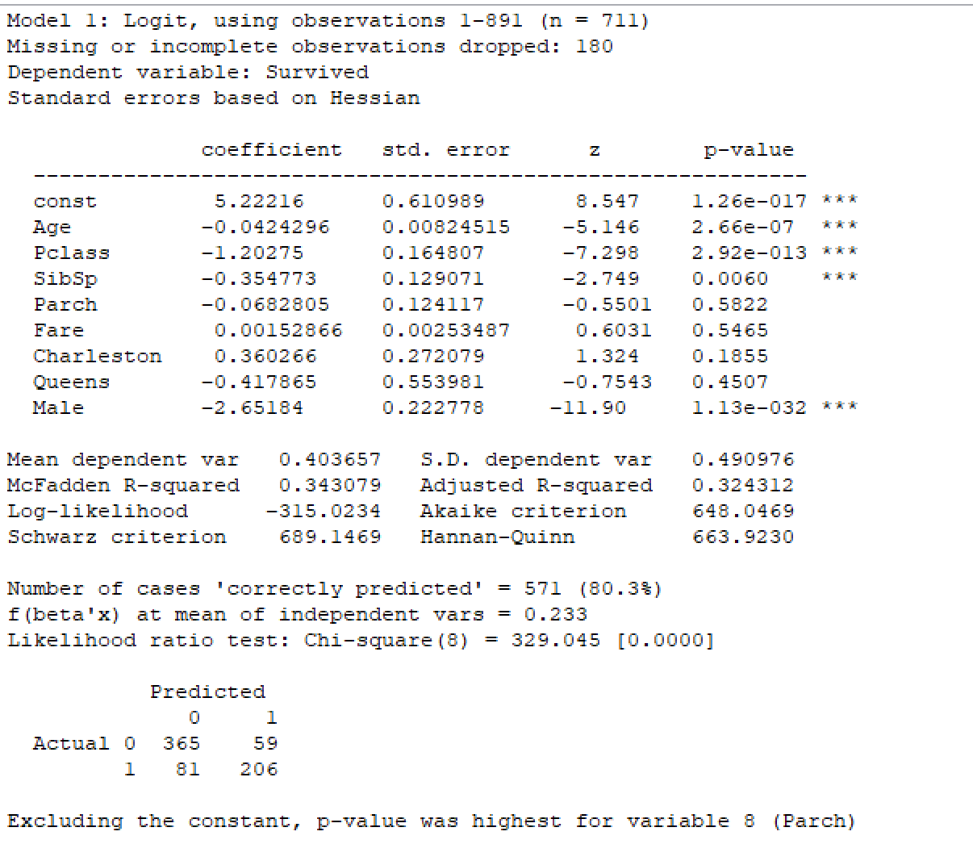
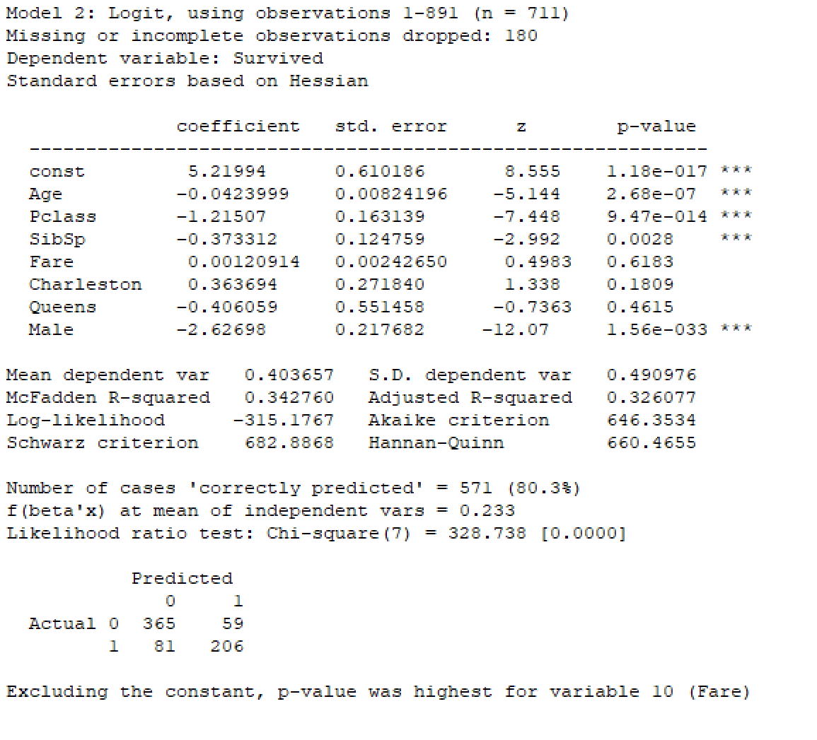
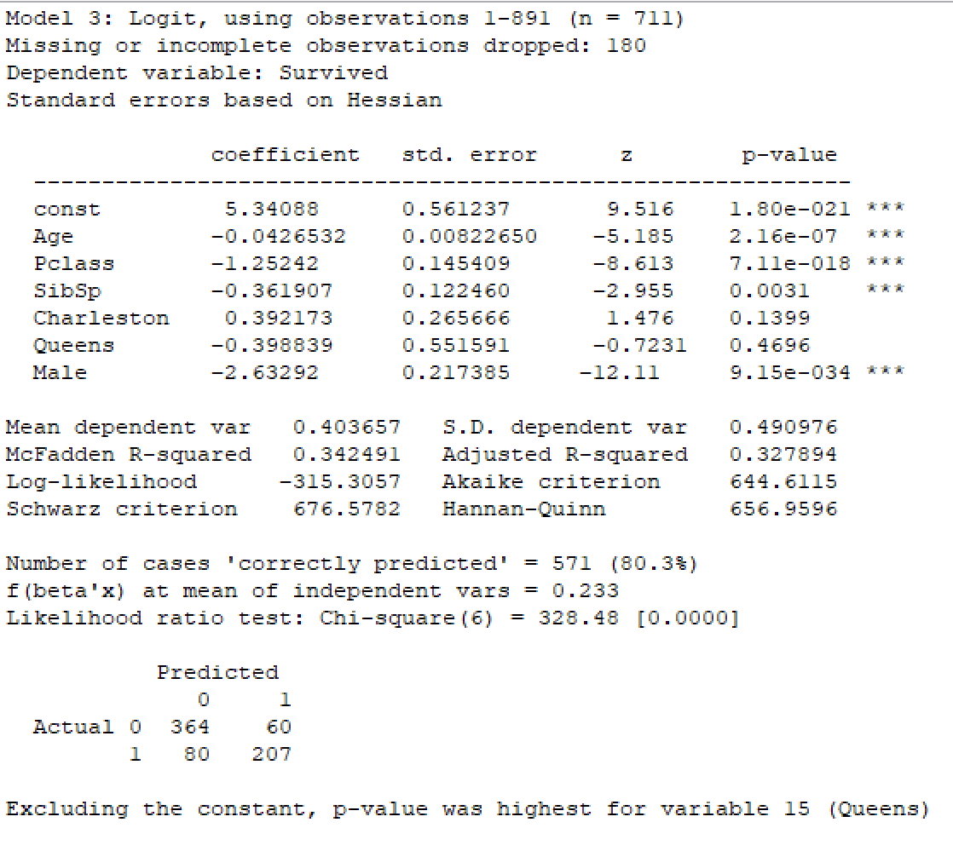

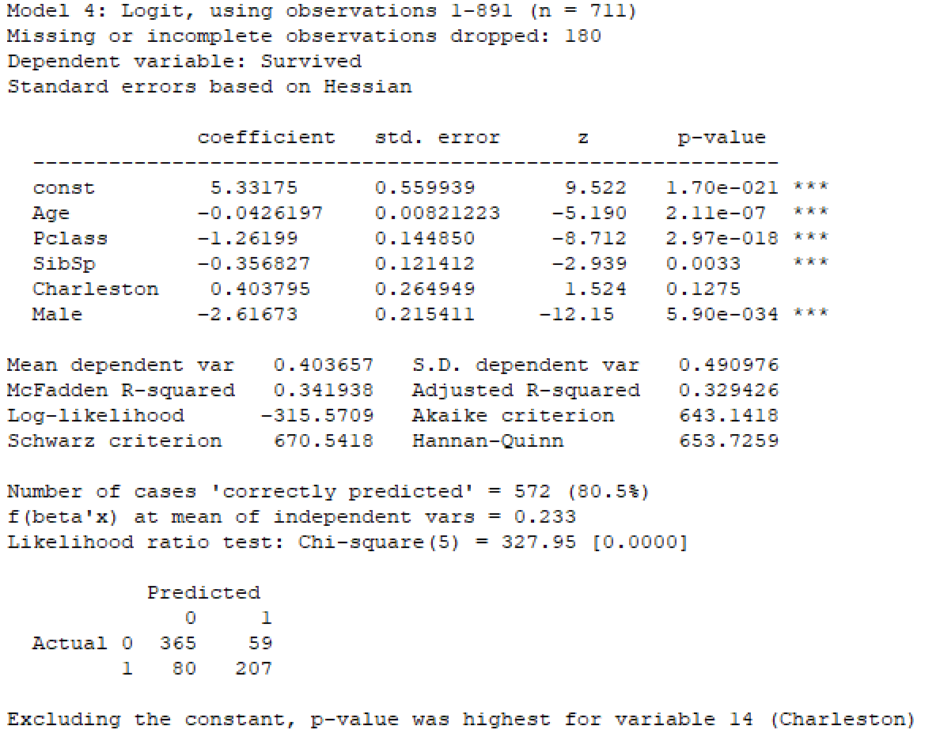
Final Model

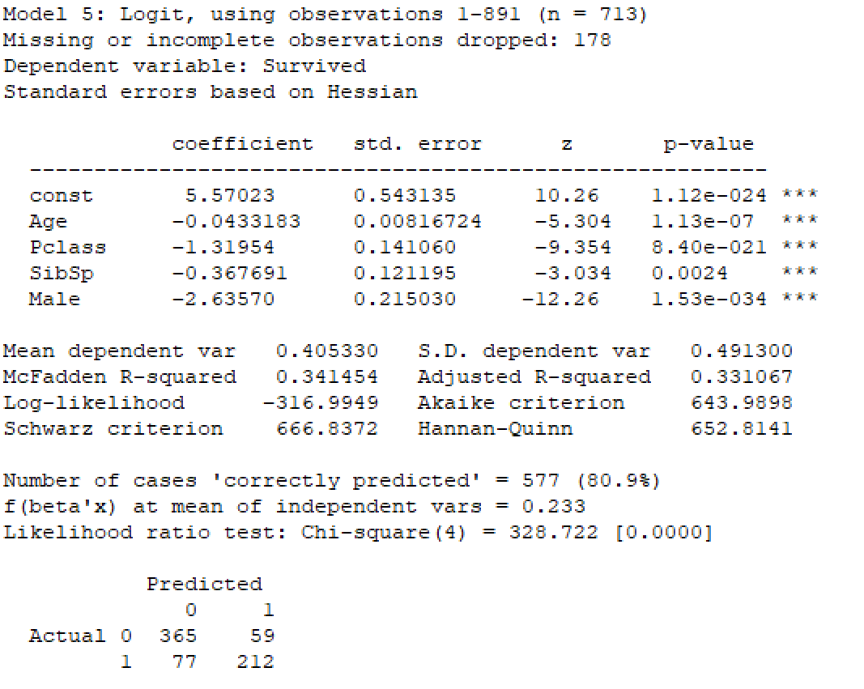

Cumulative Accuracy Profile (CAP) Curve

To determine the accuracy of the model a cap curve was developed. A Cap curve will display the difference between a model and a random selection. Both the model and the random selection show the prediction they make for an out come at any number of selections compared to the total population. In this case a random selection will show: for any number of passengers chosen at random, what is the chance of them actually surviving. Since this is a binary outcome a random selection will result in a linear line. Meaning if you chose, at random, 50% of the population aboard the ship then out of that population there are 50% of the passengers that will survive. A model will show the same result, however in this case, since the prediction is mathematically calculated, an expectation is made that out of a smaller total population chosen, a bigger chance of the survivors are found. An industry standard to evaluate the cap curve is to assess the midpoint on the x axis to see where this correlates to on the y-axis. This means when choosing half of the total population aboard the ship what population of total survivors have been found. The industry standard states if the y value equates: between 60% and 70% the model is bad, 70% and 80% the model is good, 80% and 90% the model is very good, and 90% and 100% the model is over fitted. The CAP curve is shown below, where the model is in red and the random selection is in blue. The metric results in 84%, which means this model is very good.

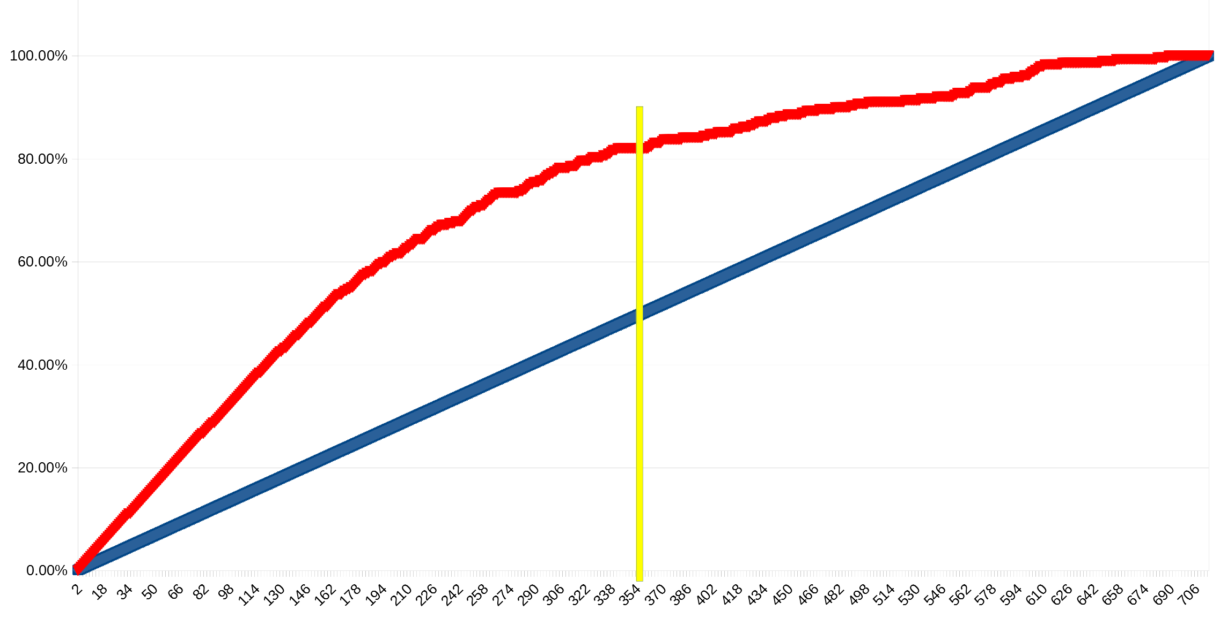

Insights

The four metrics that the model is based off of: Gender, Class, Siblings, and Age, are analyzed visually with Tableau below. Each metric was visualized as an A/B test to see what attributes about them makes them significant.

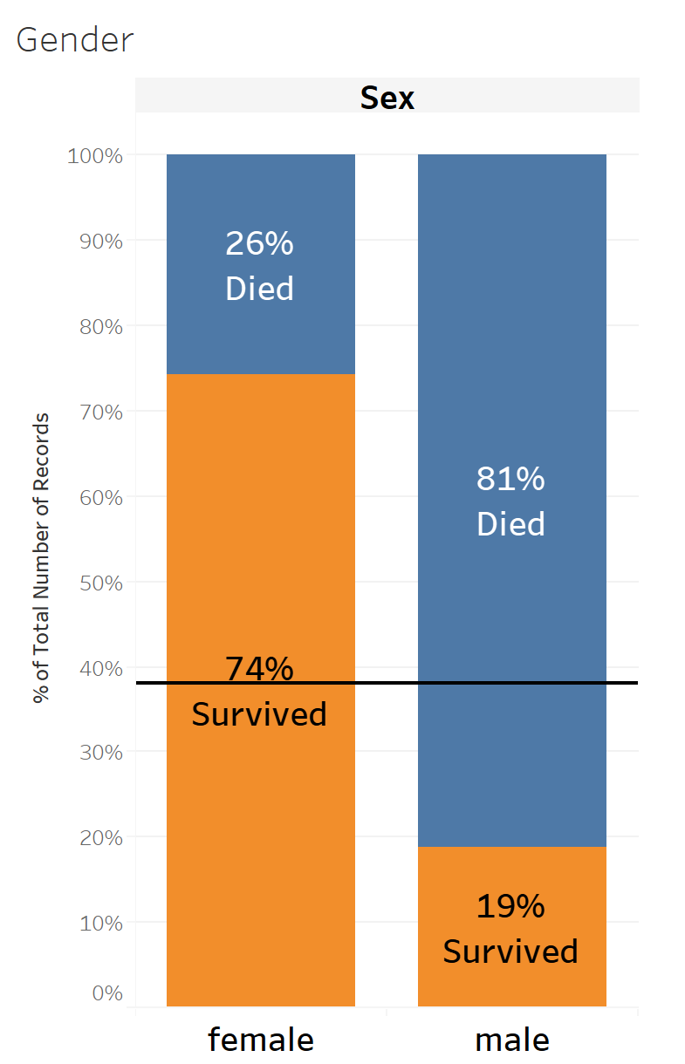

The first A/B test shows the results that gender had on the effect of surviving. The reference line shows that over all 38% of the population survived. This graph shows that Females had a 74% chance of surviving compared to males with 19%. This means that Females were 3.9 times more likely to survive than Males. This makes since, because we know that women and children were first to board the safety boats.
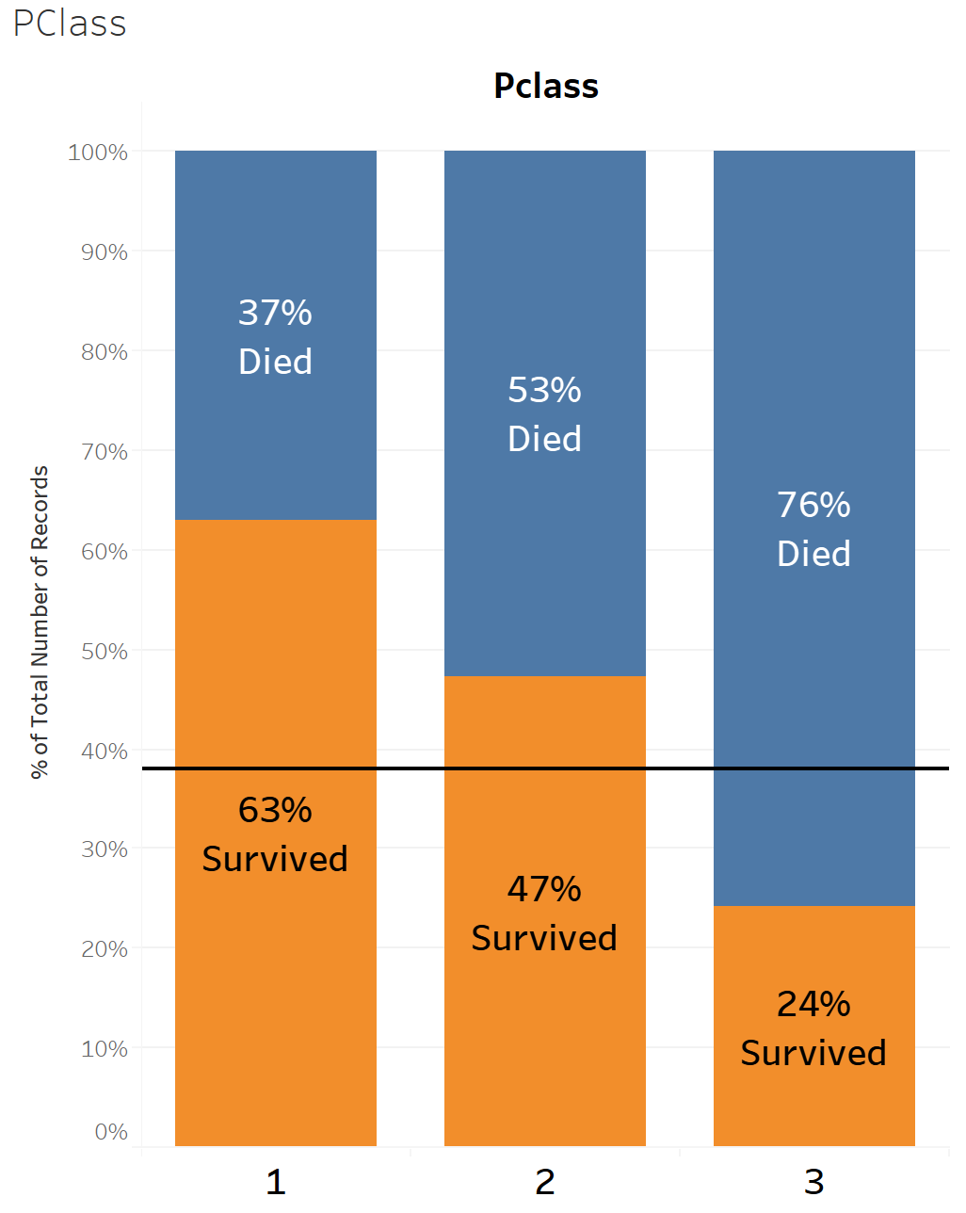

The second A/B test shows the results that class had on the effect of surviving. The reference line shows that over all 38% of the population survived. This graph shows that the first class, the more luxurious class, had a 63% chance of surviving compared to second class with 47% and third class with 24%. Visually a passenger had a higher chance of surviving if they were a part of a more prestigious class. This graph also shows that 2.6 times the passengers survived if they had the ability to afford the first class ticket compared to the third class. This makes since, because the first class was aboard the more luxurious cabins at the top of the ship which made it easier to get to safety compared to the third class suck at the bottom of the ship.
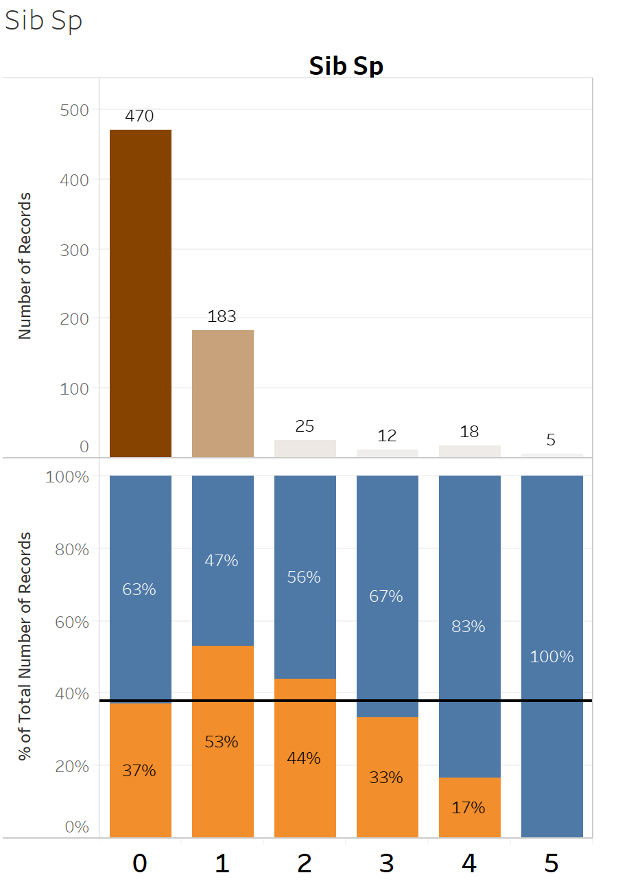

The third A/B test shows the results that the number of siblings a passenger had on the effect of their survival. The reference line shows that over all 38% of the population survived. This graph shows that, in general, an individual has decreasing chance of surviving the more siblings they have. This makes since, because the individual would have spent more time to find more of their siblings during the wreck before attempting escape. An interesting attribute this graph show that an individual had a higher chance of surviving if they had one sibling than none. This may be due to children having more siblings than adults which would lead to a higher chance of survival since women and children boarded the safety boats first.
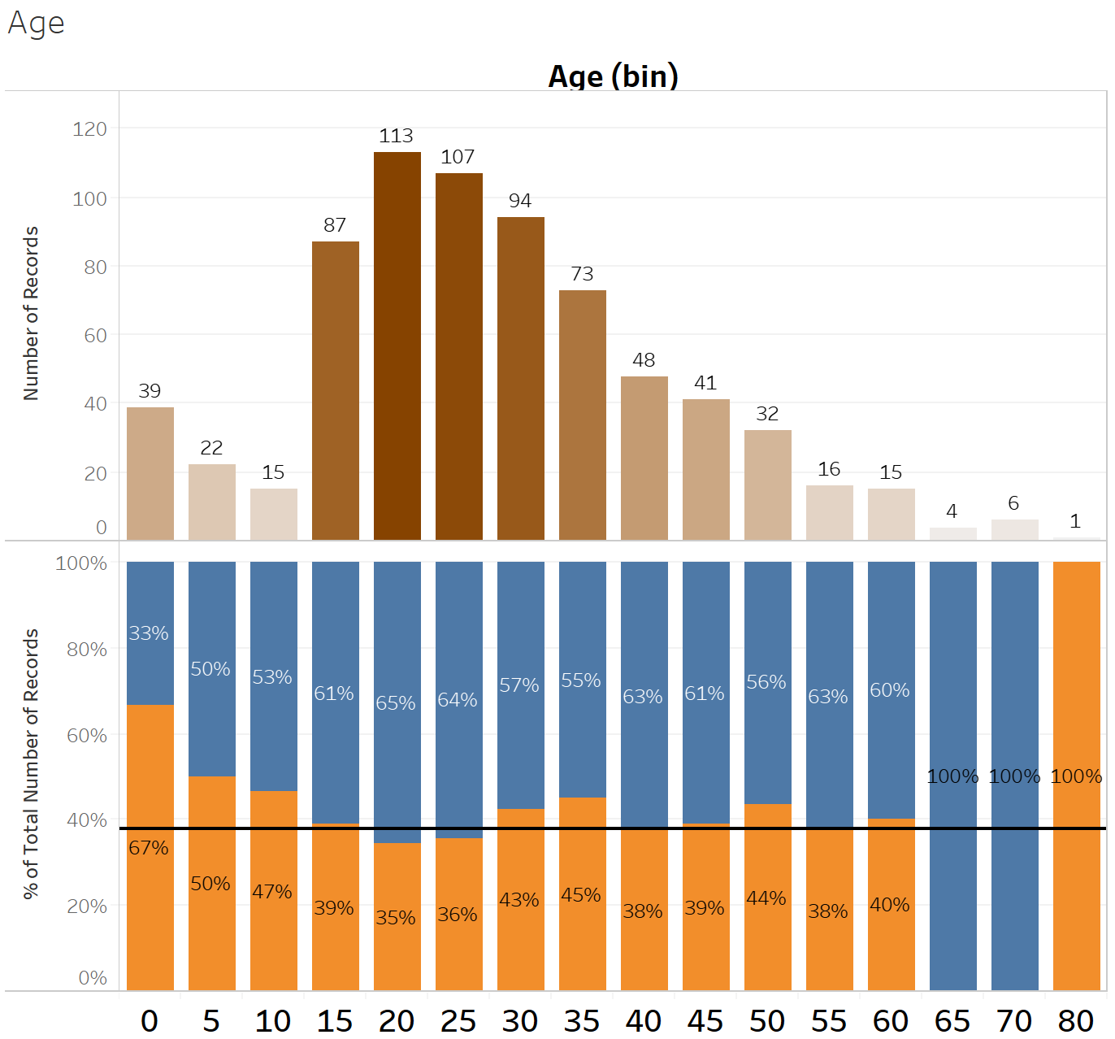
The final A/B test shows the results that a passenger’s age had on the effect of their survival. The reference line shows that over all 38% of the population survived. This graph shows that, in general, a younger passenger, under the age of 15, was more likely to live than any one else. This is because we know that women and children were first to board the safety boats during the wreck. All other age groups have about equal chance of surviving as the reference line until the age reaches over 65. These last few categories either completely died or survived and do not really provide any significance to the graph since the number of passengers in those age groups were significantly smaller than the other age groups.

Prediction

The passengers in the test file were run through the model and a probability of their survival was produced. This probability is then transformed into the passenger survival based on the magnitude of the probability. A probability of 0.5 and greater was transformed into the passenger survived and the passenger died if the probability was less than 0.5. All passengers that had a value of null for age were removed from the data set and their survival was not predicted. This is because the model can not predict the passengers survival without the age, sex, class, and siblings. The csv prediction file can be found in section 4 – Analysis.

