Capstone Project -Business Intelligence Solution for Netflix

Joseph Hand
Colorado State University Global
MIS 480: Capstone-Business Analytics and Information Systems
Dr. Orenthio Goodwin
12 March 2023

Netflix Organization Background
Netflix is a US based organization that has a global reach. The company was founded in 1997 by Reed Hastings and Marc Randolph. They provide an entertainment service of movie streaming to those who choose to subscribe to their platform. Initially, Netflix started as DVD-by-mail service, delivering DVD rentals to customers through mail. Then later chose to offer a wide range of movies, tv shows, documentaries and their own original content that could be streamed directly to various devices. Netflix has grown through the last two decades and has become the #1 streaming service for online streaming content. As the name of the company implies Netflix garnered its time by combining the two words “Net” which is short for internet, and “Flix” as a derivative of the term flicks relating to common films. (https://interestingengineering.com/culture/the-fascinating-history-of-netflix). Netflix in turn went public in 2002 with a membership of approximately 600,000 in the U.S. The stock was initially offered at $15 a share, with an initial offering of 5,500,000 shares. At the end of the year Netflix grew to 857,00 registered accounts. This year Netflix hit a new record for the registered members with more than 180 million accounts, 70 million from the United States alone.
Many experts believe that the future of the organization will not be as rosy. This partly based on the explosion of other streaming services. However, Netflix has been prepared for this situation. Netflix will continue to focus on the its content in the future rather then rely on potential streaming competitors pulling there content from Netflix. The company may move to advertisement based system to help maintain revenue, however they remain staunchly opposed to this.
I chose to go with Netflix since I was looking for a US based organization that would have to collect a lot of data to make Big Data decisions and an organization that uses current infrastructure to help collect that data. Netflix’s success is directly related to the fact that they are able to leverage data and technology to personalize content recommendations for users. Due to Netflix use of data and algorithms they had the ability to lead all the other platform streaming services which game them a competitive edge. The company’s algorithms analyze user data to suggest content that they are likely to enjoy.
Current Business Problem
Netflix has been having issues from what I have read in articles throughout the past year when it comes to content and customer sharing. They will be actively trying to use the data that they collect to help make the decisions they need to help their business remain competitive and at the same time not lose revenue. If their customers are sharing their subscriptions with friends and others, Netflix will continue to lose revenue for their business. After all they are and internet movie streaming business that provides content to their customers. Without their current customers or gaining new customers the organization will not be able to continue to be profitable and continue to competitive in the market Netflix remains the world’s largest streaming service, but the company reported its first quarterly loss in subscribers in more than a decade earlier this year and warned that it expects to lose two million global subscribers in the second quarter. That would be the single largest quarterly loss in the company’s history (Sherman, 2022). If Netflix continues to lose subscribers than they would be in serious trouble, competition in this area has been very tight and Netflix was once at the top. With more streaming services being offered subscribers may decide to leave Netflix all together. introduction, think about what context or background information the reader would benefit from knowing. As of 2021 Netflix has over 209 million subscribers worldwide. The issues is to keep subscribers and not lose them to ever increasing competition.

Code and Function
Body paragraphs should follow the MEAL structure. This structure will help your ideas build on one another in order to support your thesis statement and to develop your argument over the course of
Business Intelligence tool used for Analytics.
BI tools can help Netflix with data analysis. Powerful analytics tools can process up to terabytes of data to produce valuable information. Netflix’s success is due to its ability to make informed decisions and improve its customer experience. Tools to be used will be able to measure and collect data in these areas. Personalized viewing experience, Auto-generated personalized thumbnails, Trending and Ranking, Market optimization and Predictive and descriptive analytics. With these tools Netflix can keep track of what movies and shows the users watch. Also, will have the ability to generate thousands of videos and frames from an image. Real time data will help make real time decision on view experience and improve market optimization (Sharma, 2022).
Tools such as SAS, Tableau, Power BI and Data Pine would be helpful to the organization if not already in use. These tools will help utilize the data collected to make better informed decision for the streaming giant. My personal choice at this time is to use SAS and see how we can analyze the data for Netflix. I have used this program in a former class, and I really like it. I hope to try to implement it other areas that I am working with. Its ease of use is great for data analysis the ability to upload a data set and have the visualization of graphs charts and plots is essential to understanding the data set.
R is another great data analysis tool that could be leveraged to help evaluate the data in the large collection of big data that Netflix has the ability to collect due to its large number of subscribers. With utilizing R Netflix has the ability to ascertain which movies certain age groups enjoy. Including income of the customer and other data such as gender, marital status, location, and employment. Netflix could find correlations in the data that might find a common trend to help support them in developing or offering content that would target certain groups through marketing and other offering. R is great in this aspect in identifying these correlations.
.
Data Visualization Tools
Data visualization tools will give us the ability to see what the data is going to report. We can have real time data visualization of how many subscriber accounts are currently watching. Also, genre of the movie, age groups of the subscribers and how long they have been with Netflix. I would like to use SAS to make a plot of the data to so that we can see whom likes what type of genre. Possibly of Age, Sex, and Genre and Length of time they had ben with Netflix.
Because Netflix collects so much data from having many subscribers, there data sets are very huge. Visualization tools will help management see the number in the forms of reports and graphs, charts that will in real time give them the ability to make conscious business decisions that will impact the quality of service they provide to current and future subscribers. With these tools they can form dashboard on their PC’s to and have the ability to manipulate this data to see how it may affect the over data or how it may impact certain data points they are focused on. Visualization makes the ability to see this much better instead of using printed out documents that would be pages and pages long. Visualization techniques will make reading this data much easier to understand and to handle.
When it comes to big data, like what Netflix handles the quality of data is crucial. Raw data when captured and stored in data silos, simply isn’t valuable unless it’s being broken down, evaluated, and acted upon. Studies show that as little as 1% of the worlds data is effectively analyzed. The benefits of data visualization has 5 parts.
1 Visualized data is process faster- visual content is processed much and easier than text.
2 Data Visualization dashboards support visual learners
3 Data visualization tools show insights, causes, and trends that may be in the traditional reports
4 Data Visualization gives actionable items.
5 Data visualization increases productivity in sales. (https://www.salesforce.com/products/crm-analytics/resources/data-visualization/).
Figure 1: Genre and frequency (DRAMA, COMEDY, HORROR, DOCUMENTARY)
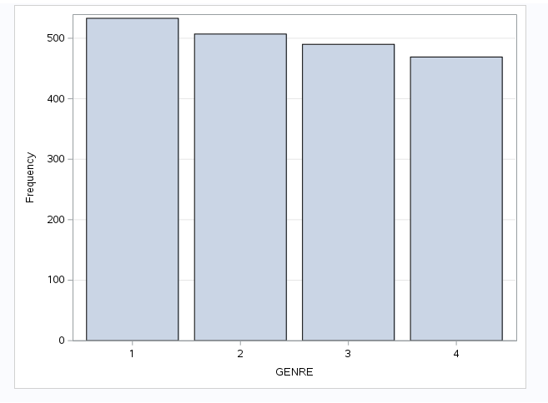

Figure 2: Boxplot of Age groups


Figure 3: Pie Chart of Genre of Entertainment preferred
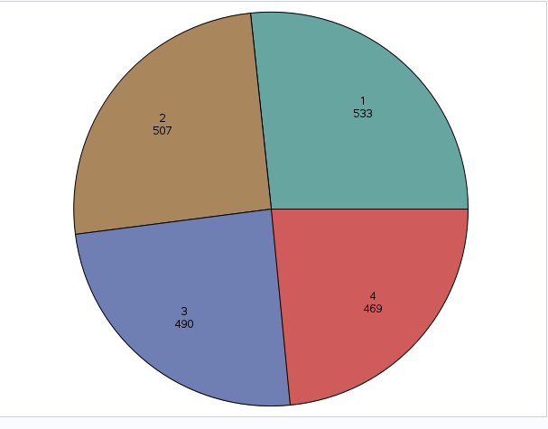
Figure 4: Correlation Analysis of Age and Genre.
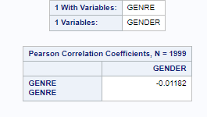
Data Analytics Outcomes and Benefits

Programming Code and Analysis / GitHub



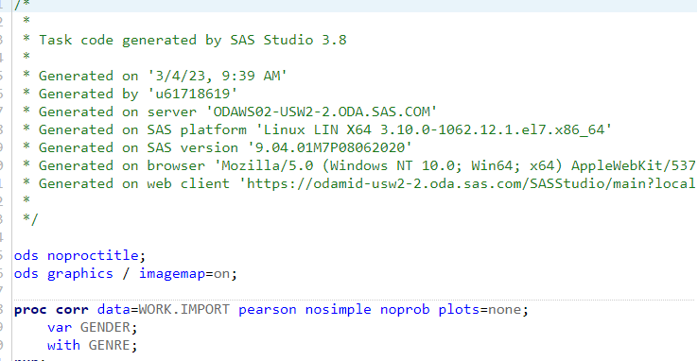
Conclusion
The last section or paragraph of your paper should be the conclusion. If you are using headers in your paper, use a “Conclusion” heading. A conclusion should reiterate the major points of your argument. To do this, think about developing your thesis by adding more detail or by retracing the steps of your argument. You can recap major sections for the reader. You can also summarize the primary supporting points or evidence you discussed in the paper. The conclusion should not introduce any new information to avoid confusing the reader. To end the paper, think about what you want your reader to do with all the information you just presented. Explain what logical next steps might be taken to learn more about this topic. Use the conclusion to establish the significance and importance of your work, motivate others to build on what you have done in this paper, and encourage the reader to explore new ideas or reach other conclusions

References
Datta, S. (2020, September 23). What led Netflix to shut their own data centers and migrate to AWS? Medium. Retrieved February 15, 2 https://shirshadatta2000.medium.com/what-led-netflix-to-shut-their-own-data-centers-and-migrate-to-aws-bb38b9e4b965#:~:text=Netflix%20uses%20AWS%20for%20nearly,100%2C000%20server%20instances%20on%20AWS.
Sharma, K. (2022, May 28). 6 Ways Netflix uses the Power of Analytics. You are being redirected... Retrieved February 15, 2023, from https://www.ascentt.com/6-ways-netflix-uses-power-analytics/.
Sherman, A. (2022, July 18). Netflix investors brace for subscriber losses as company works on long-term fixes. CNBC. Retrieved February 15, 2023, from https://www.cnbc.com/2022/07/18/netflix-investors-brace-for-subscriber-losses-as-company-builds-for-long-term.html. concept analysis. Journal of Advanced Nursing, 71(8), 1787–1796. https://doi.org/10.1111/jan.12654
Epstein, M., & Roy, M., (2003). Improving sustainability performance: Specifying, implements and measuring key principles. Journal of General Management, 29(1), 15-31.
Kinderman, P. (2019). A manifesto for mental health: Why we need a revolution in mental health care. Palgrave Macmillan. https://doi.org/10.1007/978-3-030-24386-9
Lundgren, B., & Holmberg, M. (2017). Pandemic flus and vaccination policies in Sweden. In C. Holmberg, S. Blume, & P. Greenough (Eds.), The politics of vaccination: A global history (pp. 260–287). Manchester University Press.
McWilliams, K. (2020, March 30). What’s an appendix for anyways? CSU Global Writing Center Blog. https://medium.com/@csuglobalwritingcenter/whats-an-appendix-for-anyways-ac73d89e8423
Wu, J., Cai, W., Watkins, D., & Glanz, J. (2020, March 22). How the virus got out [Interactive infographic]. The New York Times. https://www.nytimes.com/interactive/2020/03/22/world/coronavirus-spread.html

Table 1
Clarkson and Associates; Income Statement; Year Ending December 31, 2012
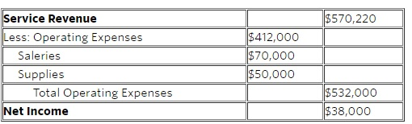
Note. Adapted from Module 4: Introduction to Team Building, by Colorado State University Global, 2020, Canvas (https://portal.csuglobal.edu). Copyright 2020 by Colorado State University Global.

Table 2
The Four Principles of Sustainability Performance
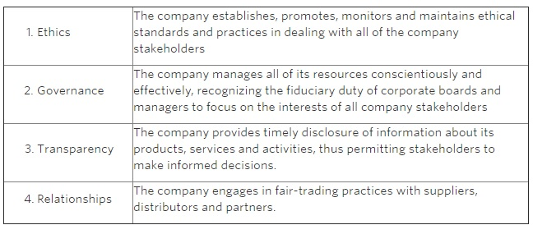 Note. Adapted from "Improving sustainability performance: Specifying, implements and measuring key principles" by M. Epstein & M. Roy, 2003, Journal of General Management, 29(1), pp.15-31. Copyright 2020 by SAGE.

