Apache-POI-ToReadExcelFile

<https://poi.apache.org/download.html>

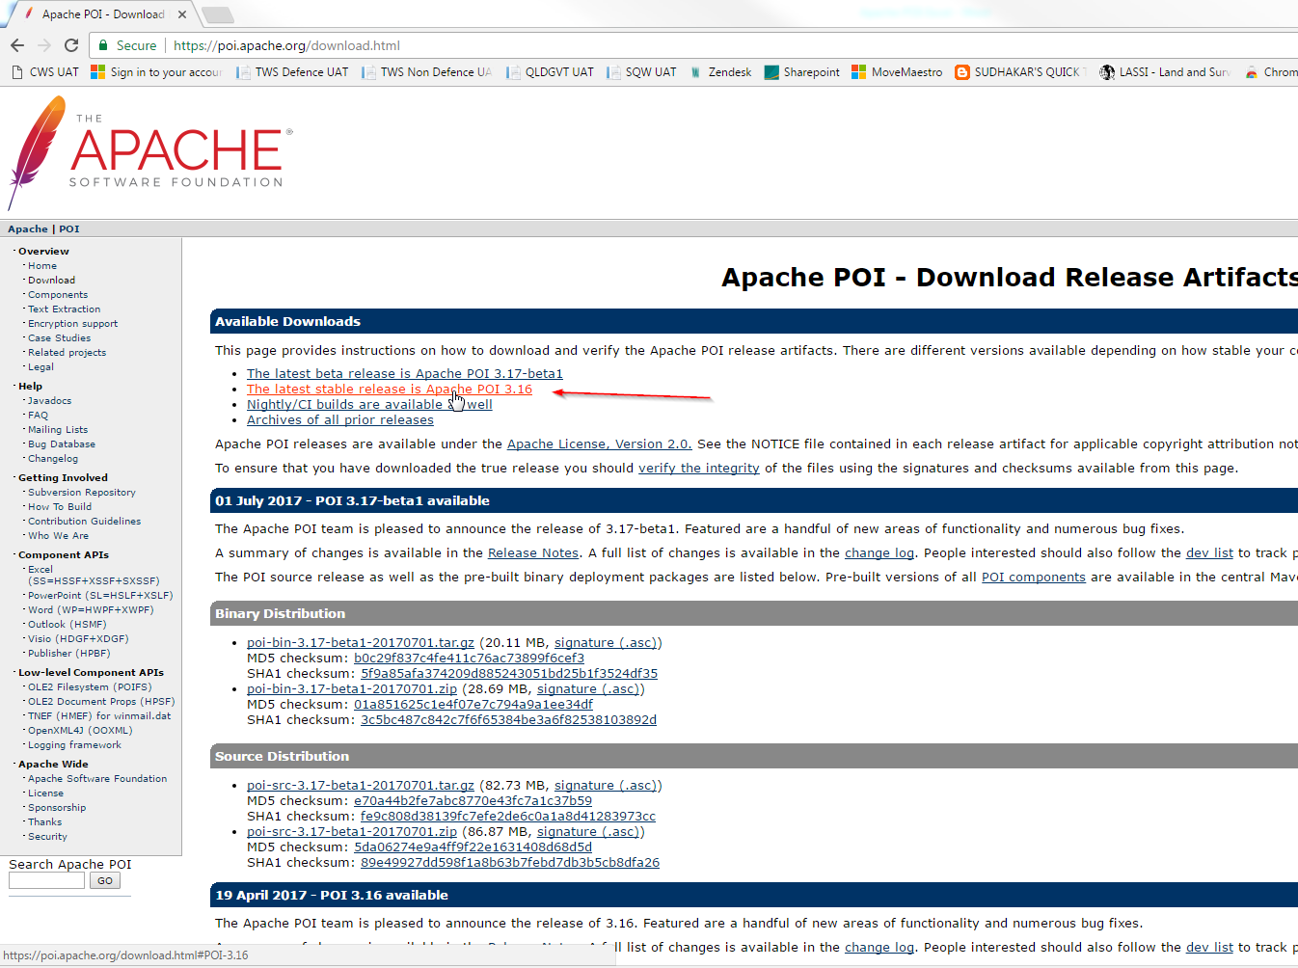

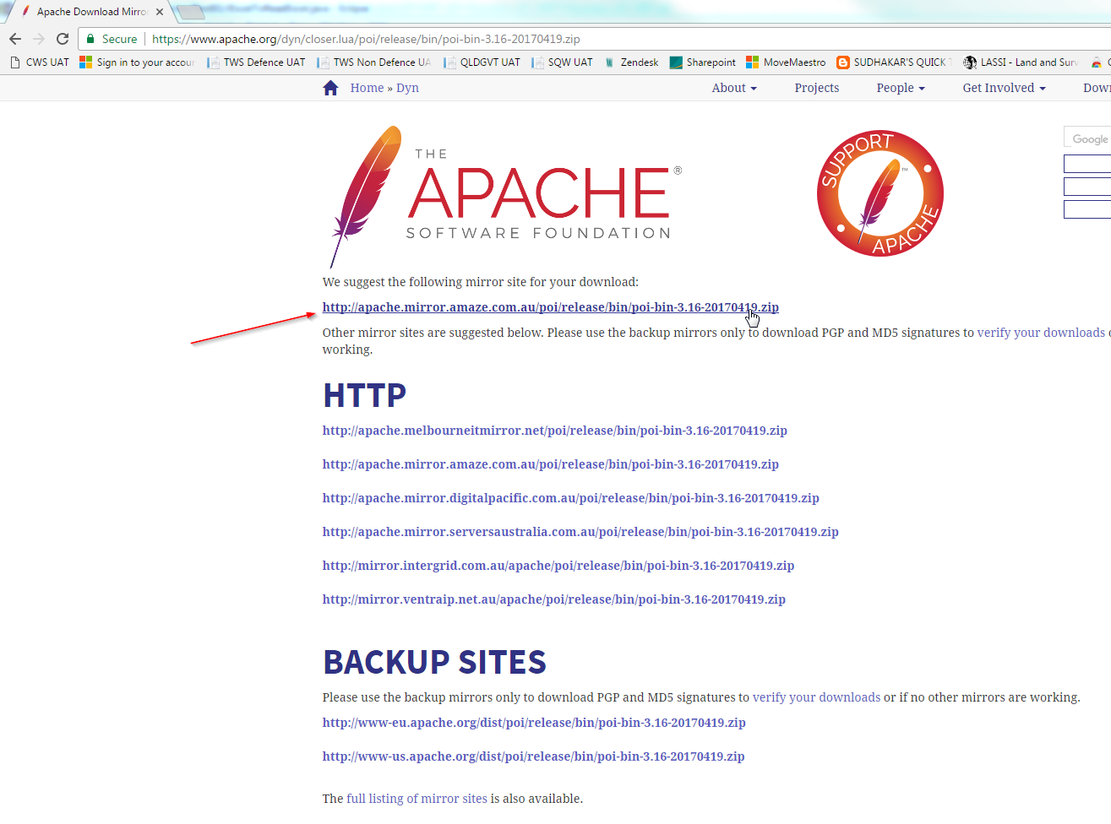

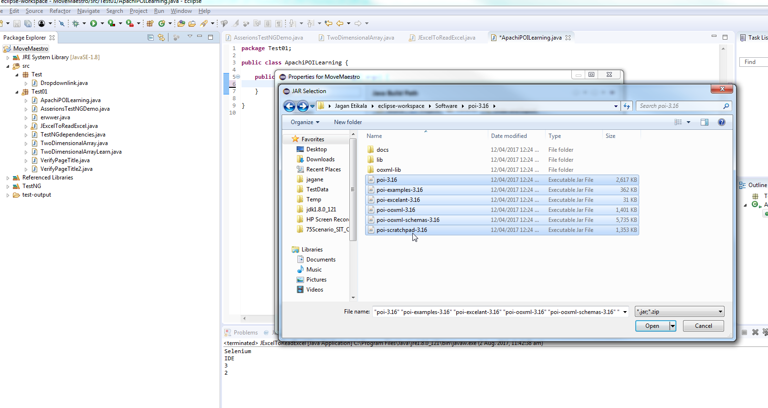

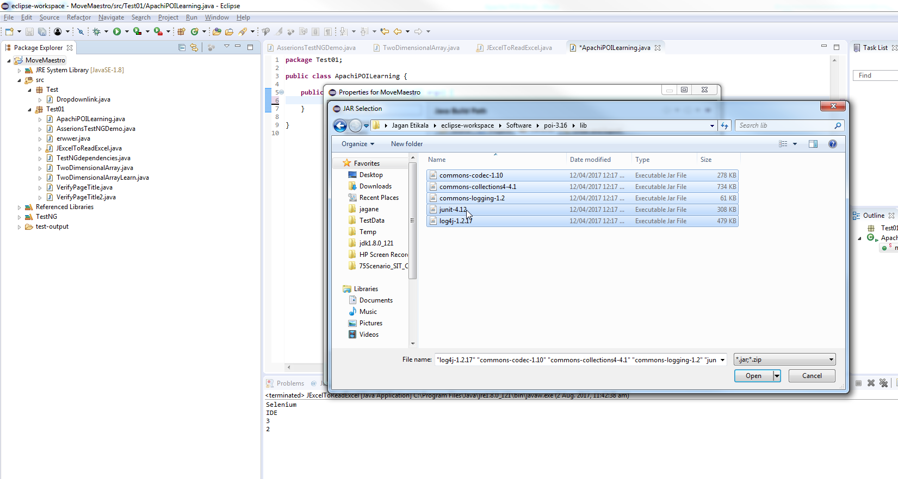

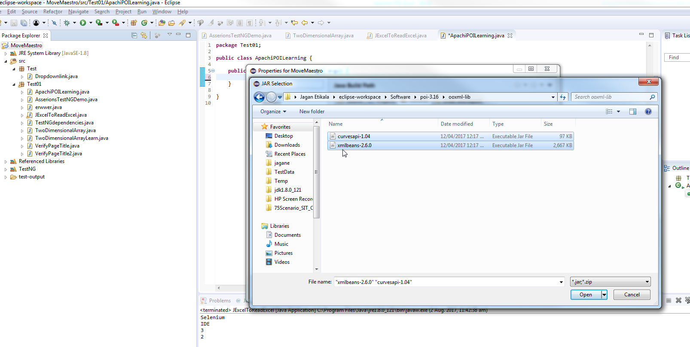

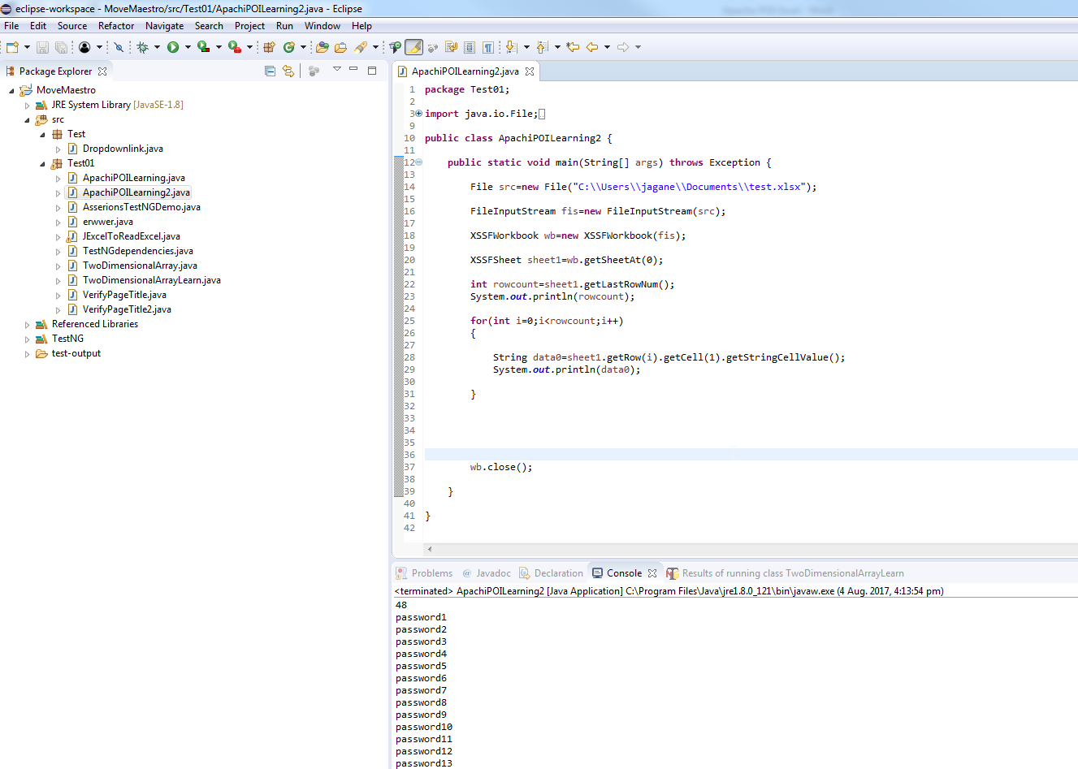

package Test01;

import java.io.File;

import java.io.FileInputStream;

//import java.io.FileNotFoundException;

import org.apache.poi.xssf.usermodel.XSSFSheet;

import org.apache.poi.xssf.usermodel.XSSFWorkbook;

public class ApachiPOILearning2 {

public static void main(String[] args) throws Exception {

File src=new File("C:\\Users\\jagane\\Documents\\test.xlsx");

FileInputStream fis=new FileInputStream(src);

XSSFWorkbook wb=new XSSFWorkbook(fis);

XSSFSheet sheet1=wb.getSheetAt(0);

int rowcount=sheet1.getLastRowNum();

System.out.println(rowcount);

for(int i=0;i<rowcount;i++)

{

String data0=sheet1.getRow(i).getCell(1).getStringCellValue();

System.out.println(data0);

}

wb.close();

}

}

<https://www.youtube.com/watch?v=sbBdj4zIMqY#t=5.698496>