**Cucumber**

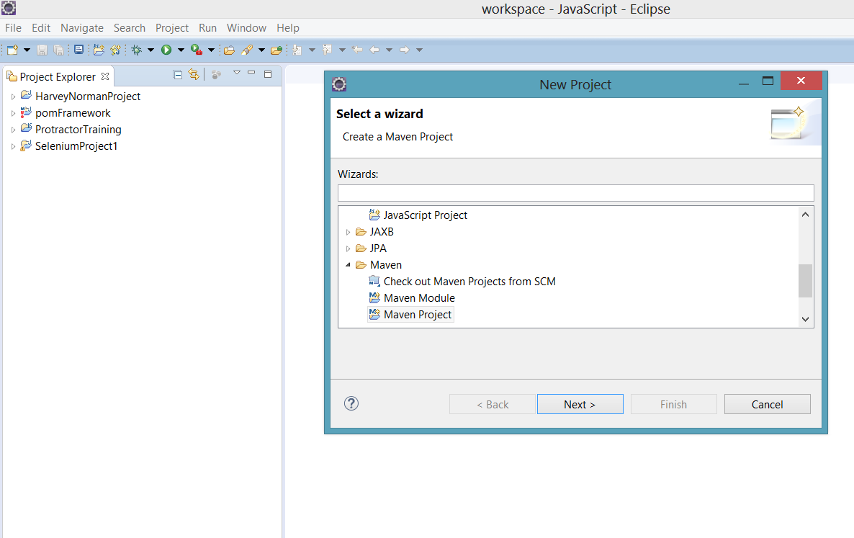

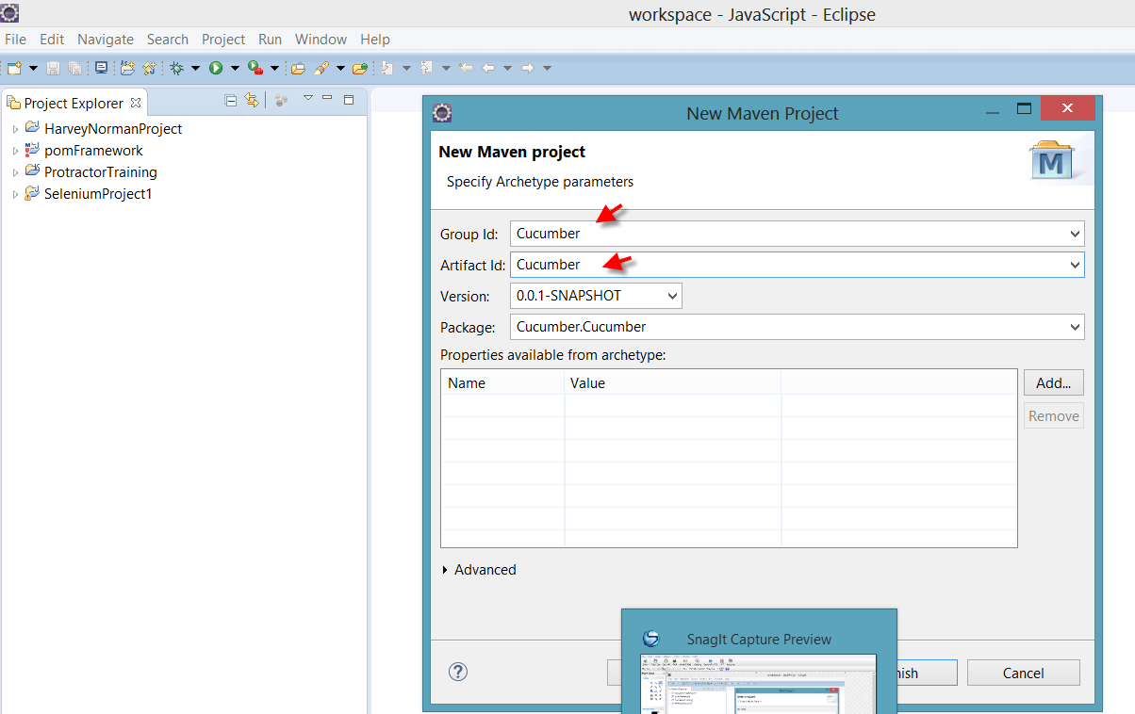

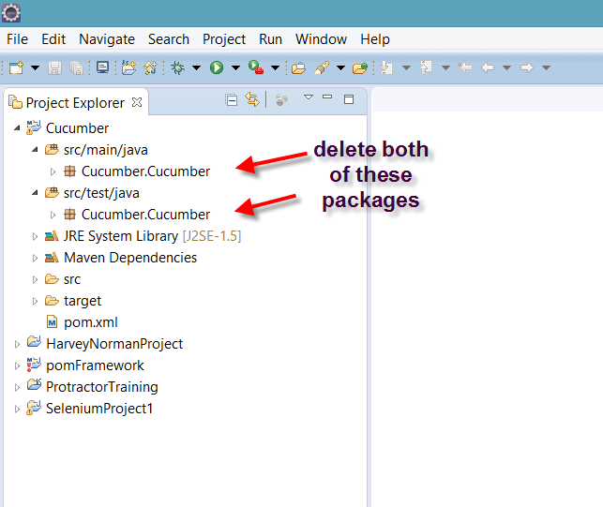

Paste below code in pom.xml file

|  |
| --- |
| <project xmlns="http://maven.apache.org/POM/4.0.0" xmlns:xsi="http://www.w3.org/2001/XMLSchema-instance" |
|  | xsi:schemaLocation="http://maven.apache.org/POM/4.0.0 http://maven.apache.org/xsd/maven-4.0.0.xsd"> |
|  | <modelVersion>4.0.0</modelVersion> |
|  |  |
|  | <groupId>FreeCrmBDDFramework</groupId> |
|  | <artifactId>FreeCrmBDDFramework</artifactId> |
|  | <version>0.0.1-SNAPSHOT</version> |
|  | <packaging>jar</packaging> |
|  |  |
|  | <name>FreeCrmBDDFramework</name> |
|  | <url>http://maven.apache.org</url> |
|  |  |
|  | <properties> |
|  | <project.build.sourceEncoding>UTF-8</project.build.sourceEncoding> |
|  | </properties> |
|  |  |
|  | <dependencies> |
|  |  |
|  |  |
|  | <dependency> |
|  | <groupId>info.cukes</groupId> |
|  | <artifactId>cucumber-java</artifactId> |
|  | <version>1.2.5</version> |
|  | <scope>test</scope> |
|  | </dependency> |
|  |  |
|  | <dependency> |
|  | <groupId>info.cukes</groupId> |
|  | <artifactId>cucumber-jvm</artifactId> |
|  | <version>1.2.5</version> |
|  | <type>pom</type> |
|  | </dependency> |
|  |  |
|  | <dependency> |
|  | <groupId>info.cukes</groupId> |
|  | <artifactId>cucumber-junit</artifactId> |
|  | <version>1.2.5</version> |
|  | <scope>test</scope> |
|  | </dependency> |
|  |  |
|  | <dependency> |
|  | <groupId>info.cukes</groupId> |
|  | <artifactId>cucumber-jvm-deps</artifactId> |
|  | <version>1.0.5</version> |
|  | </dependency> |
|  |  |
|  | <dependency> |
|  | <groupId>net.masterthought</groupId> |
|  | <artifactId>cucumber-reporting</artifactId> |
|  | <version>1.0.0</version> |
|  | </dependency> |
|  |  |
|  | <dependency> |
|  | <groupId>info.cukes</groupId> |
|  | <artifactId>gherkin</artifactId> |
|  | <version>2.12.2</version> |
|  | </dependency> |
|  |  |
|  | <dependency> |
|  | <groupId>junit</groupId> |
|  | <artifactId>junit</artifactId> |
|  | <version>3.8.1</version> |
|  | <scope>test</scope> |
|  | </dependency> |
|  |  |
|  |  |
|  |  |
|  | <dependency> |
|  | <groupId>org.seleniumhq.selenium</groupId> |
|  | <artifactId>selenium-java</artifactId> |
|  | <version>3.5.3</version> |
|  | </dependency> |
|  |  |
|  | <!-- https://mvnrepository.com/artifact/info.cukes/cucumber-picocontainer --> |
|  | <dependency> |
|  | <groupId>info.cukes</groupId> |
|  | <artifactId>cucumber-picocontainer</artifactId> |
|  | <version>1.2.5</version> |
|  | <scope>test</scope> |
|  | </dependency> |
|  |  |
|  |  |
|  |  |
|  |  |
|  | </dependencies> |
|  | </project> |

Create a package as Features under Project ‘Cucumber’

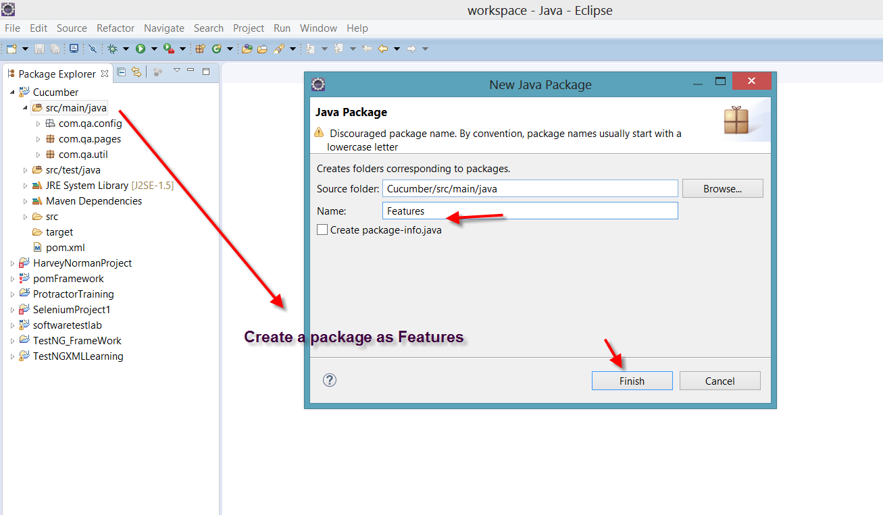

Download natural plugin

Help>eclipse market place> search for natural

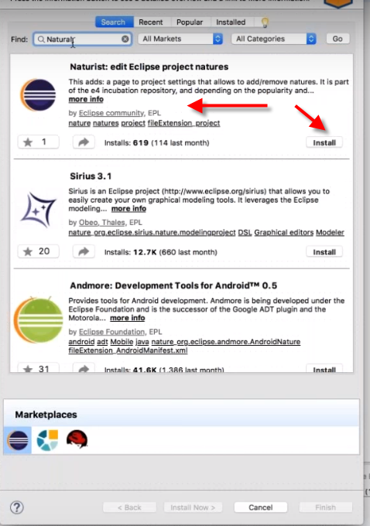

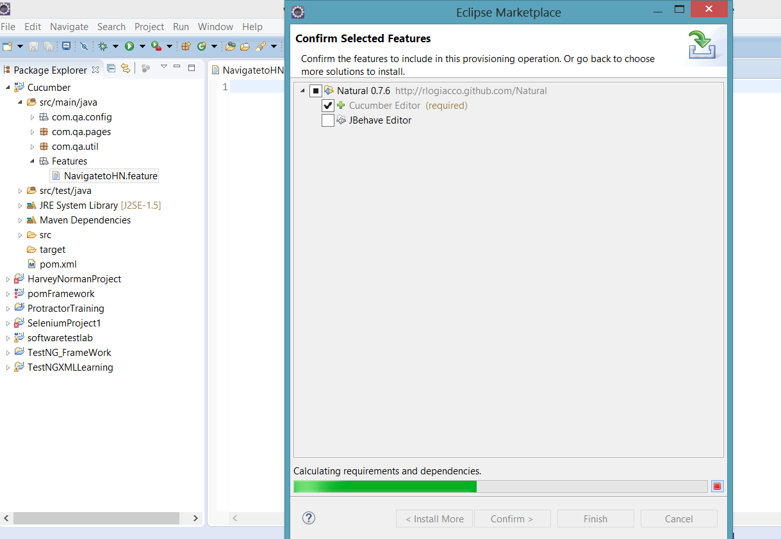

If not able to add natural from eclipse market place do below step

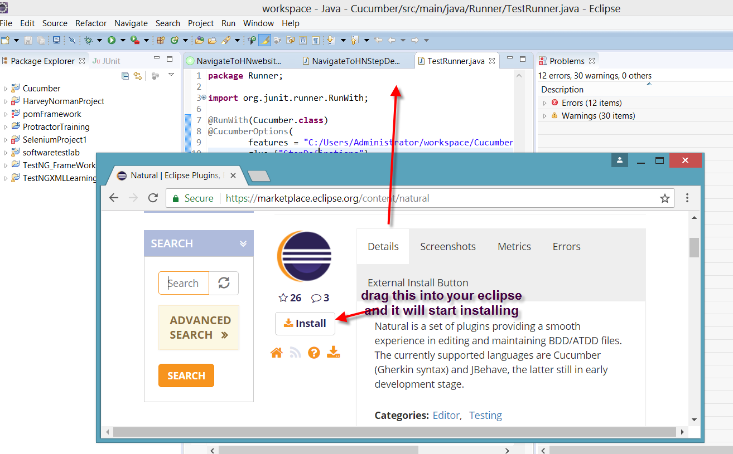

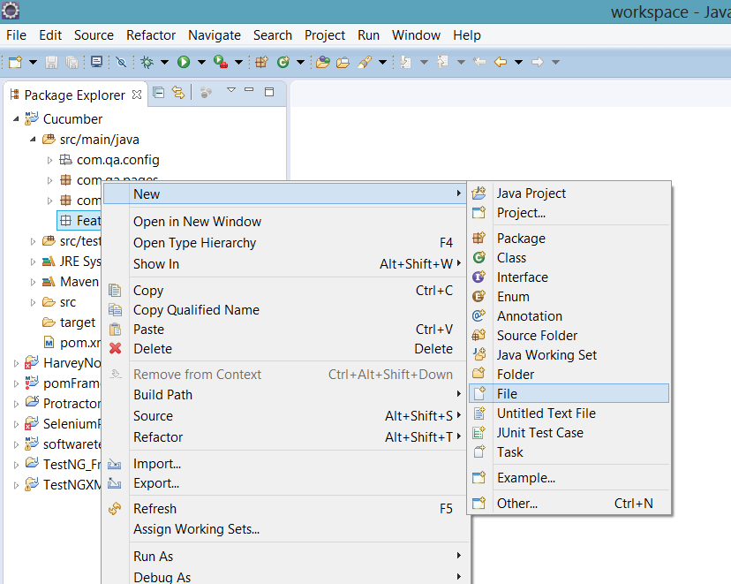

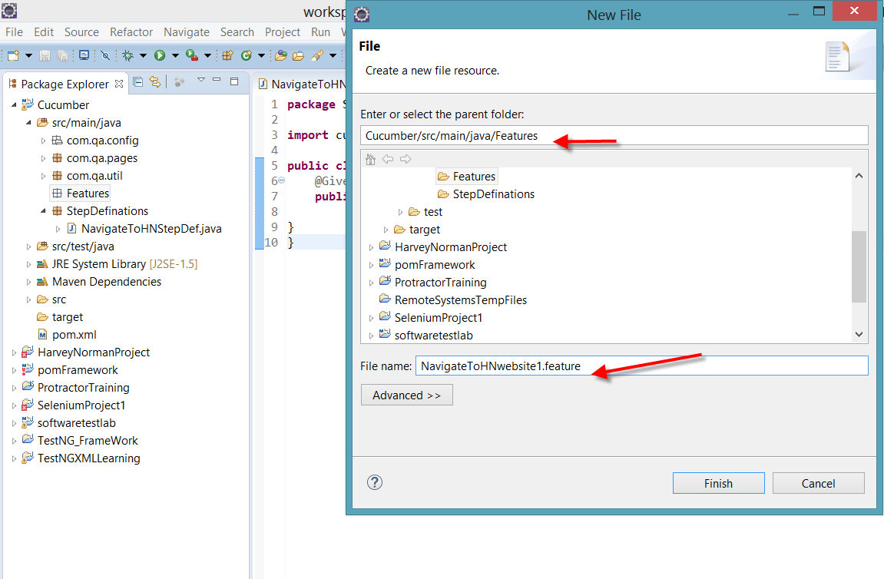

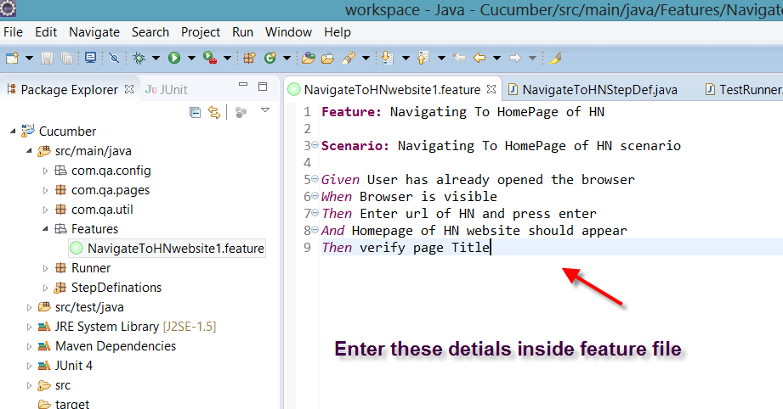

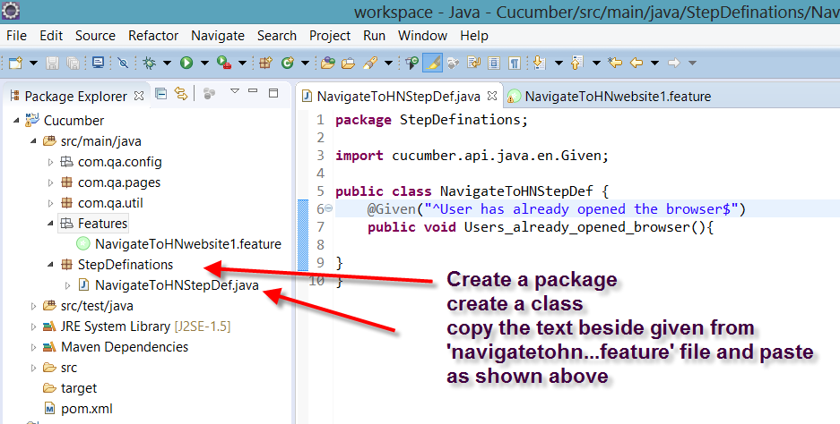

Create another package as shown below

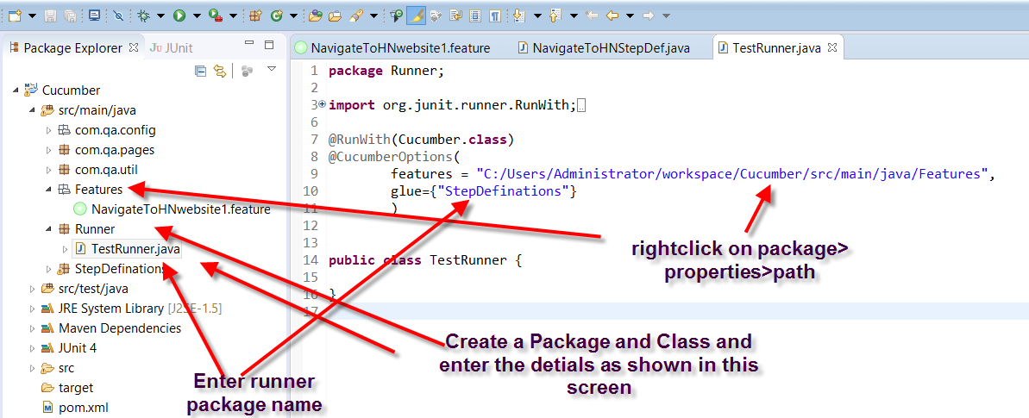

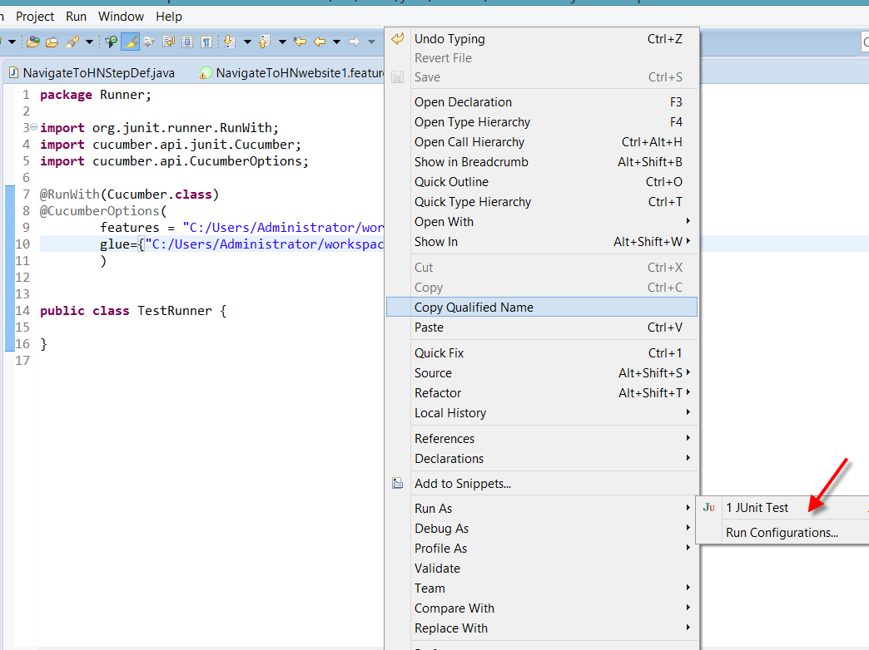

Run as >junit

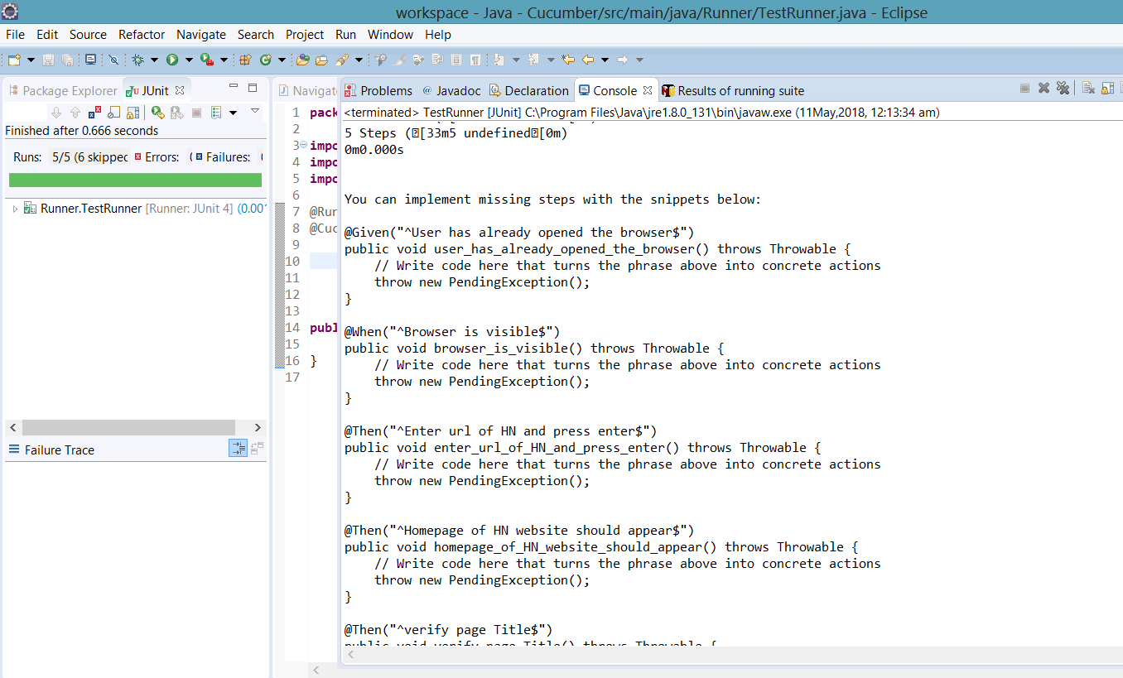

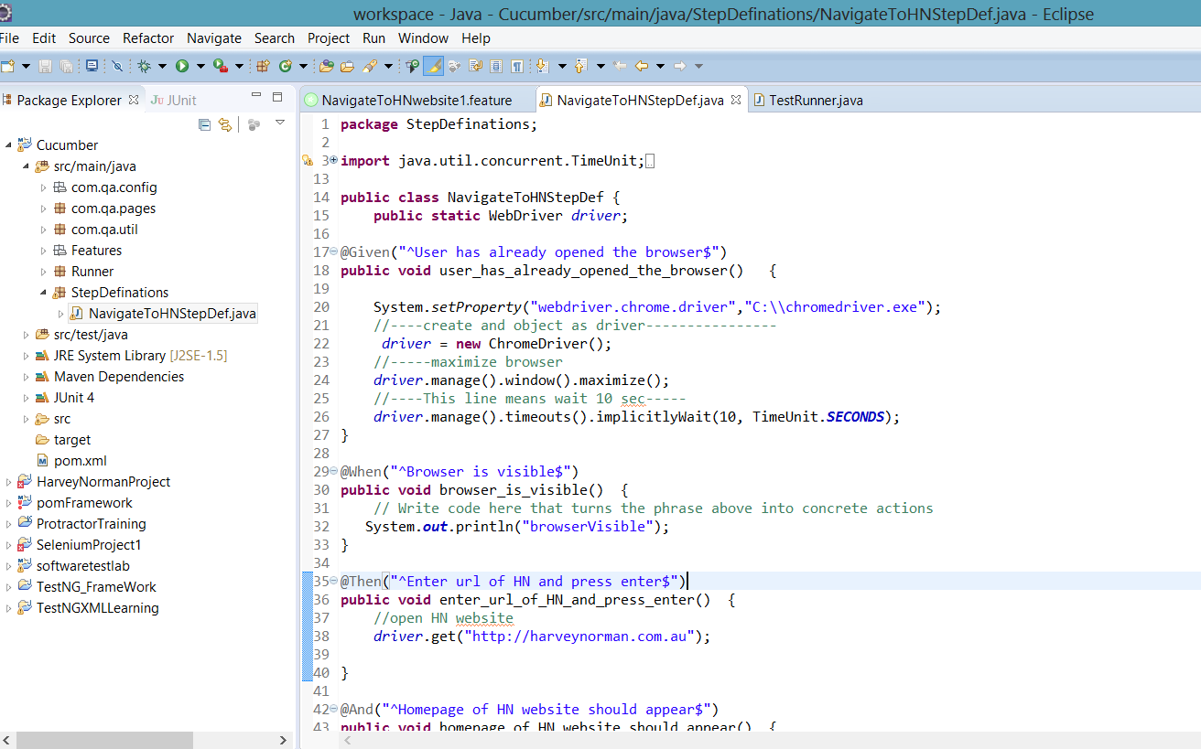

*package StepDefinations;*

*import java.util.concurrent.TimeUnit;*

*import org.openqa.selenium.By;*

*import org.openqa.selenium.WebDriver;*

*import org.openqa.selenium.chrome.ChromeDriver;*

*import cucumber.api.java.en.And;*

*import cucumber.api.java.en.Given;*

*import cucumber.api.java.en.Then;*

*import cucumber.api.java.en.When;*

*public class NavigateToHNStepDef {*

*public static WebDriver driver;*

*@Given("^User has already opened the browser$")*

*public void user_has_already_opened_the_browser() {*

*System.setProperty("webdriver.chrome.driver","C:\\chromedriver.exe");*

*//----create and object as driver----------------*

*driver = new ChromeDriver();*

*//-----maximize browser*

*driver.manage().window().maximize();*

*//----This line means wait 10 sec-----*

*driver.manage().timeouts().implicitlyWait(10, TimeUnit.SECONDS);*

*}*

*@When("^Browser is visible$")*

*public void browser_is_visible() {*

*// Write code here that turns the phrase above into concrete actions*

*System.out.println("browserVisible");*

*}*

*@Then("^Enter url of HN and press enter$")*

*public void enter_url_of_HN_and_press_enter() {*

*//open HN website*

*driver.get("http://harveynorman.com.au");*

*}*

*@And("^Homepage of HN website should appear$")*

*public void homepage_of_HN_website_should_appear() {*

*System.out.println("HomePageAppeared");*

*}*

*@Then("^verify page Title$")*

*public void verify_page_Title() {*

*System.out.println("TitleVerified");*

*}*

*}*